Ceph3升级步骤

目录
试验环境升级试炼 1
部署Ceph3.1 1
Ceph集群节点配置 1
通过镜像文件安装Ceph3.1 2
客户端测试工具配置 4
fio配置 4
挂载cephfs，并写入测试文件 4
s3客户端配置，并写入测试数据 5
Ceph3.1-->Ceph3.3升级 9
升级循序 9
升级操作系统rhel7.5-->rhel7.9 9
升级ceph到3.3版本 10
Ceph-3.3版本升级到Ceph-4.3版本 11
物理部署切换到容器部署 15
rhel7.9升级到rhel8.8 17
升級Ceph4.3到Ceph5.3 21
rhel8.8 升级 rhel9.2 24
升级Ceph5.3到Ceph6 29

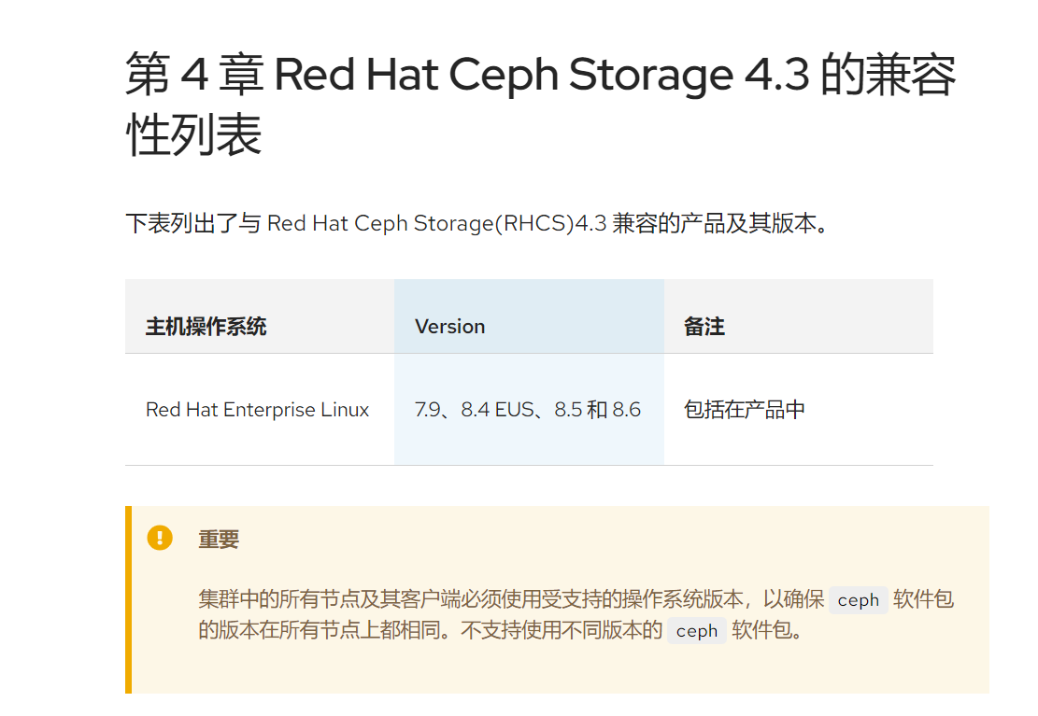

选择升级 | Ceph服务端 | Ceph客户端(openstack云平台)
1 | Ceph3.1-->Ceph3.3 | Ceph3.1-->Ceph3.3
2 | rhel7.5-->rhel7.9 | rhel7.3-->rhel7.9
3 | Ceph3.3-->Ceph4.3 | Ceph3.3-->Ceph4.3
4 | 物理部署转容器
5 | rhel7.9-->rhel8.8 | rhel7.9-->rhel8.8
6 | Ceph4.3-->Ceph5.3 | Ceph4.3-->Ceph5.3
7 | rhel8.8-->rhel9.2 | rhel8.8-->rhel9.2
8 | Ceph5.3-->Ceph6.1 | Ceph5.3-->Ceph6.1

部署Ceph3.1

Ceph集群节点配置

ceph version 12.2.5-42.el7cp (82d52d7efa6edec70f6a0fc306f40b89265535fb) luminous (stable)

hostname | ip | 部署服务
ceph01 | 10.0.79.169 | mon,mgr,client,osd
ceph02 | 10.0.78.12 | mon,mgr,client,osd
ceph03 | 10.0.78.175 | mon,mgr,client,osd,rgw
ceph04 | 10.0.79.207 | client,osd,mds
ceph05 | 10.0.79.218 | client,osd,mds
ceph06/ceph07 | 10.0.78.29 | client, fio-rbd, cephfs-kernel-mount, rgw-s3cmd

通过镜像文件安装Ceph3.1
[root@ceph06 ~]# cat /etc/ansible/hosts
[mons]
ceph01
ceph02
ceph03

[mgrs]
ceph01
ceph02
ceph03

[osds]
ceph01
ceph02
ceph03
ceph04
ceph05

[mdss]
ceph04
ceph05

[clients]
ceph01
ceph02
ceph03
ceph04
ceph05
ceph06

[rgws]
ceph03

[root@ceph06 ceph-ansible]# cat group_vars/osds.yml
osd_objectstore: bluestore
osd_scenario: lvm
lvm_volumes:
- data: data-lv1
data_vg: data-vg1

[root@ceph06 ceph-ansible]# cat group_vars/all.yml
fetch_directory: ~/ceph-ansible-keys
ntp_service_enabled: false
ceph_origin: distro
ceph_repository: rhcs
ceph_rhcs_version: 3
monitor_interface: eth0
public_network: 10.0.0.0/16
radosgw_interface: eth0
radosgw_address: 10.0.78.175

部署完后的Ceph集群
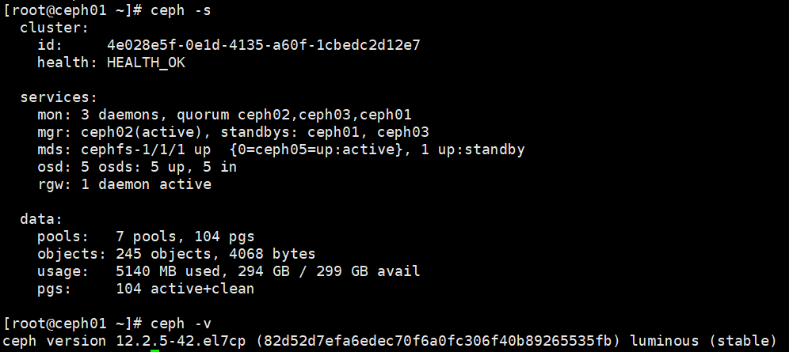

客户端测试工具配置

fio配置
fio调用Ceph 的librbd客户端插件，访问Ceph集群，模拟openstack计算节点调用librbd访问Ceph集群
[root@ceph06 examples]# cat /usr/share/doc/fio-3.7/examples/rbd.fio
[global]
#logging
#write_iops_log=write_iops_log
#write_bw_log=write_bw_log
#write_lat_log=write_lat_log
ioengine=rbd
clientname=admin
pool=test
rbdname=test10G
rw=randwrite
bs=4k

[rbd_iodepth32]
iodepth=1

挂载cephfs，并写入测试文件
注意挂载的时候对应3个mon，高可用挂载方式，这样在Ceph升级重启mon的时候Cephfs挂载可以访问任意正常状态的mon
[root@ceph06 ~]# mount -t ceph 10.0.79.169:6789,10.0.78.12:6789,10.0.78.175:6789:/ /mnt/testcephfs -o name=admin,secret=AQD96YJkpNWONxAAIHJ3hNoVCuWhUG4nwx7/Zg==
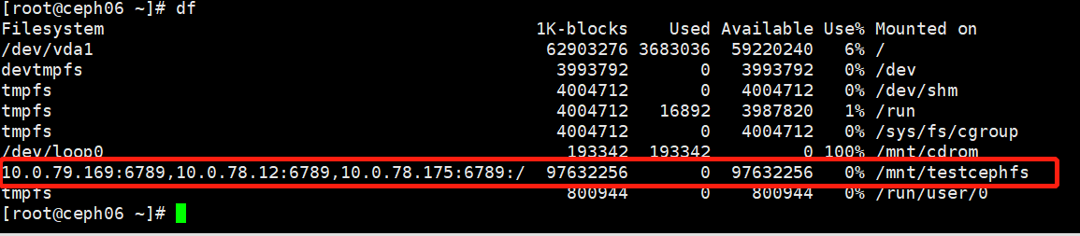
写入文件做后续升级测试验证

s3客户端配置，并写入测试数据
[root@ceph06 ~]# radosgw-admin user create --uid="testuser" --display-name="testuser"
{
"user_id": "testuser",
"display_name": "testuser",
"email": "",
"suspended": 0,
"max_buckets": 1000,
"auid": 0,
"subusers": [],
"keys": [
{
"user": "testuser",
"access_key": "P32DQH2ODG7UJZ4WD9BJ",
"secret_key": "MrJzOIGrCVNdlZn3phcSTmBgWsmTWCasEIX1B0QT"
}
],
"swift_keys": [],
"caps": [],
"op_mask": "read, write, delete",
"default_placement": "",
"placement_tags": [],
"bucket_quota": {
"enabled": false,
"check_on_raw": false,
"max_size": -1,
"max_size_kb": 0,
"max_objects": -1
},
"user_quota": {
"enabled": false,
"check_on_raw": false,
"max_size": -1,
"max_size_kb": 0,
"max_objects": -1
},
"temp_url_keys": [],
"type": "rgw"
}

yum -y install s3cmd

配置s3cmd
根据提示输入accessKey,securityKey 生成基本的配置文件
[root@ceph-node1 ~]# s3cmd --configure

Enter new values or accept defaults in brackets with Enter.
Refer to user manual for detailed description of all options.

Access key and Secret key are your identifiers for Amazon S3. Leave them empty for using the env variables.
Access Key: D3HTA2TRXBBE514USEQT ##此处填上一步获取到的access_key
Secret Key: AZxoYU6u3DkLUw9OMnRewfx73DxhjpDICwSjEIwH #此处填上一步获取到的secret_key
Default Region [US]: #默认即可，直接回车

Use "s3.amazonaws.com" for S3 Endpoint and not modify it to the target Amazon S3.
S3 Endpoint [s3.amazonaws.com]: #默认即可，直接回车

Use "%(bucket)s.s3.amazonaws.com" to the target Amazon S3. "%(bucket)s" and "%(location)s" vars can be used
if the target S3 system supports dns based buckets.
DNS-style bucket+hostname:port template for accessing a bucket [%(bucket)s.s3.amazonaws.com]:

Encryption password is used to protect your files from reading
by unauthorized persons while in transfer to S3
Encryption password:
Path to GPG program [/usr/bin/gpg]: #默认即可，直接回车

When using secure HTTPS protocol all communication with Amazon S3
servers is protected from 3rd party eavesdropping. This method is
slower than plain HTTP, and can only be proxied with Python 2.7 or newer
Use HTTPS protocol [Yes]: no #不使用https，填写no

On some networks all internet access must go through a HTTP proxy.
Try setting it here if you can’t connect to S3 directly
HTTP Proxy server name: #默认即可，直接回车

New settings:
Access Key: D3HTA2TRXBBE514USEQT
Secret Key: AZxoYU6u3DkLUw9OMnRewfx73DxhjpDICwSjEIwH
Default Region: US
S3 Endpoint: s3.amazonaws.com
DNS-style bucket+hostname:port template for accessing a bucket: %(bucket)s.s3.amazonaws.com
Encryption password:
Path to GPG program: /usr/bin/gpg
Use HTTPS protocol: False
HTTP Proxy server name:
HTTP Proxy server port: 0

Test access with supplied credentials? [Y/n] n #测试访问，此时还没配置完，不测试，填写no

Save settings? [y/N] y #是否保存，是，填写y
Configuration saved to '/root/.s3cfg'

创建bucket并且写入文件
[root@ceph06 ~]# s3cmd mb s3://test-bucket
Bucket 's3://test-bucket/' created

[root@ceph06 repodata]# s3cmd put * s3://test-bucket
upload: '377cd4b6d4c449e42d6a3c6507c6b7974873a0b7343fe30c4287ec6ae9c59347-comps-MON.x86_64.xml' -> 's3://test-bucket/377cd4b6d4c449e42d6a3c6507c6b7974873a0b7343fe30c4287ec6ae9c59347-comps-MON.x86_64.xml' [1 of 10]
1822 of 1822 100% in 1s 1287.15 B/s done

[root@ceph06 repodata]# s3cmd ls s3://test-bucket
2023-06-12 03:59 1822 s3://test-bucket/377cd4b6d4c449e42d6a3c6507c6b7974873a0b7343fe30c4287ec6ae9c59347-comps-MON.x86_64.xml
2023-06-12 03:59 422 s3://test-bucket/7bab8c572d711f36420f8d58b5e15eb23d1d0e6c918e71f88a80b57569aeb421-comps-MON.x86_64.xml.gz
2023-06-12 03:59 15181 s3://test-bucket/8ec8cc91fed583f220540e06cad0629aac39f9026616ed65c6312d02ac373c66-filelists.xml.gz
2023-06-12 03:59 2577 s3://test-bucket/TRANS.TBL
2023-06-12 03:59 14756 s3://test-bucket/b88f310b7e76256374ae2e0df3e2b828cbd02ee18ed6ec832ca81edc5cf5f0e5-other.sqlite.bz2
2023-06-12 03:59 21000 s3://test-bucket/bd4a4d8095368e9f77161c28f342ffc9ac270d8306cf144e6b03223aeed98372-filelists.sqlite.bz2
2023-06-12 03:59 13859 s3://test-bucket/d98470551378f9471807f02b87e59013dd7b4cdfd1f3a0a7b4812ed14639cdf4-primary.xml.gz
2023-06-12 03:59 9000 s3://test-bucket/d9d10bfe530814803fb93635b88a7baee5ddcd97d4502be1a1feef53458e2528-other.xml.gz
2023-06-12 03:59 33597 s3://test-bucket/fcae19f95e6cf3299a6536a32839e5ca246391a274fbae780fbe81e611e2c2df-primary.sqlite.bz2
2023-06-12 03:59 3865 s3://test-bucket/repomd.xml

边写入数据边升级，做测试
#fio rbd.fio

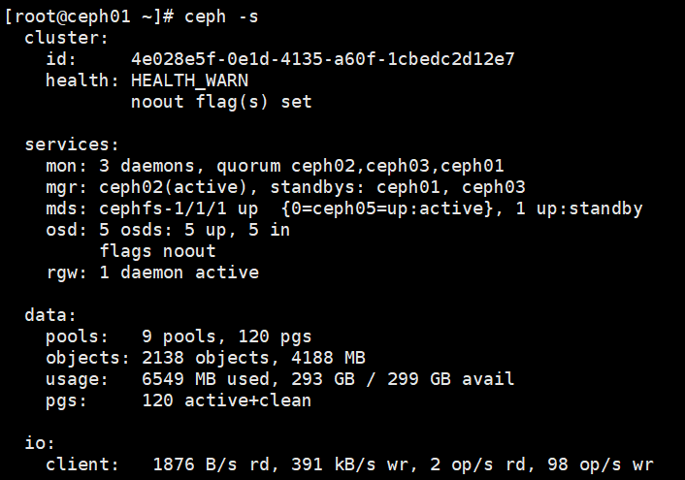

Ceph3.1-->Ceph3.3升级

升级循序
- Monitor nodes
- MGR nodes
- OSD nodes
- MDS nodes
- Ceph Object Gateway nodes
- All other Ceph client nodes

升级操作系统rhel7.5-->rhel7.9
当前版本rhel7.5
[root@ceph01 ~]# cat /etc/redhat-release
Red Hat Enterprise Linux Server release 7.5 (Maipo)

查看所有可升级的版本
subscription-manager release --list

升级操作系统
yum update -y

设置noout标签
ceph osd set noout

停止节点上的所有服务
systemctl stop ceph-mon@ceph01
systemctl stop ceph-mgr@ceph01
systemctl stop ceph-osd@2

重启操作系统
reboot
重启后内核版本会更新成升级后操作系统的内核

操作系统升级完之后
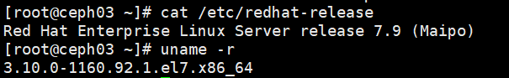

升级ceph到3.3版本
配置和升级Ceph3.1软件版本为Ceph3.3
subscription-manager repos --enable=rhel-7-server-rhceph-3-mon-rpms
subscription-manager repos --enable=rhel-7-server-rhceph-3-osd-rpms
subscription-manager repos --enable=rhel-7-server-rhceph-3-tools-rpms

升级前和升级后的ceph版本对比

设置ceph osd set noout
挨个重启Ceph 服务，重启完一个服务等到health_ok后重启下一个服务（不需要重启节点），重启完所有服务后，最终显示Ceph集群所有服务的版本如下
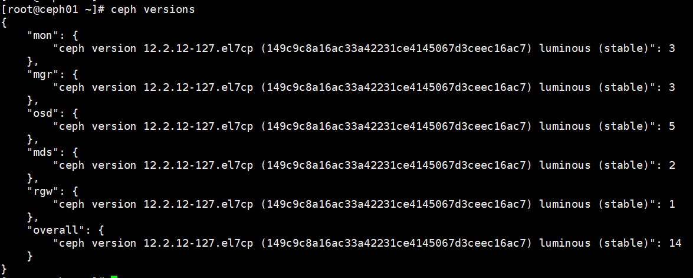

12.2.12即Ceph-3.3版本

Ceph-3.3版本升级到Ceph-4.3版本
设置mds为热备模式，防止升级的时候mds主备切换replay时间过长
ceph fs set cephfs allow_standby_replay 1

配置Ceph-4 yum源
subscription-manager repos --disable=rhel-7-server-rhceph-3-mon-rpms
subscription-manager repos --disable=rhel-7-server-rhceph-3-osd-rpms
subscription-manager repos --disable=rhel-7-server-rhceph-3-tools-rpms

subscription-manager repos --enable=rhel-7-server-rhceph-4-mon-rpms
subscription-manager repos --enable=rhel-7-server-rhceph-4-osd-rpms
subscription-manager repos --enable=rhel-7-server-rhceph-4-tools-rpms

安装Ceph-4 安装包
[root@ceph01 ~]# ceph osd set noout

停止进程
systemctl stop ceph-mon@ceph01
systemctl stop ceph-mgr@ceph01
systemctl stop ceph-osd@2
systemctl stop ceph-radosgw@rgw.ceph03.service
systemctl stop ceph-mds@ceph04

更新安装包
yum upgrade ceph-base -y

启动进程
systemctl start ceph-mon@ceph01
systemctl start ceph-mgr@ceph01
systemctl start ceph-osd@2
systemctl start ceph-radosgw@rgw.ceph03.service
systemctl start ceph-mds@ceph04

等Ceph处于health_ok状态，执行下一个节点
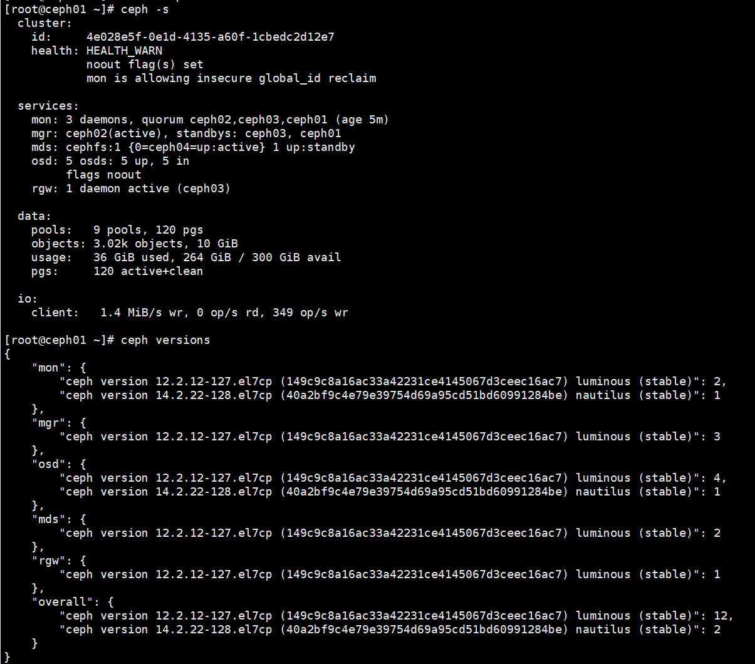
可以看到Ceph-3.3和Ceph-4.3版本在升级过程中共存于一套集群，fio读写无异常

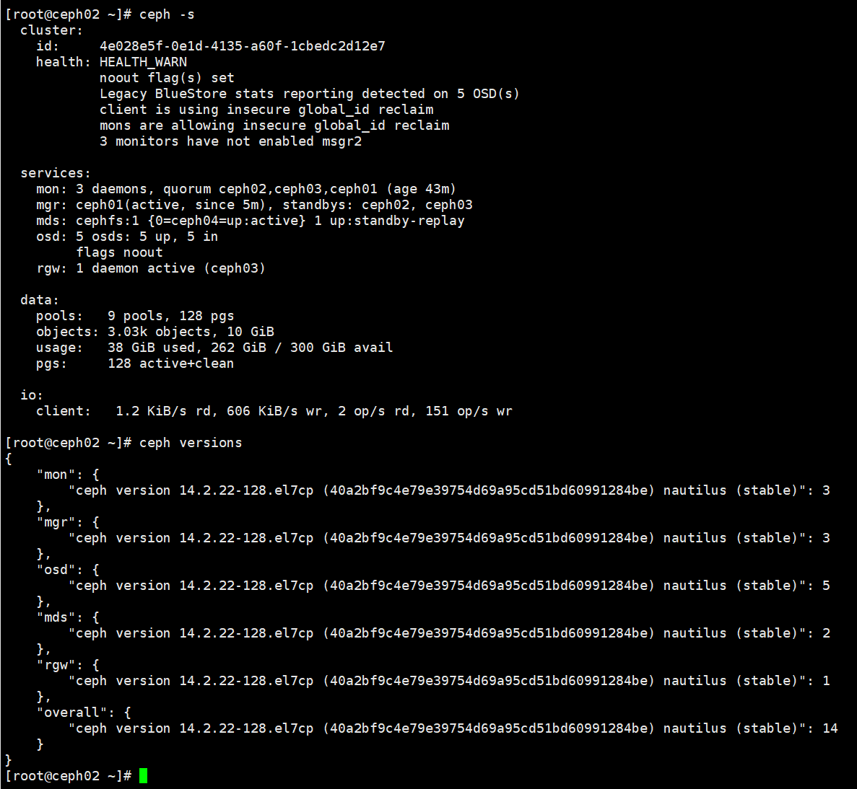
直到所有服务版本变成14.2.22，即Ceph-4.3版本

消除告警
health: HEALTH_WARN
noout flag(s) set
Legacy BlueStore stats reporting detected on 5 OSD(s)
client is using insecure global_id reclaim
mons are allowing insecure global_id reclaim
3 monitors have not enabled msgr2

#ceph osd unset noout

#ceph config set osd bluestore_fsck_quick_fix_on_mount true
# ceph osd set noout
# ceph osd set norebalance
#systemctl restart ceph-osd.target 重启节点上所有的osd
#ceph -s 等所有pg active-clean后，重启下一个节点，直到重启整个集群的osd
# ceph osd unset noout
# ceph osd unset norebalance
# ceph config set osd bluestore_fsck_quick_fix_on_mount false

#ceph mon enable-msgr2
使用msgr2模式，这个需要执行，否则ceph 带宽会变得很小，执行完后3 monitors have not enabled msgr2 告警消失。

openstack节点ceph client版本升级完，重启nova和libvirt后，ceph client版本和ceph server保持一致后，client is using insecure global_id reclaim 告警会消失

#ceph config set mon auth_allow_insecure_global_id_reclaim false
禁用不安全模式，小心使用，一旦设置后，低版本客户端将无法连接服务端。使用后
mons are allowing insecure global_id reclaim 告警消失

最终结果
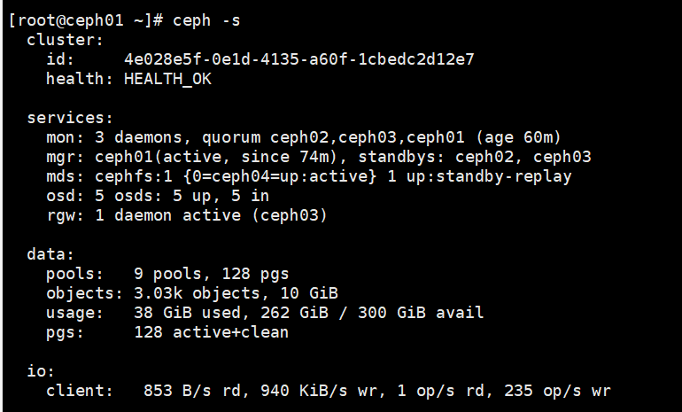

升级ceph-ansible
备份原来ceph-asnible的 hosts文件，osds.yml, all.yml
/etc/ansible/hosts
/usr/share/ceph-ansible/group_vars/osds.yml
/usr/share/ceph-ansible/group_vars/all.yml

卸载原来的ceph-ansible
yum remove ceph-ansible -y

更新ansible版本到2.9

更新ceph-ansible版本
[root@ceph07 ceph-ansible]# yum list installed | grep ansible
ansible.noarch 2.9.27-1.el7ae @rhel-7-server-ansible-2.9-rpms
ceph-ansible.noarch 4.0.70.18-1.el7cp @rhel-7-server-rhceph-4-tools-rpms

根据原先备份的yaml文件的配置参数，设置到新安装的ceph-ansible配置文件里
/etc/ansible/hosts
/usr/share/ceph-ansible/group_vars/osds.yml
/usr/share/ceph-ansible/group_vars/all.yml

在新的ceph-ansible中配置容器镜像的源
ceph_docker_image_tag: "latest"
ceph_docker_image: rhceph/rhceph-4-rhel8
containerized_deployment: true
ceph_docker_registry: registry.redhat.io
ceph_rhcs_version: 4

需要指定镜像仓库用户名和密码
ceph_docker_registry_auth: false
ceph_docker_registry_username:
ceph_docker_registry_password:

dashboard_enabled: false

node_exporter_container_image: registry.redhat.io/openshift4/ose-prometheus-node-exporter:v4.6

grafana_container_image: registry.redhat.io/rhceph/rhceph-4-dashboard-rhel8:4

prometheus_container_image: registry.redhat.io/openshift4/ose-prometheus:v4.6

alertmanager_container_image: registry.redhat.io/openshift4/ose-prometheus-alertmanager:v4.6

物理部署切换到容器部署

设置
ceph osd require-osd-release nautilus
否则跑switch-from-non-containerized-to-containerized-ceph-daemons.yml 会报错
执行playbook
# /usr/share/ceph-ansible

#cp ./infrastructure-playbooks/switch-from-non-containerized-to-containerized-ceph-daemons.yml .

# ansible-playbook switch-from-non-containerized-to-containerized-ceph-daemons.yml

执行后结果如下：
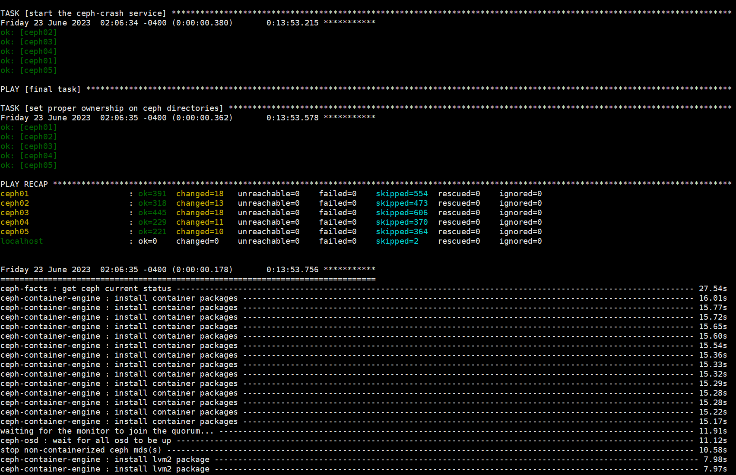

检查是否所有Ceph服务都被切换成了容器
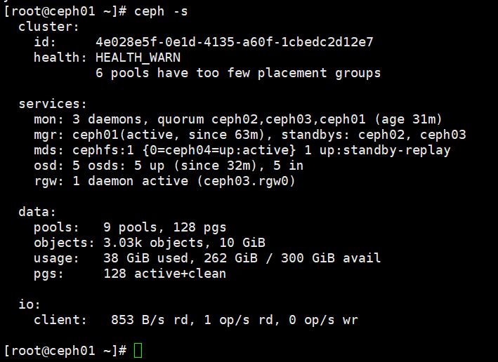

rhel7.9升级到rhel8.8

当前的操作系统版本
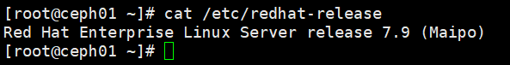

enable 对应的repo (rhel-7-server-extras-rpms 提供了leapp工具) 并且安装leapp (cockpit-leapp提供了web 管理界面)
# subscription-manager repos --enable rhel-7-server-extras-rpms
# yum install cockpit-leapp leapp -y

升级前的检查
leapp preupgrade

一般会出现几种错误
见KCS的处理方法
https://access.redhat.com/solutions/6139192
Risk Factor: high (inhibitor)
Title: Possible problems with remote login using root account
Summary: OpenSSH configuration file does not explicitly state the option PermitRootLogin in sshd_config file, which will default in RHEL8 to "prohibit-password".
Remediation: [hint] If you depend on remote root logins using passwords, consider setting up a different user for remote administration or adding "PermitRootLogin yes" to sshd_config.

https://access.redhat.com/solutions/6971716
Risk Factor: high (inhibitor)
Title: Detected loaded kernel drivers which have been removed in RHEL 8. Upgrade cannot proceed.
Summary: Support for the following RHEL 7 device drivers has been removed in RHEL 8:
- floppy
- pata_acpi

https://access.redhat.com/documentation/en-us/red_hat_enterprise_linux/8/html/upgrading_from_rhel_7_to_rhel_8/reviewing-the-pre-upgrade-report_upgrading-from-rhel-7-to-rhel-8
修改/var/log/leapp/answerfile file 文件
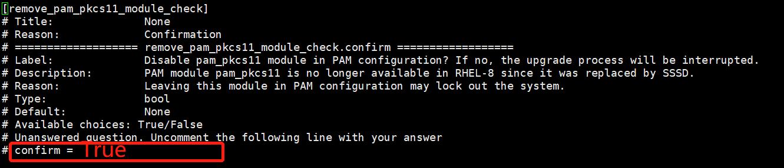

解决完检查出的问题后，重新检查
leapp preupgrade

检查通过后执行升级
leapp upgrade

最后如果一切正常，可以看到如下的输出。 到这一步，升级过程已经完成了一大半了。
.... The downloaded packages were saved in cache until the next successful transaction. You can remove cached packages by executing 'dnf clean packages'. ==> Processing phase `InterimPreparation` ====> * initram_disk_generator Creates the upgrade initram disk ====> * efi_interim_fix Adjust EFI boot entry for first reboot ====> * add_upgrade_boot_entry Add new boot entry for Leapp provided initramfs. A reboot is required to continue. Please reboot your system. Debug output written to /var/log/leapp/leapp-upgrade.log ============================================================ REPORT ============================================================ A report has been generated at /var/log/leapp/leapp-report.json A report has been generated at /var/log/leapp/leapp-report.txt ============================================================ END OF REPORT ============================================================ real 44m23.944s user 14m28.980s sys 2m20.242s

根据提示，输入命令进行重新启动。
# reboot

重新启动之后，在进入grub时， 会看到grub多了一个选项， 默认会进入这个启动项。
RHEL-Upgrade-Initramfs

进入“RHEL-Upgrade-Initramfs” 启动项后，真正的upgrade将会执行。 整个uograde过程大概需要15分钟。

upgrade 结束, 会看到类似的提示。直接输入reboot。（这个是selinux需要重新relabel。）
Entering emergency mode. Exit the shell to continue. Type "journalctl" to view system logs. You might want to save "/run/initranfs/rdsosreport.txt" to a USB stick ro /boot after mounting them and attach it to a bug report # reboot

reboot 之后， selinux 会重新relable。 执行完毕后会自动再重启一次。这个大概需要5分钟左右。

到此，整个升级过程就结束了。

以上是升级一个ceph node的步骤
升级完节点发现节点上已经没有Ceph服务，但是mon,mgr,osd等数据文件还在，需要执行ceph-ansible重新部署并启动服务
ansible-playbook -vvvv site-container.yml --limit ceph02
通过limit控制，一台一台执行，达到ceph health_ok后执行下一台

操作系统升级完后，检查所有节点服务是否正常运行
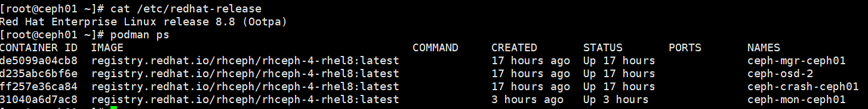

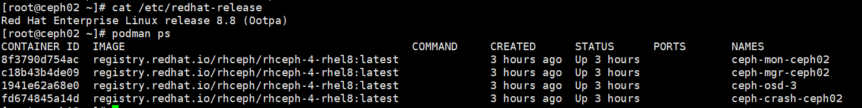

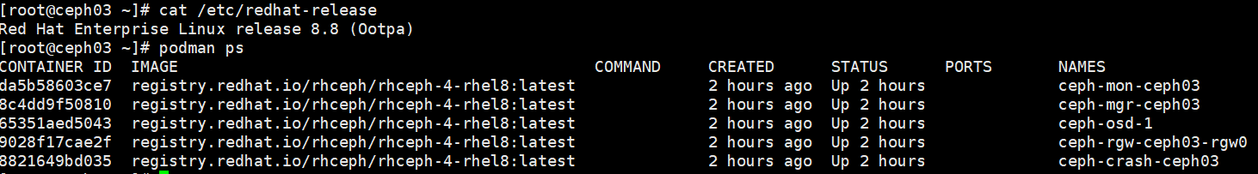

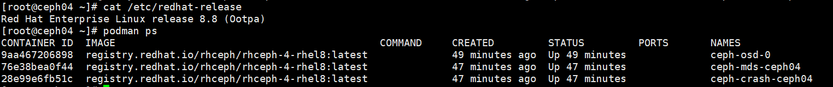

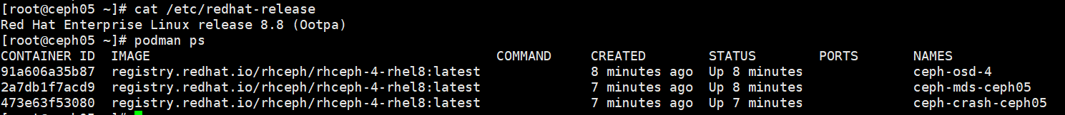

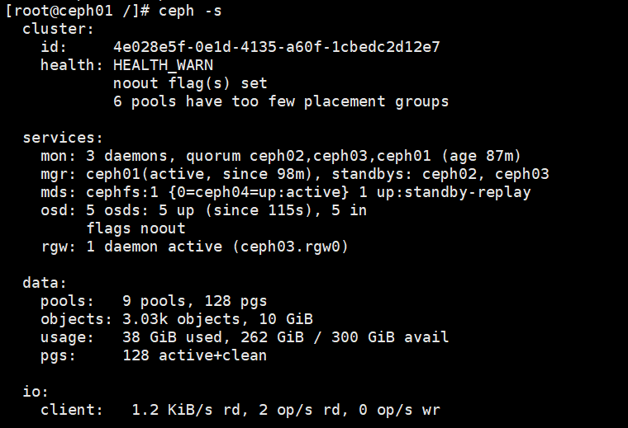

升級Ceph4.3到Ceph5.3
执行ceph-ansible脚本
---
dummy:
ntp_service_enabled: false
upgrade_ceph_packages: True
ceph_origin: distro
ceph_repository: rhcs
ceph_rhcs_version: 5
ceph_iscsi_config_dev: false
monitor_interface: eth0
public_network: 10.0.0.0/16
radosgw_interface: eth0
radosgw_address: 10.0.78.175
ceph_docker_image: "rhceph/rhceph-5-rhel8"
ceph_docker_image_tag: "latest"
ceph_docker_registry: "registry.redhat.io"
ceph_docker_registry_auth: true
ceph_docker_registry_username: rhn-support-qishi
ceph_docker_registry_password: Qq13913886148@
containerized_deployment: true
dashboard_enabled: false
node_exporter_container_image: registry.redhat.io/openshift4/ose-prometheus-node-exporter:v4.6
grafana_container_image: registry.redhat.io/rhceph/rhceph-5-dashboard-rhel8:5
prometheus_container_image: registry.redhat.io/openshift4/ose-prometheus:v4.6
alertmanager_container_image: registry.redhat.io/openshift4/ose-prometheus-alertmanager:v4.6

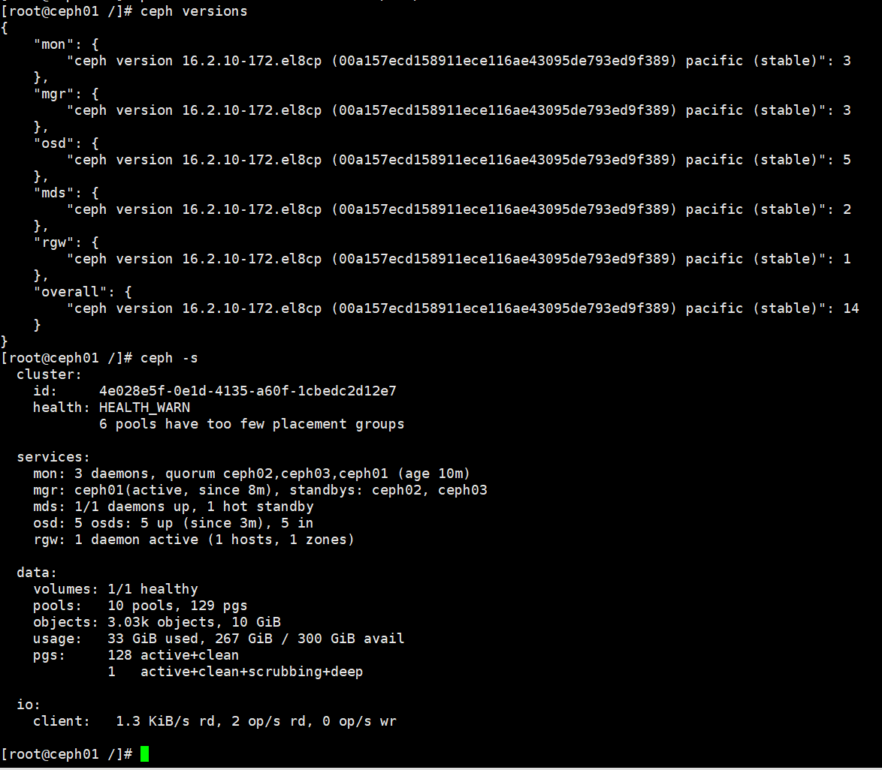
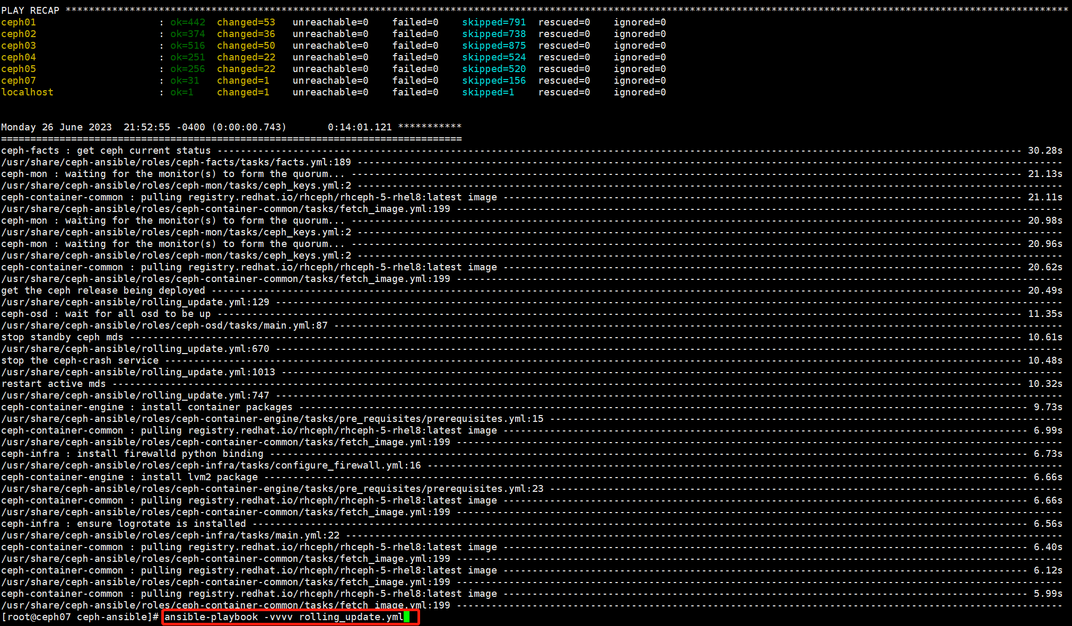

# ansible-playbook -vvvv rolling_update.yml

安装cephadm
# ansible-playbook cephadm-adopt.yml

执行后可能会出现的报错
https://access.redhat.com/solutions/7015843

TASK [manage nodes with cephadm - ipv4] ***************************************************************************************************************************************************************************
Thursday 01 June 2023 11:29:58 +0530 (0:00:01.675) 0:02:44.604 *********
fatal: [ceph80 -> {{ groups[mon_group_name][0] }}]: FAILED! =>
msg: |-
The conditional check 'cephadm_mgmt_network is ansible.utils.ipv4' failed. The error was: template error while templating string: no test named 'ansible.utils.ipv4'. String: {% if cephadm_mgmt_network is ansible.utils.ipv4 %} True {% else %} False {% endif %}

The error appears to be in '/usr/share/ceph-ansible/infrastructure-playbooks/cephadm-adopt.yml': line 371, column 7, but may
be elsewhere in the file depending on the exact syntax problem.

The offending line appears to be:

- name: manage nodes with cephadm - ipv4

在ceph-ansible节点上执行
# ansible-galaxy collection install ansible.utils

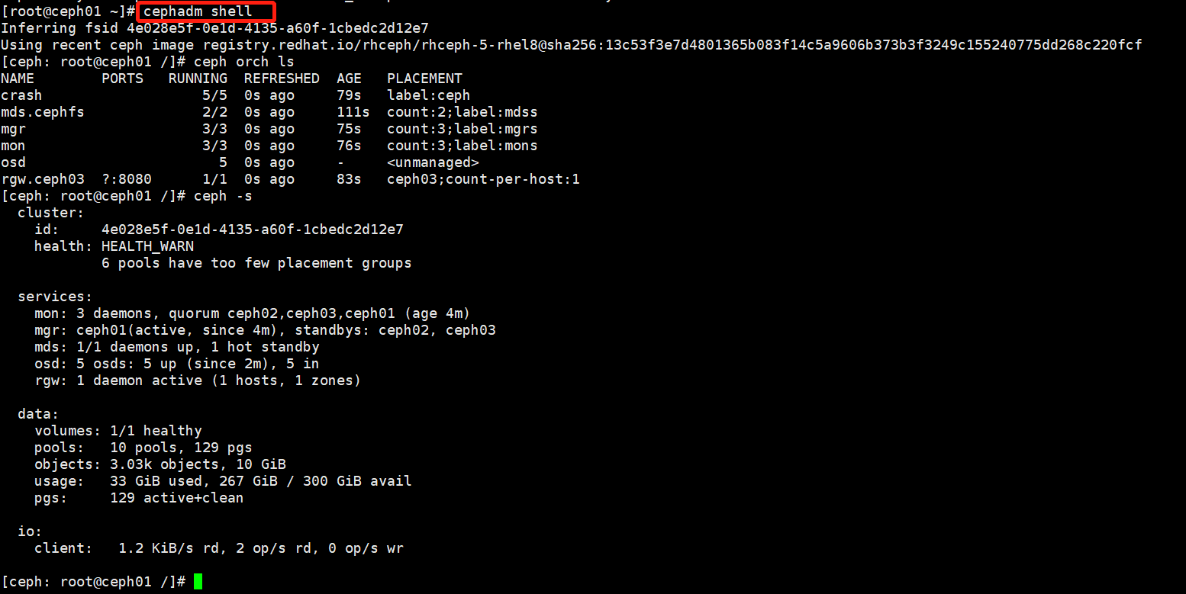
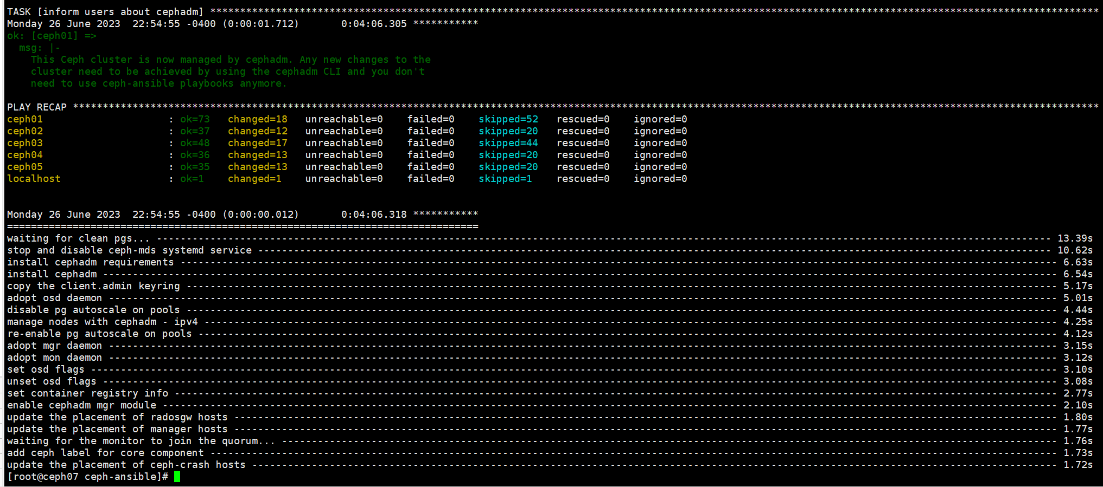

安装cephadm-ansible
#dnf remove ansible ceph-ansible
#dnf install cephadm-ansible

rhel8.8 升级 rhel9.2

升级之前备份文件
ceph.client.admin.keyring
podman-auth.json

[root@ceph01 ceph]# cat ceph.client.admin.keyring
[client.admin]
key = AQD96YJkpNWONxAAIHJ3hNoVCuWhUG4nwx7/Zg==
caps mds = "allow *"
caps mgr = "allow *"
caps mon = "allow *"
caps osd = "allow *"

[root@ceph01 ceph]# cat podman-auth.json
{
"auths": {
"registry.redhat.io": {
"auth": "cmhuLXN1cHBvcnQtcWlzaGk6UXExMzkxMzg4NjE0OEA="
}
}
}

disable 源最后只剩rhel-8-for-x86_64-appstream-rpms 和rhel-8-for-x86_64-baseos-rpms

subscription-manager repos --enable rhel-8-for-x86_64-baseos-rpms --enable rhel-8-for-x86_64-appstream-rpms

# subscription-manager repos --list-enabled
+----------------------------------------------------------+
Available Repositories in /etc/yum.repos.d/redhat.repo
+----------------------------------------------------------+
Repo ID: rhel-8-for-x86_64-appstream-rpms
Repo Name: Red Hat Enterprise Linux 8 for x86_64 - AppStream (RPMs)
Repo URL: https://cdn.redhat.com/content/dist/rhel8/8.6/x86_64/appstream/os
Enabled: 1

Repo ID: rhel-8-for-x86_64-baseos-rpms
Repo Name: Red Hat Enterprise Linux 8 for x86_64 - BaseOS (RPMs)
Repo URL: https://cdn.redhat.com/content/dist/rhel8/8.6/x86_64/baseos/os
Enabled: 1

处理不需要的repo和安装包
[root@ceph02 ~]# subscription-manager repos --disable=rhel-7-server-rhceph-4-mon-rpms
Repository 'rhel-7-server-rhceph-4-mon-rpms' is disabled for this system.
[root@ceph02 ~]# subscription-manager repos --disable=rhel-7-server-rpms
Repository 'rhel-7-server-rpms' is disabled for this system.
[root@ceph02 ~]# subscription-manager repos --disable=rhel-7-server-rhceph-4-tools-rpms
Repository 'rhel-7-server-rhceph-4-tools-rpms' is disabled for this system.
[root@ceph02 ~]# subscription-manager repos --disable=rhceph-5-tools-for-rhel-8-x86_64-rpms
Repository 'rhceph-5-tools-for-rhel-8-x86_64-rpms' is disabled for this system.
[root@ceph02 ~]# subscription-manager repos --disable=rhel-7-server-extras-rpms
Repository 'rhel-7-server-extras-rpms' is disabled for this system.
[root@ceph02 ~]# subscription-manager repos --disable=rhel-7-server-rhceph-4-osd-rpms
Repository 'rhel-7-server-rhceph-4-osd-rpms' is disabled for this system.

[root@ceph02 ~]# rpm -qa | grep leapp
leapp-0.15.1-1.el7_9.noarch
cockpit-leapp-0.1.6-5.el8_6.noarch
leapp-deps-el8-5.0.8-100.202301271308Z.f7c82a24.master.el8.noarch
python2-leapp-0.15.1-1.el7_9.noarch
leapp-repository-deps-el8-5.0.8-100.202301271308Z.f7c82a24.master.el8.noarch
leapp-upgrade-el7toel8-0.18.0-1.el7_9.noarch

[root@ceph02 ~]# rpm -e leapp-upgrade-el7toel8-0.18.0-1.el7_9.noarch leapp-0.15.1-1.el7_9.noarch cockpit-leapp-0.1.6-5.el8_6.noarch
[root@ceph02 ~]# rpm -e leapp-deps-el8-5.0.8-100.202301271308Z.f7c82a24.master.el8.noarch python2-leapp-0.15.1-1.el7_9.noarch leapp-repository-deps-el8-5.0.8-100.202301271308Z.f7c82a24.master.el8.noarch

从红帽官网下载leapp安装包
https://access.redhat.com/downloads/content/package-browser
leapp-0.15.1-1.el8.noarch.rpm
python3-leapp-0.15.1-1.el8.noarch.rpm

安装leapp
#yum install python3-leapp-0.15.1-1.el8.noarch.rpm

[root@ceph02 ~]# rpm -ivh leapp-0.15.1-1.el8.noarch.rpm
Verifying... ################################# [100%]
Preparing... ################################# [100%]
Updating / installing...
1:leapp-0.15.1-1.el8 ################################# [100%]

# yum install leapp-upgrade -y

升级前检查
# leapp preupgrade

检查报错处理
============================================================
UPGRADE INHIBITED
============================================================

Upgrade has been inhibited due to the following problems:
1. Inhibitor: Cannot perform the VDO check of block devices
2. Inhibitor: Firewalld Configuration AllowZoneDrifting Is Unsupported
3. Inhibitor: Missing required answers in the answer file

问题1不处理

问题2处理
cat /etc/firewalld/firewalld.conf | grep -i AllowZoneDrifting

# sed -i "s/^AllowZoneDrifting=.*/AllowZoneDrifting=no/" /etc/firewalld/firewalld.conf
https://access.redhat.com/solutions/6969130

问题3处理
修改/var/log/leapp/answerfile file 文件

升级
# leapp upgrade

设置osd noout并停止所有ceph服务
ceph osd set noout
systemctl stop ceph-4e028e5f-0e1d-4135-a60f-1cbedc2d12e7@mon.ceph03.service
systemctl stop ceph-4e028e5f-0e1d-4135-a60f-1cbedc2d12e7@mgr.ceph03.service
systemctl stop ceph-4e028e5f-0e1d-4135-a60f-1cbedc2d12e7@osd.1.service
systemctl stop ceph-4e028e5f-0e1d-4135-a60f-1cbedc2d12e7@rgw.ceph03.ceph03.arrwxr.service
systemctl stop ceph-4e028e5f-0e1d-4135-a60f-1cbedc2d12e7@crash.ceph03.service

升级完重启
#reboot

重启以后会安装rhel9的包，需要等待3-5分钟

重启完后
创建/etc/ceph目录
mkdir /etc/ceph

在/etc/ceph 上创建之前备份的文件podman-auth.json
[root@ceph01 ceph]# cat podman-auth.json
{
"auths": {
"registry.redhat.io": {
"auth": "cmhuLXN1cHBvcnQtcWlzaGk6UXExMzkxMzg4NjE0OEA="
}
}
}

启动Ceph服务
systemctl daemon-reload
systemctl start ceph-4e028e5f-0e1d-4135-a60f-1cbedc2d12e7@mon.ceph03.service
systemctl start ceph-4e028e5f-0e1d-4135-a60f-1cbedc2d12e7@mgr.ceph03.service
systemctl start ceph-4e028e5f-0e1d-4135-a60f-1cbedc2d12e7@osd.1.service
systemctl start ceph-4e028e5f-0e1d-4135-a60f-1cbedc2d12e7@rgw.ceph03.ceph03.arrwxr.service
systemctl start ceph-4e028e5f-0e1d-4135-a60f-1cbedc2d12e7@crash.ceph03.service

所有Ceph节点升级完操作系统
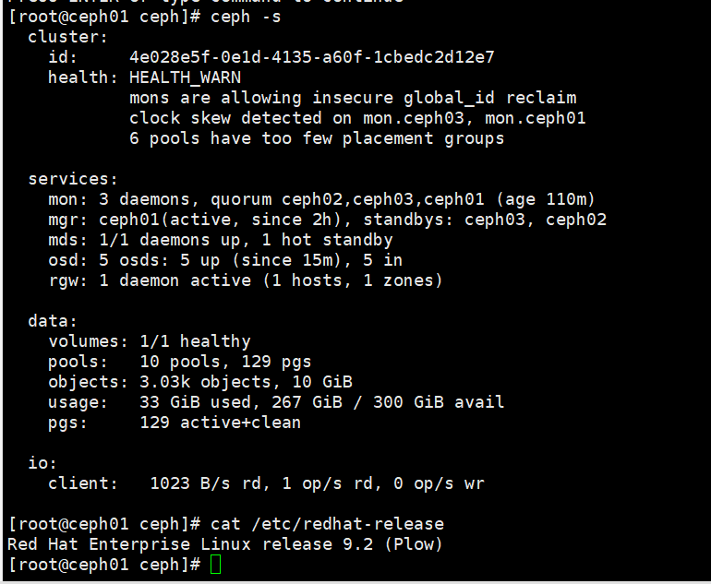

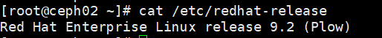

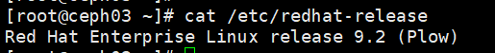



升级Ceph5.3到Ceph6
升级之前
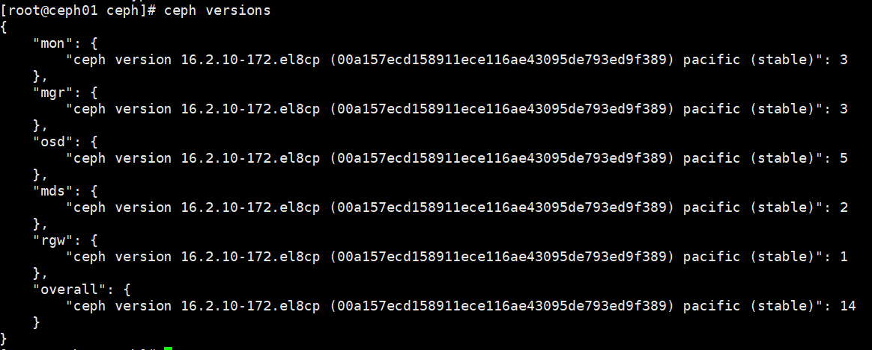

升级步骤
安装cephadm-ansible 软件包
[root@admin ~]# dnf install cephadm
[root@admin ~]# dnf install cephadm-ansible

进入 /usr/share/cephadm-ansible/ 目录
[root@admin ~]# cd /usr/share/cephadm-ansible

在存储集群的 bootstrap 主机上，运行 preflight playbook，并将 upgrade_ceph_packages 参数设置为 true,执行之前需要定义/etc/ansible/hosts文件
[root@ceph06 ~]# cat /etc/ansible/hosts
[mons]
ceph01
ceph02
ceph03

[mgrs]
ceph01
ceph02
ceph03

[osds]
ceph01
ceph02
ceph03
ceph04
ceph05

[mdss]
ceph04
ceph05

[clients]
ceph01
ceph02
ceph03
ceph04
ceph05
ceph06

[rgws]
ceph03

[grafana-server]
ceph01

ansible-playbook -i /etc/ansible/hosts cephadm-preflight.yml --extra-vars "ceph_origin=rhcs upgrade_ceph_packages=true"

登录 cephadm shell
[root@host01 ~]# cephadm shell

确定所有主机都在线，并且存储集群处于健康状态
[ceph: root@host01 /]# ceph -s

检查服务版本和可用目标容器
[ceph: root@host01 /]# ceph orch upgrade check registry.redhat.io/rhceph/rhceph-6-rhel9:latest

升级存储集群
[ceph: root@host01 /]# ceph orch upgrade start registry.redhat.io/rhceph/rhceph-6-rhel9:latest

升级过程中
检查升级的进度
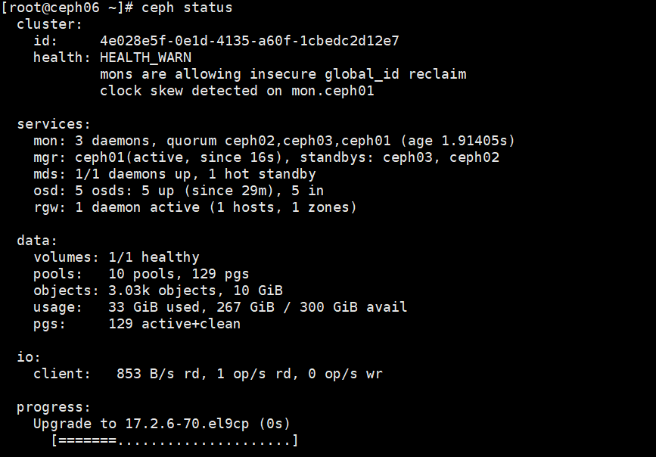

升级完
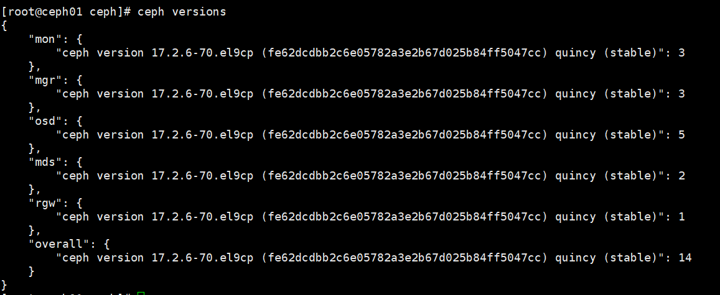

存在的问题
5 OSD(s) reporting legacy (not per-pool) BlueStore omap usage stats
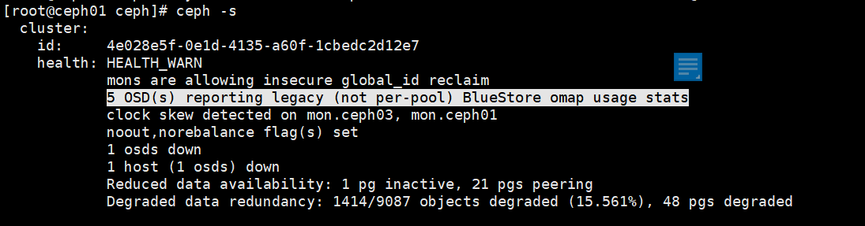

解决办法
#ceph config set osd bluestore_fsck_quick_fix_on_mount true
# ceph osd set noout
# ceph osd set norebalance
#systemctl restart ceph-osd.target 重启节点上所有的osd
#ceph -s 等所有pg active-clean后，重启下一个节点，直到重启整个集群的osd
# ceph osd unset noout
# ceph osd unset norebalance
# ceph config set osd bluestore_fsck_quick_fix_on_mount false

最后结果
