Michael Raymond

Server Write-Up:

**Note: I did not see the AAPL.csv file on blackboard, so I downloaded a fresh version from yahoo finance.**

In creating the server, I mainly followed the tutorial shown in-class. Once the server ran with a basic “Hello World” screen, I began writing each function. In order to simulate the GET requests, I used a google chrome browser and manually input the function names into the search bar. The POST, PUT, and DELETE requests were sent using underlying http functions from the flutter application created for the final project.

For the getData function, it has the options for GET and POST requests. The GET request also has an optional parameter, date. In the underlying code, the AAPL.csv file is broken into a list structure. Under the GET requests, it converts the list into json format. If there is a parameter, it simply returns this element. Otherwise, it prints the entire converted version of the csv file. The POST version finds the start and end times and returns a json formatted structure of all of these items.

addData and updateData are essentially the same. The only difference is that addData only changes data if it is new and updateData only changes if it is not new. They end by rewriting the csv file in csv format.

deleteData converts the csv to json format and then deletes the given date-key before rewriting the file in csv format.

GET ‘/getData’

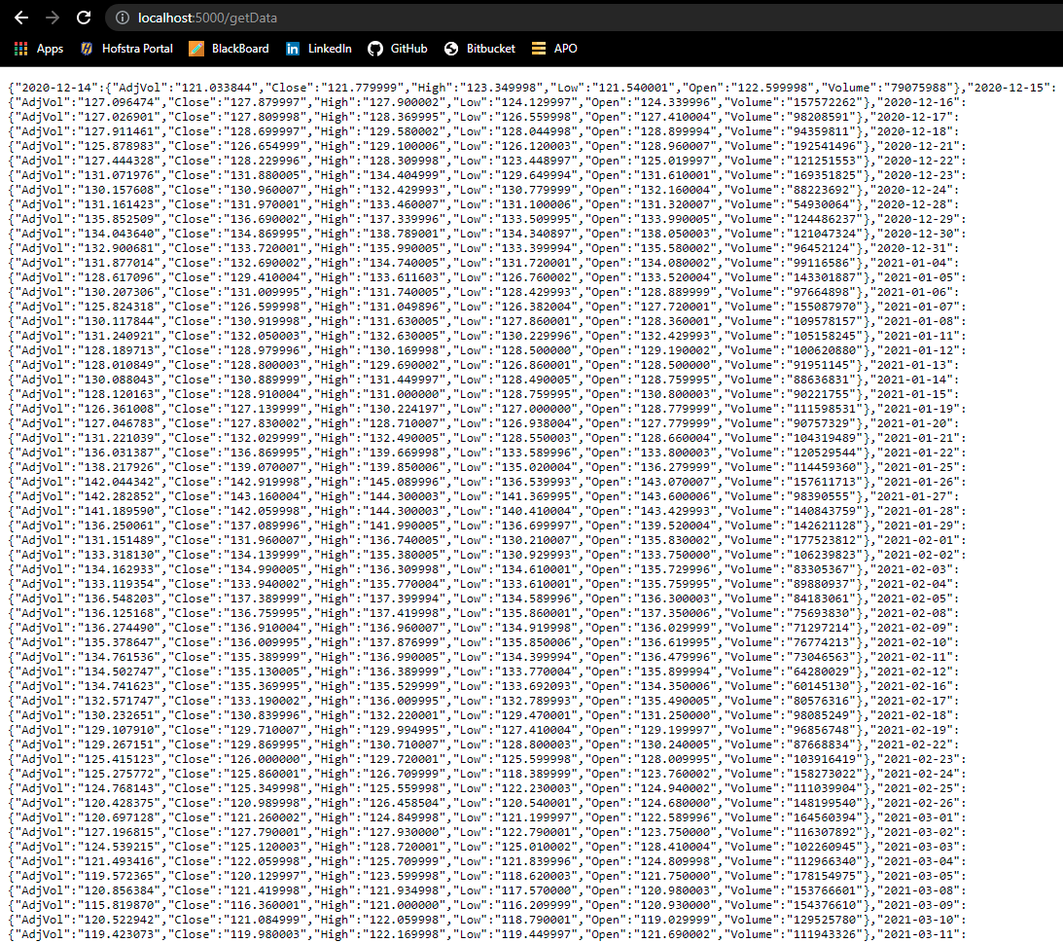

GET ‘/getData/<data>’:

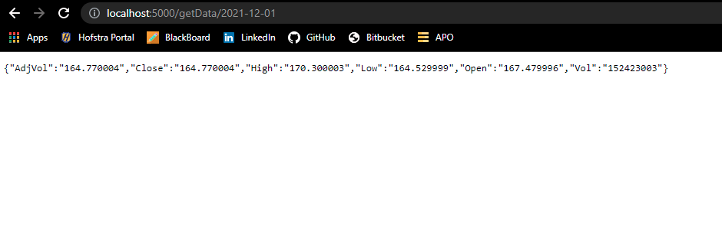

POST ‘getData’:

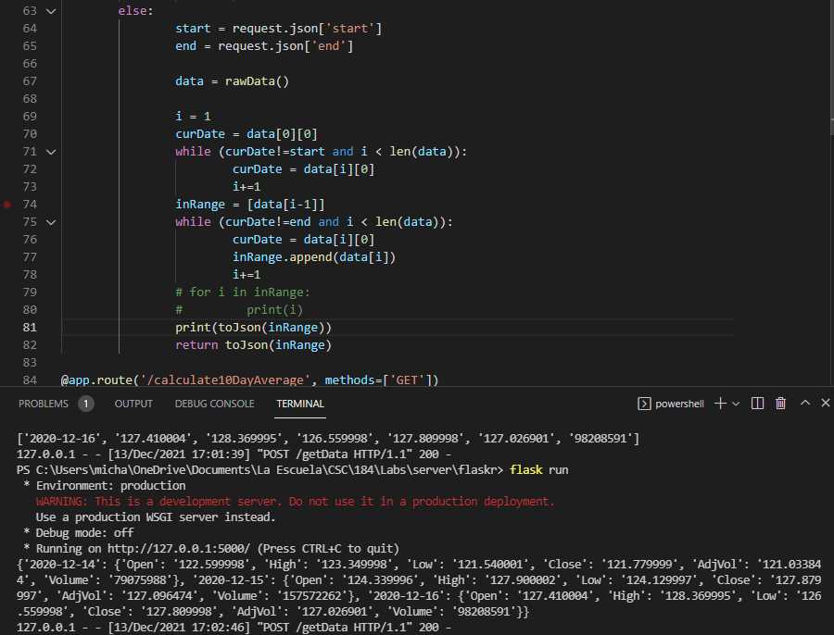

POST ‘/addData’:

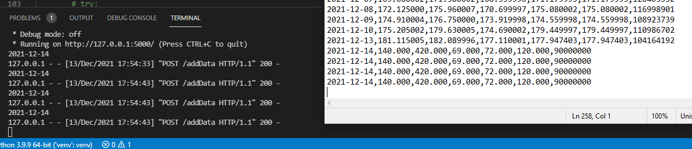

GET ‘/calc10Day’:

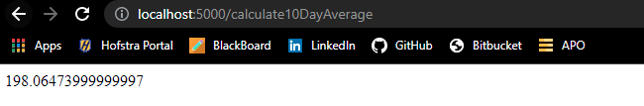

PUT ‘/updateData’:

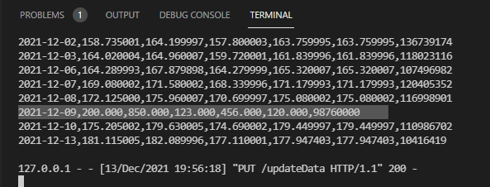

DELETE ‘/deleteData’:

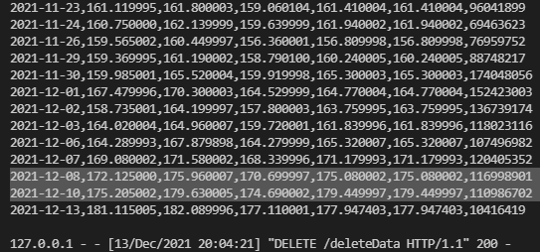 2021-12-09 deleted