Screenshots:
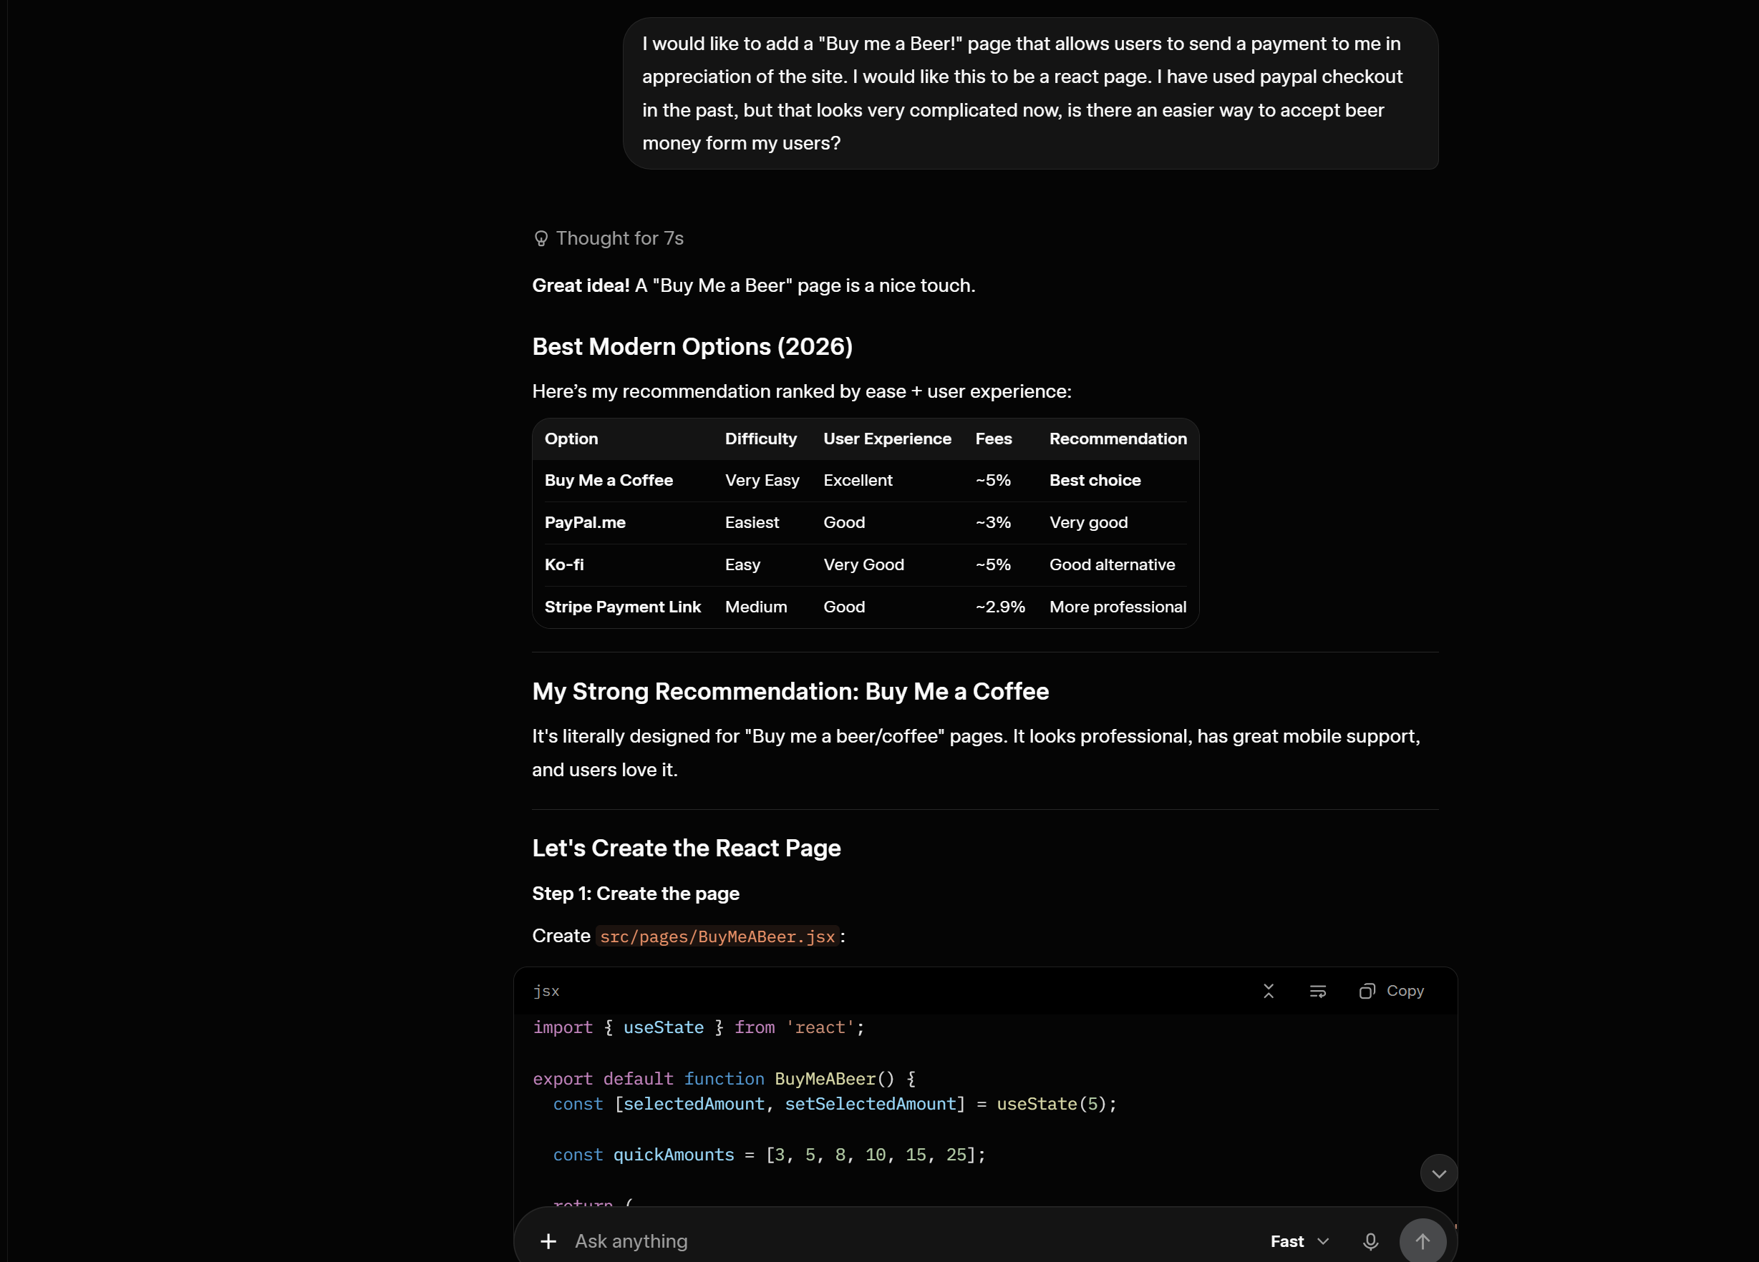

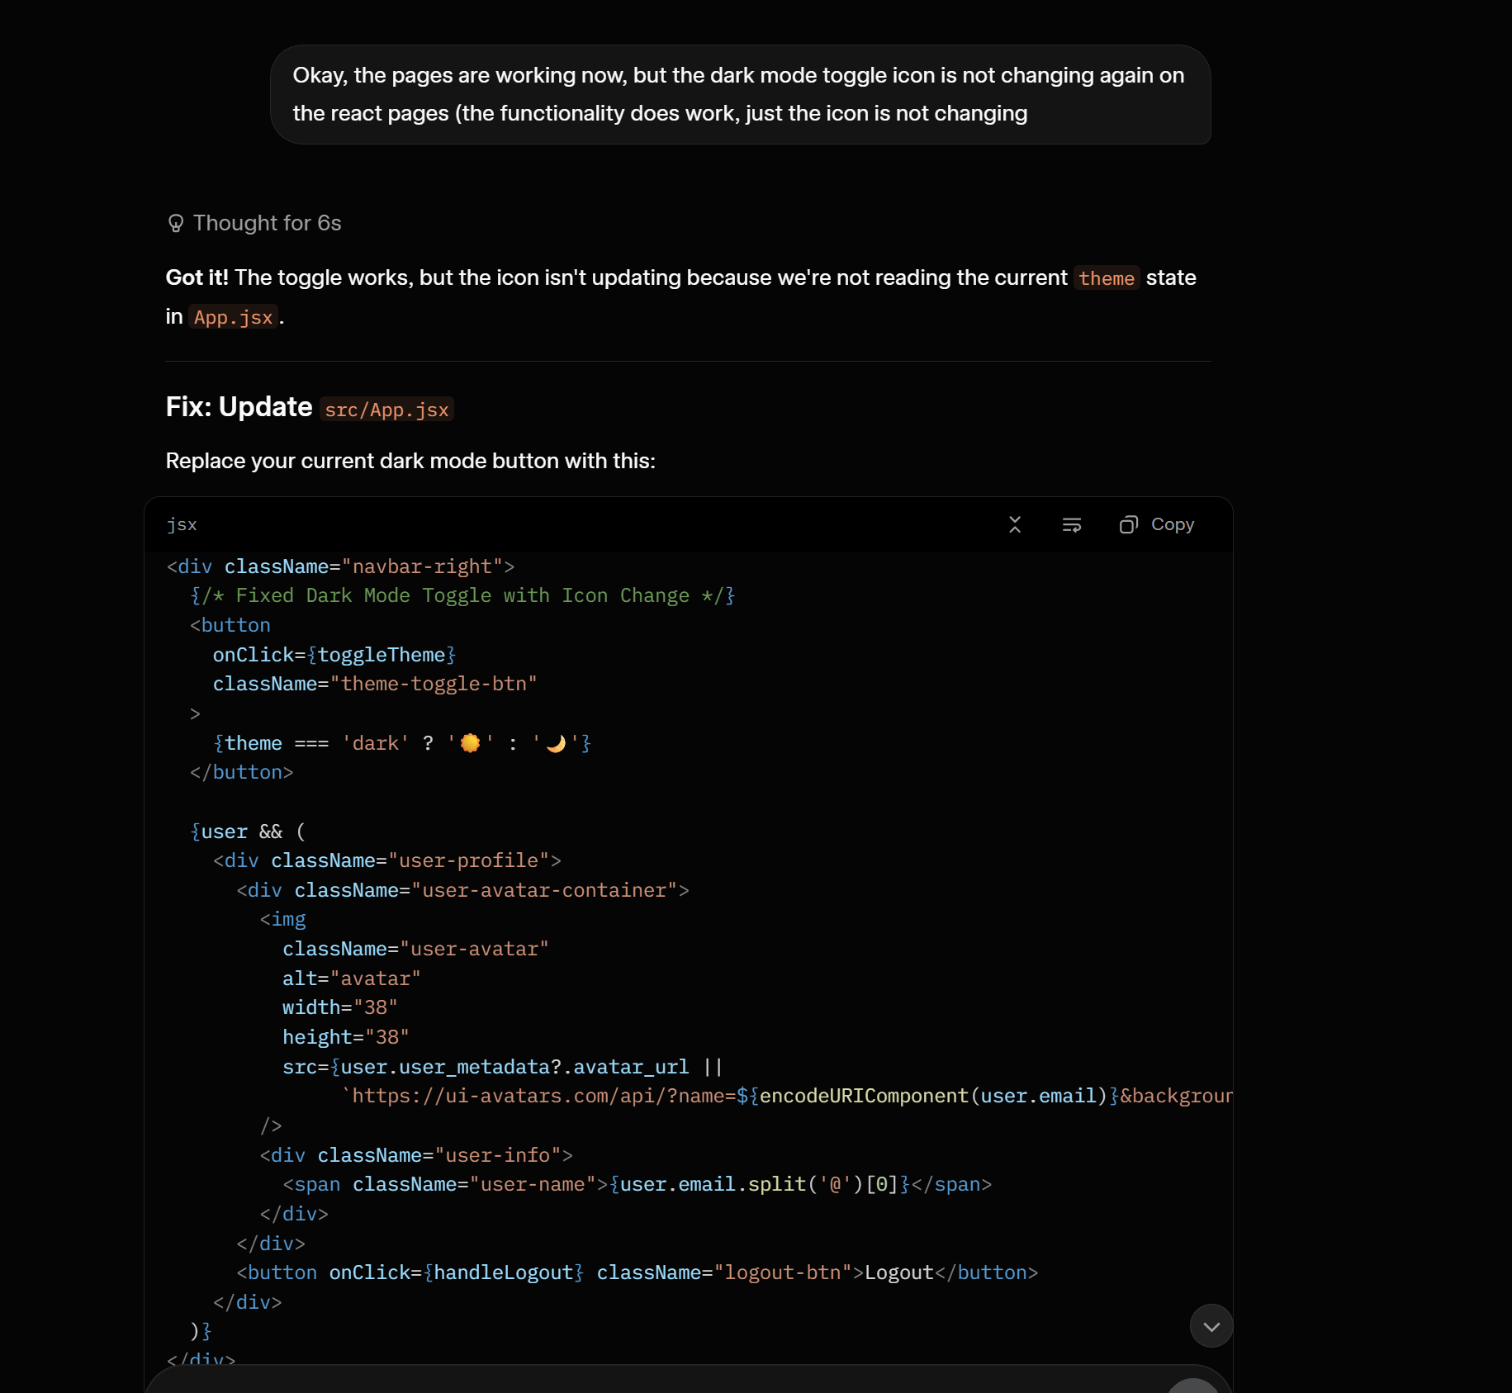
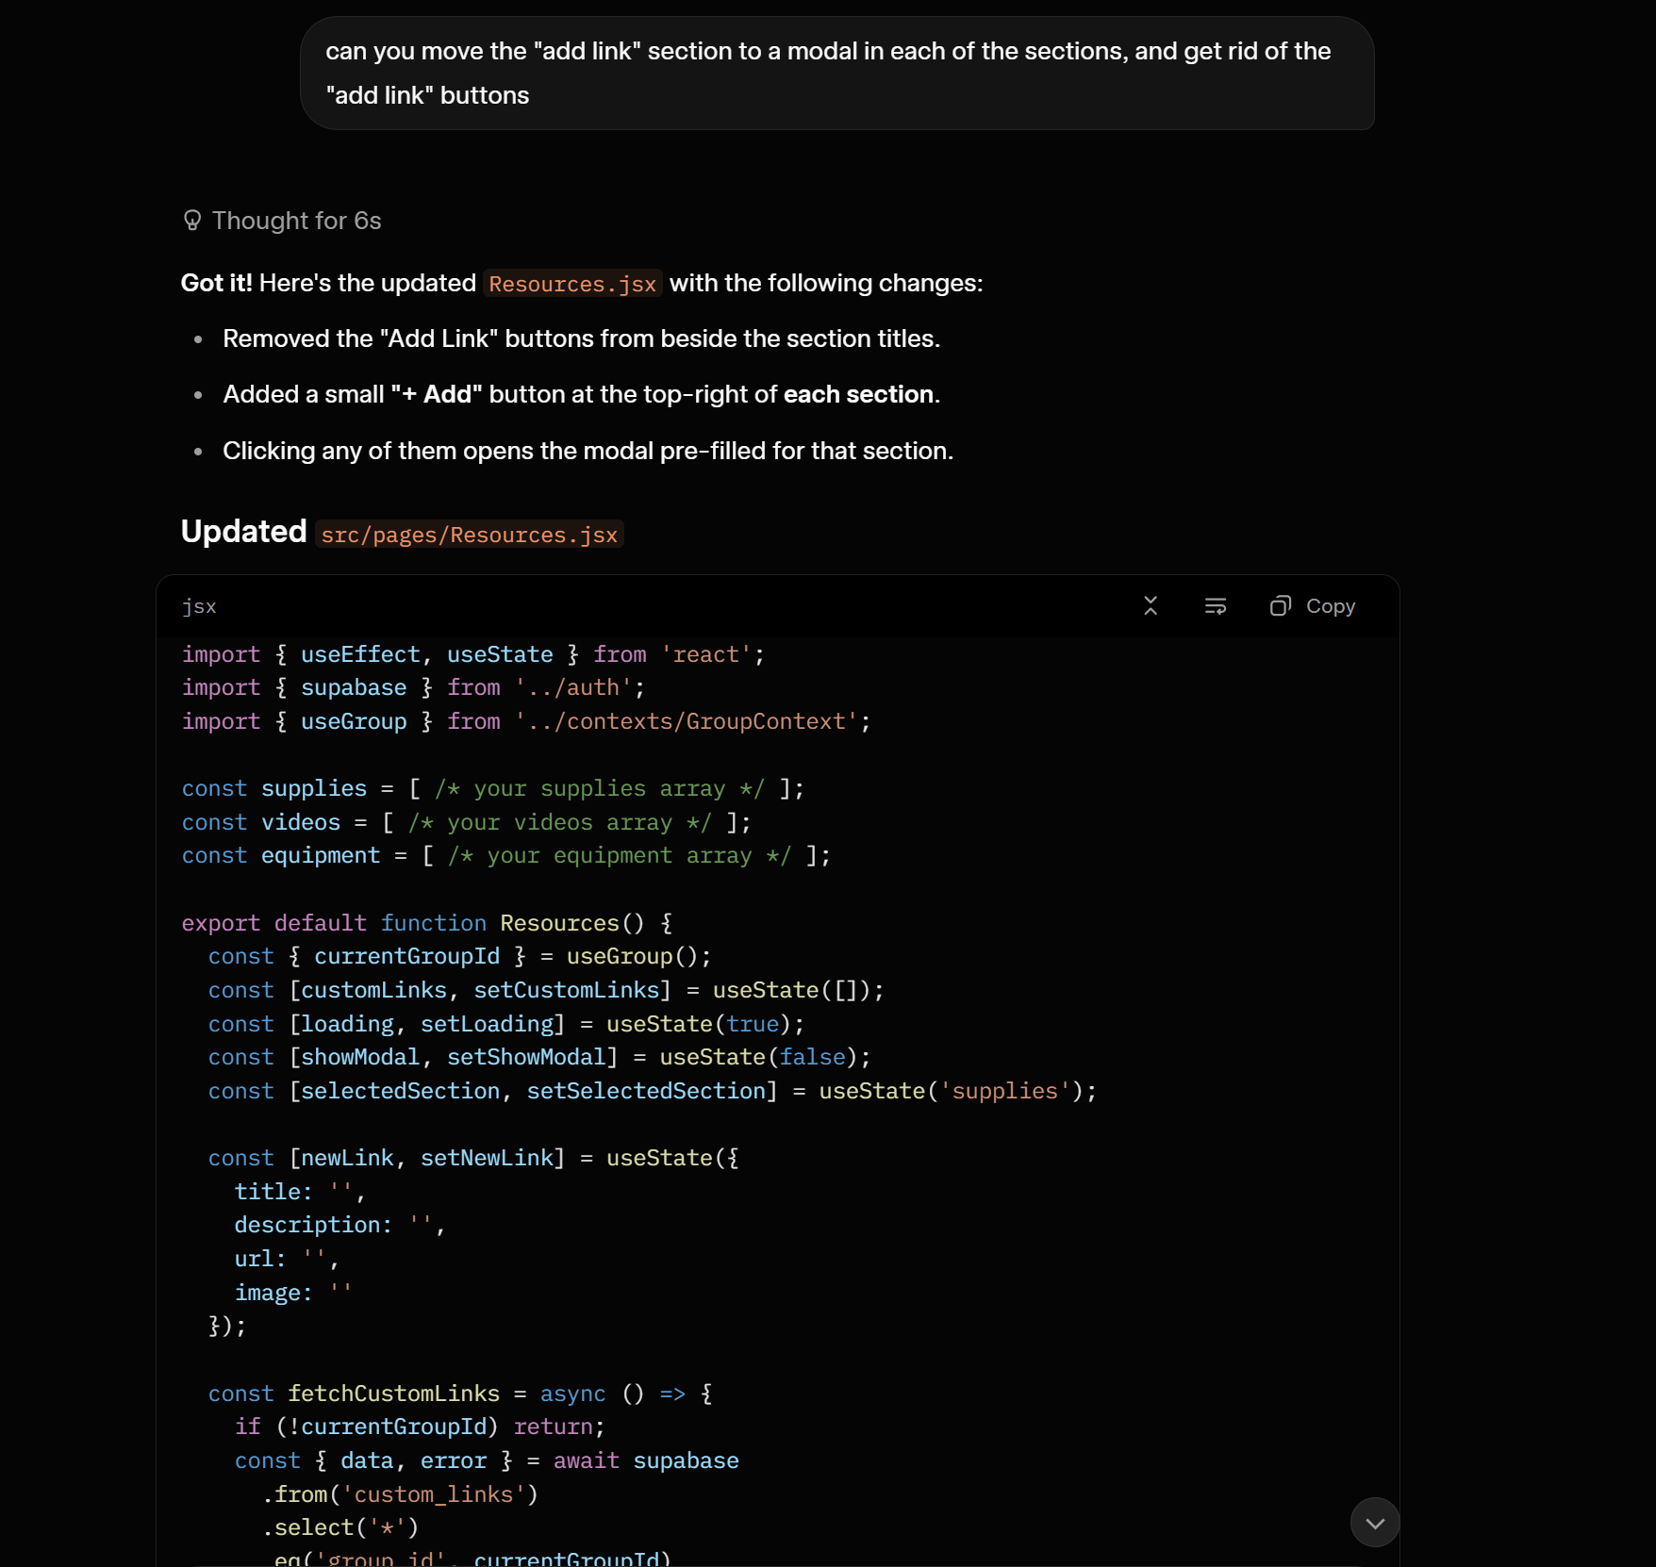

RAW Export of some of the prompts:

User: Refer to the following content: [attached files: client_secret JSON, login.html, Calc.html, index.js, index.html, inv.html, Calc.js, theme.js, auth.js, inv.js, .gitignore, styles.css]
User: walk me through step 1, I have the new credentials created, but now where do I need to update them?
Grok: [Explained where to update credentials in Supabase and Google Cloud Console]
User: Thanks Grok, next can we get the "dark mode" button working in the header of all pages, and remove the dark mode link from the bottom of the page?
Grok: [Provided code to fix dark mode toggle in header across pages]
User: Here are the full schemas for both the tables in my db: [inv and batches table schemas]
User: I would like to add the ability to have 2(or more) google accounts be able to access the same data from the database through my web app. Can you provide step by step instructions on how to do this?
User: I do not want ALL new and existing users to be part of the same group...
Grok: [Provided SQL for groups, group_members, RLS policies, and get_user_groups function]
User: Error: Failed to run sql query: ERROR: 42703: column "group_id" does not exist...
User: SQL successful
User: can you verify that I made the correct changes to inv.html: [pasted large code block with group_id changes]
... (many back-and-forth messages fixing auth.js, group creation errors, RLS 42501, avatar display, localhost redirect issues, etc.)
User: can you verify my calc.js: [pasted large Calc.js code]
Grok: Verified and provided corrections for group support.
User: I get this error when I try to load my inv.html now: Failed to initialize group...
User: Uncaught SyntaxError: The requested module './auth.js' does not provide an export named 'logout'
User: [multiple console logs showing 403 Forbidden when creating groups, RLS violations]
Grok: Provided updated auth.js with better group creation logic and RLS policy fixes.
User: Still getting this error... do I need to "flush the cache"...
Grok: Explained policy issues and provided corrected SQL.
User: all right Grok, let's have another go at this. it all seems to be working while accessed from my local computer, but the authentication is not working when I try to log in from another computer... redirecting to localhost
User: [pasted full auth.js and login.html]
Grok: Explained how to fix redirect URLs using window.location.origin
User: Looks like I may just have to wait until I get a "production version... Can you remove the "Group ID" column from the grid display on the inv.html page?
User: Thank you Grok! I want to create a new page... containing links to supplies... Please start with this Amazon link: https://www.amazon.com/dp/B0CKKK1HJ1
User: looks good, but the image returns a 404 error
User: [multiple iterations of resources.html with Amazon cards]
User: is it okay to link to images hosted by Amazon...
User: is there a way to auto generate the content from the URL?...
User: I decided to go back to how we had it... [pasted resources.html and resources.js]

User: looks good for now, I'll add more links later, but now I would like to make an update to calc.html... I would like to change the data that is saved from the grid, so that it retains the value of each field in the grid.
Grok: Suggested adding grid_data jsonb column and updated calc.js accordingly.
User: yes please, I have done the changes you suggested and they work well
User: when changing machine size, the data is still displayed from the last screen... can these be defaulted to 0...
Grok: Provided updated loadLastBatch() logic.
User: here is my current file, I seem to have an extra '{' on line 286...
Grok: Fixed syntax error and provided corrected calc.js.
User: LOOKS GREAT! Thank you Grok! ... I am going to work on adding more links, and then I'll either start the discussion on where to host it, OR I may have to convert it to React first
User: All Right Grok, Here is our next mission: I want to convert this to a React + Vite site, BUT I want to keep the calc.html, and the inv.html pages exactly as they are
User: Option A please
User: continue
User: I named the file "auth.js"...
User: full improved Resources.jsx...
User: Add Auth
User: I am having several issues with the site: 1) The Auth is not working... 2) When I navigate from one of the new react pages to either Calc.html or inv.html it is opening the page in a new tab... 3) the dark mode toggle only works on the Calc.html page...
User: Auth is not working. Here is the console error... No routes matched location "/login.html"
User: now after login, my avatar is not showing... No routes matched location "/index.html"
User: can you provide me the full index.html file...
User: now I get this error... Uncaught ReferenceError: Navigate is not defined
User: Still getting this error... [pasted App.jsx]
Grok: Provided corrected App.jsx with proper imports.

