MRD Tools - External Access Links Manager

Standard Tool (One Revit project at a time)

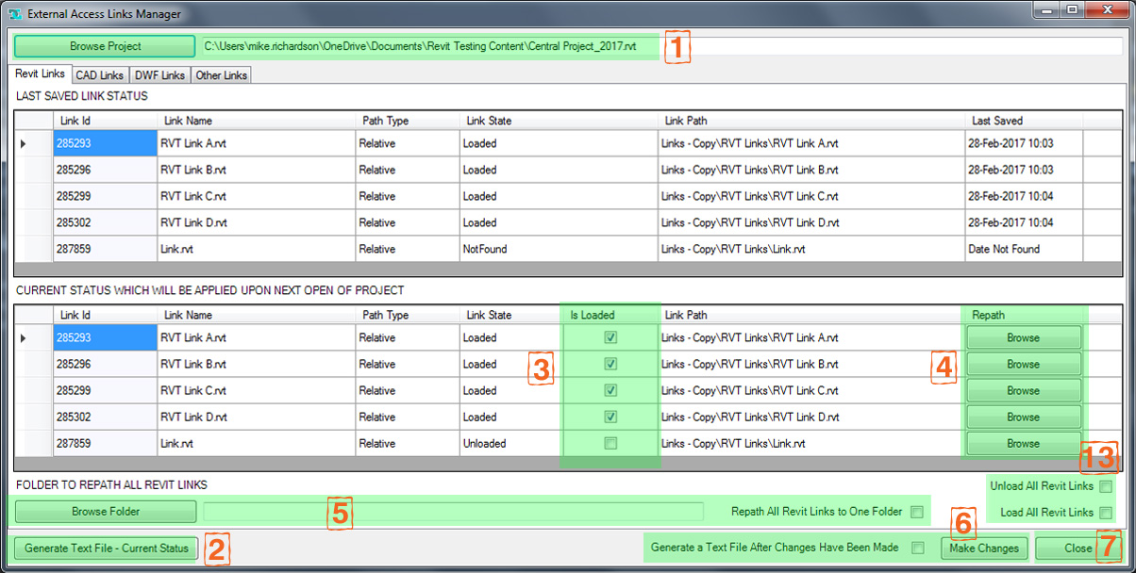

Batch Tool (Multiple Revit projects at once)

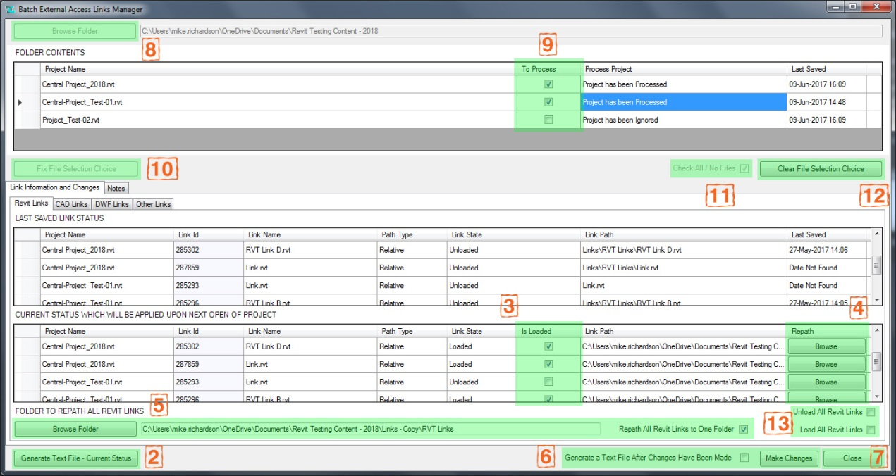

Running the application:

Open Revit
Click on the 'Add-Ins' tab.
Under the 'MRD Tools' section click on the 'Links Manager' dropdown button (This button should always be available. i.e. also when there are no Revit documents open).

Standard Tool (One Revit project at a time)

Click on the 'Links Manager' button from the dropdown list
The Links Manager interface should appear.
Browse for your project by clicking the 'Browse Project' Button (Top left). (1)
When a project has been selected the form will populate with that projects link data.

Batch Tool (Multiple Revit projects at once)

Click on the 'Links Manager Batch' button from the dropdown list
The Batch Links Manager interface should appear.
Browse for a Folder containing Revit projects by clicking the 'Browse Folder' Button (Top left). (8)
When a folder has been selected the Folder Contents form will populate with the Revit projects within that folder.
Select which projects you would like to process by using the checkboxes within the form ((9) 'To Process' column).
Alternatively, use the 'Check All/None Files' checkbox (11)
Click the 'Fix File Selection Choice' button (10)
The Link Information form will populate with each of the projects link data.

Interrogating the links:

4 tabs will be present, separating out the different types of links. Revit, Cad, Dwf and Other.
Note that IFC and Point cloud links are not supported and will not appear.
The Other links section will list things like keynote and classification files.
The Revit, Cad and Dwf tabs are each split in to 2 lists.
The upper list gives the status of the links when the project was last saved.
The lower list initially shows you the state the links will be upon opening the project next time (named from now on as 'the desired status').
The 'Generate Text File - Current Status' button on the lower left hand side can be used to generate a tab delimited txt file listing the data shown. (2)

Making changes:

In the lower list:
Use the checkboxes in the 'Is Loaded' column to set each link to be loaded or unloaded. (3)
Alternatively, use the 'Unload All' and 'Load All' checkboxes (13) to change the status of all the links at once.
Use the buttons in the 'Repath' column to individually repath each link. (4)
If you want to repath all links of a particular type to a single folder, use the 'Browse Folder' button on the lower bar and check the 'Repath All ** Links to One Folder' checkbox. (5)
Once you have finished making changes you can commit those changes by pressing the 'Make Changes' button (lower right). Checking the associated checkbox will create and open a text file listing your changes. (6)

Selecting another project (Standard Tool):

If you want to interrogate another project, click the 'Browse Project' Button (Top left) and the current data shown will be replaced with your next project.

Clearing the file selection choice (Batch Tool):

If you would like to clear the file selection choice and / or browse to another folder, click the 'Clear File Selection Choice' button (12) and either browse to another folder or make changes using the checkboxes (9 or 11)

Closing the Interface:

At any point, pressing the 'Close' button (lower right) will exit the application. (7)
Note that any changes made must be committed by pressing the 'Make Changes' button if you wish for those changes to be saved before the application is closed.

Important points to Note:

Using this tool with a workshared project - Changes made to a workshared project will set the project to a transmitted state. When opening the project next time it will ask you whether to 'save this model as a central model in its current location' or 'work with this model temporarily'

