BARRIE TRANSIT
2027–2032 Strategic Plan
Workspace Summary

A working-team snapshot of six Strategic Plan workspaces
Captured from the authenticated Barrie Transit workspace on September 2, 2026
INTERNAL WORKING DOCUMENT

REPORT GUIDE

Contents and reading notes
This report selects one summary table or graph from each workspace. It preserves the source definitions and limitations shown in the application; it is not a new analytical model or an approval record.
Section | Workspace | Page
1 | Project Work Plan | 3
2 | Current Scheduled Service | 4
3 | Trip Planning Trends | 5
4 | Annual Ridership | 6
5 | Bus Fleet Plan | 7
6 | Published Route Schedules | 8
 | Evidence definitions and source register | 9

Freshness rule
All values were read from the signed-in production workspace on the capture date. No demo values, local fallback estimates, or copied datasets were used.

How to use this report
Use the visuals as a common working reference. Return to the source workspace before making a decision that depends on current status, newly published schedules, daily ridership, or revised fleet assumptions.

1 · PROJECT CONTROL

Project Work Plan
The shared work plan contains 73 tasks across four phases. This roll-up shows the baseline timing and current status recorded in revision 1.
Source snapshot: Shared revision 1 · Dillon Consulting Limited work plan dated June 16, 2026 · baseline window August 3, 2026 to September 27, 2027
Phase | Baseline window | Tasks | Avg. progress | Unconfirmed | In progress | At risk / blocked | Complete | Unscheduled
Project Initiation and Data Collection | Aug 3, 2026–Sep 6, 2027 | 6 | 0% | 6 | 0 | 0 | 0 | 1
Stakeholder Engagement | Aug 10, 2026–Jun 7, 2027 | 10 | 0% | 10 | 0 | 0 | 0 | 0
Strategic Plan Development | Aug 17, 2026–Jul 12, 2027 | 54 | 0% | 54 | 0 | 0 | 0 | 1
Report Production and Finalization | Jul 19, 2027–Sep 27, 2027 | 3 | 0% | 3 | 0 | 0 | 0 | 0
TOTAL | Aug 3, 2026–Sep 27, 2027 | 73 | 0% | 73 | 0 | 0 | 0 | 2
Table 1. Project Work Plan status by phase
Interpretation limit
All 73 tasks remain Unconfirmed at 0% progress. The proposal establishes timing and proposed responsibility, not current completion. Two rows are unscheduled in the source.

2 · EXISTING SERVICE BASELINE

Current Scheduled Service — Weekday
This table summarizes the weekday service span, sustained peak and off-peak frequency regimes, and scheduled revenue hours for each route family in the bundled static GTFS snapshot.
Source snapshot: Barrie Transit static GTFS version 20260503b · feed validity May 27 to August 29, 2026
Route | Route name | Service span | Peak frequency and span | Off-peak frequency and span | Revenue hours / day
400 | EXPRESS | 6:45 AM–6:45 PM | 30 min  6:45 AM–6:15 PM | N/A | 19.1
100 | RED | 7:00 AM–11:00 PM | 25 min  7:00 AM–9:45 PM | 41 min  10:30 PM–11:00 PM | 27.4
101 | BLUE | 7:00 AM–10:45 PM | 25 min  7:00 AM–9:15 PM | 41 min  10:00 PM–10:45 PM | 26.6
2 | DUNLOP / PARK PLACE | 5:30 AM–11:45 PM | 30 min  5:45 AM–7:45 PM | 60 min  7:45 PM–11:00 PM | 39.6
7 | GROVE / BEAR CREEK | 5:30 AM–12:30 AM (+1) | 30 min  5:30 AM–7:30 PM | 60 min  7:30 PM–10:30 PM | 61.5
8A | RVH/YONGE | 4:30 AM–12:45 AM (+1) | 30 min  5:00 AM–6:15 PM | 60 min  6:15 PM–11:45 PM | 76.6
8B | Crosstown/Essa | 4:45 AM–12:30 AM (+1) | 30 min  5:45 AM–6:00 PM | 60 min  5:15 AM–5:45 AM; 6:00 PM–12:30 AM (+1) | 73.4
10 | NORTH LOOP | 5:45 AM–12:30 AM (+1) | 30 min  5:45 AM–9:15 PM | 60 min  9:45 PM–11:45 PM | 32.3
11 | NORTH LOOP | 5:00 AM–12:00 AM (+1) | 30 min  6:00 AM–10:00 PM | 60 min  10:00 PM–11:00 PM | 32.5
12 | GEORGIAN MALL / BARRIE SOUTH GO | 5:15 AM–12:30 AM (+1) | 35 min  5:15 AM–9:00 PM | 50 min  9:00 PM–11:30 PM | 65.9
Table 2. Current scheduled weekday service route summaries
Interpretation limit
This is a dated planning snapshot, not live service. Revenue hours exclude terminal recovery and deadhead. Frequencies are simplified route-level scheduled headways; N/A means no service in that category.

3 · RIDER-PLANNING EVIDENCE

Trip Planning Trends
The Transit App overview identifies the routes with the most nearby views and engagement during the available evidence period.
Source snapshot: Canonical Transit App aggregate · January 1 to September 30, 2025
62,396  USER-DAYS | 165,319  TRIP REQUESTS | 10  ROUTES TRACKED | 92  DAYS COVERED

Route | Nearby views | Taps | Average / day
8A | 230,375 | 17,003 | 2,504
8B | 224,333 | 15,773 | 2,438
12 | 125,792 | 13,591 | 1,367
7 | 121,100 | 8,148 | 1,316
101 | 120,139 | 9,628 | 1,306
Table 3. Top routes by nearby views and engagement
Interpretation limit
Transit App records describe app engagement and requested-trip evidence. They do not prove boardings, unique riders, residence, trip completion, or service need.

4 · LONG-RANGE BOARDING TREND

Annual Ridership
Completed annual fixed-route boardings are shown from 2008 to 2025. The 2026 point separates actual year-to-date activity from the modelled base projection.
Source snapshot: Transit Annual Ridership.xlsx through July 2026 + daily STREETS fixed-route boardings from August 1, 2026 · evidence through September 1, 2026
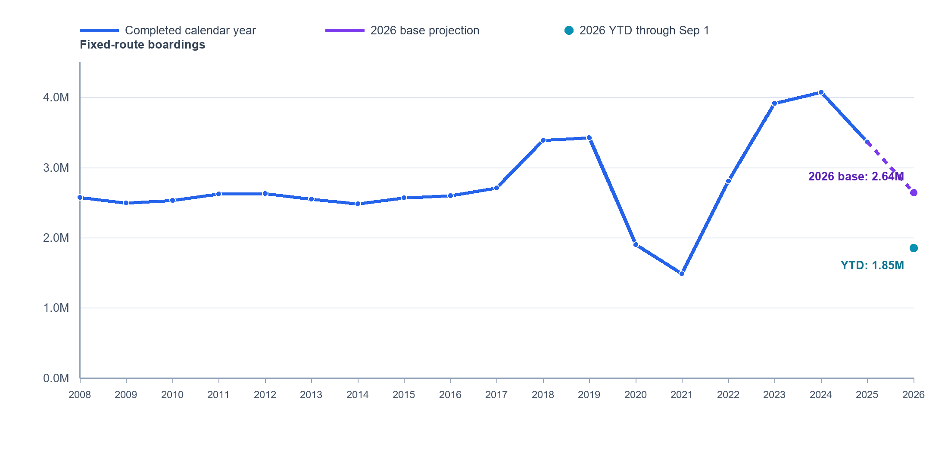
Figure 1. Scheduled-route annual ridership with 2026 YTD and base projection
1,851,423  2026 YTD | 2,640,044  BASE PROJECTION | 2,573,240  LOW SCENARIO | 2,706,848  HIGH SCENARIO

Interpretation limit
Ridership is boarding activity, not unique riders. The 2026 outlook is derived, not a target: it applies the Jan–Aug comparison with 2025 to the remaining seasonal pattern. On Demand is unavailable and is not included in the history or forecast.

5 · FLEET PLANNING ASSUMPTIONS

Bus Fleet Plan
The fleet outlook summarizes planned totals and lifecycle activity for each year of the 2027–2032 horizon.
Source snapshot: 2026-04-08 - Fleet_Plan.xlsx · version 1 · updated April 29, 2026
Year | Planned fleet total | Retiring | Replacement purchases | Growth purchases
2027 | 69 | 7 | 8 | 2
2028 | 69 | 8 | 8 | 4
2029 | 67 | 12 | 9 | 7
2030 | 71 | 10 | 3 | 6
2031 | 80 | 4 | 4 | 6
2032 | 87 | 5 | 9 | 4
Table 4. Fleet outlook by plan year

Interpretation limit
Fleet Plan records are current planning assumptions for vehicle lifecycle, replacement, and growth. They do not establish approved capital funding, procurement timing, vehicle availability, operating cost, or Council approval.

6 · PUBLISHED PLANNING SOURCE

Published Route Schedules
The Master Schedule overview aggregates service hours from the current published route/day schedules. Annual values use the configured 2026 holiday-adjusted service-day counts.
Source snapshot: Canonical Barrie Transit Master Schedule · 29 published route/day entries across 10 routes · 252 weekdays, 51 Saturdays, and 56 Sundays
Route | Weekday daily | Weekday annual | Saturday daily | Saturday annual | Sunday daily | Sunday annual | Total annual
400 | 23.4h | 5,888.4h | 19.4h | 987.7h | — | — | 6,876.1h
100 | 30.5h | 7,694.4h | 29.0h | 1,477.3h | 22.5h | 1,261.9h | 10,433.6h
101 | 29.7h | 7,480.2h | 28.6h | 1,459.5h | 22.3h | 1,246.0h | 10,185.7h
2 | 48.2h | 12,150.6h | 45.3h | 2,307.8h | 26.6h | 1,491.5h | 15,949.8h
7 | 63.9h | 16,098.6h | 59.8h | 3,049.8h | 24.9h | 1,393.5h | 20,541.9h
8A | 83.2h | 20,958.0h | 73.6h | 3,752.7h | 33.0h | 1,846.1h | 26,556.9h
8B | 79.8h | 20,109.6h | 72.6h | 3,700.9h | 32.4h | 1,812.5h | 25,623.0h
10 | 34.8h | 8,778.0h | 31.8h | 1,623.5h | 14.9h | 835.3h | 11,236.8h
11 | 34.8h | 8,778.0h | 30.8h | 1,572.5h | 14.9h | 835.3h | 11,185.8h
12 | 69.5h | 17,509.8h | 65.9h | 3,360.1h | 29.0h | 1,624.9h | 22,494.8h
TOTAL | 497.8h | 125,445.6h | 456.7h | 23,291.7h | 220.5h | 12,347.1h | 161,084.4h
Table 5. Published Master Schedule service hours
Interpretation limit
These records describe the current published planning source. They do not establish service actually delivered, reliability, ridership, cost, or future Strategic Plan approval. Route 400 has no published Sunday entry.

REFERENCE

Evidence definitions and source register
The six workspaces intentionally remain separate because their measures answer different planning questions. The report preserves those boundaries.
Workspace | Source snapshot | Use boundary
Project Work Plan | Shared revision 1 | Status and progress require confirmation; not an approval record.
Current Scheduled Service | GTFS 20260503b; May 27–Aug 29, 2026 | Static schedule snapshot; not live or delivered service.
Trip Planning Trends | Transit App; Jan 1–Sep 30, 2025 | App engagement and requested trips; not ridership.
Annual Ridership | Workbook + STREETS through Sep 1, 2026 | Fixed-route boardings; not unique riders or causation.
Bus Fleet Plan | Version 1; updated Apr 29, 2026 | Planning assumptions; not funding or procurement approval.
Published Route Schedules | 29 current route/day entries; captured Sep 2, 2026 | Published planning source; not delivered service.
Table 6. Source register and interpretation boundaries

Document controls
Prepared for: Barrie Transit Strategic Plan working team
Workspace captured: September 2, 2026
Data handling: Read-only review of authenticated source workspaces; no source records were changed or copied back into the application.

