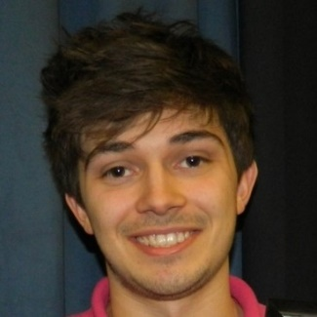

Michael Rogers

**Full Stack Software Engineer**

mikerogers_@hotmail.co.uk ~ 07810 001816 ~ 8 Knight Close, TA2 8GJ

Summary

Highly motivated, energetic and enthusiastic web application developer with over 2 years of commercial experience. Strong academic background and appetite to step out of my comfort zone enables me to learn new skills quickly and effectively.

Skills & Experience

Frontend Created Angular (2+) single page applications using TypeScript/JavaScript, HTML, CSS, and libraries such as Redux, Bootstrap and RxJS.

Backend Applied SOLID principles to build HTTP services using the ASP.NET Web API framework, including experience with Microservices using NServiceBus.

Comfortable working with functional programming paradigms, mainly using F#.

Integration Worked in large and small Scrum teams in high intensity environments, employing continuous integration/delivery techniques, managed using Git and Azure.

Testing Confident writing unit tests (pragmatically) and end-to-end automated tests; utilising frameworks/libraries such as NUnit, Selenium/Gherkin and Jasmine.

DatabasesExperience with relational (SQL Server) and document (CosmosDB) databases, using frameworks such as Entity Framework and LINQ to query.

Academic Analysis/gathering of data to solve mathematical problems using MATLAB and R.

Created financial trading algorithms in C++ utilising the MetaTrader platform.

Attended a Java training course that involved creating a draughts game and developing AI to compete against other players.

Work Experience

Oct 2018 – present **Software Engineer – Bud Systems**

Nov 2017 – Oct 2018 **Junior Software Engineer – Bud Systems**

Worked on a single page Angular 6 web application, with a microservices backend architecture implemented using NServiceBus and ASP.NET Web API. Adopted many technologies/patterns such as Typescript, Redux & Entity Framework, using multiple database technologies including CosmosDB, Azure Table Storage and SQL Server. Also obtained valuable exposure to some functional programming techniques, implemented in F#.

Oct 2016 – Nov 2017 **Graduate Software Engineer - Civica Digital**

Worked in a fast-paced, agile environment following key practises such as continuous integration/delivery and unit testing. Mostly worked with ASP.NET Web Forms, C#, JavaScript, HTML & T-SQL.

May 2010 (1 week) **Milsted Langdon Chartered Accountants – Work Experience (voluntary)**

Education & Qualifications

2013 – 2016 **University of Bath BSc (Hons) Mathematics** **1st** 89.4 %

**Awards** BP Centurion Award for Academic Excellence

*Awarded to 3 undergraduates achieving highest overall average*

David Powell Prize

*Awarded to best final year performer in Applied Mathematics*

2011 – 2013 **Richard Huish College** **A-level** Mathematics A*

Further Mathematics A*

Physics A*

**AS-level** Accounting A

2006 – 2011 **Heathfield Community School** **GCSE** Nine A*, three A, one B

*Includes A* in Mathematics, Science and English Language*

Achievements

SnookerEngland U16 International player (2012)

England U21 Premier Tour (England top 40) player

Four-time WEBSF (West of England) sporting player of the year

OtherFull, clean UK Driving Licence

Proud husband and father