**Technology Entrepreneurship**

Decision Making Unit

Mike Sadowski

CP-601-OC1: Sem in Tech Entrepreneurship

Nur Kurak

November 10th, 2021

Individuals make their own purchasing decisions when buying items such as groceries and clothes to meet their needs. In organizations, that responsibility of decision making is spread throughout a team of people who come together to make the best choice possible for a company. The team is responsible for identifying the best decision regarding a company's interests. This team or unit is known as the decision-making unit (DMU).

Aulet defines the DMU as “all the people who will be involved in the decision to acquire the product for the end user” (Aulet B, 2013, p. 141). The goal of this unit is to identify the roles and influence each member of the DMU has on the overall buying process of the company. The DMU consists of several roles: user, influencer, buyers, approvers, deciders, and gatekeepers. The user plays the role of the party that uses the final product. Influencers can influence the buying conditions by setting pre-conditions (HowandWhat.net, 2017), while deciders are responsible for deciding requirements for products and suppliers. Buyers have the authority to order a product from a supplier. Approvers are the ones who authorize the requests from deciders and buyers. Finally, gatekeepers are the ones who control the flow of information in organizations (HowandWhat.net, 2017).

To best illustrate the importance and usefulness of a DMU, we will use an example of a fictitious company and product. “Mike’s File Share” is a web-based cloud storage system/platform used for backing up files by businesses and individuals. It allows for the sharing of files, as well as the simultaneous collaboration on documents utilizing Microsoft Office Online. The sharing of documents allows employees of businesses to easily share files amongst each other and collaborate on populating the information inside of them (for example, Excel spreadsheets can be edited by everyone they are shared to within an organization). Document contents are also searchable via a search bar, so information is easily found and accessed by everyone within the company.

The business structure contains several employees to help run and maintain this product: Director/CEO (owner of the company), Product Manager (meets with customers to discuss feature requests and needs, relays product requirements to Engineering Department Manager), Engineering Department Manager (manages engineering team, leads technical decisions), Engineering Department (develops product), Development Operations Manager (manages Development Operations team, relays needs from Engineering Department), Development Operations (handles infrastructure of product, I.e. servers, databases, etc.), and finally the Customer (user of product, can be a business or individual person).

In the context of the DMU, I have assigned each employee a specific role within the DMU. The director/CEO will get the Approver role, they will oversee approving the requests of the buyers as they should have the final say of what goes on within their company. Product Manager received the Decider and Gatekeeper roles, they are the ones in discussions with the customers to help determine what their needs are. They will know best which direction the product should take. They also received the Gatekeeper role to relay this information to the CEO. Similarly, the Engineering Department Manager and Development Operations Manager received the Decider and Gatekeeper roles, as they are the ones working with the two teams that develop and maintain the product. They will know best what is needed from the engineering and infrastructure side of the product. They received the Gatekeeper role to relay this information to the CEO. In addition to these 2 roles, the Engineering Department Manager and Development Operations Manager received the Buyer role as well. Since this is a software company, not much is needed regarding purchasing physical products (besides laptops/monitors/etc. for the developers to use). However, things such as licenses for third party software (such as Microsoft Office Online), servers, hardware, and other items like these will be needed as well. They will understand what the Engineering Department and Development Operations Department will need the best, so once they gain approval from the CEO, they will have the power to purchase these items. The Engineering Department and Development Operations Department both received only the Influencer role as they can make recommendations to their respective Managers to help make the decision of what to purchase. For example, the Engineers can recommend a third-party product to implement into the application (such as Microsoft Office Online) and the Development Operations department can make recommendations for database and server hardware (such as Elastic Search) that will benefit the company is some way. Finally, the Customer received the User role as they are the people who use the product in the end. Additionally, they received the Influencer role as they can request features and promote changes to the product through the Product Manager to meet their needs.

**DMU Chart**

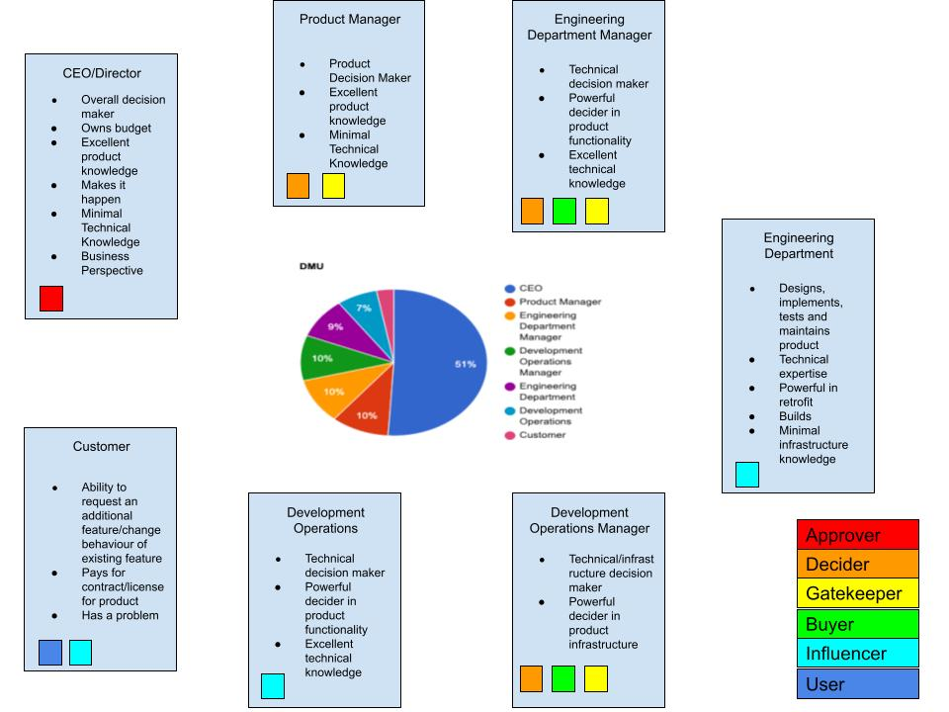

References:

1. Aulet, B. (2013). *Disciplined entrepreneurship: 24 steps to a successful startup*. Hoboken, New Jersey: John Wiley & Sons, Inc.
2. HowandWhat.net. (2017, November 26). *The decision making unit*. howandwhat. Retrieved October 11, 2021, from <https://howandwhat.net/decision-making-unit/>.