1. **How can we insert a new row of values before the first row of DataFrame object we load from crx_data.csv in Section 3? (3 points)**

**Insert a row:**

Original data:

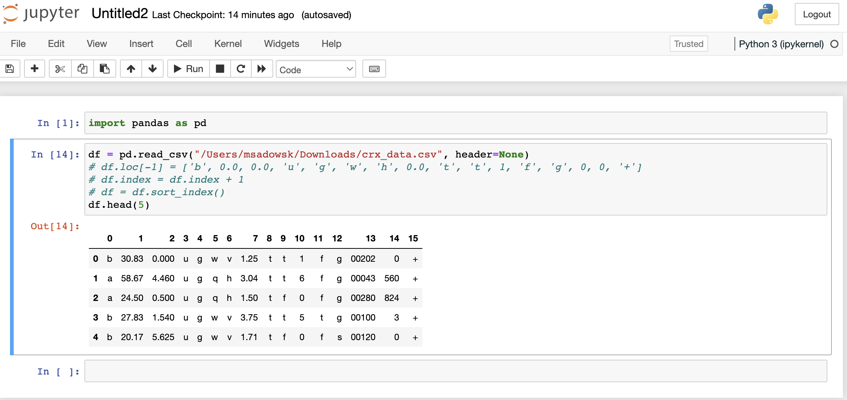

Newly inserted row before the first row of the loaded data set:

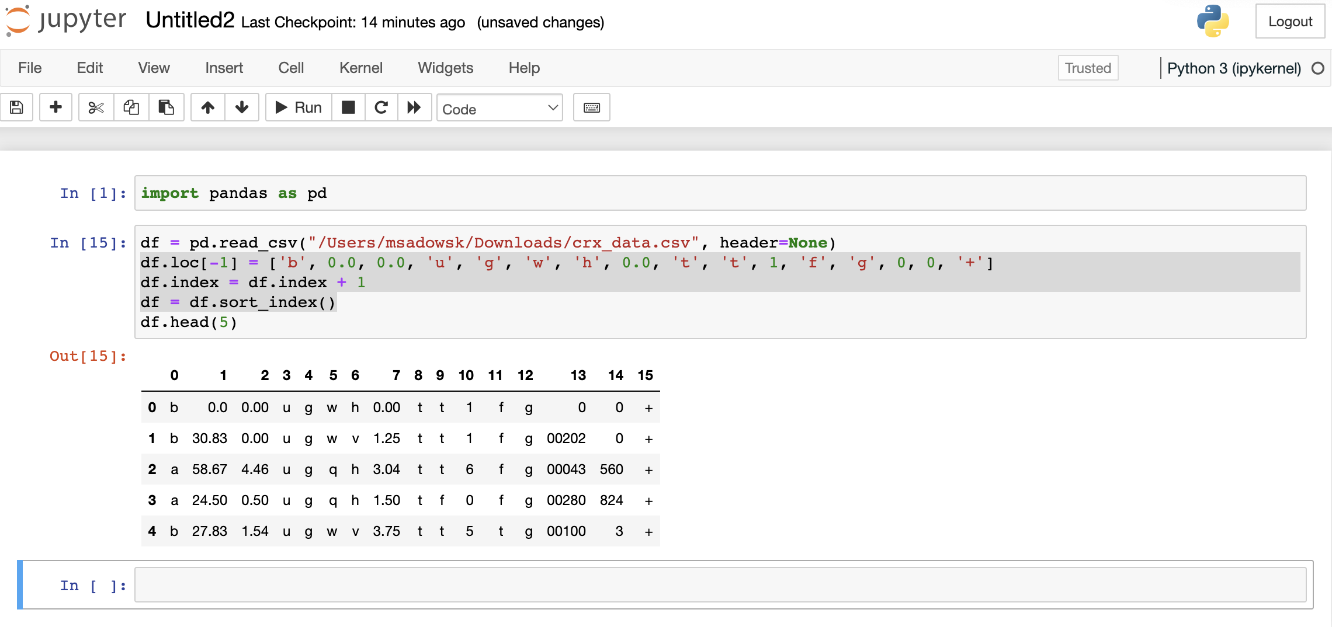

**Add a column:**

Original data:

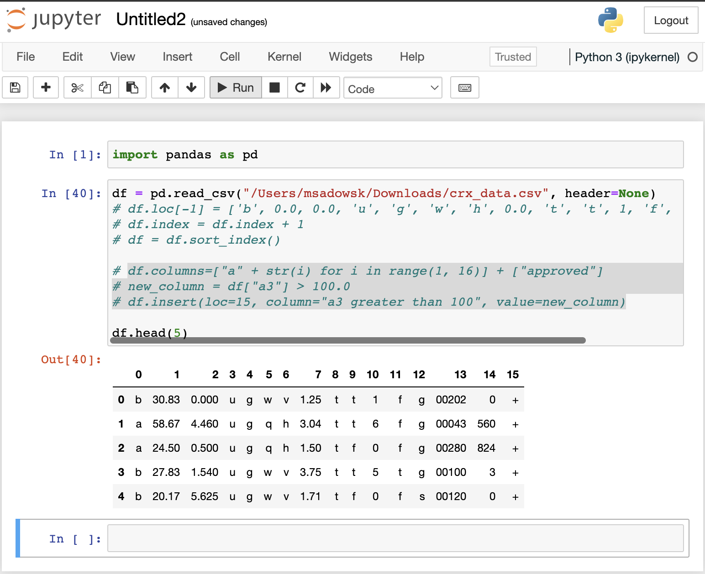

Newly inserted column in the 15th position:

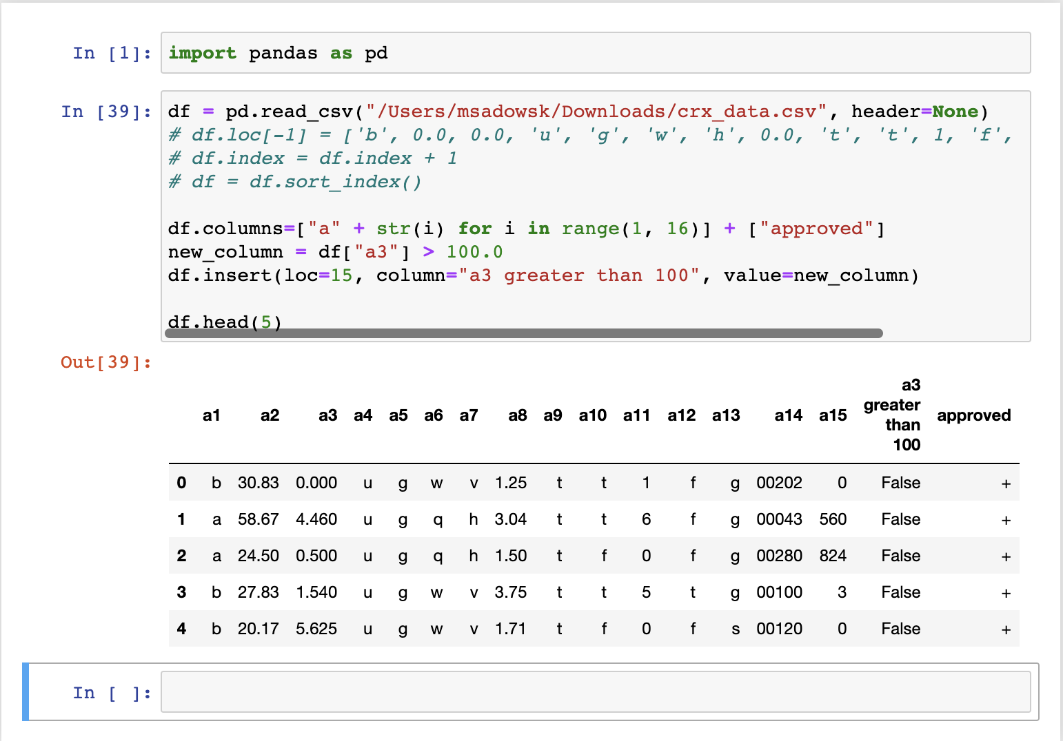

**Delete a list of columns:**

Original data:

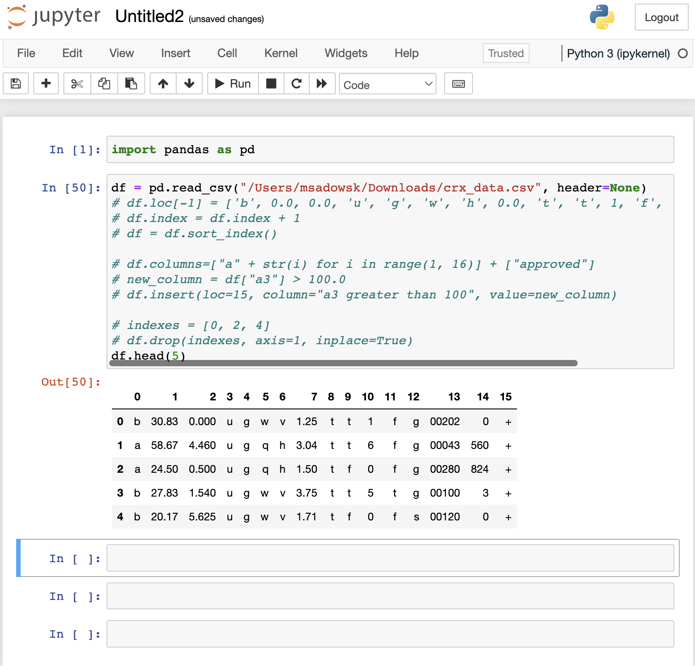

Dropped columns 0, 2, 4:

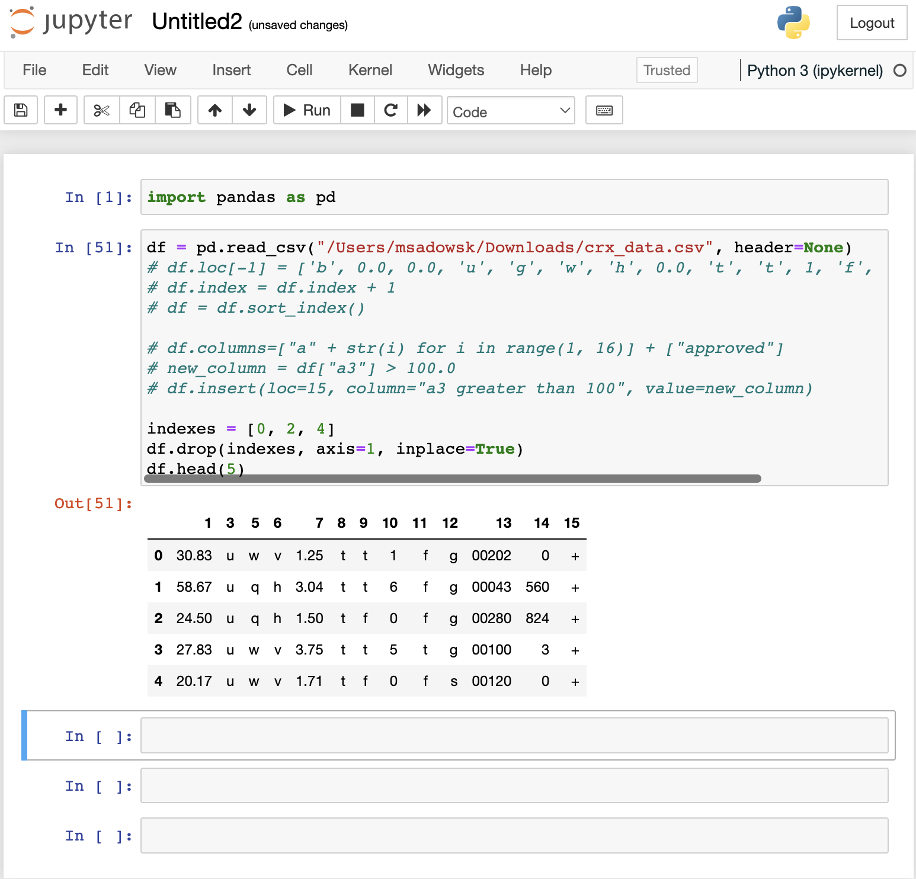

**Final Code (for all manipulations):**

import pandas as pd

df = pd.read_csv("/Users/msadowsk/Downloads/crx_data.csv", header=None)

df.loc[-1] = ['b', 0.0, 0.0, 'u', 'g', 'w', 'h', 0.0, 't', 't', 1, 'f', 'g', 0, 0, '+']

df.index = df.index + 1

df = df.sort_index()

df.columns=["a" + str(i) for i in range(1, 16)] + ["approved"]

new_column = df["a3"] > 100.0

df.insert(loc=15, column="a3 greater than 100", value=new_column)

indexes = [0, 2, 4]

df.drop(indexes, axis=1, inplace=True)

df.head(5)