1. **Can you get the feature names and the descriptions of the toy diabetes data set via python code? Please write down the code and the output of the code. [1 point]**

**Code:**

from sklearn.datasets import load_diabetes

data = load_diabetes()

features = data.feature_names

description = data.DESCR

print(features, description)

Reference: [https://scikit-](https://scikit-learn.org/stable/modules/generated/sklearn.datasets.load_diabetes.html#sklearn.datasets.load_diabetes) learn.org/stable/modules/generated/sklearn.datasets.load_diabetes.html#sklearn.datasets.load_diabetes

**Output:**

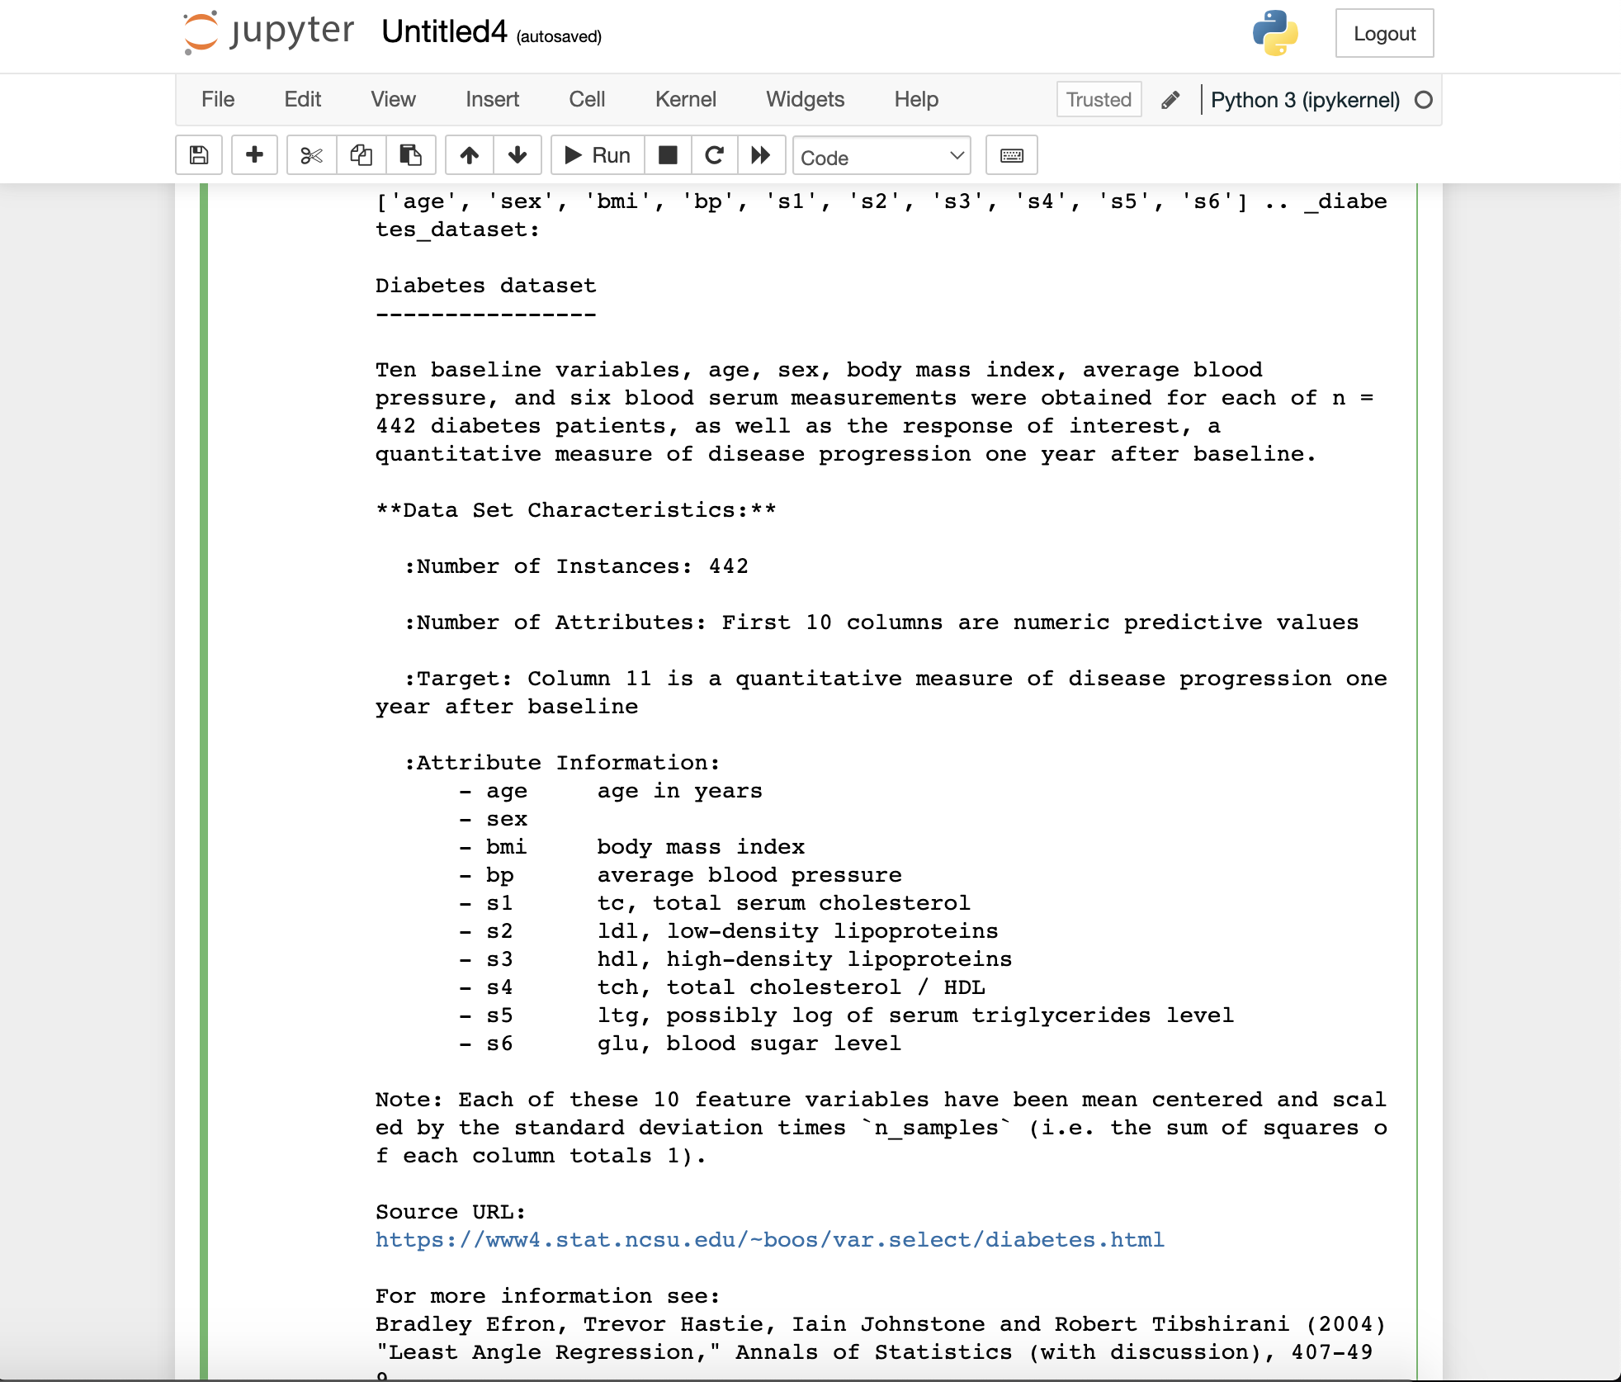

1. **It is time to play with another data set of scikit_learn: the wine data set. Use load_wine() to load the wine data set and apply logistic regression on it. We split the data set into 80/20. 80% of data points are used for model training, and 20% for test purposes. Please write the code and output (including mean accuracy and confusion matrix) in the answer. [2 points]**

**Code:**

from sklearn.datasets import load_wine

from sklearn.model_selection import train_test_split

import numpy as np

from sklearn.linear_model import LogisticRegression

from sklearn.metrics import confusion_matrix, accuracy_score

data_bunch = load_wine()

print(data_bunch.feature_names)

print(data_bunch.target_names)

print()

wine_X, wine_y = data_bunch.data, data_bunch.target

def filter_class_2(X, y):

new_X, new_y = [], []

for x, y in zip(X, y):

if y == 2:

continue

else:

new_X.append(x)

new_y.append(y)

return np.array(new_X), np.array(new_y)

wine_X, wine_y = filter_class_2(wine_X, wine_y)

# split the data into train/test (80/20)

wine_X_train, wine_X_test, wine_y_train, wine_y_test = train_test_split(wine_X, wine_y, test_size=0.20, random_state=15)

# logistic regression model

logistic_regression_model = LogisticRegression()

# train

logistic_regression_model.fit(wine_X_train, wine_y_train)

# prediction

wine_y_pred = logistic_regression_model.predict(wine_X_test)

accuracy = accuracy_score(wine_y_test, wine_y_pred)

confusion_matrix = confusion_matrix(wine_y_test, wine_y_pred)

print("accuracy:", accuracy * 100)

print("confusion_matrix:", confusion_matrix)

**Output:**

