1. **implement a mydist function as in Code Listing 7.04. Hint: use one common distance metric in this** [**Wikipedia page**](https://en.wikipedia.org/wiki/Metric_(mathematics)) **(1 point)**

**Code:**

# calculate the Euclidean distance between x and y

def mydist(x, y):

distance = 0.0

for i in range(len(x)-1):

distance += (x[i] - y[i])**2

return sqrt(distance)

I used the Euclidean metric from the Wikipedia page:

<https://en.wikipedia.org/wiki/Euclidean_distance>

1. **use the mydist function for a k-NN classifier with k=10 and train it with 80% of the breast cancer training set (we can reuse Code Listing 7.05) (1 point)**

**Output:**

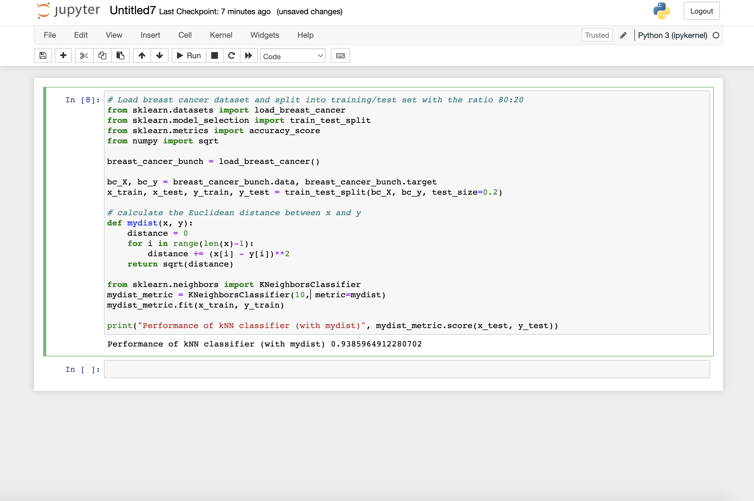

Performance of kNN classifier (with mydist) 0.9385964912280702

**Code:**

# Load breast cancer dataset and split into training/test set with the ratio 80:20

from sklearn.datasets import load_breast_cancer

from sklearn.model_selection import train_test_split

from numpy import sqrt

breast_cancer_bunch = load_breast_cancer()

bc_X, bc_y = breast_cancer_bunch.data, breast_cancer_bunch.target

x_train, x_test, y_train, y_test = train_test_split(bc_X, bc_y, test_size=0.2)

# calculate the Euclidean distance between x and y

def mydist(x, y):

distance = 0

for i in range(len(x)-1):

distance += (x[i] - y[i])**2

return sqrt(distance)

from sklearn.neighbors import KNeighborsClassifier

mydist_metric = KNeighborsClassifier(10, metric=mydist)

mydist_metric.fit(x_train, y_train)

print("Performance of kNN classifier (with mydist)", mydist_metric.score(x_test, y_test))

1. **evaluate the performance of the k-NN classifier by the average accuracy score on the breast cancer test set and compare its performance with a k-NN classifier with k=10 and it uses the default distance metric. Write down the comparison result. (1 point)**

**Output:**

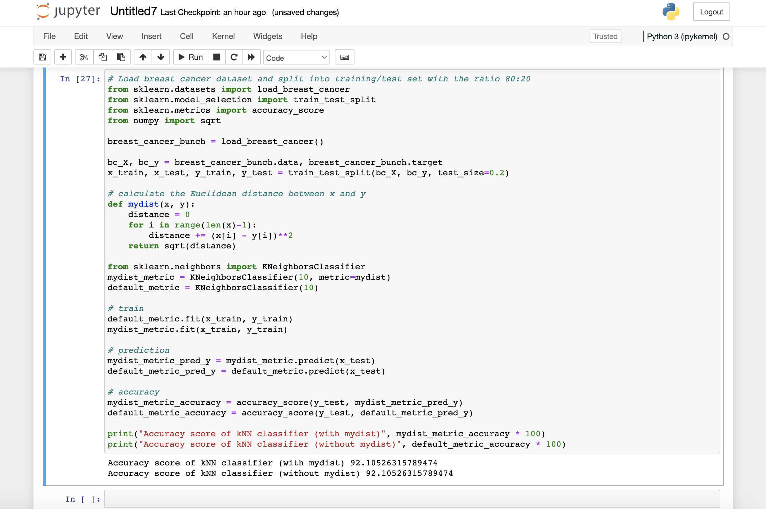

Run 1:

Accuracy score of kNN classifier (with mydist) 92.10526315789474  
Accuracy score of kNN classifier (without mydist) 92.10526315789474

Run 2:

Accuracy score of kNN classifier (with mydist) 90.35087719298247  
Accuracy score of kNN classifier (without mydist) 90.35087719298247

Run 3:

Accuracy score of kNN classifier (with mydist) 92.98245614035088  
Accuracy score of kNN classifier (without mydist) 92.98245614035088

The default distance metric (which is, according to <https://scikit-learn.org/stable/modules/generated/sklearn.neighbors.KNeighborsClassifier.html>, the Minkowski metric) performs identically to the Euclidean metric I’ve implemented in the mydist() function. At first I thought this was an error, after repeated runs they are always identical. However, if I change the metric of the default model to be cosine (metric=‘cosine’), the accuracy score does change, so I do not believe this is an error. It appears that the performance of the default metric and mydist() custom Euclidean metric are identical.

**Code:**

# Load breast cancer dataset and split into training/test set with the ratio 80:20

from sklearn.datasets import load_breast_cancer

from sklearn.model_selection import train_test_split

from sklearn.metrics import accuracy_score

from numpy import sqrt

breast_cancer_bunch = load_breast_cancer()

bc_X, bc_y = breast_cancer_bunch.data, breast_cancer_bunch.target

x_train, x_test, y_train, y_test = train_test_split(bc_X, bc_y, test_size=0.2)

# calculate the Euclidean distance between x and y

def mydist(x, y):

distance = 0

for i in range(len(x)-1):

distance += (x[i] - y[i])**2

return sqrt(distance)

from sklearn.neighbors import KNeighborsClassifier

mydist_metric = KNeighborsClassifier(10, metric=mydist)

default_metric = KNeighborsClassifier(10)

# train

default_metric.fit(x_train, y_train)

mydist_metric.fit(x_train, y_train)

# prediction

mydist_metric_pred_y = mydist_metric.predict(x_test)

default_metric_pred_y = default_metric.predict(x_test)

# accuracy

mydist_metric_accuracy = accuracy_score(y_test, mydist_metric_pred_y)

default_metric_accuracy = accuracy_score(y_test, default_metric_pred_y)

print("Accuracy score of kNN classifier (with mydist)", mydist_metric_accuracy * 100)

print("Accuracy score of kNN classifier (without mydist)", default_metric_accuracy * 100)