1. **In section 6, we have learned how to apply the randomized search for hyperparameter tuning together with cross-validation. Let's try to do the same thing on a k-NN model. We can reuse the code in Code Listing 9.03, and continue with your code of applying 5-fold cross-validation by RandomizedSearchCV(). You can define your hyperparameter grid and compare the fine-tune k-NN model with the one with default parameters. The hyperparameter list of k-NN regressors can be found at** [**sklearn.neighbors.KNeighborsRegressor**](https://scikit-learn.org/stable/modules/generated/sklearn.neighbors.KNeighborsRegressor.html)**.**

**Output:**

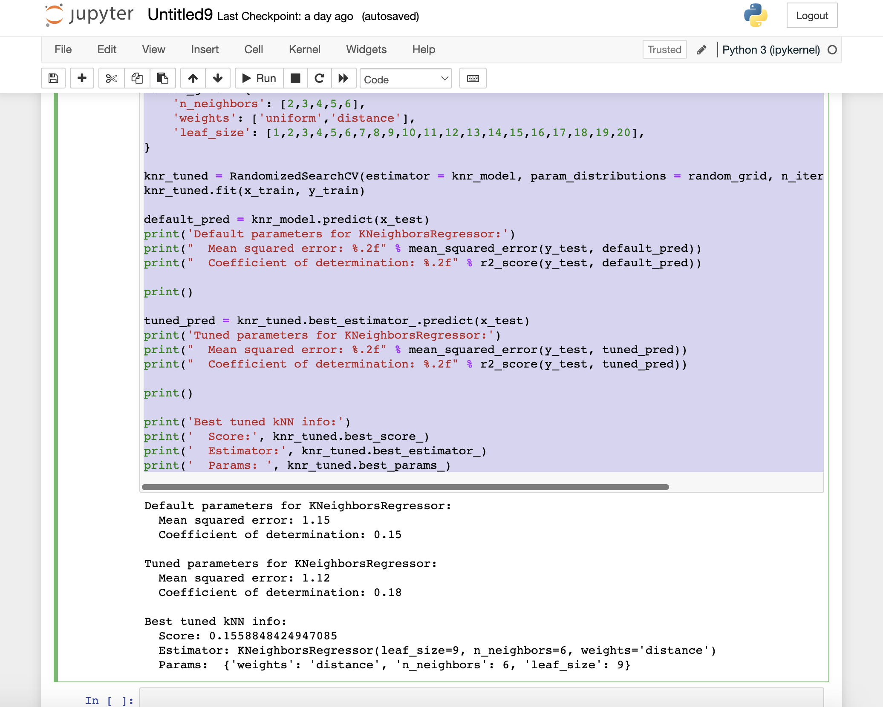

Default parameters for KNeighborsRegressor:  
 Mean squared error: 1.15  
 Coefficient of determination: 0.15  
  
Tuned parameters for KNeighborsRegressor:  
 Mean squared error: 1.12  
 Coefficient of determination: 0.18  
  
Best tuned kNN info:  
 Score: 0.1558848424947085  
 Estimator: KNeighborsRegressor(leaf_size=9, n_neighbors=6, weights='distance')  
 Params: {'weights': 'distance', 'n_neighbors': 6, 'leaf_size': 9}

Tuning the hyperparameters of the 2nd model improves the performance as can be seen from the output above. The most optimal parameters are listed above as well.

**Code:**

import numpy as np

from sklearn.ensemble import RandomForestRegressor

from sklearn.model_selection import RandomizedSearchCV

from sklearn.datasets import fetch_california_housing

from sklearn.model_selection import train_test_split

from sklearn.metrics import mean_squared_error, r2_score

california_housing_bunch = fetch_california_housing()

california_housing_X, california_housing_y = california_housing_bunch.data, california_housing_bunch.target

x_train, x_test, y_train, y_test = train_test_split(california_housing_X, california_housing_y, test_size=0.2)

from sklearn.neighbors import KNeighborsRegressor

knr_model = KNeighborsRegressor()

knr_model.fit(x_train, y_train)

random_grid = {

'n_neighbors': [2,3,4,5,6],

'weights': ['uniform','distance'],

'leaf_size': [1,2,3,4,5,6,7,8,9,10,11,12,13,14,15,16,17,18,19,20],

}

knr_tuned = RandomizedSearchCV(estimator = knr_model, param_distributions = random_grid, n_iter = 10, cv = 5, n_jobs = -1)

knr_tuned.fit(x_train, y_train)

default_pred = knr_model.predict(x_test)

print('Default parameters for KNeighborsRegressor:')

print(" Mean squared error: %.2f" % mean_squared_error(y_test, default_pred))

print(" Coefficient of determination: %.2f" % r2_score(y_test, default_pred))

print()

tuned_pred = knr_tuned.best_estimator_.predict(x_test)

print('Tuned parameters for KNeighborsRegressor:')

print(" Mean squared error: %.2f" % mean_squared_error(y_test, tuned_pred))

print(" Coefficient of determination: %.2f" % r2_score(y_test, tuned_pred))

print()

print('Best tuned kNN info:')

print(' Score:', knr_tuned.best_score_)

print(' Estimator:', knr_tuned.best_estimator_)

print(' Params: ', knr_tuned.best_params_)

**References**:

1. <https://openclassrooms.com/en/courses/6401081-improve-the-performance-of-a-machine-learning-model/6559796-tune-your-hyperparameters>