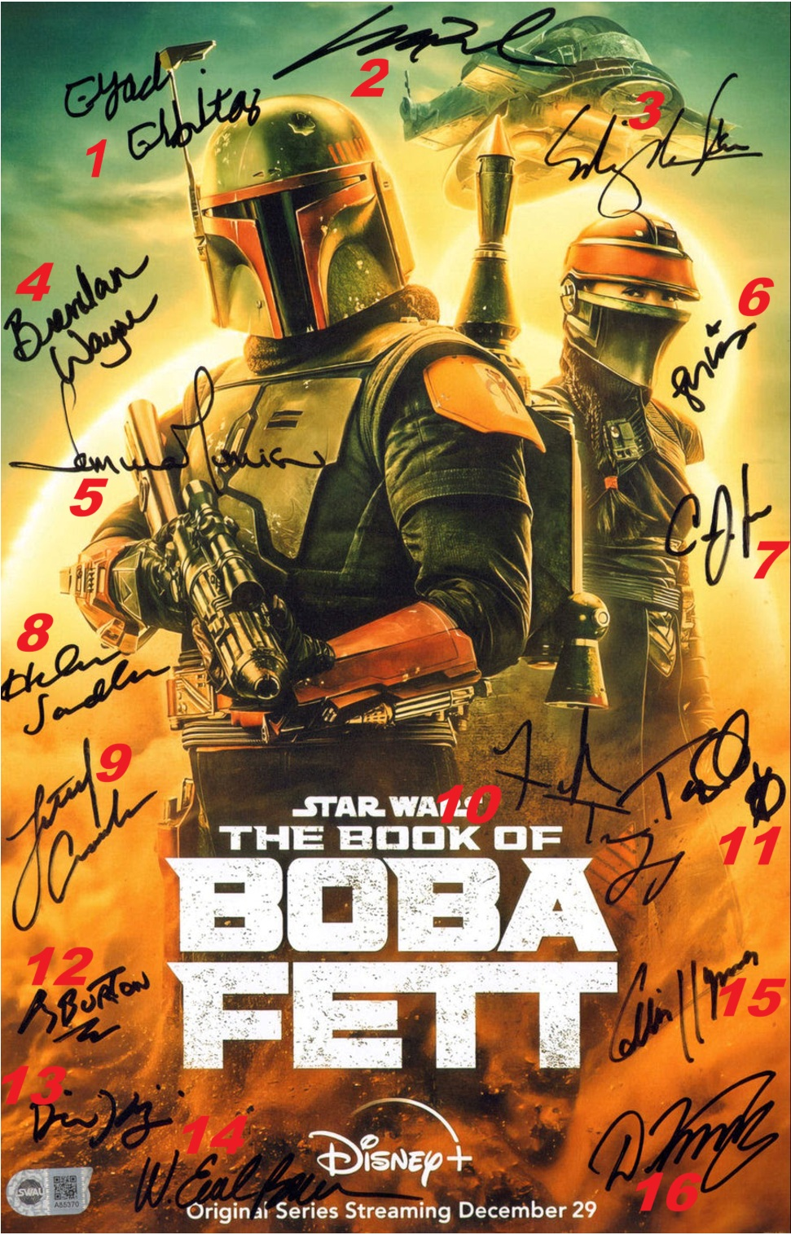Star Wars: The Book of Boba Fett (SWAU) 11x17 Mini Poster

-4959528-3692115

Cast Signed by:

|  |  |
| --- | --- |
| 1 | Eyad Elbitar |
| 2 | Matt Wood |
| 3 | Ming-Na Wen |
| 4 | Brendan Wayne |
| 5 | Temuera Morrison |
| 6 | Leilani Shiu |
| 7 | Carey Jones |
| 8 | Helen Sadler |
| 9 | Lateef Crowder |
| 10 | Frank Trigg |
| 11 | Tait Fletcher |
| 12 | Corey Burton |
| 13 | Dorian King |
| 14 | W. Earl Brown |
| 15 | Collin Hymes |
| 16 | Dmitriy Kara |