Note: From Anna Marie Tancongco Anastacio’s Facebook Messenger  
  
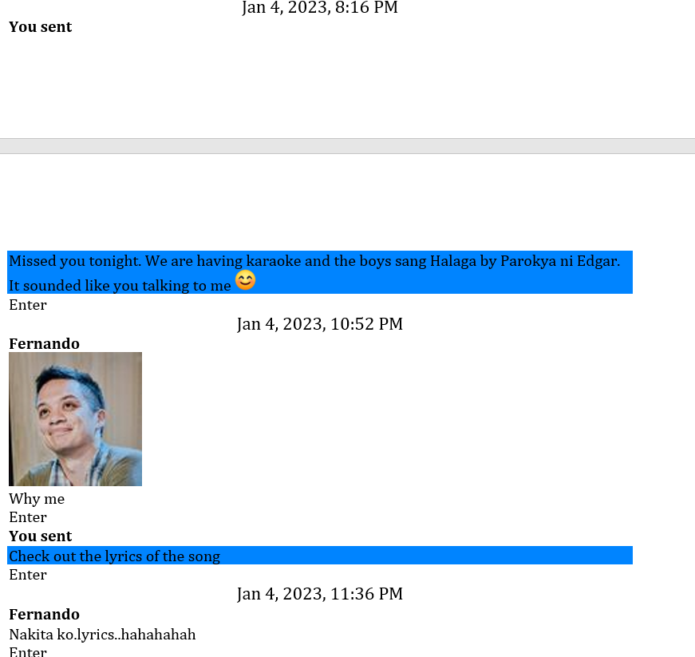

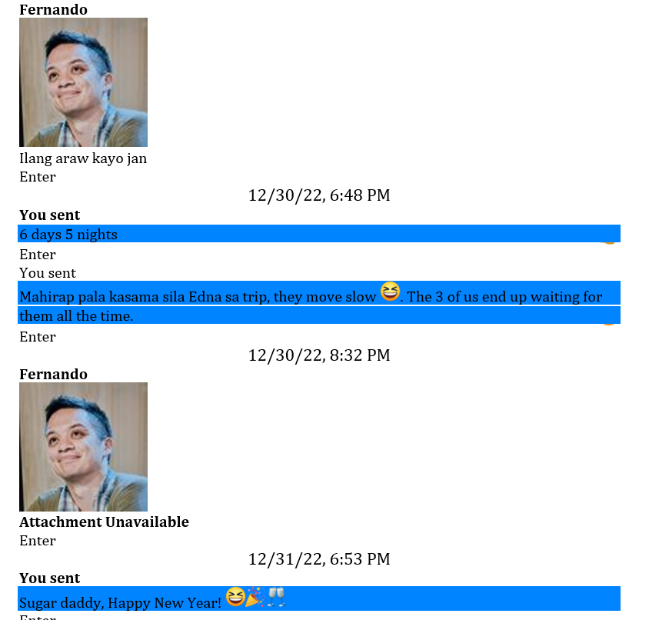

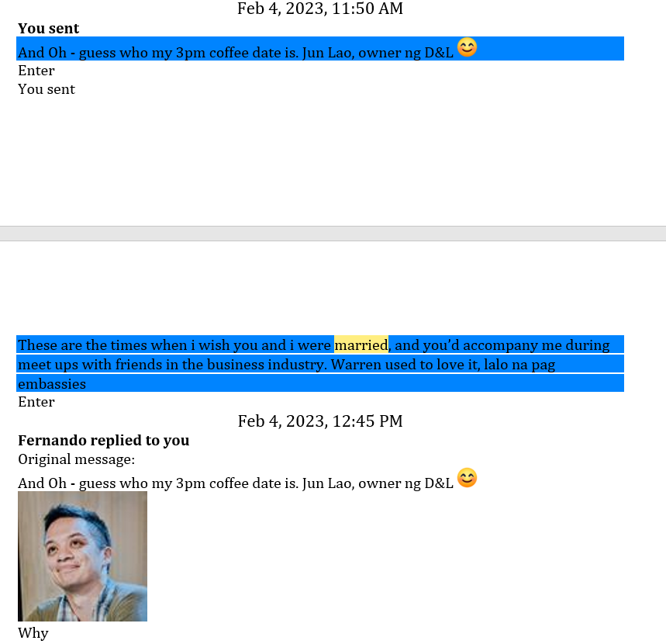

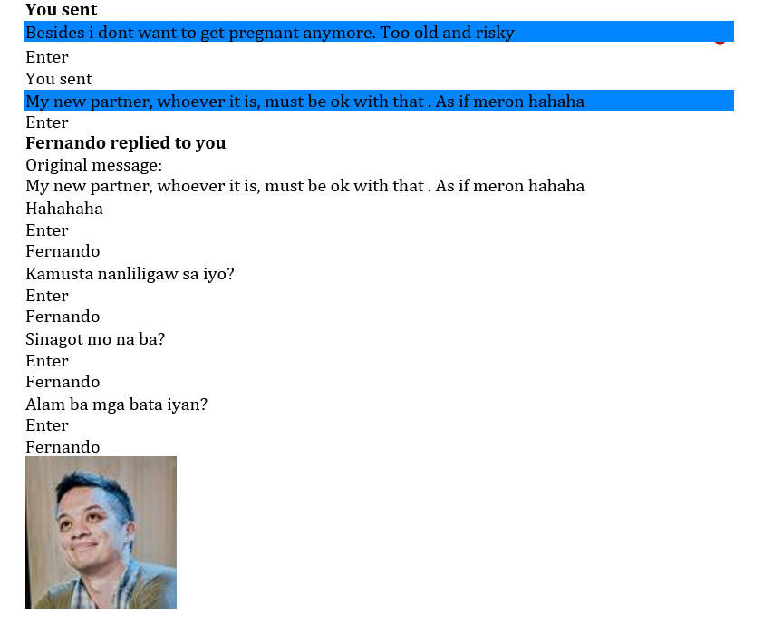

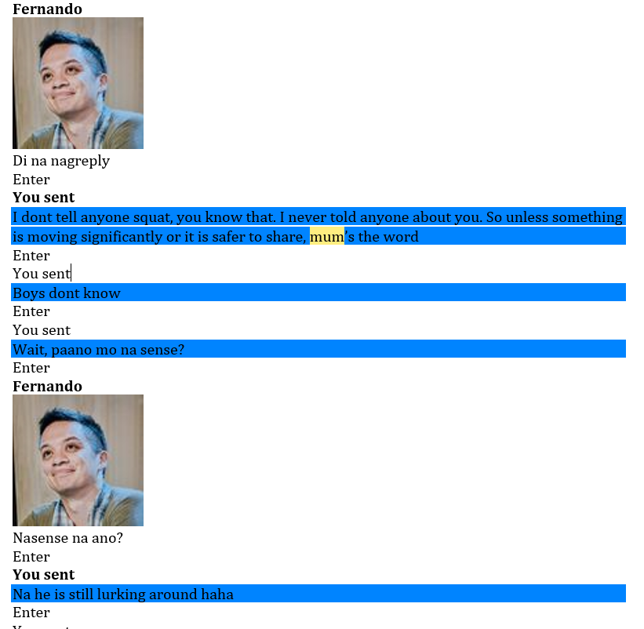

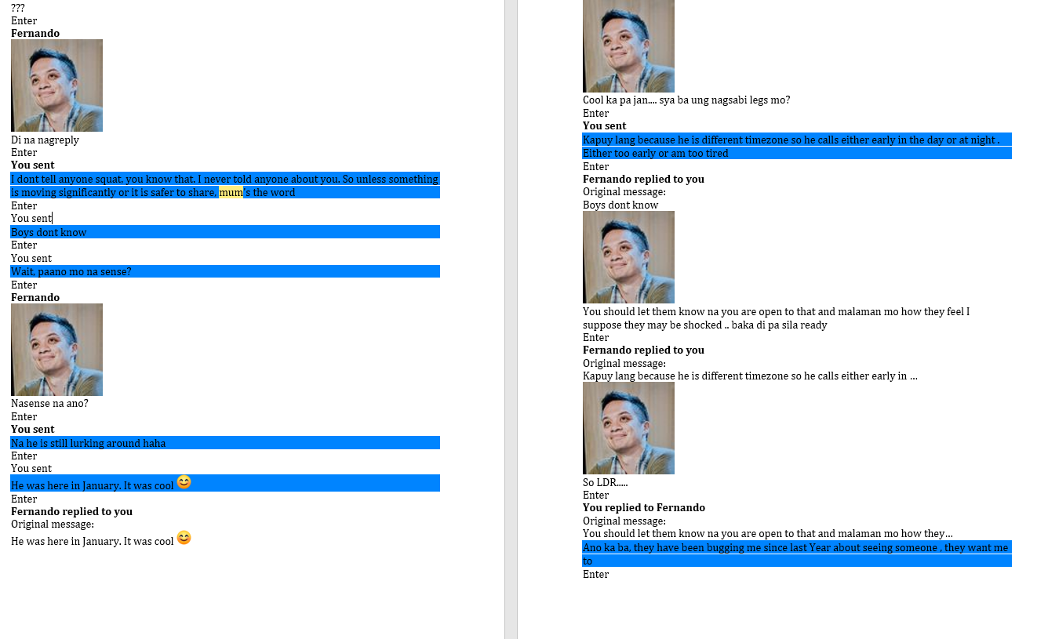

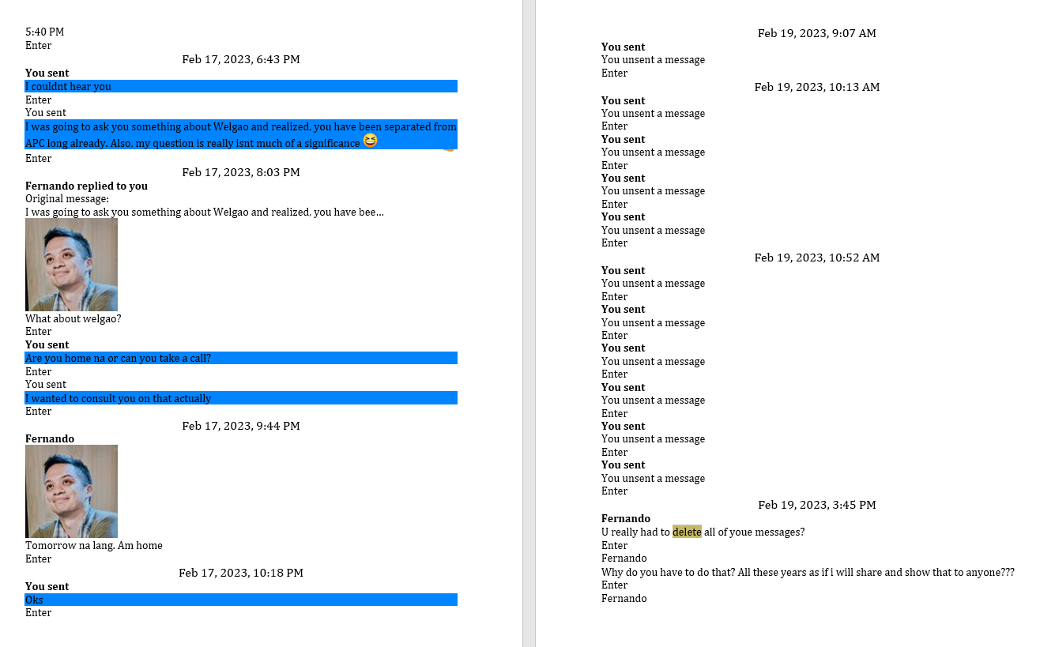

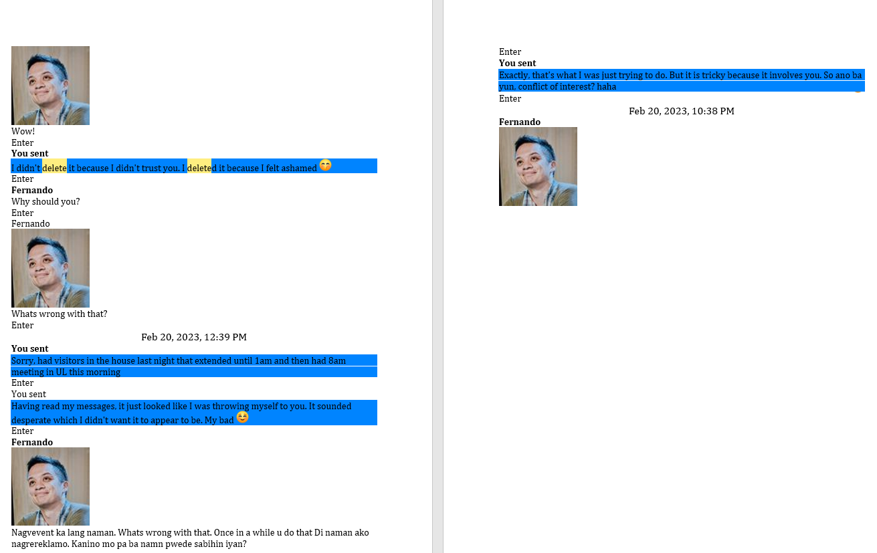

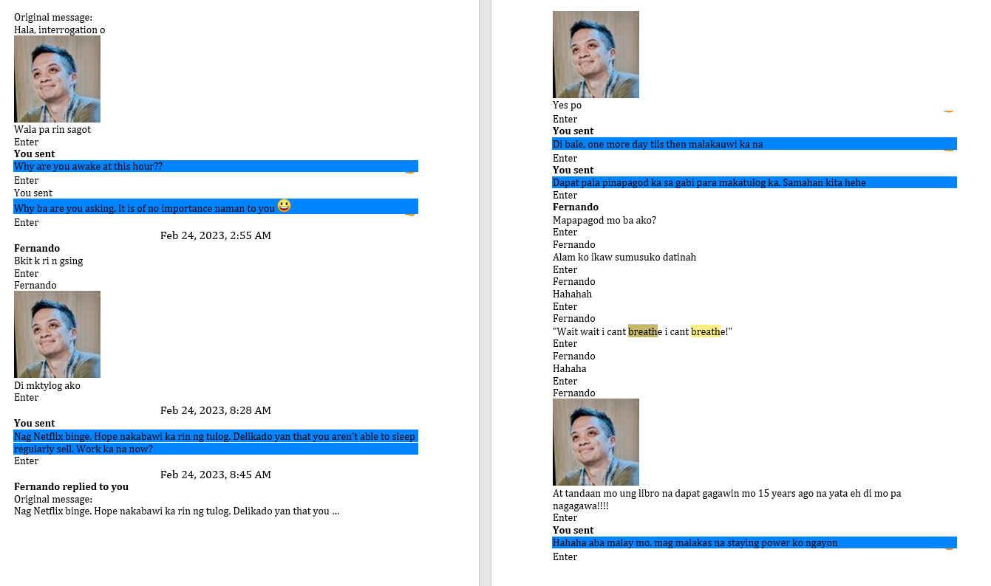

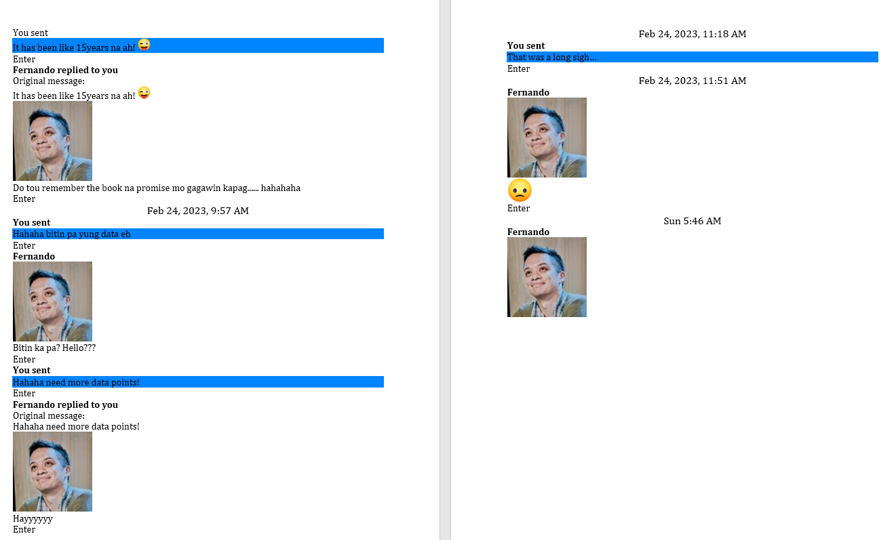

😆

Enter

**Fernando**

Kaikan pa kayo akabalik from japan?

Enter

Fernando



Lang days kayo dun

Enter

**You sent**

Pauwi palang, at the airport na. We will arrive 1.30am

👍

Enter

**Fernando**



Ilang araw kayo jan

Enter

12/30/22, 6:48 PM

**You sent**

6 days 5 nights

👍

Enter

You sent

Mahirap pala kasama sila Edna sa trip, they move slow 😆. The 3 of us end up waiting for them all the time.

😮

Enter

12/30/22, 8:32 PM

**Fernando**



**Attachment Unavailable**

Enter

12/31/22, 6:53 PM

**You sent**

Sugar daddy, Happy New Year! 😆🎉🥂

Enter

**Fernando**

Hahahaha

Enter

Fernando

Happy new year!!!

Enter

Fernando



Enjoy the day!!

Enter

**You sent**

The day ka jan. Gabi na!

Enter

**Fernando**

The night!!!

Enter

Fernando



Hahaha

Enter

12/31/22, 7:22 PM

**You sent**

Enter

Jan 2, 2023, 5:32 AM

**Fernando**



**Attachment Unavailable**

Enter

Enter

Jan 4, 2023, 8:16 PM

**You sent**

Missed you tonight. We are having karaoke and the boys sang Halaga by Parokya ni Edgar. It sounded like you talking to me 😊

Enter

Jan 4, 2023, 10:52 PM

**Fernando**



Why me

Enter

**You sent**

Check out the lyrics of the song

Enter

Jan 4, 2023, 11:36 PM

**Fernando**

Nakita ko.lyrics..hahahahah

Enter

Fernando

Di naman ako ganun ka brutal

Enter

Fernando

To some.extent maybe. Frank ako

Enter

Fernando



Pero di naman ganun ka walang.modo..hahaha

Enter

**You sent**

Hahaha i just saw some lines and remembered you. Not naman the entire song because i cant understand all of it also. Tagalog eh hahaha

Enter

You sent

And why are you still awake so late? Unusual for you. Sleep ka na!

Enter

Jan 5, 2023, 6:41 AM

**Fernando**



Umuwi ako from clark..pinawfh Sore throat

Enter

Jan 5, 2023, 8:57 AM

**You sent**

Oh no. Hopefully negative ka sa Covid. Sila Diego nga, online muna this week kasi everyone had high interaction over the holidays, precaution lang.

❤️

Enter

Jan 14, 2023, 11:40 AM

**You sent**

Someone is studying hard for the Ateneo entrance exams tomorrow 🙏🏼

Enter

You sent

[[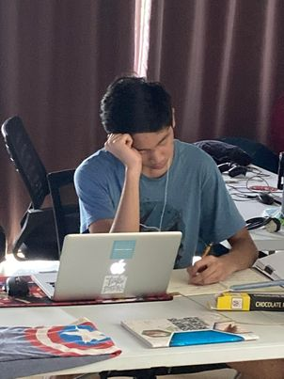](https://www.facebook.com/messenger_media/?attachment_id=3029737413996641&message_id=mid.%24cAABa8wrhSTmL36L1UGFrl2jAzn4v&thread_id=100000521194097)](https://www.facebook.com/messenger_media/?attachment_id=3029737413996641&message_id=mid.%24cAABa8wrhSTmL36L1UGFrl2jAzn4v&thread_id=100000521194097)

❤️

Enter

**Fernando**



Good.luck kamo!!!

Enter

Jan 16, 2023, 8:59 AM

**Fernando**



Isang taxi driver si Joey. isang araw, habang nakapark sya sa harap ng isang radio station ay may lalaking lumapit sa kanya. LALAKE: Manong hatid mo naman ako oh,sa libertad pasay Ing sa harap ng puregold. JOEY: Oh cge po sir, sakay na po kau. habang bumabyahe sila ay nakita ng lalake ang kanyang asawa na pumasok sa isang hotel na may kaakbay na isang lalake. Pinahinto nya si joey. JOEY: bakit po sir? Malayo pa po tau ah. LALAKE: Alam ko. Gusto mo bang kumita ng 20,000 pesos ngaun? JOEY: (natuwa) Ho? sympre naman po, bakit? LALAKE: Pwes bibigyan kita, pumasok ka Ing sa hotel na yan at kaladkarin mo hawak sa buhok palabas ang asawa ko at dalhin mo dito! Heto ang litrato nya! Agad pumasok sa hotel si Joey. IIang sandali pa ay lumabas syang may kinakaladkad na babae. Pinagsisipa nya pa ito at pinagsusuntok sa tyan. pagdating sa taxi... LALAKE: DIyos ko! Bat mo naman ginulpi? At tsaka....hala!! hInd yan ang asawa ko! JOEY: Sakin yan sir! Asawa ko yan! hawakan mo muna at babalikan ko pa ang sayo!

😆

Enter

Jan 16, 2023, 9:30 AM

**You sent**

How weird, I just thought of you 30mins ago!

😆

Enter

You sent

Soemthing i noticed a while back pa actually but since i passed it this morning… how ironic that the street name is Christian Route yet the while Street is lined with Motels 😆

Enter

You sent

[[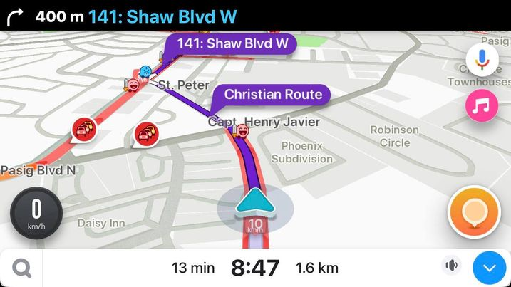](https://www.facebook.com/messenger_media/?attachment_id=1230823020979130&message_id=mid.%24cAABa8wrhSTmL6XqEiGFuDTshb2en&thread_id=100000521194097)](https://www.facebook.com/messenger_media/?attachment_id=1230823020979130&message_id=mid.%24cAABa8wrhSTmL6XqEiGFuDTshb2en&thread_id=100000521194097)

Enter

**Fernando**



Why are u there? Sino kasama mo?

Enter

**You sent**

10am meeting with UL owner, Clinton Campos

Enter

You sent

Wait, did you think i was in one of the motels with someone?!? Haha

Enter

**Fernando replied to you**

Original message:

Wait, did you think i was in one of the motels with someone?!? Haha



Hahahahaha

Enter

**Fernando replied to you**

Original message:

10am meeting with UL owner, Clinton Campos

So is it interview pa rin?

Enter

Fernando

Is Jun aware at all?

Enter

Fernando

Paano na team mo na bunuo mo jan?

Enter

Fernando



Am sure they will be sad

Enter

**You sent**

Chat lang. At this level naman, there is no such thing as interview na. Also, I know Clint for 15years in VMV board, so this is chika lang talaga

Enter

**You replied to Fernando**

Original message:

Is Jun aware at all?

Not yet, will only let him know if i decide to leave. No sense rocking the boat now if i won’t leave naman pala

Enter

**Fernando replied to you**

Original message:

Chat lang. At this level naman, there is no such thing as interview na. …



So its a discussion about u joining them?

Enter

**You sent**

Yup

Enter

**Fernando replied to you**

Original message:

Not yet, will only let him know if i decide to leave. No sense rocking t…

Fair enough

Enter

Fernando



Ung mga undr sa iyo.. lalo na ung taga vmv dati na sinundan ka. Will u bring hin later din with u?

Enter

**You replied to Fernando**

Original message:

Am sure they will be sad

Maybe. But interestingly enough, 2 have opened up to me and actually said na parang hindi ako bagay sa Tao culture. Like, i can do so much more what i do today and the peeps there don’t acknowledge my level of knowledge and skills.

Enter

You sent

Di ba i had a Christmas Greeting video that Got played in airports and seaports? Nakita ni Jun sa Dumaguete AirPort yun. Naku, nagka selosan pa sa management team, bakit ako daw napili ng Island Living, etc hahaha kaloka sila

Enter

**Fernando replied to you**

Original message:

Maybe. But interestingly enough, 2 have opened up to me and actually sai…



How would they know that? Did yiu get to share your sentiments sa kanila? Are they in meetings seeing it first hand?

Enter

**You replied to Fernando**

Original message:

How would they know that? Did yiu get to share your sentiments sa kanila…

They attended the weekly Commercial meetings with me. I try to Expose them with me kasi. They observed it

😮

Enter

**Fernando replied to you**

Original message:

Di ba i had a Christmas Greeting video that Got played in airports and s…



Isnt he proud to learn about it? Would he prefer that u run it by him before agreeing sa interview?

Enter

**You sent**

Jun was proud. It was the people in the Commercial team, his Tao Execom na mga babae

❤️

Enter

You sent

Remember B players are threatened by A players. A players Love A players because they get better too

😠

Enter

You sent

Unfortunately, Jun has B players around him at Tao Corp level

👍

Enter

Jan 16, 2023, 12:01 PM

**You sent**

**Audio call**

12:01 PM

Enter

You sent

**Audio call**

12:05 PM

Enter

**You sent**

Asus, cannot be reached ka

Enter

**Fernando**

Naglunch

Enter

Fernando



Shoukd i call now?

Enter

**You sent**

Bakit ‘should’ naman

Enter

You sent

Just wanted to chat about what happened

Enter

**Fernando**



Baka may kausap ka na

Enter

**You sent**

Am in the car alone naman

Enter

Jan 16, 2023, 12:51 PM

**Fernando**



**Audio Call**

24 mins

Enter

**You sent**

**Audio Call**

11 secs

Enter

Jan 16, 2023, 3:29 PM

**You sent**

Hala oi, di mo na ako tinawagan pala. Anyhoo

Enter

**Fernando**



Later.. i removed my HR director.. need magbawas pa ng tao

Enter

Jan 16, 2023, 4:33 PM

**You sent**

Awww 😥

Enter

**Fernando**



Hayyyyy. The things i have to do....

Enter

**You sent**

**Hugs**

Enter

**Fernando**

Umiyak sa harap ko

Enter

Fernando



Breadwinner. Pastor asawa

Enter

**You sent**

awww, man, THAT IS hard

Enter

**Fernando**

Marami payables

Enter

Fernando



Outstanding loans dami

Enter

**You sent**

Can you give her a little bit of palugit? Instead of 30 days, like 60 or 90 days so she can find a new job?

Enter

**Fernando**

Nope

Enter

Fernando



Her monthly salary is 173k

Enter

**You sent**

Holy moly - that is the salary of an HR DIrector lang??

Enter

You sent

Man, I am paid so low

Enter

You sent

Hahahaha

Enter

You sent

But I can understand the shock of this to her finances then...

Enter

**Fernando replied to you**

Original message:

Holy moly - that is the salary of an HR DIrector lang??



It shouldnt for this small org Inabutan ko na ganun na

Enter

**Fernando replied to you**

Original message:

Man, I am paid so low



Two things Nataas ang bibigay dito ng di dapat Abd she is not a director level talent

Enter

Jan 16, 2023, 5:25 PM

**You sent**

Yikes! Baka nadala lang sa tenure

Enter

You sent

Hire mo ko, your 2nd in Command haha

Enter

**Fernando replied to you**

Original message:

Yikes! Baka nadala lang sa tenure



Hindi rin

Enter

**Fernando replied to you**

Original message:

Hire mo ko, your 2nd in Command haha

Di kita kaya vayaran

Enter

Fernando



Bayaran

Enter

**You sent**

Btw, may rule na pala ngayon na if economic zone companies will sell to local market, they tax at 40% as a pass through?

Enter

You sent

Was going to order Savonille Labels and boxes from Image Labels sana: 32 product SKUs yun

Enter

**Fernando**

Merin na naman tax un from the start

Enter

Fernando

Nagbago lang rate

Enter

Fernando



Pero meron na iyan dati

Enter

**You sent**

But Kiran told me this and therefore his quote was not competitive

Enter

**Fernando**



Meron din na ceiling iyan 30% max of your sales pwede mo benta local

Enter

**You sent**

Anyway, sayang, di ko nabigay Project kanya

Jan 17, 2023, 10:08 PM

**You sent**

❤️

Enter

Jan 19, 2023, 3:15 PM

**Fernando**



Do u think pwede mo.maarrange magtour kaminunilab whse sa mamplasan?

Enter

Jan 19, 2023, 4:18 PM

**You sent**

Hahaha wala pa nga ako sa loob eh

Enter

You sent

Try ko when i am inside na

Enter

Jan 19, 2023, 5:17 PM

**Fernando**

Nakausap mo na jun?

Enter

Fernando



Sino ba nagpaapprove kay ujilab dati nung nag tour tayo dun?

Enter

Jan 19, 2023, 6:14 PM

**You sent**

Ako rin pero siyempre, because they were our partners in vmv then. Also, vmv signed on as client of FPDI

Enter

**Fernando**



Fpdi?

Enter

**You sent**

Are you intending ba to use them as your logistical partner? Or you just want to go for learning purposes?

Enter

**Fernando replied to you**

Original message:

Are you intending ba to use them as your logistical partner? Or you just…



The latter

Enter

**You sent**

First Pioneer Distributors Inc is the name of UL owned warehouse in Mamplasan

Enter

**You sent**

Yeah, i don’t think they open their warehouse to people they don’t know or have business with. You know what I mean? If I request it for myself, am sure they would accommodate even for learning purposes. But if I ask for someone else they dont know and no official business with them, baka hindi. Lalo na that I am still an outsider now.

Enter

**Fernando**



Kapag nasa loob ka na lang

Enter

**You sent**

Yup, no worries. Soon. UL will email me by Monday their offer

Enter

You sent

Btw, just had a tough discussion with Diego about relationships and how to treat a woman properly. The good thing: he was very honest with me on what is going on between him and his girlfriend. But boy, hirap to avoid being judgemental and preachy

Enter

You sent

**[Y no se diga más 🤝](https://www.facebook.com/RodrigoChandiaStaJuana/posts/pfbid029UZ9Xjg3D5VxgNdUS4dPLQHBpxKKjLwhiUgDVJXpKd5aQJX7gdrBdNMdnYHf9mEjl" \t "_blank)**

[Concejal Rodrigo Chandia Ramírez](https://www.facebook.com/RodrigoChandiaStaJuana/posts/pfbid029UZ9Xjg3D5VxgNdUS4dPLQHBpxKKjLwhiUgDVJXpKd5aQJX7gdrBdNMdnYHf9mEjl" \t "_blank)

Enter

Jan 20, 2023, 7:34 AM

**Fernando forwarded an image**



[[](https://www.facebook.com/messenger_media/?attachment_id=5804263739627648&message_id=mid.%24cAABa8wrhSTmL_ac6aGFzGHAqO5VQ&thread_id=100000521194097)](https://www.facebook.com/messenger_media/?attachment_id=5804263739627648&message_id=mid.%24cAABa8wrhSTmL_ac6aGFzGHAqO5VQ&thread_id=100000521194097)

Enter

**You sent**

Andoy?!

Enter

**Fernando**



Yes.. why di mo nakilala?

Enter

**You sent**

I did. I guess I was surprised that he has much resemblance with Diego. Uh oh 😆

Enter

You sent

That reminds me, wala me regalo kanya last Christmas!

😆

Enter

**Fernando replied to you**

Original message:

I did. I guess I was surprised that he has much resemblance with Diego. Uh oh 😆



Pati sa ugali... Parehong hilig nila old music

Enter

**Fernando replied to you**

Original message:

I did. I guess I was surprised that he has much resemblance with Diego. Uh oh 😆



Napansin ko rin iyon nung naglalaro kami basketball diego

Enter

**Fernando replied to you**

Original message:

That reminds me, wala me regalo kanya last Christmas!



Its ok

Enter

Jan 20, 2023, 8:22 AM

**You replied to Fernando**

Original message:

Napansin ko rin iyon nung naglalaro kami basketball diego

Haha patay tayo nyan

Enter

**Fernando**

PaDNA mo

Enter

Fernando



Hahahahah

Enter

**You sent**

Ayoko, let sleeping dogs lie 🤪

😆

Enter

**Fernando**



Loka As if naman...

Enter

**You sent**

Well…

Enter

Jan 20, 2023, 11:59 AM

**Fernando**



[[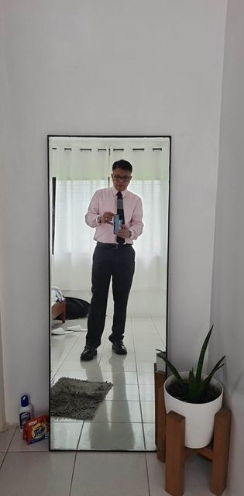](https://www.facebook.com/messenger_media/?attachment_id=709620060719670&message_id=mid.%24cAABa8wrhSTmL_pogsWFzVSo-CrYU&thread_id=100000521194097)](https://www.facebook.com/messenger_media/?attachment_id=709620060719670&message_id=mid.%24cAABa8wrhSTmL_pogsWFzVSo-CrYU&thread_id=100000521194097)

Enter

**You sent**

Anong ganap? Are you in a hotel or something?

Enter

Jan 20, 2023, 12:33 PM

**Fernando**



Kasal. Magninong. Tagaytay

Enter

Jan 20, 2023, 12:57 PM

**You sent**

Awww ganyan talag pag matanda na hahahaha

😆

Enter

😆

Jan 25, 2023, 3:01 PM

**You sent**

Ugh... what is it about men and sex... is it because we are old na? no more inhibitions kapag nag express ng interest?

Enter

You sent

Ganoon na ba ang new ligaw lines? Sigh

Enter

Jan 25, 2023, 3:24 PM

**Fernando replied to you**

Original message:

Ugh... what is it about men and sex... is it because we are old na? no m…



Who is this?

Enter

**You sent**

A friend from way back who is separated too and medyo nagpaparamdam ng interest. So may friendship naman there but still, awkward

Enter

You sent

He remembers my long legs daw and imagining massage and all

Enter

You sent

You know in the movies, it seems easy to play along sa mga ganyan. Pero hindi pala easy sa real Life hahaha

Enter

**Fernando**



Wala ako sagot

Enter

**Fernando replied to you**

Original message:

Ugh... what is it about men and sex... is it because we are old na? no m…

Do not generalize I can say it differently din "Whats with anna and sex?" Kasi sa iba gusto frank and upfront.. bakit sa anna traditional pa knowing we are adults and mature na

Enter

Fernando



I can also try to argue differently

Enter

**You sent**

Ah well. Lagay ko sa dating site "looking for cerebrally engaging partner with loving tender care" hahaha

❤️

Enter

**Fernando**



Simplehan mo na lang Looking for ding poe clone

Enter

**You sent**

Nyahahaha assuming o!

Enter

Jan 26, 2023, 12:17 PM

**Fernando**



[[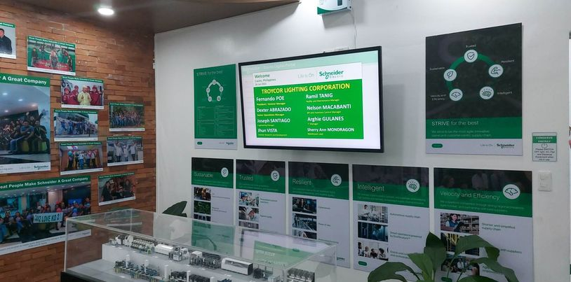](https://www.facebook.com/messenger_media/?attachment_id=1226166658294221&message_id=mid.%24cAABa8wrhSTmMHZD4CmF7EuuD15Fz&thread_id=100000521194097)](https://www.facebook.com/messenger_media/?attachment_id=1226166658294221&message_id=mid.%24cAABa8wrhSTmMHZD4CmF7EuuD15Fz&thread_id=100000521194097)

Enter

Jan 26, 2023, 4:43 PM

**You sent**

Oh you are in Schneider all the way to Cavite?!

👍

Enter

**Fernando**



With my mngr team from clark

Enter

**You sent**

Why man?

Enter

You sent

Tapos balikan kayo nyan to Clark?

Enter

**Fernando**



Sila babalik Magwfh na ako bukas

Enter

**Fernando replied to you**

Original message:

Why man?

Benchmarking

Enter

Fernando

Best practice

Enter

Fernando



Copy paste

Enter

**You sent**

Cool!

Enter

**Fernando**



Enter

Jan 26, 2023, 6:58 PM

**You sent**

**Audio call**

6:58 PM

Enter

You sent

Call me!!!!!

Enter

You sent

Have news 😊

Enter

**Fernando**



**Missed audio call**

7:05 PM

Enter

**You sent**

**Audio call**

7:06 PM

Enter

Jan 26, 2023, 9:15 PM

**You sent**

Ay pala, I tried to lok for the VitaFusion Melatonin gummy bears, couldn't find here. Nakalimuta ko to check in Singapore and Japan. Anyway, I started buying Sleepasil na. It is also Melatonin but in capsule form . Same naman na 3mg Melatonin. Try mo kung hiyang ka. Available in normal Mercury Drug stores

👍

Enter

Jan 27, 2023, 9:13 AM

**You sent**

Call? Wanted to vet something urgent

Enter

**Fernando**

**Audio Call**

43 secs

Enter

Fernando



**Video chat**

17 secs

Enter

**You sent**

**Audio Call**

3 mins

Enter

**Fernando**



Nasa st lukes kami gladys for chk up

Enter

**You sent**

Oh why? You guys ok?

Enter

**Fernando**



We're ok

Enter

Jan 27, 2023, 10:11 AM

**You sent**

Jun asked me to go to the Rockwell office na and we meet at 11.30am. I think he didn’t want to wait for Sunday kasi. Please pray 🙏🏼🙏🏼🙏🏼🙏🏼🙏🏼

👍

Enter

Jan 27, 2023, 10:32 AM

**Fernando**





Enter

Jan 27, 2023, 10:59 AM

**You sent**

Sana hindi siya magalit at magwala dito sa Rockwell office. He has the tendency to do so pa naman 😆

Enter

Jan 27, 2023, 12:04 PM

**Fernando**



Text me after.

Enter

**You sent**

It went really well!!!!!!

Enter

**You sent**

At first his face was irritated and shock. He thought it was about Warren and our home situation. But when I brought up the idea for UL to buy Savonille, his face changed and loved the idea. He said that if I leave, he will close down OPTIMITY. He opened the company for me because he believed in me. He would rather focus on his passion, which is food. He wa every gracious in the end and even congratulated me.

Enter

**You sent**

Phew!

Enter

**You sent**

I clarified on the car and I said yes na!!

Enter

You sent

[[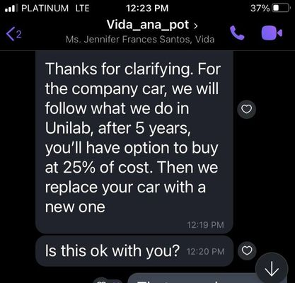](https://www.facebook.com/messenger_media/?attachment_id=579024853737958&message_id=mid.%24cAABa8wrhSTmMIr2OgGF8XhEB-y3e&thread_id=100000521194097)](https://www.facebook.com/messenger_media/?attachment_id=579024853737958&message_id=mid.%24cAABa8wrhSTmMIr2OgGF8XhEB-y3e&thread_id=100000521194097)

Enter

Jan 27, 2023, 12:48 PM

**Fernando**

Papajiram ko sa akin? Hahaha

Enter

Fernando



So jun will sell and UL will buy savonille?

Enter

Jan 27, 2023, 1:10 PM

**You replied to Fernando**

Original message:

So jun will sell and UL will buy savonille?

I won’t advise UL to buy the company, just the brand. Full acquisition

Enter

**You sent**

You unsent a message

Enter

**You sent**

You unsent a message

Enter

**You sent**

You unsent a message

Enter

Jan 29, 2023, 10:56 AM

**You sent**

You know, suddenly,, I miss our intellectual discourse of anything under the sun 😊

Enter

**Fernando**



Ano ung dinelete mo.messages kahapon

Enter

**Fernando replied to you**

Original message:

You know, suddenly,, I miss our intellectual discourse of anything under the sun 😊



Yeah..me too

Enter

**You sent**

Oh messages for Edna dapat yun. She was asking where I was working kasi nagyaya mag drinks sa Barcino eastwood. Kaya Sabi ko ‘zoom from home’ and thumbs up

Enter

**Fernando replied to you**

Original message:

You know, suddenly,, I miss our intellectual discourse of anything under the sun 😊



Ano samples in the past na pinag didiskuyunan natin?

Enter

**You sent**

Kaya pala Sabi niya sa akin , “Ano na, di ka sumagot” sa iyo ko pala napadala 😆

Enter

**Fernando replied to you**

Original message:

Oh messages for Edna dapat yun. She was asking where I was working kasi …



Ahhh..un ba un? Akala ko kasi mesaage mo rin akin na may kausap ka na kaya nagstop na ako magmessage

Enter

**You replied to Fernando**

Original message:

Ano samples in the past na pinag didiskuyunan natin?

From politics to news to food to new places to parenting to hobbies . Kahit ano-ano man yun hehe

👍

Enter

Jan 29, 2023, 11:32 AM

**Fernando replied to you**

Original message:

From politics to news to food to new places to parenting to hobbies . Ka…

Alam na ba UL na ok na si jun?

Enter

Fernando

Kailan ka magsimula UL?

Enter

Fernando



And kapag binili brand u will also hire your current team?

Enter

**You sent**

Discussions will start next week. To be honest, I don't want to take everyone from my current team. There are a couple who are not really performers kasi. We'll see

👍

Enter

Jan 31, 2023, 7:07 PM

**You sent**

You know lately, I have been avoiding bikini type of panties. I use na the Daisy Dukes or booty shorts and loving it! Kasi no elastic is rubbing against my singit

Enter

**Fernando**



Patingin?

Enter

**You sent**

Ayaw ko nga, kita no taba ko hehe

Enter

**Fernando**

Patingin

Enter

Fernando

Magkwento ka tapos di mo.papakita

😆

Enter

Fernando

Kailan ka magstart sa kabila

Enter

Fernando



Pano pagpurchase ng savonille?

Enter

Jan 31, 2023, 7:55 PM

**You sent**

March 1 start. Just submitted the company and brand profile of Savonille. Jun and I will sit down on the financials on Thursday and if no edits, send to UL

👍

Enter

Jan 31, 2023, 9:07 PM

**You sent**

Am craving a really good steak but can’t afford Wolfgang

Enter

**Fernando replied to you**

Original message:

Am craving a really good steak but can’t afford Wolfgang



Di bale once with UL kaya mo na iyan

Enter

**You sent**

I miss Ikinari Steak, yummy but cheap. Makapunta nga ng MOA

👍

Enter

**You replied to Fernando**

Original message:

Di bale once with UL kaya mo na iyan

Did you know that UL had unwritten rules about dining out and being seen in public?

Enter

You sent

It is ‘highly encouraged’ to be properly dressed when going out and eating only in ‘refined’ places. When dining in fast food, drive through is suggested and not to be seen inside. Social media kept to minimum and develop a ‘self-branding’ 😆😆😆

Enter

You sent

Kaya sabi ng mga ibang UL execs, mas nakakatipid din kasi hindi lagi kain sa labas. Luto na lang and eat at home. Or delivery/drive through.

Enter

**Fernando replied to you**

Original message:

It is ‘highly encouraged’ to be properly dressed when going out and eati…

Omg!!!

Enter

Fernando



Why would they have that protocol? Image and branding pa rin?

Enter

**You replied to Fernando**

Original message:

Why would they have that protocol? Image and branding pa rin?

Yep! And oh, encouraged to network and social drinking but not to be caught drunk in public

😢

Enter

**You sent**

Unwritten rules lang siya… nasabihan nga ako na I was seen eating with the boys sa Ramen Cool. It is a casual dining na Japanese. Pot (Clinton’s chief of staff) told me, ‘don’t eat there na, there are better Japanese restaurants in the area.’ I remembered pa na I was just in maong shorts and blouse at that time 😆

Enter

**Fernando replied to you**

Original message:

Unwritten rules lang siya… nasabihan nga ako na I was seen eating with t…

I will be terminated there

Enter

Fernando

I want to be incognito when i am myself

Enter

Fernando

Di na ako.makakakin sa dampa macapagal?

Enter

Fernando

Di na ako.peede magshorts?

Enter

Fernando



I xant do that

Enter

**You replied to Fernando**

Original message:

Di na ako.makakakin sa dampa macapagal?

Di Pwede

Enter

**Fernando**



I cant be not me

Enter

**You replied to Fernando**

Original message:

Di na ako.peede magshorts?

Pwede naman kasi maporma ka naman Kahit nakashorts. Ako kasi, parang mamamalengke lang hitsura

Enter

You sent

Now I understand why my brother and sister are also very careful sa looks nila and where they go, or when they are tagged in social media

Enter

**Fernando replied to you**

Original message:

Pwede naman kasi maporma ka naman Kahit nakashorts. Ako kasi, parang mam…



I was discriminated several times when we dine out. Order ako steak and was told the price 2x by waitress and her manager... twice in heritage hotel!!

Enter

**You sent**

Eh ako youngest, walang pakialam

Enter

**Fernando**

Wala din ako pakialam.

Enter

Fernando

I go in flipflops

Enter

Fernando



Di na pwede.mamalengke sa talipapa??? Ohmy!!! Cant do!!!

Enter

**You replied to Fernando**

Original message:

I was discriminated several times when we dine out. Order ako steak and…

Huwat?!?!?!? Sampalin mo ng Benjamins mo!!

Enter

**Fernando replied to you**

Original message:

Huwat?!?!?!? Sampalin mo ng Benjamins mo!!

Wala amo benjamins

Enter

Fernando



Hahaha

Enter

**You replied to Fernando**

Original message:

Di na pwede.mamalengke sa talipapa??? Ohmy!!! Cant do!!!

Hindi na kasi may maids who can do that for you

👍

Enter

You sent

Maiba ako, how much is the current monthly rate ng drivers?

Enter

**Fernando**

Wala na sa akin si danny

Enter

Fernando



Daily na lang when he drives me

Enter

**You sent**

[[](https://l.facebook.com/l.php?u=https%3A%2F%2Fwww.esquiremag.ph%2Fculture%2Fsex%2Faverage-penis-length-a1974-20191103-src-esquire%3Futm_source%3DFacebook-EsquireMoney%26utm_medium%3DSiteshare%26utm_campaign%3D20230131-fbnp-culture-average-penis-length-a1974-20191103-src-esquire-fbold%26fbclid%3DIwAR3lqcQTDaKgmPHRSIjpvtZSvf42vmkm66J-cTj-tSfxi_1E4yKJPVqwstw&h=AT3AAfaWfdJ1RTzx7Bj11NnJ4wXDyMCZSDiWWkIt9u-aaKpbkuBLX8DTnjEgKj_Hi4JUkAyWOrJkyZoSuO_Ed3g1TEmg086-FtsN3zPu5NfQBWxrUTbCyYO66vnZffRfiScWkyFY_OeI)](https://l.facebook.com/l.php?u=https%3A%2F%2Fwww.esquiremag.ph%2Fculture%2Fsex%2Faverage-penis-length-a1974-20191103-src-esquire%3Futm_source%3DFacebook-EsquireMoney%26utm_medium%3DSiteshare%26utm_campaign%3D20230131-fbnp-culture-average-penis-length-a1974-20191103-src-esquire-fbold%26fbclid%3DIwAR3lqcQTDaKgmPHRSIjpvtZSvf42vmkm66J-cTj-tSfxi_1E4yKJPVqwstw&h=AT3AAfaWfdJ1RTzx7Bj11NnJ4wXDyMCZSDiWWkIt9u-aaKpbkuBLX8DTnjEgKj_Hi4JUkAyWOrJkyZoSuO_Ed3g1TEmg086-FtsN3zPu5NfQBWxrUTbCyYO66vnZffRfiScWkyFY_OeI" \t "_blank)

**[15,000 Penis Measurements Later, We Have an Average Size](https://l.facebook.com/l.php?u=https%3A%2F%2Fwww.esquiremag.ph%2Fculture%2Fsex%2Faverage-penis-length-a1974-20191103-src-esquire%3Futm_source%3DFacebook-EsquireMoney%26utm_medium%3DSiteshare%26utm_campaign%3D20230131-fbnp-culture-average-penis-length-a1974-20191103-src-esquire-fbold%26fbclid%3DIwAR3lqcQTDaKgmPHRSIjpvtZSvf42vmkm66J-cTj-tSfxi_1E4yKJPVqwstw&h=AT3AAfaWfdJ1RTzx7Bj11NnJ4wXDyMCZSDiWWkIt9u-aaKpbkuBLX8DTnjEgKj_Hi4JUkAyWOrJkyZoSuO_Ed3g1TEmg086-FtsN3zPu5NfQBWxrUTbCyYO66vnZffRfiScWkyFY_OeI" \t "_blank)**

Enter

**You replied to Fernando**

Original message:

Daily na lang when he drives me

Yeah you told me. But if I were to hire a driver, how much na kaya nowadays?

Enter

You sent

When I had one back in 2016-2017, parang P14k na bayad ko nun. Siguro ang mahal na ngayon 😭

Enter

**Fernando**



DNny was 16k sa akin wala pa sss philhealth ans pagibig kasi ako nagbabayad nun for him

😢

Enter

**You sent**

Kasi kapag nakapasa si diego sa Ateneo and he has regular basketball weekday practices na, di ko na kaya maging soccer/sports mom

Enter

You sent

50 na ako this year, kapuy na

Enter

Jan 31, 2023, 9:56 PM

**Fernando**

**Video chat**

1 sec

Enter

Fernando



Sorry

Enter

**You sent**

You calling?

Enter

**Fernando**



Npindot

Enter

**You sent**

Haha

Enter

Feb 1, 2023, 5:06 PM

**Fernando**

6'6" na ba diego?

Enter

Fernando



Kala ko 6'0"?

Enter

**You sent**

Ano ka ba, 6’5” na siya last year. Kulang lang sa muscular mass. Kailangan mag mature yung body

👍

Enter

Feb 1, 2023, 6:57 PM

**You sent**

I saw that! Ang galing di ba. Parang aso lang nalumalangoy. Yung side fins nya akin to wagging of tail

Enter

Feb 1, 2023, 9:32 PM

**You sent**

Did you just post in your stories a GCash payment of P1,500 to someone?

Enter

You sent

[[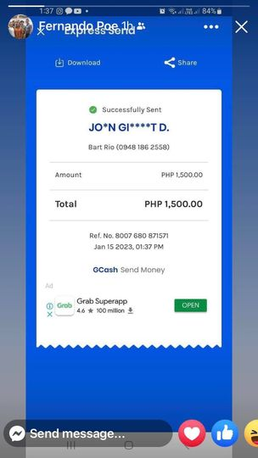](https://www.facebook.com/messenger_media/?attachment_id=484206433912484&message_id=mid.%24cAABa8wrhSTmMPnMgr2GDS3PG9AqM&thread_id=100000521194097)](https://www.facebook.com/messenger_media/?attachment_id=484206433912484&message_id=mid.%24cAABa8wrhSTmMPnMgr2GDS3PG9AqM&thread_id=100000521194097)

Enter

You sent

Ano yun?

Enter

**Fernando**

Di ko alam

Enter

Fernando



Tagal na niyan

Enter

**You sent**

Ngek, it is showing as your FB stories now. Baka accidentally mo upload. No one told you about seeing it

Enter

You sent

?

Enter

**Fernando**



Dineleteko na

👍

Enter

**You sent**

So this is how tall diego is versus me

Enter

You sent

[[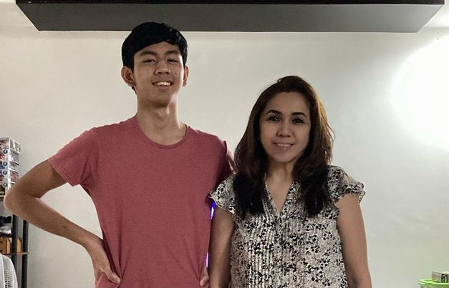](https://www.facebook.com/messenger_media/?attachment_id=1263226897598029&message_id=mid.%24cAABa8wrhSTmMPn2pwGGDThcPsk4m&thread_id=100000521194097)](https://www.facebook.com/messenger_media/?attachment_id=1263226897598029&message_id=mid.%24cAABa8wrhSTmMPn2pwGGDThcPsk4m&thread_id=100000521194097)

❤️

Enter

You sent

Eh 5’8-5’10” ako

👍

Enter

Feb 2, 2023, 12:20 PM

**You sent**

So - Edna and I were chatting. Through TAO and Savonille, I was able to prove that with P10M, I can make something as big as that work. I say 'big', meaning come up with a brand and make it work at retail level. We finished the year with 71 stores. Although the company was still on negative on Year 1, Year 2 will actually be positive based on my projections. So let's say, with additional capital infusion of P5M, it should reach at a level where it is consistently cash neutral and grow to profitability towards the end of Year 2.

Enter

**You sent**

Our plan was I will work with UL, save as much. Sell Papa's lands and get our share. Then when I retire at 65, we start our own company. I will manage it but she, I and a 3rd partner will infuse. Why a 3rd partner, so that it isn't just family. At equity level, there is a neutral person. Would you be interested?

Enter

**You sent**

When I am 65, how old are you then?

Enter

You sent



Enter

Feb 2, 2023, 1:13 PM

**Fernando replied to you**

Original message:

When I am 65, how old are you then?



Ilang taon ka na ba ngayn?

Enter

**You sent**

49

Enter

You sent

I have 16 years to make ipon from UL

Enter

**Fernando replied to you**

Original message:

When I am 65, how old are you then?

73...

Enter

Fernando



Why

Enter

**Fernando replied to you**

Original message:

Our plan was I will work with UL, save as much. Sell Papa's lands and ge…

Why should u start then

Enter

Fernando

Why not now

Enter

Fernando



Sell the propeety now

Enter

**You sent**

Edna and I were planning:

1 business on personal care, skin care that I will manage. Distribution business model. Food : restaurant... we will come up with the concept around that time depends on what is relevant, what trends are, etc

Enter

**Fernando**



By 65 u should be enjoying life and not thinking about opening new buainess

Enter

**You sent**

Oh I am not going to stop working

Enter

**Fernando replied to you**

Original message:

Our plan was I will work with UL, save as much. Sell Papa's lands and ge…



Why too late??? Do it earlier

Enter

**Fernando replied to you**

Original message:

Oh I am not going to stop working



Who says stop working??

Enter

**You sent**

So work muna with UL until 65 and then new business (parang retirement) after I retire

Enter

**Fernando**

I wont and i cant

Enter

Fernando



But to start at 65? Hello?? Di ka spring chicken nun

Enter

**You replied to Fernando**

Original message:

Why too late??? Do it earlier

Maybe 60yo

Enter

**You replied to Fernando**

Original message:

But to start at 65? Hello?? Di ka spring chicken nun

By then, hawak ko na yung lahat ng connections ko, hinog na rin

Enter

**Fernando replied to you**

Original message:

By then, hawak ko na yung lahat ng connections ko, hinog na rin



Ngayn nga nagawa mo na sa savonille

Enter

**You sent**

we want to do business when the kids are done with school and I have sorted out my marital status, etc

Enter

**Fernando**



Why wait 11 or 16 years feim now

Enter

**You sent**

don't want warren to have a dip in the jar today

Enter

**Fernando replied to you**

Original message:

we want to do business when the kids are done with school and I have sor…



Dont wait for things to be perfect before making the move

Enter

**You sent**

legal separation takes 5 years

Enter

**You replied to Fernando**

Original message:

Dont wait for things to be perfect before making the move

No, it is his legal ability to dip his hands in the jar

Enter

**Fernando**



Pwede mo naman ipangalan sa dalawang bata iyan

Enter

**You sent**

when I create that company with Edna, he will conjugally own what i own

Enter

**Fernando**



Iyan na pamana mo sa kanila

Enter

**You replied to Fernando**

Original message:

Iyan na pamana mo sa kanila

May technicalities din yun. We don't want to put our children's names and they don't actually run it. It has to be professionally and correctly done. Not your nego-negosyo style

Enter

**Fernando replied to you**

Original message:

when I create that company with Edna, he will conjugally own what i own



As i said dont own it with edna. Owners should ve edna and the kids

Enter

**You sent**

Not the chinese style... we want to do correctly

Enter

You sent

I cannot nga make the kids owners with board positions and they aren't really functioning as board

Enter

You sent

That is so hokey

Enter

**Fernando replied to you**

Original message:

May technicalities din yun. We don't want to put our children's names an…



5 years from now gian and diego will be what age?

Enter

**Fernando replied to you**

Original message:

Not the chinese style... we want to do correctly



How much inheritance tax?

Enter

**You sent**

30%

Enter

You sent

We will pass on the shares if they are able to actually work and operate the compnay

Enter

**Fernando**



Nabawasan pa iiwan mo sa mga bata?

Enter

**You sent**

In the meantime, they will find work and make mistakes in other people's businesses

Enter

**Fernando**

Work on the legal separation now

Enter

Fernando

In 2 years time taoos na iyan

Enter

Fernando



Whats holding u up from filing annulment?

Enter

**You replied to Fernando**

Original message:

Nabawasan pa iiwan mo sa mga bata?

No nga, they will eventually earn shares so we avoid the inheritance tax. That will be on the family consitution

Enter

You sent

Annulment or separation - they all costs so much and takes at least 5 years

Enter

You sent

my dad's took 10 years

Enter

**Fernando replied to you**

Original message:

Annulment or separation - they all costs so much and takes at least 5 years



2 years lang 2 ko kasama sa apc

Enter

**Fernando replied to you**

Original message:

my dad's took 10 years



Panahon pa tatay mo un

Enter

**You replied to Fernando**

Original message:

2 years lang 2 ko kasama sa apc

if both parties are cooperative. eh ang warren, he wants to make it hard on me

Enter

You sent

he expressed that clearly

Enter

**You replied to Fernando**

Original message:

Panahon pa tatay mo un

Also, complicated kay Papa kasi Catholic wedding so it needed the church's approval or something. Eh hindi kami catholic, so it should be faster.

Enter

You sent

Anyway. - just floating the idea to you! Kasi we were thinking of a tri-party company. And I brought up your name and Edna likes the idea of you in it

Enter

**Fernando**

Ok ako sa idea

Enter

Fernando



[[](https://www.facebook.com/reel/5820100468079311?fs=e&s=m)](https://www.facebook.com/reel/5820100468079311?fs=e&s=m" \t "_blank)

**[Reel by josh A official](https://www.facebook.com/reel/5820100468079311?fs=e&s=m" \t "_blank)**

[Facebook](https://www.facebook.com/reel/5820100468079311?fs=e&s=m" \t "_blank)

Enter

Feb 2, 2023, 3:10 PM

**You sent**

Yeah yeah, no use for me hahaha

Enter

Feb 2, 2023, 7:35 PM

**You sent**

One of my goals paglipat sa UL is to have tummy tuck. Hindi limiliit tiyan ko eh Kahit sobrang exercise na

Enter

**Fernando replied to you**

Original message:

One of my goals paglipat sa UL is to have tummy tuck. Hindi limiliit tiy…



Hmmmmm

Enter

**You sent**

I lost pounds na from 164 to 150 but my tummy is still big… although I need to have ultrasound kasi Baka my lumps in uterus is back pala

Enter

**Fernando**



Panay papaganda ah

Enter

**You sent**

Well, that. Plus, I want to fit in my clothes from 2015-2016!

😮

Enter

You sent

That was when I was always ‘out’. Sayang the clothes eh. Dami ko Nang pinamigay sa ssli. Si janice nga, is wearing my marks & spender blouse na. Si Jef is wearing old navy from diego

👍

Enter

You sent

Meilyn also got one of my marks & sparks. Need to save in a way but need to spend to tummy tuck!!

😆

Enter

You sent



Enter

Feb 3, 2023, 9:26 PM

**You sent**

[[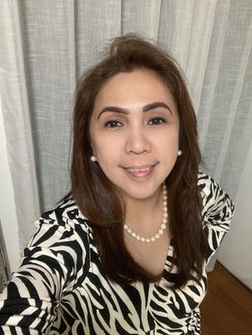](https://www.facebook.com/messenger_media/?attachment_id=568861628467087&message_id=mid.%24cAABa8wrhSTmMSLo0amGF3TgqfThi&thread_id=100000521194097)](https://www.facebook.com/messenger_media/?attachment_id=568861628467087&message_id=mid.%24cAABa8wrhSTmMSLo0amGF3TgqfThi&thread_id=100000521194097)

❤️

Enter

You sent

Just arrived home from a dinner with savonille reseller. Night and have a good weekend, sugar daddy! 😆

😆

Enter

Feb 4, 2023, 10:30 AM

**You sent**

So - am asked by UL to visit a Toyota branch this weekend to pick na the specs of the Cross I want. Checking online, parang puro automatic lang 😭paano kaya ako mag-aral ng automatic driving na hindi mahal 🤔

Enter

**Fernando**

No need mag aral

Enter

Fernando

If u know manual, u should be able to drive matic right from casa

Enter

Fernando

The reverse will be a problem

Enter

Fernando

Puro ka lang gas

Enter

Fernando

Your left foot will have nothing to do with matic

Enter

Fernando



Gas and brake lang aapakan right foot mo... no more shifter to worry about

Enter

Feb 4, 2023, 10:55 AM

**You sent**

Huwag naman ko mabangga ang bagong kotse when i drive it

Enter

**Fernando replied to you**

Original message:

Huwag naman ko mabangga ang bagong kotse when i drive it



You wont

Enter

**You sent**

Sanay ako mag timpla ng clutch and brake kasi

Enter

You sent

Kainis

Enter

**Fernando**



It should ve so easy to transition for u

Enter

**You sent**

Ok ok kaya ko yan

Enter

**Fernando replied to you**

Original message:

Sanay ako mag timpla ng clutch and brake kasi



Once u go matic, ayaw mo na magmanual in heavy traffic

Enter

**You sent**

Am so used to manual kasi. College palang, driving na ako kaya para na akong taxi driver mag drive pag manual. Anyhoo… gotta learn something new

Enter

**Fernando replied to you**

Original message:

Am so used to manual kasi. College palang, driving na ako kaya para na a…

When mo.makuha car?

Enter

Fernando



Nagkikita pa ba kayo warren?

Enter

**You sent**

I Go to the dealer today and order. Then i will know when.

Enter

**You replied to Fernando**

Original message:

Nagkikita pa ba kayo warren?

Not since Dec 22. Nagalit ako sa kanya kasi i am being Nice na in letting him into the house and visit the boys. I told the boys pa to celebrate early Christmas with him on Dec 22, they went out.

Enter

You sent

Then I notice we were missing keys sa gate and sa bike ni Diego. I asked him if he took it. Nagalit, bakit ko daw siya suspected. Sabi ko, How can i not suspect him when he takes things from the house without asking me.

Enter

**Fernando replied to you**

Original message:

I Go to the dealer today and order. Then i will know when.



Ano kulay?

Enter

**You sent**

Then he rambles on How i do not respect and submit to him as my husband. How i am full of pride in not forgiving him and getting back with him. Very looooong messages. I just decided i just cant tolerate that anymore. So i cut him off in comms and said he couldnt come to the house anymore. If he wants to see the boys, they go out. Silence since then

Enter

**You replied to Fernando**

Original message:

Ano kulay?

White. I always choose either White or silver para kita agad sa road. My dad always advised that sa amin mga daughters niya. Para mas safe daw

👍

Enter

**Fernando replied to you**

Original message:

Then I notice we were missing keys sa gate and sa bike ni Diego. I asked…



So nasan na keys?

Enter

**You replied to Fernando**

Original message:

So nasan na keys?

I dont know. I just changed locks. I even told him that i knew about the GPS he placed under the Toyota before. He didnt comment. Crazy

Enter

You sent

Why ask about Warren out of the Blue?

Enter

**Fernando replied to you**

Original message:

I dont know. I just changed locks. I even told him that i knew about the…



I was about to tell you to change the locks.. good job

Enter

**Fernando replied to you**

Original message:

Why ask about Warren out of the Blue?



Wala naman. Natatakot lang ako for u and the boys na baka bukas magkatabi na kayo uli sa bed.. 🙁

Enter

**You sent**

Hi naku. I feel bad that everytime i think or talk about him, it just doesnt spark Joy anymore.

👍

Enter

**You replied to Fernando**

Original message:

Wala naman. Natatakot lang ako for u and the boys na baka bukas magkata…

Actually yun din fear nila. We were praying together once and Diego asked me that if allowing Warren in the house means we are trying to get back together. Sabi ko not at all. Then they felt relief. I asked why , they would really rather not. They are Happy the way we are. Awww

❤️

Enter

You sent

And hey, Gian drives around the Village na! Using the crosswind. He delivers his orders by driving the car para sabay practice

❤️

Enter

You sent

Got to shower na. Balikan ko na sa basketball practice si Diego and Gian needs to Go LBC to deliver one of his Gundam orders. Just finished working out when i messaged you

👍

Enter

**Fernando replied to you**

Original message:

Got to shower na. Balikan ko na sa basketball practice si Diego and Gian…

Sama ako shower

Enter

Fernando



Hahahah

Enter

**You sent**

Hahaha

Enter

Feb 4, 2023, 11:50 AM

**You sent**

And Oh - guess who my 3pm coffee date is. Jun Lao, owner ng D&L 😊

Enter

You sent

These are the times when i wish you and i were married, and you’d accompany me during meet ups with friends in the business industry. Warren used to love it, lalo na pag embassies

Enter

Feb 4, 2023, 12:45 PM

**Fernando replied to you**

Original message:

And Oh - guess who my 3pm coffee date is. Jun Lao, owner ng D&L 😊



Why

Enter

**Fernando replied to you**

Original message:

These are the times when i wish you and i were married, and you’d accomp…

Ayaw ko niyan to be honest

Enter

Fernando

I just want to be home and do personal stuff

Enter

Fernando

My weekdays are already work related

Enter

Fernando

I just want personal stuff

Enter

Fernando



I want to bw with my birds

Enter

**Fernando replied to you**

Original message:

And Oh - guess who my 3pm coffee date is. Jun Lao, owner ng D&L 😊



Why kayo meet?

Enter

Feb 4, 2023, 1:16 PM

**You replied to Fernando**

Original message:

Why kayo meet?

Catch up lang

Enter

**Fernando**



Ok

Enter

**You replied to Fernando**

Original message:

I just want to be home and do personal stuff

Hindi naman ito all the time. I think because you are away from your kids on weekdays kaya you feel that way. But i actually like the idea that i have my own Life outside the kids para i am not in their hair all the time. Lalo na now that my boys are older, i let them have space

Enter

**Fernando**



Oh yeah for sure.. tama naman iyan

Enter

Feb 4, 2023, 2:28 PM

**Fernando**



[[](https://www.facebook.com/reel/579227214057585?fs=e&s=m)](https://www.facebook.com/reel/579227214057585?fs=e&s=m" \t "_blank)

**[Reel by Ren-Ren Pitogo Manlimos](https://www.facebook.com/reel/579227214057585?fs=e&s=m" \t "_blank)**

[Facebook](https://www.facebook.com/reel/579227214057585?fs=e&s=m" \t "_blank)

Enter

**You sent**

What the… 😆

Enter

Feb 4, 2023, 3:43 PM

**Fernando**



Kaya mo iyan?

Enter

Feb 4, 2023, 4:38 PM

**You sent**

Hahaha dito pa ako with Jun Lao

👍

Enter

Feb 4, 2023, 5:57 PM

**You sent**

Enter

**You sent**

Phew! Just finished with Jun Lao. Walang ending na kwentuhan 😆😆😆

Enter

You sent

And he is interested to hire Gian for one of his new businesses as a sales field person! Gian will be interviewed by his HR next week. They are hiring mode now.

Enter

You sent

Who knew our conversation will get there.

Enter

**Fernando**

Pwede ba ako apply

Enter

Fernando



Hahahah

Enter

**You sent**

Ang mahal mo kasi!

Enter

You sent

But he did say, sayang that I signed na with UL. He would have wanted to get me as partner of his sucession plan

Enter

**Fernando replied to you**

Original message:

Ang mahal mo kasi!



Hahahaha

Enter

**Fernando replied to you**

Original message:

But he did say, sayang that I signed na with UL. He would have wanted to…



Wow!!

Enter

**You sent**

He is 57yo na pala.

Enter

Feb 4, 2023, 6:35 PM

**Fernando**



Same as me

Enter

Feb 4, 2023, 6:52 PM

**You sent**

Very nice guy. If it weren’t because it was 6pm na, tuloy tuloy the kwentuhan. Am humbled that a guy like him of his stature and wealth would bother having coffee time with me. Parang si Clinton din, nagulat ako when he made beso-beso with me. Mga hindi ko naman ka-level but the relationship is there.

😠

Enter

**You sent**

Ah and Edna ran into UL’s VP for Consumer during a Robinsons party. She doesnt know him but he (Baci) knows me, when Edna told him that she is my sister and How excited she is that i am joining Clint’s new venture, he was quick to say that they are excited nga with my joining the UL Family. Sana I will do well there, pressure!!!!

Enter

**Fernando replied to you**

Original message:

Ah and Edna ran into UL’s VP for Consumer during a Robinsons party. She …



Ikawpa ba? You always EXCEL!! Minsan a woman of few WORDs... and always on the POWERPOINT!! I always take a NOTEPAD of you!!

Enter

Feb 4, 2023, 7:34 PM

**You sent**

Hahaha and awww. I appreciate the encouragement. My new challenge nga lang is driving an automatic car 😆

👍

Enter

Feb 5, 2023, 7:20 AM

**Fernando forwarded a video**



Enter

Feb 5, 2023, 8:54 AM

**You sent**

Uy by the way, naisip ko. You want to do factory Tour sa bagong planta ni Jun Lao? P13B worth. 26 hectares. Ang laki and very impressive! He showed me on his phone yesterday.

Enter

You sent

I can ask him if he can give me a tour then sama kita with maybe 1 or 2 peoole from your team? Tanauan Batangas

Enter

**Fernando replied to you**

Original message:

I can ask him if he can give me a tour then sama kita with maybe 1 or 2 …

Kailan?

Enter

Fernando



Kahit ako lang muna?

Enter

Feb 5, 2023, 9:28 AM

**You sent**

Sige. Will ask him. I suppose Fridays are best for you so that you dont have to Go back to Clark for the week and straight home ka na?

👍

Enter

**You sent**

Ok will ask him. He doesnt have to accompany us naman, pwede tao na niya. Baka maya pa yun sasagot. We were chatting earlier but i know he drives his fancy cars to the bondoks of Tanay every Sunday morning

👍

Enter

Feb 5, 2023, 1:19 PM

**You sent**

Parang mas nice ang Toyota Veloz than Cross. 1.5 lang siya than Cross’ 1.8 pero mas malaking headroom. Mas kasya mga boys. Also, can sit up 3 rows of people. 3rd row can be converted to to luggage space, malaki.

👍

Enter

Feb 5, 2023, 1:36 PM

**Fernando**



Ano desisyon mo?

Enter

**You sent**

Veloz na siguro. The Innova, magandang resale value but is a van! I dont want to look like a a soccer Mom naman

👍

Enter

Feb 5, 2023, 3:41 PM

**You sent**

[[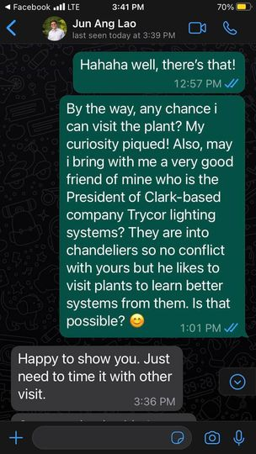](https://www.facebook.com/messenger_media/?attachment_id=1324673374777773&message_id=mid.%24cAABa8wrhSTmMUcsY7GGIIXHI3Pgm&thread_id=100000521194097)](https://www.facebook.com/messenger_media/?attachment_id=1324673374777773&message_id=mid.%24cAABa8wrhSTmMUcsY7GGIIXHI3Pgm&thread_id=100000521194097)

Enter

You sent

[[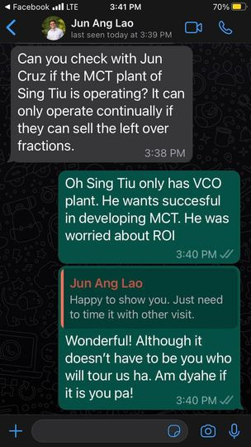](https://www.facebook.com/messenger_media/?attachment_id=3646870138926923&message_id=mid.%24cAABa8wrhSTmMUcsis2GIIXLCRnR7&thread_id=100000521194097)](https://www.facebook.com/messenger_media/?attachment_id=3646870138926923&message_id=mid.%24cAABa8wrhSTmMUcsis2GIIXLCRnR7&thread_id=100000521194097)

Enter

Feb 5, 2023, 4:35 PM

**Fernando**

Sana nga siya

Enter

Fernando

I maybe able to share with him some thouggts how to make his plant better

Enter

Fernando



Ung team ko need makakita iba planta so they learn more

Enter

Feb 5, 2023, 5:04 PM

**You sent**

He said siya daw

❤️

Enter

Feb 6, 2023, 12:58 PM

**Fernando**



**Audio Call**

1 min

Enter

Feb 7, 2023, 6:54 AM

**You sent**

[[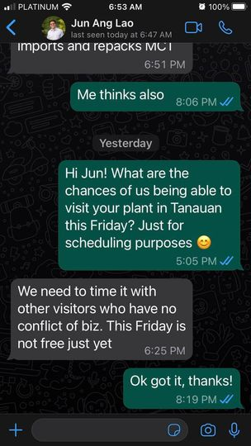](https://www.facebook.com/messenger_media/?attachment_id=553318676819263&message_id=mid.%24cAABa8wrhSTmMWjTv-GGKO-d-dV1N&thread_id=100000521194097)](https://www.facebook.com/messenger_media/?attachment_id=553318676819263&message_id=mid.%24cAABa8wrhSTmMWjTv-GGKO-d-dV1N&thread_id=100000521194097)

👍

Enter

Feb 7, 2023, 8:51 PM

**You sent**

It is full moon! It is full moon!

👍

Enter

**Fernando**



Feb 7, 2023, 10:01 PM

**You sent**

hehe ang galing

Enter

Feb 8, 2023, 8:22 AM

**Fernando**



[[](https://www.facebook.com/reel/911135646706599?fs=e&s=m)](https://www.facebook.com/reel/911135646706599?fs=e&s=m" \t "_blank)

**[Reel by Jolly Ann Capangpangan](https://www.facebook.com/reel/911135646706599?fs=e&s=m" \t "_blank)**

[Facebook](https://www.facebook.com/reel/911135646706599?fs=e&s=m" \t "_blank)

Enter

**You sent**

Haha parang totoo ah

Enter

**Fernando**

Totoo nga

Enter

Fernando



Siya ang talagang voice over

Enter

**You sent**

Ano ka ba

Enter

You sent

Magka ibang voice signatures yun

Enter

You sent

Ni lip sync nya lang yan

Enter

**Fernando**

Hindi nga

Enter

Fernando



Siya iyan

Enter

Feb 8, 2023, 8:59 AM

**You sent**

Nyahaha

Enter

**Fernando**

Nagmesaage diego. I think you two think na college na lianne. Senior high pa lang siya sa ust

Enter

Fernando



I asked diego kung ok un. Di pa siya reply

Enter

**You sent**

Ah he has a survey he needs to do for a subject in School. Dapat College respondents. Sabi ko kanya message niya ikaw, thinking na College na lianne

Enter

**Fernando**



Nagreply na akompero di pa siya sumagot

Enter

Feb 8, 2023, 10:06 AM

**You sent**

Nasa class siguro

👍

Enter

Feb 8, 2023, 1:00 PM

**Fernando**



[[](https://www.facebook.com/reel/904385624024560?fs=e&s=m)](https://www.facebook.com/reel/904385624024560?fs=e&s=m" \t "_blank)

**[Reel by Randel De Oro Braganza](https://www.facebook.com/reel/904385624024560?fs=e&s=m" \t "_blank)**

[Facebook](https://www.facebook.com/reel/904385624024560?fs=e&s=m" \t "_blank)

Enter

Feb 8, 2023, 6:27 PM

**You sent**

so gross on many levels haha

😆

Enter

Feb 8, 2023, 7:42 PM

**You sent**

What happened, bakit si Bamboo ang profile pic mo?

😆

Enter

Feb 8, 2023, 8:26 PM

**You sent**

[[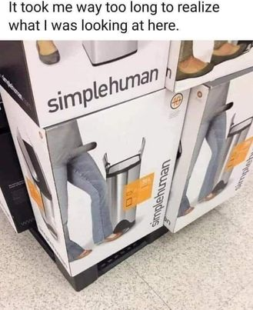](https://www.facebook.com/messenger_media/?attachment_id=874968653573318&message_id=mid.%24cAABa8wrhSTmMYkMeW2GMP3VFRNep&thread_id=100000521194097)](https://www.facebook.com/messenger_media/?attachment_id=874968653573318&message_id=mid.%24cAABa8wrhSTmMYkMeW2GMP3VFRNep&thread_id=100000521194097)

Enter

**Fernando**



Anoniyan!!! Hahahha

Enter

**You sent**

haha look at the photo closer

Enter

**Fernando**



I know.. but what is it

Enter

**You sent**

If you look at the photo closer nga, the 'dong' is actually the box cut out where you hold the box when you carry it. Unfortunately, the marketing or packaging developer didn't double check that before finally executing the box design 😆

😆

Enter

You sent

The product really is just a step open trashcan so it has the legs of a woman beside it trying to step it open

😆

Enter

Feb 9, 2023, 2:57 AM

**Fernando**



[[](https://www.facebook.com/reel/631810172083762?fs=e&s=m)](https://www.facebook.com/reel/631810172083762?fs=e&s=m" \t "_blank)

**[Reel by Gie-bhoy Oliveros Laylay II](https://www.facebook.com/reel/631810172083762?fs=e&s=m" \t "_blank)**

[Facebook](https://www.facebook.com/reel/631810172083762?fs=e&s=m" \t "_blank)

Enter

**Fernando**



[https://youtube.com/watch?v=AZlLE\_\_Qxqc&feature=share](https://l.facebook.com/l.php?u=https%3A%2F%2Fyoutube.com%2Fwatch%3Fv%3DAZlLE__Qxqc%26feature%3Dshare%26fbclid%3DIwAR3wSm8Lf2TaxtZJfBlYIwqEksD4V6kAONG3OSTdF1kCtI96-Nt2VoS80C0&h=AT1H3EIM8EvG1FYz0a7xA8YNstlxN04gpadTZy16q4beaJ8nVkdRC7qJlm7nIHwua6XVtQzqdghVxlQe0kwjsyctbY1BUUwN9Uvof2c4DiOmAR8pIUMGx-_ulIJLwYstEQozZTEq)

[[](https://l.facebook.com/l.php?u=https%3A%2F%2Fyoutube.com%2Fwatch%3Fv%3DAZlLE__Qxqc%26feature%3Dshare%26fbclid%3DIwAR2cH9L7Lc4BhzuweoEn98EQ0s6GPPdFv3lN8YGqdnrSaIvPHaVaavwvWf8&h=AT3bwCF7MDfuVckpMqImrmN55fWVlLdYsNup-8r3VgYmXDvXsLRcsTC4G7MPRlPf16P2NT5bCu61nnYJYW0zJcyZ77hhieaF7Qz_MkNOlZLRdBu5BGMAkKZvQOFPgwxUayxMUdHXr72p)](https://l.facebook.com/l.php?u=https%3A%2F%2Fyoutube.com%2Fwatch%3Fv%3DAZlLE__Qxqc%26feature%3Dshare%26fbclid%3DIwAR2cH9L7Lc4BhzuweoEn98EQ0s6GPPdFv3lN8YGqdnrSaIvPHaVaavwvWf8&h=AT3bwCF7MDfuVckpMqImrmN55fWVlLdYsNup-8r3VgYmXDvXsLRcsTC4G7MPRlPf16P2NT5bCu61nnYJYW0zJcyZ77hhieaF7Qz_MkNOlZLRdBu5BGMAkKZvQOFPgwxUayxMUdHXr72p" \t "_blank)

**[David Armand - Careless Whisper (Interpretative Dance)](https://l.facebook.com/l.php?u=https%3A%2F%2Fyoutube.com%2Fwatch%3Fv%3DAZlLE__Qxqc%26feature%3Dshare%26fbclid%3DIwAR2cH9L7Lc4BhzuweoEn98EQ0s6GPPdFv3lN8YGqdnrSaIvPHaVaavwvWf8&h=AT3bwCF7MDfuVckpMqImrmN55fWVlLdYsNup-8r3VgYmXDvXsLRcsTC4G7MPRlPf16P2NT5bCu61nnYJYW0zJcyZ77hhieaF7Qz_MkNOlZLRdBu5BGMAkKZvQOFPgwxUayxMUdHXr72p" \t "_blank)**

Enter

Feb 9, 2023, 7:04 AM

**You replied to Fernando**

Original message:

https://youtube.com/watch?v=AZlLE\_\_Qxqc&feature=share

Ang galing hehe

Enter

**You sent**

<https://www.facebook.com/100064061563955/posts/552851366860244/?vh=e>

**[The Real Thing 1976](https://www.facebook.com/sixtiesseventiesrevenge/posts/pfbid02jwRnSQE8ztTYEpYwDX3KcQSczgWySP35EYFv4xTwYbGaNtVMtpjacptLuc61T3Pvl" \t "_blank)**

[The Sixties & Seventies Revenge](https://www.facebook.com/sixtiesseventiesrevenge/posts/pfbid02jwRnSQE8ztTYEpYwDX3KcQSczgWySP35EYFv4xTwYbGaNtVMtpjacptLuc61T3Pvl" \t "_blank)

Enter

Feb 9, 2023, 7:37 AM

**You sent**

Been feeling very uneady since last night. Not sure if because Jun has been pressuring me to sell Savonille to UL or because Valentine’s is around the corner or because of my biological clock. Mag field work na lang ako haha!

Enter

**You sent**

<https://www.facebook.com/788348771557632/posts/2430853023973857/?vh=e>

**[Clingy Cat Never Wants To Leave Shiba Inu Dogs Side](https://www.facebook.com/WoofWoofTV/posts/pfbid0U1qdXfLHD33PBHjuZkNb4tgPKqRUog7ANt7qZitKawCAuF17sG9MJoDAjLJRAWhxl" \t "_blank)**

[Woof Woof](https://www.facebook.com/WoofWoofTV/posts/pfbid0U1qdXfLHD33PBHjuZkNb4tgPKqRUog7ANt7qZitKawCAuF17sG9MJoDAjLJRAWhxl" \t "_blank)

Enter

**You sent**

You unsent a message

Enter

**You sent**

We all have that one clingy best friend. Ako ba yun? Hahahha sugar daddy!

😆

Enter

Feb 9, 2023, 9:38 AM

**Fernando replied to you**

Original message:

Been feeling very uneady since last night. Not sure if because Jun has b…



What feeling?

Enter

Feb 9, 2023, 9:55 AM

**You sent**

Uneasy

Enter

**Fernando**

Why

Enter

Fernando

What kind?

Enter

Fernando

Hiw can i help

Enter

Fernando



Whats with valentines?

Enter

**You sent**

I dont know nga why. Nagpalpitations last night and then this morning again

Enter

**Fernando replied to you**

Original message:

I dont know nga why. Nagpalpitations last night and then this morning again



I can understand pressure ni jhun but valentines and bio clock?

Enter

**You replied to Fernando**

Original message:

Whats with valentines?

Eh, the whole romanticism and knowing i got no one you know. Seeing it in FB na. Will take an FB leave fir a few days hehe

😢

Enter

You sent

Bio Clock - hormonal changes that just messes up your system

Enter

**Fernando replied to you**

Original message:

Eh, the whole romanticism and knowing i got no one you know. Seeing it i…



Understand.... youve been there... kaya mo iyan

Enter

**Fernando replied to you**

Original message:

Bio Clock - hormonal changes that just messes up your system



Menopausal period mo?

Enter

**You sent**

But i am excited about the car and Gian’s new job!

❤️

Enter

You sent

Small wins

👍

Enter

**You replied to Fernando**

Original message:

Menopausal period mo?

Haven’t had period for months, i only got it for 2 months last Year

😮

Enter

You sent

Sana matukoy na birthday ko sa sarili ko for hysterectomy this Year

Enter

**Fernando replied to you**

Original message:

Sana matukoy na birthday ko sa sarili ko for hysterectomy this Year



Huh? Didnt understand

Enter

Feb 9, 2023, 10:36 AM

**You sent**

Sana MATULOY hehe. I want to have hysterectomy on my birthday, gift to myself

Enter

**Fernando**

Bakit gusto mo na matanggal?

Enter

Fernando



Need ba iyan o want?

Enter

**You sent**

Both need and want - reproductive cancer is prevalent in our tancongco boood / Family. All my sisters had theirs removed na.

Enter

**Fernando replied to you**

Original message:

Both need and want - reproductive cancer is prevalent in our tancongco b…



Ok

Enter

**You sent**

Besides i dont want to get pregnant anymore. Too old and risky

❤️

Enter

You sent

My new partner, whoever it is, must be ok with that . As if meron hahaha

Enter

**Fernando replied to you**

Original message:

My new partner, whoever it is, must be ok with that . As if meron hahaha

Hahahaha

Enter

Fernando

Kamusta nanliligaw sa iyo?

Enter

Fernando

Sinagot mo na ba?

Enter

Fernando

Alam ba mga bata iyan?

Enter

Fernando



???

Enter

**Fernando**



Di na nagreply

Enter

**You sent**

I dont tell anyone squat, you know that. I never told anyone about you. So unless something is moving significantly or it is safer to share, mum’s the word

Enter

You sent

Boys dont know

Enter

You sent

Wait, paano mo na sense?

Enter

**Fernando**



Nasense na ano?

Enter

**You sent**

Na he is still lurking around haha

Enter

You sent

He was here in January. It was cool 😊

Enter

**Fernando replied to you**

Original message:

He was here in January. It was cool 😊



Cool ka pa jan.... sya ba ung nagsabi legs mo?

Enter

**You sent**

Kapuy lang because he is different timezone so he calls either early in the day or at night . Either too early or am too tired

Enter

**Fernando replied to you**

Original message:

Boys dont know



You should let them know na you are open to that and malaman mo how they feel I suppose they may be shocked .. baka di pa sila ready

Enter

**Fernando replied to you**

Original message:

Kapuy lang because he is different timezone so he calls either early in …



So LDR.....

Enter

**You replied to Fernando**

Original message:

You should let them know na you are open to that and malaman mo how they…

Ano ka ba, they have been bugging me since last Year about seeing someone , they want me to

Enter

**Fernando replied to you**

Original message:

Ano ka ba, they have been bugging me since last Year about seeing someone , they want me to



Ok di ko alam

Enter

**Fernando replied to you**

Original message:

He was here in January. It was cool 😊



Ano nangyari?

Enter

**You replied to Fernando**

Original message:

So LDR.....

Hahaha LDR sounds so hokey. You do know that LDR nowadays doesnt really feel far due to video calls

Enter

You sent

Anyway, dont want to talk about it!

Enter

**Fernando replied to you**

Original message:

Hahaha LDR sounds so hokey. You do know that LDR nowadays doesnt really …



I know...

Enter

**Fernando replied to you**

Original message:

Anyway, dont want to talk about it!



Damot mo... pati ako ayaw mo sabihan... 🙂

Enter

**You sent**

You are weird. You are the only guy friend i have who likes to ask these kinds of questions. Straight ka ba talaga? 😆

Enter

You sent

Are you like that with other female friends, you ask them about their romantic relationships ?! 🤔

Enter

**Fernando replied to you**

Original message:

You are weird. You are the only guy friend i have who likes to ask these…



Pambihira ka! You will ask about that after all these years???

Enter

**Fernando replied to you**

Original message:

Are you like that with other female friends, you ask them about their ro…



Most of the time They share theirs and seek advise and ask opinions Sometimes in our discussion napuphnta dun and i aak

Enter

**You sent**

Ah

Enter

You sent

So basically, the way we chat is how you typically talk to your women friends?

Enter

You sent

How ordinary I am or is this relationship then 🥲

Enter

**Fernando replied to you**

Original message:

So basically, the way we chat is how you typically talk to your women friends?

Bakit biglang pumasok iyong relationship

Enter

Fernando

Wala bang common topics na nadidisicuss ako sa mga kaibigan ko at sa iyo?

Enter

Fernando

Sinabi na na exlusive topics ang mga iyon?

Enter

Fernando



Pls wag mo dagdagan ng context ang kwestyon mo sa sagot ko

Enter

Feb 9, 2023, 2:31 PM

**You sent**

Basta ako lang pwedeng tumawag sa iyo ng sugar daddy ha? ☺️

😆

Enter

Feb 9, 2023, 3:54 PM

**You sent**

Oh! Since you know about people’s relationships, musta na si Gilbert and Jasmin?!?

Enter

**Fernando replied to you**

Original message:

Oh! Since you know about people’s relationships, musta na si Gilbert and Jasmin?!?

Dont know

Enter

Fernando

Palagay mo?

Enter

Fernando



Ikaw lang nagsabi akin niyan?

Enter

Feb 9, 2023, 4:25 PM

**You sent**

I sent Gilbert a message a month ago yata, deadma hehe

Enter

You sent

It was Meilyn then Dina who told me. 2 people so totoo yata

😢

Enter

You sent

Uy may chika ako about Meilyn. She either lost or quit her job. Sabi nag resign pero i doubt because she was sent by SM to Italy. Normally may bond yan na you cannot resign in less than 1 Year. So feeling, she wasnt regularized sa work

😢

Enter

**You sent**

On the other hand, pwede pa ako manganak!

Enter

You sent

[[](https://www.facebook.com/messenger_media/?attachment_id=505391268197900&message_id=mid.%24cAABa8wrhSTmMZpyE1mGNVc13AkY-&thread_id=100000521194097)](https://www.facebook.com/messenger_media/?attachment_id=505391268197900&message_id=mid.%24cAABa8wrhSTmMZpyE1mGNVc13AkY-&thread_id=100000521194097)

Enter

**Fernando**

Surrogate yata iyan

Enter

Fernando



Kasi alam.ko.parang nasa egg bank yata ung kanya

Enter

Feb 9, 2023, 7:11 PM

**You sent**

Oh ok

Enter

Feb 12, 2023, 4:04 PM

**Fernando**



Balita?

Enter

Feb 12, 2023, 5:52 PM

**You sent**

Not much. Well, I went to 2 kiddie parties and that wine crawl in Manila Polo club yesterday. Today was full of errands with the boys.

👍

Enter

You sent

Naiilang ako sa profile pic mo. Bamboo looks like you but you look more pogi naman and hindi alcohol dried yung skin haha

❤️

Enter

**Fernando replied to you**

Original message:

Naiilang ako sa profile pic mo. Bamboo looks like you but you look more …



Hahahahah

Enter

Feb 13, 2023, 12:39 PM

**Fernando**



[[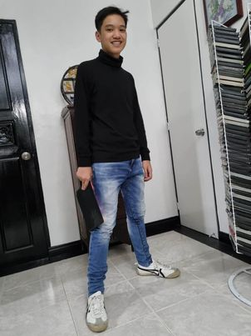](https://www.facebook.com/messenger_media/?attachment_id=564858588997222&message_id=mid.%24cAABa8wrhSTmMelesZmGSRJf8Hm54&thread_id=100000521194097)](https://www.facebook.com/messenger_media/?attachment_id=564858588997222&message_id=mid.%24cAABa8wrhSTmMelesZmGSRJf8Hm54&thread_id=100000521194097)

❤️

Enter

**You sent**

Awww so cool! Pero hindi na niya kamukha si Diego dito 'no?

😆

Enter

You sent

[[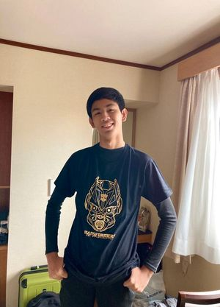](https://www.facebook.com/messenger_media/?attachment_id=920350385989428&message_id=mid.%24cAABa8wrhSTmMelqt5mGSRVdvR_IY&thread_id=100000521194097)](https://www.facebook.com/messenger_media/?attachment_id=920350385989428&message_id=mid.%24cAABa8wrhSTmMelqt5mGSRVdvR_IY&thread_id=100000521194097)

👍

Enter

Feb 13, 2023, 5:03 PM

**You sent**

Gian took the personality test for his D&L job soon. He is ENFJ! Ganda ng profile and career options

Enter

You sent

To understand more your personality - read this [https://www.truity.com/personality-type/ENFJ/careers](https://l.facebook.com/l.php?u=https%3A%2F%2Fwww.truity.com%2Fpersonality-type%2FENFJ%2Fcareers%3Ffbclid%3DIwAR2ApEwhyP9HaYVk0kMo3ZXVhYx5SVRa7OjC1tmz4HW8EZHQ7I5fukgkV88&h=AT1H3EIM8EvG1FYz0a7xA8YNstlxN04gpadTZy16q4beaJ8nVkdRC7qJlm7nIHwua6XVtQzqdghVxlQe0kwjsyctbY1BUUwN9Uvof2c4DiOmAR8pIUMGx-_ulIJLwYstEQozZTEq)

[[](https://l.facebook.com/l.php?u=https%3A%2F%2Fwww.truity.com%2Fpersonality-type%2FENFJ%2Fcareers%3Ffbclid%3DIwAR3RH_Eh6IBnFB5yQq-gh1iw4GFck7PMQdGRRQAkiG6sGE94MhrhIF6ZI5Y&h=AT2K1NAQMbTCE5v2gR8iHmdiJ6dAn0wsntphYmo0g_f5ue-kFuj_1k0srbls9AQuMv7_Uf8U2R4vd7Mrd-aXpkXH21_vpBwq-66fvHke0mtLo_sdqWd6waK4v_2urhE_8J18bJI-QUqn)](https://l.facebook.com/l.php?u=https%3A%2F%2Fwww.truity.com%2Fpersonality-type%2FENFJ%2Fcareers%3Ffbclid%3DIwAR3RH_Eh6IBnFB5yQq-gh1iw4GFck7PMQdGRRQAkiG6sGE94MhrhIF6ZI5Y&h=AT2K1NAQMbTCE5v2gR8iHmdiJ6dAn0wsntphYmo0g_f5ue-kFuj_1k0srbls9AQuMv7_Uf8U2R4vd7Mrd-aXpkXH21_vpBwq-66fvHke0mtLo_sdqWd6waK4v_2urhE_8J18bJI-QUqn" \t "_blank)

**[The Best Careers for ENFJ Personality Types](https://l.facebook.com/l.php?u=https%3A%2F%2Fwww.truity.com%2Fpersonality-type%2FENFJ%2Fcareers%3Ffbclid%3DIwAR3RH_Eh6IBnFB5yQq-gh1iw4GFck7PMQdGRRQAkiG6sGE94MhrhIF6ZI5Y&h=AT2K1NAQMbTCE5v2gR8iHmdiJ6dAn0wsntphYmo0g_f5ue-kFuj_1k0srbls9AQuMv7_Uf8U2R4vd7Mrd-aXpkXH21_vpBwq-66fvHke0mtLo_sdqWd6waK4v_2urhE_8J18bJI-QUqn" \t "_blank)**

Enter

You sent

Magkalapit personality namin. Ako ENTJ naman. Feeler/intuitive si Gian while I am a thinker.

Enter

Feb 13, 2023, 5:42 PM

**Fernando**

Si diego? Logical.... visual....

Enter

Fernando



Hahahaha

Enter

**You sent**

Actually.., sige nga pa take ko si Diego

Enter

**Fernando replied to you**

Original message:

Actually.., sige nga pa take ko si Diego



Go!!

Enter

Feb 13, 2023, 6:28 PM

**You sent**

Very interesting! So I took the test - I am also an ENFJ like Gian!

👍

Enter

You sent

Diego is ESFJ

Enter

**Fernando replied to you**

Original message:

Diego is ESFJ



Ano naman ito?

Enter

**You sent**

The ESFJ personality type, also known as "The Caregiver" or "The Consul," is one of the 16 personality types identified by the Myers-Briggs Type Indicator (MBTI). People with an ESFJ personality type tend to be outgoing, loyal, organized, and tender-hearted. ESFJs gain energy from interacting with other people. They are typically described as outgoing and gregarious. They have a way of encouraging other people to be their best and often have a hard time believing anything bad about the people they are close to.

Enter

**You sent**

People with an ESFJ personality type tend to: Be sensitive to the needs and feelings of others Derive their value system from external sources, including the community at large, rather than from intrinsic, ethical, and moral guidelines Enjoy helping others Expect their kind and giving ways to be noticed and appreciated by others Get easily hurt by unkindness or indifference Have a need for approval Provide care for others Want to be liked by others ESFJs raised with high values and standards tend to grow up to be generous adults. Conversely, those raised in a less generous environment may not be as naturally in tune with giving to others and be more focused on themselves. ESFJs also have a strong desire to exert control over their environment. They feel in control of the world around them by organizing, planning, and scheduling. Those with an ESFJ personality type are naturally geared toward understanding other people. They are careful observers of others and are adept at supporting and bringing out the best in people. Because they are so good at helping others feel good about themselves, people often feel drawn to ESFJs. Although ESFJs are people pleasers, they are not pushovers.

Enter

**You sent**

[[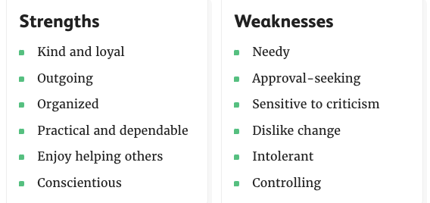](https://www.facebook.com/messenger_media/?attachment_id=612060140761417&message_id=mid.%24cAABa8wrhSTmMe6b--WGSmFMaIjWd&thread_id=100000521194097)](https://www.facebook.com/messenger_media/?attachment_id=612060140761417&message_id=mid.%24cAABa8wrhSTmMe6b--WGSmFMaIjWd&thread_id=100000521194097)

Enter

You sent

Ikaw, what is your personality type kaya

Enter

**Fernando replied to you**

Original message:

People with an ESFJ personality type tend to: Be sensitive to the needs…



I dont remwmber which test i took where pero.parang ito run kay myers briggs at esfj ako talaga

Enter

**You sent**

Oh you and Diego are the same!

Enter

You sent

I can see that in you

Enter

**Fernando replied to you**

Original message:

Oh you and Diego are the same!

Yes

Enter

Fernando



Parang carbon copy

❤️

Enter

Feb 15, 2023, 9:38 AM

**Fernando**



Feb 17, 2023, 5:13 AM

**Fernando**



Feb 17, 2023, 7:03 AM

**You replied to Fernando**

Original message:

*Attachment*

Kaloka 😆

Enter

Feb 17, 2023, 4:47 PM

**You sent**

You unsent a message

Enter

Feb 17, 2023, 5:25 PM

**Fernando**



????

Enter

**Fernando**



????

Enter

**Fernando**



**Missed audio call**

5:40 PM

Enter

Feb 17, 2023, 6:43 PM

**You sent**

I couldnt hear you

Enter

You sent

I was going to ask you something about Welgao and realized, you have been separated from APC long already. Also, my question is really isnt much of a significance 😆

👍

Enter

Feb 17, 2023, 8:03 PM

**Fernando replied to you**

Original message:

I was going to ask you something about Welgao and realized, you have bee…



What about welgao?

Enter

**You sent**

Are you home na or can you take a call?

Enter

You sent

I wanted to consult you on that actually

Enter

Feb 17, 2023, 9:44 PM

**Fernando**



Tomorrow na lang. Am home

Enter

Feb 17, 2023, 10:18 PM

**You sent**

Oks

Enter

Feb 19, 2023, 9:07 AM

**You sent**

You unsent a message

Enter

Feb 19, 2023, 10:13 AM

**You sent**

You unsent a message

Enter

**You sent**

You unsent a message

Enter

**You sent**

You unsent a message

Enter

**You sent**

You unsent a message

Enter

Feb 19, 2023, 10:52 AM

**You sent**

You unsent a message

Enter

**You sent**

You unsent a message

Enter

**You sent**

You unsent a message

Enter

**You sent**

You unsent a message

Enter

**You sent**

You unsent a message

Enter

**You sent**

You unsent a message

Enter

Feb 19, 2023, 3:45 PM

**Fernando**

U really had to delete all of youe messages?

Enter

Fernando

Why do you have to do that? All these years as if i will share and show that to anyone???

Enter

Fernando



Wow!

Enter

**You sent**

I didn't delete it because I didn't trust you. I deleted it because I felt ashamed 😚

Enter

**Fernando**

Why should you?

Enter

Fernando



Whats wrong with that?

Enter

Feb 20, 2023, 12:39 PM

**You sent**

Sorry, had visitors in the house last night that extended until 1am and then had 8am meeting in UL this morning

Enter

You sent

Having read my messages, it just looked like I was throwing myself to you. It sounded desperate which I didn't want it to appear to be. My bad ☺️

Enter

**Fernando**



Nagvevent ka lang naman. Whats wrong with that. Once in a while u do that Di naman ako nagrereklamo. Kanino mo pa ba namn pwede sabihin iyan?

Enter

**You sent**

Exactly, that's what I was just trying to do. But it is tricky because it involves you. So ano ba yun, conflict of interest? haha

😆

Enter

Feb 20, 2023, 11:06 PM

**Fernando replied to you**

Original message:

Hirap lang linisin haha



Actually lahat maganda in erson

Enter

**You sent**

Well, I wouldn't know because I can't see it in person 😔

😆

Enter

You sent

Will you buy that for me?

Enter

You sent



Enter

**Fernando replied to you**

Original message:

Will you buy that for me?

Ako nga di makakuha!

Enter

Fernando



Ung luma namin na item na for disposal, hinuli ng pulis clark ung isa amanager namin na may permit na Ayaw ko.maglabas!! Bawal export zone at tax and duty free

Enter

**You sent**

Imagine if I had that chandelier in my bedroom. It will be a witness to everything that happens in there ...😜

Enter

**Fernando replied to you**

Original message:

Imagine if I had that chandelier in my bedroom. It will be a witness to …



With whom? Hahahahha

Enter

**You sent**

Ganyan ka, making fun out of my being alone 😔

Enter

**Fernando replied to you**

Original message:

Ganyan ka, making fun out of my being alone 😔



Bah malay ko ba if you want it with you long distance guy.... 🙁

Enter

**You sent**

And I guess, you'll never know 🫢

😢

Enter

Feb 21, 2023, 9:03 PM

**You sent**

Omg. I think I know how high blood feels like 😆Gian just drove for me from house to UP. Then around UP. We ate at Rodics. Then he drove from Rodics to home. The whole time, I had to keep my cool as I guided him. I would always tell him to relax and not to scared. When we got home, biglang nagpalpitate ako 😆

😮

Enter

Feb 22, 2023, 12:50 AM

**Fernando**



Ok k na?

Enter

Feb 22, 2023, 7:58 AM

**You sent**

Yup, a few minutes at home, I was able to relax na 😆

❤️

Enter

You sent

Why text so late? Hope you have been getting your 7-9hrs sleep ha

Enter

**Fernando replied to you**

Original message:

Why text so late? Hope you have been getting your 7-9hrs sleep ha



Nope. My sleep is very erratic

😢

Enter

**You sent**

Oh no! Dina is going to the US. Will ask her to buy that melatonin gummies. Bigyan kita pagbalik nya

❤️

Enter

Feb 22, 2023, 11:16 AM

**You sent**

My favorite perfume is back in PH!!!! Been using this since college and it went away. It is here in Look Watsons in MOA! 😍

Enter

You sent

[[](https://www.facebook.com/messenger_media/?attachment_id=1855352184801224&message_id=mid.%24cAABa8wrhSTmMqGUWGmGdx_AvMJ4a&thread_id=100000521194097)](https://www.facebook.com/messenger_media/?attachment_id=1855352184801224&message_id=mid.%24cAABa8wrhSTmMqGUWGmGdx_AvMJ4a&thread_id=100000521194097)

Enter

Feb 22, 2023, 1:02 PM

**Fernando**

Awwwww....

Enter

Fernando



Paamoy momkapag nagkita tayo

Enter

Feb 22, 2023, 1:27 PM

**You sent**

Naku, pag may ganap sa ating dalawa after you smell that on me, not my fault ha 😆

Enter

**Fernando replied to you**

Original message:

Naku, pag may ganap sa ating dalawa after you smell that on me, not my fault ha 😆

Hahahahaha

Enter

Fernando



Magdala na ako rubber? Hahahaha

Enter

Feb 22, 2023, 2:08 PM

**You sent**

Hahaha better be safe than sorry? Haha!

Enter

Feb 22, 2023, 2:28 PM

**Fernando**



Hahahahaha

Enter

Feb 22, 2023, 3:49 PM

**Fernando**



**[q&a muna kayo](https://www.facebook.com/Lorenzo.Benitez159/posts/pfbid02TbA3Yds3y44CgzZ8ffpo3fz4JYFa7iQnogEpbSDHFVJykdv1RSEGqZvwoQ1cwFNAl" \t "_blank)**

[Lorenzo](https://www.facebook.com/Lorenzo.Benitez159/posts/pfbid02TbA3Yds3y44CgzZ8ffpo3fz4JYFa7iQnogEpbSDHFVJykdv1RSEGqZvwoQ1cwFNAl" \t "_blank)

Enter

Feb 22, 2023, 5:06 PM

**You sent**

Tama naman sagot niya ah! 🤪

Enter

**Fernando**



Hahahaha

Enter

Feb 23, 2023, 6:08 PM

**Fernando**



**[EXHIBITION STUFF! 🤩 Persson vs Rosskopf](https://www.facebook.com/WTT/posts/pfbid02FTBszEqohLFQQT9MhyPaNFqCqCYEMft34hyXsAjBoniTdNE94uaRyHF29N2cfnBkl" \t "_blank)**

[World Table Tennis](https://www.facebook.com/WTT/posts/pfbid02FTBszEqohLFQQT9MhyPaNFqCqCYEMft34hyXsAjBoniTdNE94uaRyHF29N2cfnBkl" \t "_blank)

Enter

Feb 23, 2023, 9:33 PM

**You sent**

No work tomorrow! So you get to go home one day earlier ❤️

👍

Enter

You sent

As if naman, 'home' is with me 😆Wala lang, happy lang 😁

😆

Enter

**Fernando replied to you**

Original message:

No work tomorrow! So you get to go home one day earlier ❤️



Not really. Habol kami prodn

Enter

**You sent**

Awww, baka Clark kami Sat-Sun. Gian will drive us going to The Mansion. He wants to try na the highway and the NLEX and SCTEX are quite safe naman.

👍

Enter

You sent

Praying for safety 🙏🙏🙏

❤️

Enter

**Fernando**



Kamusta na ka LDR mo?

Enter

**You sent**

Hala, interrogation o

Enter

**You sent**

Na inggit yata si Diego kay Gian, wants to also learn driving na rin. He is turning 16 na kasi sa May 4. Do we let him?

Enter

**Fernando replied to you**

Original message:

Hala, interrogation o



Ayaw magshare

Enter

**Fernando replied to you**

Original message:

Na inggit yata si Diego kay Gian, wants to also learn driving na rin. He…

Di pwede. I asked the same kay lianne before

Enter

Fernando



Di pwede

Enter

**You sent**

What do you mean? LTO won't let them? I started driving in college ah. They increased the age of driving na ba?

Enter

**Fernando**

Di papayagan mag aral driving school

Enter

Fernando

18 driving

Enter

Fernando



You can ask

Enter

**You sent**

Ah. Well actually I started on my junior year so around that time nga, 18

Enter

You sent

Ok, will tell him

Enter

Feb 24, 2023, 2:37 AM

**Fernando replied to you**

Original message:

Hala, interrogation o



Wala pa rin sagot

Enter

**You sent**

Why are you awake at this hour??

😢

Enter

You sent

Why ba are you asking. It is of no importance naman to you 😃

👍

Enter

Feb 24, 2023, 2:55 AM

**Fernando**

Bkit k ri n gsing

Enter

Fernando



Di mktylog ako

Enter

Feb 24, 2023, 8:28 AM

**You sent**

Nag Netflix binge. Hope nakabawi ka rin ng tulog. Delikado yan that you aren’t able to sleep regularly sell. Work ka na now?

Enter

Feb 24, 2023, 8:45 AM

**Fernando replied to you**

Original message:

Nag Netflix binge. Hope nakabawi ka rin ng tulog. Delikado yan that you …



Yes po

😢

Enter

**You sent**

Di bale, one more day tiis then malakauwi ka na

👍

Enter

**You sent**

Dapat pala pinapagod ka sa gabi para makatulog ka. Samahan kita hehe

Enter

**Fernando**

Mapapagod mo ba ako?

Enter

Fernando

Alam ko ikaw sumusuko datinah

Enter

Fernando

Hahahah

Enter

Fernando

"Wait wait i cant breathe i cant breathe!"

Enter

Fernando

Hahaha

Enter

Fernando



At tandaan mo ung libro na dapat gagawin mo 15 years ago na yata eh di mo pa nagagawa!!!!

Enter

**You sent**

Hahaha aba malay mo, mag malakas na staying power ko ngayon

😆

Enter

You sent

It has been like 15years na ah! 😜

Enter

**Fernando replied to you**

Original message:

It has been like 15years na ah! 😜



Do tou remember the book na promise mo gagawin kapag...... hahahaha

Enter

Feb 24, 2023, 9:57 AM

**You sent**

Hahaha bitin pa yung data eh

Enter

**Fernando**



Bitin ka pa? Hello???

Enter

**You sent**

Hahaha need more data points!

Enter

**Fernando replied to you**

Original message:

Hahaha need more data points!



Hayyyyyy

Enter

Feb 24, 2023, 11:18 AM

**You sent**

That was a long sigh…

Enter

Feb 24, 2023, 11:51 AM

**Fernando**





Enter

Sun 10:57 AM

**You sent**

Ganun na yun

Enter

You sent

Ba

Enter

**Fernando**



I sent to your boys

❤️

Enter

Sun 4:23 PM

**You sent**

Free on Tuesday for visit to D&L in Tanauan?

Enter

You sent

[[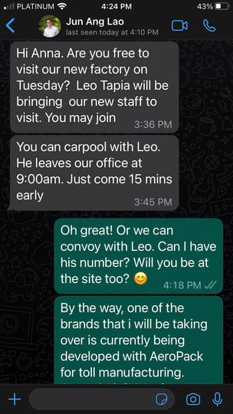](https://www.facebook.com/messenger_media/?attachment_id=1606296409846462&message_id=mid.%24cAABa8wrhSTmMvhhMXmGjNL-XKARZ&thread_id=100000521194097)](https://www.facebook.com/messenger_media/?attachment_id=1606296409846462&message_id=mid.%24cAABa8wrhSTmMvhhMXmGjNL-XKARZ&thread_id=100000521194097)

Enter

**Fernando**

Wow...no....

Enter

Fernando

Pwede ba friday?

Enter

Fernando

Hayyyy

Enter

Fernando



Pano ba ito

Enter

**You sent**

I think they are making it sabay with other people para one group together

Enter

**Fernando**



U going?

Enter

**You sent**

Checking with him if pwede Friday.

Enter

**Fernando**



San ka now

Enter

**You replied to Fernando**

Original message:

U going?

Ano ka ba, am only going because of you. If you can’t, then I won’t go. Aliw lang ako to see but you are the one with the agenda talaga.

❤️

Enter

**You replied to Fernando**

Original message:

San ka now

House

👍

Enter

Sun 4:51 PM

**Fernando**



Whats new?

Enter

**You replied to Fernando**

Original message:

Pwede ba friday?

Di daw pwede Friday. Di ka talaga pwede Tuesday?

Enter

**Fernando**



**Video chat**

5 mins

Enter

Sun 10:10 PM

**You sent**

Someone is in love…

Enter

You sent

[[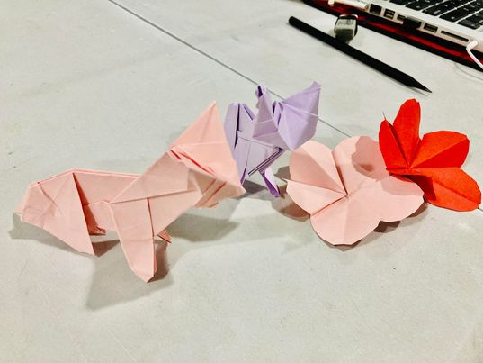](https://www.facebook.com/messenger_media/?attachment_id=893035721844306&message_id=mid.%24cAABa8wrhSTmMv1S_z2Gjg9ugYl80&thread_id=100000521194097)](https://www.facebook.com/messenger_media/?attachment_id=893035721844306&message_id=mid.%24cAABa8wrhSTmMv1S_z2Gjg9ugYl80&thread_id=100000521194097)

Enter

You sent

[[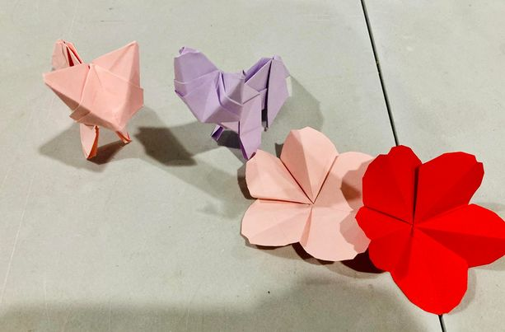](https://www.facebook.com/messenger_media/?attachment_id=961420201961771&message_id=mid.%24cAABa8wrhSTmMv1TI8mGjg9ynog4Q&thread_id=100000521194097)](https://www.facebook.com/messenger_media/?attachment_id=961420201961771&message_id=mid.%24cAABa8wrhSTmMv1TI8mGjg9ynog4Q&thread_id=100000521194097)

Enter

**Fernando**



???

Enter

**You sent**

He has been making origami for his girlfriend ~> Diego

👍

Enter

Mon 7:23 AM

**You sent**

[[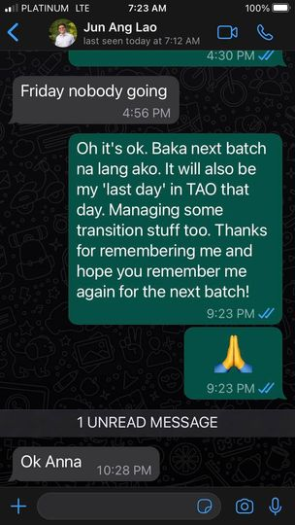](https://www.facebook.com/messenger_media/?attachment_id=709383074258108&message_id=mid.%24cAABa8wrhSTmMwU-R6WGkApDwdyfZ&thread_id=100000521194097)](https://www.facebook.com/messenger_media/?attachment_id=709383074258108&message_id=mid.%24cAABa8wrhSTmMwU-R6WGkApDwdyfZ&thread_id=100000521194097)

👍

Enter

Mon 2:04 PM

You sent

Guess who was my morning date

Enter

You sent

[[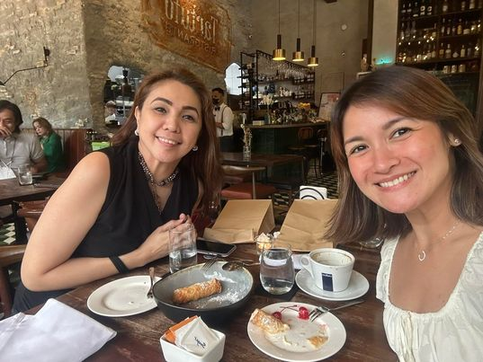](https://www.facebook.com/messenger_media/?attachment_id=1228310351133098&message_id=mid.%24cAABa8wrhSTmMwsqAWmGkYU26W1pE&thread_id=100000521194097)](https://www.facebook.com/messenger_media/?attachment_id=1228310351133098&message_id=mid.%24cAABa8wrhSTmMwsqAWmGkYU26W1pE&thread_id=100000521194097)

Enter

You sent

[[](https://www.facebook.com/messenger_media/?attachment_id=2201696060017182&message_id=mid.%24cAABa8wrhSTmMwsqIg2GkYU-O39bL&thread_id=100000521194097)](https://www.facebook.com/messenger_media/?attachment_id=2201696060017182&message_id=mid.%24cAABa8wrhSTmMwsqIg2GkYU-O39bL&thread_id=100000521194097)

❤️

Enter

You sent

We meet 1x a month as accountability partners. Such a blessing to me ❤️

Enter

**Fernando replied to you**

Original message:

We meet 1x a month as accountability partners. Such a blessing to me ❤️



Why????

Enter

**You sent**

We share our struggles and victories. Then we pray for each other. Nakakatuwa yan, galing din sa toxic relationship yan with the first husband. But the husband died for cancer, that is why, she was able to remarry. Daming miracles din sa buhay nyan.

Enter

**Fernando**



From cancer....

Enter

**Fernando replied to you**

Original message:

We share our struggles and victories. Then we pray for each other. Nakak…



Ikaw din dami.miracles...

Enter

**You sent**

But we never post in social media or share to people about our accountability partnership. It is something that both she and I treasure as 'private'

👍

Enter

**You replied to Fernando**

Original message:

Ikaw din dami.miracles...

Exactly... God has been Good kahit minsan we make really bad mistakes

Enter

**Fernando replied to you**

Original message:

Exactly... God has been Good kahit minsan we make really bad mistakes



Ako ba eh milagro din sa buhay mo? O curse? Hahahahaha

Enter

**You sent**

Hahaha haven’t decided which category 😆

😆

Enter

You sent

Of course, in many ways, a blessing!!! 💗

😆

Enter

Mon 8:13 PM

**You sent**

Ngeh. Don’t know how to read and interpret that haha

Enter

You sent

Summary please hehe

Enter

**Fernando**



Claveria birds are mine

Enter

**You sent**

Wow!!! Puro no1!

Enter

**Fernando**



Yup

Enter

**You sent**

Ano prize sa ganyan? May bolato ba ako dyan, sugar daddy? 🥰

😆

Enter

**Fernando**



2 more laps to go

Enter

**You sent**

The birds naman are happy when they do that, right?

👍

Enter

Tue 8:49 AM

**You sent**

So, Gian will be selling his Say Cheese during the Bannister Family Day in Eastside Heights in Antipolo this Saturday. Because it involves 250 families, siyempre, mega planning and preparation. Eh I also have my transition this week.

Enter

You sent

So tempted to tell Gian, ‘Anak, huwag ka na mag benta, bigyan na lang kita ng P10k which is your potential net earning’. Para hindi ako mapagod.

Enter

**Fernando replied to you**

Original message:

So tempted to tell Gian, ‘Anak, huwag ka na mag benta, bigyan na lang ki…



No... i think you should teach him instead how to make people work for him

Enter

**You sent**

Kaya lang, siyempre iba yung pride niya na kinita niya yung pera niya di ba? Pero sa totoo lang, it is stressing me out 😆

Enter

**Fernando**

Para matuto siya magmanage tao

Enter

Fernando



Let him pay people to work for him instead of you

Enter

**You sent**

He has staff naman of 5 people who will be there sa araw na iyo . He is also selling Japanese rice toppings

Enter

**Fernando**

Thats where this will go to anyways

Enter

Fernando



Di naman siya at ikaw gagawa

Enter

**You sent**

He does that, he also pays for the staff etc

Enter

**Fernando replied to you**

Original message:

He has staff naman of 5 people who will be there sa araw na iyo . He is …

.wag ka na kasi makialam

Enter

Fernando



Di mo malaman kung nakakabenta ba siya by himself or with you

Enter

**You sent**

Pero sa food prep, Siyempre, I can’t help but be involved to ensure consistent ang quality

Enter

**Fernando**



You have guided him enough

Enter

**Fernando replied to you**

Original message:

Pero sa food prep, Siyempre, I can’t help but be involved to ensure consistent ang quality

Nagawa mo na siguro dapat

Enter

Fernando

Let him fail

Enter

Fernando



Para matuto lalo

Enter

**You sent**

Ok ok.., sigh… my OCness is coming out

😆

Enter

You sent

Si Diego is also busy kasi grade level rep siya sa student council. Baka mag overnight pa by Friday for the preparations

👍

Enter

You sent

So daming ganap masyado sa bahay

👍

Enter

You sent

Calmness…. I need calmness…

❤️

Enter

Wed 3:11 PM

**You sent**

SOS!!! Can I call please?

Enter

You sent

**Audio call**

3:14 PM

Enter

Wed 4:03 PM

**Fernando**



Wait mtg

Enter

Wed 4:40 PM

**Fernando**

**Missed audio call**

4:40 PM

Enter

Fernando



**Video chat**

58 secs

Enter

**You sent**

**Audio Call**

7 mins

Enter

Wed 5:07 PM

**You sent**

Paano pag stopped while inclined ? So I step on gas to climb but had to step on brake kasi traffic on the slope. Can I leave it on D while stepped on the break or I move it to N? Then when I leave the break to step on the gas to proceed, it won’t fall backwards naman? Walang clutch so walang timpla na sanay ako

Enter

**Fernando replied to you**

Original message:

Paano pag stopped while inclined ? So I step on gas to climb but had to …

It wint slide sa steep na incline but hold on the brakes anyway You only step on either gas or brake with your right foot Your left foot will n3ver be used anytime sa automatic Because u never step on the pedals simultaneously

Enter

Fernando

There are vehicles that move when in D and some which dont... step on the brakes at D all the time...

Enter

Fernando



Walang timpla

Enter

**You sent**

But when stopped at the incline, do i move it to N muna while waiting to move forward or no more na?

Enter

**Fernando**



I hardly go to N.. almost never in almost 20+++ years i drive it

Enter

**You sent**

Oh, ok

Enter

You sent

Baka I will take the crosswind muna now kasi peak traffic

Enter

**Fernando replied to you**

Original message:

Baka I will take the crosswind muna now kasi peak traffic

Ok

Enter

Fernando



Magdrive ka.muna around clark

Enter

**You sent**

Then come back tonight to get the Veloz so I am not panicking through traffic. Less cars when it is much later tonight

Enter

**Fernando replied to you**

Original message:

Then come back tonight to get the Veloz so I am not panicking through tr…

Sa sabado mo na kunin

Enter

Fernando

Magdrive ka around unilab parking sabado umaga

Enter

Fernando

Get a hang of it

Enter

Fernando

Sabado mas light traffice

Enter

Fernando

Dont push it now

Enter

Fernando



So.much excitemnt iyo now

Enter

**You sent**

May Bannister family day on saturday

Enter

**Fernando**

New car and new drive

Enter

Fernando



Up to.you

Enter

**You sent**

Hhhmmm, ok!

Enter

Thu 6:35 AM

**You sent**

I was able to drive the car home yesterday. Yay!!!! Parang driving a Go Kart lang pala siya 😆

Enter

Thu 7:00 AM

**Fernando replied to you**

Original message:

I was able to drive the car home yesterday. Yay!!!! Parang driving a G…

Hahahaha

Enter

Fernando

How was it?

Enter

Fernando



Ano sabi mga bata?

Enter

Thu 7:39 AM

**You sent**

Happy sila. Futuristic daw the controls and features. I even let Gian drive it. Kuha nya agad

❤️

Enter

Thu 5:03 PM

**You sent**

**Audio call**

5:03 PM

Enter

Thu 5:34 PM

**Fernando**



**Audio Call**

16 mins

Enter

Fri 12:01 PM

**You sent**

Wow, after a year since March 2022, nagkaregla ako! Weird. And before that was 7mos apart. Akala ko no more egg production na hahaha Sigh. My road to 50!

Enter

Fri 12:47 PM

**Fernando replied to you**

Original message:

Wow, after a year since March 2022, nagkaregla ako! Weird. And before th…



Hahahahah



Enter

Write to Fernando Poe