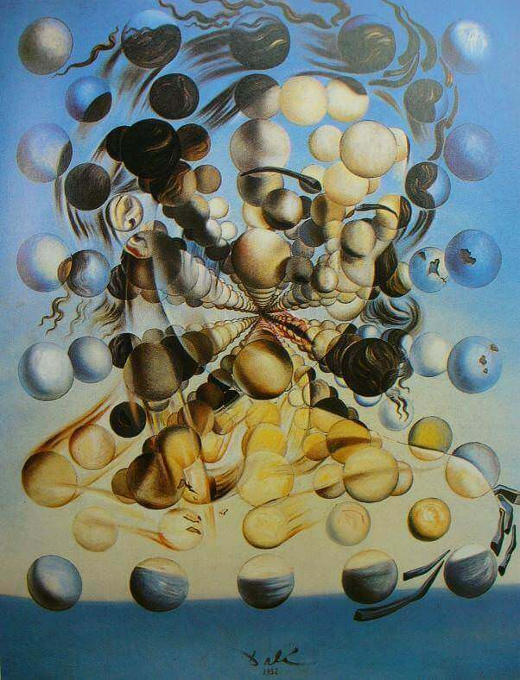

Galatea of the Spheres, Salvador Dali, 1952, Dali Theatre and Museum, Figueroa, Spain

And we are back to the surreal world of Salvador Dali.

To make a point- which often gets lost.

And that point is that while most people focus on his bizarre personal life and his over the top public life- he was a brilliant artist.

The work above evidences that fact (and we will soon deal with yet another of his works to further amplify that point).

Admittedly, I will spare you his Dream Caused By A Flight Of A Bee Around A Pomegranate A Second Before Awakening.

And his Fried Egg On A Plate Without The Plate.

And his The Great Masturbator.

So, in that sense, the work above is more “traditional” than most.

But it is quite something in its own right.

Some background about the painting:

After the bombings of Hiroshima and Nagasaki (and you think things are tough now), Sal became obsessed with nuclear physics and theories related to the disintegration of the atom (as the concept that the basic building blocks of life (atoms) were being used (in atomic power) to destroy life, freaked him (and many others) out).

It was also- not coincidentally- a time when he had a renewed interest in Catholicism (fear of imminent death will do that to you).

All of which led to the development of what he called his Nuclear Mysticism period

(By the way, in case you’re wondering, I’m not making any of this up).

Dali defined this period as his attempt to use ideas from modern science as a way of rationalizing Christian religion (are you still with me, cause I’m a bit lost?).

Simply put, realizing that all matter is made of atoms, Dali made his works appear to disintegrate from a unifying form into its component parts of multiple atoms.

Which led to works like the one above.

The painting is a portrait of Gala Dali, his wife and muse (and, to remind you, the woman who he encouraged to have affairs with other men (and she happily obliged), so he could watch them in their “private” moments- and also the woman who later required him to have a written invitation before he was allowed in his own house).

In other words, his paintings were not the only odd aspect of his life.



Here’s the magical couple fairly late in life

Now back to the painting:

Gala’s face is composed of densely populated spheres, representing atomic particles, giving the work a wonderful three dimensional effect. It is a work which manages to say, in Dali’s own wacky way, that we are a sum of our parts- and those parts are things we all have in common.

So an interesting work.

Let’s now move on to yet another interesting work- as Dali was always interesting- to see the diversity of Dali’s genius.

I selected this painting (below) in an attempt to demonstrate that the man’s talent extended beyond the surreal. To evidence the artistic dexterity of this odd man. And to show the other major focus of his Nuclear Mysticism period: his emphasis on religion and how it impacts- or should impact- our thinking about the world.

This work is his attempt to let us know that God is watching all of this. And that given all his work and sacrifice, he might be less than happy about what we are doing down here on planet earth.

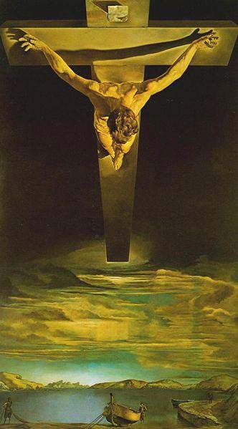

Christ of Saint John of the Cross, Salvador Dali, 1951, Kelvingrove Art Gallery and Museum, Glasgow, Scotland

Here, while taking his typical unique approach, Dali evidences his ability to paint in a realistic manner- to the point where you can even begin to see the influence of Caravaggio on his work (note the use of a dark background to make the foreground look even closer; note how realistically he painted Christ’s body- using light and shadows to highlight his muscles; note how he refused to show blood (as Caravaggio did in his Crucifixion of Saint Peter), unwilling to diminish Christ’s sacrifice).

The painting is based on a “cosmic dream” that Dali had, where, still obsessed with atoms and nuclear energy, he saw Christ as the “nucleus” of mankind. And decided to paint him from what he imagined was God’s perspective up in heaven.

In order to create the work, Dali had a stuntman hang from an overhead gantry in the shape of the cross to see how the body would appear on the cross and to see the pull of gravity on the body.

Weird, yes.

But talented.

Even (maybe) moving.

A few tidbits:

With respect to the Galatea of the Spheres, Dali specifically requested that he work, which he was especially proud of, be displayed in the Dali Museum in Figueroa, Spain- which is where it was placed. It remains there to this day.

Dali also designed his museum in Figueroa.

It looks like you might imagine it might look

With respect to the Christ of the Saint John of the Cross, the body of water depicted is the bucolic bay of Port Lligat- which was Dali’s residence at the time of the painting.

Final irrelevant tidbit: Dali had a lifelong, paralyzing fear of grasshoppers. And sex.