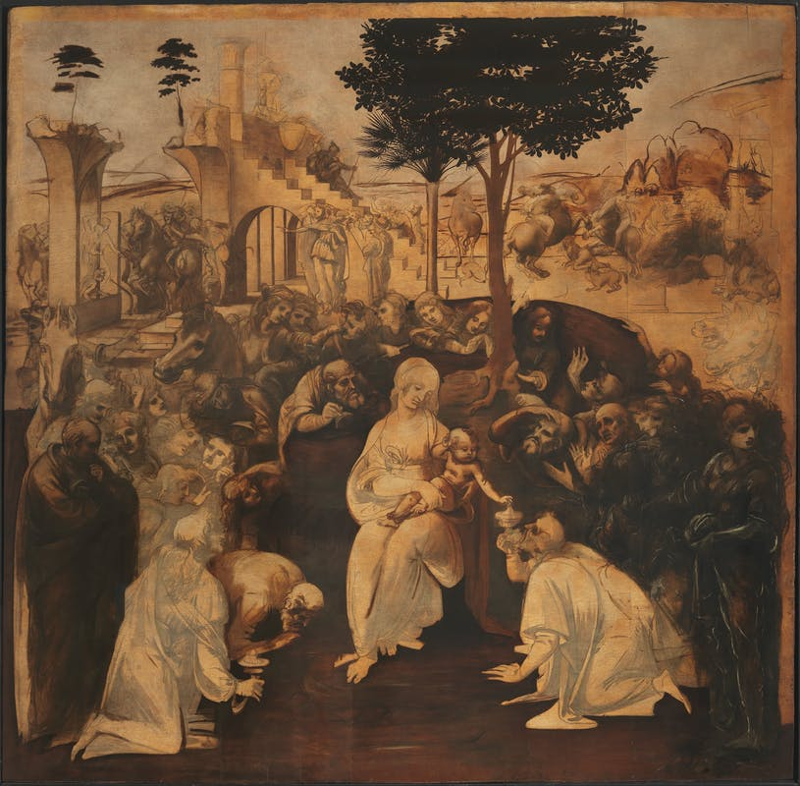

Adoration Of The Magi, Leonardo da Vinci, 1481, Uffizi, Florence, Italy

We are back with poor, brilliant, tortured Leonardo.

And with two of his works, executed - or sort of executed- around the same time. With all too common results.

The most obvious similarity being that they are both unfinished, abandoned in midstream by the temperamental artist.

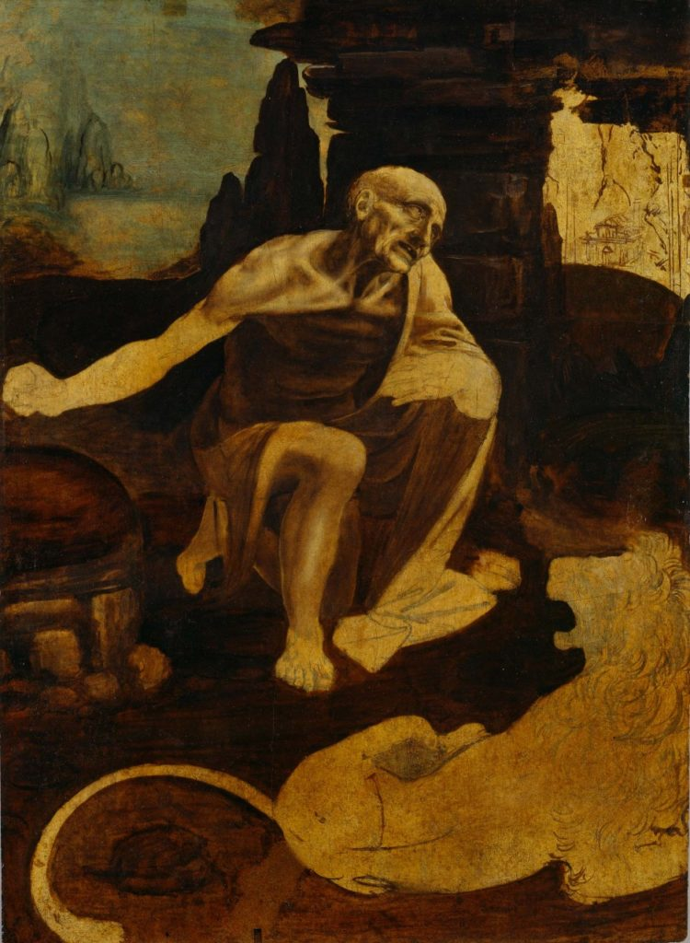

Saint Jerome In The Wilderness, Leonardo da Vinci, 1480, Vatican Museums, Vatican City

Let’s start with The Adoration of the Magi. A potential masterpiece (like every one of his works; the key word always being “potential”), it was commissioned by the Augustinian monks of San Donato in Scopeta in Florence in 1481, but after framing out the work, the whimsical Leo scrammed to Milan, leaving it unfinished.

As we can see in the outline form he left us, the Virgin and Child are the centerpiece of the work, with everyone else swirling around them in amazement- including what most critics consider to be a self-portrait of the young Leo in the far right foreground (the good looking dude in the dark, who, ironically, looks distracted).

The ruins in the background may be a reference to the Basilica of Maxentius, which, according to the legend of the time (they certainly were big on legends, weren’t they?), would stand until a virgin gave birth (?)- and it supposedly collapsed on the night of JC’s birth (supposedly). The ruins also serve a double purpose as they are likely intended to serve as a reminder of how Christianity had eclipsed, replaced (and destroyed) paganism.

As was Leo’s style (or lack thereof), the work was never delivered to the patrons (there being little point), forcing the poor duped monks to commission Filippino Lippi (not as good, but twice as reliable) to deliver a new and completed version of the work (which, fortunately, he did).

In the end, we are haunted, again, with the question of what could have been. And why it wasn’t.

And the next painting may provide a clue.

So now on to Leo’s Saint Jerome, which offers a tantalizing hint as to why- in addition to being genetically flighty- Leo might have been in such a hurry to skip town.

Saint Jerome kneels in the desert (he spent most of his life there there as a hermit) praying to a difficult-to-see crucifix, while holding a rock in his hand (which, tradition holds, he used to beat against his chest in a continuing act of penance (lighten up Jerry)). At his feet is a lion (in a desert?), which became his loyal companion after he extracted a thorn from the big cat’s paw. (wonder how he pulled that one off).

But the interesting part, at least for me, is that Saint Jerome is widely understood as a symbol of Penitence, as it is the central theme of Jerry’s life. And it has been speculated that Leo might have been in a penitent mood at the time of the commission- if it was a commission at all.

A prominent art critic has maintained that the painting’s subject matter reflects what was going on in Leo’s life at the time- as he had recently been accused of sodomy with a male prostitute (by the name of Jacopo Saltarelli). It is further speculated that Leo was either feeling remorse for this act or (more likely, in my opinion) was feeling persecuted by the accusation.

Whether true or not, Leo certainly seemed to be in a melancholy mood during these years (1480-1481), as he made a number of references in his notebooks at the time indicating a less than content man. In the margin of his codexes, we see entries like: “Why do you suffer so?”; “The greater one is, the greater grows one’s capacity for suffering.” and “I thought I was learning to live. I was only learning to die.”

So maybe the art critic is out of line. Maybe Leo was just having a tough time. Maybe he just related to Jerry at that point of his life.

And maybe we should just leave the poor guy alone.

Then there’s the wacky story of what happened to the painting.

In another Leo-esque twist, his Saint Jerome was lost for well over a hundred years.

As the story goes, Joseph Cardinal Fesch, coincidentally an uncle of Napoleon (small world), on a visit to Rome, spotted a segment of the painting- which was being used as a tablecloth for a shoemaker’s table (as any teenage girl would say: seriously?). Thinking he recognized the work, Fesch purchased the tablecloth and soon discovered the painting had been divided into five pieces. He then made it his mission in life to find the missing portions, finding the final fragment five years later in another shoemaker’s store- this time the piece was being used as a wedge in the shoemaker’s shop (like, really, seriously?).

Fesch then had the work stitched back together (and he sold it off to the Pope (the French!)).

That’s what happens when you don’t finish what you start, Leo.

A few tidbits:

More of Leo’s works were either not completed (the Adoration, the Saint Jerome, the Battle of Anghiari), destroyed (the Sforza Horse) or effectively destroyed (The Last Supper) or not delivered to the patron (the Virgin of the Rocks, the Mona Lisa), than those that were executed and delivered.

To prove that Leo wasn’t always a Debbie Downer, here are a few of his less morose quotes: ”The noblest pleasure is the joy of understanding.”; “Inaction saps the vigor of the mind.” (ha!); “Nature is the source of all true knowledge.”; and “When the spirit does not work with the hand, there is no art.”

He also said: “Marriage is like putting your hand into a bag of snakes in the hope of pulling out an eel.”

So I’m guessing he wasn’t a big advocate of matrimony.

Bill Gates, in an attempt to reinforce how wealthy he was and to rub it in, bought Leo’s Codex Leicester in 1994 for $31 million (which is $51 million in today’s money).

Not to be outdone, Prince Badr bin Abdullah bought Leonardo’s recently rediscovered Salvator Mundi for $450.1 million dollars (which is infinity in today’s money).