AI-FDS Student Investigation Brief
Plain-language findings, priority actions, and traceable technical evidence
Case: AI-FDS-20260726-2326-CORRECTED | Generated: 2026-07-27 00:30:49 (Asia/Kuala_Lumpur, GMT+08:00)
Purpose: Educational review of the six evidence records selected in the original Student Brief export. | Evidence reviewed: 6

Investigation Summary
6  Evidence | 2  Immediate | 2  Review | 2  No immediate action

What should I do next?
1 | Pause contact and do not send money, credentials, OTPs, files, or remote access.  Stopping the interaction limits further exposure while the evidence is verified. | Immediate
2 | Do not disclose the code or password; change exposed credentials and contact the account provider.  OTPs and passwords can enable account takeover. | Immediate
3 | Verify the person or organization through a separately obtained official channel.  An independent channel avoids relying on details supplied by the same contact. | Prompt review

Evidence Review
Evidence 1 - Transcript | No Immediate Action
Result: Legitimate | Evidence score: 20.0% | Time: 2026-07-26 22:15:12
Source: innocent long audio.mp3 | Analysis method: Transcript model consensus (0/3 suspicious) | Score meaning: Maximum dashboard concern signal
Why: Transcript suspicious-risk probability: 13.8%. Maximum dashboard concern signal: 20.0%.
Key indicators: No explicit indicators saved
Relevant excerpt: [Uploaded audio transcript]
Next action: Retain the earliest available recording, transcript, timestamps, and unedited working copy.

Evidence 2 - Transcript | Immediate Action Required
Result: Suspicious | Evidence score: 79.4% | Time: 2026-07-25 22:31:03
Source: [Uploaded audio transcript] Hello, this is the security department fro | Analysis method: Transcript model consensus (3/3 suspicious) | Score meaning: Concern score
Why: Transcript suspicious-risk probability: 79.4%. Stored as risk so dashboard/report history does not treat legitimate confidence as threat.
Key indicators: Urgent, Login, Suspended
Relevant excerpt: We detected an urgent login attempt on your account today.
Next action: Pause contact and do not send money, credentials, OTPs, files, or remote access.

Evidence 3 - Phone | Review Required
Result: Lower concern | Evidence score: 0.0% | Time: 2026-07-25 14:38:03
Source: Veriphone: success; PenipuMY: success | Analysis method: Phone provider reputation rules | Score meaning: Concern score
Why: Continue with normal caution.
Key indicators: Phone ownership unconfirmed
Relevant excerpt: +60182874831
Next action: Verify the person or organization through a separately obtained official channel.

Evidence 4 - Phone | Immediate Action Required
Result: High concern | Evidence score: 72.0% | Time: 2026-07-25 14:35:06
Source: Veriphone: success; PenipuMY: success | Analysis method: Phone provider reputation rules | Score meaning: Concern score
Why: Pause the interaction and verify independently.
Key indicators: 5 police report(s) found, Fraud flag returned, Spam flag returned
Relevant excerpt: +60123456789
Next action: Pause contact and do not send money, credentials, OTPs, files, or remote access.

Evidence 5 - Email | Review Required
Result: Suspicious | Evidence score: N/A | Time: 2026-07-18 22:30:28
Source: Subject: URGENT: Verification Required - Immediate Security Action Req | Analysis method: Email Random Forest | Score meaning: Concern score
Why: The evidence is incomplete, conflicting, or suspicious enough to verify.
Key indicators: No explicit indicators saved
Relevant excerpt: 1.
Next action: Verify the person or organization through a separately obtained official channel.

Evidence 6 - Email | No Immediate Action
Result: Legitimate | Evidence score: N/A | Time: 2026-07-18 22:29:40
Source: Subject: Project Kickoff & Sync Meeting - Q3 Roadmap Hi Team, I hope | Analysis method: Email Support Vector Machine | Score meaning: Concern score
Why: The available evidence does not indicate immediate action, but normal caution still applies.
Key indicators: No explicit indicators saved
Relevant excerpt: Hi Team,
Next action: Retain the original message, complete headers, attachments, URLs, and timestamps.

Combined Investigation Findings
Finding | Evidence | Priority
5 police report(s) found | Phone #4 | High
5 total report indicator(s) | Phone #4 | High
Do not tell | Transcript #2 | High
Fraud flag returned | Phone #4 | High
Immediately | Transcript #2 | High

Visual Evidence Summary
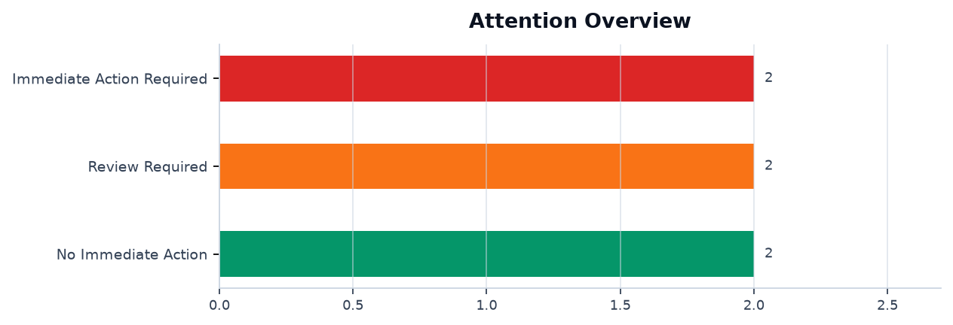
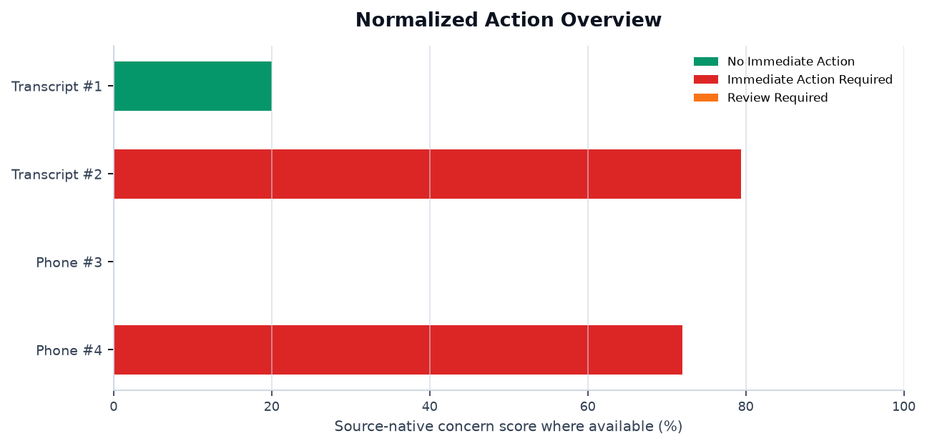
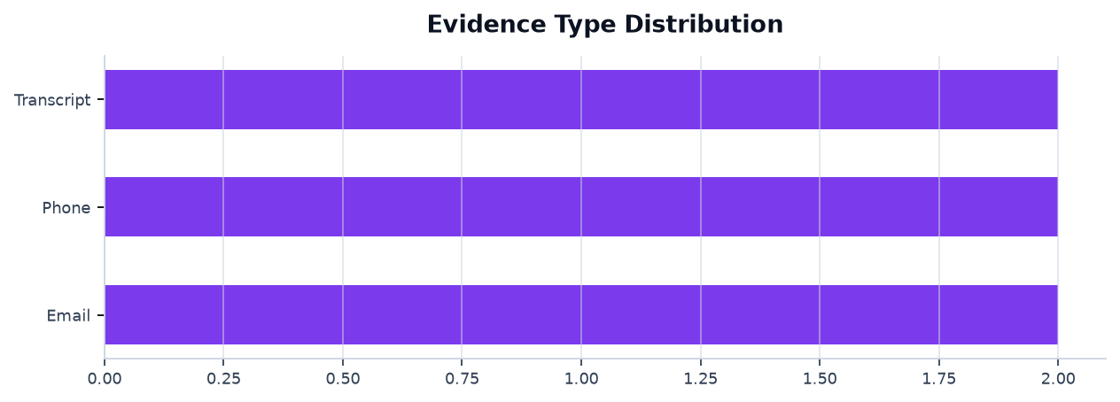
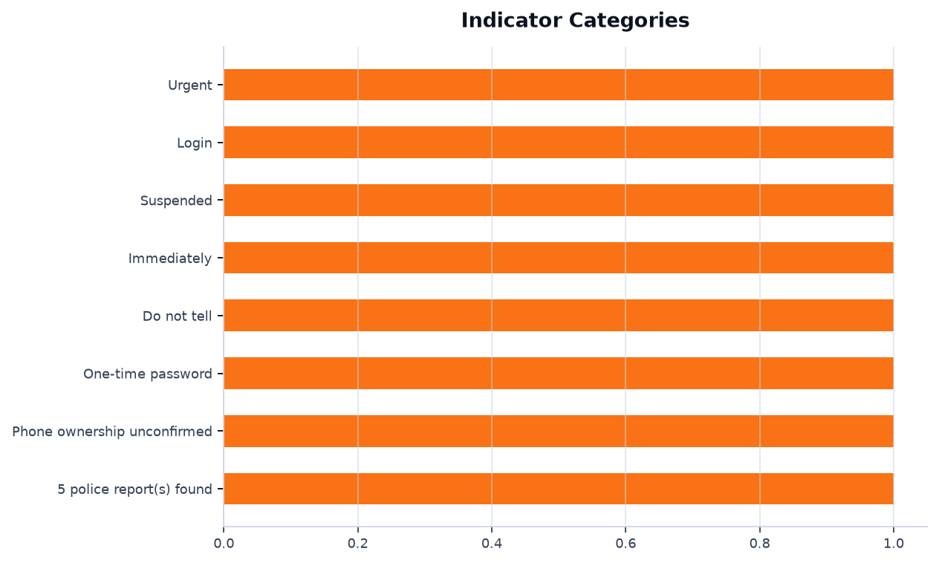
Interpretation note: email probabilities, transcript/audio risk signals, and phone evidence scores use different methods and are not directly comparable.

Reviewer Note
Verify suspicious contact through official channels, do not share OTP/passwords, preserve the evidence, and report urgent financial or identity-related requests to the relevant campus or organisation support team.

Technical Appendix
Investigation-specific output is grouped under its evidence record. Shared training evaluation metrics appear once in a separate reference section.

Evidence-Specific Supporting Visuals and Data
Evidence 1 - Transcript | No Immediate Action
Result: Legitimate | Source: innocent long audio.mp3 | Time: 2026-07-26 22:15:12

Supporting Visuals and Data

1. [Chart] Recording 1 - Decision Risk Timeline
Decision risk for every processed chunk in this recording.
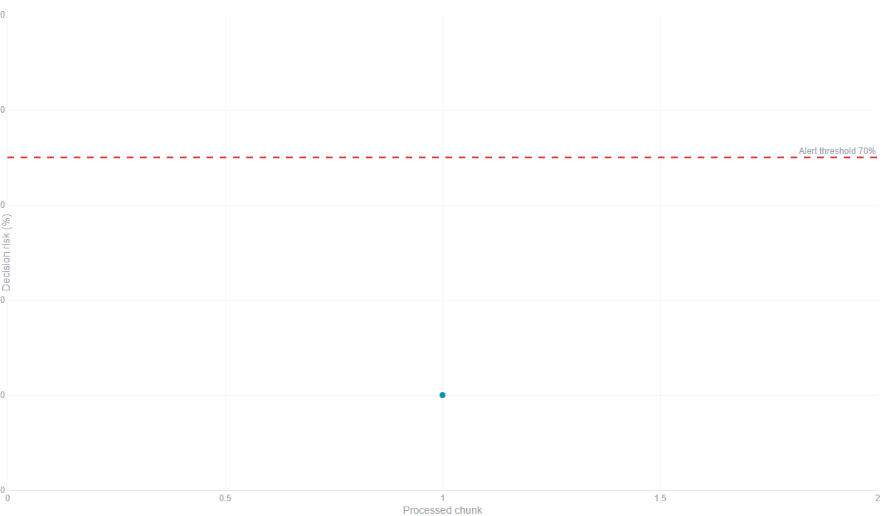
clip | chunk | decision | risk
1 | 1 | Lower threat - limited voice evidence | 20.0

2. [Table] Recording 1 - Chunk Investigation Table
Clip | Chunk | Time | Decision | Decision Risk
1 | 1 | 22:15:11 | Lower threat - limited voice evidence | 20.0%
Raw Blend | Voice Evidence | Raw Voice AI | Transcript | Behavioral Evidence
59.6% | 18.3% | 99.9% | 15.6% | 54.5%
Raw Behavioral RF | Voice Reliability | Behavioral Reliability | Content Reliability | Content Level
63.3% | 87.5% | 86.0% | 57.5% | Lower scam-content concern
Voice Level | Speech quality | Whisper | Language check | Detected text
Weak voice-authenticity evidence | Usable speech-like audio | Transcript accepted | en | Hello, this is me trying to tell you about your call status warranty. Please message me back whenever you can. You have something like that.
Flags
-

3. [Chart] Recording 1 - MFCC Feature Heatmap
Each heatmap column is a recent chunk, and each row is an MFCC coefficient: a compact fingerprint of vocal tone, timbre, and spectral shape used by the voice model. The heatmap supports the raw voice score, but reliability checks decide whether that pattern is strong enough to trust. Current reading: 1 chunk(s), 11.7s latest audio, weak voice-authenticity evidence. Reliability limits: none.
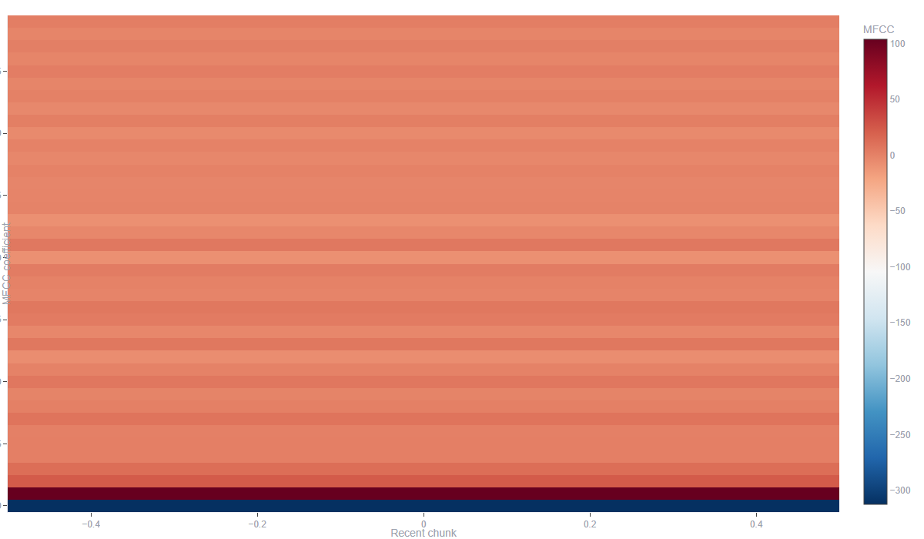

4. [Chart] Recording 1 - Frequency Spectrum
Relative frequency levels from the latest processed chunk.
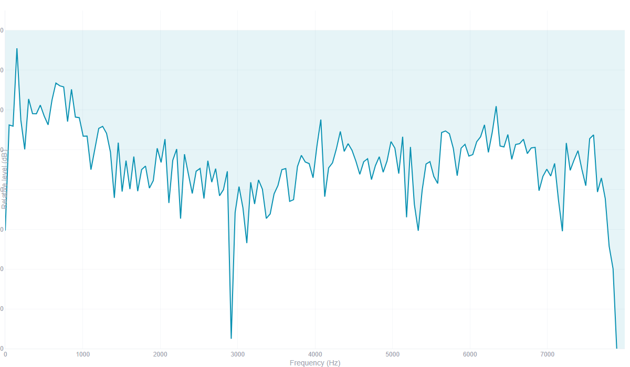

5. [Chart] Recording 1 - Voice Evidence Metrics
This chart separates raw model probabilities from reliability-weighted evidence. Primary voice evidence source: Trained voice evidence calibrator. Conclusion: Lower threat - limited voice evidence; the raw voice model is high, but it is not strong evidence after reliability checks; behavioral RF moved from 63.3% raw to 54.5% evidence.
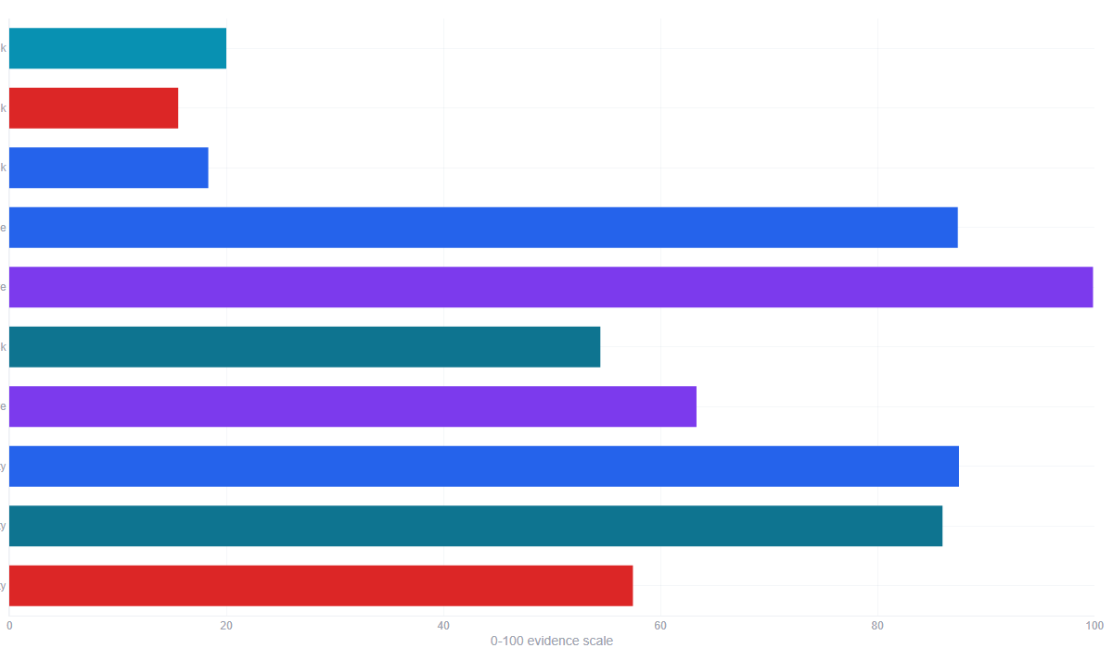

6. [Chart] Recording 1 - Behavioral RF Signal Metrics
Behavioral RF looks at duration, voiced activity, silence, energy, spectral shape, pauses, and speech rate. The bars are normalized so mixed units can be compared visually; hover details keep the raw measurement. Conclusion: RF is 63.3% raw, 54.5% after 86.0% reliability. Reliability limits: none.
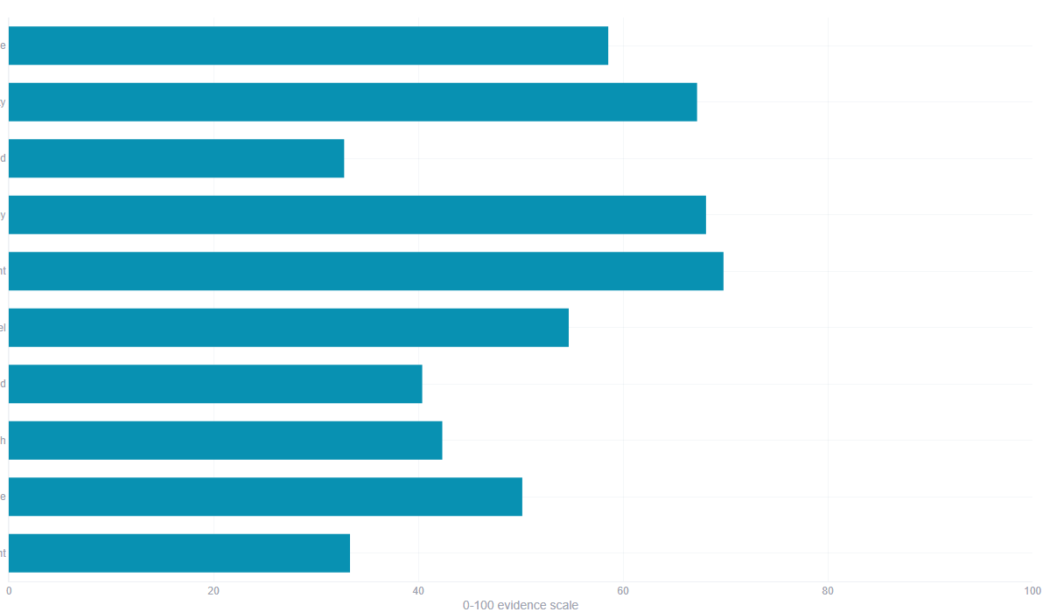

7. [Table] Recording 1 - Behavioral Feature Values
Behavior Feature | Value
Duration Seconds | 11.7120
Rms Energy Mean | 0.0341
Rms Energy Std | 0.0279
Zero Crossing Rate Mean | 0.1094
Zero Crossing Rate Std | 0.1174
Spectral Centroid Mean | 1615.6310
Spectral Centroid Std | 1060.3790
Spectral Bandwidth Mean | 1694.0490
Spectral Rolloff Mean | 3151.6106
Silence Ratio | 0.3276
Speech Activity Ratio | 0.6724
Pause Count | 4.0000
Estimated Speech Rate | 4.0130

8. [Chart] Transcript Live Model Comparison
Suspicious-risk probability for every selected transcript model.
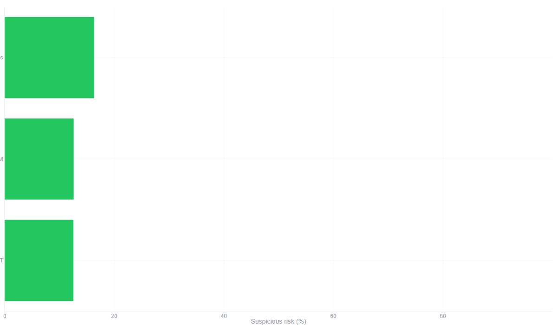
Model | Model Key | Metrics Model | Prediction | Risk Score
DistilBERT | distilbert | DistilBERT | Legitimate | 12.56
SVM | svm | SVM | Legitimate | 12.6
Naive Bayes | nb | Naive Bayes | Legitimate | 16.34
Confidence | Accuracy | Precision | Recall | F1 Score
87.44 | 83.62 | 86.36 | 74.51 | 80.0
87.4 | 81.9 | 81.25 | 76.47 | 78.79
83.66 | 80.17 | 85.0 | 66.67 | 74.73
ROC-AUC | Training Time (s) | Prediction Time (ms) | Engine
91.28 | 590.212 | 322.4884 | Transcript DistilBERT
90.86 | 0.078 | 0.0382 | Transcript SVM
91.19 | 0.004 | 0.0039 | Transcript Naive Bayes

9. [Table] Transcript Live Model Comparison Table
Model | Model Key | Metrics Model | Prediction | Risk Score
DistilBERT | distilbert | DistilBERT | Legitimate | 12.56
SVM | svm | SVM | Legitimate | 12.6
Naive Bayes | nb | Naive Bayes | Legitimate | 16.34
Confidence | Accuracy | Precision | Recall | F1 Score
87.44 | 83.62 | 86.36 | 74.51 | 80.0
87.4 | 81.9 | 81.25 | 76.47 | 78.79
83.66 | 80.17 | 85.0 | 66.67 | 74.73
ROC-AUC | Training Time (s) | Prediction Time (ms) | Engine
91.28 | 590.212 | 322.4884 | Transcript DistilBERT
90.86 | 0.078 | 0.0382 | Transcript SVM
91.19 | 0.004 | 0.0039 | Transcript Naive Bayes

10. [Chart] Transcript Consensus Probability
Legitimate and suspicious probabilities represented by the live dashboard.
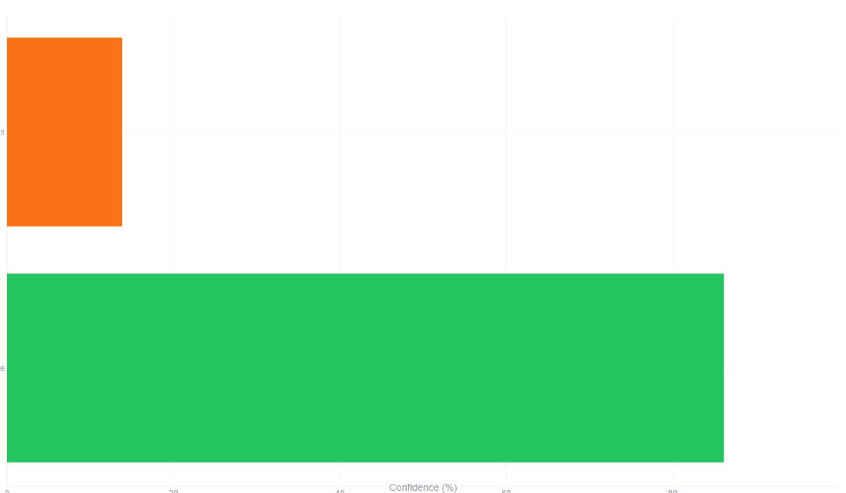
Field | Value
Legitimate | 0.8616666666666667
Suspicious | 0.13833333333333334

11. [Table] Transcript Explainability Evidence
Indicator | Type | Model Weight | Impact | Intention
tell | SVM: Legitimate wording | -0.2094 | Medium | Shows which words pushed a transparent baseline model up or down; supporting evidence only.
status | SVM: Legitimate wording | -0.1719 | Medium | Shows which words pushed a transparent baseline model up or down; supporting evidence only.
message | SVM: Legitimate wording | -0.1701 | Low | Shows which words pushed a transparent baseline model up or down; supporting evidence only.
like | SVM: Legitimate wording | -0.0812 | Low | Shows which words pushed a transparent baseline model up or down; supporting evidence only.
trying | SVM: Suspicious wording | 0.0438 | Low | Shows which words pushed a transparent baseline model up or down; supporting evidence only.
hello | SVM: Legitimate wording | -0.0022 | Low | Shows which words pushed a transparent baseline model up or down; supporting evidence only.
tell | Naive Bayes: Legitimate wording | -0.3695 | High | Shows which words pushed a transparent baseline model up or down; supporting evidence only.
message | Naive Bayes: Legitimate wording | -0.344 | High | Shows which words pushed a transparent baseline model up or down; supporting evidence only.
hello | Naive Bayes: Legitimate wording | -0.2759 | High | Shows which words pushed a transparent baseline model up or down; supporting evidence only.
status | Naive Bayes: Legitimate wording | -0.2507 | Medium | Shows which words pushed a transparent baseline model up or down; supporting evidence only.
like | Naive Bayes: Legitimate wording | -0.1475 | Low | Shows which words pushed a transparent baseline model up or down; supporting evidence only.
trying | Naive Bayes: Legitimate wording | -0.0196 | Low | Shows which words pushed a transparent baseline model up or down; supporting evidence only.

12. [Text] Original Combined Transcript
Exact labelled transcript input submitted to the text models.
[Uploaded audio transcript]
Hello, this is me trying to tell you about your call status warranty. Please message me back whenever you can. You have something like that.
Evidence 2 - Transcript | Immediate Action Required
Result: Suspicious | Source: [Uploaded audio transcript] Hello, this is the security department fro | Time: 2026-07-25 22:31:03

Supporting Visuals and Data
No investigation-specific dashboard artifacts were captured for this evidence record.
Evidence 3 - Phone | Review Required
Result: Lower concern | Source: Veriphone: success; PenipuMY: success | Time: 2026-07-25 14:38:03

Supporting Visuals and Data
No investigation-specific dashboard artifacts were captured for this evidence record.
Evidence 4 - Phone | Immediate Action Required
Result: High concern | Source: Veriphone: success; PenipuMY: success | Time: 2026-07-25 14:35:06

Supporting Visuals and Data
No investigation-specific dashboard artifacts were captured for this evidence record.
Evidence 5 - Email | Review Required
Result: Suspicious | Source: Subject: URGENT: Verification Required - Immediate Security Action Req | Time: 2026-07-18 22:30:28

Supporting Visuals and Data
No investigation-specific dashboard artifacts were captured for this evidence record.
Evidence 6 - Email | No Immediate Action
Result: Legitimate | Source: Subject: Project Kickoff & Sync Meeting - Q3 Roadmap Hi Team, I hope | Time: 2026-07-18 22:29:40

Supporting Visuals and Data
No investigation-specific dashboard artifacts were captured for this evidence record.

Shared Model Reference Metrics
These are model evaluation references, not measurements produced by a single investigation.

1. [Chart] Performance Metrics
Used by: Evidence 1 - Transcript
Evaluation tab 1 of 3: saved transcript training metrics.
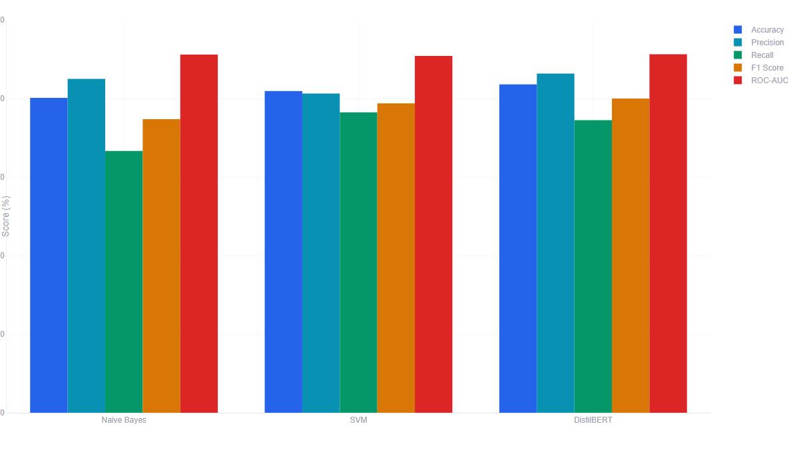
Model | Accuracy | Precision | Recall | F1 Score
Naive Bayes | 80.17 | 85.0 | 66.67 | 74.73
SVM | 81.9 | 81.25 | 76.47 | 78.79
DistilBERT | 83.62 | 86.36 | 74.51 | 80.0
ROC-AUC | Training Time (s) | Prediction Time (ms) | True Positive | False Positive
91.19 | 0.004 | 0.0039 | 34 | 6
90.86 | 0.078 | 0.0382 | 39 | 9
91.28 | 590.212 | 322.4884 | 38 | 6
True Negative | False Negative
59 | 17
56 | 12
59 | 13

2. [Table] Performance Metrics data
Used by: Evidence 1 - Transcript
Model | Accuracy | Precision | Recall | F1 Score
Naive Bayes | 80.17 | 85.0 | 66.67 | 74.73
SVM | 81.9 | 81.25 | 76.47 | 78.79
DistilBERT | 83.62 | 86.36 | 74.51 | 80.0
ROC-AUC | Training Time (s) | Prediction Time (ms) | True Positive | False Positive
91.19 | 0.004 | 0.0039 | 34 | 6
90.86 | 0.078 | 0.0382 | 39 | 9
91.28 | 590.212 | 322.4884 | 38 | 6
True Negative | False Negative
59 | 17
56 | 12
59 | 13

3. [Chart] Confusion Matrix Heatmap
Used by: Evidence 1 - Transcript
Evaluation tab 2 of 3 for the recommended transcript model.
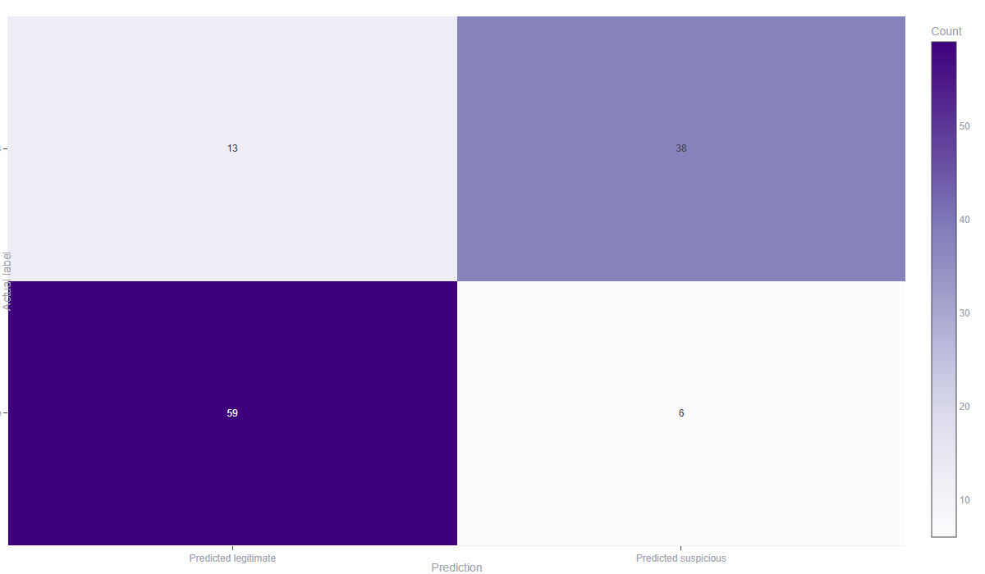

4. [Chart] ROC-AUC Curve
Used by: Evidence 1 - Transcript
Evaluation tab 3 of 3 for selected transcript models.
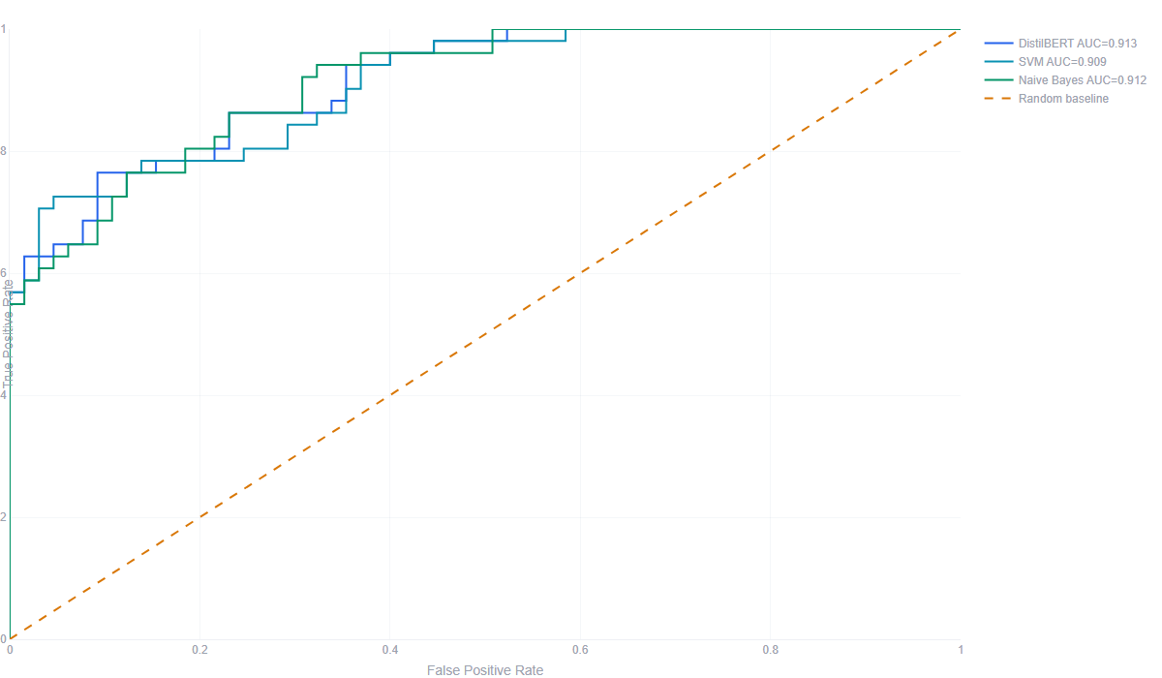

Evidence Register
# | Type | Time | Source | Input SHA-256 | AI analysis
1 | Transcript | 2026-07-26 22:15:12 | innocent long audio.mp3 | fc272fb45527e47dad52e9e54a36becb048f06b3ab1b9c1caf2531a0aa3353e8 | Transcript model consensus (0/3 suspicious)
2 | Transcript | 2026-07-25 22:31:03 | [Uploaded audio transcript] Hello, this is the security department fro | Legacy - not captured | Transcript model consensus (3/3 suspicious)
3 | Phone | 2026-07-25 14:38:03 | Veriphone: success; PenipuMY: success | Legacy - not captured | Phone provider reputation rules
4 | Phone | 2026-07-25 14:35:06 | Veriphone: success; PenipuMY: success | Legacy - not captured | Phone provider reputation rules
5 | Email | 2026-07-18 22:30:28 | Subject: URGENT: Verification Required - Immediate Security Action Req | Legacy - not captured | Email Random Forest
6 | Email | 2026-07-18 22:29:40 | Subject: Project Kickoff & Sync Meeting - Q3 Roadmap Hi Team, I hope | Legacy - not captured | Email Support Vector Machine
Legacy limitation: 5 selected record(s) predate immutable evidence snapshots.

Scope and References
Educational scam-awareness support only. Results support review and do not prove identity, intent, legal liability, or authenticity.
EC-Council CEH - Social Engineering, Phishing, AI Impersonation, and Countermeasures: https://www.eccouncil.org/train-certify/certified-ethical-hacker-ceh/
NIST SP 800-61 Rev. 3 - Incident Response Recommendations and Considerations: https://csrc.nist.gov/pubs/sp/800/61/r3/final
SWGDE Requirements for Report Writing in Digital and Multimedia Forensics: https://www.swgde.org/documents/published-complete-listing/18-q-002-swgde-requirements-for-report-writing-in-digital-and-multimedia-forensics/
SWGDE Best Practices for Digital Evidence Collection: https://www.swgde.org/documents/published-complete-listing/18-f-002-best-practices-for-digital-evidence-collection/
NISTIR 8312 - Four Principles of Explainable Artificial Intelligence: https://www.nist.gov/publications/four-principles-explainable-artificial-intelligence
CISA Secure Our World - Recognize and Report Phishing: https://www.cisa.gov/secure-our-world
FTC Consumer Advice - AI Voice Cloning and Family Emergency Scams: https://consumer.ftc.gov/articles/scammers-use-fake-emergencies-steal-your-money
FCC Consumer Complaints - Unwanted Calls, Texts, and Caller ID Spoofing: https://consumercomplaints.fcc.gov/hc/en-us/articles/115002234203-Unwanted-Calls-Texts-Phone

