AI-FDS Student Investigation Brief
Plain-language findings, priority actions, and traceable technical evidence
Case: AIFDS-EDU-SAMPLE-001 | Generated: 2026-07-26 23:19:41 (Asia/Kuala_Lumpur, GMT+08:00)
Purpose: Educational review of email phishing, phone-based social engineering, and carrier lookup evidence. | Evidence reviewed: 3

Investigation Summary
3  Evidence | 1  Immediate | 1  Review | 1  No immediate action

What should I do next?
1 | Pause contact and do not send money, credentials, OTPs, files, or remote access.  Stopping the interaction limits further exposure while the evidence is verified. | Immediate
2 | Do not disclose the code or password; change exposed credentials and contact the account provider.  OTPs and passwords can enable account takeover. | Immediate
3 | Change the password from a trusted device, revoke sessions, and enable multi-factor authentication.  Shared credentials should be treated as compromised. | Immediate

Evidence Review
Evidence 1 - Email | Immediate Action Required
Result: Suspicious | Evidence score: 92.0% | Time: 2026-07-26 20:45:00
Source: student-services-alert.eml | Analysis method: Email model consensus | Score meaning: Average suspicious risk
Why: Multiple email models agree that the message resembles phishing. The strongest signals are an OTP request, a forced deadline, and a look-alike sender domain.
Key indicators: OTP request, Urgency and account suspension threat, Sender-domain mismatch
Relevant excerpt: Reply with the six-digit verification code.
Next action: Pause contact and do not send money, credentials, OTPs, files, or remote access.

Evidence 2 - Transcript | Review Required
Result: Likely social-engineering script | Evidence score: 78.0% | Time: 2026-07-26 20:48:00
Source: support-call.txt | Analysis method: Transcript multi-model analysis | Score meaning: Behavioral concern score
Why: The transcript combines authority impersonation, an urgent transfer request, and secrecy. Those patterns warrant independent verification before any action.
Key indicators: Authority impersonation, Payment pressure, Secrecy request
Relevant excerpt: Do not tell branch staff.
Next action: Stop payment and contact the bank or payment provider through its official fraud channel.

Evidence 3 - Phone | No Immediate Action
Result: No listed report; identity unconfirmed | Evidence score: 28.0% | Time: 2026-07-26 20:52:00
Source: +60 12-345 6789 | Analysis method: Carrier metadata + reputation rules | Score meaning: Phone evidence concern score
Why: The lookup found ordinary carrier metadata and no matching community report. This lowers immediate concern but cannot verify the caller or rule out spoofing.
Key indicators: Carrier metadata available, No community scam report matched, Caller identity not verified
Relevant excerpt: Malaysia mobile number; no matching community report; ownership not verified.
Next action: Call the organization using a number from its official website or trusted statement.

Combined Investigation Findings
Finding | Evidence | Priority
Authority impersonation | Transcript #2 | Review
Caller identity not verified | Phone #3 | Informative
Carrier metadata available | Phone #3 | Informative
No community scam report matched | Phone #3 | Informative
OTP request | Email #1 | High

Visual Evidence Summary
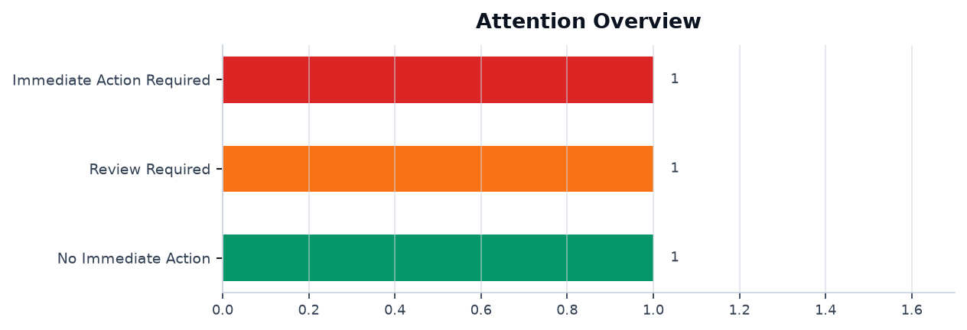
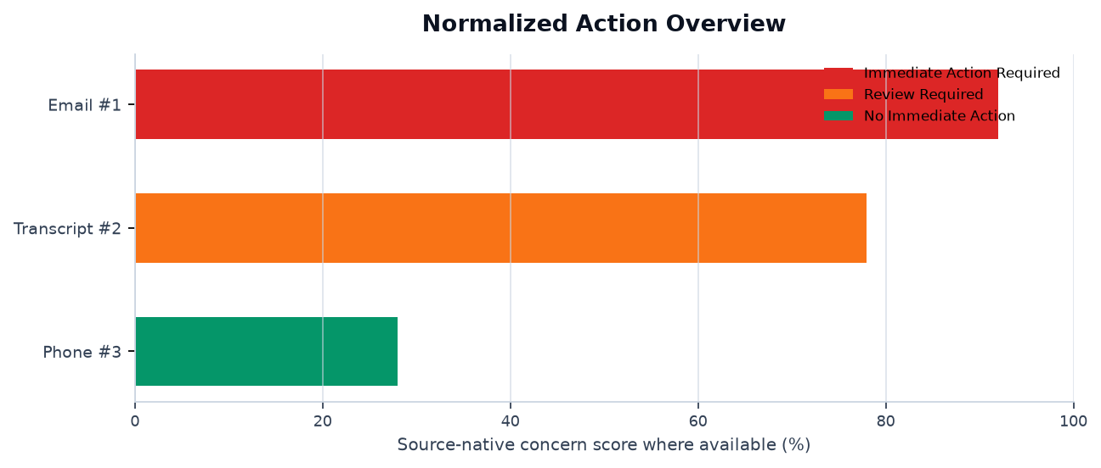
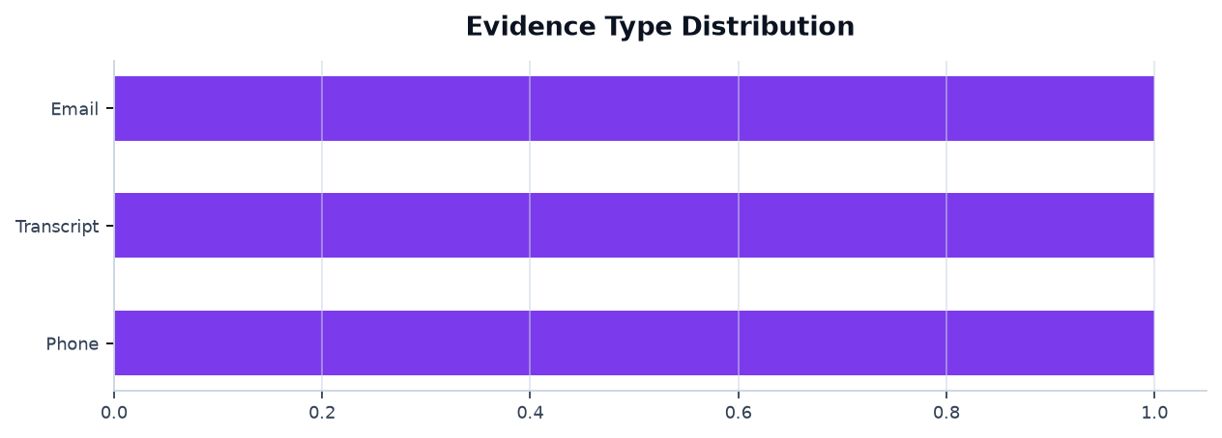
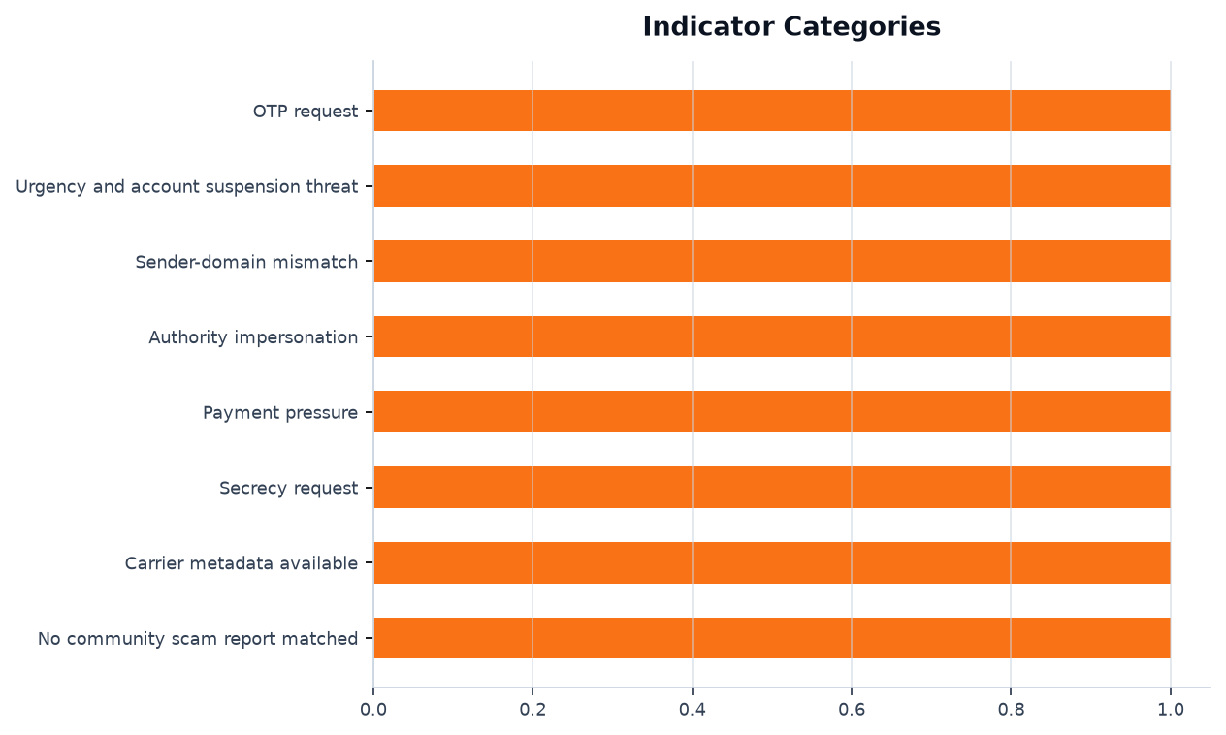
Interpretation note: email probabilities, transcript/audio risk signals, and phone evidence scores use different methods and are not directly comparable.

Reviewer Note
Treat the output as decision support. Verify people and organizations through independently sourced official channels before taking action.

Technical Appendix
Investigation-specific output is grouped under its evidence record. Shared training evaluation metrics appear once in a separate reference section.

Evidence-Specific Supporting Visuals and Data
Evidence 1 - Email | Immediate Action Required
Result: Suspicious | Source: student-services-alert.eml | Time: 2026-07-26 20:45:00

Supporting Visuals and Data

1. [Table] Email Indicator Evidence
Scan-specific findings from the email investigation.
Indicator | Observed evidence | Impact
OTP request | Reply with the six-digit verification code | High
Urgency | Account closes in 15 minutes | High
Sender mismatch | look-alike student-services domain | High
Evidence 2 - Transcript | Review Required
Result: Likely social-engineering script | Source: support-call.txt | Time: 2026-07-26 20:48:00

Supporting Visuals and Data

1. [Table] Transcript Scam Indicators
Timestamped scan-specific transcript findings.
Time | Category | Excerpt | Priority
00:12 | Authority impersonation | I am calling from your bank fraud department | High
00:34 | Payment pressure | Move the funds to the safe account now | High
00:51 | Secrecy | Do not tell branch staff | High
Evidence 3 - Phone | No Immediate Action
Result: No listed report; identity unconfirmed | Source: +60 12-345 6789 | Time: 2026-07-26 20:52:00

Supporting Visuals and Data

1. [Table] Phone Carrier and Reputation Lookup
Scan-specific carrier and community-reputation output.
Field | Result | Meaning
Carrier | Example Mobile Berhad | Network metadata only
Line type | Mobile | Does not establish ownership
PenipuMY match | No matching report | Absence of a report is not proof of safety
Country | Malaysia | Numbering-plan metadata

Shared Model Reference Metrics
These are model evaluation references, not measurements produced by a single investigation.

1. [Chart] Performance Metrics
Used by: Evidence 1 - Email
Email Metrics tab 1 of 3: shared model precision, recall, and F1.
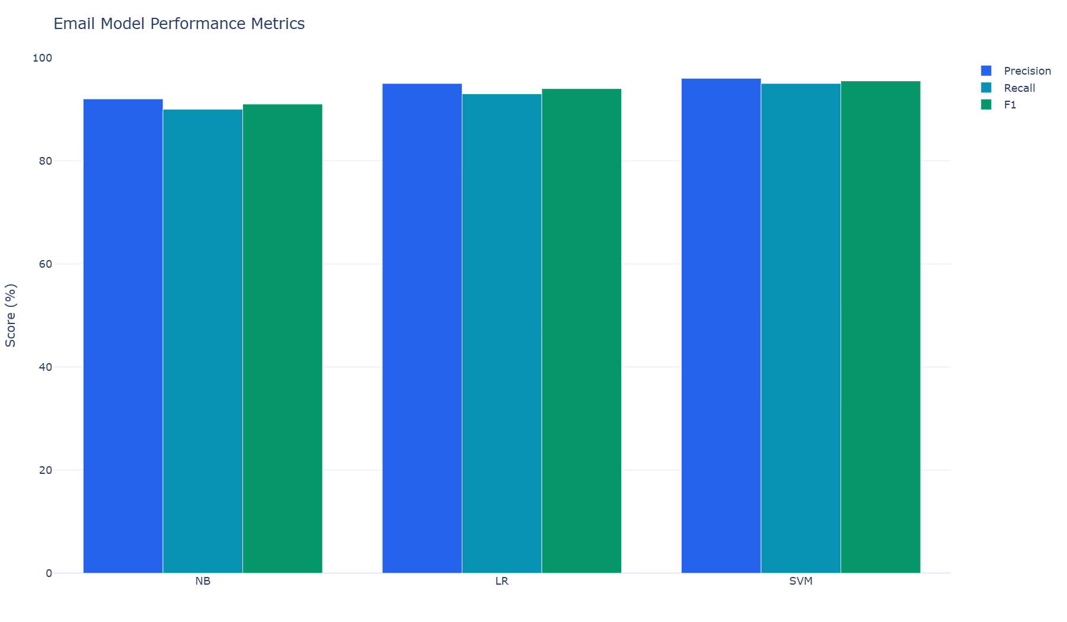
Model | Precision | Recall | F1
Naive Bayes | 92 | 90 | 91
Logistic Regression | 95 | 93 | 94
SVM | 96 | 95 | 95.5

2. [Table] Performance Metrics data
Used by: Evidence 1 - Email
Exact values displayed beneath evaluation tab 1 of 3.
Model | Precision | Recall | F1
Naive Bayes | 92 | 90 | 91
Logistic Regression | 95 | 93 | 94
SVM | 96 | 95 | 95.5

3. [Chart] Confusion Matrix Heatmap
Used by: Evidence 1 - Email
Email Metrics tab 2 of 3: shared held-out classification counts.
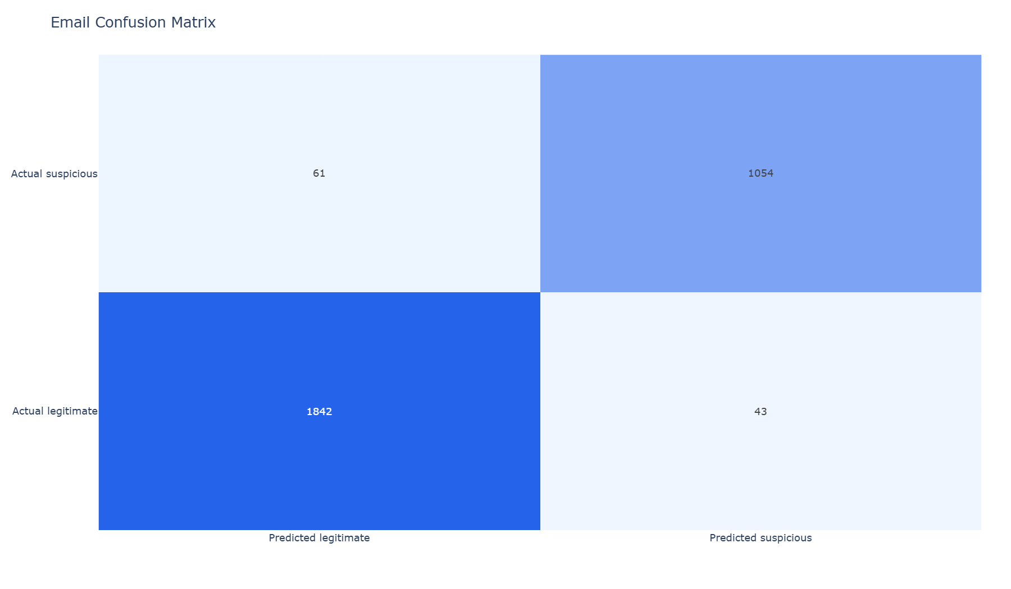
Actual | Predicted legitimate | Predicted suspicious
Legitimate | 1842 | 43
Suspicious | 61 | 1054

4. [Chart] ROC-AUC Curve
Used by: Evidence 1 - Email
Email Metrics tab 3 of 3: shared decision-threshold performance.
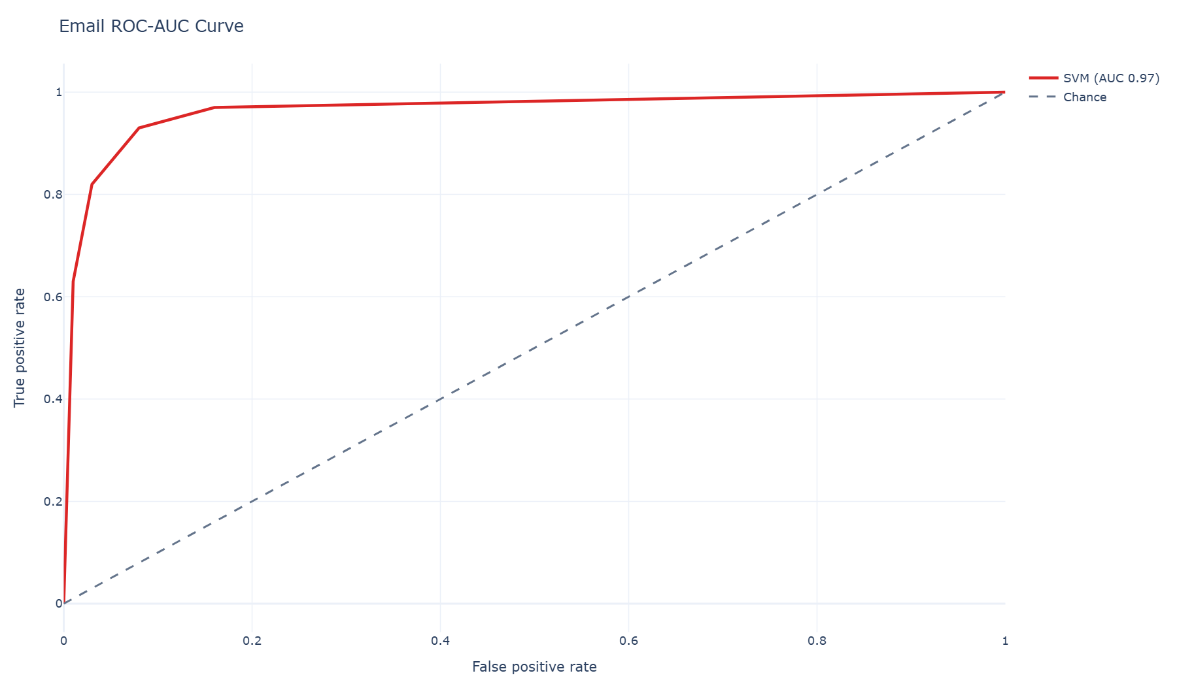
Model | AUC
SVM | 0.97

Evidence Register
# | Type | Time | Source | Input SHA-256 | AI analysis
1 | Email | 2026-07-26 20:45:00 | student-services-alert.eml | 0f8ae295a59ad3b23be54e4ad8b65e55cae15056efba2a2c41d95955cdbee269 | Email model consensus
2 | Transcript | 2026-07-26 20:48:00 | support-call.txt | fea8f1e538cb656efc4c8a2bf3ebb8802273f6b57e4c877b5e35f58beda05fd5 | Transcript multi-model analysis
3 | Phone | 2026-07-26 20:52:00 | +60 12-345 6789 | cfb757a43cea773c54bd5c586345fca0c4ca1b9b2b9e154de8b993cd4af9c917 | Carrier metadata + reputation rules

Scope and References
Educational scam-awareness support only. Results support review and do not prove identity, intent, legal liability, or authenticity.
EC-Council CEH - Social Engineering, Phishing, AI Impersonation, and Countermeasures: https://www.eccouncil.org/train-certify/certified-ethical-hacker-ceh/
NIST SP 800-61 Rev. 3 - Incident Response Recommendations and Considerations: https://csrc.nist.gov/pubs/sp/800/61/r3/final
SWGDE Requirements for Report Writing in Digital and Multimedia Forensics: https://www.swgde.org/documents/published-complete-listing/18-q-002-swgde-requirements-for-report-writing-in-digital-and-multimedia-forensics/
SWGDE Best Practices for Digital Evidence Collection: https://www.swgde.org/documents/published-complete-listing/18-f-002-best-practices-for-digital-evidence-collection/
NISTIR 8312 - Four Principles of Explainable Artificial Intelligence: https://www.nist.gov/publications/four-principles-explainable-artificial-intelligence
CISA Secure Our World - Recognize and Report Phishing: https://www.cisa.gov/secure-our-world
FTC Consumer Advice - AI Voice Cloning and Family Emergency Scams: https://consumer.ftc.gov/articles/scammers-use-fake-emergencies-steal-your-money
FCC Consumer Complaints - Unwanted Calls, Texts, and Caller ID Spoofing: https://consumercomplaints.fcc.gov/hc/en-us/articles/115002234203-Unwanted-Calls-Texts-Phone

