AI-FDS Student Investigation Brief
Plain-language findings, priority actions, and traceable technical evidence
Case: AI-FDS-CURATED-DEMO-20260801 | Generated: 2026-08-01 15:48:03 (Asia/Kuala_Lumpur, GMT+08:00)
Purpose: Lecturer walkthrough using curated non-personal email, transcript, and reserved-number phone evidence. | Evidence reviewed: 8

Investigation Summary
8  Evidence | 5  Immediate | 0  Review | 3  No immediate action

What should I do next?
1 | Pause contact and do not send money, credentials, OTPs, files, or remote access.  Stopping the interaction limits further exposure while the evidence is verified. | Immediate
2 | Stop payment and contact the bank or payment provider through its official fraud channel.  Fast reporting may improve the chance of limiting or tracing a transfer. | Immediate
3 | Do not disclose the code or password; change exposed credentials and contact the account provider.  OTPs and passwords can enable account takeover. | Immediate

Evidence Review
Evidence 1 - Phone | No Immediate Action
Result: Lower concern | Evidence score: 8.0% | Time: 2026-08-01 09:07:00
Source: +447700900102 | Analysis method: Curated Phone Demo Fixture | Score meaning: Curated expected concern
Why: The seeded fixture represents a lower-concern phone scenario and does not identify a real caller.
Key indicators: Reserved demo number, No curated scam reports, Routine campus contact
Relevant excerpt: +447700900102 | campus office
Next action: Call the organization using a number from its official website or trusted statement.

Evidence 2 - Phone | Immediate Action Required
Result: High concern | Evidence score: 86.0% | Time: 2026-08-01 09:06:00
Source: +447700900101 | Analysis method: Curated Phone Demo Fixture | Score meaning: Curated expected concern
Why: The seeded fixture represents a high-concern phone reputation scenario without storing a real person's number.
Key indicators: Reserved demo number, Bank impersonation tag, 31 curated reports
Relevant excerpt: +447700900101 | bank impersonation
Next action: Pause contact and do not send money, credentials, OTPs, files, or remote access.

Evidence 3 - Transcript | Immediate Action Required
Result: Scam | Evidence score: 90.0% | Time: 2026-08-01 09:05:00
Source: demo_transcript_police_case.txt | Analysis method: Transcript DistilBERT/TF-IDF Ensemble | Score meaning: Curated expected concern
Why: Authority impersonation, secrecy, and urgent transfer instructions indicate high-risk scam behavior.
Key indicators: Authority impersonation, Secrecy request, Money transfer pressure
Relevant excerpt: Keep this confidential.
Next action: Pause contact and do not send money, credentials, OTPs, files, or remote access.

Evidence 4 - Transcript | No Immediate Action
Result: Non-scam | Evidence score: 14.0% | Time: 2026-08-01 09:04:00
Source: demo_transcript_advisor_portal.txt | Analysis method: Transcript DistilBERT/TF-IDF Ensemble | Score meaning: Curated expected concern
Why: The call points to an official portal and contains no money, credential, secrecy, or threat indicators.
Key indicators: Official portal, Routine academic process, No secrecy request
Relevant excerpt: Advisor: Your course registration form is due Friday.
Next action: Retain the earliest available recording, transcript, timestamps, and unedited working copy.

Evidence 5 - Transcript | Immediate Action Required
Result: Scam | Evidence score: 92.0% | Time: 2026-08-01 09:03:00
Source: demo_transcript_bank_otp.txt | Analysis method: Transcript DistilBERT/TF-IDF Ensemble | Score meaning: Curated expected concern
Why: The caller impersonates a bank and requests TAC/OTP codes under immediate pressure.
Key indicators: Bank impersonation, OTP request, Pressure to stay on call
Relevant excerpt: Do not end this call.
Next action: Pause contact and do not send money, credentials, OTPs, files, or remote access.

Evidence 6 - Email | Immediate Action Required
Result: Suspicious | Evidence score: 84.0% | Time: 2026-08-01 09:02:00
Source: demo_email_scholarship_fee.txt | Analysis method: Email TF-IDF Ensemble | Score meaning: Curated expected concern
Why: Unexpected scholarship reward plus urgent processing-fee pressure is a common student-targeted scam pattern.
Key indicators: Unexpected reward, Processing fee, Same-day pressure
Relevant excerpt: Pay the RM150 processing fee today by instant transfer or your award will be cancelled.
Next action: Pause contact and do not send money, credentials, OTPs, files, or remote access.

Evidence 7 - Email | No Immediate Action
Result: Legitimate | Evidence score: 10.0% | Time: 2026-08-01 09:01:00
Source: demo_email_library_notice.txt | Analysis method: Email TF-IDF Ensemble | Score meaning: Curated expected concern
Why: The message is routine and does not ask for money, OTPs, passwords, secrecy, or off-platform verification.
Key indicators: Routine campus notice, No payment request, No credential request
Relevant excerpt: Please bring your student card.
Next action: Do not disclose the code or password; change exposed credentials and contact the account provider.

Evidence 8 - Email | Immediate Action Required
Result: Suspicious | Evidence score: 88.0% | Time: 2026-08-01 09:00:00
Source: demo_email_urgent_mailbox.txt | Analysis method: Email TF-IDF Ensemble | Score meaning: Curated expected concern
Why: Urgency, credential collection, OTP request, and a non-official verification URL align with phishing indicators.
Key indicators: Urgent deadline, Password request, OTP request
Relevant excerpt: Subject: Action required: mailbox suspension
Next action: Pause contact and do not send money, credentials, OTPs, files, or remote access.

Combined Investigation Findings
Finding | Evidence | Priority
OTP request | Email #8, Transcript #5 | High
Reserved demo number | Phone #1, Phone #2 | High
31 curated reports | Phone #2 | High
Authority impersonation | Transcript #3 | High
Bank impersonation | Transcript #5 | High

Visual Evidence Summary
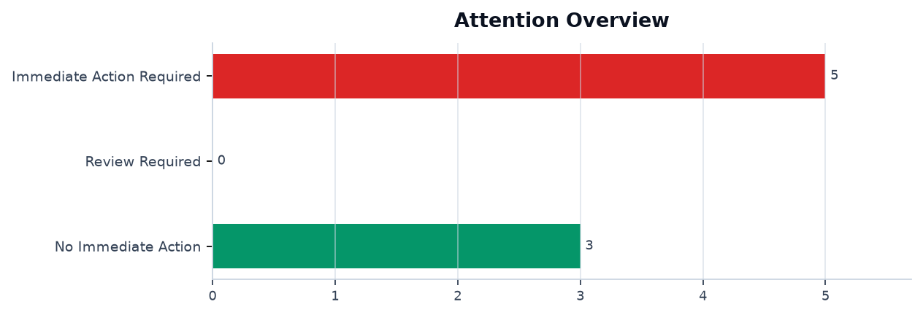
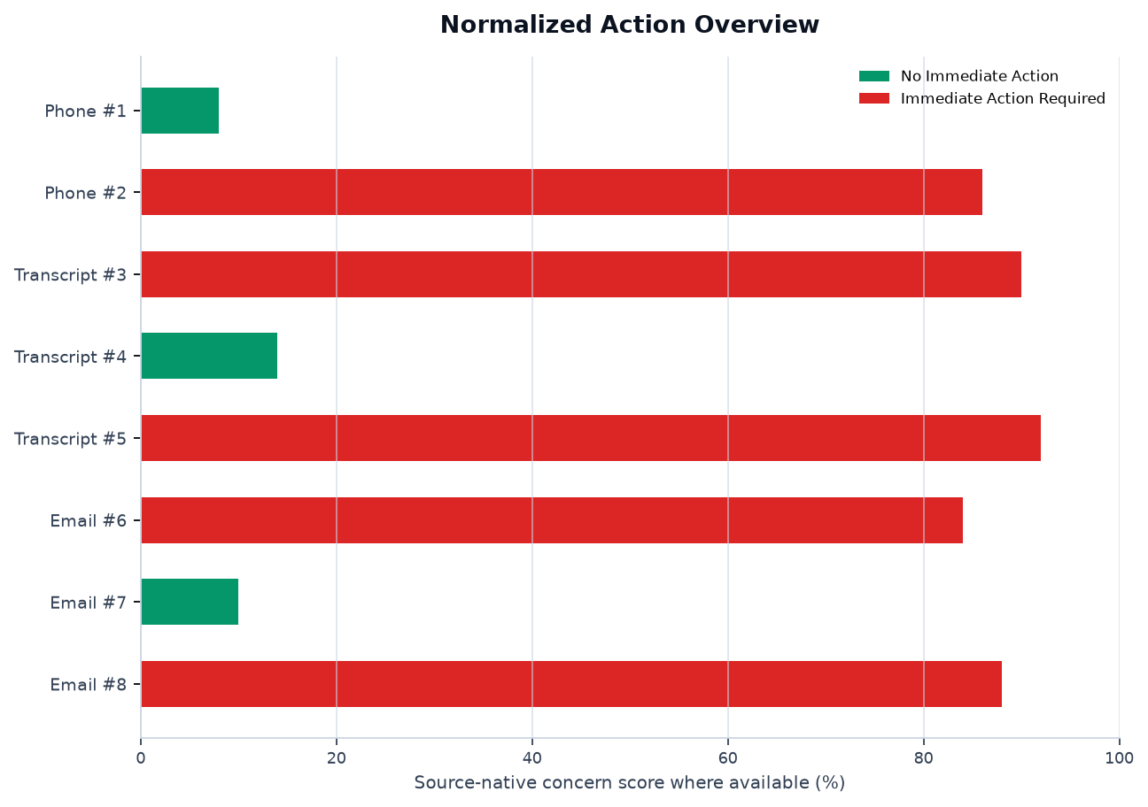
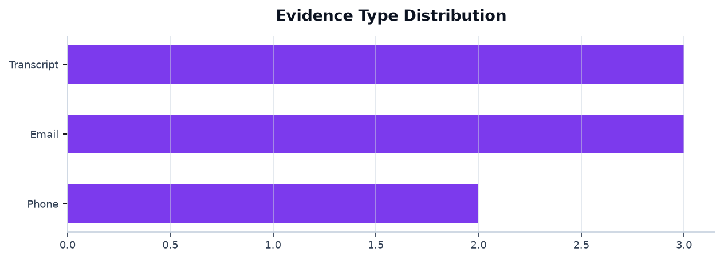
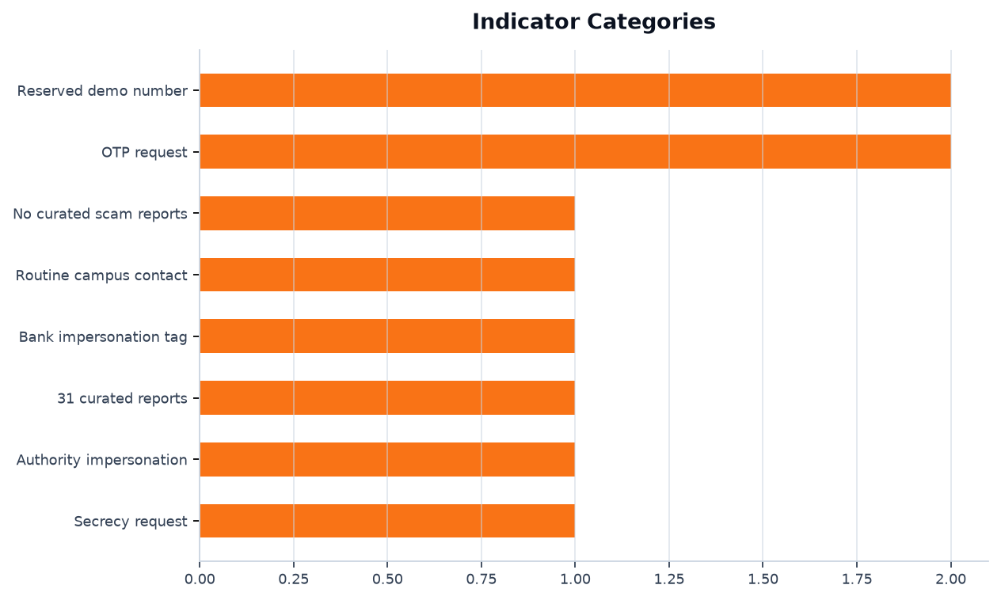
Interpretation note: email probabilities, transcript/audio risk signals, and phone evidence scores use different methods and are not directly comparable.

Reviewer Note
Verify suspicious contact through official channels, do not share OTP/passwords, preserve the evidence, and report urgent financial or identity-related requests to the relevant campus or organisation support team.

Technical Appendix
Investigation-specific output is grouped under its evidence record. Shared training evaluation metrics appear once in a separate reference section.

Evidence-Specific Supporting Visuals and Data
Evidence 1 - Phone | No Immediate Action
Result: Lower concern | Source: +447700900102 | Time: 2026-08-01 09:07:00

Supporting Visuals and Data

1. [Table] Phone demo reputation fixture
Reserved-number fixture for repeatable lecturer report generation.
sample_id | phone_number | reports | tag | expected_prediction
DEMO-PHONE-LEGIT-001 | +447700900102 | 0 | campus office | Lower concern
expected_action_status | expected_concern_score
No Immediate Action | 8.0
Evidence 2 - Phone | Immediate Action Required
Result: High concern | Source: +447700900101 | Time: 2026-08-01 09:06:00

Supporting Visuals and Data

1. [Table] Phone demo reputation fixture
Reserved-number fixture for repeatable lecturer report generation.
sample_id | phone_number | reports | tag | expected_prediction
DEMO-PHONE-SCAM-001 | +447700900101 | 31 | bank impersonation | High concern
expected_action_status | expected_concern_score
Immediate Action Required | 86.0
Evidence 3 - Transcript | Immediate Action Required
Result: Scam | Source: demo_transcript_police_case.txt | Time: 2026-08-01 09:05:00

Supporting Visuals and Data

1. [Text] Demo call transcript
Upload-ready transcript text used for the seeded result.
Caller: Your parcel is connected to a police case. Keep this confidential. Transfer RM500 to the secure account today so we can clear your name.

2. [Table] Expected output
Curated expected output for lecturer demo checks.
sample_id | expected_prediction | expected_action_status | expected_concern_score
DEMO-TRANSCRIPT-SCAM-002 | Scam | Immediate Action Required | 90.0
Evidence 4 - Transcript | No Immediate Action
Result: Non-scam | Source: demo_transcript_advisor_portal.txt | Time: 2026-08-01 09:04:00

Supporting Visuals and Data

1. [Text] Demo call transcript
Upload-ready transcript text used for the seeded result.
Advisor: Your course registration form is due Friday. Please submit it through the official student portal. Email me if you have questions about the module list.

2. [Table] Expected output
Curated expected output for lecturer demo checks.
sample_id | expected_prediction | expected_action_status | expected_concern_score
DEMO-TRANSCRIPT-LEGIT-001 | Non-scam | No Immediate Action | 14.0
Evidence 5 - Transcript | Immediate Action Required
Result: Scam | Source: demo_transcript_bank_otp.txt | Time: 2026-08-01 09:03:00

Supporting Visuals and Data

1. [Text] Demo call transcript
Upload-ready transcript text used for the seeded result.
Caller: I am from the bank fraud team. Your account is frozen. Do not end this call. Read me the TAC and OTP now so I can cancel the suspicious transfer.

2. [Table] Expected output
Curated expected output for lecturer demo checks.
sample_id | expected_prediction | expected_action_status | expected_concern_score
DEMO-TRANSCRIPT-SCAM-001 | Scam | Immediate Action Required | 92.0
Evidence 6 - Email | Immediate Action Required
Result: Suspicious | Source: demo_email_scholarship_fee.txt | Time: 2026-08-01 09:02:00

Supporting Visuals and Data

1. [Text] Demo email body
Upload-ready email text used for the seeded result.
Subject: Scholarship selected notice
Congratulations, you were selected for a student grant. Pay the RM150 processing fee today by instant transfer or your award will be cancelled.

2. [Table] Expected output
Curated expected output for lecturer demo checks.
sample_id | expected_prediction | expected_action_status | expected_concern_score
DEMO-EMAIL-SCAM-002 | Suspicious | Immediate Action Required | 84.0
Evidence 7 - Email | No Immediate Action
Result: Legitimate | Source: demo_email_library_notice.txt | Time: 2026-08-01 09:01:00

Supporting Visuals and Data

1. [Text] Demo email body
Upload-ready email text used for the seeded result.
From: Library Services <library@example.edu>
Subject: Requested book is ready
The book you requested is ready for collection at the circulation desk. Please bring your student card.

2. [Table] Expected output
Curated expected output for lecturer demo checks.
sample_id | expected_prediction | expected_action_status | expected_concern_score
DEMO-EMAIL-LEGIT-001 | Legitimate | No Immediate Action | 10.0
Evidence 8 - Email | Immediate Action Required
Result: Suspicious | Source: demo_email_urgent_mailbox.txt | Time: 2026-08-01 09:00:00

Supporting Visuals and Data

1. [Text] Demo email body
Upload-ready email text used for the seeded result.
From: University IT Helpdesk <notice@example.edu>
Subject: Action required: mailbox suspension
Your student mailbox will be suspended in two hours. Confirm your password and OTP at https://student-mail-verify.example.invalid to keep access.

2. [Table] Expected output
Curated expected output for lecturer demo checks.
sample_id | expected_prediction | expected_action_status | expected_concern_score
DEMO-EMAIL-SCAM-001 | Suspicious | Immediate Action Required | 88.0

Shared Model Reference Metrics
These are model evaluation references, not measurements produced by a single investigation.
No shared model evaluation artifacts were captured.

Evidence Register
# | Type | Time | Source | Input SHA-256 | AI analysis
1 | Phone | 2026-08-01 09:07:00 | +447700900102 | 3663765d6908e4e2d47bc8371d83a5da1aac95d981cdc71ee3e09f75f7a957c4 | Curated Phone Demo Fixture
2 | Phone | 2026-08-01 09:06:00 | +447700900101 | 26c74270c576f3fef307024bc8f5dc64d98bf240c5dd02ccd10e8f214feb3573 | Curated Phone Demo Fixture
3 | Transcript | 2026-08-01 09:05:00 | demo_transcript_police_case.txt | 7f452fb4fa13ca23b077602a498f787e4b8454de6ebf6977a936b500f2af9121 | Transcript DistilBERT/TF-IDF Ensemble
4 | Transcript | 2026-08-01 09:04:00 | demo_transcript_advisor_portal.txt | 6ad7dccb14a243d8e2fbf4a863a75a5a03d7d5e47788712f844f4d8df0ced71a | Transcript DistilBERT/TF-IDF Ensemble
5 | Transcript | 2026-08-01 09:03:00 | demo_transcript_bank_otp.txt | b866f2ea9c87e16e189315df202ffeb2110815891725964d3974e51eb43c21e4 | Transcript DistilBERT/TF-IDF Ensemble
6 | Email | 2026-08-01 09:02:00 | demo_email_scholarship_fee.txt | 57e7f0f2ce8b7445ff2d4867491f5f9821512468479fb82527b9b4e173cf256c | Email TF-IDF Ensemble
7 | Email | 2026-08-01 09:01:00 | demo_email_library_notice.txt | a6d980b805a967a4e05ebe4414fb5a387676dffac1dde1d3e1e3e2d75d49047d | Email TF-IDF Ensemble
8 | Email | 2026-08-01 09:00:00 | demo_email_urgent_mailbox.txt | 7ae758c076a0994cb1340dedb04b4adde82c42bf5eb256a8571cca78f610acdf | Email TF-IDF Ensemble

Scope and References
Educational scam-awareness support only. Results support review and do not prove identity, intent, legal liability, or authenticity.
EC-Council CEH - Social Engineering, Phishing, AI Impersonation, and Countermeasures: https://www.eccouncil.org/train-certify/certified-ethical-hacker-ceh/
NIST SP 800-61 Rev. 3 - Incident Response Recommendations and Considerations: https://csrc.nist.gov/pubs/sp/800/61/r3/final
SWGDE Requirements for Report Writing in Digital and Multimedia Forensics: https://www.swgde.org/documents/published-complete-listing/18-q-002-swgde-requirements-for-report-writing-in-digital-and-multimedia-forensics/
SWGDE Best Practices for Digital Evidence Collection: https://www.swgde.org/documents/published-complete-listing/18-f-002-best-practices-for-digital-evidence-collection/
NISTIR 8312 - Four Principles of Explainable Artificial Intelligence: https://www.nist.gov/publications/four-principles-explainable-artificial-intelligence
CISA Secure Our World - Recognize and Report Phishing: https://www.cisa.gov/secure-our-world
FTC Consumer Advice - AI Voice Cloning and Family Emergency Scams: https://consumer.ftc.gov/articles/scammers-use-fake-emergencies-steal-your-money
FCC Consumer Complaints - Unwanted Calls, Texts, and Caller ID Spoofing: https://consumercomplaints.fcc.gov/hc/en-us/articles/115002234203-Unwanted-Calls-Texts-Phone

