Business Requirement Document (BRD)
Project title: Design and Development of Business email platform for receiving and sending business emails whit brandnames
Prepared by: Hackton CEO.
Date: September 23, 2025

1. Executive Summary:
Hackton Business email aims to design and develop a platform where business owners and multiple people can manage and use their brand name to send business emails, though the dashboard given to them by Hackton or though a third party e.g google, outlook etc.
2. Objectives:
- Accessibility: Provide a dashboard where user can manage and send emails.
- Scalability: Ensure the platform can support numerous concurrent users.
- Flexibility: Allow customization and easy access for user in the platform.
- Engagement: Corporate feature to enhance business, development and learning.
- Integration: Make sure the emails can be connected whit third parties.
- Security: Customizable security, ensure data protection and secure user authentication
3. Scope:
Include:
- Design and prototype
- Development of web-based platform
- Core modules: User management, email dashboard, login system.
- Personal and third parties integration.
Exclude:
- Hardware procurement for users.
- Offline accessibility.
4. Key Features:
4.i User Management:
- Roles: Admin, User.
- Profile management and customizable dashboard.
- Single sign-on (SSO) and multi-factor authentication (MFA)
- Security customization and authenticator.
4.ii Dashboard Management:
- Sending and receiving emails.
- Email Controls and customization.
- Email spam and trash bin.
- Analyzing and database management.
4.iii User Management:
- Login and logout.
- Dashboard control.
- Customization and integration.
- Security check.
5. Tools and Technologies:
- Stacks: PYTHON, JavaScript, XML, JSON.
- Framework: DJANGO, Node.js, React
- Hosting: VPS cloud service configured whit NGINX.
- Third-Party Integrations: Email APIs.
- APIs: RESTAPI, DJANGORESFRAMEWORK.
- Database: Postgres SQL.
6. Image Examples:
Dashbords:
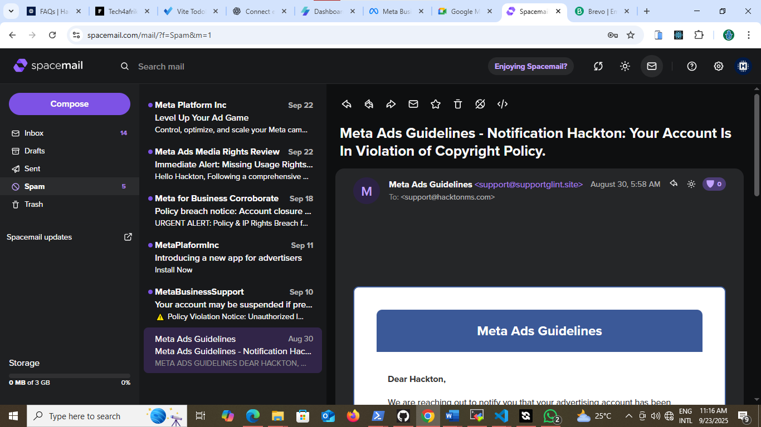
Example of what it should look like or a better design will also be good.
Login form:
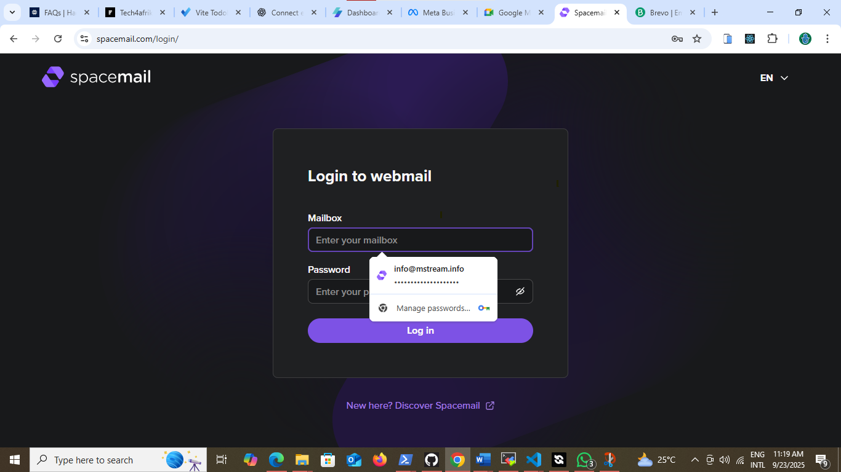
A simple login whit just mailbox name and it password required.

