Ovito

Ovito is a visualization software for looking at and analysing particle simulations. Home page is here:

https://ovito.org/

Installation:

Download and install latest version from Ovito home page do not install the version listed with apt repository it is quite out of date. It downloads and installs easily on Ubuntu 16.04.
----------------------------------------------------------------------------------------------------
I had the following issue with the internal python console not working in the gui. The issue was answered in this thread.: http://forum.ovito.org/index.php?topic=288.msg893#msg893

Here is a way to do it: Open the file ovito-3.0.0-dev155-x86_64/lib/python3.5/site.py in a text editor and change line 80 from
ENABLE_USER_SITE = None
to
ENABLE_USER_SITE = False
After this change, Ovito's Python interpreter should ignore your user package directory.

1. To run Ovito navigate into ovito3.0 directory and then type ‘bin/ovito’ into the terminal.

2. Data files are in the .xyz format. These look like this:

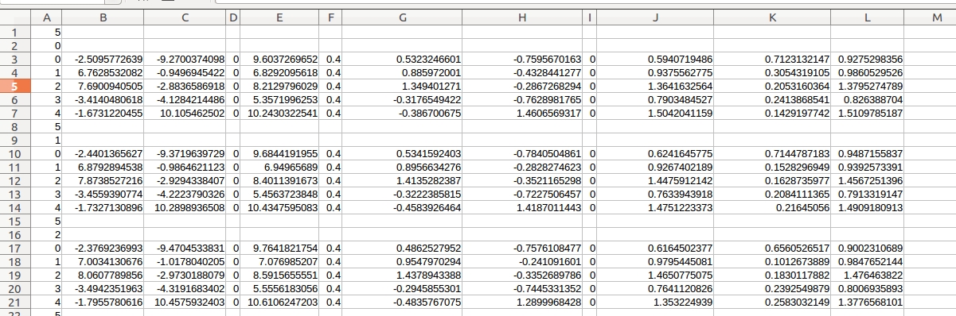
The first row tells you how many particles are in this frame. Second row is the frame number. Each subsequent row is the data for a particle. This pattern is repeated for multiple frame simulations. Columns 2-4 are x,y,z coordinates and must be in these positions. The remaining data fields are optional and can contain info such as particle radius, velocities etc.

Load a data file with ctrl + I. You should check the box which says file contains multiple time steps in the xyz pane.

3. Adding an overlay. You probably want to uncheck the Simulation cell top right. Click the additional layer tab top right (to the right of the camera). Select Python Script. Click Edit Script. Click Load Script from disk (in PythonScripts folder) or write a new one. Examples of overlays can also be found on the website here:

http://ovito.org/manual/viewport_overlays.python_script.html

See also faq:

http://forum.ovito.org/index.php?topic=289.msg898#msg898

4. To export images or movies:

-Click render tab on the right
-Select settings eg resolution, number frames etc.
-check to save to file and choose name and location
-Then at the top of this tab click “Render Active Viewport”
- File should now appear.

