# 1 Designing an API is Hard

It sure doesn’t seem like it at first, but honestly, the hardest part of building an API - is not writing the code - but designing it. Creating an API that your users will love, and that you will be able to continue to build upon, adding in more and more functionality as your platform grows.

Perhaps the biggest challenge is that we’re not very good at long-term API design, or as Roy Fielding, the creator of REST, states:

Unfortunately, people are fairly good at short-term design, and usually awful at long-term design.

The problem comes in that we often are thinking of a specific problem that WE want to solve, but are building an API that needs to be able to solve hundreds of thousands of problems. To meet our customers’ or end users’ needs, and not just our own.

Take for example the Constant Contact API. It was developed to provide developers the functionality they needed to enable email marketing campaigns within their own applications - and eventually to enable simplistic event reporting.

No one would ever have dreamed of using that API for a wifi router based service to build customer loyalty and offer coupons upon arrival – yet that’s exactly what not just one, but three of their API partners, Wavespot, SocialSign.in, and RewardMyWay did!!!

The great thing about building an API is that if it is usable, people will use it, and use it in ways you never imagined. The bad thing about building a usable API, however, is that people will use it.

And when they use it, they will have a list of expectations:

* The API will be easy to use and understand
* It will be consistent throughout and adhere to standards
* It will be easy to maintain and won’t just “stop working”
* It will last for years without them having to rewrite their code

#### API is Easy to Use and Understand

Like a good user interface, it’s important to understand that the ease of use of your API is key to it’s success. Businesses want to implement your API to take advantage of the benefits it would offer, whether it be accessing your customers, or adding new functionality to their service. But as with any business decision, there is a cost-analysis - and unless you’re a company like Google or SalesForce - there’s a good chance that if they struggle to integrate with your API, they’ll simply choose a competitors instead.

This is why it is so important to be able to understand first what your users are looking for (as I describe in my book, [*Undisturbed REST: a Guide to Designing the Perfect API*](http://www.mikestowe.com/books), but also to user test the interface you are creating to ensure that it makes sense to you, your developers, and to your potential API users.

It’s also critical to have strong, and readable documentation that walks developers through how to get started with your API, and how to use the different resources and methods within it.

Without good documentation, your API is almost guaranteed to fail.

#### It will be Consistent Throughout

One of the most frustrating aspects of any API is when you implement one resource, and then implement the other exactly the same way - only to find out that it doesn’t work as expected. Surprisingly, this is unfortunately very, very common - especially on APIs built by large teams.

Even some of the most popular APIs struggle with having inconsistencies in their API, which developers are quick to take to Twitter, StackOverflow, and other sources to gripe about.

All in all, every aspect of your API should be consistent - from how you get collections or methods, to how you perform searches, filtering, or pagination.

And just as important, be sure to take advantage of Best Practices and Standards. If you are building a RESTful HTTP API (as RAML is intended for), then make sure you are following the HTTP standards for that API, as well as incorporating the five required REST Constraints (and optimally, the sixth - code on demand).

#### It will be Easy to Maintain

Just like implementing your API, if it is difficult to maintain the integration with your API, businesses may be forced to find a different solution. One key to ensuring that your API is maintained and free of bugs/ errors is to build in extensive testing. By carefully testing your API throughout you can ensure that the contract you establish with your users (whether written or implied) is met.

This includes:

* Unit tests for the services driving your API
* Unit tests for your API interface
* Implementing testing services/ scripts for API calls
* Load testing your API to ensure it can scale with demand

It’s also important that as your platform grows that documentation is kept up to date. You might be surprised how often documentation, not the API itself drives business decisions. Without having up-to-date documentation, developers may struggle to implement features of your API (or be unaware that they exist to begin with), and again be forced to start looking for other options.

Last but not least, it is critical that your API is not riddled with backwards incompatibility breaks. Once something is pushed to production, developers will start writing code around it, relying on that interface, that contract for their application.

While versioning is, as I say, “a necessary evil,” it is an evil that while we need to plan for it, we should do our best to avoid.

Remember, businesses are relying on your API to help them meet their financial objectives. When you introduce backwards breaks, you are requiring them to step away from their actual business model (aka making money) and focus on fixing your mistakes.

As such, you need to build your API not just for the platform you have today, or the platform you might have in a month from now, but for the platform you will have in 2 years. That means creating an API that is designed to be flexible and extendable - when the future is unpredictable.

#### It lasts for Years

Inline with being easy to maintain, when businesses make the upfront investment to integrate with your API, they are expecting that your API will remain consistent for some substantial length of time - long enough for them to recover that initial investment and more.

Versioning, while at times necessary, is often extremely costly not just for your users, but for your company as well as you will find yourself having to maintain and support multiple API versions - EVEN if you deprecated the old version.

You’ll also find yourself dealing with numerous complaints from developers who will wait until the last minute to rewrite their entire application to work with your new version (something that you’ll not only feel in the support channels, but in public facing community channels as well).

Again, versioning is something you should plan for, but something you’ll also want to avoid as long as you can. Really the only time to version your API is if:

* Your platform has completely changed (ie you “pivoted” your application)
* Your users are demanding a newer format (such as REST when you support only SOAP)
* Or your API is no longer extensible (what we are trying to avoid here)

### Did I Mention: Designing an API is Hard

As you can see, there is a lot that goes into designing an API. Like a legal contract, once this contract is released it is VERY difficult to go back and start changing it. There are just too many dependencies, which means ultimately if not designed properly you’ll find yourself having to version, and costing yourself far more than it would just to do it the right way - the first time.

Thankfully, there is a way to design your API in such a way that you can visually see what it will look like, use design patterns and templates to ensure it is consistent, get invaluable user and client feedback, and even generate documentation, test scripts, and SDKs for it!

What is this magic tool that completely changes the way we design, build, test, document, and share APIs? An open source spec called RAML, or the **R**ESTful **A**PI **M**odeling **L**anguage.

RAML was designed by Uri Sarid and released back in October of 2013 to address these very issues. Inspired by Swagger, a spec that was designed to help you document and generate your already built API - RAML was designed to encompass the entire API lifecycle, from start to finish.

And if you already have your API, don’t worry! You can start implementing RAML at any stage of the API lifecycle, and even use the design aspects as you continue to expand your API (or as they say, better late than never).

#### Human & Machine Readable

Another thing that makes RAML truly unique is that it was built on YAML, a format designed to be both machine and human readable. This means that RAML can be parsed by numerous languages (Java, .NET, Python, PHP, Ruby, JavaScript, Go, etc) while also being readable (and editable) by people with no technical knowledge.

Rather than having to dig through JSON, or use a converter, anyone on your team can quickly modify descriptions to create even better documentation. You can even place your RAML file on GitHub to encourage your community to help maintain and build your documentation for you!

#### Get More Bang for Your Buck

This single RAML file can also be used by a myriad of services to help developers integrate your API - from Integration tools like MuleSoft’s Anypoint Platform - to SDK generators such as APIMatic.io, to directories such as ProgrammableWeb, and a large pool of opensource tooling.

This ensures that you get the “most bang out of your buck.” In fact, the benefits have already been realized by some very large companies who have put RAML at the core of their API design - and are using it to innovate and rennovate within their companies!

In short, RAML let’s you do more, faster, with less.

# 2 Getting Started

### Using the API Designer

### Installing API Workbench

STUFF NEEDS TO GO HERE

### RAML Basics

The nice thing about using a tool like the API Designer is that it will automatically prefill the required aspects of your RAML file for you. These are the: - RAML and version declaration - Your API Title - The BaseUri for your API - The version of your API (ie version 1, 2, 4, etc)

To start the file off, we’ll simply add #RAML followed by the version of RAML that we are using, in this case 1.0:

#%RAML 1.0

This tells the parser that this should be handled as a RAML file, and also what version of RAML so that the parser knows how to handle the different types of functionality (for example, many features available in RAML 1.0 are not available in RAML 0.8 - this tells the parser to take adavntage of these features).

Once we have declared the file as a RAML file (as shown above) the next thing we need to do is give our API a title, such as My API:

#%RAML 1.0   
title: My API

So far this has been pretty easy, right? The next thing to add is our baseUri, or what the root domain and path for the API is. This will be used by the majority of the tooling to tell your users where to make the calls, and even help them test their calls. To add the baseUri, simply add it in like so:

#%RAML 1.0  
title: My API  
baseUri: http://api.mydomain.com  
version: 1

Last but not least, we should declare what version of the API “My API” this is. This will be used to help ensure developers know which version of the API they’re using, as well as for all of your documentation. This will also help you segment versions of your API for when you inevitably have to create a new version.

We do this by adding in the version property like so:

#%RAML 1.0  
title: My API  
baseUri: http://api.mydomain.com  
version: 1

And there you go! Just like that you have started off your RAML file. The next part is adding in resources, methods, and properties - which the next few sections will walk you through. The nice thing is, each aspect of RAML is as easy, and as clear-cut as the four items we declared above.

#### Adding in a Default Media Type

Stuff goes here

#### Adding in Available Protocols

Stuff goes here

### Creating Resources

Creating resources in RAML is as easy as writing down it’s path. For example, if we wanted to create an API with a /users resource, all we would need to type is /users: like so:

#%RAML 1.0  
title: My API  
baseUri: http://api.mydomain.com  
version: 1  
  
/users:

Just like that we now have a /users resource:

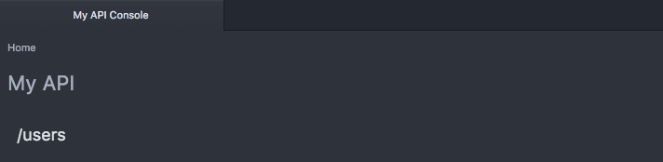

To add a description to our /users resource, we simply follow YAML conventions and add the description property:

#%RAML 1.0  
title: My API  
baseUri: http://api.mydomain.com  
version: 1  
  
/users:  
 description: this is my users resource! isn't this easy?!

And once again, just like that, the description is added to our resource:

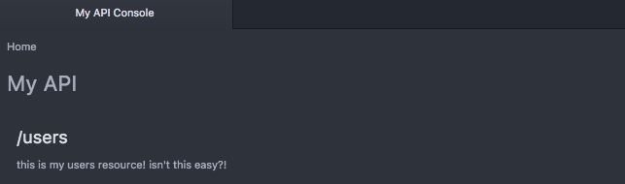

#### URI Properties

To create more complex resources, or resources that utilize names or IDs, you can take advantage of URI properties, or placeholders within the resource. To do this, simply tell the spec that your ID is a URI Property by placing curly brackets around it, like so:

/users/{id}:

Just like that you can setup IDs or dynamic resource paths:

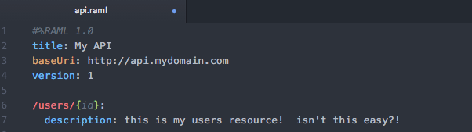

MULTIPLE URI PROPERTIES

#### Nested Resources

But another great feature of RAML is something called resource nesting, or creating child resources. To add a nested resource, simply follow YAML convention by tabbing in once under the parent resource, and then declare your child resource as you did your parent resource - but with a relative path from the parent’s path:

#%RAML 1.0  
title: My API  
baseUri: http://api.mydomain.com  
version: 1  
  
/users:  
 description: this is my users resource! isn't this easy?!  
   
 /{id}:  
 description: this is a nested dynamic resource using a URI property

As you can see, the /{id} resource is now a child of the parent resource. This lets you define your API in a way that is efficiently organized, letting you quickly find all sub-resources under their parent.

However, it’s important to note that the child resources inherit the parent path ONLY - and do not inherit any of parent’s properties such as it’s resourceType or methods, unless specifically specified in the child resource (as you did in the parent).

For example, if we look at this RAML snippet:

#%RAML 1.0  
title: My API  
baseUri: http://api.mydomain.com  
version: 1  
  
/users:  
 get:  
   
 /{id}:

You’ll notice that the resource /users has a GET method, however the child resource /{id} does not.



Again, this is because the child resource only inherits the path and not the properties of its parent.

### Creating Methods

Just as creating resources was as simple as declaring the path, adding methods is as simple as declaring the method:

#%RAML 1.0  
title: My API  
baseUri: http://api.mydomain.com  
version: 1  
  
/users:  
 get:

Which in turn creates:



RAML supports GET, PUT, PATCH, POST, DELETE, TRACE, HEAD, and OPTIONS although you’ll want to be careful which ones you use as not all are official methods, and not all are supported by all servers.

It’s also important to understand the difference between each of these methods as they all have VERY specific purposes with careful and well established standards surrounding them. Refer to my other book, [*Undisturbed REST: a Guide to Designing the Perfect API*](http://www.mikestowe.com/books) if you’re not sure how to properly use them.

Like with resources, you can add a description to your methods. This is a perfect place to share what the method is and what it does, and can be used in generating documentation for your API.

To add a description, simply use the description property:

#%RAML 1.0  
title: My API  
baseUri: http://api.mydomain.com  
version: 1  
  
/users:  
 get:  
 description: this is my get method

#### Querystring Parameters

Another common functionality with APIs is Querystring Parameters, or manipulating the response using the URI querystring.

RAML lets you document the different querystrings under the method they are being implemented under (hopefully this is the GET method!!!) by using the queryParameters property, like so:

#%RAML 1.0  
title: My API  
baseUri: http://api.mydomain.com  
version: 1  
  
/users:  
 get:  
 description: this is my get method  
 queryParameters:

For each queryParameter you will simply need to declare the name of the parameter, keeping it consistent with how it is used within the URL. So if our URL was http://api.mydomain.com/users?status=active we would call the query parameter “status” like so:

#%RAML 1.0  
title: My API  
baseUri: http://api.mydomain.com  
version: 1  
  
/users:  
 get:  
 description: this is my get method  
 queryParameters:  
 status:

And as simple as that, we now have the status query parameter showing up in our API documentation:

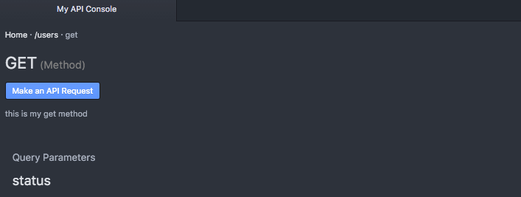

Of course, there is much more you can do with the query parameter, such as providing it’s display name, a description, an example, the default value, whether or not it is required, and even it’s type:

#%RAML 1.0  
title: My API  
baseUri: http://api.mydomain.com  
version: 1  
  
/users:  
 get:  
 description: this is my get method  
 queryParameters:  
 status:  
 displayName: Status  
 description: Status of the users to retrive (active, inactive, all)  
 default: all  
 required: false  
 type: string

Need to add:

validWhen/ requiredWhen

By providing this additional information, you are empowering your users as this information can be passed through to them in your documentation, as well as taken advantage of by other tools that parse your API’s RAML spec.

#### Form Data

This needs to be filled out!

#### Body Data

More common than using form data for PUT, PATCH, and POST calls, however, is the use of a format like JSON or XML within the body.

RAML also lets you share examples of what the user should be sending when making these calls by using the body property, and then the corresponding content-type:

#%RAML 1.0  
title: My API  
baseUri: http://api.mydomain.com  
version: 1  
  
/users:  
 post:  
 body:  
 application/json:

Unfortunately, this really doesn’t change the way our documentation works as we still have not provided WHAT the body should look like.

To do this we have two options, we can share a schema (more often used with XML) or provide an example of the data being shared.

Of course, if we’d like we can share both by using the corresponding properties:

#%RAML 1.0  
title: My API  
baseUri: http://api.mydomain.com  
version: 1  
  
/users:  
 post:  
 body:  
 application/json:  
 schema: |  
 {  
 "$schema": "http://json-schema.org/draft-04/schema#",  
 "id": "http://jsonschema.net",  
 "type": "object",  
 "properties": {  
 "name": {  
 "id": "http://jsonschema.net/name",  
 "type": "string"  
 },  
 "city": {  
 "id": "http://jsonschema.net/city",  
 "type": "string"  
 },  
 "state": {  
 "id": "http://jsonschema.net/state",  
 "type": "string"  
 }  
 },  
 "required": [  
 "name",  
 "city",  
 "state"  
 ]  
 }  
 example: |  
 {  
 "name": "Mike Stowe",  
 "city": "San Francisco",  
 "state": "CA"  
 }

By providing both this lets us share with our users what the request should look like, as well as the specific information about what the request needs to include and how it should be formatted, something that again can be provided to them via your documentation and also used to generate auto-validating SDKs:

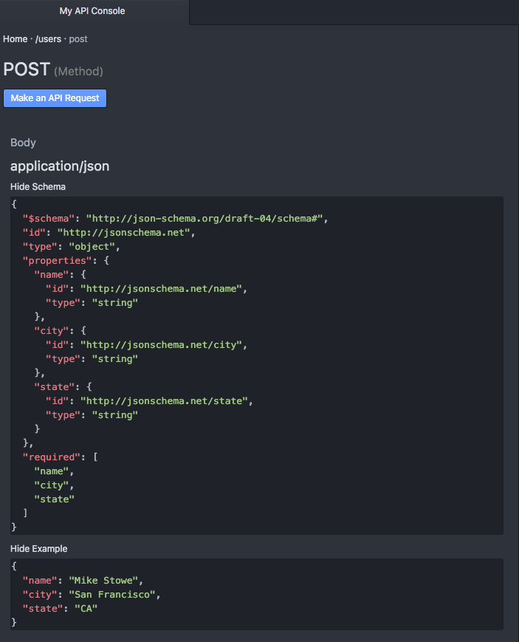

Of course, your API may support numerous content-types, which works fairly well with RAML, as all you have to do to add an additional content type is, well, add it (I’m removing schemas in this case to keep it short, but of course RAML supports multiple content-types having schemas):

#%RAML 1.0  
title: My API  
baseUri: http://api.mydomain.com  
version: 1  
  
/users:  
 post:  
 body:  
 application/json:  
 example: |  
 {  
 "name": "Mike Stowe",  
 "city": "San Francisco",  
 "state": "CA"  
 }  
 text/xml:  
 example: |  
 <user>  
 <name>Mike Stowe</name>  
 <city>San Francisco</city>  
 <state>CA</state>  
 </user>

As you can see, we now have multiple content types to choose from shown in our documentation:

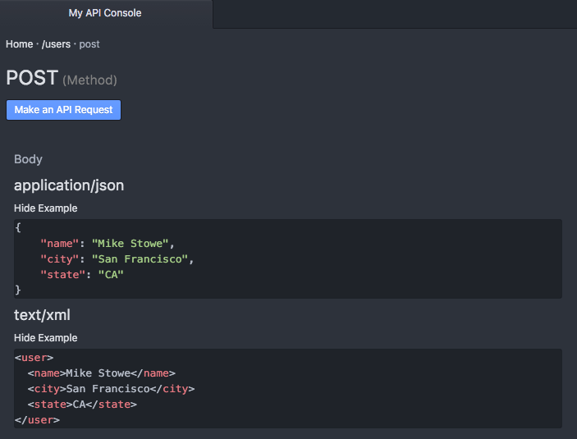

What’s important to remember is that schemas describe the request content, where-as examples are “real-life demos” of what that formatted content would look like when being sent to your server via the content-type body.

### Handling Responses

RAML lets you easily describe all aspects of your API resource method’s responses for multiple status codes including defining headers, content-types, schemas, and example responses.

To declare responses in RAML, simply use the responses property:

#%RAML 1.0  
title: My API  
baseUri: http://api.mydomain.com  
version: 1  
  
/users:  
 post:  
 responses:

#### Status Codes

As RAML is intended to describe HTTP REST APIs, responses rely on the standard HTTP status codes.

The most popular status codes are:

|  |  |  |
| --- | --- | --- |
| Status Code | Description | Generally Returned For |
| **2xx** | **Successful** |
| 200 | The request was handled successfully | GET, PUT, PATCH |
| 201 | A new object has been created | POST |
| 204 | The request was successful, but there’s no content to return | DELETE |
| **3xx** | **Redirection** |
| 301 | Resource or item moved permanently | ALL |
| 304 | Nothing was modified by the request | PUT, PATCH |
| **4xx** | **Client Error** |
| 400 | The request could not be understood by the server | ALL |
| 401 | Not authorized to access or perform action | ALL |
| 404 | The resource or item could not be found | GET |
| 405 | The method attempted (GET, PUT, POST, etc) is not allowed | ALL |
| 415 | The media type request (JSON, XML, etc) is not supported | ALL |
| **5xx** | **Server Error** |
| 500 | The server experienced an unexpected error and could not complete the request | ALL |

However, you can find a more detailed list in chapter 9 my book, “Undisturbed REST.”

To setup responses for each status, use the status code as the key for the response, like so:

#%RAML 1.0  
title: My API  
baseUri: http://api.mydomain.com  
version: 1  
  
/users:  
 post:  
 responses:  
 201:  
 # 200 - Object Created  
   
 400:  
 # 400 - Bad Request  
   
 500:  
 # 500 - Server Error

Which as you can see adds them to our API documentation for that method:

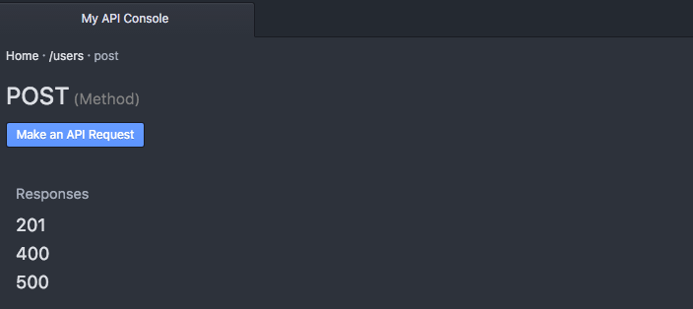

#### Headers

Headers are used to transmit important information about the response, such as the location of newly created object.

Adding headers is as simple as using the headers property within the status code’s response block. Then add the name of the header (such as location) as the property.

#%RAML 1.0  
title: My API  
baseUri: http://api.mydomain.com  
version: 1  
  
/users:  
 post:  
 responses:  
 201:  
 headers:  
 location:  
 #location data will go here  
 401:  
 # Not Authorized

Once you have defined the header by the property name you can add the following properties to each header property as necessary:

|  |  |
| --- | --- |
| Property | Description |
| displayName | How to display the header in documenation |
| type | Data type of the header property such as string, integer, etc |
| example | An example of the type of data the header may return |

For example:

#%RAML 1.0  
title: My API  
baseUri: http://api.mydomain.com  
version: 1  
  
/users:  
 post:  
 responses:  
 201:  
 headers:  
 location:  
 displayName: Location  
 type: string  
 example: http://http://api.mydomain.com/users/109  
 401:  
 # Not Authorized

As you can see, this is then translated into our documentation for us:

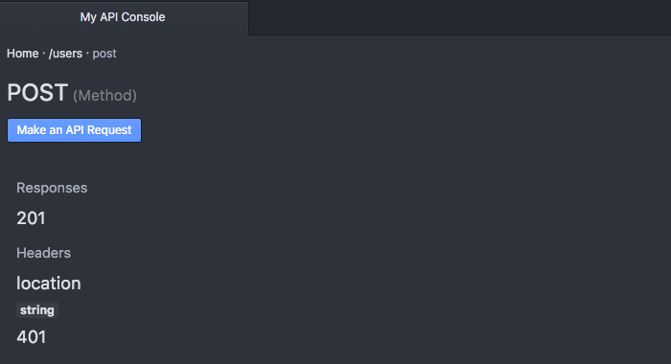

#### Content Types

RAML also lets you define not just one, but multiple content types for each HTTP Status Response code.

This means that you can return back data as JSON, XML, plain text, form-encoded, or other formats.

To define a content type, first state that you are returning back body data by using the body property, and then use the associated content-type for that content type, like so:

#%RAML 1.0  
title: My API  
baseUri: http://api.mydomain.com  
version: 1  
  
/users:  
 post:  
 responses:  
 201:  
 headers:  
 # header information  
   
 body:  
 application/json:

To list multiple content types, you can simply add additional content types within the body section of the status code response data, like so:

#%RAML 1.0  
title: My API  
baseUri: http://api.mydomain.com  
version: 1  
  
/users:  
 post:  
 responses:  
 201:  
 headers:  
 # header information  
   
 body:  
 application/json:  
   
 text/xml:

The next step to showing off these content types is adding in example response data so that we can see what they look like.

#### Examples

A unique feature of RAML compared to some other specifications is the ability to create your own examples rather than forcing you to build a schema for the response.

Adding an example is as simple as using the example property. However, because most examples are multi-lined, and because RAML is written in the YAML format, you’ll need to add a pipe “|” so that it can be properly parsed.

Another option, of course, is to include your example using !include which we will talk about in a later chapter.

#%RAML 1.0  
title: My API  
baseUri: http://api.mydomain.com  
version: 1  
  
/users:  
 post:  
 responses:  
 201:  
 headers:  
 # header information  
   
 body:  
 application/json:  
 example: |  
 {  
 "response" : "data"  
 }  
   
 text/xml:  
 example: |  
 <response>  
 data  
 </response>

Now if we look at the API Console we can see multiple content types (one for JSON and one for XML) as well as the example response data for each:

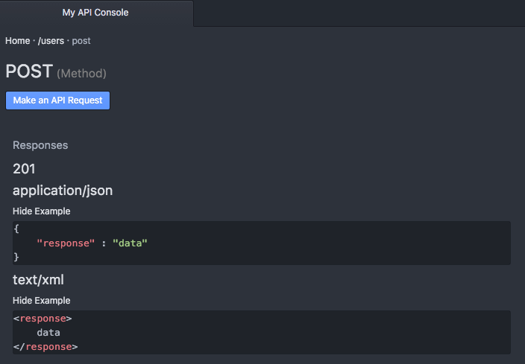

#### Schemas

Schemas work very similarly to examples, except you need to use the schema property, like so:

#%RAML 1.0  
title: My API  
baseUri: http://api.mydomain.com  
version: 1  
  
/users:  
 post:  
 responses:  
 201:  
 headers:  
 # header information  
   
 body:  
 application/json:  
 example: |  
 {  
 "response" : "data"  
 }  
   
 schema: |  
 {  
 "$schema": "http://json-schema.org/draft-04/schema#",  
 "id": "http://jsonschema.net",  
 "type": "object",  
 "properties": { "response": {  
 "id": "http://jsonschema.net/response",  
 "type": "string"  
 }  
 },  
 "required": [  
 "response"  
 ]  
 }

As you can see in the above example, RAML lets you explain your content types with examples, schemas, or both.

Now if we look in the API Console, while we still have the example, we can now see the schema for the application/json response body:

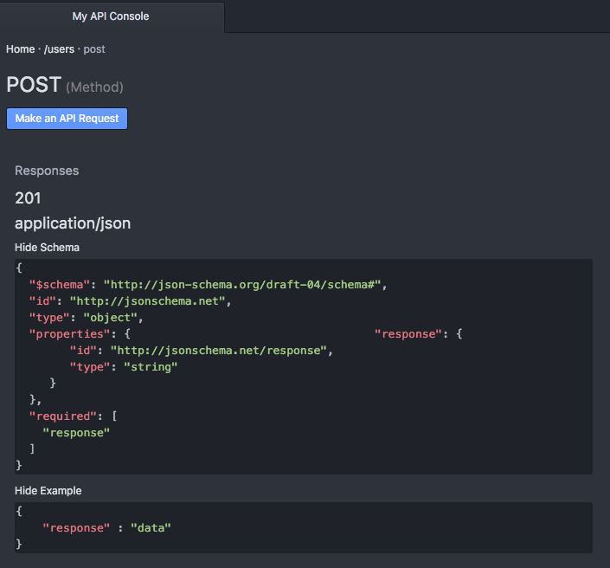

#### Hypermedia

One of the most popular feature requests for RAML 1.0 was added support for hypermedia, or dynamically driven linking formats.

However, one of the problems with hypermedia is the fact that it can be so truly dynamic, meaning that there may not be a way to actually define what responses are available for which items as each can be so individualistic.

The other challenge with supporting hypermedia is the number of hypermedia specifications in the market. For example, you have JSON API, HAL, JSON-LD, Collection+JSON, Siren, Uber, Yahapi, CPHL, and many more.

However, because hypermedia is represented in the body of the response, you are still able to describe a static representation of what types of links MAY be returned, as well as what hypermedia format you are returning.

For example, if we are using HAL (content type: application/json+hal) we can represent an example of its usage like so:

/users:  
 post:  
 responses:  
 201:  
 headers:  
 # header information  
   
 body:  
 application/json+hal:  
 example: |  
 {  
 "field1" : "data",  
 "field2" : "data",  
 "field3" : "data",  
 "_links" : {  
 "self": { "href": "/users/1" },  
 "messages": { "href": "/users/1/messages" },  
 }  
 }

#### Error Handling

# 3 Using Templates

Now that you have an idea of what your API resources will look like, RAML let’s you setup includes and templates to allow for both code reuse and the implementation of design patterns. This not only ensures that your API is consistent throughout, but also lets you organize your API to keep it easily readable by those working with the RAML spec.

It’s important to remember that the benefits of code reuse and design patterns are both immediate and long-term. While you may feel that you can build a consistent API, the patterns ensure consistency. This especially becomes important as your API grows and newer developers start working with it - often times trying to implement new resources or methods without having a strong and full understanding of your entire API. ###Includes The easiest of the templates to setup, the !include function lets you pull in external files, whether they be another RAML file, example response files, or schemas.

Using the !include file is as simple as:

#%RAML 1.0  
title: My API  
baseUri: http://api.mydomain.com  
version: 1  
  
/resource:  
 get:  
 responses:  
 200:  
 body:  
 application/json:  
 example: !include examples/resource_get.json  
 schema: !include schemas/resource_get.json

### Base

I wish I was an oscar meyer weiner...

### ResourceTypes

ResourceTypes on the other hand let you create resource templates, or specific templates based on the type of resource, often split into item or collection.

For example, if you are performing an operation on a collection (usually the resource WITHOUT an ID) you can setup a resourceType so that all your collection based resources operate exactly the same (just with different data).

You can also do the same with your item resources (/resource/{ID}), again creating a specific template that ensures that all item resources look and feel the same way.

Another huge advantage of resourceTypes is that it lets you define all your possible responses in a single place, rather than having to repeat your general status code responses (200, 201, 301, 304, 401, 404, 405, 415, 500) for each of the individual resources.

#%RAML 1.0  
title: My API  
baseUri: http://api.mydomain.com  
version: 1  
  
resourceTypes:  
 - collection:  
 get:  
 description: this is a get method  
   
 post:  
 description: this is a post method  
   
 delete:  
 description: this is a delete method  
 responses:   
 202:  
 headers:  
 304:  
 body:  
 application/json:  
 example: |  
 {"Response" : "Nothing Mofidied"}ers:  
 401:  
 body:  
 application/json:  
 example: |  
 {"Response" : "Not Authorized"}  
 405:  
 body:  
 application/json:  
 example: |  
 {"Response" : "Method Not Allowed"}  
 415:  
 body:  
 application/json:  
 example: |  
 {"Response" : "Content-type Not Recognized"}  
 500:  
 body:  
 application/json:  
 example: |  
 {"Response" : "Internal Server Error"}  
  
/users:  
 type: collection

You’ll noticed that the /users doesn’t actually have any properties assigned to it other than type: item, but because it is of a known resourceType, all of the information will be automatically pulled into it for us:



Including method properties:

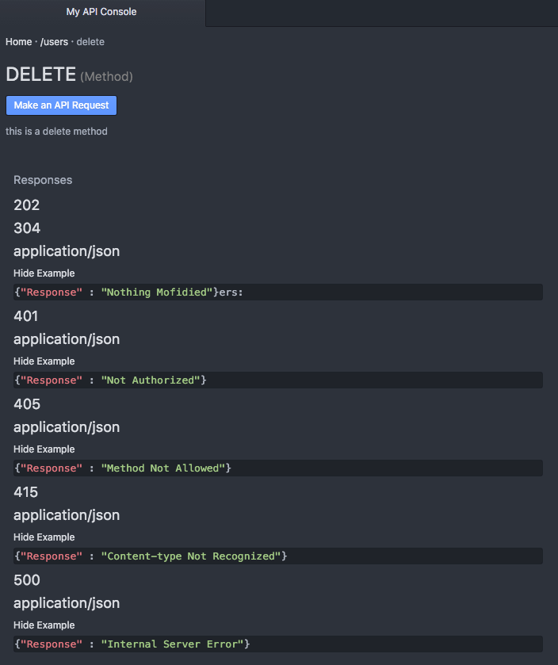

#### Declaring Optional Methods

Of course, chances are you do not want ALL the information to be pulled in all of the time, in which case you can make methods OPTIONAL by adding a ? to the end of the method name, like so:

#%RAML 1.0  
title: My API  
baseUri: http://api.mydomain.com  
version: 1  
  
resourceTypes:  
 - collection:  
 get?:  
 description: this is a get method  
   
 put?:  
 description: this is a put method  
   
 post?:  
 description: this is a post method  
   
 delete?:  
 description: this is a delete method  
  
/users:  
 type: collection

Now the /resource does not have ANY properties being pulled in because we have declared all the methods to be optional, and to only be pulled in if explicitly called by the resource.

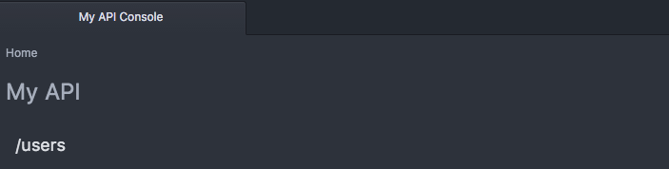

But the second we call in one of the properties, we now have it’s description and any underlying properties that we would delcared:

/users:  
 type: collection  
 get:

As you can see here:



#### Placeholders within ResourceTypes

Just as you probably do not want all methods in every resource, chances are you probably want different descriptions, examples, properties, and other data within your resources.

Keep in mind, that you can always override the resourceType by typing in the data again, or by not having the data wtihin your resource to begin with.

However, for properties that are consistent across your resources, it may be most efficient to take advantage of placeholders, or variables within the template that will be replaced by the placeholder value assigned by that resource once pulled in.

Placeholders within RAML are denoted by double less than and greater than signs, or <<PLACEHOLDER>>.

#%RAML 1.0  
title: My API  
baseUri: http://api.mydomain.com  
version: 1  
  
resourceTypes:  
 - collection:  
 get:  
 description: this is a get method  
 responses:  
 200:  
 body:  
 application/json:  
 example: |  
 <<exampleItem>>

As you can see from the code above, first we declare our placeholders in the resourceType itself, and then we specify the values in the calling resource, under that specific type:

/users:  
 type:   
 collection:  
 exampleItem: |  
 {  
 "name": "Mike Stowe",  
 "city": "San Francisco",  
 "state": "CA"  
 }

These placeholders are automatically replaced with the correct data in our documentation:

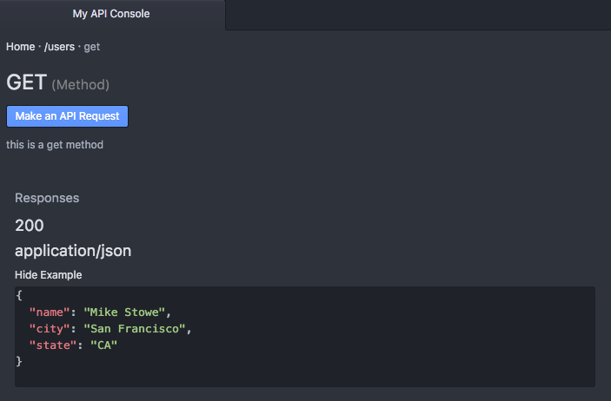

This allows us to ensure consistency not only in how our resources operate, but also in our documentation. Making it easy for our developers to go from resource to resource, knowing that the code and the documentation will be consistent.

### Traits

Traits operate in a fairly similar fashion to resourceTypes except that they operate more as functions with the placeholder values being sent as properties in an array, and are designed specifically for use within the method (such as GET, PUT, PATCH, POST, or DELETE).

Traits are typically used for operations such as pagination, searching, or filtering the method data.

To delcare a trait, first we need to declare it at the top of our spec under the traits property:

#%RAML 1.0  
title: My API  
baseUri: http://api.mydomain.com  
version: 1  
  
traits:   
 - pageable:  
 queryParameters:  
 offset:  
 description: Skip over a number of elements by specifying an offset value for the query  
 type: integer  
 required: false  
 example: 20  
 default: 0  
 limit:  
 description: Limit the number of elements on the response  
 type: integer  
 required: false  
 example: 80  
 default: 10

And then we will pull it into our method using the is property:

/users:  
 get:  
 is: [pageable]

Once the trait is successfully pulled in, we can see it within the API designer or in our documentation:

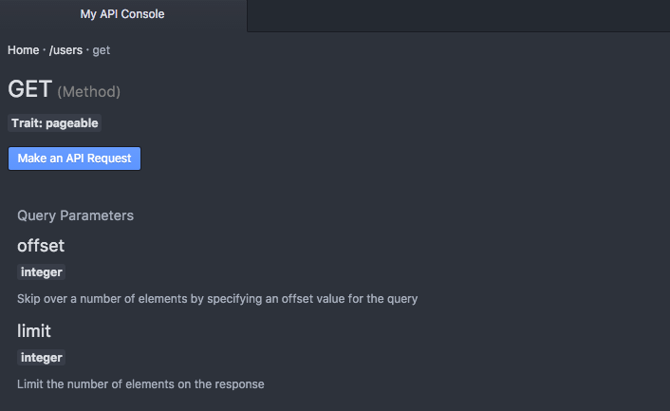

As mentioned, you can also take advantage of placeholders with traits by sending these values back in a key, value based array:

#%RAML 1.0  
title: My API  
baseUri: http://api.mydomain.com  
version: 1  
  
traits:   
 - filterable:  
 - pageable:  
 queryParameters:  
 offset:  
 description: Skip over a number of elements by specifying an offset value for the query  
 type: integer  
 required: false  
 example: 20  
 default: <<offsetDefault>>  
 limit:  
 description: Limit the number of elements on the response  
 type: integer  
 required: false  
 example: 80  
 default: <<limitDefault>>  
   
/users:  
 get:  
 is: [  
 filterable,  
 pageable: {offsetDefault: 0, limitDefault: 20}  
 ]

The biggest advantage of traits is that they ensure consistency in the way your methods are acted upon. Remember in Chapter 1 where we talked about how easy it is for these inconsitencies to crop up, making APIs difficult to use (as you have to search one resource one way, but another a completely different way - or worse, the same resource different ways) - by using traits you are creating a sure way NOT to run into this issue and have such inconsistences across your API.

The other nice thing about traits is that you can apply mulitple traits to your methods, letting you pull in and utilize multiple types of functions as much or as little as needed.

### Libraries

As you start adding traits, resourceTypes, schemas, and examples, it’s easy for your specifcation to become bloated. Of course you can call all of these in with !include but you still are not able to take advantage of code reuse at scale.

One of the new features of RAML 1.0 is libraries, or the ability to call in parts of your specification in a namespaced scope - meaning that you can pick and choose which of these items to apply to your spec.

This is particularly helpful if you have multiple APIs that share common themes (/users for example).

To pull in a namespaced library, you’ll first want to create a library file. We declare that a RAML specification is only to be used as a library by adding “Library” to the top of the file, like so:

#%RAML 1.0 Library

By adding this line, we are telling the RAML spec to treat this file as a class, and not as an independent RAML specification.

Let’s move our resourceTypes and Traits into this file:

#%RAML 1.0 Library  
resourceTypes:  
 - collection:  
 get:  
 # Get method goes here  
 post:  
 # Post method goes here  
 delete:  
 # Delete method goes here  
  
traits:  
 - filterable:  
 #Filterable trait goes here  
 - pageable:  
 #Pageable trait goes here

Now to call in this library, we will again pull it in using the uses property and the !include command:

#%RAML 1.0  
title: My API  
baseUri: http://api.mydomain.com  
version: 1  
  
uses:  
 users: !include libraries/users.raml  
  
/users:  
 get:

However, at this point nothing is being applied to the resource or the method. If we try to apply the “collection” resourceType as we did before, the result will be an error:

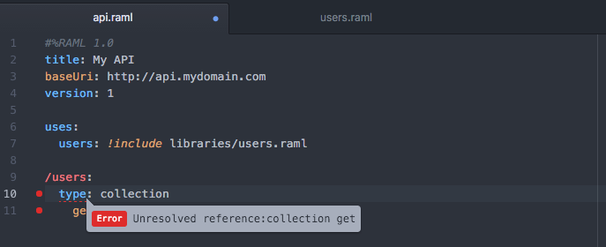

The reason for this is that the resourceType “collection” doesn’t exist! Instead, it is part of the users object that we declared above, and as such to utilize that resourceType we have to call it with respect to its parent’s name, like so:

#%RAML 1.0  
title: My API  
baseUri: http://api.mydomain.com  
version: 1  
  
uses:  
 users: !include libraries/users.raml  
  
/users:  
 type: users.collection  
 get:

As you can see, now the resourceType users.collection has been applied to our resource:

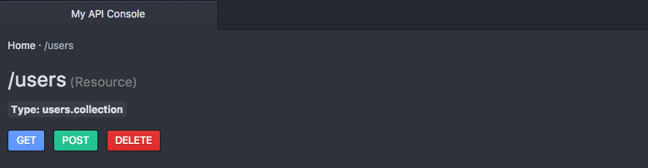

By having your resourceTypes, traits, schemas, and examples namespaced, you are able to prevent collisions and only use the components of a library that you choose - keeping your specification clean, and your code reusable.

### Overlays

Overlays… (a RAML file that extends another RAML file but in a strict Interface sense)

CODE

Blah:



Picture Needed

### Annotations

A new feature in RAML 1.0, annotations are designed to allow for vendor specific properties to be placed within your RAML specification, or preferably within an overlay that pulls in your standardized specification.

CODE

Blah:



Picture Needed

# 4 Advanced Features

### Data Types

Can be used in place of schemas

### Dynamic Properties

first match

### Overloading

### Security

#### Basic Auth

#### Digest Auth

#### OAuth 1

#### OAuth 2

#### Custom Auth

### Strict Typing

# 5 Community Tooling

One of the strengths of RAML is the fact that the spec is surrounded by a very active open source community, while also being supported by some of the leading enterprises - ensuring a large selection of tooling to help you in all aspects of the API lifecycle.

Along with the release of RAML 1.0, however, MuleSoft also contributed a new tool - the API WorkBench which encompasses nearly every aspect of the API lifecycle, letting you not only design your API, but test and generate SDKs and tooling all from a single source.

Because of the unique capabilities of this tool, we’ll first take a look at all it offers, and then jump into some of the most popular tools segemented by capability (tools for designing your API, building your API, testing your API, documenting your API, and sharing your API).

### Design

#### API Notebook

### Build

#### JavaScript

##### Osprey

Osprey is a JavaScript framework for rapidly building applications that expose RAML APIs. It’s based on Node and Express.

#### Java

##### Restlet

With Restlet Framework’s powerful routing and filtering capabilities, unified client and server Java API, developers can build secure and scalable RESTful web APIs. It is available for all major platforms (Java SE/EE, Google AppEngine, OSGi, GWT, Android) and offers numerous extensions to fit the needs of all developers.

##### RAML for JAX-RS

The goal of RAML for JAX-RS is to provide a set of tools to work with these technologies in a way of being able to scaffold a JAVA + JAX-RS application based on an existing RAML API definition (Code Generation), or its roundtrip, generate the RAML API definition based on an existing JAVA + JAX-RS application (Documentation).

#### .NET

NEEDS TO BE FILLED OUT

#### Python

##### FLASK-RAML

Flask-RAML (REST API Markup Language) generates an API server with parameter conversion, response encoding, and examples.

##### raml-python

RAML-python uses NodeJS to generate a framework for your API in Python.

### Test

#### Community Projects

##### Abao

Abao is a NodeJS command-line tool for testing API documentation written in RAML format against its backend implementation. With Abao you can easily plug your API documentation into the Continuous Integration system like Travis CI or Jenkins and have API documentation up-to-date, all the time. Abao uses Mocha for judging if a particular API response is valid or if is not.

##### Vigia

Vigia is a adaptable API integration test suite which supports test generation based on a RAML definition file.

##### Postman

Postman is one of the most popular API calling and testing tools used by developers today. Freely available as a Chrome app, Postman supports API calls to any RESTful API and lets you setup scripts and tests after importing your RAML spec. You can learn more about Postman at http://www.getpostman.com

#### Paid Services

##### API Fortress

API Fortress provides testing by checking latency and response speeds within your API. With API Fortress you can also validate responses and payloads to ensure that whether in dev or production your API is functioning correctly. On top their services, API Fortress offers their own API - letting you test your API on demand. Learn more about API Fortress athttp://apifortress.com/

##### API Science

API Science offers worldwide monitoring and testing of your API to identify performance issues, outages, errors. With API Science you’re able to test multiple aspects of your HTTP based REST API including JSON, OAuth, and XML. You can even test real, advanced CRUD sequences in production and receive alerts via Slack, PagerDuty, or via webhooks. Learn more about API Science at https://www.apiscience.com/

##### SmartBear

SmartBear offers a large suite of testing tools for your API, letting you pull in your RAML spec to identify latency/ speed issues, errors, and verify response data. Along with API Readiness tools, they also offer API Virtualization, Continuous Integration tooling, and Performance testing. Learn more about SmartBear at http://smartbear.com/

### Document

#### API Console

#### API Notebook

#### RAML to HTML

#### RAML to HTML for PHP

### Share

#### APIMatic.io

### Build Your Own

Talk about Parsers and contributing :)

# 6 Spec Driven Development

Spec Driven Development isn’t part of RAML itself, but is a methodology that lets you incorporate design and development best practices, while ensuring you get the most out of your RAML spec.

Sometimes companies and project managers are adverse to the idea of contract driven design as they instantly jump back to their struggles in meeting deadlines and producing a viable product with the infamous Waterfall Methodology.

However, Spec Driven Development is not Waterfall or even Document Driven Design. Instead, Spec Driven Development is designed to take best from all worlds, letting you establish a contract while incorporating agile sprints!

So if Spec Driven Development isn’t waterfall, what is it?

### What is Spec Driven Development

Put simply Spec Driven Development is taking two agile processes and forcing them to work together.

The first agile iteration is the creation of a design - or a process that incorporates agile user testing and careful reviews to ensure that the contract or spec you create is *nearly* flawless.

This process is done in agile iterations, and can usually be accomplished in a matter of two to three weeks.

The next process is development. But how does it differ from Waterfall in this case? Unlike Waterfall, you still use agile iterations and Test Driven Development to ensure that the parts of the API you are building meet your customers’ needs. You can even change the design still - HOWEVER this requires going back and fool-proofing the design by testing it and taking advantage of user testing to ensure that once again all the bugs are out.

Essentially, the flow looks something like this:

In the design stage you are creating a spec, mocking it out, getting user feedback, and validating or making changes to that spec:



Picture Needed

Once you have a strong spec, one where you are confident it is consistent and your users have helped you rid yourself of a majority of the flaws (this means having a group of 20 or more outside developers provide feedback) you would then move into the development cycle, which is a one-way road UNLESS you find defects in which case you again go back to the design cycle in order to test them:



Picture Needed

This in essence gives you the benefits of Waterfall with the power of Agile - a unique combination that APIs require as once your API goes into production it is too late to change the contract (something you can usually do with web applications making pure agile ideal).

And while it may seem like an added step, by implementing Spec Driven Development you’ll be able to identify the very flaws and inconsistencies that would otherwise doom your API, greatly shortening it’s life cycle and rending all of your hard work useless!

### The Constraints of Spec Driven Development

Spec Driven Development is language/ tool agnostic, and can be used with any other API spec (such as Swagger or API Blueprint), but in order to be succesful, the Spec must be:

1. **Standardized** – Use of a standardized spec related to the type of application you are building
2. **Consistent** - The spec should remain consistent throughout in operations, utilizing consistent design patterns.
3. **Tested** - Agile development of the spec, incorporating repeated user feedback with a long-term focus in mind
4. **Concrete** – The creation of a complete, foundational spec to be used for your application
5. **Immutable** – Coding to the Spec without deviation
6. **Persistent** – The spec is not changed without strong reason and careful testing

#### Standardized

Spec Driven Development encourages the use of a standardized format applicable to the type of application you are building. In the case of building an API for example, the following specs would be considered standard, or common among the industry: RAML, Swagger, API Blueprint, IO Docs.

Utilizing a standard spec ensures easy portability among developers, while also ensuring that the spec your application relies on has been thoroughly tested by the community to ensure that it will meet both your short-term and long-term needs while maintaining consistency in its own format.

##### Consistent

In developing your spec you should utilize pattern driven design as well as code reuse when possible to ensure that each aspect of your spec is consistent. In the event of building an API, this would mean ensuing your resources are all formatted similarly and your methods all operate in a similar format – both in regards to the request and available responses.

The purpose of consistency is to avoid confusion in both the development, and use of your application as all aspects of the application work similarly providing the end user with the freedom to move seamlessly from one focus to another.

#### Tested

Spec Driven Development requires a strong, tested spec in order to build a reliable application. This means that the spec has to be carefully crafted and then tested with both internal and external uses to ensure that it accomplishes its goals, and meets all parties needs.

The spec should be crafted, mocked/ prototyped, and tested to retrieve user feedback. Once user feedback is received, the spec should be modified appropriately, mocked, and tested again- creating a continuous cycle until you have perfected the spec – or at the least eliminated a large majority of the design issues to ensure spec and application longevity.

#### Concrete

The specification should be the very foundation of your application, or in essence the concrete foundation of the house you are building. The spec should encompass all aspects of your application, providing a solid blueprint that your developers can code to. The spec does not have to encompass future additions, but should have taken as many of them into consideration as possible. However, there is nothing that relates to the spec that is coded outside of existing inside of the spec.

#### Immutable

The spec is the blueprint for development and is unchangeable by code. This means that at no time is the code to deviate from the spec, or to override the spec. The spec is the ultimate authority of the application design, being the aspect that has been most thought-out and carefully designed and tested by real-world users. It is important to realize that short-term coding implementations can be detrimental to an application’s longevity, and as such have no place in spec driven development.

#### Persistent

All things evolve, and the application and spec are no different. However, each evolution must be just as carefully thought out as the original foundation. The spec can change, however each change must be justified, carefully evaluated, tested, and perfected. In the event of development, if the spec is found to be not renderable, it is important to go back and correct the spec, re-engaging in user testing and validation, and then updating the code to match to ensure that your code is consistent with your spec while also ensuring that the necessary changes do not reduce the longevity of your application.

### The Benefits of Spec Driven Development

Once again, by choosing a spec such as RAML, and implementing Spec Driven Development you are setting yourself up for success, and letting your developers develop fearlessly (as they no longer have to make things up as they go, or try to look things up and learn in “real time”).

Here are just some of the benefits that implementing Spec Driven Development provides:

* It provides a clear path for developers, letting them do what they do best, Code
* It ensures best practices as forced by RAML and other specs
* It interjects user testing at the beginning of the development lifecycle, saving you time and money with invaluable testing and feedback from your real-world users
* It forces long-term thinking and planning to avoid backwards incompatibilities, while also encouraging pattern based design to help reduce discrepancies in the consistency of the application
* Allows for parallel development of dependencies based on prototypes, expediting the ability to release to production (ie you can start building your mobile app based on the prototype before having completed the code necessary to make your API functional)
* Enables the use of open source communities and tools surrounding the spec, providing you with a strong community to learn from and freely available tooling that can save you thousands

# 7 Putting it All Together

Now that we have a strong understanding of how RAML works, we can create a fairly large and complex API in very little time, and keep it not only organized, but easy to read and edit for our technical writers!

Then once the API is done, we can create a myriad of tools around it for our community to take advantage of - from API Notebooks, to documentation, to SDKs, to status notifiers, to so much more!!!

Let’s get started by taking a real world API and showing how simple it is to keep it organized and readable:

### More Resources

Hopefully after reading this book you have a solid foundation of what RAML is, and how to take advantage of it. But RAML is only one small piece of the puzzle, and there is so much more to learn.

I would encourage you to continue learning about how RAML can benefit you, as well as read up on API Best practices to ensure that your API provides the best experience to your users as possible, while also staying flexible enough to meet the demands of your business and platform for the next several years.

You can find more information and resources on RAML at **http://raml.org**

For more information on API Design and Best Practices, I would urge you to check out my book [**Undisturbed REST: a Guide to Designing the Perfect API**](http://www.mikestowe.com/books) available for download at http://mulesoft.com/restbook or for purchase at Amazon.com.

Of course, there are many great books on API design, and of the many out there I would also personally recommend:

* **API University Book**, *Authors*
* **KEITH CASEY BOOK**, *Authors*
* **KIRSTEN’s BOOK**, *Authors*
* **Mike Amundsens Book**, *Authors*