Laboratory Activity 2:
CASE STUDY Opening Case: Of men and mice: an ERP case
Objectives:
After the completion of the chapter, students should be able to:
- Analyze the case study about enterprise system; and
- Express its ideas on operation of the case study

Source: Based on the article by Katz, D. (2001). Of Men and Mice: An ERP Case Study, CFO.com, March 21.

Jackson Laboratory is a nonprofit, independent, world-renowned genetic research institute founded in 1929. Located in Bar Harbor, Maine, it had a budget of $80 million and 1,200 employees, including 32 in IT. Jackson Laboratory decided to install an ERP system with a $5 million budget and a one-year time frame. Despite the installation challenges, the project’s actual cost was close to the budget and took only about six months longer than expected.
Jackson Lab’s major installation challenge was the integration of its unique mouse-development functions into Oracle’s ERP system. One of the problems faced by Jackson stemmed from an internal HR issue (i.e., the risk that the action or inaction of the software provider would hinder the implementation). Jackson Lab coped with these challenges by modifying the ERP system to accommodate its business process, placing special emphasis on training, seeking a fixed-fee contract with Oracle, and purchasing a surety bond to reduce project risk. The surety bond was issued by an entity on behalf of a second party, guaranteeing that the second party would fulfil an obligation or series of obligations to a third party. In the event that the obligations are not met, the third party would recover its losses via the bond. Every year about $3 billion worth of surety bonds are generated by construction projects compared with a mere $8 million for IT (mostly for governmental contracts); however, there is insufficient commonality and standardization in the IT industry on the bonds. A surety bond works well only for a fixed-fee contract because it provides the benchmarks needed to frame a bond price.
Jackson Lab selected an integrated ERP suite from Oracle rather than a best-of-breed option. The Oracle applications suite included modules for process manufacturing, accounting, e-procurement, and HR, among others. Their biggest challenge was modification of the Oracle Process Manufacturing (OPM) module to accommodate the lab’s unique business processes of raising and distributing mice. The OPM module was designed for companies that mix ingredients together to produce such products as bread or beer, not for a lab environment.
The implementation team chose a phased-implementation approach instead of a big bang approach. The first phase initially went live in February, including the management of production capacity, accounts receivable, some general-ledger functions, and the purchasing of manufacturing material; in April, they launched other modules including accounting for research grants, the rest of general-ledger functions, accounts payable, and fixed assets. For the second phase, which began in June, the remaining modules including process management, human resources, payroll, labor distribution, and a grant filing application were installed.
Jackson faced personnel problems during ERP installation when the best and brightest employees were involved in the implementation process, leaving them shorthanded to do the everyday work. In addition, Jackson’s IT staff lacked experience with ERP, only one person had some experience in installing an ERP. Further cost overruns resulted from training, an especially big-cost item. The time-and-materials basis contract would have increased the risk of overtime and going over budget because vendors and consultants have an interest in quoting low and seeing the work grow as the project proceeds. There is a natural competitiveness between the buyer and the ERP vendor. The vendor benefits by placing a “veil of complexity” over their work; the buyer wants to get the system up and running with the least amount of work and customization.
The service-level agreements generally tend to be very complex because a much clearer definition of roles and responsibilities between client and service provider is needed. From a consultant’s and vendor’s perspective, a high (>25 percent) contingency is quite reasonable depending on the nature of the work, whereas this is too much from the buyer’s perspective
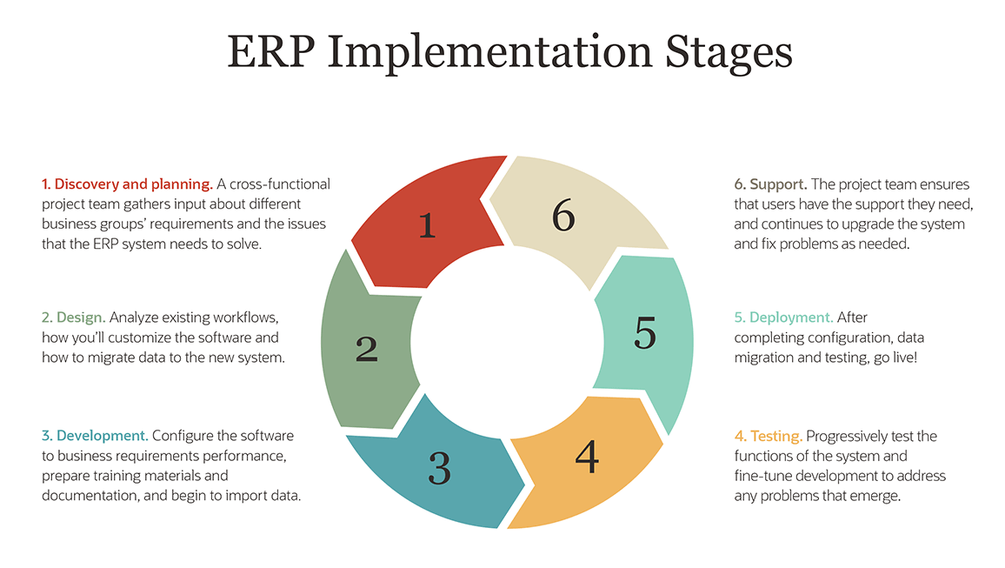
Rubrics for a Case Study
Criterion
- Followed Instruction (40%)
  - Must be handwritten in an A4 bond paper;
  - First write your name, “Case Study 2”, and the date of submission.
  - Must have at least 100 words per Case Question;
  - Highlight the important terms via placing underline
- Quality of information (40%)
  - Clear discussion of how you understand the lesson
- Bases of Contents (20%)
  - Identify the page or pages in the given reading materials the basis of your idea/s
  - if you used other sources such as the internet, books, or journals. You must site the URL, the book identification such as book title, author’s name, publication, the page it was read, and the date it was published; for the journal, identify the name of the journal, title, page/s, date, the author.
Instructions:
- You are given only 1 week to finish your work (October 14);
- And submit it after our laboratory class.

CASE QUESTIONS

Using ERP Implementation Stage, tell us what you found out from the situation given by filling up the following stages or how will you do from the stages at you own knowledge:
  - Discovery and planning
  - Design
  - Development
  - Support
  - Deployment
  - Testing

- - - = = = Good Luck!!! = = = - - -

