Course Code / Title: | ITEC 116 – IT Elective 4 (Systems Integration and Architecture 2)

Prelim Midterm Finals

Semester / A.Y.: First semester, 2026-2027

COURSE OUTCOMES | INTENDED LEARNING OUTCOMES | KNOWLEDGE | COMPREHENSION | APPLICATION | ANALYSIS | SYNTHESIS | EVALUATION | TOTAL
CO 1. Differentiate the foundational concepts of Systems Integration.  CO 2. Apply Program Management principles. | ILO 1-2: Logical/Physical SI, Middleware, Web Services, Planning, Barriers (Covers 8 K items) | 5 | 2 |  |  | 10 |  | 12
 | ILO 3-4: PMO, Scope, Change Control, Decision Process (Covers 6 K items) | 2 | 6 |  |  |  |  | 8
CO 3. Evaluate ERP Implementation Methodologies.  CO 4. Synthesize strategic success drivers. | ILO 5-6: ERP Life Cycle, Traditional SDLC, Implementation Categories (Covers 6 K items) | 10 | 5 |  |  |  |  | 5
 | ILO 7-8: Teamwork, Standardization, Organizational Change, ROI Justification | – | – | – | 10 |  |  | 5
TOTAL |  | 17 | 13 | 0 | 10 | 10 |  | 60

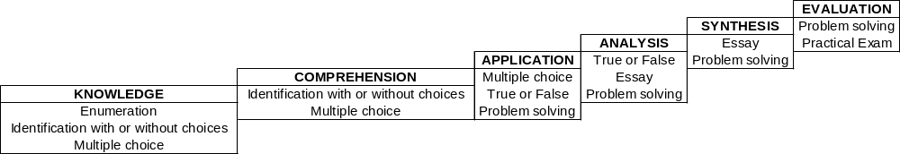

Prepared by: Endorsed by: Approved by:

RAILEY ANDREI ACOSTA SIMEON E. DAEZ CHARLOTTE B. CARANDANG
Instructor Cluster Head Chairperson

WILLIE C. BUCLATIN
Dean, CEIT

