Michael Warren
August 8, 2019
Independent Study: GEOG 497
Final Paper
Dr. Tom Allen

Geostatistics: Modeling First Floor Elevation (FFE) with EBK and CoKriging
Abstract/Introduction
This study evaluates different geostatistical models to predict First Floor Elevations (FFE) across a flood zone study area in Newport News, VA. FFE prediction surfaces produced by the models were compared to Elevation Certificates (EC) to evaluate the performance of each model and the dataset. The study demonstrates that FFEs can be evaluated at errors greater than LiDAR across wide ranges and provides insight into improving our model for future geostatistics.
Methodology
The ODU team collected First Floor (flood) Elevations (FFE) using a TruPulse 360 Laser Inclinometer and foundation types were observed for each house. Foundation types were used for cross validating existing city data sets. Within the study area, 1767 residential structures were recorded of the 5763 sample. The data was then post-processed and merged to existing city data using parcel identifiers. Then, a machine learning statistical algorithm was applied across the study area. Finally, the models were compared to Elevation Certificates (EC) provided by the city of Newport News.
Post-Processing
First Floor Elevation (FFE) data was consolidated into a Geographic Information System (GIS) for analysis. FFEs were added to a summarized elevation of each house based on the Digital Elevation Model (DEM). Below is a diagram which shows how the elevation was determined for each house.
Geostatistics
Spatial analysis and machine learning statistical models were run using ArcPro Geostatistical Wizard tool. Two models were run utilizing the Empirical Bayesian Kriging (EBK) method and one model with CoKriging. Below is a list of the three models that were run.
- EBK – FFE_Only
- EBK – Elevation_mean
- CoKrig- Elevation_mean + Foundation Type (City)
In the EBK models, the K-Bessel transformation was used as the semi-variogram with 1000 simulations.
In the CoKriging, the K-Bessel transformation was also used for the semi-variogram with the Foundation Type being the covariable.
Elevation Certificates
Models were compared to open access Elevation Certificates on HRGEO (HRPDC et al., 2019).
Results
Empirical Bayesian Kriging (EBK)
FFE Only
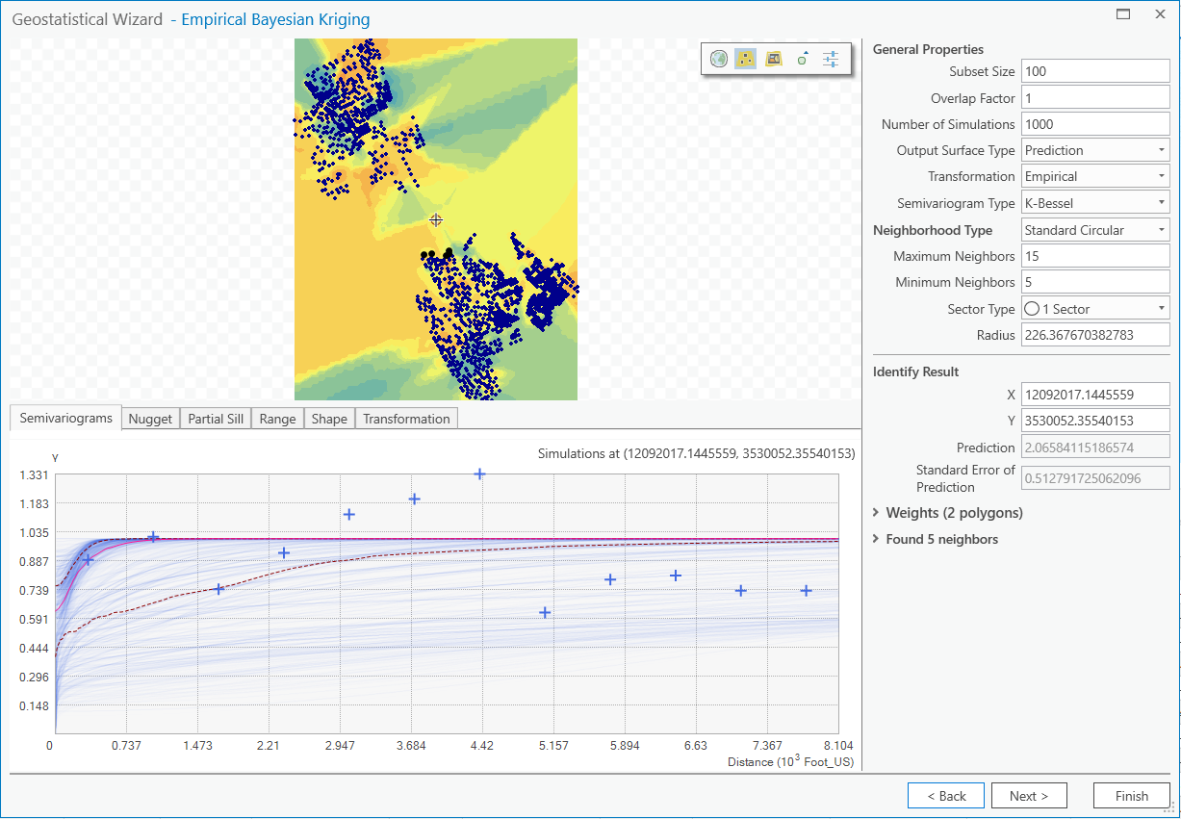
Figure 1: Properties of FFE_Only EBK
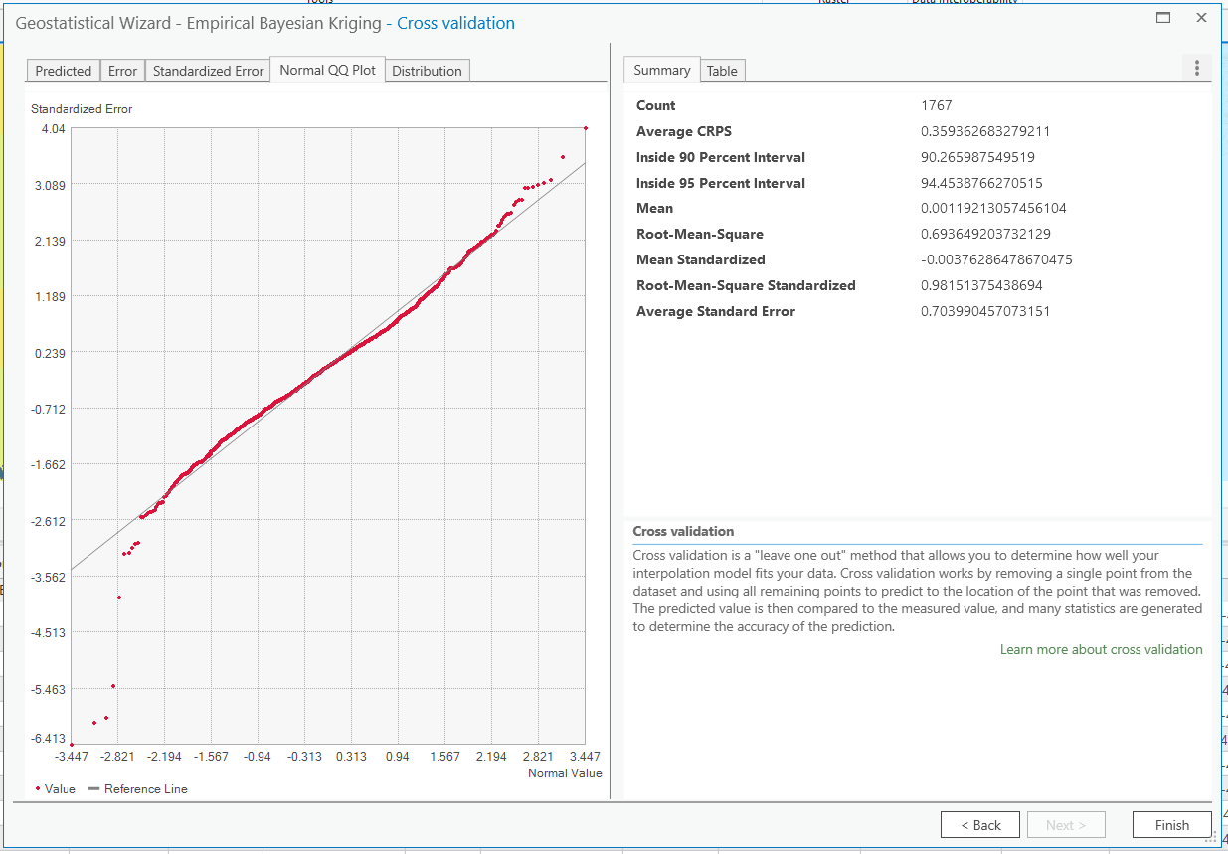Figure 2: Normal QQ Plot of FFE_Only EBK Simulation
Empirical Bayesian Kriging (EBK)
Elevmean
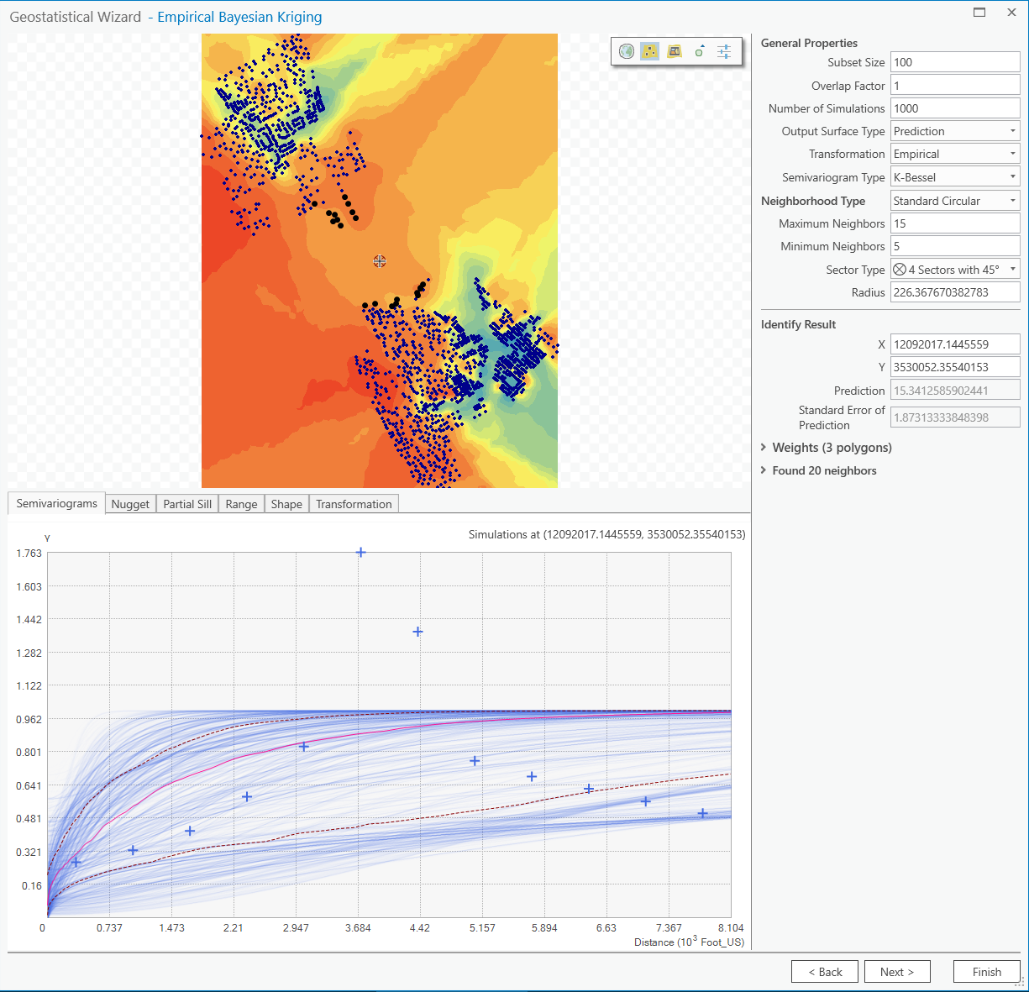
Figure 3: Properties of Elevation_mean EBK
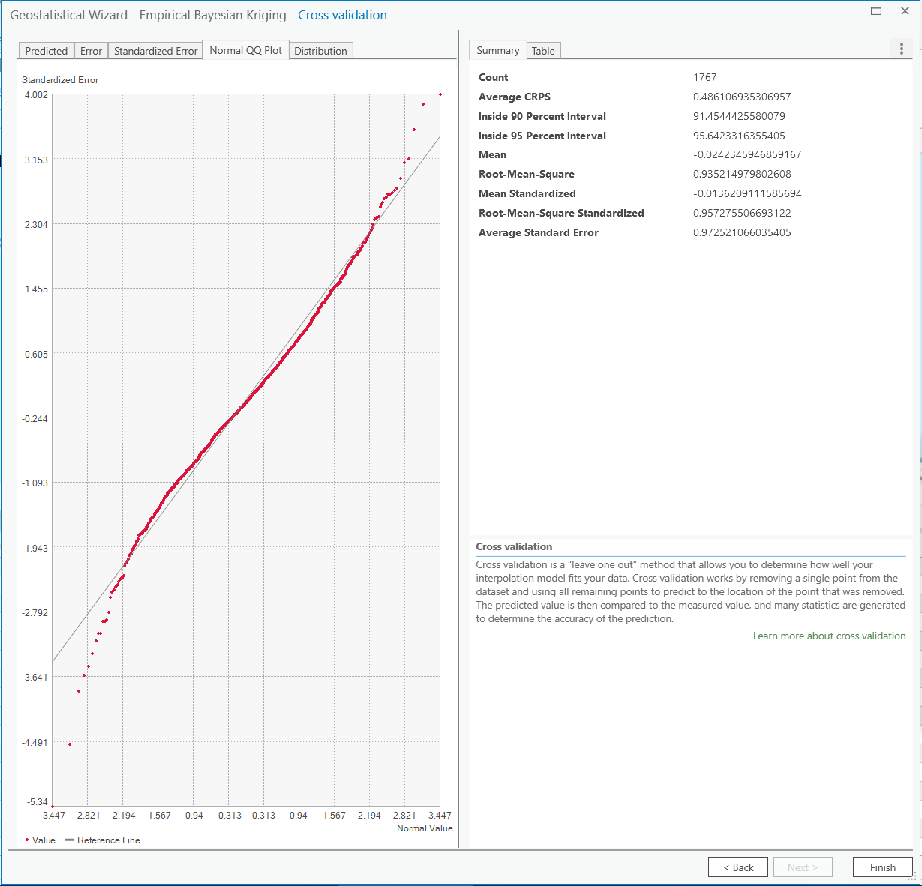
Figure 4: Normal QQ Plot of Elevation_mean EBK Simulation

Cokriging
Elevmean + Foundation Type (city data)
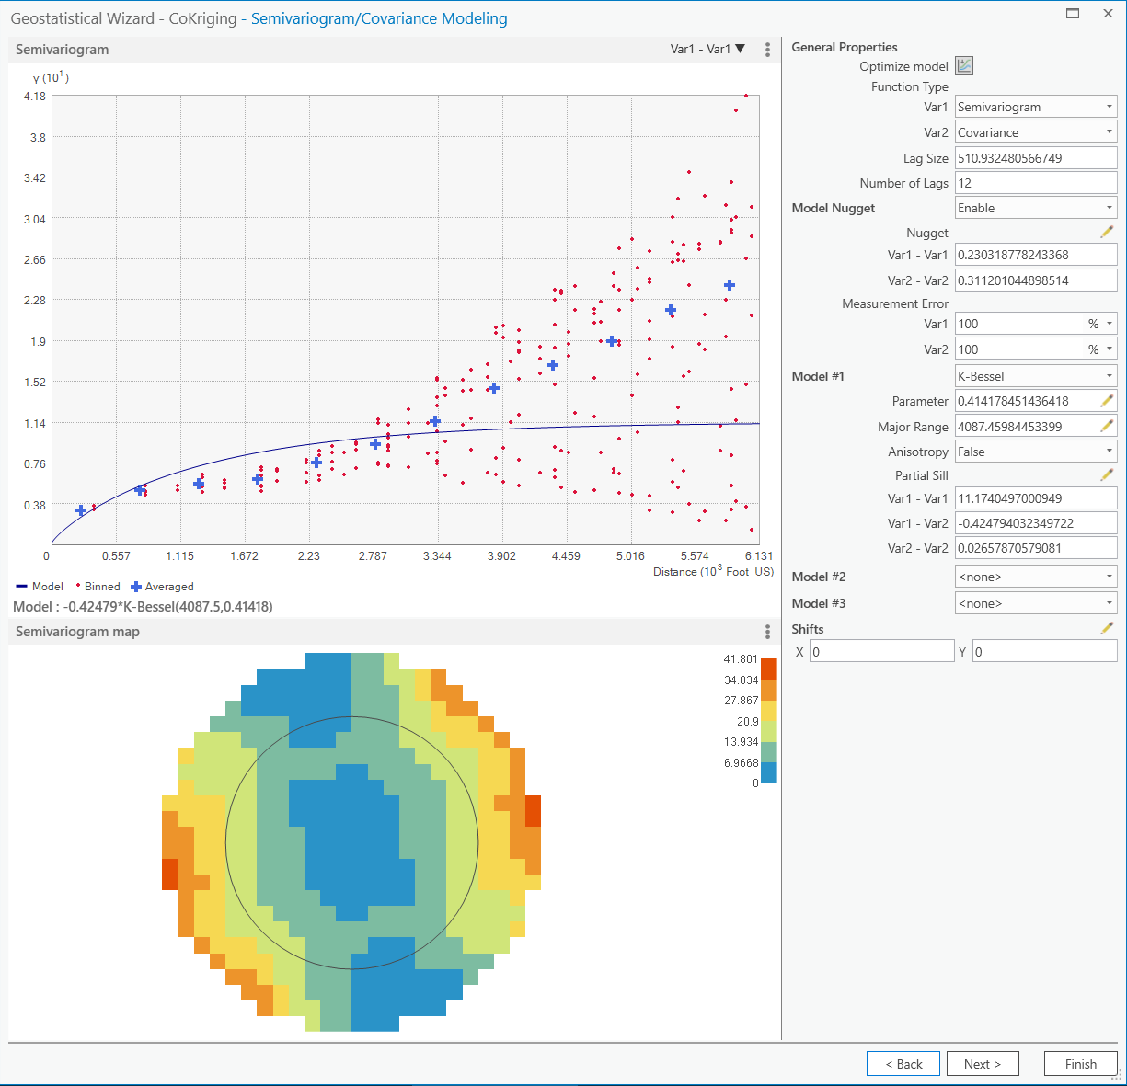
Figure 5: Properties of Elevmean and Foundation Type CoKrig

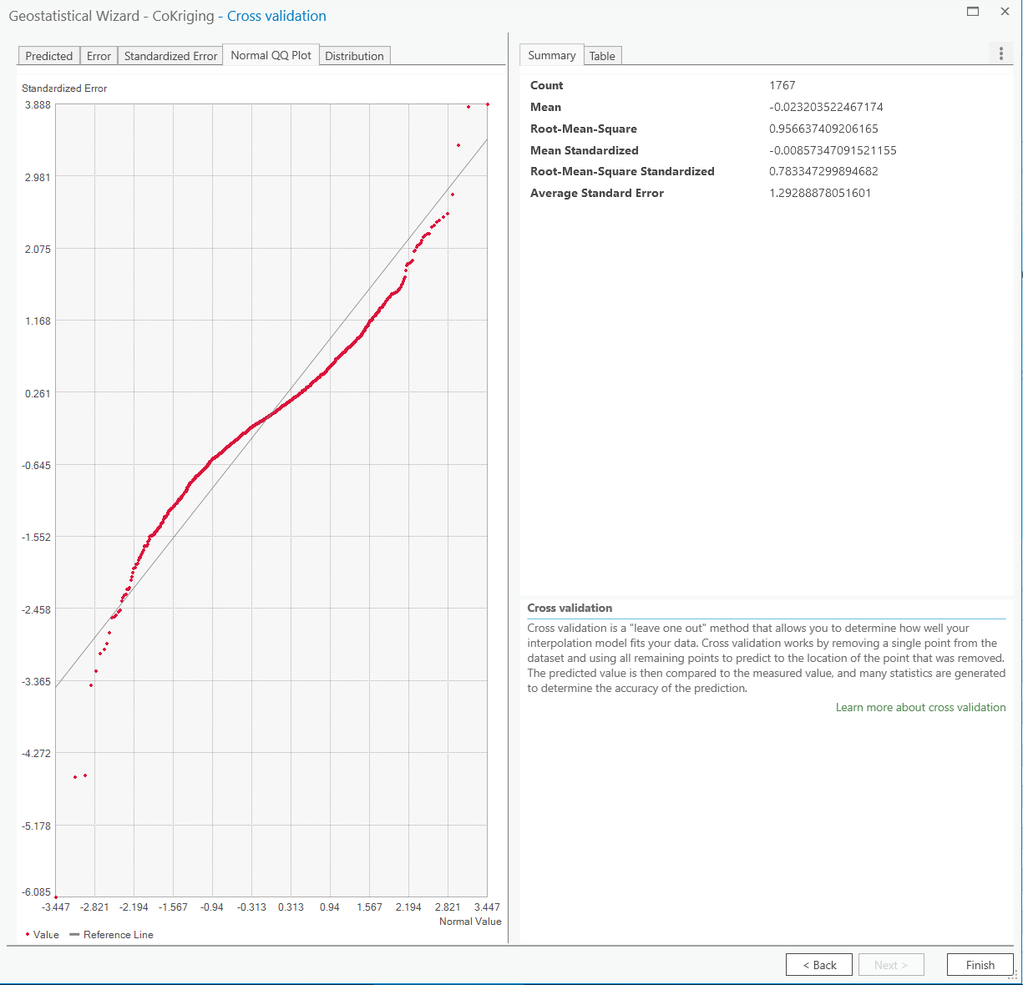
Figure 6: Normal QQ of Elevmean and Foundation Type CoKrig

Error Analysis
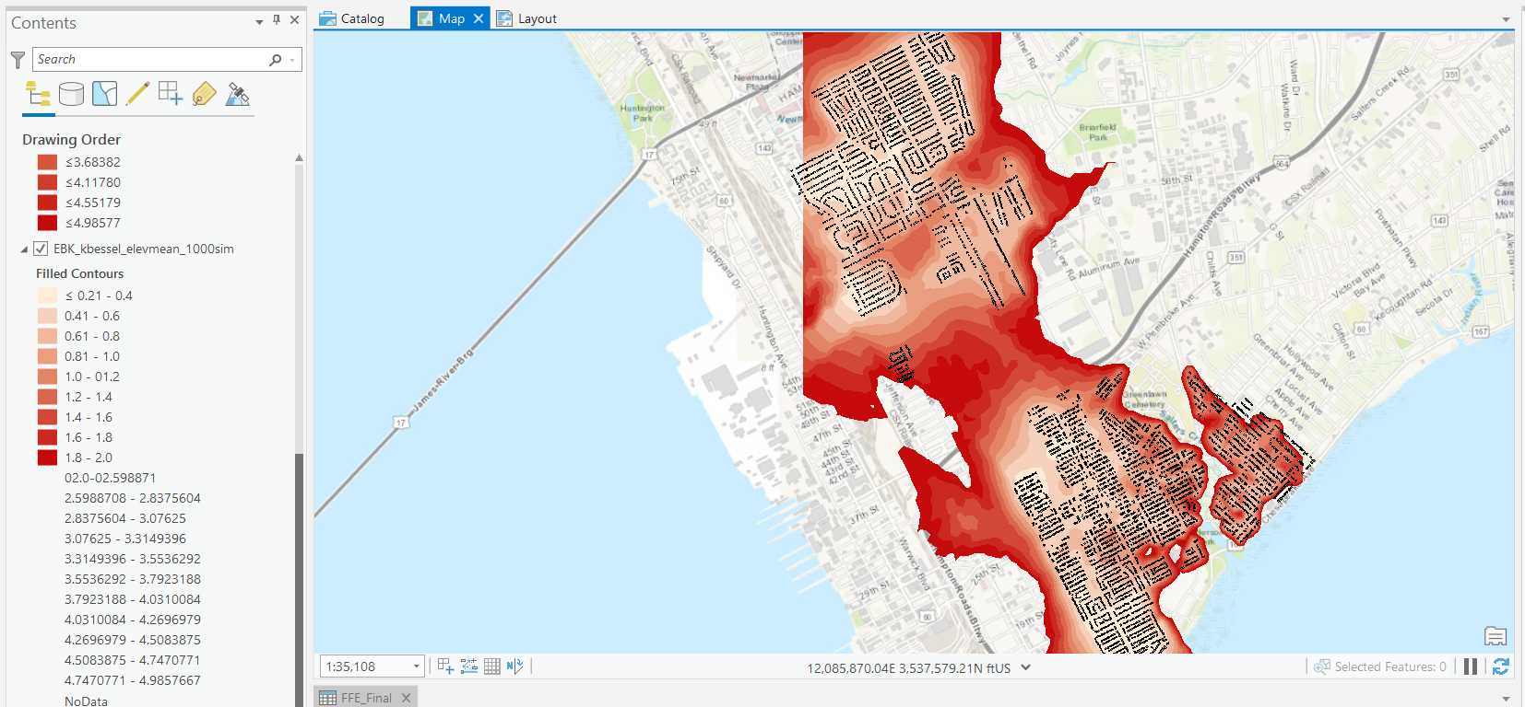
Figure 6: Error of Elevmean EBK with 0.2ft classification (2.0 ft error cutoff)
Elevation Certificate Comparison
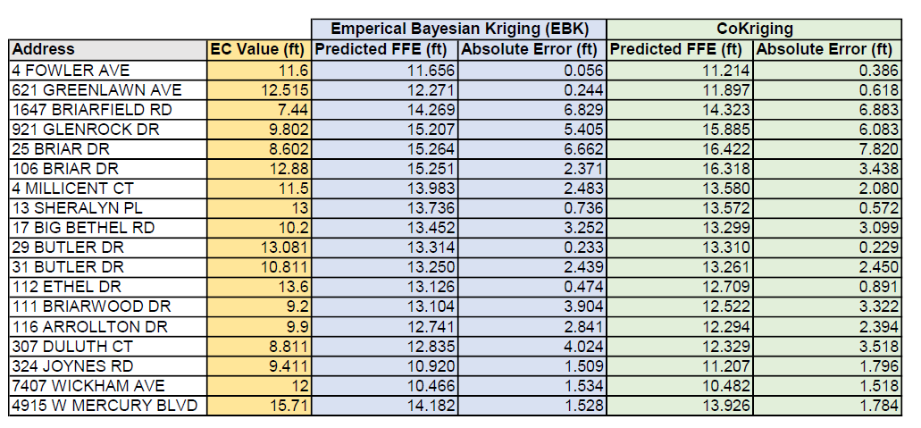
Table 1: Comparison Based on Elevation Certificates (EC)
Discussion
Geostatistics
FFE_Only performed with the lowest overall error, followed by Elevation_Mean (EBK). The cokriging had the highest overall error which included the city’s foundation type as a co-variate. While the source of the error is unknown, there is multiple possibilities. First, there is the propagation of error as multiple data sets are assimilated together (FFE, DEM, city data, etc.). Second, the geostatistical model may not have been configured properly in each specific scenario to rule out all possibilities of error. Third, the DEM could not be directly input as the secondary data set for the CoKrig and a drawing of the DEM to points took many hours and ultimately failed. Lastly, it was unknown how to accurately weigh the foundation type against the FFE, and thus the model was selected to “Optimize Model” under the K-Bessel transformation.
Figure 5 shows that the CoKrig prediction surface will overestimate observed FFEs in the lower ranges while (mostly) underestimating them in the higher ranges. This is due to two clear trends towards the higher end of the data set. The divergence of the data set is unknown (see above) but may be due to Salter’s Creek and New Market Creek not being spatially excluded. The Normal QQ plot shows this divergence in Figure 6.
The increase in error calls for a higher resolution Digital Elevation Model, as the cell size was quite large (2.5 feet x 2.5 feet) and thus a better model could be derived on this limiting factor. However, this may increase time in computation of the elevation models, and during the geostatistics. Additionally, a different size buffer around the houses may change how the elevation is averaged, and a maximum value may be more appropriate.
Error Analysis
Figure 7 depicts the error classified in 0.2ft increments with a 2.0ft cutoff. This cutoff was determined based upon LiDAR error (Dewberry and Davis LLC, 2005). As you can see, our EBK model of Elevmean, which is shown in Figure 7, encompasses nearly the entirety of the 5763 houses. Given that only 1767 houses were observed (30.7%), our model shows that a large number of houses can be predicted with a small sample size, while remaining in permissible amounts of error.
Elevation Certificate Comparison
While FFE_Only EBK performed the lowest amount of overall error, it was unable to be compared to the Elevation Certificates. This was because the DEM was not assumed flat under the houses (See Figure 8 Below).
A predicted FFE of 7.8ft + 2.0ft ±0.3ft = 9.8ft ± 0.3ft is reasonable, an FFE of 4.4ft + 2.0ft ± 0.3ft = 6.4ft ± 0.3ft is unlikely. This is because our FFE_Only EBK, demonstrated an overall lowest reported error. While this is only one example, the entire model was excluded from the analysis because it could not be compared to the other data models based upon its known EC value. FFE_Only is independent of elevation, and thus it is inappropriate to compare to known values of FFEs. Nonetheless, the finding in Figure 8 may provide insight to develop a model that increases accuracy for future geostatistical models, or to assume that the ground under houses is flat with the maximum value recorded (due to a foundation being built level with the Earth).

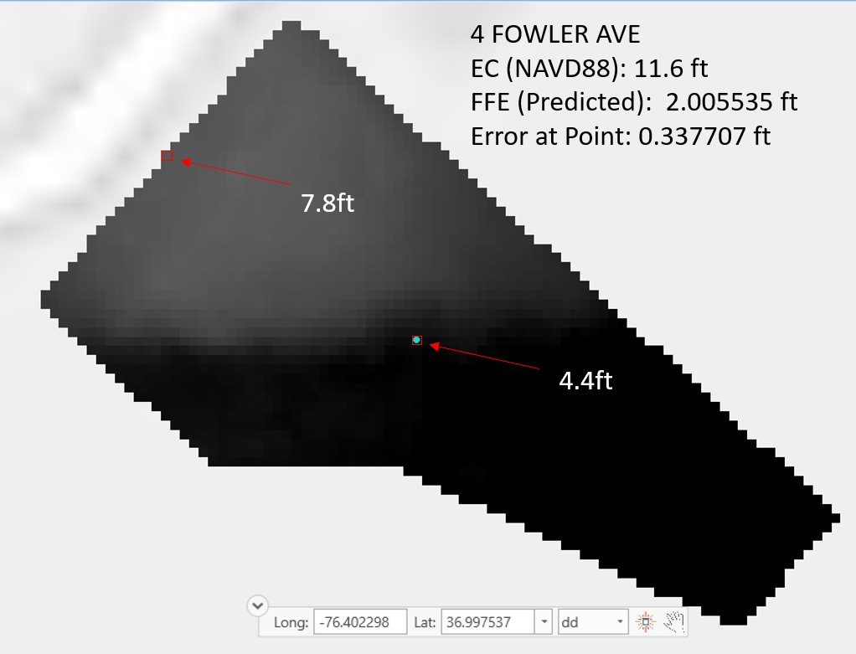

Figure 7: DEM depicting 4.4 ft difference and un-assumed flat under houses
Future Work
There is uncertainty at validating the model based on the limited number of Elevation Certificates available. Furthermore, many of the ECs were located on the periphery of the geostatistical models which is where error is generally the highest. Thus, it is inconclusive as to which model performs the best at evaluating FFEs across large regions. Nonetheless, our research shows that FFEs can be predicted with error comparable to LiDAR (Dewberry and Davis LLC, 2005).
Using Geostatistics remains a powerful tool at estimating critical values across large regions. Our study areas’ unique flood hazards call for an integrated GIS in the Hampton Roads area. Creative techniques are needed to solving these multifaceted issues at the local, state, regional, and national levels. Our study shows that we can create key infrastructure data (First Floor Elevation) using Geostatistics at low-cost, and within acceptable error. These attributes (FFE and Foundation Type) allow for better modeling and decision making of scientists, engineers, emergency management, and city officials. During storms or hurricanes, FFEs can be used to better evaluate flood damage and evacuation routes or expected storm surge. Our research shows, that these missing attributes can be predicted at low cost while have the benefit of saving lives and the critical infrastructures of our communities.
This research calls for more funding within the Norfolk, Chesapeake, and greater Hampton Roads area as it tackles an increasing rate of recurrent flooding.

Work Cited
Dewberry and Davis LLC (2005). Evaluation of Alternatives in Obtaining Structural Elevation Data. pp.49-56.
HRPDC, Hampton Roads Regional Parcels, VGIN Building Footprints and FEMA National Flood Hazard Layer (2019). Elevation Certificates - Building Footprints (NAVD88). [online] Hrgeo.org. Available at: http://www.hrgeo.org/datasets/elevation-certificates-building-footprints-navd88 [Accessed 8 Aug. 2019].

