Picturio Aesthetic scoring – Real Estate Images POC

Picturio scoring – old, decision forest based method

AADB scoring – new, deep learnng based method

Photos were scored based on the above two methods

Image Test Set: 90 images, split to 3 subjective catgegories:

* bad – 30 images
* mid – 30 images
* nice – 30 images

## Analysis

### Scores means by category

AADB Picturio

Class name

bad 0.383354 0.302377

mid 0.400361 0.374330

nice 0.486072 0.507594

### Scores std by category

AADB Picturio

Class name

bad 0.105481 0.143134

mid 0.104895 0.122787

nice 0.059341 0.090463

Distribution of scores for BAD category

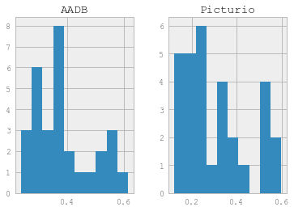

Distribution of scores for MID category

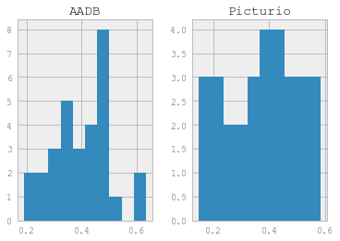

Distribution of scores for NICE category

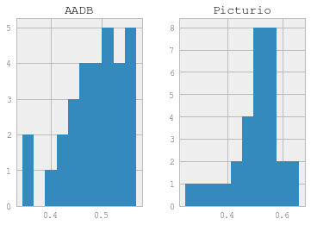

## Conclusion