THESIS DRAFT - appendix: heart-paper explanation certificate - for review

Explanation certificate: Heart, AAAI paper genome
Rendered from the canonical JSON record heart-paper.json (schema 1.0.0, SHA-256 ae2a73baae0507a6bb122be13c78ec321d84882c02c55591f1d760ead16f486b), which holds every evidence payload and the full graphs.
Dataset | Heart Disease (binary, prepared)
Experiment | Heart Binary
Genome | 9022a9eb-ecf9-41ba-b138-28ed4d131c9d (NEAT key 9493, generation 38)
Explanation | a03ebc86-a14d-4860-9eb6-29f040d16633 (40 operations)
Train AUC / accuracy | 0.9455 / 0.8636 (n = 242)
Test AUC / accuracy | 0.8966 / 0.8033 (n = 61)
Output activation | sigmoid
Phenotype | 32 nodes (26 inputs, 5 hidden, 1 output), 31 enabled edges
Explained model state | 42 nodes, 34 enabled edges
Function preservation | max |change in output| = 2.22e-16 (train)
Annotations | 6 (4 leaf, 2 composition)
Structural coverage | 1 (41 of 41; 7 Null)
Compositional coverage | 1
Uncovered nodes / edges | 0 / 0
Missing compositions | 0
Full coverage | yes
Drafted by | unknown
Verified by | unverified

Coverage
Candidate nodes are all nodes of the explained model state except the output nodes. A candidate node is covered when some annotation of the hierarchy (a leaf, or a composition with its descendants) contains it and all its enabled outgoing edges. Exact Null parts (no path to an output over enabled, non-zero-weight edges; zero-weight edges) count as covered.
- Null, disconnected input (7): -12 (restecg:0), -14 (restecg:2), -17 (exang:1), -21 (slope:3), -23 (thal:3), -3 (sex:1), -6 (cp:3)
- Uncovered nodes: none
- Uncovered edges: none
- Missing compositions: none

Annotation hierarchy
- A1: heart_disease_risk_score (composition)
- A2: benign_profile_gate (leaf)
- A3: restbp_chol_interaction (leaf)
- A4: risk_aggregation_gate (composition)
- A5: benign_profile_gate_534path (leaf)
- A6: chol_threshold (leaf)

Network figures
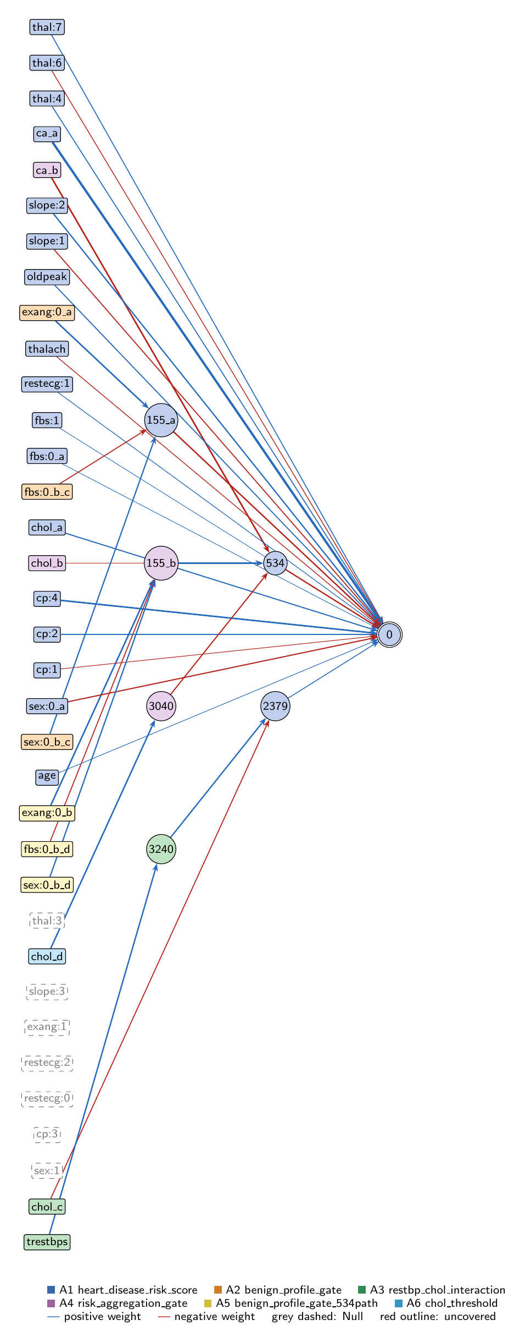
Heart, AAAI paper genome: full view of the explained model state.
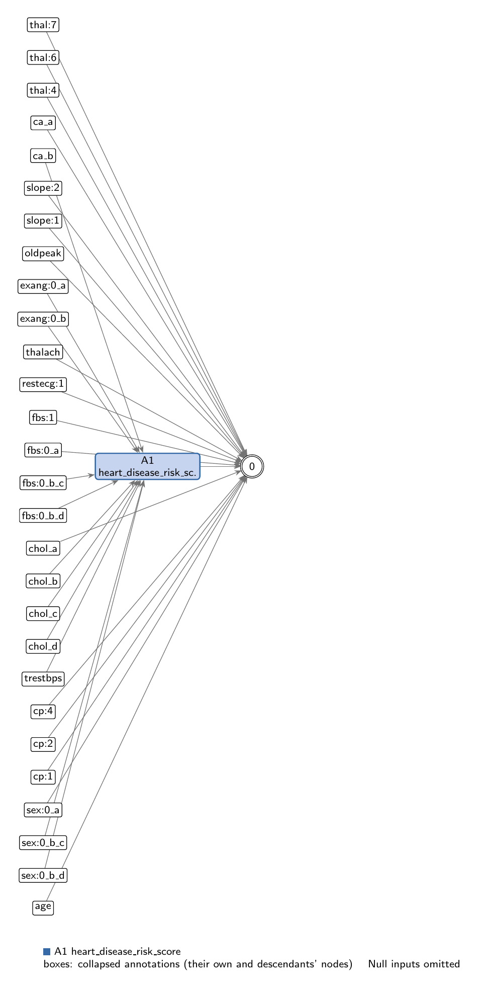
Heart, AAAI paper genome: collapsed view at hierarchy level 0 (fully recomposed).
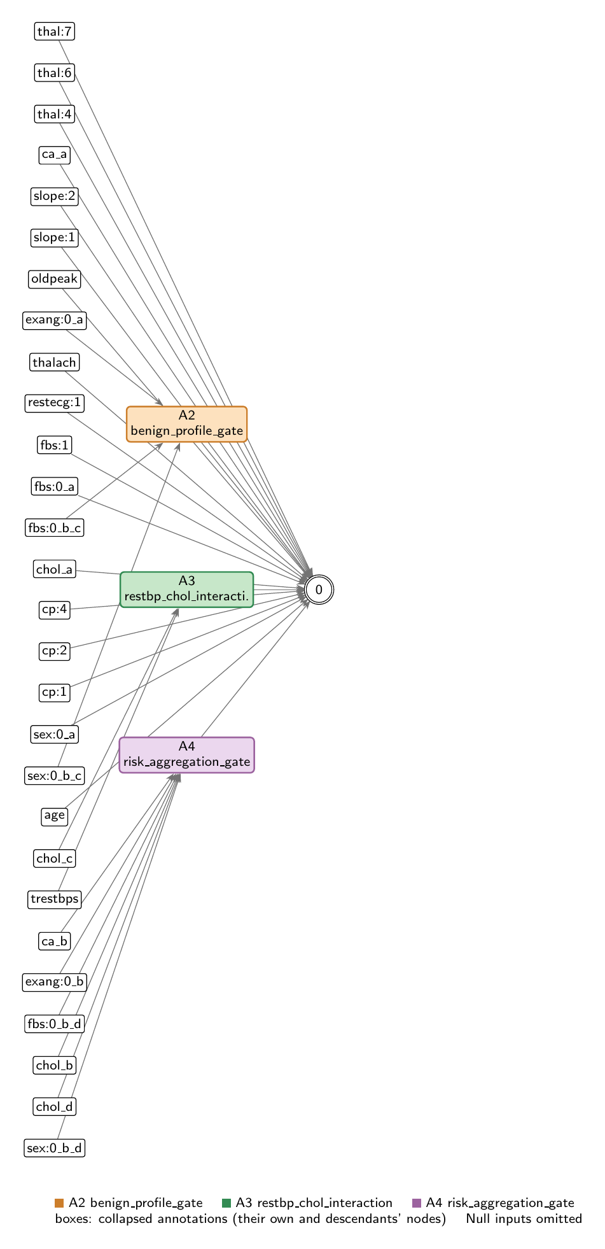
Heart, AAAI paper genome: collapsed view at hierarchy level 1.
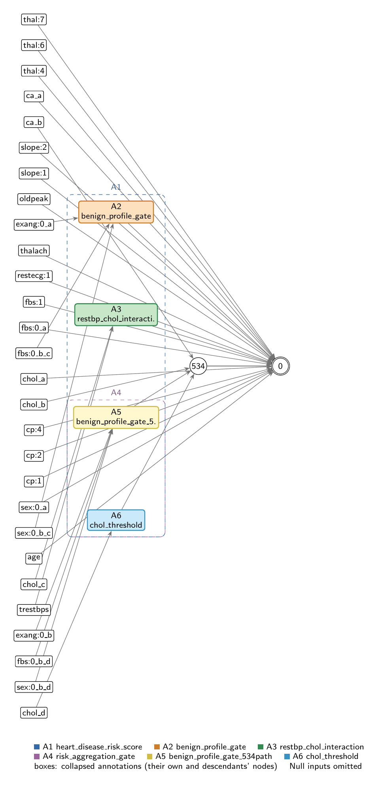
Heart, AAAI paper genome: collapsed view at hierarchy level 2.

Refactoring operations
All operations are function-preserving; max output change 2.22e-16 over 242 training rows.
- #26: split -22 into -22_a, -22_b
- #27: split -9 into -9_a, -9_b, -9_c, -9_d
- #28: split -2 into -2_a, -2_b
- #29: split -10 into -10_a, -10_b
- #30: split 155 into 155_a, 155_b
- #31: split -16 into -16_a, -16_b
- #32: split -2_b into -2_c, -2_d
- #33: split -10_b into -10_c, -10_d

Annotations

A1: heart_disease_risk_score
Composition annotation (depth 0); children A2, A3, A4.
- Entry nodes: -1 (age), -4 (cp:1), -5 (cp:2), -7 (cp:4), -11 (fbs:1), -13 (restecg:1), -15 (thalach), -18 (oldpeak), -19 (slope:1), -20 (slope:2), -24 (thal:4), -25 (thal:6), -26 (thal:7), -22_a (ca_a), -9_a (chol_a), -2_a (sex:0_a), -10_a (fbs:0_a), -3 (sex:1), -6 (cp:3), -12 (restecg:0), -14 (restecg:2), -17 (exang:1), -21 (slope:3), -23 (thal:3)
- Exit nodes: 0
- Internal nodes: none
- Edges: 20; covers 41 candidate node(s)
Hypothesis. Root: y0 = ReLU(bias 0.318 + linear core + 3 nonlinear pathways). (1) DIRECT LINEAR CORE of 17 inputs to the output - ca (largest, +2.03), cp:4 (+1.21), slope:2, chol, cp:2, oldpeak push risk up; sex:0 (-0.71), slope:1, thalach push down. By SHAP the top drivers are ca, cp:4, sex:0, slope:2, chol. (2) benign_profile_gate (155_a, -0.96) lowers risk for females without exertional angina. (3) restbp_chol_interaction (2379, +0.364). (4) risk_aggregation_gate (534, -0.884), the elaborate composed unit. 7 features unused. PERFORMANCE: train AUC 0.946 / test 0.897. ABLATION LADDER (test AUC, baseline 0.897): linear-core only 0.860 (nonlinearity buys +0.037); remove benign gate -0.028; remove restbp -0.012; remove 534 gate +0.002. So the two simple gates (benign, restbp) carry all the generalising benefit; the elaborate 534 aggregation gate is train-only. The benign signal is redundantly encoded twice (155_a direct + 155_b inside 534).
Closed form (SymPy, weights at 3 significant figures; y_i = exit node i):
y_0 = 1.0*exp(0.0907*x_{age} + 2.03*x_{ca_a} + 0.676*x_{chol_a} + 0.683*x_{cp:2} + 1.21*x_{cp:4} + 0.0357*x_{fbs:0_a} + 0.0269*x_{fbs:1} + 0.559*x_{oldpeak} + 0.19*x_{restecg:1} + 0.853*x_{slope:2} + 0.482*x_{thal:4} + 0.463*x_{thal:7} + 0.364*relu(-0.529*x_{chol_c} + 0.931*relu(0.978*x_{trestbps} + 3.4) - 0.754))/(0.728*exp(0.14*x_{cp:1} + 0.711*x_{sex:0_a} + 0.526*x_{slope:1} + 0.305*x_{thal:6} + 0.256*x_{thalach} + 0.96*relu(1.11*x_{exang:0_a} - 0.509*x_{fbs:0_b_c} + 0.824*x_{sex:0_b_c} + 0.0879) + 0.884*relu(-1.16*x_{ca_b} - 0.592*x_{chol_b} - 0.677*relu(1.05*x_{chol_d} - 0.864) + 0.818*relu(1.11*x_{exang:0_b} - 0.509*x_{fbs:0_b_d} + 0.824*x_{sex:0_b_d} + 0.0879) - 0.761)) + 1.0*exp(0.0907*x_{age} + 2.03*x_{ca_a} + 0.676*x_{chol_a} + 0.683*x_{cp:2} + 1.21*x_{cp:4} + 0.0357*x_{fbs:0_a} + 0.0269*x_{fbs:1} + 0.559*x_{oldpeak} + 0.19*x_{restecg:1} + 0.853*x_{slope:2} + 0.482*x_{thal:4} + 0.463*x_{thal:7} + 0.364*relu(-0.529*x_{chol_c} + 0.931*relu(0.978*x_{trestbps} + 3.4) - 0.754)))
Training split (n = 242): displayed closed form within 0.00241 of the forward pass; exact function within 2.22e-16.
Evidence (2 items; payloads in the JSON record):
- [empirical] performance_metrics; split: train+test (inferred). Whole-model performance and coverage. Complete structural and compositional coverage reached with 8 node splits and ZERO function-changing operations - the explained network is computationally identical to the trained one. Wider generalisation gap (0.049 AUC) on the small 61-row test split.
- [empirical] ablation_study; split: test (inferred). Full ablation ladder, re-verified end-to-end on the test split. Nonlinearity as a whole buys +0.037 test AUC, but the benefit comes almost entirely from the two shallow gates encoding recognised protective/risk factors. The elaborate composed gate contributes nothing on held-out data. A complete explanation doubles as a diagnosis of how much nonlinear structure earns its place.
Authorship: drafted by unknown on 2026-07-08; verified by nobody (unverified).

A2: benign_profile_gate
Leaf annotation (depth 1); parent A1.
- Entry nodes: -2_c (sex:0_b_c), -10_c (fbs:0_b_c), -16_a (exang:0_a)
- Exit nodes: 155_a
- Internal nodes: none
- Edges: 3; covers 3 candidate node(s)
Hypothesis. Node 155_a computes a 'benign profile' gate: 155_a = ReLU(0.824*sex:0 + 1.109*exang:0 - 0.509*fbs:0 + 0.088). Activates for female patients (sex:0=1) with no exertional angina (exang:0=1); normal fasting glucose slightly attenuates. Output-facing copy of hidden node 155. Activation profile: active 70% / hard-zero 30% (verified). Reads out to output with weight -0.960, lowering predicted risk. Ablation: removing this readout drops test AUC 0.897->0.869 (-0.028) - the single largest nonlinear contribution to generalisation.
Closed form (SymPy, weights at 3 significant figures; y_i = exit node i):
y_0 = relu(1.11*x_{exang:0_a} - 0.509*x_{fbs:0_b_c} + 0.824*x_{sex:0_b_c} + 0.0879)
Training split (n = 242): displayed closed form within 0.00159 of the forward pass; exact function within 0.
Evidence (3 items; payloads in the JSON record):
- [analytical] analytical_formula; split: n/a (analytical). Closed-form gate. A shallow, single-step gate encoding a recognised protective factor (female + no exertional angina).
- [empirical] activation_profile; split: test (inferred). Activation profile verified on the test split: active for ~70% of patients, hard-zero for ~30%. A genuinely used gate, not a dead or saturated unit.
- [empirical] ablation_study; split: test (inferred). The single largest nonlinear contribution to generalisation: removing this gate costs 0.028 test AUC. A shallow protective-factor gate that genuinely generalises. Re-verified on the full test split.
Authorship: drafted by unknown on 2026-07-08; verified by nobody (unverified).

A3: restbp_chol_interaction
Leaf annotation (depth 1); parent A1.
- Entry nodes: -8 (trestbps), -9_c (chol_c)
- Exit nodes: 2379
- Internal nodes: 3240
- Edges: 3; covers 3 candidate node(s)
Hypothesis. Subgraph {trestbps, chol_c, 3240, 2379}: a near-linear resting-blood-pressure signal. 3240 = ReLU(0.978*trestbps + 3.4) is always-on (100% active, verified) - a linear pass-through, not a gate. 2379 = ReLU(0.931*3240 - 0.529*chol_c - 0.754) simplifies to ReLU(0.911*trestbps - 0.529*chol_c + 2.41), near-always-on. Reads out to output with +0.364 (higher resting BP raises risk). Ablation: removing this readout drops test AUC 0.897->0.885 (-0.012) - a modest but real generalising contribution.
Closed form (SymPy, weights at 3 significant figures; y_i = exit node i):
y_0 = relu(-0.529*x_{chol_c} + 0.931*relu(0.978*x_{trestbps} + 3.4) - 0.754)
Training split (n = 242): displayed closed form within 0.00246 of the forward pass; exact function within 8.88e-16.
Evidence (3 items; payloads in the JSON record):
- [analytical] analytical_formula; split: n/a (analytical). Despite the two-node structure this collapses to a near-linear resting-BP term: 3240 is always-on (a pass-through, not a gate) and 2379 is near-always-on. A shallow, generalising risk term.
- [empirical] activation_profile; split: not recorded. Activation profile verified: 3240 is 100% active - confirming it is a linear pass-through rather than a gate, which is why the whole pathway reduces to a near-linear resting-BP term.
- [empirical] ablation_study; split: test (inferred). A modest but real generalising contribution: removing the resting-BP term costs 0.012 test AUC. Re-verified on the test split.
Authorship: drafted by unknown on 2026-07-08; verified by nobody (unverified).

A4: risk_aggregation_gate
Composition annotation (depth 1); parent A1; children A5, A6.
- Entry nodes: -22_b (ca_b), -9_b (chol_b)
- Exit nodes: 534
- Internal nodes: none
- Edges: 4; covers 8 candidate node(s)
Hypothesis. Node 534 = ReLU(0.818*[benign_profile_gate_534path] - 0.677*[chol_threshold] - 1.155*ca - 0.592*chol - 0.761): the model's most elaborate unit, a genuine ReLU gate (hard-zero 53.5% verified) composing four risk signals - vessel count (ca), a cholesterol copy, the cholesterol threshold (3040), and the redundant benign-profile copy (155_b). Net per-unit output effects: ca +1.02, chol +0.52, chol_threshold +0.60, benign -0.72; when the benign signal is strong the whole block is clipped off together. KEY ABLATION RESULT: disabling 534's readout changes test AUC only 0.897->0.899 (+0.002) while train drops 0.946->0.942 - i.e. this showpiece unit is essentially train-only and does not generalise. Signs match cardiology but the structure is fit to the 242 training cases.
Closed form (SymPy, weights at 3 significant figures; y_i = exit node i):
y_0 = relu(-1.16*x_{ca_b} - 0.592*x_{chol_b} - 0.677*relu(1.05*x_{chol_d} - 0.864) + 0.818*relu(1.11*x_{exang:0_b} - 0.509*x_{fbs:0_b_d} + 0.824*x_{sex:0_b_d} + 0.0879) - 0.761)
Training split (n = 242): displayed closed form within 0.00694 of the forward pass; exact function within 4.44e-16.
Evidence (3 items; payloads in the JSON record):
- [analytical] analytical_formula; split: n/a (analytical). Composed closed form (the composition annotation resolves into its two children plus two direct inputs). On paper the model's most sophisticated structure - a rectified gate folding four risk signals together. Signs match cardiology.
- [empirical] activation_profile; split: not recorded. Activation profile verified: hard-zero for 53.5% of patients, confirming 534 is a genuine gate rather than a pass-through.
- [empirical] ablation_study; split: train+test (inferred). KEY RESULT. The model's most elaborate structure does no real work on held-out data: removing it changes test AUC by +0.002 (slightly helps) while costing on train. Structural elaboration is where the overfitting concentrates. Only holding structure against ablation reveals it - the gate looks like the centrepiece, yet measurement shows it is decorative while the plainest gates do the work. Re-verified on both splits.
Authorship: drafted by unknown on 2026-07-08; verified by nobody (unverified).

A5: benign_profile_gate_534path
Leaf annotation (depth 2); parent A4.
- Entry nodes: -2_d (sex:0_b_d), -10_d (fbs:0_b_d), -16_b (exang:0_b)
- Exit nodes: 155_b
- Internal nodes: none
- Edges: 3; covers 3 candidate node(s)
Hypothesis. Node 155_b computes the SAME benign-profile gate as 155_a (identical incoming weights and bias 0.088); it is the second copy of hidden node 155, routed into node 534 instead of the output. The benign signal is therefore encoded twice - once directly to the output (155_a) and once inside the 534 gate (155_b). 155_b enters 534 with weight +0.818; net path effect (+0.818)*(-0.884) = -0.72 per unit, same risk-lowering direction as the direct copy.
Closed form (SymPy, weights at 3 significant figures; y_i = exit node i):
y_0 = relu(1.11*x_{exang:0_b} - 0.509*x_{fbs:0_b_d} + 0.824*x_{sex:0_b_d} + 0.0879)
Training split (n = 242): displayed closed form within 0.00159 of the forward pass; exact function within 0.
Evidence (1 items; payloads in the JSON record):
- [analytical] analytical_formula; split: n/a (analytical). 155_b shares incoming weights and bias 0.088 with 155_a exactly (bit-identical). The benign protective signal is therefore redundantly encoded twice - once direct to output, once inside the 534 gate. Redundant double-encoding is a symptom of the same overfitting the 534 gate exhibits.
Authorship: drafted by unknown on 2026-07-08; verified by nobody (unverified).

A6: chol_threshold
Leaf annotation (depth 2); parent A4.
- Entry nodes: -9_d (chol_d)
- Exit nodes: 3040
- Internal nodes: none
- Edges: 1; covers 1 candidate node(s)
Hypothesis. Node 3040 = ReLU(1.052*chol - 0.864): a one-sided cholesterol threshold. Since cholesterol is z-normalised, this turns on only above ~0.82 SD above the mean. Activation profile: hard-zero 82.5% / active 17.5% (verified) - a sparse threshold detector. Feeds node 534 with -0.677; net path effect +0.60 per unit (high cholesterol raises predicted risk). This is the sub-unit that lets cholesterol act as a risk factor only above a level rather than linearly - but it sits inside the 534 gate, which the ablation shows contributes nothing on test.
Closed form (SymPy, weights at 3 significant figures; y_i = exit node i):
y_0 = relu(1.05*x_{chol_d} - 0.864)
Training split (n = 242): displayed closed form within 0.00824 of the forward pass; exact function within 0.
Evidence (2 items; payloads in the JSON record):
- [analytical] analytical_formula; split: test (inferred). A sparse one-sided cholesterol threshold - the sub-unit that lets cholesterol act as a risk factor only above a level rather than linearly. But it sits inside the 534 gate, which ablation shows contributes nothing on test.
- [empirical] activation_profile; split: not recorded. Activation profile verified: fires for only ~17.5% of patients, confirming a sparse one-sided threshold detector rather than a linear response.
Authorship: drafted by unknown on 2026-07-08; verified by nobody (unverified).

Audit against the definitions
- WARNING unverified: No human verification is recorded for this explanation.
- WARNING evidence_without_split [chol_threshold]: Empirical evidence item 1 (activation_profile) records no data split.
- WARNING evidence_without_split [restbp_chol_interaction]: Empirical evidence item 1 (activation_profile) records no data split.
- WARNING evidence_without_split [risk_aggregation_gate]: Empirical evidence item 1 (activation_profile) records no data split.
- INFO authorship_unknown: Drafter of the explanation is not recorded.
- INFO evidence_split_inferred: 6 findings
end of thesis draft

