THESIS DRAFT - appendix: heart-s1-c1 explanation certificate - for review

Explanation certificate: heart-s1-c1
Rendered from the canonical JSON record heart-s1-c1.json (schema 1.4.0, SHA-256 555774df08fc19cc0dd5fe846e6c3e4fb3823536efda28def15a994d5545f6e2), which holds every evidence payload and the full graphs.
Dataset | Heart Disease (binary, prepared)
Experiment | 10seed-heart-s1, seed 1
Genome | a2df22ce-983d-47b6-bbd6-3176d38ed5ff (NEAT key 9674, generation 39)
Explanation | 492866e6-a73b-4465-92a8-ecad82a2adcc (35 operations)
Train AUC / accuracy | 0.9392 / 0.8802 (n = 242)
Test AUC / accuracy | 0.861 / 0.7705 (n = 61)
Output activation | sigmoid
Phenotype | 34 nodes (26 inputs, 7 hidden, 1 output), 30 enabled edges
Explained model state | 38 nodes, 30 enabled edges
Function preservation | max |change in output| = 3.33e-16 (train)
Annotations | 6 (5 leaf, 1 composition)
Structural coverage | 1 (37 of 37; 9 Null)
Compositional coverage | 1
Uncovered nodes / edges | 0 / 0
Missing compositions | 0
Full coverage | yes
Drafted by | AI-assisted draft
Verified by | unverified
Drafter's summary. Essentially logistic regression (all hidden units linearised: train AUC 0.9355 vs 0.9392; L2 logistic regression 0.9355). 13 direct edges carry logit SD 4.25 of 5.63; ca enters by three parallel routes (effective +2.60 logit per SD), cp:3 only via always-on relay 1173. The one consequential nonlinearity is gate 1801 = ReLU(1.54 restecg:0 + 0.82 oldpeak - 1.52): ST depression adds risk only with a normal resting ECG (+0.0034 AUC over linear). Typical angina (cp:1) lowers risk via switch 3210, less with more vessels; a small hinge lets higher max heart rate lower risk. Same design as the 10-seed heart-s1 record (gen-31 genome), with an added typical-angina switch and heart-rate hinge.
What resisted explanation. Nothing resisted coverage; only input fan-out needed splitting (ca x3, slope:2, thalach). Four of seven hidden ReLUs (664, 1173, 2245, 2650) never clip on train, so their annotations describe affine relays (reweighting of ca, slope:2, cp:3 and the heart-rate hinge) rather than distinct concepts. 3210 is a pure cp:1 switch (on for all 22 typical-angina patients, off for the rest), so its best linear fit is almost exact. Nine unconnected inputs (sex:1, fbs:0, restecg:1, restecg:2, exang:0, exang:1, slope:1, thal:4, thal:7) listed as zero-effect root entries.

Plain-language summary
AI-assisted draft for review (unverified). Each sentence cites the claims that back it; every cited claim was computed on the model and the training split and passed its automatic checks. Magnitudes are changes in predicted risk for a typical patient; confidence words follow the test-split check and n. The text describes what the model does, not the world.
Summary (drafted). For a typical patient (a 56-year-old man with no chest pain symptoms and median test results) the model predicts a risk of heart disease of about 18%; it adds up most of its inputs independently, and five parts add to that sum: two add more for each extra vessel coloured, one lowers the risk for typical angina, one lowers it for non-anginal chest pain, one acts only on the 42 of 242 training patients with a normal resting ECG and marked ST depression, and one lowers it for a higher maximum heart rate, with nothing until about 145 beats per minute, then steadily. [C29, C30, C40, C31, C43, C38, C46] These add up independently, and these lower the risk: being a woman takes a typical patient's predicted risk from about 18% to below 1% and fasting blood sugar above 120 mg/dL to about 8%; through this sum alone, compared with no chest pain symptoms, typical angina or non-anginal chest pain lowers it to about 2% and atypical angina to about 5% (chest pain type also acts through the parts below). [C10, C19, C12, C17] A reversible defect (or the undefined code 4) on the thallium scan raises it to about 55%; higher cholesterol (from about 8% at 193 mg/dL to about 45% at 308 mg/dL), higher resting blood pressure (from about 9% at 110 mm Hg to about 35% at 155 mm Hg) and older age (from about 10% at 42 years to about 25% at 66 years) raise it steadily. [C05, C07, C08, C13] Through this sum alone, each extra vessel coloured by fluoroscopy adds about the same (from about 18% at 0 to about 80% at 2 vessels) and a flat ST segment raises it to about 87%, while the maximum heart rate barely changes it; all three also act through the parts below. [C04, C03, C21] Rarer results also count (the model has little data on this, n = 15 and 17): a fixed defect on the thallium scan lowers the risk to about 3%, and through this sum alone a downsloping ST segment raises it to about 32%; the model ignores exercise-induced angina. [C14, C15, C28] This part combines chest pain type with the number of vessels coloured: through it, typical angina lowers a typical patient's predicted risk from about 18% to about 2%, and each extra vessel adds about the same, from about 18% at 0 to about 61% at 2 vessels. [C31, C30] Across the whole model, more vessels raise the predicted risk, and even more so with typical angina, each extra vessel adding about the same: going from 0 to 2 vessels moves a typical patient from below 1% to about 55% with typical angina, and from about 18% to about 99% with any other chest pain type. [C32] Across the whole model, typical angina takes a typical patient's predicted risk to below 1%. [C09] This part combines the resting ECG with ST depression on exercise and acts on 42 of 242 training patients, nearly all with a normal resting ECG, 26 of whom had heart disease; for the typical patient it acts on, the predicted risk is about 98% without it and about 99% with it. [C38] Through it, more ST depression raises the predicted risk only once it rises above about 1.0 mm, for patients with a normal resting ECG, in an uneven way: for a typical such patient from about 13% at 0 mm to about 63% at 3.5 mm. [C37] More ST depression therefore raises the predicted risk, but only if the resting ECG is normal: going from 0 to 2.8 mm moves a typical patient from about 18% to about 55% with a normal resting ECG, in an uneven way, and leaves it at about 18% otherwise. [C36] This part combines the number of vessels coloured with a flat ST segment: through it, each extra vessel adds about the same, from about 18% at 0 to about 36% at 2 vessels for a typical patient, and a flat ST segment raises the risk from about 18% to about 23%. [C40, C41] Across the whole model, each extra vessel takes a typical patient from about 18% at 0 to about 99% at 2 vessels, about the same for each, flattening out near the top because the predicted risk cannot go much higher, and a flat ST segment takes it to about 91%. [C01, C02] This part reads only non-anginal chest pain: through it, non-anginal chest pain lowers a typical patient's predicted risk from about 18% to about 8%. [C43] Across the whole model, non-anginal chest pain takes it to about 1%. [C11] This part reads only the maximum heart rate: a higher maximum heart rate lowers the predicted risk with nothing until about 145 beats per minute, then steadily, for a typical patient from about 19% at 118 to about 14% at 175 beats per minute. [C45, C46] Across the whole model the same holds, from about 19% at 118 to about 14% at 175 beats per minute. [C20]
Summary (offline template). The model treats a higher number of vessels coloured by fluoroscopy as raising the predicted risk of heart disease steadily, each extra vessel adding about the same: for a typical patient, it goes from about 18% at 0 vessels to about 99% at 2 vessels, flattening out near the top because the predicted risk cannot go much higher (on the training data only). [C01] For a typical patient, the model gives a higher predicted risk of heart disease if the ST segment is flat at peak exercise (about 91%) than if the ST segment slopes up at peak exercise (about 18%) (on the training data only). [C02] For a typical patient, the model gives a higher predicted risk of heart disease if the ST segment is flat at peak exercise (about 87%) than if the ST segment slopes up at peak exercise (about 18%) (on the training data only). [C03] Through one part of the model, ST depression on exercise only adds to the predicted risk of heart disease once it rises above about 1.0 mm for patients with a normal resting ECG: for a typical such patient, going from 0.0 mm to 3.5 mm moves it from about 13% to about 63%; across patients the change happens in an uneven way (on the training data only). [C37] For a typical patient, number of vessels coloured by fluoroscopy going from 0 vessels to 2 vessels moves the predicted risk of heart disease from below 1% to about 55% if the patient has typical angina, and from about 18% to about 99% if chest pain type is something other than typical angina (it moves steadily, each extra vessel adding about the same for patients with typical angina). [C32] The model ignores exercise-induced angina. [C28]
ann_34 (heart_disease_logit). The model treats a higher number of vessels coloured by fluoroscopy as raising the predicted risk of heart disease steadily, each extra vessel adding about the same: for a typical patient, it goes from about 18% at 0 vessels to about 99% at 2 vessels, flattening out near the top because the predicted risk cannot go much higher (on the training data only). [C01] For a typical patient, the model gives a higher predicted risk of heart disease if the ST segment is flat at peak exercise (about 91%) than if the ST segment slopes up at peak exercise (about 18%) (on the training data only). [C02] For a typical patient, the model gives a higher predicted risk of heart disease if the ST segment is flat at peak exercise (about 87%) than if the ST segment slopes up at peak exercise (about 18%) (on the training data only). [C03] The model treats a higher number of vessels coloured by fluoroscopy as raising the predicted risk of heart disease steadily, each extra vessel adding about the same: for a typical patient, it goes from about 18% at 0 vessels to about 80% at 2 vessels (on the training data only). [C04] For a typical patient, the model gives a higher predicted risk of heart disease if thallium stress test result is something other than a normal thallium scan, a fixed defect on the thallium scan (about 55%) than if the thallium scan is normal (about 18%) (on the training data only). [C05] It ignores exercise-induced angina. [C28] Other effects: a higher ST depression on exercise raises it in an uneven way; a higher serum cholesterol raises it steadily; a higher resting blood pressure raises it steadily; typical angina (rather than no chest pain (asymptomatic)) lowers it; female (rather than male) lowers it; non-anginal chest pain (rather than no chest pain (asymptomatic)) lowers it; any other chest pain type (rather than no chest pain (asymptomatic)) lowers it; a higher age raises it steadily; and 6 still smaller effects listed in the evidence table (on the training data only). [C06, C07, C08, C09, C10, C11, C12, C13] Smaller effects, each changing the predicted value only slightly: a higher maximum heart rate lowers it with nothing until about 145 beats per minute, then steadily; a higher maximum heart rate raises it only barely; any other resting ECG (rather than a normal resting ECG) lowers it (on the training data only). [C20, C21, C22]
ann_33 (typical_angina_ca_switch). For a typical patient, number of vessels coloured by fluoroscopy going from 0 vessels to 2 vessels moves the predicted risk of heart disease from below 1% to about 55% if the patient has typical angina, and from about 18% to about 99% if chest pain type is something other than typical angina (it moves steadily, each extra vessel adding about the same for patients with typical angina). [C32] Through this part, the model treats a higher number of vessels coloured by fluoroscopy as raising the predicted risk of heart disease steadily, each extra vessel adding about the same: for a typical patient, it goes from about 18% at 0 vessels to about 61% at 2 vessels (on the training data only). [C30] Through this part, for a typical patient, the model gives a lower predicted risk of heart disease if the patient has typical angina (about 2%) than if chest pain type is something other than typical angina (about 18%) (on the training data only). [C31]
ann_31 (st_depression_normal_ecg_gate). This part acts on 42 of 242 training patients (17%); nearly all of them are patients with a normal resting ECG. [C38] For a typical patient it acts on, it slightly raises the predicted risk of heart disease from about 98% without this part to about 99% with it (on the training data only). [C38] In the training data, 26 of these 42 patients had heart disease. [C38] A higher ST depression on exercise clearly raises the predicted risk of heart disease, but only if the resting ECG is normal (in an uneven way for patients with a normal resting ECG): for a typical patient, ST depression on exercise going from 0.0 mm to 2.8 mm moves the predicted risk of heart disease from about 18% to about 55% if the resting ECG is normal, and from about 18% to about 18% if resting ECG is something other than a normal resting ECG. [C36] Other effects: ST depression on exercise past about 1.0 mm raises it in an uneven way; a higher ST depression on exercise raises it in an uneven way (on the training data only). [C37, C34] Smaller effects, each changing the predicted value only slightly: any other resting ECG (rather than a normal resting ECG) lowers it (on the training data only). [C35]
ann_29 (ca_slope2_relay). Through this part, the model treats a higher number of vessels coloured by fluoroscopy as raising the predicted risk of heart disease steadily, each extra vessel adding about the same: for a typical patient, it goes from about 18% at 0 vessels to about 36% at 2 vessels (on the training data only). [C40] Through this part, for a typical patient, the model gives a higher predicted risk of heart disease if the ST segment is flat at peak exercise (about 23%) than if slope of the ST segment at peak exercise is something other than a flat ST segment (about 18%) (on the training data only). [C41]
ann_30 (cp3_relay). Through this part, for a typical patient, the model gives a lower predicted risk of heart disease if the patient has non-anginal chest pain (about 8%) than if chest pain type is something other than non-anginal chest pain (about 18%) (on the training data only). [C43]
ann_32 (max_heart_rate_hinge). Through this part, maximum heart rate only lowers the predicted risk of heart disease once it rises above about 145 beats per minute: for a typical such patient, going from 71 beats per minute to 182 beats per minute moves it from about 19% to about 13% (on the training data only). [C46] Through this part, the model treats a higher maximum heart rate as slightly lowering the predicted risk of heart disease with nothing until about 145 beats per minute, then steadily: for a typical patient, it goes from about 19% at 118 beats per minute to about 14% at 175 beats per minute (on the training data only). [C45]
Worth checking against what is known. Worth checking: patients with typical angina or non-anginal chest pain get the lowest predicted risk of all chest pain types (below 1% and about 1% for a typical patient), below patients with no chest pain symptoms. [C09, C11] Worth checking: the model treats a fixed defect on the thallium scan as lowering the risk compared with a normal scan, from only 15 training patients. [C14] Worth checking: the model treats fasting blood sugar above 120 mg/dL as lowering the risk of heart disease (for a typical patient from about 18% to about 8%). [C19] Worth checking: going from 0 to 2 vessels coloured moves a typical patient's predicted risk from about 18% to about 99%. [C01] Worth checking: ST depression on exercise raises the predicted risk only when the resting ECG is normal. [C36] Worth checking: the model ignores exercise-induced angina. [C28]
Claim | What is checked | Risk, typical patient | Estimate (log-odds; OR); range across patients | n | Test check | Verified | Words
C01 | direction: number of vessels coloured by fluoroscopy: 0 vessels to 2 vessels (whole model) | 18% to 99% | log-odds 5.89, OR 362; range across patients 5.83 to 5.83 | 242 | train; test unclear (AUC gain 0.041 [-0.032, 0.123], n=61) | yes | on the training data only
C02 | direction: slope of the ST segment at peak exercise: an upsloping ST segment to a flat ST segment (whole model) | 18% to 91% | log-odds 3.81, OR 44.9; range across patients 3.81 to 3.81 | 115, 110 | train; test disagrees (AUC gain -0.011 [-0.065, 0.036], n=61) | yes | on the training data only
C03 | direction: slope of the ST segment at peak exercise: an upsloping ST segment to a flat ST segment (direct contribution only, not through any part) | 18% to 87% | log-odds 3.46, OR 31.9; range across patients 3.46 to 3.46 | 115, 110 | train; test disagrees (AUC gain -0.012 [-0.059, 0.030], n=61) | yes | on the training data only
C04 | direction: number of vessels coloured by fluoroscopy: 0 vessels to 2 vessels (direct contribution only, not through any part) | 18% to 80% | log-odds 2.91, OR 18.3; range across patients 2.91 to 2.91 | 242 | train; test disagrees (AUC gain -0.001 [-0.039, 0.032], n=61) | yes | on the training data only
C05 | direction: thallium stress test result: a normal thallium scan to thallium stress test result other than a normal thallium scan, a fixed defect on the thallium scan (whole model) | 18% to 55% | log-odds 1.74, OR 5.71; range across patients 1.74 to 1.74 | 135, 92 | train; test unclear (AUC gain 0.012 [-0.017, 0.044], n=61) | yes | on the training data only
C06 | direction: ST depression on exercise: 0.0 mm to 2.8 mm (whole model) | 18% to 55% | log-odds 0.87, OR 2.38; range across patients 0.00 to 1.74 | 242 | train; test unclear (AUC gain 0.005 [-0.005, 0.022], n=61) | yes | on the training data only
C07 | direction: serum cholesterol: 193 mg/dL (5.0 mmol/L) to 308 mg/dL (8.0 mmol/L) (whole model) | 8% to 45% | log-odds 2.22, OR 9.23; range across patients 2.22 to 2.22 | 242 | train; test disagrees (AUC gain -0.022 [-0.066, 0.011], n=61) | yes | on the training data only
C08 | direction: resting blood pressure: 110 mm Hg to 155 mm Hg (whole model) | 9% to 35% | log-odds 1.65, OR 5.20; range across patients 1.65 to 1.65 | 242 | train; test unclear (AUC gain 0.000 [-0.022, 0.020], n=61) | yes | on the training data only
C09 | direction: chest pain type: no chest pain (asymptomatic) to typical angina (whole model) | 18% to <1% | log-odds -4.55, OR 0.01; range across patients -4.78 to -4.08 | 108, 22 | train; test agrees (AUC gain 0.041 [0.003, 0.083], n=61) | yes | clearly
C10 | direction: sex: male to female (whole model) | 18% to <1% | log-odds -3.94, OR 0.02; range across patients -3.94 to -3.94 | 159, 83 | train; test unclear (AUC gain 0.023 [-0.014, 0.068], n=61) | yes | on the training data only
C11 | direction: chest pain type: no chest pain (asymptomatic) to non-anginal chest pain (whole model) | 18% to 1% | log-odds -3.43, OR 0.03; range across patients -3.43 to -3.43 | 108, 70 | train; test agrees (AUC gain 0.041 [0.003, 0.083], n=61) | yes | clearly
C12 | direction: chest pain type: no chest pain (asymptomatic) to chest pain type other than atypical angina, no chest pain (asymptomatic) (direct contribution only, not through any part) | 18% to 2% | log-odds -2.51, OR 0.08; range across patients -2.51 to -2.51 | 108, 92 | train; test agrees (AUC gain 0.037 [0.006, 0.074], n=61) | yes | clearly
C13 | direction: age: 42 years to 66 years (whole model) | 10% to 25% | log-odds 1.05, OR 2.87; range across patients 1.05 to 1.05 | 242 | train; test disagrees (AUC gain -0.008 [-0.018, 0.001], n=61) | yes | on the training data only
C14 | direction: thallium stress test result: a normal thallium scan to a fixed defect on the thallium scan (whole model) | 18% to 3% | log-odds -1.83, OR 0.16; range across patients -1.83 to -1.83 | 135, 15 (small n) | train; test unclear (AUC gain 0.012 [-0.017, 0.044], n=61) | yes | the model has little data on this; on the training data only
C15 | direction: slope of the ST segment at peak exercise: an upsloping ST segment to a downsloping ST segment (direct contribution only, not through any part) | 18% to 32% | log-odds 0.77, OR 2.16; range across patients 0.77 to 0.77 | 115, 17 (small n) | train; test disagrees (AUC gain -0.012 [-0.059, 0.030], n=61) | yes | the model has little data on this; on the training data only
C16 | direction: slope of the ST segment at peak exercise: an upsloping ST segment to a downsloping ST segment (whole model) | 18% to 32% | log-odds 0.77, OR 2.16; range across patients 0.77 to 0.77 | 115, 17 (small n) | train; test disagrees (AUC gain -0.011 [-0.065, 0.036], n=61) | yes | the model has little data on this; on the training data only
C17 | direction: chest pain type: no chest pain (asymptomatic) to atypical angina (direct contribution only, not through any part) | 18% to 5% | log-odds -1.34, OR 0.26; range across patients -1.34 to -1.34 | 108, 42 | train; test agrees (AUC gain 0.037 [0.006, 0.074], n=61) | yes | clearly
C18 | direction: chest pain type: no chest pain (asymptomatic) to atypical angina (whole model) | 18% to 5% | log-odds -1.34, OR 0.26; range across patients -1.34 to -1.34 | 108, 42 | train; test agrees (AUC gain 0.041 [0.003, 0.083], n=61) | yes | clearly
C19 | direction: fasting blood sugar: fasting blood sugar of 120 mg/dL or less to fasting blood sugar above 120 mg/dL (whole model) | 18% to 8% | log-odds -0.92, OR 0.40; range across patients -0.92 to -0.92 | 209, 33 | train; test disagrees (AUC gain -0.001 [-0.010, 0.009], n=61) | yes | on the training data only
C20 | direction: maximum heart rate: 118 beats per minute to 175 beats per minute (whole model) | 19% to 14% | log-odds -0.36, OR 0.70; range across patients -0.36 to -0.36 | 242 | train; test unclear (AUC gain 0.002 [0.000, 0.009], n=61) | yes | slightly; on the training data only
C21 | direction: maximum heart rate: 118 beats per minute to 175 beats per minute (direct contribution only, not through any part) | 18% to 18% | log-odds 0.005, OR 1.00; range across patients 0.005 to 0.005 | 242 | train; test unclear (AUC gain 0.000 [0.000, 0.000], n=61) | yes | slightly; on the training data only
C22 | direction: resting ECG: a normal resting ECG to resting ECG other than a normal resting ECG (whole model) | 18% to 18% | log-odds -0.46, OR 0.63; range across patients -1.74 to 0.00 | 121, 121 | train; test disagrees (AUC gain -0.008 [-0.021, 0.000], n=61) | yes | slightly; on the training data only
C23 | magnitude: number of vessels coloured by fluoroscopy: 0 vessels to 2 vessels, typical patient | 18% to 99% | log-odds 5.83, OR 340 | 242 | train; test unclear (AUC gain 0.041 [-0.032, 0.123], n=61) | yes | on the training data only
C24 | magnitude: slope of the ST segment at peak exercise: an upsloping ST segment to a flat ST segment, typical patient | 18% to 91% | log-odds 3.81, OR 44.9 | 115, 110 | train; test disagrees (AUC gain -0.011 [-0.065, 0.036], n=61) | yes | on the training data only
C25 | magnitude: thallium stress test result: a normal thallium scan to thallium stress test result other than a normal thallium scan, a fixed defect on the thallium scan, typical patient | 18% to 55% | log-odds 1.74, OR 5.71 | 135, 92 | train; test unclear (AUC gain 0.012 [-0.017, 0.044], n=61) | yes | on the training data only
C26 | magnitude: ST depression on exercise: 0.0 mm to 2.8 mm, typical patient | 18% to 55% | log-odds 1.74, OR 5.68 | 242 | train; test unclear (AUC gain 0.005 [-0.005, 0.022], n=61) | yes | on the training data only
C27 | magnitude: serum cholesterol: 193 mg/dL (5.0 mmol/L) to 308 mg/dL (8.0 mmol/L), typical patient | 8% to 45% | log-odds 2.22, OR 9.23 | 242 | train; test disagrees (AUC gain -0.022 [-0.066, 0.011], n=61) | yes | on the training data only
C28 | null: model ignores exercise-induced angina (exact rule) |  | max change 0.000 (max |change in log-odds|) | 242 | train | yes
C29 | structure: made of ca_slope2_relay, cp3_relay, st_depression_normal_ecg_gate, max_heart_rate_hinge, typical_angina_ca_switch and inputs age, sex, cp, trestbps, chol, fbs, thalach, slope, ca, thal; added |  | log-odds n/a, OR n/a | 242 | train | yes
C30 | direction: number of vessels coloured by fluoroscopy: 0 vessels to 2 vessels (through this part) | 18% to 61% | log-odds 2.04, OR 7.73; range across patients 1.98 to 1.98 | 242 | train; test disagrees (AUC gain -0.003 [-0.032, 0.019], n=61) | yes | on the training data only
C31 | direction: chest pain type: chest pain type other than typical angina to typical angina (through this part) | 18% to 2% | log-odds -2.04, OR 0.13; range across patients -2.26 to -1.57 | 220, 22 | train; test unclear (AUC gain 0.001 [-0.005, 0.008], n=61) | yes | on the training data only
C32 | interaction: effect of number of vessels coloured by fluoroscopy (0 vessels to 2 vessels) by chest pain type: typical angina minus chest pain type other than typical angina; stronger in typical angina | typical angina: <1% to 55%; chest pain type other than typical angina: 18% to 99% | log-odds difference 0.70, OR 2.00 | 22, 220 | train; test agrees (AUC gain 0.001 [-0.005, 0.008], n=61); group difference on test 0.70 [0.70, 0.70] | yes | clearly
C33 | structure: its formula reproduces it on 242 training patients (largest difference 0.0) |  | log-odds 0.00, OR n/a | 242 | train | yes
C34 | direction: ST depression on exercise: 0.0 mm to 2.8 mm (through this part) | 18% to 55% | log-odds 0.87, OR 2.38; range across patients 0.00 to 1.74 | 242 | train; test unclear (AUC gain 0.005 [-0.005, 0.022], n=61) | yes | on the training data only
C35 | direction: resting ECG: a normal resting ECG to resting ECG other than a normal resting ECG (through this part) | 99% to 98% (typical patient this part acts on) | log-odds -0.46, OR 0.63; range across patients -1.74 to 0.00 | 121, 121 | train; test disagrees (AUC gain -0.008 [-0.021, 0.000], n=61) | yes | slightly; on the training data only
C36 | interaction: effect of ST depression on exercise (0.0 mm to 2.8 mm) by resting ECG: resting ECG other than a normal resting ECG minus a normal resting ECG; stronger in a normal resting ECG | resting ECG other than a normal resting ECG: 18% to 18%; a normal resting ECG: 18% to 55% | log-odds difference -1.74, OR 0.18 | 121, 121 | train; test agrees (AUC gain -0.008 [-0.021, 0.000], n=61); group difference on test -1.74 [-1.74, -1.74] | yes | clearly
C37 | threshold: ST depression on exercise: fold at about 1.0 mm (starts) for patients with a normal resting ECG | 13% to 63% (typical patient with a fold (patients with a normal resting ECG)) | fold 1.01 mm (IQR 1.01 to 1.01); past it log-odds 2.41, OR 11.1; range across patients 2.41 to 2.41 | 121, 41 | train; test unclear (AUC gain 0.005 [-0.005, 0.022], n=61) | yes | on the training data only
C38 | subgroup: who this part acts on: 42 of 242 patients | 98% to 99% (typical patient this part acts on (risk without the part, then with it)) | share 0.17; log-odds 1.08, OR 2.95; range across patients 0.19 to 2.50 | 42, 200 | train; test unclear (AUC gain 0.005 [-0.006, 0.025], n=61) | yes | slightly; on the training data only
C39 | structure: its formula reproduces it on 242 training patients (largest difference 2.22045e-16) |  | log-odds 2e-16, OR n/a | 242 | train | yes
C40 | direction: number of vessels coloured by fluoroscopy: 0 vessels to 2 vessels (through this part) | 18% to 36% | log-odds 0.94, OR 2.56; range across patients 0.94 to 0.94 | 242 | train; test disagrees (AUC gain -0.002 [-0.019, 0.011], n=61) | yes | on the training data only
C41 | direction: slope of the ST segment at peak exercise: slope of the ST segment at peak exercise other than a flat ST segment to a flat ST segment (through this part) | 18% to 23% | log-odds 0.34, OR 1.41; range across patients 0.34 to 0.34 | 132, 110 | train; test disagrees (AUC gain -0.003 [-0.016, 0.005], n=61) | yes | on the training data only
C42 | structure: its formula reproduces it on 242 training patients (largest difference 2.22045e-16) |  | log-odds 2e-16, OR n/a | 242 | train | yes
C43 | direction: chest pain type: chest pain type other than non-anginal chest pain to non-anginal chest pain (through this part) | 18% to 8% | log-odds -0.92, OR 0.40; range across patients -0.92 to -0.92 | 172, 70 | train; test unclear (AUC gain 0.001 [-0.008, 0.013], n=61) | yes | on the training data only
C44 | structure: its formula reproduces it on 242 training patients (largest difference 0.0) |  | log-odds 0.00, OR n/a | 242 | train | yes
C45 | direction: maximum heart rate: 118 beats per minute to 175 beats per minute (through this part) | 19% to 14% | log-odds -0.36, OR 0.70; range across patients -0.36 to -0.36 | 242 | train; test unclear (AUC gain 0.002 [0.000, 0.009], n=61) | yes | slightly; on the training data only
C46 | threshold: maximum heart rate: fold at about 145 beats per minute (starts) | 19% to 13% (typical patient with a fold) | fold 145 beats per minute (IQR 145 to 145); past it log-odds -0.44, OR 0.64; range across patients -0.44 to -0.44 | 242, 155 | train; test unclear (AUC gain 0.002 [0.000, 0.009], n=61) | yes | on the training data only
C47 | structure: its formula reproduces it on 242 training patients (largest difference 0.0) |  | log-odds 0.00, OR n/a | 242 | train | yes

Coverage
Candidate nodes are all nodes of the explained model state except the output nodes. A candidate node is covered when some annotation of the hierarchy (a leaf, or a composition with its descendants) contains it and all its enabled outgoing edges. Exact Null parts (no path to an output over enabled, non-zero-weight edges; zero-weight edges) count as covered.
- Null, disconnected input (9): -10 (fbs:0), -13 (restecg:1), -14 (restecg:2), -16 (exang:0), -17 (exang:1), -19 (slope:1), -24 (thal:4), -26 (thal:7), -3 (sex:1)
- Uncovered nodes: none
- Uncovered edges: none
- Missing compositions: none

Annotation hierarchy
- A1: heart_disease_logit (composition)
- A2: ca_slope2_relay (leaf)
- A3: cp3_relay (leaf)
- A4: st_depression_normal_ecg_gate (leaf)
- A5: max_heart_rate_hinge (leaf)
- A6: typical_angina_ca_switch (leaf)

Network figures
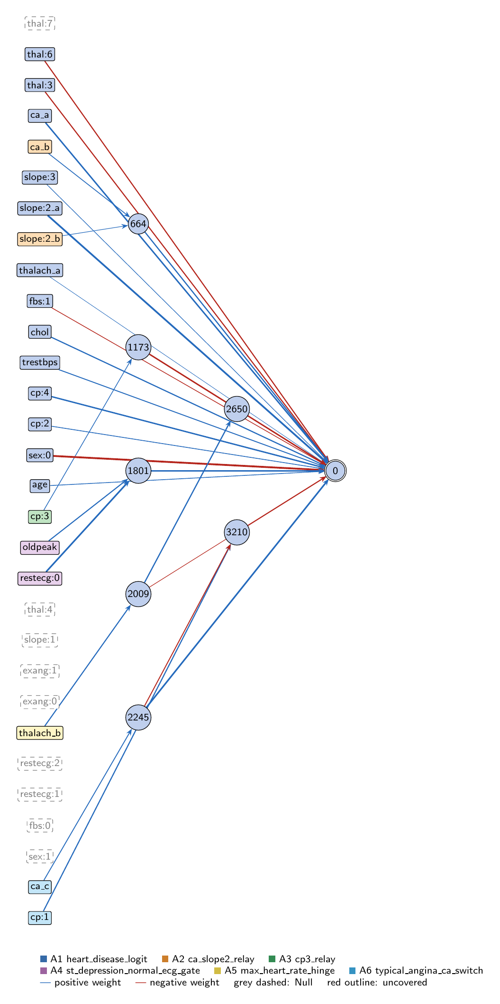
heart-s1-c1: full view of the explained model state.
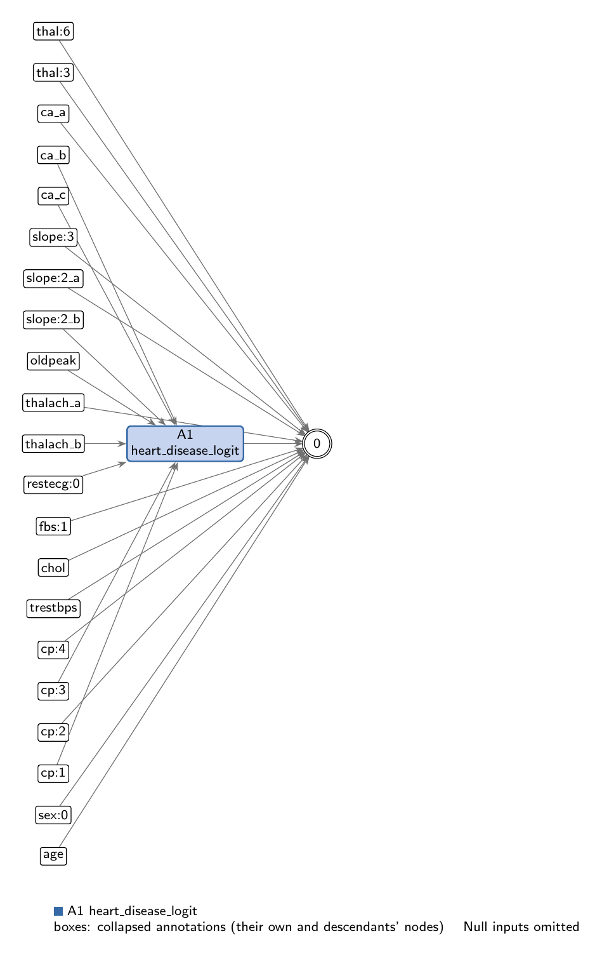
heart-s1-c1: collapsed view at hierarchy level 0 (fully recomposed).
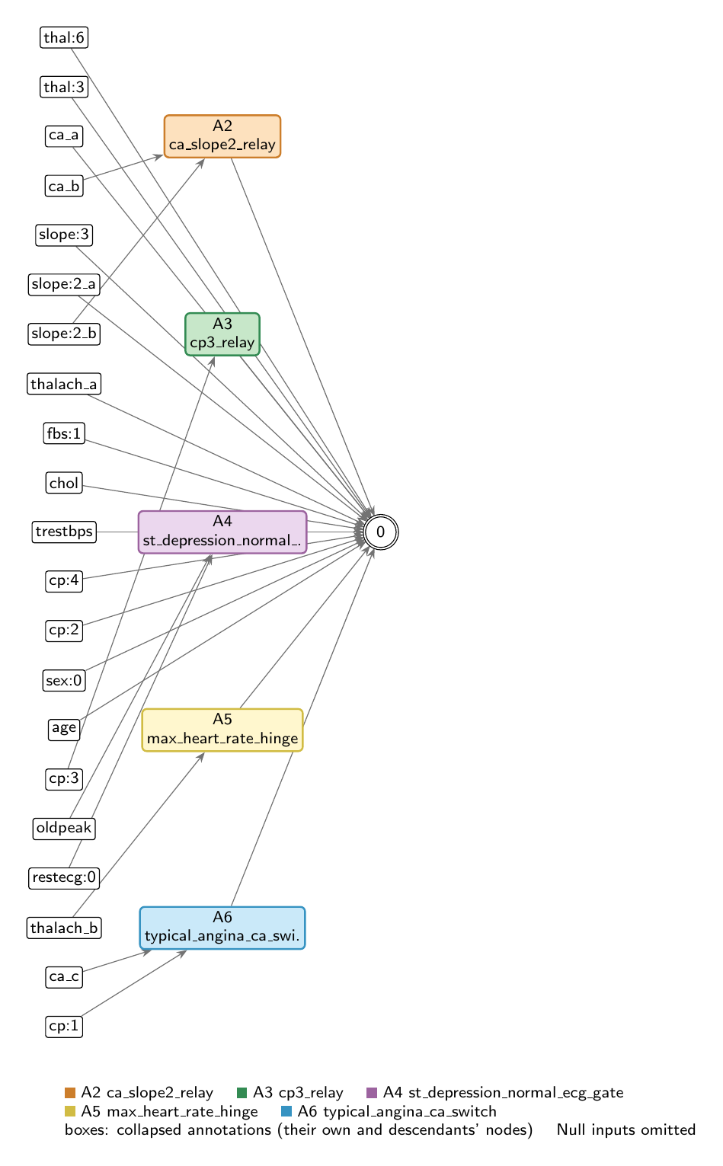
heart-s1-c1: collapsed view at hierarchy level 1.

Refactoring operations
All operations are function-preserving; max output change 3.33e-16 over 242 training rows.
- #26: split -22 into -22_a, -22_b, -22_c
- #27: split -20 into -20_a, -20_b
- #28: split -15 into -15_a, -15_b

Annotations

A1: heart_disease_logit
Composition annotation (depth 0); children A2, A3, A4, A5, A6.
- Entry nodes: -1 (age), -2 (sex:0), -3 (sex:1), -5 (cp:2), -7 (cp:4), -8 (trestbps), -9 (chol), -10 (fbs:0), -11 (fbs:1), -13 (restecg:1), -14 (restecg:2), -15_a (thalach_a), -16 (exang:0), -17 (exang:1), -19 (slope:1), -20_a (slope:2_a), -21 (slope:3), -22_a (ca_a), -23 (thal:3), -24 (thal:4), -25 (thal:6), -26 (thal:7)
- Exit nodes: 0
- Internal nodes: none
- Edges: 20; covers 37 candidate node(s)
Hypothesis. Hypothesis: the heart-disease logit is essentially a logistic regression. 13 direct input->output edges (largest: sex:0 -1.87, slope:2 +1.72, ca +1.30, cp:4 +1.25, chol +0.93, thal:3 -0.87, thal:6 -0.86, trestbps +0.67, cp:2 +0.44, age +0.40, fbs:1 -0.32, slope:3 +0.20, thalach +0.002) are added to five children: ca_slope2_relay and the 2245 relay (raise the effective ca weight to 2.60 per SD), cp3_relay (non-anginal pain lowers risk), st_depression_normal_ecg_gate (ST depression raises risk only with a normal resting ECG), typical_angina_ca_switch's 3210 (typical angina lowers risk, less with more vessels) and max_heart_rate_hinge (small). Nine inputs are unconnected (sex:1, fbs:0, restecg:1, restecg:2, exang:0, exang:1, slope:1, thal:4, thal:7): exercise-induced angina is ignored. Evidence (train, n=242): AUC 0.9392; all hidden units replaced by their best linear fits 0.9355 (= L2 logistic regression 0.9355); all ReLUs as identity 0.9078; all hidden mean-ablated 0.9241. The gain over linear (+0.0037) comes from the ECG/ST gate (+0.0034 restored alone), the heart-rate hinge (+0.0008) and the typical-angina switch (+0.0003); the relays contribute none. Direct edges carry logit SD 4.25 of 5.63.
Closed form (SymPy, weights at 3 significant figures; y_i = exit node i):
y_0 = 1.0*exp(0.399*x_{age} + 1.3*x_{ca_a} + 0.931*x_{chol} + 0.443*x_{cp:2} + 1.25*x_{cp:4} + 1.72*x_{slope:2_a} + 0.197*x_{slope:3} + 0.00188*x_{thalach_a} + 0.666*x_{trestbps} + 1.53*relu(0.578*x_{ca_c} + 1.28) + 0.92*relu(0.456*x_{ca_b} + 0.185*x_{slope:2_b} + 0.783) + 1.4*relu(0.818*x_{oldpeak} + 1.54*x_{restecg:0} - 1.52))/(1.32*exp(0.315*x_{fbs:1} + 1.87*x_{sex:0} + 0.866*x_{thal:3} + 0.861*x_{thal:6} + 1.24*relu(0.336*x_{cp:3} + 1.82) + 0.151*relu(0.833*x_{thalach_b} + 0.201) + 0.172*relu(0.982*relu(0.833*x_{thalach_b} + 0.201) + 0.859) + 0.833*relu(0.901*x_{cp:1} - 0.644*relu(0.578*x_{ca_c} + 1.28) + 0.42)) + 1.0*exp(0.399*x_{age} + 1.3*x_{ca_a} + 0.931*x_{chol} + 0.443*x_{cp:2} + 1.25*x_{cp:4} + 1.72*x_{slope:2_a} + 0.197*x_{slope:3} + 0.00188*x_{thalach_a} + 0.666*x_{trestbps} + 1.53*relu(0.578*x_{ca_c} + 1.28) + 0.92*relu(0.456*x_{ca_b} + 0.185*x_{slope:2_b} + 0.783) + 1.4*relu(0.818*x_{oldpeak} + 1.54*x_{restecg:0} - 1.52)))
Training split (n = 242): displayed closed form within 0.00427 of the forward pass; exact function within 4.44e-16.
Evidence (2 items; payloads in the JSON record):
- [analytical] analytical_formula; split: n/a (analytical). Root closed form (get_formula force=True) and effective linear weights through the always-on relays
- [empirical] ablation_study; split: train. Train split, full sample; ablations and linear replacements on in-memory copies (no graph edits)
Authorship: drafted by AI-assisted draft on 2026-11-10; verified by nobody (unverified).

A2: ca_slope2_relay
Leaf annotation (depth 1); parent A1.
- Entry nodes: -22_b (ca_b), -20_b (slope:2_b)
- Exit nodes: 664
- Internal nodes: none
- Edges: 2; covers 2 candidate node(s)
Hypothesis. Hypothesis: node 664 = ReLU(0.456 ca + 0.185 slope:2 + 0.783) is an affine relay that strengthens the direct ca and flat-ST-slope (slope:2) effects. Evidence (train, n=242): pre-activation 0.28..2.19, never clips, so the part is exactly affine on the data; it adds +0.42 logit per SD of ca and +0.17 per SD of slope:2 (output weight 0.92). Mean ablation AUC 0.9392 -> 0.9375; linear replacement leaves AUC at 0.9392. No concept beyond reweighting.
Closed form (SymPy, weights at 3 significant figures; y_i = exit node i):
y_0 = relu(0.456*x_{ca_b} + 0.185*x_{slope:2_b} + 0.783)
Training split (n = 242): displayed closed form within 4.47e-04 of the forward pass; exact function within 0.
Evidence (2 items; payloads in the JSON record):
- [analytical] analytical_formula; split: train (inferred). Closed form from get_formula (force=True)
- [empirical] empirical_viz; split: train. Train split, full sample (242); local forward passes on in-memory copies for ablations
Authorship: drafted by AI-assisted draft on 2026-11-10; verified by nobody (unverified).

A3: cp3_relay
Leaf annotation (depth 1); parent A1.
- Entry nodes: -6 (cp:3)
- Exit nodes: 1173
- Internal nodes: none
- Edges: 1; covers 1 candidate node(s)
Hypothesis. Hypothesis: node 1173 = ReLU(0.336 cp:3 + 1.818) is an always-on relay through which non-anginal chest pain (cp:3) lowers predicted risk. Evidence (train, n=242): pre-activation 1.60..2.34, never clips (entry-exit correlation 1.0); with output weight -1.24 it contributes -0.417 logit per SD of cp:3, about -0.92 logit for non-anginal pain vs other types. cp:3 has no direct edge, so this is its only route. Mean ablation AUC 0.9373; linear replacement 0.9392.
Closed form (SymPy, weights at 3 significant figures; y_i = exit node i):
y_0 = relu(0.336*x_{cp:3} + 1.82)
Training split (n = 242): displayed closed form within 0.00246 of the forward pass; exact function within 0.
Evidence (2 items; payloads in the JSON record):
- [analytical] analytical_formula; split: train (inferred). Closed form from get_formula (force=True)
- [empirical] empirical_viz; split: train. Train split, full sample (242); local forward passes on in-memory copies for ablations
Authorship: drafted by AI-assisted draft on 2026-11-10; verified by nobody (unverified).

A4: st_depression_normal_ecg_gate
Leaf annotation (depth 1); parent A1.
- Entry nodes: -12 (restecg:0), -18 (oldpeak)
- Exit nodes: 1801
- Internal nodes: none
- Edges: 2; covers 2 candidate node(s)
Hypothesis. Hypothesis: node 1801 = ReLU(1.542 restecg:0 + 0.817 oldpeak - 1.521) is a gate in which ST depression (oldpeak) raises predicted risk only for patients with a normal resting ECG (restecg:0), once oldpeak is above about its mean (threshold -0.03 SD); with an abnormal resting ECG the threshold is 3.75 SD and the gate is effectively closed. Evidence (train, n=242): active for 41 of 121 normal-ECG patients and 1 of 121 others; adds 1.40 x activation = +1.14 logit per SD oldpeak when open. It is the model's main nonlinearity: mean ablation AUC 0.9339, linear replacement 0.9362, and restoring it onto the all-linear model gains +0.0034 AUC. oldpeak has no direct edge, so the model ignores ST depression for patients with an abnormal resting ECG.
Closed form (SymPy, weights at 3 significant figures; y_i = exit node i):
y_0 = relu(0.818*x_{oldpeak} + 1.54*x_{restecg:0} - 1.52)
Training split (n = 242): displayed closed form within 0.00514 of the forward pass; exact function within 0.
Evidence (2 items; payloads in the JSON record):
- [analytical] analytical_formula; split: train (inferred). Closed form from get_formula (force=True)
- [empirical] empirical_viz; split: train. Train split, full sample (242); local forward passes on in-memory copies for ablations
Authorship: drafted by AI-assisted draft on 2026-11-10; verified by nobody (unverified).

A5: max_heart_rate_hinge
Leaf annotation (depth 1); parent A1.
- Entry nodes: -15_b (thalach_b)
- Exit nodes: 2009, 2650
- Internal nodes: none
- Edges: 2; covers 1 candidate node(s)
Hypothesis. Hypothesis: a small hinge on maximum heart rate (thalach). Node 2009 = ReLU(0.833 thalach + 0.201) feeds the output (-0.151) and the always-on relay 2650 = ReLU(0.982*2009 + 0.859) (-0.172), a net -0.32 x 2009: higher maximum heart rate lowers predicted risk, but only above about -0.24 SD; below that it has no effect (the direct thalach edge, +0.002, is negligible). Evidence (train, n=242): 2009 active for 64% of patients; logit contribution SD 0.16 (small); mean ablation AUC 0.9391, linear replacement 0.9392, restore-onto-linear gain +0.0008.
Closed form (SymPy, weights at 3 significant figures; y_i = exit node i):
y_0 = relu(0.833*x_{thalach_b} + 0.201)
y_1 = relu(0.982*relu(0.833*x_{thalach_b} + 0.201) + 0.859)
Training split (n = 242): displayed closed form within 7.41e-04 of the forward pass; exact function within 0.
Evidence (2 items; payloads in the JSON record):
- [analytical] analytical_formula; split: train (inferred). Closed form from get_formula (force=True)
- [empirical] empirical_viz; split: train. Train split, full sample (242); local forward passes on in-memory copies for ablations
Authorship: drafted by AI-assisted draft on 2026-11-10; verified by nobody (unverified).

A6: typical_angina_ca_switch
Leaf annotation (depth 1); parent A1.
- Entry nodes: -22_c (ca_c), -4 (cp:1)
- Exit nodes: 2245, 3210
- Internal nodes: none
- Edges: 3; covers 2 candidate node(s)
Hypothesis. Hypothesis: (i) node 2245 = ReLU(0.578 ca + 1.276) is an always-on ca relay adding +0.88 logit per SD of ca (output weight 1.528); (ii) node 3210 = ReLU(0.901 cp:1 - 0.644*2245 + 0.420) is a typical-angina switch: it is on only for cp:1 patients and then lowers the logit by 0.833 x its activation, from about -2.26 at the lowest ca (-0.73 SD) to about -1.22 at the highest ca (2.64 SD). So typical angina lowers predicted risk, and the reduction shrinks with more narrowed vessels. Evidence (train, n=242): 2245 never clips (0.86..2.80); 3210 active for all 22 cp:1 patients and none of the 220 others. Mean ablation AUC 2245 0.9339, 3210 0.9354; linear replacement 0.9392 / 0.9391 (3210 is a cp:1 switch whose within-group response is linear in ca).
Closed form (SymPy, weights at 3 significant figures; y_i = exit node i):
y_0 = relu(0.578*x_{ca_c} + 1.28)
y_1 = relu(0.901*x_{cp:1} - 0.644*relu(0.578*x_{ca_c} + 1.28) + 0.42)
Training split (n = 242): displayed closed form within 0.00423 of the forward pass; exact function within 0.
Evidence (2 items; payloads in the JSON record):
- [analytical] analytical_formula; split: train (inferred). Closed form from get_formula (force=True)
- [empirical] empirical_viz; split: train. Train split, full sample (242); local forward passes on in-memory copies for ablations
Authorship: drafted by AI-assisted draft on 2026-11-10; verified by nobody (unverified).

Audit against the definitions
- WARNING unverified: No human verification is recorded for this explanation.
end of thesis draft

