THESIS DRAFT - appendix: heart-s2-c2 explanation certificate - for review

Explanation certificate: heart-s2-c2
Rendered from the canonical JSON record heart-s2-c2.json (schema 1.4.0, SHA-256 1276e9a13f62dbc089618dbbcbf8c7fcbf1ae0d7094c9016ac0b90a0a0c036ac), which holds every evidence payload and the full graphs.
Dataset | Heart Disease (binary, prepared)
Experiment | 10seed-heart-s2, seed 2
Genome | d4bbc960-816a-4781-8979-fdd4165debf2 (NEAT key 9685, generation 39)
Explanation | 3531d96c-aa00-4141-863a-2c85155afe8f (31 operations)
Train AUC / accuracy | 0.9403 / 0.8967 (n = 242)
Test AUC / accuracy | 0.9009 / 0.8197 (n = 61)
Output activation | sigmoid
Phenotype | 31 nodes (26 inputs, 4 hidden, 1 output), 24 enabled edges
Explained model state | 33 nodes, 24 enabled edges
Function preservation | max |change in output| = 2.22e-16 (train)
Annotations | 3 (2 leaf, 1 composition)
Structural coverage | 1 (32 of 32; 8 Null)
Compositional coverage | 1
Uncovered nodes / edges | 0 / 0
Missing compositions | 0
Full coverage | yes
Drafted by | AI-assisted draft
Verified by | unverified
Drafter's summary. Mostly logistic regression: 16 direct edges (logit SD 3.66; train AUC 0.934 alone, L2 logistic regression 0.9355) plus one consequential nonlinear part to 0.940. The protective gate 3842 = ReLU(1.02 ReLU(0.688 thalach - 0.374 thal:6 + 2.15 [non-anginal pain] - 0.347) - 0.295), read out -0.519, opens for nearly all non-anginal-pain patients, for others only above about +0.8 SD max heart rate, and never with a fixed thallium defect; once open a higher max heart rate lowers risk 3.4x as steeply. A restecg:2 relay is negligible. Unlike the generation-38 heart-s2 record (age/thalach/thal:7 gate, flat-slope gate, oldpeak hinges), age and oldpeak here act only linearly and the gate is keyed on chest-pain type and fixed defect instead.
What resisted explanation. Nothing resisted coverage; only input fan-out needed splitting (thalach, thal:6). Relay 3607 is a step on the binary restecg:2 input, so exactly affine on the data and negligible (read out -0.021). Eight inputs are unconnected (thal:3, thal:4, slope:3, exang:0, exang:1, restecg:0, restecg:1, fbs:0) and listed as zero-effect root entries; exercise angina is ignored entirely. Counter-directional signs reported, not explained: cp:2 +0.26 and fbs:1 -0.22 in the linear core, and thal:6 (fixed defect) -0.30 directly plus closing the protective gate.

Plain-language summary
AI-assisted draft for review (unverified). Each sentence cites the claims that back it; every cited claim was computed on the model and the training split and passed its automatic checks. Magnitudes are changes in predicted risk for a typical patient; confidence words follow the test-split check and n. The text describes what the model does, not the world.
Summary (drafted). For a typical patient (a 56-year-old man with no chest pain symptoms and median test results) the model predicts a risk of heart disease of about 32%; it adds up most of its inputs independently, and two parts add to that sum: one acts on 104 of 242 training patients through chest pain type, maximum heart rate and the thallium scan, and one through the resting ECG barely changes the predictions. [C29, C37, C41] These add up independently, and these lower the risk: through this sum alone, compared with no chest pain symptoms, typical angina takes a typical patient's predicted risk from about 32% to about 2%, non-anginal chest pain to about 7% and atypical angina to about 14%; being a woman lowers it to about 4% and fasting blood sugar above 120 mg/dL to about 20%; and a higher maximum heart rate lowers it steadily, from about 37% at 118 to about 28% at 175 beats per minute (chest pain type and maximum heart rate also act through the heart rate gate, below). [C04, C12, C16, C08, C18, C20] Each extra vessel coloured by fluoroscopy adds about the same, from about 32% at 0 to about 96% at 2 vessels, flattening out near the top because the predicted risk cannot go much higher; a flat rather than upsloping ST segment raises it to about 81%; and ST depression on exercise, cholesterol and resting blood pressure each raise it steadily, from about 25% at 0 mm to about 55% at 2.8 mm, from about 22% at 193 mg/dL to about 50% at 308 mg/dL, and from about 21% at 110 mm Hg to about 48% at 155 mm Hg. [C01, C02, C03, C07, C09] Through this sum alone a reversible defect on the thallium scan raises it to about 57% (the thallium scan also acts through the heart rate gate, below); older age raises it steadily but only from about 31% at 42 to about 32% at 66 years; and the model ignores chest pain brought on by exercise. [C10, C21, C28] Some rarer results also count (the model has little data on this, n = 15 to 17): a downsloping ST segment raises the risk to about 54%, and through this sum alone a fixed defect on the thallium scan lowers it to about 12%. [C13, C14] This part reads chest pain type, maximum heart rate and the thallium scan, and acts on 104 of 242 training patients, 24 of whom had heart disease; for the typical patient it acts on, the predicted risk is about 5% without it and about 2% with it. [C37] Across the whole model, non-anginal chest pain lowers the predicted risk, and even more so without a fixed defect on the thallium scan: from about 32% to about 3% then, against about 12% to about 2% with one (the model has little data on this, n = 15). [C33] Across the whole model, a higher maximum heart rate lowers the risk, and even more so with non-anginal chest pain, where it falls steadily from about 7% at 118 to about 2% at 175 beats per minute, flattening out near the bottom because the predicted risk cannot go much lower; for other chest pain types it falls from about 37% to about 26%. [C35] Through this part alone, for most patients a higher maximum heart rate does nothing until about 168 beats per minute, then lowers the risk steadily, but for patients with non-anginal chest pain it lowers it steadily all along: for a typical patient from about 32% at 118 to about 29% at 175 beats per minute (the model has little data on this, n = 14). [C31, C36] This part reads only the resting ECG: signs of left ventricular hypertrophy take a typical patient's predicted risk from about 32% to about 31%, and switching the part off changes any prediction by at most about half a percentage point. [C39, C41]
Summary (offline template). The model treats a higher number of vessels coloured by fluoroscopy as raising the predicted risk of heart disease steadily, each extra vessel adding about the same: for a typical patient, it goes from about 32% at 0 vessels to about 96% at 2 vessels, flattening out near the top because the predicted risk cannot go much higher (on the training data only). [C01] For a typical patient, the model gives a higher predicted risk of heart disease if the ST segment is flat at peak exercise (about 81%) than if the ST segment slopes up at peak exercise (about 32%) (on the training data only). [C02] The model treats a higher ST depression on exercise as raising the predicted risk of heart disease steadily: for a typical patient, it goes from about 25% at 0.0 mm to about 55% at 2.8 mm (on the training data only). [C03] For a typical patient, maximum heart rate going from 118 beats per minute to 175 beats per minute moves the predicted risk of heart disease from about 7% to about 2% if the patient has non-anginal chest pain, and from about 37% to about 26% if chest pain type is something other than non-anginal chest pain (it moves steadily for patients with non-anginal chest pain). [C35] The model ignores exercise-induced angina. [C28]
ann_30 (heart_disease_logit). The model treats a higher number of vessels coloured by fluoroscopy as raising the predicted risk of heart disease steadily, each extra vessel adding about the same: for a typical patient, it goes from about 32% at 0 vessels to about 96% at 2 vessels, flattening out near the top because the predicted risk cannot go much higher (on the training data only). [C01] For a typical patient, the model gives a higher predicted risk of heart disease if the ST segment is flat at peak exercise (about 81%) than if the ST segment slopes up at peak exercise (about 32%) (on the training data only). [C02] The model treats a higher ST depression on exercise as raising the predicted risk of heart disease steadily: for a typical patient, it goes from about 25% at 0.0 mm to about 55% at 2.8 mm (on the training data only). [C03] For a typical patient, the model gives a clearly lower predicted risk of heart disease if the patient has typical angina (about 2%) than if the patient has no chest pain symptoms (about 32%). [C04] For a typical patient, the model gives a clearly lower predicted risk of heart disease if the patient has typical angina (about 2%) than if the patient has no chest pain symptoms (about 32%). [C05] It ignores exercise-induced angina. [C28] Other effects: non-anginal chest pain (rather than no chest pain (asymptomatic)) lowers it; a higher serum cholesterol raises it steadily; female (rather than male) lowers it; a higher resting blood pressure raises it steadily; a reversible defect on the thallium scan (rather than any other thallium stress test result) raises it; a reversible defect on the thallium scan (rather than any other thallium stress test result) raises it; non-anginal chest pain (rather than no chest pain (asymptomatic)) lowers it; a downsloping ST segment (rather than an upsloping ST segment) raises it; and 7 still smaller effects listed in the evidence table (on the training data only). The model has little data on some of these: only 17 training patients (a downsloping ST segment). [C06, C07, C08, C09, C10, C11, C12, C13] Smaller effects, each changing the predicted value only slightly: a higher age raises it steadily; signs of left ventricular hypertrophy on the resting ECG (rather than any other resting ECG) lowers it (on the training data only). [C21, C22]
ann_28 (heart_rate_nonanginal_gate). This part acts on 104 of 242 training patients (43%). [C37] For a typical patient it acts on, it slightly lowers the predicted risk of heart disease from about 5% without this part to about 2% with it (on the training data only). [C37] In the training data, 24 of these 104 patients had heart disease. [C37] The model gives a lower predicted risk of heart disease if the patient has non-anginal chest pain than if chest pain type is something other than non-anginal chest pain, and even more so if thallium stress test result is something other than a fixed defect on the thallium scan: for a typical patient, going from chest pain type other than non-anginal chest pain to non-anginal chest pain moves the predicted risk of heart disease from about 32% to about 3% if thallium stress test result is something other than a fixed defect on the thallium scan, and from about 12% to about 2% if the thallium scan shows a fixed defect. The model has little data on this: only 15 training patients (a fixed defect on the thallium scan). [C33] Other effects: non-anginal chest pain (rather than any other chest pain type) lowers it; maximum heart rate depending on thallium stress test result lowers it slowly at first, then faster for most patients, but for patients with non-anginal chest pain it moves steadily; maximum heart rate depending on chest pain type lowers it steadily (on the training data only). The model has little data on some of these: only 15 training patients (a fixed defect on the thallium scan). [C30, C34, C35] Smaller effects, each changing the predicted value only slightly: a higher maximum heart rate lowers it with nothing until about 168 beats per minute, then steadily for most patients, but for patients with non-anginal chest pain it moves steadily; a fixed defect on the thallium scan (rather than any other thallium stress test result) raises it; maximum heart rate past about 168 beats per minute lowers it with nothing until about 168 beats per minute, then steadily (on the training data only). The model has little data on some of these: only 15 training patients (a fixed defect on the thallium scan) and 14 training patients (of them, patients already past their fold). [C31, C32, C36]
ann_29 (restecg2_relay). Through this part, for a typical patient, the model gives a slightly lower predicted risk of heart disease if the resting ECG shows left ventricular hypertrophy (about 31%) than if resting ECG is something other than signs of left ventricular hypertrophy on the resting ECG (about 32%) (on the training data only). [C39] This part barely changes the model's predictions (by at most 0.5 percentage points). [C41]
Worth checking against what is known. Worth checking: going from 0 to 2 vessels coloured moves a typical patient's predicted risk from about 32% to about 96%. [C01] Worth checking: patients with typical angina get the lowest predicted risk of all chest pain types, below patients with no chest pain symptoms. [C05, C06, C17] Worth checking: the model treats fasting blood sugar above 120 mg/dL as lowering the risk of heart disease (for a typical patient from about 32% to about 20%). [C18] Worth checking: the model treats a fixed defect on the thallium scan as lowering the risk (for a typical patient from about 32% to about 12%), from only 15 training patients. [C15] Worth checking: the model ignores whether exercise brings on chest pain. [C28]
Claim | What is checked | Risk, typical patient | Estimate (log-odds; OR); range across patients | n | Test check | Verified | Words
C01 | direction: number of vessels coloured by fluoroscopy: 0 vessels to 2 vessels (whole model) | 32% to 96% | log-odds 3.99, OR 54.0; range across patients 3.99 to 3.99 | 242 | train; test unclear (AUC gain 0.037 [-0.038, 0.119], n=61) | yes | on the training data only
C02 | direction: slope of the ST segment at peak exercise: an upsloping ST segment to a flat ST segment (whole model) | 32% to 81% | log-odds 2.21, OR 9.14; range across patients 2.21 to 2.21 | 115, 110 | train; test disagrees (AUC gain -0.004 [-0.044, 0.034], n=61) | yes | on the training data only
C03 | direction: ST depression on exercise: 0.0 mm to 2.8 mm (whole model) | 25% to 55% | log-odds 1.31, OR 3.72; range across patients 1.31 to 1.31 | 242 | train; test unclear (AUC gain 0.011 [-0.005, 0.034], n=61) | yes | on the training data only
C04 | direction: chest pain type: no chest pain (asymptomatic) to typical angina (direct contribution only, not through any part) | 32% to 2% | log-odds -3.03, OR 0.05; range across patients -3.03 to -3.03 | 108, 22 | train; test agrees (AUC gain 0.039 [0.009, 0.076], n=61) | yes | clearly
C05 | direction: chest pain type: no chest pain (asymptomatic) to typical angina (whole model) | 32% to 2% | log-odds -3.03, OR 0.05; range across patients -3.03 to -3.03 | 108, 22 | train; test agrees (AUC gain 0.057 [0.017, 0.104], n=61) | yes | clearly
C06 | direction: chest pain type: no chest pain (asymptomatic) to non-anginal chest pain (whole model) | 32% to 3% | log-odds -2.53, OR 0.08; range across patients -2.88 to -1.96 | 108, 70 | train; test agrees (AUC gain 0.057 [0.017, 0.104], n=61) | yes | clearly
C07 | direction: serum cholesterol: 193 mg/dL (5.0 mmol/L) to 308 mg/dL (8.0 mmol/L) (whole model) | 22% to 50% | log-odds 1.28, OR 3.58; range across patients 1.28 to 1.28 | 242 | train; test disagrees (AUC gain -0.011 [-0.039, 0.012], n=61) | yes | on the training data only
C08 | direction: sex: male to female (whole model) | 32% to 4% | log-odds -2.34, OR 0.10; range across patients -2.34 to -2.34 | 159, 83 | train; test unclear (AUC gain 0.027 [-0.01, 0.074], n=61) | yes | on the training data only
C09 | direction: resting blood pressure: 110 mm Hg to 155 mm Hg (whole model) | 21% to 48% | log-odds 1.22, OR 3.38; range across patients 1.22 to 1.22 | 242 | train; test unclear (AUC gain 0.009 [-0.013, 0.034], n=61) | yes | on the training data only
C10 | direction: thallium stress test result: thallium stress test result other than a fixed defect on the thallium scan, a reversible defect on the thallium scan to a reversible defect on the thallium scan (direct contribution only, not through any part) | 32% to 57% | log-odds 1.04, OR 2.82; range across patients 1.04 to 1.04 | 137, 90 | train; test unclear (AUC gain 0.018 [-0.012, 0.053], n=61) | yes | on the training data only
C11 | direction: thallium stress test result: thallium stress test result other than a fixed defect on the thallium scan, a reversible defect on the thallium scan to a reversible defect on the thallium scan (whole model) | 32% to 57% | log-odds 1.04, OR 2.82; range across patients 1.04 to 1.04 | 137, 90 | train; test unclear (AUC gain 0.018 [-0.012, 0.053], n=61) | yes | on the training data only
C12 | direction: chest pain type: no chest pain (asymptomatic) to non-anginal chest pain (direct contribution only, not through any part) | 32% to 7% | log-odds -1.75, OR 0.17; range across patients -1.75 to -1.75 | 108, 70 | train; test agrees (AUC gain 0.039 [0.009, 0.076], n=61) | yes | clearly
C13 | direction: slope of the ST segment at peak exercise: an upsloping ST segment to a downsloping ST segment (whole model) | 32% to 54% | log-odds 0.94, OR 2.56; range across patients 0.94 to 0.94 | 115, 17 (small n) | train; test disagrees (AUC gain -0.004 [-0.044, 0.034], n=61) | yes | the model has little data on this; on the training data only
C14 | direction: thallium stress test result: thallium stress test result other than a fixed defect on the thallium scan, a reversible defect on the thallium scan to a fixed defect on the thallium scan (direct contribution only, not through any part) | 32% to 12% | log-odds -1.24, OR 0.29; range across patients -1.24 to -1.24 | 137, 15 (small n) | train; test unclear (AUC gain 0.018 [-0.012, 0.053], n=61) | yes | the model has little data on this; on the training data only
C15 | direction: thallium stress test result: thallium stress test result other than a fixed defect on the thallium scan, a reversible defect on the thallium scan to a fixed defect on the thallium scan (whole model) | 32% to 12% | log-odds -1.00, OR 0.37; range across patients -1.24 to -0.42 | 137, 15 (small n) | train; test unclear (AUC gain 0.018 [-0.012, 0.053], n=61) | yes | the model has little data on this; on the training data only
C16 | direction: chest pain type: no chest pain (asymptomatic) to atypical angina (direct contribution only, not through any part) | 32% to 14% | log-odds -1.05, OR 0.35; range across patients -1.05 to -1.05 | 108, 42 | train; test agrees (AUC gain 0.039 [0.009, 0.076], n=61) | yes | clearly
C17 | direction: chest pain type: no chest pain (asymptomatic) to atypical angina (whole model) | 32% to 14% | log-odds -1.05, OR 0.35; range across patients -1.05 to -1.05 | 108, 42 | train; test agrees (AUC gain 0.057 [0.017, 0.104], n=61) | yes | clearly
C18 | direction: fasting blood sugar: fasting blood sugar of 120 mg/dL or less to fasting blood sugar above 120 mg/dL (whole model) | 32% to 20% | log-odds -0.65, OR 0.52; range across patients -0.65 to -0.65 | 209, 33 | train; test unclear (AUC gain 0.000 [-0.011, 0.013], n=61) | yes | on the training data only
C19 | direction: maximum heart rate: 118 beats per minute to 175 beats per minute (whole model) | 37% to 26% | log-odds -0.73, OR 0.48; range across patients -1.32 to -0.51 | 242 | train; test agrees (AUC gain 0.014 [0.002, 0.037], n=61) | yes | clearly
C20 | direction: maximum heart rate: 118 beats per minute to 175 beats per minute (direct contribution only, not through any part) | 37% to 28% | log-odds -0.39, OR 0.68; range across patients -0.39 to -0.39 | 242 | train; test unclear (AUC gain 0.006 [0.000, 0.020], n=61) | yes | on the training data only
C21 | direction: age: 42 years to 66 years (whole model) | 31% to 32% | log-odds 0.07, OR 1.08; range across patients 0.07 to 0.07 | 242 | train; test disagrees (AUC gain -0.001 [-0.005, 0.000], n=61) | yes | slightly; on the training data only
C22 | direction: resting ECG: resting ECG other than signs of left ventricular hypertrophy on the resting ECG to signs of left ventricular hypertrophy on the resting ECG (whole model) | 32% to 31% | log-odds -0.02, OR 0.98; range across patients -0.02 to -0.02 | 123, 119 | train; test unclear (AUC gain 0.000 [0.000, 0.000], n=61) | yes | slightly; on the training data only
C23 | magnitude: number of vessels coloured by fluoroscopy: 0 vessels to 2 vessels, typical patient | 32% to 96% | log-odds 3.99, OR 54.0 | 242 | train; test unclear (AUC gain 0.037 [-0.038, 0.119], n=61) | yes | on the training data only
C24 | magnitude: slope of the ST segment at peak exercise: an upsloping ST segment to a flat ST segment, typical patient | 32% to 81% | log-odds 2.21, OR 9.14 | 115, 110 | train; test disagrees (AUC gain -0.004 [-0.044, 0.034], n=61) | yes | on the training data only
C25 | magnitude: ST depression on exercise: 0.0 mm to 2.8 mm, typical patient | 25% to 55% | log-odds 1.31, OR 3.72 | 242 | train; test unclear (AUC gain 0.011 [-0.005, 0.034], n=61) | yes | on the training data only
C26 | magnitude: chest pain type: no chest pain (asymptomatic) to typical angina, typical patient | 32% to 2% | log-odds -3.03, OR 0.05 | 108, 22 | train; test agrees (AUC gain 0.057 [0.017, 0.104], n=61) | yes | clearly
C27 | magnitude: serum cholesterol: 193 mg/dL (5.0 mmol/L) to 308 mg/dL (8.0 mmol/L), typical patient | 22% to 50% | log-odds 1.28, OR 3.58 | 242 | train; test disagrees (AUC gain -0.011 [-0.039, 0.012], n=61) | yes | on the training data only
C28 | null: model ignores exercise-induced angina (exact rule) |  | max change 0.000 (max |change in log-odds|) | 242 | train | yes
C29 | structure: made of heart_rate_nonanginal_gate, restecg2_relay and inputs age, sex, cp, trestbps, chol, fbs, thalach, oldpeak, slope, ca, thal; added |  | log-odds n/a, OR n/a | 242 | train | yes
C30 | direction: chest pain type: chest pain type other than non-anginal chest pain to non-anginal chest pain (through this part) | 32% to 16% | log-odds -0.79, OR 0.46; range across patients -1.14 to -0.21 | 172, 70 | train; test unclear (AUC gain 0.008 [-0.012, 0.030], n=61) | yes | on the training data only
C31 | direction: maximum heart rate: 118 beats per minute to 175 beats per minute (through this part) | 32% to 29% | log-odds -0.34, OR 0.71; range across patients -0.93 to -0.12 | 242 | train; test unclear (AUC gain 0.008 [0.000, 0.022], n=61) | yes | slightly; on the training data only
C32 | direction: thallium stress test result: thallium stress test result other than a fixed defect on the thallium scan to a fixed defect on the thallium scan (through this part) | 2% to 4% (typical patient this part acts on) | log-odds 0.24, OR 1.27; range across patients 0.00 to 0.82 | 227, 15 (small n) | train; test unclear (AUC gain 0.001 [0.000, 0.006], n=61) | yes | slightly; the model has little data on this; on the training data only
C33 | interaction: effect of chest pain type (chest pain type other than non-anginal chest pain to non-anginal chest pain) by thallium stress test result: a fixed defect on the thallium scan minus thallium stress test result other than a fixed defect on the thallium scan; stronger in thallium stress test result other than a fixed defect on the thallium scan | a fixed defect on the thallium scan: 12% to 2%; thallium stress test result other than a fixed defect on the thallium scan: 32% to 3% | log-odds difference 0.79, OR 2.20 | 15, 227 (small n) | train; test agrees (AUC gain 0.001 [0.000, 0.006], n=61); group difference on test 0.73 [0.60, 0.85] | yes | the model has little data on this
C34 | interaction: effect of maximum heart rate (118 beats per minute to 175 beats per minute) by thallium stress test result: a fixed defect on the thallium scan minus thallium stress test result other than a fixed defect on the thallium scan; stronger in thallium stress test result other than a fixed defect on the thallium scan | a fixed defect on the thallium scan: 14% to 10%; thallium stress test result other than a fixed defect on the thallium scan: 37% to 26% | log-odds difference 0.30, OR 1.35 | 15, 227 (small n) | train; test agrees (AUC gain 0.001 [0.000, 0.006], n=61); group difference on test 0.34 [0.26, 0.44] | yes | the model has little data on this
C35 | interaction: effect of maximum heart rate (118 beats per minute to 175 beats per minute) by chest pain type: non-anginal chest pain minus chest pain type other than non-anginal chest pain; stronger in non-anginal chest pain | non-anginal chest pain: 7% to 2%; chest pain type other than non-anginal chest pain: 37% to 26% | log-odds difference -0.80, OR 0.45 | 70, 172 | train; test agrees (AUC gain 0.008 [-0.012, 0.030], n=61); group difference on test -0.82 [-0.83, -0.81] | yes | clearly
C36 | threshold: maximum heart rate: fold at about 168 beats per minute (starts) for patients with no chest pain symptoms (asymptomatic) | 99% to 99% (typical patient with a fold (patients with no chest pain symptoms (asymptomatic))) | fold 168 beats per minute (IQR 168 to 168); past it log-odds -0.23, OR 0.79; range across patients -0.23 to -0.23 | 99, 14 (small n) | train; test unclear (AUC gain 0.008 [0.000, 0.022], n=61) | yes | slightly; the model has little data on this; on the training data only
C37 | subgroup: who this part acts on: 104 of 242 patients | 5% to 2% (typical patient this part acts on (risk without the part, then with it)) | share 0.43; log-odds -0.67, OR 0.51; range across patients -1.22 to -0.05 | 104, 138 | train; test unclear (AUC gain 0.018 [0.000, 0.044], n=61) | yes | slightly; on the training data only
C38 | structure: its formula reproduces it on 242 training patients (largest difference 4.44089e-16) |  | log-odds 4e-16, OR n/a | 242 | train | yes
C39 | direction: resting ECG: resting ECG other than signs of left ventricular hypertrophy on the resting ECG to signs of left ventricular hypertrophy on the resting ECG (through this part) | 32% to 31% | log-odds -0.02, OR 0.98; range across patients -0.02 to -0.02 | 123, 119 | train; test unclear (AUC gain 0.000 [0.000, 0.000], n=61) | yes | slightly; on the training data only
C40 | subgroup: who this part acts on: 119 of 242 patients | 85% to 84% (typical patient this part acts on (risk without the part, then with it)) | share 0.49; log-odds -0.02, OR 0.98; range across patients -0.02 to -0.02 | 119, 123 | train; test unclear (AUC gain 0.000 [0.000, 0.000], n=61) | no | slightly; on the training data only
C41 | null: this part barely changes predictions (switched off) |  | max change 0.005 (max |change in predicted risk|) | 242 | train | yes
C42 | structure: its formula reproduces it on 242 training patients (largest difference 0.0) |  | log-odds 0.00, OR n/a | 242 | train | yes

Not supported by the model
- C40: subgroup claim about resting ECG in part ann_29: not supported by the model (its effect is negligible).

Coverage
Candidate nodes are all nodes of the explained model state except the output nodes. A candidate node is covered when some annotation of the hierarchy (a leaf, or a composition with its descendants) contains it and all its enabled outgoing edges. Exact Null parts (no path to an output over enabled, non-zero-weight edges; zero-weight edges) count as covered.
- Null, disconnected input (8): -10 (fbs:0), -12 (restecg:0), -13 (restecg:1), -16 (exang:0), -17 (exang:1), -21 (slope:3), -23 (thal:3), -24 (thal:4)
- Uncovered nodes: none
- Uncovered edges: none
- Missing compositions: none

Annotation hierarchy
- A1: heart_disease_logit (composition)
- A2: heart_rate_nonanginal_gate (leaf)
- A3: restecg2_relay (leaf)

Network figures
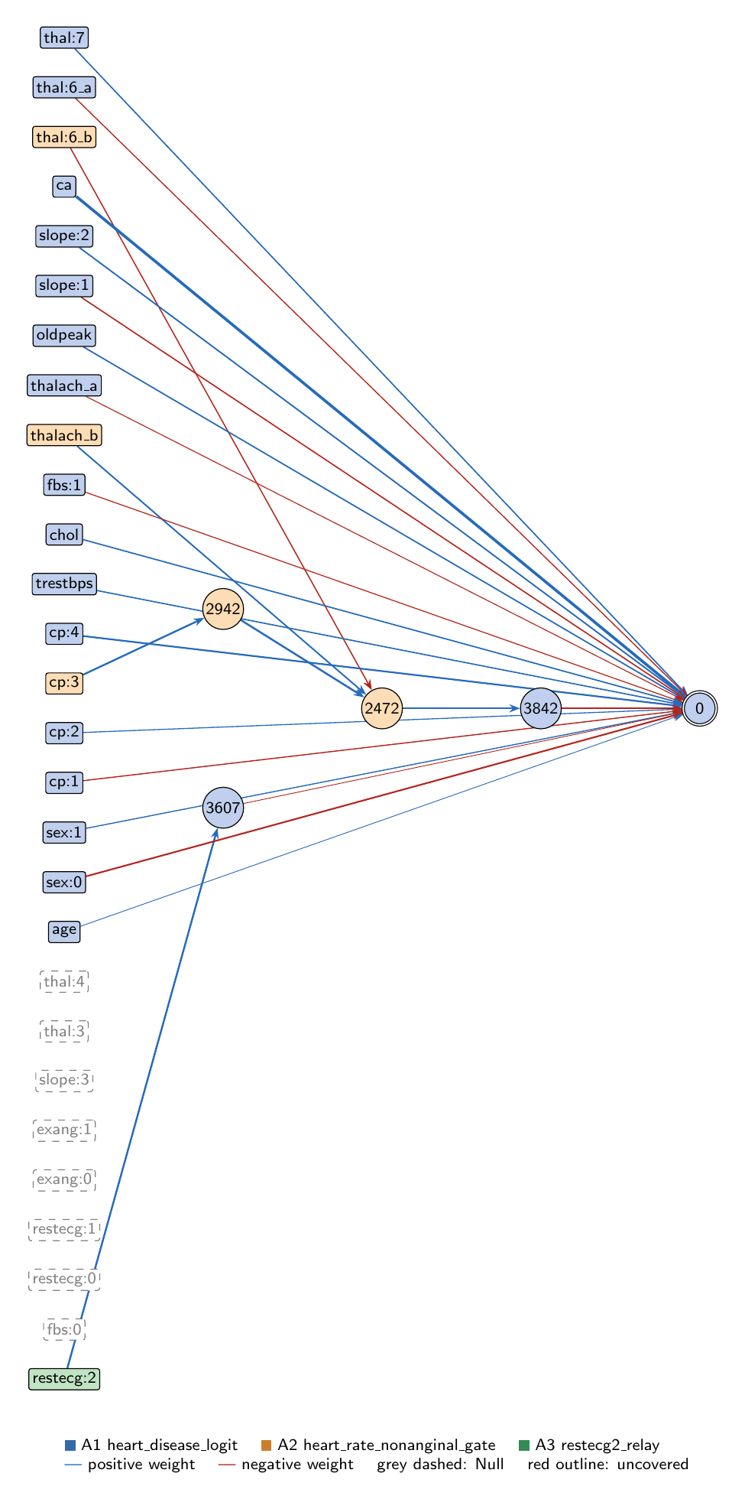
heart-s2-c2: full view of the explained model state.
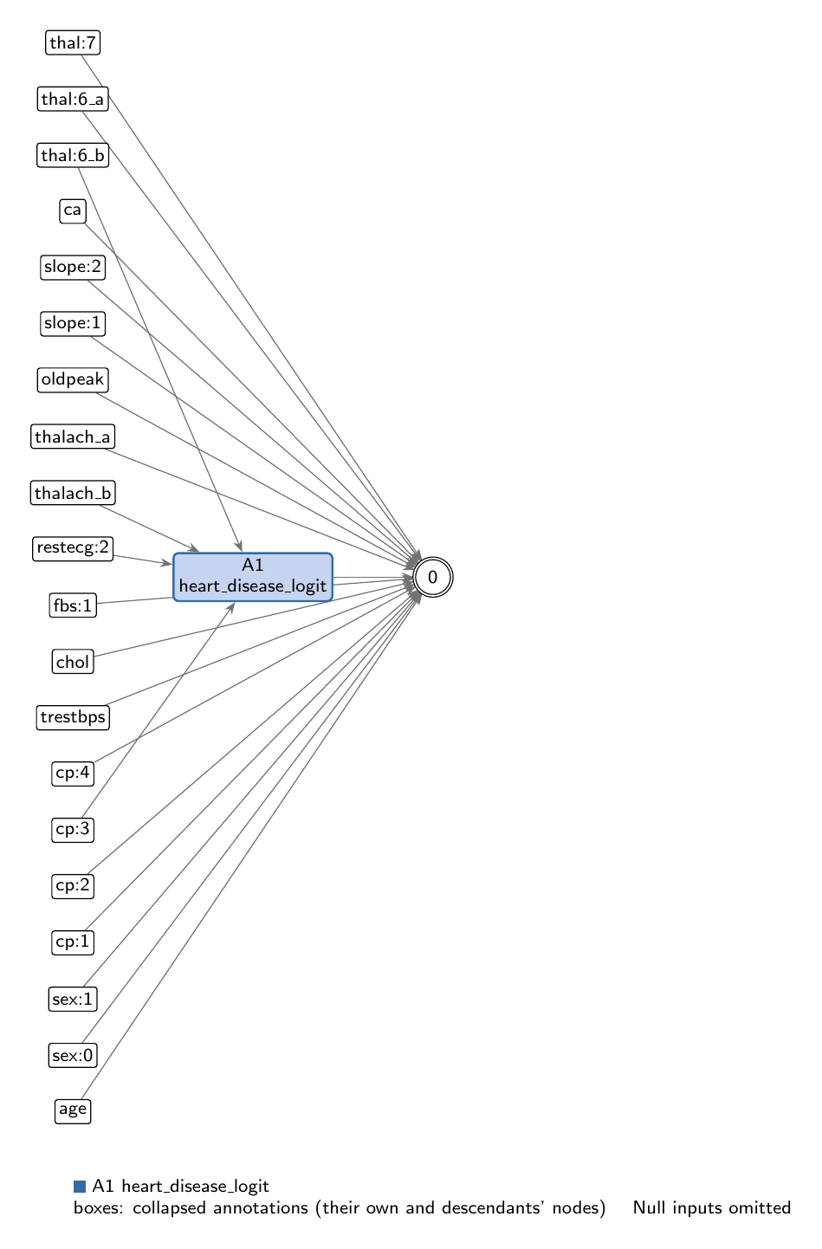
heart-s2-c2: collapsed view at hierarchy level 0 (fully recomposed).
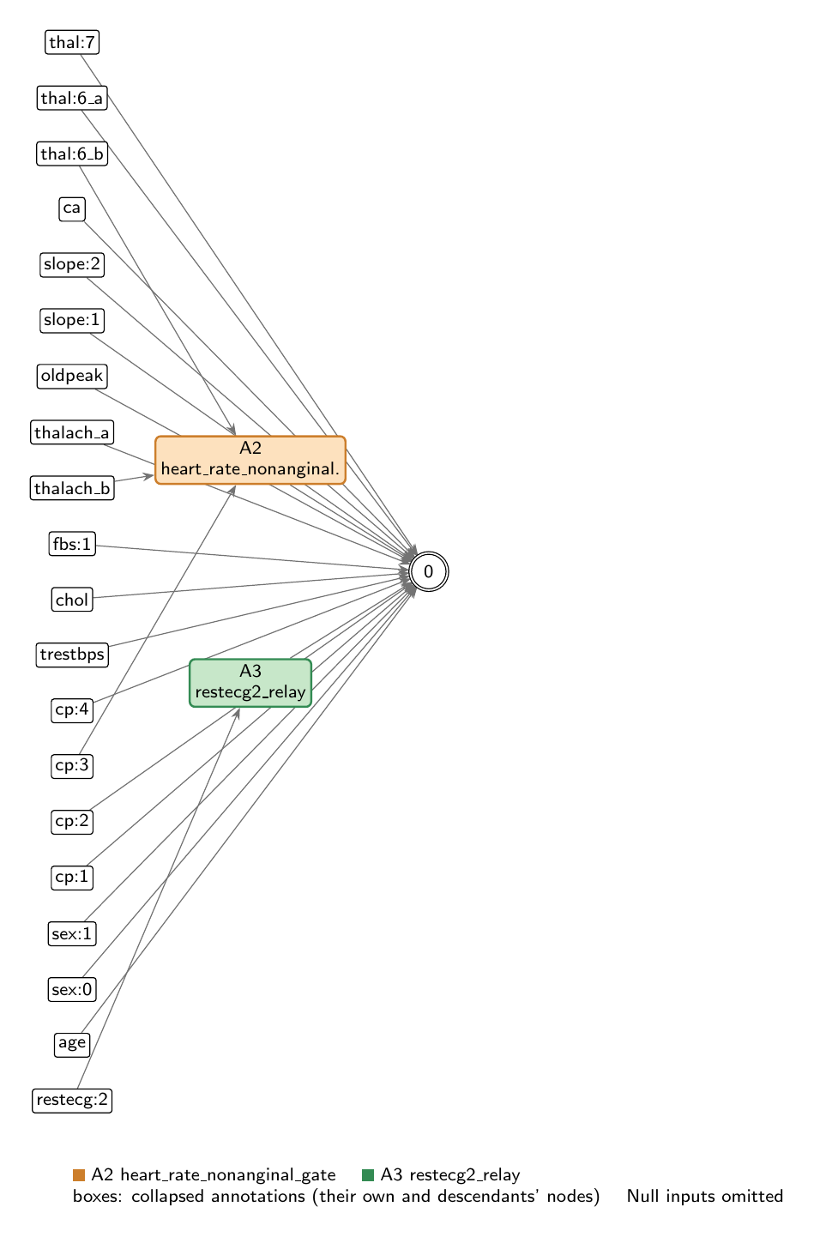
heart-s2-c2: collapsed view at hierarchy level 1.

Refactoring operations
All operations are function-preserving; max output change 2.22e-16 over 242 training rows.
- #26: split -15 into -15_a, -15_b
- #27: split -25 into -25_a, -25_b

Annotations

A1: heart_disease_logit
Composition annotation (depth 0); children A2, A3.
- Entry nodes: -1 (age), -2 (sex:0), -3 (sex:1), -4 (cp:1), -5 (cp:2), -7 (cp:4), -8 (trestbps), -9 (chol), -10 (fbs:0), -11 (fbs:1), -12 (restecg:0), -13 (restecg:1), -15_a (thalach_a), -16 (exang:0), -17 (exang:1), -18 (oldpeak), -19 (slope:1), -20 (slope:2), -21 (slope:3), -22 (ca), -23 (thal:3), -24 (thal:4), -25_a (thal:6_a), -26 (thal:7)
- Exit nodes: 0
- Internal nodes: none
- Edges: 18; covers 32 candidate node(s)
Hypothesis. Root: heart-disease logit at output 0 (sigmoid). Essentially logistic regression: 16 direct edges (ca +1.78, cp:4 +0.87, sex:0 -0.77, slope:2 +0.63, oldpeak +0.56, chol +0.54, thal:7 +0.50, trestbps +0.49, slope:1 -0.47, cp:1 -0.37, sex:1 +0.34, thal:6 -0.30, cp:2 +0.26, fbs:1 -0.22, thalach -0.15, age +0.03) carry logit SD 3.66 and train AUC 0.9343 alone (L2 logistic regression on all 26 inputs: 0.9355). The two children are added to the logit: heart_rate_nonanginal_gate (x -0.519; +0.006 AUC, the only consequential nonlinearity) and restecg2_relay (x -0.021, negligible). Eight inputs are unconnected, zero effect: thal:3, thal:4, slope:3, exang:0, exang:1, restecg:0, restecg:1, fbs:0 (exercise angina is ignored). Evidence (train, n=242): composed closed form; sensitivity and mean |SHAP| both rank ca first (0.16), then cp:4, sex:0, slope:2; full-model train AUC 0.9403, accuracy 0.897.
Closed form (SymPy, weights at 3 significant figures; y_i = exit node i):
y_0 = 1.0*exp(0.0279*x_{age} + 1.78*x_{ca} + 0.535*x_{chol} + 0.264*x_{cp:2} + 0.869*x_{cp:4} + 0.556*x_{oldpeak} + 0.34*x_{sex:1} + 0.634*x_{slope:2} + 0.501*x_{thal:7} + 0.492*x_{trestbps})/(0.723*exp(0.369*x_{cp:1} + 0.222*x_{fbs:1} + 0.771*x_{sex:0} + 0.469*x_{slope:1} + 0.3*x_{thal:6_a} + 0.153*x_{thalach_a} + 0.0209*relu(0.997*x_{restecg:2} - 0.016) + 0.519*relu(1.02*relu(-0.374*x_{thal:6_b} + 0.688*x_{thalach_b} + 1.03*relu(0.968*x_{cp:3} + 0.571) - 0.347) - 0.295)) + 1.0*exp(0.0279*x_{age} + 1.78*x_{ca} + 0.535*x_{chol} + 0.264*x_{cp:2} + 0.869*x_{cp:4} + 0.556*x_{oldpeak} + 0.34*x_{sex:1} + 0.634*x_{slope:2} + 0.501*x_{thal:7} + 0.492*x_{trestbps}))
Training split (n = 242): displayed closed form within 8.94e-04 of the forward pass; exact function within 2.22e-16.
Evidence (2 items; payloads in the JSON record):
- [analytical] analytical_formula; split: n/a (analytical). Root closed form (get_formula force=True): direct logistic terms plus the two child functions
- [empirical] ablation_study; split: train. Train split, full sample; ablations and linear replacements on in-memory copies (no graph edits); SHAP on all 242 train rows
Authorship: drafted by AI-assisted draft on 2026-11-10; verified by nobody (unverified).

A2: heart_rate_nonanginal_gate
Leaf annotation (depth 1); parent A1.
- Entry nodes: -6 (cp:3), -15_b (thalach_b), -25_b (thal:6_b)
- Exit nodes: 3842
- Internal nodes: 2942, 2472
- Edges: 5; covers 5 candidate node(s)
Hypothesis. Protective heart-rate gate, gated by chest-pain type and thallium. 2942 = ReLU(0.968 cp:3 + 0.571) is a non-anginal-pain indicator (2.09 for the 70 cp:3 patients, 0 otherwise). 3842 = ReLU(1.021*ReLU(0.688 thalach - 0.374 thal:6 + 1.028*2942 - 0.347) - 0.295) is read out -0.519 into the logit. The gate opens once max heart rate passes a threshold set by the other two inputs: about -2.3 SD with non-anginal pain (open for 66 of 68), about +0.78 SD for other pain types without a fixed defect (38 of 159), and never with a fixed thallium defect (0 of 15). Once open, each SD of thalach lowers the logit by 0.36 more (total -0.52 vs -0.15 closed), and non-anginal pain lowers it by about 1.1. Evidence (train, n=242): closed form from get_formula; gate open for 104 patients (disease rate 23% vs 60% when closed); logit contribution SD 0.45; removing it drops train AUC 0.9403 -> 0.9344, a linear refit on cp:3, thalach, thal:6 recovers 0.9378 (R2 0.87), so most of its value is the gating rather than the linear trend. It is the model's only consequential nonlinearity.
Closed form (SymPy, weights at 3 significant figures; y_i = exit node i):
y_0 = relu(1.02*relu(-0.374*x_{thal:6_b} + 0.688*x_{thalach_b} + 1.03*relu(0.968*x_{cp:3} + 0.571) - 0.347) - 0.295)
Training split (n = 242): displayed closed form within 0.00534 of the forward pass; exact function within 4.44e-16.
Evidence (2 items; payloads in the JSON record):
- [analytical] analytical_formula; split: n/a (analytical). Closed form from get_formula (force=True)
- [empirical] empirical_viz; split: train. Train split, full sample (242); local forward passes on in-memory copies for ablations
Authorship: drafted by AI-assisted draft on 2026-11-10; verified by nobody (unverified).

A3: restecg2_relay
Leaf annotation (depth 1); parent A1.
- Entry nodes: -14 (restecg:2)
- Exit nodes: 3607
- Internal nodes: none
- Edges: 1; covers 1 candidate node(s)
Hypothesis. restecg:2 relay: 3607 = ReLU(0.997 restecg:2 - 0.016) is 0.998 for the 119 patients with left ventricular hypertrophy on the resting ECG and 0 for the other 123, i.e. exactly affine in the binary input on the data. Read out -0.021, it lowers the logit by 0.02 for LVH: negligible. Evidence (train, n=242): closed form; entry-exit correlation 1.0; logit SD 0.01; removing it changes train AUC 0.9403 -> 0.9401.
Closed form (SymPy, weights at 3 significant figures; y_i = exit node i):
y_0 = relu(0.997*x_{restecg:2} - 0.016)
Training split (n = 242): displayed closed form within 1.39e-04 of the forward pass; exact function within 0.
Evidence (2 items; payloads in the JSON record):
- [analytical] analytical_formula; split: n/a (analytical). Closed form from get_formula (force=True)
- [empirical] empirical_viz; split: train. Train split, full sample (242); local forward passes on in-memory copies for ablations
Authorship: drafted by AI-assisted draft on 2026-11-10; verified by nobody (unverified).

Audit against the definitions
- WARNING unverified: No human verification is recorded for this explanation.
end of thesis draft

