THESIS DRAFT - appendix: heart-s2-c3 explanation certificate - for review

Explanation certificate: heart-s2-c3
Rendered from the canonical JSON record heart-s2-c3.json (schema 1.4.0, SHA-256 6b36c4ae4f91161350a650f7da79e66ec93b2fa97254ec7aeab35bbb6828150b), which holds every evidence payload and the full graphs.
Dataset | Heart Disease (binary, prepared)
Experiment | 10seed-heart-s2, seed 2
Genome | 1a5255ec-4f4d-4ff4-916a-1b5c4622ccc9 (NEAT key 9600, generation 39)
Explanation | 6565cffd-9c19-4ae2-b635-a2e35f3d485a (34 operations)
Train AUC / accuracy | 0.9381 / 0.8884 (n = 242)
Test AUC / accuracy | 0.8987 / 0.8197 (n = 61)
Output activation | sigmoid
Phenotype | 30 nodes (26 inputs, 3 hidden, 1 output), 26 enabled edges
Explained model state | 36 nodes, 26 enabled edges
Function preservation | max |change in output| = 2.22e-16 (train)
Annotations | 4 (3 leaf, 1 composition)
Structural coverage | 1 (35 of 35; 9 Null)
Compositional coverage | 1
Uncovered nodes / edges | 0 / 0
Missing compositions | 0
Full coverage | yes
Drafted by | AI-assisted draft
Verified by | unverified
Drafter's summary. Mostly logistic regression: 16 direct edges (logit SD 3.67; train AUC 0.934 alone) plus three additive ReLU gates (logit SD 0.42) to 0.938. All three gates are switched by non-anginal chest pain (cp:3), which has no direct edge: a protective gate ReLU(-0.35 + 1.08 cp:3 + 0.68 thalach) read out -0.51, open for 97% of non-anginal-pain patients, and a smaller low-cholesterol gate for the same patients (-0.24), plus a near-null oldpeak hinge for everyone else. Age is not used at all. Unlike the 10-seed heart-s2 record (key 9083, an age/heart-rate-reserve gate and oldpeak hinges), this genome's only nonlinear effect is a chest-pain-type-specific level and thalach/cholesterol slope.
What resisted explanation. Nothing resisted coverage. The ST-depression gate for patients without non-anginal pain is a near-null part (readout -0.018, SD 0.009 logit units; ablating it raises train AUC by 0.0001) and is annotated as such. Counter-directional signs reported, not explained: cp:2 +0.27 and fbs:1 -0.21 in the linear core, extra protection for non-anginal-pain patients with lower cholesterol, and the gate that slightly lowers risk with more ST depression.

Plain-language summary
AI-assisted draft for review (unverified). Each sentence cites the claims that back it; every cited claim was computed on the model and the training split and passed its automatic checks. Magnitudes are changes in predicted risk for a typical patient; confidence words follow the test-split check and n. The text describes what the model does, not the world.
Summary (drafted). For a typical patient (a 56-year-old man with no chest pain symptoms and median test results) the model predicts a risk of heart disease of about 30%; it adds up most of its inputs independently, and three parts that all read chest pain type add to that sum: one acts on 76 of 242 training patients through maximum heart rate, one on 61 through cholesterol, and one barely changes the predictions. [C29, C34, C40, C50] These add up independently, and these lower the risk: through this sum alone, compared with no chest pain symptoms, typical angina takes a typical patient's predicted risk from about 30% to about 2%, non-anginal chest pain to about 7% and atypical angina to about 13% (chest pain type also acts through the parts below); being a woman lowers it to about 4% and fasting blood sugar above 120 mg/dL to about 19%; and through this sum alone a higher maximum heart rate lowers it steadily, from about 36% at 118 to about 27% at 175 beats per minute (it also acts through the parts below). [C05, C14, C16, C10, C18, C19] Each extra vessel coloured by fluoroscopy adds about the same, from about 30% at 0 to about 96% at 2 vessels, flattening out near the top because the predicted risk cannot go much higher; a flat rather than upsloping ST segment raises it to about 80%, higher resting blood pressure raises it steadily from about 20% at 110 mm Hg to about 46% at 155 mm Hg, and a reversible defect on the thallium scan raises it to about 55%. [C01, C02, C11, C12] Through this sum alone, more ST depression on exercise raises it steadily from about 23% at 0 mm to about 53% at 2.8 mm, and higher cholesterol raises it steadily from about 21% at 193 mg/dL to about 48% at 308 mg/dL; both also act through the parts below. [C03, C07] Some rarer results also count (the model has little data on this, n = 15 to 17): a downsloping ST segment raises the risk to about 54% and a fixed defect on the thallium scan lowers it to about 12%, while signs of left ventricular hypertrophy on the resting ECG raise it from about 30% to about 33%. [C13, C15, C21] This part reads chest pain type and maximum heart rate, and acts on 76 of 242 training patients, mostly patients with non-anginal chest pain, 15 of whom had heart disease; for the typical patient it acts on, the predicted risk is about 5% without it and about 2% with it. [C34] Through it, non-anginal chest pain rather than any other chest pain type takes a typical patient's predicted risk from about 30% to about 17%. [C30] Across the whole model, a higher maximum heart rate lowers the risk slowly at first, then faster, and more with non-anginal chest pain: from about 7% at 118 to about 2% at 175 beats per minute then, flattening out near the bottom because the predicted risk cannot go much lower, against about 36% to about 27% for other chest pain types. [C32] This part reads chest pain type and cholesterol, and acts on 61 of 242 training patients, all of them with non-anginal chest pain, 13 of whom had heart disease; for the typical patient it acts on, the predicted risk is about 3% without it and about 2% with it. [C40] Through it, for patients with non-anginal chest pain, higher cholesterol raises the predicted risk steadily up to about 282 mg/dL, where the part switches off, then no further: for the typical patient it acts on, from about 2% at 193 mg/dL to about 3% at 308 mg/dL. [C37, C39] Across the whole model, higher cholesterol raises the risk in an uneven way from about 2% to about 7% with non-anginal chest pain, against about 21% to about 48% for other chest pain types. [C38] This part reads chest pain type, maximum heart rate and ST depression on exercise, and barely changes the predictions (by at most 0.5 percentage points). [C50] It switches on when ST depression on exercise minus about 0.019 × the maximum heart rate exceeds about -1.71, which never happens with non-anginal chest pain; 73 of 242 training patients are on, and 79% of them had heart disease, against 29% of the others. [C52]
Summary (offline template). The model treats a higher number of vessels coloured by fluoroscopy as raising the predicted risk of heart disease steadily, each extra vessel adding about the same: for a typical patient, it goes from about 30% at 0 vessels to about 96% at 2 vessels, flattening out near the top because the predicted risk cannot go much higher (on the training data only). [C01] For a typical patient, the model gives a higher predicted risk of heart disease if the ST segment is flat at peak exercise (about 80%) than if the ST segment slopes up at peak exercise (about 30%) (on the training data only). [C02] The model treats a higher ST depression on exercise as raising the predicted risk of heart disease steadily: for a typical patient, it goes from about 23% at 0.0 mm to about 53% at 2.8 mm (on the training data only). [C03] For a typical patient, serum cholesterol going from 193 mg/dL (5.0 mmol/L) to 308 mg/dL (8.0 mmol/L) moves the predicted risk of heart disease from about 2% to about 7% if the patient has non-anginal chest pain, and from about 21% to about 48% if chest pain type is something other than non-anginal chest pain (it moves in an uneven way for patients with non-anginal chest pain). [C38] This changes the prediction only slightly: for a typical patient, maximum heart rate going from 118 beats per minute to 175 beats per minute moves the predicted risk of heart disease from about 7% to about 2% if the patient has non-anginal chest pain, and from about 36% to about 27% if chest pain type is something other than non-anginal chest pain (it moves slowly at first, then faster for patients with non-anginal chest pain). [C32] The model ignores age and exercise-induced angina. [C27, C28]
ann_33 (heart_disease_logit). The model treats a higher number of vessels coloured by fluoroscopy as raising the predicted risk of heart disease steadily, each extra vessel adding about the same: for a typical patient, it goes from about 30% at 0 vessels to about 96% at 2 vessels, flattening out near the top because the predicted risk cannot go much higher (on the training data only). [C01] For a typical patient, the model gives a higher predicted risk of heart disease if the ST segment is flat at peak exercise (about 80%) than if the ST segment slopes up at peak exercise (about 30%) (on the training data only). [C02] The model treats a higher ST depression on exercise as raising the predicted risk of heart disease steadily: for a typical patient, it goes from about 23% at 0.0 mm to about 53% at 2.8 mm (on the training data only). [C03] The model treats a higher ST depression on exercise as raising the predicted risk of heart disease steadily: for a typical patient, it goes from about 23% at 0.0 mm to about 53% at 2.8 mm (on the training data only). [C04] For a typical patient, the model gives a clearly lower predicted risk of heart disease if the patient has typical angina (about 2%) than if the patient has no chest pain symptoms (about 30%). [C05] It ignores age and exercise-induced angina. [C27, C28] Other effects: typical angina (rather than no chest pain (asymptomatic)) lowers it; a higher serum cholesterol raises it steadily; a higher serum cholesterol raises it steadily; non-anginal chest pain (rather than no chest pain (asymptomatic)) lowers it; female (rather than male) lowers it; a higher resting blood pressure raises it steadily; a reversible defect on the thallium scan (rather than any other thallium stress test result) raises it; a downsloping ST segment (rather than an upsloping ST segment) raises it; and 7 still smaller effects listed in the evidence table (on the training data only). The model has little data on some of these: only 17 training patients (a downsloping ST segment). [C06, C07, C08, C09, C10, C11, C12, C13] Smaller effects, each changing the predicted value only slightly: signs of left ventricular hypertrophy on the resting ECG (rather than any other resting ECG) raises it (on the training data only). [C21]
ann_30 (nonanginal_thalach_gate). This part acts on 76 of 242 training patients (31%). [C34] For a typical patient it acts on, it slightly lowers the predicted risk of heart disease from about 5% without this part to about 2% with it (on the training data only). [C34] In the training data, 15 of these 76 patients had heart disease. [C34] This changes the prediction only slightly: for a typical patient, maximum heart rate going from 118 beats per minute to 175 beats per minute moves the predicted risk of heart disease from about 7% to about 2% if the patient has non-anginal chest pain, and from about 36% to about 27% if chest pain type is something other than non-anginal chest pain (it moves slowly at first, then faster for patients with non-anginal chest pain). [C32] Through this part, for a typical patient, the model gives a lower predicted risk of heart disease if the patient has non-anginal chest pain (about 17%) than if chest pain type is something other than non-anginal chest pain (about 30%) (on the training data only). [C30] Through this part, the model treats a higher maximum heart rate as slightly lowering the predicted risk of heart disease in an uneven way: for a typical patient this part acts on, it goes from about 4% at 118 beats per minute to about 2% at 175 beats per minute, flattening out near the bottom because the predicted risk cannot go much lower (on the training data only). [C31]
ann_32 (nonanginal_low_chol_gate). This part acts on 61 of 242 training patients (25%); nearly all of them are patients with non-anginal chest pain. [C40] For a typical patient it acts on, it slightly lowers the predicted risk of heart disease from about 3% without this part to about 2% with it (on the training data only). [C40] In the training data, 13 of these 61 patients had heart disease. [C40] For a typical patient, serum cholesterol going from 193 mg/dL (5.0 mmol/L) to 308 mg/dL (8.0 mmol/L) moves the predicted risk of heart disease from about 2% to about 7% if the patient has non-anginal chest pain, and from about 21% to about 48% if chest pain type is something other than non-anginal chest pain (it moves in an uneven way for patients with non-anginal chest pain). [C38] Smaller effects, each changing the predicted value only slightly: non-anginal chest pain (rather than any other chest pain type) lowers it; serum cholesterol past about 282 mg/dL (7.3 mmol/L) raises it steadily up to about 282 mg/dL (7.3 mmol/L), then no further; a higher serum cholesterol raises it steadily up to about 282 mg/dL (7.3 mmol/L), then no further (on the training data only). [C36, C39, C37]
ann_31 (oldpeak_gate_without_nonanginal). Through this part, the model treats a higher ST depression on exercise as slightly lowering the predicted risk of heart disease only barely: for a typical patient, it goes from about 30% at 0.0 mm to about 30% at 2.8 mm (on the training data only). [C42] Through this part, the model treats a higher maximum heart rate as slightly raising the predicted risk of heart disease only barely: for a typical patient, it goes from about 30% at 118 beats per minute to about 30% at 175 beats per minute (on the training data only). [C43] Through this part, for a typical patient this part acts on, the model gives a slightly higher predicted risk of heart disease if the patient has non-anginal chest pain (above 99%) than if chest pain type is something other than non-anginal chest pain (above 99%) (on the training data only). [C44] This part barely changes the model's predictions (by at most 0.5 percentage points). [C50]
Worth checking against what is known. Worth checking: going from 0 to 2 vessels coloured moves a typical patient's predicted risk from about 30% to about 96%. [C01] Worth checking: patients with typical angina get the lowest predicted risk of all chest pain types (about 2%), below non-anginal chest pain (about 3%), atypical angina (about 13%) and no chest pain symptoms (about 30%). [C06, C09, C17] Worth checking: the model treats fasting blood sugar above 120 mg/dL as lowering the risk of heart disease (for a typical patient from about 30% to about 19%). [C18] Worth checking: the model treats a fixed defect on the thallium scan as lowering the risk (for a typical patient from about 30% to about 12%), from only 15 training patients. [C15] Worth checking: the model ignores age. [C27] Worth checking: with non-anginal chest pain, one part lowers the predicted risk for cholesterol below about 282 mg/dL, so cholesterol moves the risk from about 2% to about 7% for these patients, against about 21% to about 48% for others. [C38, C39]
Claim | What is checked | Risk, typical patient | Estimate (log-odds; OR); range across patients | n | Test check | Verified | Words
C01 | direction: number of vessels coloured by fluoroscopy: 0 vessels to 2 vessels (whole model) | 30% to 96% | log-odds 3.99, OR 54.1; range across patients 3.99 to 3.99 | 242 | train; test unclear (AUC gain 0.039 [-0.034, 0.120], n=61) | yes | on the training data only
C02 | direction: slope of the ST segment at peak exercise: an upsloping ST segment to a flat ST segment (whole model) | 30% to 80% | log-odds 2.20, OR 9.04; range across patients 2.20 to 2.20 | 115, 110 | train; test disagrees (AUC gain -0.005 [-0.050, 0.037], n=61) | yes | on the training data only
C03 | direction: ST depression on exercise: 0.0 mm to 2.8 mm (direct contribution only, not through any part) | 23% to 53% | log-odds 1.32, OR 3.74; range across patients 1.32 to 1.32 | 242 | train; test unclear (AUC gain 0.011 [-0.01, 0.038], n=61) | yes | on the training data only
C04 | direction: ST depression on exercise: 0.0 mm to 2.8 mm (whole model) | 23% to 53% | log-odds 1.31, OR 3.69; range across patients 1.30 to 1.32 | 242 | train; test unclear (AUC gain 0.011 [-0.01, 0.038], n=61) | yes | on the training data only
C05 | direction: chest pain type: no chest pain (asymptomatic) to typical angina (direct contribution only, not through any part) | 30% to 2% | log-odds -3.11, OR 0.04; range across patients -3.11 to -3.11 | 108, 22 | train; test agrees (AUC gain 0.038 [0.011, 0.072], n=61) | yes | clearly
C06 | direction: chest pain type: no chest pain (asymptomatic) to typical angina (whole model) | 30% to 2% | log-odds -3.11, OR 0.04; range across patients -3.11 to -3.11 | 108, 22 | train; test agrees (AUC gain 0.055 [0.014, 0.101], n=61) | yes | clearly
C07 | direction: serum cholesterol: 193 mg/dL (5.0 mmol/L) to 308 mg/dL (8.0 mmol/L) (direct contribution only, not through any part) | 21% to 48% | log-odds 1.26, OR 3.54; range across patients 1.26 to 1.26 | 242 | train; test disagrees (AUC gain -0.012 [-0.044, 0.013], n=61) | yes | on the training data only
C08 | direction: serum cholesterol: 193 mg/dL (5.0 mmol/L) to 308 mg/dL (8.0 mmol/L) (whole model) | 21% to 48% | log-odds 1.31, OR 3.71; range across patients 1.26 to 1.43 | 242 | train; test disagrees (AUC gain -0.012 [-0.044, 0.013], n=61) | yes | on the training data only
C09 | direction: chest pain type: no chest pain (asymptomatic) to non-anginal chest pain (whole model) | 30% to 3% | log-odds -2.51, OR 0.08; range across patients -2.96 to -2.01 | 108, 70 | train; test agrees (AUC gain 0.055 [0.014, 0.101], n=61) | yes | clearly
C10 | direction: sex: male to female (whole model) | 30% to 4% | log-odds -2.33, OR 0.10; range across patients -2.33 to -2.33 | 159, 83 | train; test unclear (AUC gain 0.025 [-0.011, 0.071], n=61) | yes | on the training data only
C11 | direction: resting blood pressure: 110 mm Hg to 155 mm Hg (whole model) | 20% to 46% | log-odds 1.22, OR 3.39; range across patients 1.22 to 1.22 | 242 | train; test unclear (AUC gain 0.004 [-0.019, 0.032], n=61) | yes | on the training data only
C12 | direction: thallium stress test result: thallium stress test result other than a fixed defect on the thallium scan, a reversible defect on the thallium scan to a reversible defect on the thallium scan (whole model) | 30% to 55% | log-odds 1.03, OR 2.81; range across patients 1.03 to 1.03 | 137, 90 | train; test unclear (AUC gain 0.020 [-0.008, 0.054], n=61) | yes | on the training data only
C13 | direction: slope of the ST segment at peak exercise: an upsloping ST segment to a downsloping ST segment (whole model) | 30% to 54% | log-odds 0.98, OR 2.66; range across patients 0.98 to 0.98 | 115, 17 (small n) | train; test disagrees (AUC gain -0.005 [-0.050, 0.037], n=61) | yes | the model has little data on this; on the training data only
C14 | direction: chest pain type: no chest pain (asymptomatic) to non-anginal chest pain (direct contribution only, not through any part) | 30% to 7% | log-odds -1.75, OR 0.17; range across patients -1.75 to -1.75 | 108, 70 | train; test agrees (AUC gain 0.038 [0.011, 0.072], n=61) | yes | clearly
C15 | direction: thallium stress test result: thallium stress test result other than a fixed defect on the thallium scan, a reversible defect on the thallium scan to a fixed defect on the thallium scan (whole model) | 30% to 12% | log-odds -1.17, OR 0.31; range across patients -1.17 to -1.17 | 137, 15 (small n) | train; test unclear (AUC gain 0.020 [-0.008, 0.054], n=61) | yes | the model has little data on this; on the training data only
C16 | direction: chest pain type: no chest pain (asymptomatic) to atypical angina (direct contribution only, not through any part) | 30% to 13% | log-odds -1.03, OR 0.36; range across patients -1.03 to -1.03 | 108, 42 | train; test agrees (AUC gain 0.038 [0.011, 0.072], n=61) | yes | clearly
C17 | direction: chest pain type: no chest pain (asymptomatic) to atypical angina (whole model) | 30% to 13% | log-odds -1.03, OR 0.36; range across patients -1.03 to -1.03 | 108, 42 | train; test agrees (AUC gain 0.055 [0.014, 0.101], n=61) | yes | clearly
C18 | direction: fasting blood sugar: fasting blood sugar of 120 mg/dL or less to fasting blood sugar above 120 mg/dL (whole model) | 30% to 19% | log-odds -0.61, OR 0.54; range across patients -0.61 to -0.61 | 209, 33 | train; test unclear (AUC gain 0.001 [-0.012, 0.016], n=61) | yes | on the training data only
C19 | direction: maximum heart rate: 118 beats per minute to 175 beats per minute (direct contribution only, not through any part) | 36% to 27% | log-odds -0.45, OR 0.64; range across patients -0.45 to -0.45 | 242 | train; test unclear (AUC gain 0.005 [-0.004, 0.020], n=61) | yes | on the training data only
C20 | direction: maximum heart rate: 118 beats per minute to 175 beats per minute (whole model) | 36% to 27% | log-odds -0.70, OR 0.50; range across patients -1.33 to -0.44 | 242 | train; test unclear (AUC gain 0.012 [-0.002, 0.034], n=61) | yes | on the training data only
C21 | direction: resting ECG: resting ECG other than signs of left ventricular hypertrophy on the resting ECG to signs of left ventricular hypertrophy on the resting ECG (whole model) | 30% to 33% | log-odds 0.11, OR 1.11; range across patients 0.11 to 0.11 | 123, 119 | train; test disagrees (AUC gain -0.002 [-0.010, 0.000], n=61) | yes | slightly; on the training data only
C22 | magnitude: number of vessels coloured by fluoroscopy: 0 vessels to 2 vessels, typical patient | 30% to 96% | log-odds 3.99, OR 54.1 | 242 | train; test unclear (AUC gain 0.039 [-0.034, 0.120], n=61) | yes | on the training data only
C23 | magnitude: slope of the ST segment at peak exercise: an upsloping ST segment to a flat ST segment, typical patient | 30% to 80% | log-odds 2.20, OR 9.04 | 115, 110 | train; test disagrees (AUC gain -0.005 [-0.050, 0.037], n=61) | yes | on the training data only
C24 | magnitude: ST depression on exercise: 0.0 mm to 2.8 mm, typical patient | 23% to 53% | log-odds 1.30, OR 3.68 | 242 | train; test unclear (AUC gain 0.011 [-0.01, 0.038], n=61) | yes | on the training data only
C25 | magnitude: chest pain type: no chest pain (asymptomatic) to typical angina, typical patient | 30% to 2% | log-odds -3.11, OR 0.04 | 108, 22 | train; test agrees (AUC gain 0.055 [0.014, 0.101], n=61) | yes | clearly
C26 | magnitude: serum cholesterol: 193 mg/dL (5.0 mmol/L) to 308 mg/dL (8.0 mmol/L), typical patient | 21% to 48% | log-odds 1.26, OR 3.54 | 242 | train; test disagrees (AUC gain -0.012 [-0.044, 0.013], n=61) | yes | on the training data only
C27 | null: model ignores age (exact rule) |  | max change 0.000 (max |change in log-odds|) | 242 | train | yes
C28 | null: model ignores exercise-induced angina (exact rule) |  | max change 0.000 (max |change in log-odds|) | 242 | train | yes
C29 | structure: made of nonanginal_thalach_gate, oldpeak_gate_without_nonanginal, nonanginal_low_chol_gate and inputs sex, cp, trestbps, chol, fbs, restecg, thalach, oldpeak, slope, ca, thal; added |  | log-odds n/a, OR n/a | 242 | train | yes
C30 | direction: chest pain type: chest pain type other than non-anginal chest pain to non-anginal chest pain (through this part) | 30% to 17% | log-odds -0.69, OR 0.50; range across patients -1.07 to -0.19 | 172, 70 | train; test unclear (AUC gain 0.008 [-0.009, 0.028], n=61) | yes | on the training data only
C31 | direction: maximum heart rate: 118 beats per minute to 175 beats per minute (through this part) | 4% to 2% (typical patient this part acts on) | log-odds -0.25, OR 0.78; range across patients -0.88 to 0.00 | 242 | train; test unclear (AUC gain 0.006 [0.000, 0.020], n=61) | yes | slightly; on the training data only
C32 | interaction: effect of maximum heart rate (118 beats per minute to 175 beats per minute) by chest pain type: non-anginal chest pain minus chest pain type other than non-anginal chest pain; stronger in non-anginal chest pain | non-anginal chest pain: 7% to 2%; chest pain type other than non-anginal chest pain: 36% to 27% | log-odds difference -0.89, OR 0.41 | 70, 172 | train; test agrees (AUC gain 0.008 [-0.009, 0.028], n=61); group difference on test -0.89 [-0.89, -0.88] | yes | slightly
C33 | threshold: maximum heart rate: fold at about 184 beats per minute (starts) for patients with no chest pain symptoms (asymptomatic) | 99% to 99% (typical patient with a fold (patients with no chest pain symptoms (asymptomatic))) | fold 184 beats per minute (IQR 184 to 184); past it log-odds 0.00, OR 1.00; range across patients 0.00 to 0.00 | 108, 3 (small n) | train; test unclear (AUC gain 0.006 [0.000, 0.020], n=61) | no | slightly; the model has little data on this; on the training data only
C34 | subgroup: who this part acts on: 76 of 242 patients | 5% to 2% (typical patient this part acts on (risk without the part, then with it)) | share 0.31; log-odds -0.71, OR 0.49; range across patients -1.06 to -0.14 | 76, 166 | train; test unclear (AUC gain 0.013 [-0.001, 0.038], n=61) | yes | slightly; on the training data only
C35 | structure: its formula reproduces it on 242 training patients (largest difference 4.44089e-16) |  | log-odds 4e-16, OR n/a | 242 | train | yes
C36 | direction: chest pain type: chest pain type other than non-anginal chest pain to non-anginal chest pain (through this part) | 30% to 29% | log-odds -0.08, OR 0.92; range across patients -0.16 to 0.00 | 172, 70 | train; test unclear (AUC gain 0.002 [0.000, 0.009], n=61) | yes | slightly; on the training data only
C37 | direction: serum cholesterol: 193 mg/dL (5.0 mmol/L) to 308 mg/dL (8.0 mmol/L) (through this part) | 2% to 3% (typical patient this part acts on) | log-odds 0.05, OR 1.05; range across patients 0.00 to 0.16 | 242 | train; test disagrees (AUC gain -0.001 [-0.006, 0.000], n=61) | yes | slightly; on the training data only
C38 | interaction: effect of serum cholesterol (193 mg/dL (5.0 mmol/L) to 308 mg/dL (8.0 mmol/L)) by chest pain type: non-anginal chest pain minus chest pain type other than non-anginal chest pain; stronger in non-anginal chest pain | non-anginal chest pain: 2% to 7%; chest pain type other than non-anginal chest pain: 21% to 48% | log-odds difference 0.16, OR 1.18 | 70, 172 | train; test agrees (AUC gain 0.002 [0.000, 0.009], n=61); group difference on test 0.16 [0.16, 0.16] | yes | clearly
C39 | threshold: serum cholesterol: fold at about 282 mg/dL (7.3 mmol/L) (stops) for patients with non-anginal chest pain | 2% to 3% (typical patient with a fold) | fold 282 mg/dL (IQR 282 to 282); past it log-odds 0.19, OR 1.21; range across patients 0.19 to 0.19 | 70, 61 | train; test disagrees (AUC gain -0.001 [-0.006, 0.000], n=61) | yes | slightly; on the training data only
C40 | subgroup: who this part acts on: 61 of 242 patients | 3% to 2% (typical patient this part acts on (risk without the part, then with it)) | share 0.25; log-odds -0.10, OR 0.91; range across patients -0.18 to -0.02 | 61, 181 | train; test unclear (AUC gain 0.000 [0.000, 0.000], n=61) | yes | slightly; on the training data only
C41 | structure: its formula reproduces it on 242 training patients (largest difference 2.22045e-16) |  | log-odds 2e-16, OR n/a | 242 | train | yes
C42 | direction: ST depression on exercise: 0.0 mm to 2.8 mm (through this part) | 30% to 30% | log-odds -0.01, OR 0.99; range across patients -0.02 to 0.00 | 242 | train; test unclear (AUC gain 0.000 [0.000, 0.000], n=61) | yes | slightly; on the training data only
C43 | direction: maximum heart rate: 118 beats per minute to 175 beats per minute (through this part) | 30% to 30% | log-odds 0.004, OR 1.00; range across patients 0.00 to 0.01 | 242 | train; test unclear (AUC gain 0.000 [0.000, 0.000], n=61) | yes | slightly; on the training data only
C44 | direction: chest pain type: chest pain type other than non-anginal chest pain to non-anginal chest pain (through this part) | >99% to >99% (typical patient this part acts on) | log-odds 0.005, OR 1.01; range across patients 0.00 to 0.02 | 172, 70 | train; test unclear (AUC gain 0.000 [0.000, 0.000], n=61) | yes | slightly; on the training data only
C45 | interaction: effect of ST depression on exercise (0.0 mm to 2.8 mm) by chest pain type: non-anginal chest pain minus chest pain type other than non-anginal chest pain; stronger in non-anginal chest pain | non-anginal chest pain: 2% to 8%; chest pain type other than non-anginal chest pain: 23% to 53% | log-odds difference 0.02, OR 1.02 | 70, 172 | train; test agrees (AUC gain 0.000 [0.000, 0.000], n=61); group difference on test 0.02 [0.02, 0.02] | no | clearly
C46 | interaction: effect of ST depression on exercise (0.0 mm to 2.8 mm) by maximum heart rate: maximum heart rate above 152 beats per minute minus maximum heart rate at or below 152 beats per minute; stronger in maximum heart rate above 152 beats per minute | maximum heart rate above 152 beats per minute: 21% to 50%; maximum heart rate at or below 152 beats per minute: 26% to 56% | log-odds difference 0.007, OR 1.01 | 121, 121 | train; test agrees (AUC gain 0.000 [0.000, 0.000], n=61); group difference on test 0.008 [0.004, 0.01] | no | slightly
C47 | threshold: ST depression on exercise: fold at about 1.0 mm (starts) for patients with no chest pain symptoms (asymptomatic) | 99% to 99% (typical patient with a fold (patients with no chest pain symptoms (asymptomatic))) | fold 1.01 mm (IQR 0.67 to 1.31); past it log-odds -0.03, OR 0.97; range across patients -0.03 to -0.02 | 106, 58 | train; test unclear (AUC gain 0.000 [0.000, 0.000], n=61) | no | slightly; on the training data only
C48 | threshold: maximum heart rate: fold at about 90 beats per minute (stops) for patients with atypical angina | 9% to 9% (typical patient with a fold (patients with atypical angina)) | fold 90.0 beats per minute (IQR 90.0 to 104); past it log-odds 0.002, OR 1.00; range across patients 0.00 to 0.008 | 42, 3 (small n) | train; test unclear (AUC gain 0.000 [0.000, 0.000], n=61) | no | slightly; the model has little data on this; on the training data only
C49 | subgroup: who this part acts on: 73 of 242 patients | >99% to >99% (typical patient this part acts on (risk without the part, then with it)) | share 0.30; log-odds -0.02, OR 0.98; range across patients -0.03 to -0.002 | 73, 169 | train; test unclear (AUC gain 0.000 [0.000, 0.000], n=61) | no | slightly; on the training data only
C50 | null: this part barely changes predictions (switched off) |  | max change 0.005 (max |change in predicted risk|) | 242 | train | yes
C51 | structure: its formula reproduces it on 242 training patients (largest difference 2.22045e-16) |  | log-odds 2e-16, OR n/a | 242 | train | yes
C52 | boundary: boundary |  | log-odds 1.00, OR n/a | 242 | train | yes

Not supported by the model
- C33: threshold claim about maximum heart rate reached during the exercise test in part ann_30: not supported by the model (the effect past the fold is too small or not consistent across patients).
- C45: interaction claim about ST depression during exercise (compared with rest) and chest pain type in part ann_31: not supported by the model (the group difference is below 0.1 log-odds).
- C46: interaction claim about ST depression during exercise (compared with rest) and maximum heart rate reached during the exercise test in part ann_31: not supported by the model (the group difference is below 0.1 log-odds).
- C47: threshold claim about ST depression during exercise (compared with rest) in part ann_31: not supported by the model (the fold changes the curve by only 0.011 log-odds compared with a straight line (needed 0.1); the effect past the fold is too small or not consistent across patients).
- C48: threshold claim about maximum heart rate reached during the exercise test in part ann_31: not supported by the model (the fold changes the curve by only 0.022 log-odds compared with a straight line (needed 0.1); the effect past the fold is too small or not consistent across patients).
- C49: subgroup claim about chest pain type and maximum heart rate reached during the exercise test in part ann_31: not supported by the model (its effect is negligible).

Coverage
Candidate nodes are all nodes of the explained model state except the output nodes. A candidate node is covered when some annotation of the hierarchy (a leaf, or a composition with its descendants) contains it and all its enabled outgoing edges. Exact Null parts (no path to an output over enabled, non-zero-weight edges; zero-weight edges) count as covered.
- Null, disconnected input (9): -1 (age), -10 (fbs:0), -12 (restecg:0), -13 (restecg:1), -16 (exang:0), -17 (exang:1), -21 (slope:3), -23 (thal:3), -24 (thal:4)
- Uncovered nodes: none
- Uncovered edges: none
- Missing compositions: none

Annotation hierarchy
- A1: heart_disease_logit (composition)
- A2: nonanginal_thalach_gate (leaf)
- A3: oldpeak_gate_without_nonanginal (leaf)
- A4: nonanginal_low_chol_gate (leaf)

Network figures
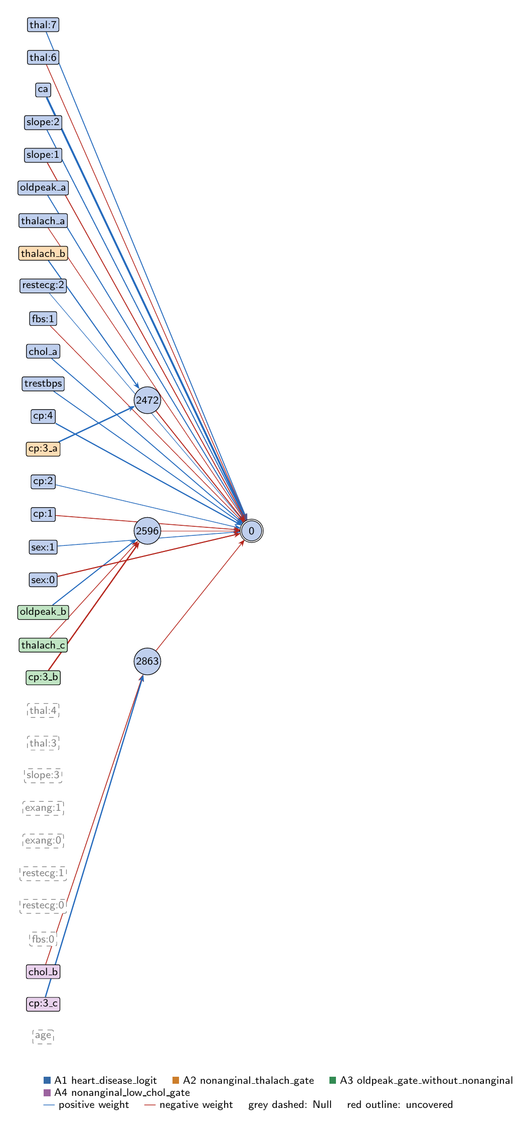
heart-s2-c3: full view of the explained model state.
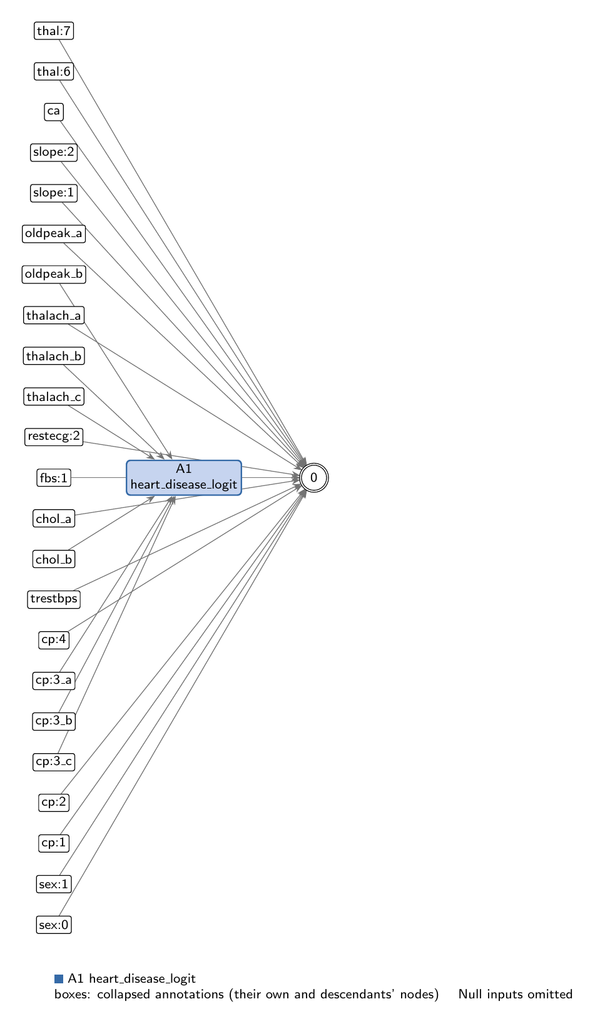
heart-s2-c3: collapsed view at hierarchy level 0 (fully recomposed).
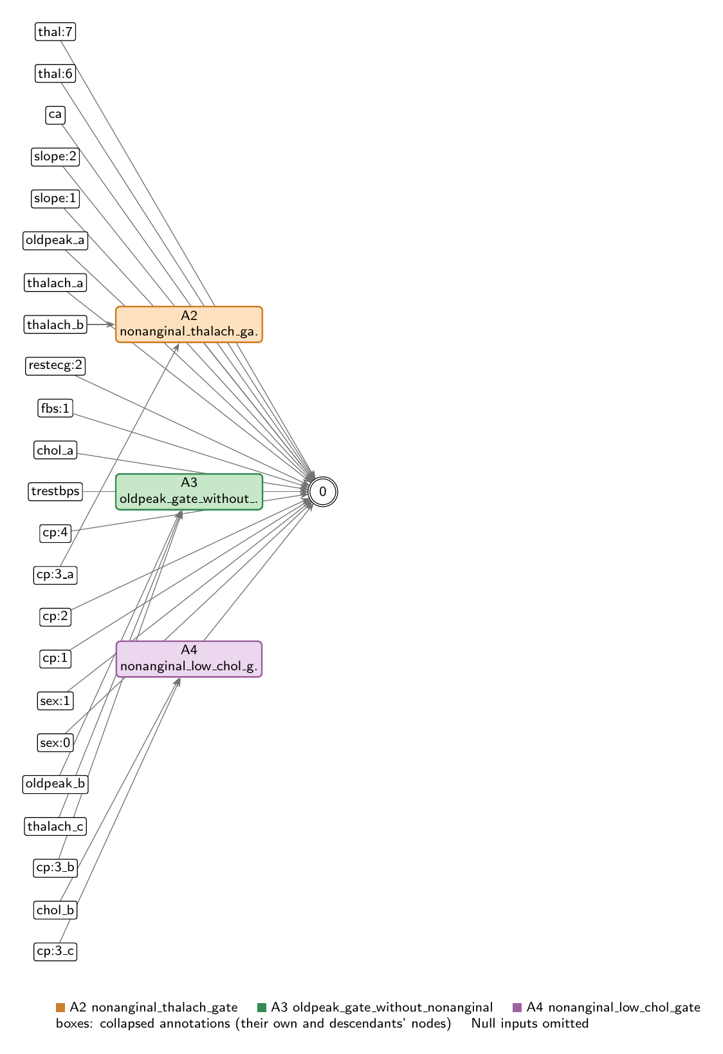
heart-s2-c3: collapsed view at hierarchy level 1.

Refactoring operations
All operations are function-preserving; max output change 2.22e-16 over 242 training rows.
- #26: split -6 into -6_a, -6_b, -6_c
- #27: split -15 into -15_a, -15_b, -15_c
- #28: split -18 into -18_a, -18_b
- #29: split -9 into -9_a, -9_b

Annotations

A1: heart_disease_logit
Composition annotation (depth 0); children A2, A3, A4.
- Entry nodes: -2 (sex:0), -3 (sex:1), -4 (cp:1), -5 (cp:2), -7 (cp:4), -8 (trestbps), -9_a (chol_a), -11 (fbs:1), -14 (restecg:2), -15_a (thalach_a), -18_a (oldpeak_a), -19 (slope:1), -20 (slope:2), -22 (ca), -25 (thal:6), -26 (thal:7), -1 (age), -10 (fbs:0), -12 (restecg:0), -13 (restecg:1), -16 (exang:0), -17 (exang:1), -21 (slope:3), -23 (thal:3), -24 (thal:4), -6_a (cp:3_a), -15_b (thalach_b), -6_b (cp:3_b), -15_c (thalach_c), -18_b (oldpeak_b), -6_c (cp:3_c), -9_b (chol_b)
- Exit nodes: 0
- Internal nodes: none
- Edges: 19; covers 35 candidate node(s)
Hypothesis. Root: p = sigmoid(z), z = 0.323 + LINEAR CORE - 0.511*nonanginal_thalach_gate - 0.018*oldpeak_gate_without_nonanginal - 0.235*nonanginal_low_chol_gate. LINEAR CORE (16 direct input->output edges, z-scored inputs): ca +1.779, cp:4 +0.869, sex:0 -0.760, slope:2 +0.610, oldpeak +0.559, chol +0.529, thal:7 +0.500, trestbps +0.493, slope:1 -0.488, cp:1 -0.393, sex:1 +0.347, thal:6 -0.282, cp:2 +0.273, fbs:1 -0.209, thalach -0.176, restecg:2 +0.053. Nine inputs are unused (age, fbs:0, restecg:0, restecg:1, exang:0, exang:1, slope:3, thal:3, thal:4; zero-effect entries of this root). Non-anginal pain (cp:3) has no direct edge; it acts only through the three children, all of which are switched by it. COMPOSITION: purely additive in the logit. The children share no hidden nodes and are coupled only through shared inputs (cp:3 feeds all three; thalach, oldpeak and chol also have direct edges). (1) nonanginal_thalach_gate: open for 97% of non-anginal-pain patients, lowers their risk, more with higher max heart rate; (2) nonanginal_low_chol_gate: open for 87% of non-anginal-pain patients (those with z-chol < 0.76), lowers their risk more the lower the cholesterol; (3) oldpeak_gate_without_nonanginal: a near-null oldpeak hinge for the other patients (readout -0.018). Together (1)+(2) give non-anginal pain an average logit shift of -0.85 and make thalach and chol slopes depend on chest-pain type. EVIDENCE (train, n=242): full model AUC 0.9381, acc 0.888 (compute_performance). Linear core alone AUC 0.934; logit SD 3.67 (core) vs 0.42 (all nonlinear readouts). Zero-ablating one child at a time: thalach gate 0.934, oldpeak gate 0.938, low-chol gate 0.938. Replacing all hidden readouts with one least-squares linear fit in their four inputs gives 0.938; an L2 logistic regression on all 26 inputs gives 0.936. Mean |SHAP| (train, all 242 rows): ca 0.161, cp:4 0.099, sex:0 0.073, slope:2 0.066, thal:7 0.054, slope:1 0.053, oldpeak 0.047, chol 0.041, trestbps 0.040, cp:3 (thalach gate copy) 0.029; unused inputs about 0.001 (estimator noise). Interpretation: logistic regression on 16 inputs plus a non-anginal-pain block whose nonlinearity is small (a linear refit loses nothing on train AUC). Counter-directional signs reported, not explained: cp:2 +0.27 and fbs:1 -0.21 in the core, the low-cholesterol protection for non-anginal pain. Compared with the 10-seed heart-s2 record (key 9083, gen 38, a different cluster of the same run): that genome has an age/heart-rate-reserve gate and oldpeak hinges and uses age; this one ignores age entirely and puts its only nonlinear effect on non-anginal chest pain.
Closed form (SymPy, weights at 3 significant figures; y_i = exit node i):
y_0 = 1.0*exp(1.78*x_{ca} + 0.529*x_{chol_a} + 0.273*x_{cp:2} + 0.869*x_{cp:4} + 0.559*x_{oldpeak_a} + 0.053*x_{restecg:2} + 0.347*x_{sex:1} + 0.61*x_{slope:2} + 0.5*x_{thal:7} + 0.493*x_{trestbps})/(0.724*exp(0.393*x_{cp:1} + 0.209*x_{fbs:1} + 0.76*x_{sex:0} + 0.488*x_{slope:1} + 0.282*x_{thal:6} + 0.176*x_{thalach_a} + 0.235*relu(-0.376*x_{chol_b} + 0.983*x_{cp:3_c} - 1.25) + 0.511*relu(1.08*x_{cp:3_a} + 0.678*x_{thalach_b} - 0.348) + 0.0184*relu(-0.985*x_{cp:3_b} + 0.673*x_{oldpeak_b} - 0.241*x_{thalach_c} - 0.688)) + 1.0*exp(1.78*x_{ca} + 0.529*x_{chol_a} + 0.273*x_{cp:2} + 0.869*x_{cp:4} + 0.559*x_{oldpeak_a} + 0.053*x_{restecg:2} + 0.347*x_{sex:1} + 0.61*x_{slope:2} + 0.5*x_{thal:7} + 0.493*x_{trestbps}))
Training split (n = 242): displayed closed form within 0.00141 of the forward pass; exact function within 2.22e-16.
Evidence (2 items; payloads in the JSON record):
- [analytical] analytical_formula; split: n/a (analytical). Root closed form (get_formula force=true); output is sigmoid.
- [empirical] empirical_viz; split: train. Train-split performance, ablations, linear replacements and SHAP.
Authorship: drafted by AI-assisted draft on 2026-11-10; verified by nobody (unverified).

A2: nonanginal_thalach_gate
Leaf annotation (depth 1); parent A1.
- Entry nodes: -6_a (cp:3_a), -15_b (thalach_b)
- Exit nodes: 2472
- Internal nodes: none
- Edges: 2; covers 2 candidate node(s)
Hypothesis. Non-anginal-pain gate (protective). 2472 = ReLU(-0.348 + 1.076*cp:3 + 0.678*thalach), read out -0.511 into the logit. Hypothesis: this gate is how the model gives non-anginal chest pain (cp:3, which has no direct edge) a lower risk: it is open for nearly every non-anginal-pain patient and almost never otherwise, and once open a higher achieved max heart rate lowers the risk further (on top of thalach's small direct -0.176 edge). EVIDENCE (train, n=242): active for 97% of the 70 non-anginal-pain patients (closed only for z-thalach < -1.97) and 5% of the 172 others (only z-thalach > 1.53). Disease rate 20% when active vs 55% when inactive. For a non-anginal-pain patient it adds -0.684 - 0.346*z-thalach to the logit (mean -0.76). Mean |sensitivity| cp:3 0.34 > thalach 0.21. Zero-ablating its readout lowers train AUC 0.938 -> 0.934, the only nonlinear part that matters; a linear refit in (cp:3, thalach) recovers 0.938 (R2 0.87), so the gate acts almost as a cp:3 main effect plus a cp:3-specific thalach slope. Supported.
Closed form (SymPy, weights at 3 significant figures; y_i = exit node i):
y_0 = relu(1.08*x_{cp:3_a} + 0.678*x_{thalach_b} - 0.348)
Training split (n = 242): displayed closed form within 0.00675 of the forward pass; exact function within 0.
Evidence (2 items; payloads in the JSON record):
- [analytical] analytical_formula; split: n/a (analytical). Closed form from get_formula with the on-data reading of the gate.
- [empirical] empirical_viz; split: train. Train-split sensitivity, activity, outcome rates and ablation.
Authorship: drafted by AI-assisted draft on 2026-11-10; verified by nobody (unverified).

A3: oldpeak_gate_without_nonanginal
Leaf annotation (depth 1); parent A1.
- Entry nodes: -6_b (cp:3_b), -15_c (thalach_c), -18_b (oldpeak_b)
- Exit nodes: 2596
- Internal nodes: none
- Edges: 3; covers 3 candidate node(s)
Hypothesis. ST-depression gate for patients without non-anginal pain (negligible). 2596 = ReLU(-0.688 - 0.985*cp:3 - 0.241*thalach + 0.673*oldpeak), read out -0.018. Hypothesis: a hinge on ST depression (and lower max heart rate) for patients without non-anginal pain, whose readout is too small to change predictions. EVIDENCE (train, n=242): active for 42% of patients without non-anginal pain and never with it; disease rate 80% when active vs 29% when inactive, so it tracks risk, but its readout has SD 0.009 logit units against 3.67 for the linear core, and removing it changes train AUC by +0.0001. Its sign (slightly lowering the risk with more ST depression) runs against oldpeak's direct +0.559 edge, which dominates. Supported as a near-null part; a vestige rather than a mechanism.
Closed form (SymPy, weights at 3 significant figures; y_i = exit node i):
y_0 = relu(-0.985*x_{cp:3_b} + 0.673*x_{oldpeak_b} - 0.241*x_{thalach_c} - 0.688)
Training split (n = 242): displayed closed form within 0.00186 of the forward pass; exact function within 0.
Evidence (2 items; payloads in the JSON record):
- [analytical] analytical_formula; split: n/a (analytical). Closed form from get_formula with the on-data reading of the gate.
- [empirical] empirical_viz; split: train. Train-split sensitivity, activity, outcome rates and ablation.
Authorship: drafted by AI-assisted draft on 2026-11-10; verified by nobody (unverified).

A4: nonanginal_low_chol_gate
Leaf annotation (depth 1); parent A1.
- Entry nodes: -6_c (cp:3_c), -9_b (chol_b)
- Exit nodes: 2863
- Internal nodes: none
- Edges: 2; covers 2 candidate node(s)
Hypothesis. Non-anginal-pain, low-cholesterol gate (protective, small). 2863 = ReLU(-1.255 + 0.983*cp:3 - 0.376*chol), read out -0.235. Hypothesis: open only for non-anginal-pain patients whose cholesterol is not high (z-chol below 0.76); it lowers their risk, by more the lower the cholesterol, so for these patients cholesterol's direct +0.529 edge is partly undone. EVIDENCE (train, n=242): active for 87% of the 70 non-anginal-pain patients and none of the others. Disease rate 21% when active vs 52% when inactive. Readout up to -0.29 logit units (SD 0.053). Mean |sensitivity| cp:3 0.25 > chol 0.09. Zero-ablating it leaves train AUC unchanged (0.9381 -> 0.9382): it shifts the level of the non-anginal-pain group rather than ranking patients. Supported but small.
Closed form (SymPy, weights at 3 significant figures; y_i = exit node i):
y_0 = relu(-0.376*x_{chol_b} + 0.983*x_{cp:3_c} - 1.25)
Training split (n = 242): displayed closed form within 0.00471 of the forward pass; exact function within 0.
Evidence (2 items; payloads in the JSON record):
- [analytical] analytical_formula; split: n/a (analytical). Closed form from get_formula with the on-data reading of the gate.
- [empirical] empirical_viz; split: train. Train-split sensitivity, activity, outcome rates and ablation.
Authorship: drafted by AI-assisted draft on 2026-11-10; verified by nobody (unverified).

Audit against the definitions
- WARNING unverified: No human verification is recorded for this explanation.
end of thesis draft

