THESIS DRAFT - appendix: heart-s4-c1 explanation certificate - for review

Explanation certificate: heart-s4-c1
Rendered from the canonical JSON record heart-s4-c1.json (schema 1.4.0, SHA-256 5bb264e6720c1a25b94714c430f44b3b1f28f41592eef373c0a2d422a381b5a0), which holds every evidence payload and the full graphs.
Dataset | Heart Disease (binary, prepared)
Experiment | 10seed-heart-s4, seed 4
Genome | c85804fa-08bd-4207-ac69-a31a8567473c (NEAT key 9679, generation 39)
Explanation | 10565a81-f55b-47f4-b51e-21641ec08556 (36 operations)
Train AUC / accuracy | 0.9423 / 0.8884 (n = 242)
Test AUC / accuracy | 0.8858 / 0.8197 (n = 61)
Output activation | sigmoid
Phenotype | 31 nodes (26 inputs, 4 hidden, 1 output), 29 enabled edges
Explained model state | 36 nodes, 29 enabled edges
Function preservation | max |change in output| = 3.33e-16 (train)
Annotations | 5 (4 leaf, 1 composition)
Structural coverage | 1 (35 of 35; 6 Null)
Compositional coverage | 1
Uncovered nodes / edges | 0 / 0
Missing compositions | 0
Full coverage | yes
Drafted by | AI-assisted draft
Verified by | unverified
Drafter's summary. Essentially logistic regression: 19 direct edges (logit SD 4.55; train AUC 0.933 alone; ca +2.25, slope:2 +1.12, sex:1 +0.90) plus four additive hidden readouts (logit SD 0.86) to 0.942. The one meaningful nonlinearity is an AND gate 2065 = 3.64*[thal:6 AND fbs=0] read out -1.08, lowering the logit by 3.9 for the 10 fixed-defect patients with normal fasting sugar (core mean predicted 0.83, disease rate 50%). The cp:4 and slope:3 hidden indicators are exactly affine on their binary inputs and a floored thalach relay is near-inert. Same gate and linear core as the 10-seed heart-s4 record (key 9650, gen 38); here cp:4 and slope:3 indicators replace that genome's cp:2 indicator.
What resisted explanation. Nothing resisted coverage. The one real interaction (fixed thallium defect AND normal fasting sugar, gate 2065) rests on 10 training patients and may be partly noise-fitted. Hidden nodes 1754 (cp:4) and 3504 (slope:3) are exactly affine on their binary inputs, so they are re-parameterisations of linear terms, not mechanisms. Counter-directional signs reported, not explained: fbs:1 -0.58 in the linear core, and the gate making a fixed defect protective for normal-sugar patients.

Plain-language summary
AI-assisted draft for review (unverified). Each sentence cites the claims that back it; every cited claim was computed on the model and the training split and passed its automatic checks. Magnitudes are changes in predicted risk for a typical patient; confidence words follow the test-split check and n. The text describes what the model does, not the world.
Summary (drafted). For a typical patient (a 56-year-old man with no chest pain symptoms and median test results) the model predicts a risk of heart disease of about 24%; it adds up most of its inputs independently, and four small parts add to that sum: one for a fixed defect on the thallium scan with normal fasting blood sugar, one for chest pain type, one for a downsloping ST segment and one for maximum heart rate. [C31] These add up independently, and these lower the risk: being a woman takes a typical patient's predicted risk from about 24% to about 1%; through this sum alone, compared with no chest pain symptoms, typical angina lowers it to about 2%, non-anginal chest pain to about 3% and atypical angina to about 14%, fasting blood sugar above 120 mg/dL lowers it to about 7%, and a higher maximum heart rate lowers it steadily, from about 27% at 118 to about 21% at 175 beats per minute; chest pain type, fasting blood sugar and maximum heart rate also act through the parts below. [C12, C13, C15, C22, C17, C24] Each extra vessel coloured by fluoroscopy adds about the same, from about 24% at 0 to about 98% at 2 vessels, flattening out near the top because the predicted risk cannot go much higher; through this sum alone a flat rather than upsloping ST segment raises it to about 82% and any thallium result other than a normal scan to about 48%, and chest pain brought on by exercise raises it to about 36% (the ST segment and the thallium scan also act through the parts below). [C01, C02, C06, C21] Higher cholesterol (from about 14% at 193 mg/dL to about 44% at 308 mg/dL), more ST depression on exercise (from about 18% at 0 mm to about 42% at 2.8 mm), higher resting blood pressure (from about 14% at 110 mm Hg to about 41% at 155 mm Hg) and older age (from about 21% at 42 to about 25% at 66 years) raise it steadily. [C04, C08, C05, C25] Through this sum alone a downsloping ST segment raises it to about 39% (the model has little data on this, n = 17), and an ST-T wave abnormality on the resting ECG raises it to about 38% (the model has little data on this, n = 2). [C19, C20] This part reads fasting blood sugar and the thallium scan and acts on 10 of 242 training patients, nearly all of them with a fixed defect on the thallium scan, 5 of whom had heart disease; for the typical patient it acts on, the predicted risk is about 94% without it and about 24% with it (the model has little data on this, n = 10). [C35] Through it, a fixed defect on the thallium scan lowers a typical patient's predicted risk from about 24% to about 2% if fasting blood sugar is 120 mg/dL or less, but the other way if it is above 120 mg/dL, from about 7% to about 18% (the model has little data on this, n = 15). [C34] For the typical patient it acts on, fasting blood sugar above 120 mg/dL raises the risk through it from about 24% to about 94%. [C32] This part reads only chest pain type and acts on the 134 of 242 training patients who have some chest pain symptom, 30 of whom had heart disease; for the typical patient it acts on, the predicted risk is about 2% without it and about 1% with it. [C38] Through it, any chest pain type other than no chest pain symptoms lowers a typical patient's predicted risk from about 24% to about 12%. [C37] This part reads only the slope of the ST segment and acts on the 17 of 242 training patients with a downsloping ST segment, 8 of whom had heart disease; for the typical patient it acts on, the predicted risk is about 66% without it and about 73% with it (the model has little data on this, n = 17). [C41] Through it, a downsloping ST segment raises a typical patient's predicted risk from about 24% to about 29% (the model has little data on this, n = 17). [C40] This part reads only maximum heart rate and acts on 190 of 242 training patients, 71 of whom had heart disease; for the typical patient it acts on, the predicted risk is about 21% without it and about 20% with it. [C45] Through it, a higher maximum heart rate changes nothing until about 131 beats per minute, then lowers the predicted risk steadily, for a typical patient from about 24% at 118 to about 23% at 175 beats per minute. [C43, C44]
Summary (offline template). The model treats a higher number of vessels coloured by fluoroscopy as raising the predicted risk of heart disease steadily, each extra vessel adding about the same: for a typical patient, it goes from about 24% at 0 vessels to about 98% at 2 vessels, flattening out near the top because the predicted risk cannot go much higher (on the training data only). [C01] For a typical patient, the model gives a higher predicted risk of heart disease if the ST segment is flat at peak exercise (about 82%) than if the ST segment slopes up at peak exercise (about 24%) (on the training data only). [C02] For a typical patient, the model gives a higher predicted risk of heart disease if the ST segment is flat at peak exercise (about 82%) than if the ST segment slopes up at peak exercise (about 24%) (on the training data only). [C03] Through one part of the model, maximum heart rate only slightly lowers the predicted risk of heart disease once it rises above about 131 beats per minute: for a typical such patient, going from 71 beats per minute to 182 beats per minute moves it from about 24% to about 23% (on the training data only). [C44]
ann_35 (heart_disease_logit). The model treats a higher number of vessels coloured by fluoroscopy as raising the predicted risk of heart disease steadily, each extra vessel adding about the same: for a typical patient, it goes from about 24% at 0 vessels to about 98% at 2 vessels, flattening out near the top because the predicted risk cannot go much higher (on the training data only). [C01] For a typical patient, the model gives a higher predicted risk of heart disease if the ST segment is flat at peak exercise (about 82%) than if the ST segment slopes up at peak exercise (about 24%) (on the training data only). [C02] For a typical patient, the model gives a higher predicted risk of heart disease if the ST segment is flat at peak exercise (about 82%) than if the ST segment slopes up at peak exercise (about 24%) (on the training data only). [C03] The model treats a higher serum cholesterol as raising the predicted risk of heart disease steadily: for a typical patient, it goes from about 14% at 193 mg/dL (5.0 mmol/L) to about 44% at 308 mg/dL (8.0 mmol/L) (on the training data only). [C04] The model treats a higher resting blood pressure as raising the predicted risk of heart disease steadily: for a typical patient, it goes from about 14% at 110 mm Hg to about 41% at 155 mm Hg (on the training data only). [C05] For a typical patient, the model gives a clearly higher predicted risk of heart disease if thallium stress test result is something other than a normal thallium scan (about 48%) than if the thallium scan is normal (about 24%). [C06] Other effects: any other thallium stress test result (rather than a normal thallium scan) raises it; a higher ST depression on exercise raises it steadily; a downsloping ST segment (rather than an upsloping ST segment) raises it; typical angina (rather than no chest pain (asymptomatic)) lowers it; non-anginal chest pain (rather than no chest pain (asymptomatic)) lowers it; female (rather than male) lowers it; typical angina (rather than no chest pain (asymptomatic)) lowers it; non-anginal chest pain (rather than no chest pain (asymptomatic)) lowers it; and 9 still smaller effects listed in the evidence table (on the training data only). The model has little data on some of these: only 17 training patients (a downsloping ST segment). [C07, C08, C09, C10, C11, C12, C13, C15] Smaller effects, each changing the predicted value only slightly: a higher age raises it steadily (on the training data only). [C25]
ann_31 (fixed_defect_normal_sugar_gate). This part acts on 10 of 242 training patients (4%); nearly all of them are patients with a fixed defect on the thallium scan. [C35] For a typical patient it acts on, it lowers the predicted risk of heart disease from about 94% without this part to about 24% with it (on the training data only). The model has little data on this: only 10 training patients (patients the part acts on). [C35] In the training data, 5 of these 10 patients had heart disease. [C35] The model gives a lower predicted risk of heart disease if the thallium scan shows a fixed defect than if thallium stress test result is something other than a fixed defect on the thallium scan if fasting blood sugar is 120 mg/dL or less, but the other way if fasting blood sugar is above 120 mg/dL: for a typical patient, going from thallium stress test result other than a fixed defect on the thallium scan to a fixed defect on the thallium scan moves the predicted risk of heart disease from about 24% to about 2% if fasting blood sugar is 120 mg/dL or less, and from about 7% to about 18% if fasting blood sugar is above 120 mg/dL. The model has little data on this: only 15 training patients (a fixed defect on the thallium scan). [C34] Through this part, for a typical patient this part acts on, the model gives a higher predicted risk of heart disease if fasting blood sugar is above 120 mg/dL (about 94%) than if fasting blood sugar is 120 mg/dL or less (about 24%) (on the training data only). [C32] Through this part, for a typical patient, the model gives a lower predicted risk of heart disease if the thallium scan shows a fixed defect (about 1%) than if thallium stress test result is something other than a fixed defect on the thallium scan (about 24%) (on the training data only). The model has little data on this: only 15 training patients (a fixed defect on the thallium scan). [C33]
ann_32 (no_asymptomatic_pain_indicator). This part acts on 134 of 242 training patients (55%). [C38] For a typical patient it acts on, it slightly lowers the predicted risk of heart disease from about 2% without this part to about 1% with it (on the training data only). [C38] In the training data, 30 of these 134 patients had heart disease. [C38] Through this part, for a typical patient, the model gives a lower predicted risk of heart disease if chest pain type is something other than no chest pain (asymptomatic) (about 12%) than if the patient has no chest pain symptoms (about 24%) (on the training data only). [C37]
ann_33 (downsloping_st_indicator). This part acts on 17 of 242 training patients (7%); nearly all of them are patients with a downsloping ST segment. [C41] For a typical patient it acts on, it raises the predicted risk of heart disease from about 66% without this part to about 73% with it (on the training data only). The model has little data on this: only 17 training patients (patients the part acts on). [C41] In the training data, 8 of these 17 patients had heart disease. [C41] Through this part, for a typical patient, the model gives a higher predicted risk of heart disease if the ST segment slopes down at peak exercise (about 29%) than if slope of the ST segment at peak exercise is something other than a downsloping ST segment (about 24%) (on the training data only). The model has little data on this: only 17 training patients (a downsloping ST segment). [C40]
ann_34 (thalach_floor_relay). This part acts on 190 of 242 training patients (79%). [C45] For a typical patient it acts on, it slightly lowers the predicted risk of heart disease from about 21% without this part to about 20% with it (on the training data only). [C45] In the training data, 71 of these 190 patients had heart disease. [C45] Through this part, maximum heart rate only slightly lowers the predicted risk of heart disease once it rises above about 131 beats per minute: for a typical such patient, going from 71 beats per minute to 182 beats per minute moves it from about 24% to about 23% (on the training data only). [C44] Through this part, the model treats a higher maximum heart rate as slightly lowering the predicted risk of heart disease with nothing until about 131 beats per minute, then steadily: for a typical patient, it goes from about 24% at 118 beats per minute to about 23% at 175 beats per minute (on the training data only). [C43]
Worth checking against what is known. Worth checking: going from 0 to 2 vessels coloured moves a typical patient's predicted risk from about 24% to about 98%. [C01] Worth checking: patients with typical angina get the lowest predicted risk of all chest pain types, below patients with no chest pain symptoms. [C10, C11, C16] Worth checking: the model treats fasting blood sugar above 120 mg/dL as lowering the risk of heart disease (for a typical patient from about 24% to about 7%). [C18] Worth checking: through one part, the model treats a fixed defect on the thallium scan as lowering the risk for patients with normal fasting blood sugar (for a typical patient from about 24% to about 2%), from only 15 training patients. [C34]
Claim | What is checked | Risk, typical patient | Estimate (log-odds; OR); range across patients | n | Test check | Verified | Words
C01 | direction: number of vessels coloured by fluoroscopy: 0 vessels to 2 vessels (whole model) | 24% to 98% | log-odds 5.04, OR 154; range across patients 5.04 to 5.04 | 242 | train; test unclear (AUC gain 0.044 [-0.038, 0.127], n=61) | yes | on the training data only
C02 | direction: slope of the ST segment at peak exercise: an upsloping ST segment to a flat ST segment (direct contribution only, not through any part) | 24% to 82% | log-odds 2.72, OR 15.1; range across patients 2.72 to 2.72 | 115, 110 | train; test disagrees (AUC gain -0.014 [-0.061, 0.025], n=61) | yes | on the training data only
C03 | direction: slope of the ST segment at peak exercise: an upsloping ST segment to a flat ST segment (whole model) | 24% to 82% | log-odds 2.72, OR 15.1; range across patients 2.72 to 2.72 | 115, 110 | train; test disagrees (AUC gain -0.013 [-0.058, 0.026], n=61) | yes | on the training data only
C04 | direction: serum cholesterol: 193 mg/dL (5.0 mmol/L) to 308 mg/dL (8.0 mmol/L) (whole model) | 14% to 44% | log-odds 1.60, OR 4.97; range across patients 1.60 to 1.60 | 242 | train; test disagrees (AUC gain -0.019 [-0.049, 0.002], n=61) | yes | on the training data only
C05 | direction: resting blood pressure: 110 mm Hg to 155 mm Hg (whole model) | 14% to 41% | log-odds 1.48, OR 4.37; range across patients 1.48 to 1.48 | 242 | train; test unclear (AUC gain 0.002 [-0.018, 0.023], n=61) | yes | on the training data only
C06 | direction: thallium stress test result: a normal thallium scan to thallium stress test result other than a normal thallium scan (direct contribution only, not through any part) | 24% to 48% | log-odds 1.09, OR 2.98; range across patients 1.09 to 1.09 | 135, 107 | train; test agrees (AUC gain 0.026 [0.005, 0.055], n=61) | yes | clearly
C07 | direction: thallium stress test result: a normal thallium scan to thallium stress test result other than a normal thallium scan, a fixed defect on the thallium scan (whole model) | 24% to 48% | log-odds 1.09, OR 2.98; range across patients 1.09 to 1.09 | 135, 92 | train; test unclear (AUC gain 0.005 [-0.028, 0.039], n=61) | yes | on the training data only
C08 | direction: ST depression on exercise: 0.0 mm to 2.8 mm (whole model) | 18% to 42% | log-odds 1.16, OR 3.19; range across patients 1.16 to 1.16 | 242 | train; test unclear (AUC gain 0.005 [-0.01, 0.024], n=61) | yes | on the training data only
C09 | direction: slope of the ST segment at peak exercise: an upsloping ST segment to a downsloping ST segment (whole model) | 24% to 47% | log-odds 1.05, OR 2.85; range across patients 1.05 to 1.05 | 115, 17 (small n) | train; test disagrees (AUC gain -0.013 [-0.058, 0.026], n=61) | yes | the model has little data on this; on the training data only
C10 | direction: chest pain type: no chest pain (asymptomatic) to typical angina (whole model) | 24% to 1% | log-odds -3.84, OR 0.02; range across patients -3.84 to -3.84 | 108, 22 | train; test agrees (AUC gain 0.057 [0.016, 0.105], n=61) | yes | clearly
C11 | direction: chest pain type: no chest pain (asymptomatic) to non-anginal chest pain (whole model) | 24% to 1% | log-odds -3.12, OR 0.04; range across patients -3.12 to -3.12 | 108, 70 | train; test agrees (AUC gain 0.057 [0.016, 0.105], n=61) | yes | clearly
C12 | direction: sex: male to female (whole model) | 24% to 1% | log-odds -3.07, OR 0.05; range across patients -3.07 to -3.07 | 159, 83 | train; test unclear (AUC gain 0.025 [-0.01, 0.069], n=61) | yes | on the training data only
C13 | direction: chest pain type: no chest pain (asymptomatic) to typical angina (direct contribution only, not through any part) | 24% to 2% | log-odds -2.98, OR 0.05; range across patients -2.98 to -2.98 | 108, 22 | train; test unclear (AUC gain 0.029 [0.000, 0.065], n=61) | yes | on the training data only
C14 | direction: thallium stress test result: a normal thallium scan to a fixed defect on the thallium scan (whole model) | 24% to 2% | log-odds -2.29, OR 0.10; range across patients -2.83 to 1.09 | 135, 15 (small n) | train; test unclear (AUC gain 0.005 [-0.028, 0.039], n=61) | no | the model has little data on this; on the training data only
C15 | direction: chest pain type: no chest pain (asymptomatic) to non-anginal chest pain (direct contribution only, not through any part) | 24% to 3% | log-odds -2.27, OR 0.10; range across patients -2.27 to -2.27 | 108, 70 | train; test unclear (AUC gain 0.029 [0.000, 0.065], n=61) | yes | on the training data only
C16 | direction: chest pain type: no chest pain (asymptomatic) to atypical angina (whole model) | 24% to 7% | log-odds -1.47, OR 0.23; range across patients -1.47 to -1.47 | 108, 42 | train; test agrees (AUC gain 0.057 [0.016, 0.105], n=61) | yes | clearly
C17 | direction: fasting blood sugar: fasting blood sugar of 120 mg/dL or less to fasting blood sugar above 120 mg/dL (direct contribution only, not through any part) | 24% to 7% | log-odds -1.43, OR 0.24; range across patients -1.43 to -1.43 | 209, 33 | train; test disagrees (AUC gain -0.002 [-0.020, 0.015], n=61) | yes | on the training data only
C18 | direction: fasting blood sugar: fasting blood sugar of 120 mg/dL or less to fasting blood sugar above 120 mg/dL (whole model) | 24% to 7% | log-odds -1.18, OR 0.31; range across patients -1.43 to -1.43 | 209, 33 | train; test disagrees (AUC gain -0.005 [-0.025, 0.013], n=61) | yes | on the training data only
C19 | direction: slope of the ST segment at peak exercise: an upsloping ST segment to a downsloping ST segment (direct contribution only, not through any part) | 24% to 39% | log-odds 0.75, OR 2.11; range across patients 0.75 to 0.75 | 115, 17 (small n) | train; test disagrees (AUC gain -0.014 [-0.061, 0.025], n=61) | yes | the model has little data on this; on the training data only
C20 | direction: resting ECG: resting ECG other than an ST-T wave abnormality on the resting ECG to an ST-T wave abnormality on the resting ECG (whole model) | 24% to 38% | log-odds 0.68, OR 1.98; range across patients 0.68 to 0.68 | 240, 2 (small n) | train; test unclear (AUC gain 0.000 [0.000, 0.000], n=61) | yes | the model has little data on this; on the training data only
C21 | direction: exercise-induced angina: no chest pain on exercise to chest pain brought on by exercise (whole model) | 24% to 36% | log-odds 0.60, OR 1.81; range across patients 0.60 to 0.60 | 160, 82 | train; test unclear (AUC gain 0.009 [-0.002, 0.026], n=61) | yes | on the training data only
C22 | direction: chest pain type: no chest pain (asymptomatic) to atypical angina (direct contribution only, not through any part) | 24% to 14% | log-odds -0.62, OR 0.54; range across patients -0.62 to -0.62 | 108, 42 | train; test unclear (AUC gain 0.029 [0.000, 0.065], n=61) | yes | on the training data only
C23 | direction: maximum heart rate: 118 beats per minute to 175 beats per minute (whole model) | 28% to 21% | log-odds -0.41, OR 0.67; range across patients -0.41 to -0.41 | 242 | train; test unclear (AUC gain 0.004 [-0.005, 0.016], n=61) | yes | on the training data only
C24 | direction: maximum heart rate: 118 beats per minute to 175 beats per minute (direct contribution only, not through any part) | 27% to 21% | log-odds -0.32, OR 0.73; range across patients -0.32 to -0.32 | 242 | train; test unclear (AUC gain 0.004 [0.000, 0.012], n=61) | yes | on the training data only
C25 | direction: age: 42 years to 66 years (whole model) | 21% to 25% | log-odds 0.23, OR 1.25; range across patients 0.23 to 0.23 | 242 | train; test disagrees (AUC gain -0.002 [-0.009, 0.000], n=61) | yes | slightly; on the training data only
C26 | magnitude: number of vessels coloured by fluoroscopy: 0 vessels to 2 vessels, typical patient | 24% to 98% | log-odds 5.04, OR 154 | 242 | train; test unclear (AUC gain 0.044 [-0.038, 0.127], n=61) | yes | on the training data only
C27 | magnitude: slope of the ST segment at peak exercise: an upsloping ST segment to a flat ST segment, typical patient | 24% to 82% | log-odds 2.72, OR 15.1 | 115, 110 | train; test disagrees (AUC gain -0.013 [-0.058, 0.026], n=61) | yes | on the training data only
C28 | magnitude: serum cholesterol: 193 mg/dL (5.0 mmol/L) to 308 mg/dL (8.0 mmol/L), typical patient | 14% to 44% | log-odds 1.60, OR 4.97 | 242 | train; test disagrees (AUC gain -0.019 [-0.049, 0.002], n=61) | yes | on the training data only
C29 | magnitude: resting blood pressure: 110 mm Hg to 155 mm Hg, typical patient | 14% to 41% | log-odds 1.48, OR 4.37 | 242 | train; test unclear (AUC gain 0.002 [-0.018, 0.023], n=61) | yes | on the training data only
C30 | magnitude: thallium stress test result: a normal thallium scan to thallium stress test result other than a normal thallium scan, a fixed defect on the thallium scan, typical patient | 24% to 48% | log-odds 1.09, OR 2.98 | 135, 92 | train; test unclear (AUC gain 0.005 [-0.028, 0.039], n=61) | yes | on the training data only
C31 | structure: made of fixed_defect_normal_sugar_gate, no_asymptomatic_pain_indicator, downsloping_st_indicator, thalach_floor_relay and inputs age, sex, cp, trestbps, chol, fbs, restecg, thalach, exang, oldpeak, slope, ca, thal; added |  | log-odds n/a, OR n/a | 242 | train | yes
C32 | direction: fasting blood sugar: fasting blood sugar of 120 mg/dL or less to fasting blood sugar above 120 mg/dL (through this part) | 24% to 94% (typical patient this part acts on) | log-odds 0.24, OR 1.27; range across patients 0.00 to 0.00 | 209, 33 | train; test disagrees (AUC gain -0.004 [-0.017, 0.000], n=61) | yes | on the training data only
C33 | direction: thallium stress test result: thallium stress test result other than a fixed defect on the thallium scan to a fixed defect on the thallium scan (through this part) | 24% to 1% | log-odds -3.38, OR 0.03; range across patients -3.92 to 0.00 | 227, 15 (small n) | train; test disagrees (AUC gain -0.016 [-0.044, 0.001], n=61) | yes | the model has little data on this; on the training data only
C34 | interaction: effect of thallium stress test result (thallium stress test result other than a fixed defect on the thallium scan to a fixed defect on the thallium scan) by fasting blood sugar: fasting blood sugar above 120 mg/dL minus fasting blood sugar of 120 mg/dL or less; stronger in fasting blood sugar of 120 mg/dL or less | fasting blood sugar above 120 mg/dL: 7% to 18%; fasting blood sugar of 120 mg/dL or less: 24% to 2% | log-odds difference 3.92, OR 50.3 | 33, 209, 15 (small n) | train; test agrees (AUC gain -0.004 [-0.017, 0.000], n=61); group difference on test 3.92 [3.92, 3.92] | yes | the model has little data on this
C35 | subgroup: who this part acts on: 10 of 242 patients | 94% to 24% (typical patient this part acts on (risk without the part, then with it)) | share 0.04; log-odds -3.92, OR 0.02; range across patients -3.92 to -3.92 | 10, 232 (small n) | train; test disagrees (AUC gain -0.016 [-0.044, 0.000], n=61) | yes | the model has little data on this; on the training data only
C36 | structure: its formula reproduces it on 242 training patients (largest difference 4.44089e-16) |  | log-odds 4e-16, OR n/a | 242 | train | yes
C37 | direction: chest pain type: no chest pain (asymptomatic) to chest pain type other than no chest pain (asymptomatic) (through this part) | 24% to 12% | log-odds -0.85, OR 0.43; range across patients -0.85 to -0.85 | 108, 134 | train; test unclear (AUC gain 0.017 [-0.004, 0.043], n=61) | yes | on the training data only
C38 | subgroup: who this part acts on: 134 of 242 patients | 2% to 1% (typical patient this part acts on (risk without the part, then with it)) | share 0.55; log-odds -0.85, OR 0.43; range across patients -0.85 to -0.85 | 134, 108 | train; test unclear (AUC gain 0.017 [-0.004, 0.043], n=61) | yes | slightly; on the training data only
C39 | structure: its formula reproduces it on 242 training patients (largest difference 0.0) |  | log-odds 0.00, OR n/a | 242 | train | yes
C40 | direction: slope of the ST segment at peak exercise: slope of the ST segment at peak exercise other than a downsloping ST segment to a downsloping ST segment (through this part) | 24% to 29% | log-odds 0.30, OR 1.35; range across patients 0.30 to 0.30 | 225, 17 (small n) | train; test unclear (AUC gain 0.001 [0.000, 0.006], n=61) | yes | the model has little data on this; on the training data only
C41 | subgroup: who this part acts on: 17 of 242 patients | 66% to 73% (typical patient this part acts on (risk without the part, then with it)) | share 0.07; log-odds 0.30, OR 1.35; range across patients 0.30 to 0.30 | 17, 225 (small n) | train; test unclear (AUC gain 0.001 [0.000, 0.006], n=61) | yes | the model has little data on this; on the training data only
C42 | structure: its formula reproduces it on 242 training patients (largest difference 0.0) |  | log-odds 0.00, OR n/a | 242 | train | yes
C43 | direction: maximum heart rate: 118 beats per minute to 175 beats per minute (through this part) | 24% to 23% | log-odds -0.09, OR 0.92; range across patients -0.09 to -0.09 | 242 | train; test unclear (AUC gain 0.000 [0.000, 0.000], n=61) | yes | slightly; on the training data only
C44 | threshold: maximum heart rate: fold at about 131 beats per minute (starts) | 24% to 23% (typical patient with a fold) | fold 131 beats per minute (IQR 131 to 131); past it log-odds -0.10, OR 0.90; range across patients -0.10 to -0.10 | 242, 190 | train; test unclear (AUC gain 0.000 [0.000, 0.000], n=61) | yes | slightly; on the training data only
C45 | subgroup: who this part acts on: 190 of 242 patients | 21% to 20% (typical patient this part acts on (risk without the part, then with it)) | share 0.79; log-odds -0.06, OR 0.95; range across patients -0.09 to -0.02 | 190, 52 | train; test unclear (AUC gain 0.000 [0.000, 0.000], n=61) | yes | slightly; on the training data only
C46 | null: this part barely changes predictions (switched off) |  | max change 0.026 (max |change in predicted risk|) | 242 | train | no
C47 | structure: its formula reproduces it on 242 training patients (largest difference 0.0) |  | log-odds 0.00, OR n/a | 242 | train | yes

Not supported by the model
- C14: direction claim about thallium stress test result in the whole model: not supported by the model (14% of patients have the opposite sign (allowed: 10%)).
- C46: null claim about maximum heart rate reached during the exercise test in part ann_34: not supported by the model (predictions move by up to 0.026).

Coverage
Candidate nodes are all nodes of the explained model state except the output nodes. A candidate node is covered when some annotation of the hierarchy (a leaf, or a composition with its descendants) contains it and all its enabled outgoing edges. Exact Null parts (no path to an output over enabled, non-zero-weight edges; zero-weight edges) count as covered.
- Null, disconnected input (6): -12 (restecg:0), -14 (restecg:2), -16 (exang:0), -24 (thal:4), -26 (thal:7), -5 (cp:2)
- Uncovered nodes: none
- Uncovered edges: none
- Missing compositions: none

Annotation hierarchy
- A1: heart_disease_logit (composition)
- A2: fixed_defect_normal_sugar_gate (leaf)
- A3: no_asymptomatic_pain_indicator (leaf)
- A4: downsloping_st_indicator (leaf)
- A5: thalach_floor_relay (leaf)

Network figures
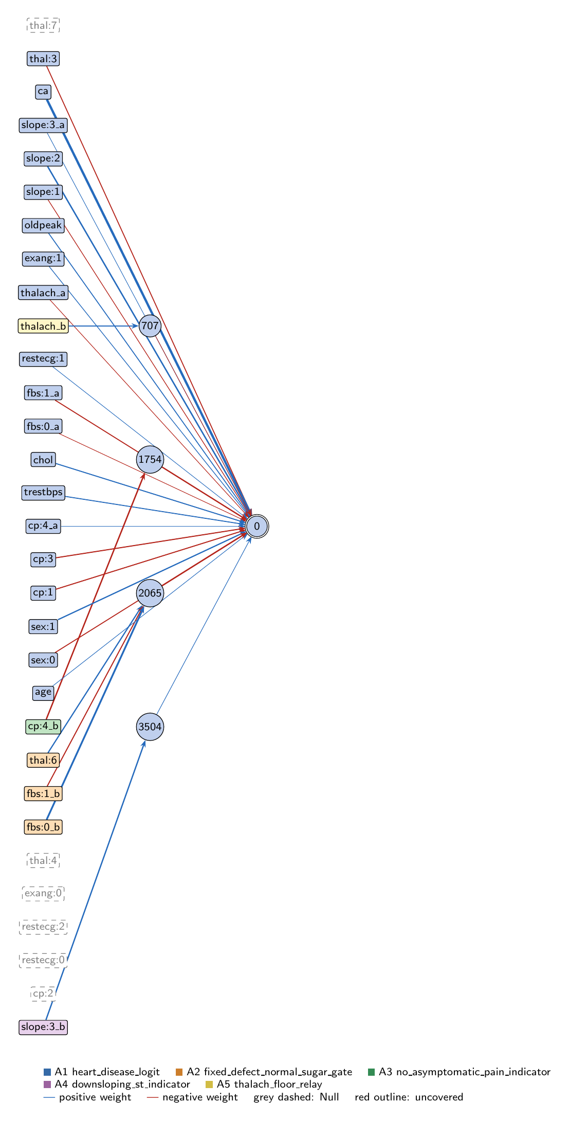
heart-s4-c1: full view of the explained model state.
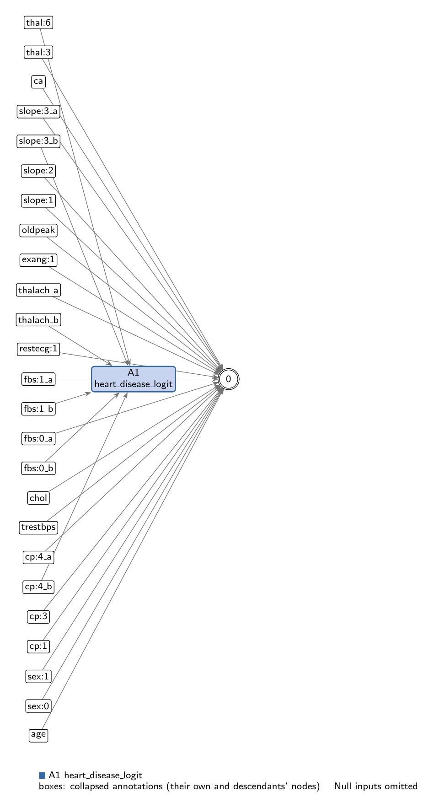
heart-s4-c1: collapsed view at hierarchy level 0 (fully recomposed).
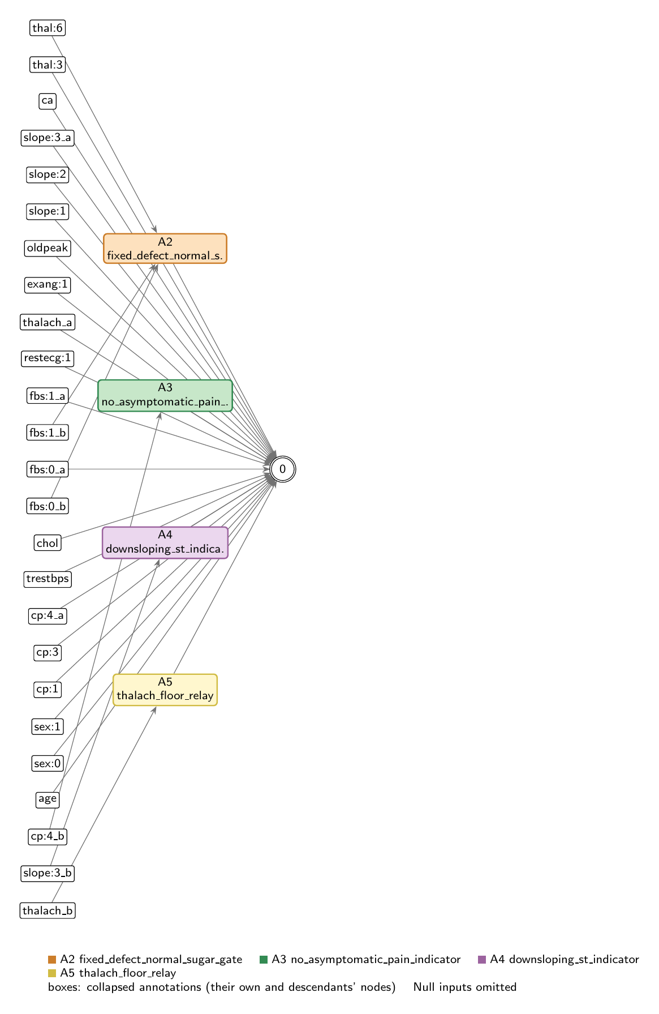
heart-s4-c1: collapsed view at hierarchy level 1.

Refactoring operations
All operations are function-preserving; max output change 3.33e-16 over 242 training rows.
- #26: split -10 into -10_a, -10_b
- #27: split -11 into -11_a, -11_b
- #28: split -15 into -15_a, -15_b
- #29: split -21 into -21_a, -21_b
- #30: split -7 into -7_a, -7_b

Annotations

A1: heart_disease_logit
Composition annotation (depth 0); children A2, A3, A4, A5.
- Entry nodes: -1 (age), -2 (sex:0), -3 (sex:1), -4 (cp:1), -6 (cp:3), -8 (trestbps), -9 (chol), -13 (restecg:1), -17 (exang:1), -18 (oldpeak), -19 (slope:1), -20 (slope:2), -22 (ca), -23 (thal:3), -10_a (fbs:0_a), -11_a (fbs:1_a), -15_a (thalach_a), -21_a (slope:3_a), -7_a (cp:4_a), -26 (thal:7), -24 (thal:4), -16 (exang:0), -14 (restecg:2), -12 (restecg:0), -5 (cp:2), -10_b (fbs:0_b), -11_b (fbs:1_b), -25 (thal:6), -7_b (cp:4_b), -21_b (slope:3_b), -15_b (thalach_b)
- Exit nodes: 0
- Internal nodes: none
- Edges: 23; covers 35 candidate node(s)
Hypothesis. Root: p = sigmoid(z), z = 0.466 + LINEAR CORE - 1.077*fixed_defect_normal_sugar_gate - 0.899*no_asymptomatic_pain_indicator + 0.114*downsloping_st_indicator - 0.047*thalach_floor_relay. LINEAR CORE (19 direct input->output edges, z-scored inputs): ca +2.246, slope:2 +1.115, sex:1 +0.899, cp:3 -0.749, cp:1 -0.679, chol +0.671, trestbps +0.596, fbs:1 -0.583, sex:0 -0.559, thal:3 -0.541, oldpeak +0.491, cp:4 +0.308, exang:1 +0.282, slope:1 -0.238, thalach -0.125, fbs:0 -0.094, age +0.085, slope:3 +0.069, restecg:1 +0.062. Six inputs are unconnected (cp:2, restecg:0, restecg:2, exang:0, thal:4, thal:7; zero-effect entries of this root). thal:6 has no direct edge; it acts only through the fixed-defect gate. COMPOSITION: purely additive in the logit. Children: (1) fixed_defect_normal_sugar_gate, the one genuine interaction: an AND of fixed thallium defect and normal fasting sugar that lowers the logit by 3.92 for 10 patients; (2) no_asymptomatic_pain_indicator and (3) downsloping_st_indicator, binary ReLUs exactly affine on their one-hot inputs (re-parameterisations of the cp:4 and slope:3 linear terms; cp:4 total +1.47 logit, slope:3 total +0.57); (4) thalach_floor_relay, a near-inert hinge on max heart rate. The children share no hidden nodes; they are coupled only through inputs that also have direct edges (fbs:0, fbs:1, cp:4, slope:3, thalach). EVIDENCE (train, n=242): full model AUC 0.9423, acc 0.888 (compute_performance). Linear core alone (direct edges only) AUC 0.9328; logit SD 4.55 (core) vs 0.86 (all hidden readouts). Zero-ablating one child at a time: fixed-defect gate 0.9343, cp:4 indicator 0.9411, thalach relay 0.9416, slope:3 indicator 0.9421. Replacing all hidden readouts with one least-squares linear fit in their six inputs gives 0.9371; an L2 logistic regression on all 26 inputs gives 0.9355. Mean |SHAP| (train, all 242, probability scale): ca 0.172, slope:2 0.099, sex:1 0.069, cp:4 0.068, cp:3 0.056, thal:3 0.049, sex:0 0.042, chol 0.042. Interpretation: essentially logistic regression with one meaningful nonlinearity, the fixed-defect/normal-sugar gate, which cancels the core's over-prediction for that small group (10 patients). Counter-directional signs reported, not explained: fbs:1 -0.58 (high fasting sugar lowers the logit) and the gate itself making a fixed defect protective for normal-sugar patients. Same mechanism family as the 10-seed heart-s4 record (key 9650, gen 38): the same gate and linear core (ca +2.16 there), but here a cp:4 indicator and a slope:3 indicator replace that genome's cp:2 indicator, and the thalach relay feeds the output directly.
Closed form (SymPy, weights at 3 significant figures; y_i = exit node i):
y_0 = 1.0*exp(0.0855*x_{age} + 2.25*x_{ca} + 0.671*x_{chol} + 0.308*x_{cp:4_a} + 0.282*x_{exang:1} + 0.491*x_{oldpeak} + 0.0618*x_{restecg:1} + 0.899*x_{sex:1} + 1.11*x_{slope:2} + 0.0688*x_{slope:3_a} + 0.596*x_{trestbps} + 0.114*relu(1.01*x_{slope:3_b} - 1.02))/(0.628*exp(0.679*x_{cp:1} + 0.749*x_{cp:3} + 0.0936*x_{fbs:0_a} + 0.583*x_{fbs:1_a} + 0.559*x_{sex:0} + 0.238*x_{slope:1} + 0.542*x_{thal:3} + 0.125*x_{thalach_a} + 0.899*relu(-1.1*x_{cp:4_b} - 0.0387) + 0.0469*relu(0.959*x_{thalach_b} + 0.812) + 1.08*relu(1.58*x_{fbs:0_b} - 0.683*x_{fbs:1_b} + 0.885*x_{thal:6} - 0.703)) + 1.0*exp(0.0855*x_{age} + 2.25*x_{ca} + 0.671*x_{chol} + 0.308*x_{cp:4_a} + 0.282*x_{exang:1} + 0.491*x_{oldpeak} + 0.0618*x_{restecg:1} + 0.899*x_{sex:1} + 1.11*x_{slope:2} + 0.0688*x_{slope:3_a} + 0.596*x_{trestbps} + 0.114*relu(1.01*x_{slope:3_b} - 1.02)))
Training split (n = 242): displayed closed form within 0.00419 of the forward pass; exact function within 2.78e-16.
Evidence (2 items; payloads in the JSON record):
- [analytical] analytical_formula; split: n/a (analytical). Root closed form (get_formula force=true); output is sigmoid.
- [empirical] empirical_viz; split: train. Train-split performance, ablations, linear replacements and SHAP.
Authorship: drafted by AI-assisted draft on 2026-11-10; verified by nobody (unverified).

A2: fixed_defect_normal_sugar_gate
Leaf annotation (depth 1); parent A1.
- Entry nodes: -10_b (fbs:0_b), -11_b (fbs:1_b), -25 (thal:6)
- Exit nodes: 2065
- Internal nodes: none
- Edges: 3; covers 3 candidate node(s)
Hypothesis. Fixed-defect AND normal-sugar gate (lowers risk). 2065 = ReLU(-0.703 + 1.576*fbs:0 - 0.683*fbs:1 + 0.885*thal:6), read out -1.077. Hypothesis: a discrete AND detector that is on only for patients with a fixed thallium defect (thal 6) and fasting blood sugar <= 120 mg/dL, and then lowers their logit by 3.92, cancelling the linear core's over-calling of this group (thal:6 has no direct edge; the core gives these patients a mean predicted probability of 0.83 while their disease rate is 50%). EVIDENCE (train, n=242): exact on-data reduction 2065 = 3.639*[thal:6=1 AND fbs=0] (fbs=1 drives the pre-activation to <= -6.39). Active for exactly the 10 patients in that group; disease rate 5/10. Zero-ablating it lowers train AUC 0.9423 -> 0.9343, the largest nonlinear effect; a linear refit in its three inputs recovers only to 0.937 (R2 0.69), because an AND cannot be written additively. Mean |sensitivity| fbs:0 0.065 > thal:6 0.037 > fbs:1 0.028 (small because the gate is off for 96%). Supported, but the correction rests on 10 training patients and may be partly noise-fitted. Same gate as the 10-seed heart-s4 record (gen 38), now also fed by fbs:0.
Closed form (SymPy, weights at 3 significant figures; y_i = exit node i):
y_0 = relu(1.58*x_{fbs:0_b} - 0.683*x_{fbs:1_b} + 0.885*x_{thal:6} - 0.703)
Training split (n = 242): displayed closed form within 4.34e-04 of the forward pass; exact function within 0.
Evidence (2 items; payloads in the JSON record):
- [analytical] analytical_formula; split: n/a (analytical). Closed form from get_formula with the on-data simplification.
- [empirical] empirical_viz; split: train. Train-split sensitivity, activity, outcome rates and ablation.
Authorship: drafted by AI-assisted draft on 2026-11-10; verified by nobody (unverified).

A3: no_asymptomatic_pain_indicator
Leaf annotation (depth 1); parent A1.
- Entry nodes: -7_b (cp:4_b)
- Exit nodes: 1754
- Internal nodes: none
- Edges: 1; covers 1 candidate node(s)
Hypothesis. Not-asymptomatic chest-pain indicator (lowers risk). 1754 = ReLU(-0.039 - 1.098*cp:4), read out -0.899. Hypothesis: a 0/1 indicator for chest pain other than asymptomatic (typical, atypical or non-anginal pain); because cp:4 is binary it is exactly affine on the data, so it only adds to the cp:4 direct edge (+0.308 per z-unit): together, asymptomatic chest pain raises the logit by 1.47 relative to the other pain types. EVIDENCE (train, n=242): on for exactly the 134 patients without asymptomatic pain (value 0.947, logit -0.852); disease rate 22% when on vs 71% when off. A linear replacement in cp:4 reproduces it exactly (R2 1.00, AUC unchanged 0.9423); zero-ablation (which also removes cp:4's main effect) gives 0.9411. Supported: a re-parameterisation of a linear cp:4 term, no interaction.
Closed form (SymPy, weights at 3 significant figures; y_i = exit node i):
y_0 = relu(-1.1*x_{cp:4_b} - 0.0387)
Training split (n = 242): displayed closed form within 0.00173 of the forward pass; exact function within 0.
Evidence (2 items; payloads in the JSON record):
- [analytical] analytical_formula; split: n/a (analytical). Closed form from get_formula with the on-data simplification.
- [empirical] empirical_viz; split: train. Train-split sensitivity, activity, outcome rates and ablation.
Authorship: drafted by AI-assisted draft on 2026-11-10; verified by nobody (unverified).

A4: downsloping_st_indicator
Leaf annotation (depth 1); parent A1.
- Entry nodes: -21_b (slope:3_b)
- Exit nodes: 3504
- Internal nodes: none
- Edges: 1; covers 1 candidate node(s)
Hypothesis. Downsloping-ST indicator (raises risk slightly). 3504 = ReLU(-1.020 + 1.010*slope:3), read out +0.114. Hypothesis: a 0/1 indicator for a downsloping peak-exercise ST segment; exactly affine on the binary input, adding +0.30 logit to slope:3's direct edge (total +0.57 logit for downsloping vs not). EVIDENCE (train, n=242): on for exactly the 17 downsloping patients; disease rate 47% vs 44%. Linear replacement exact (R2 1.00); zero-ablation 0.9423 -> 0.9421. Supported but nearly inert; rests on 17 patients.
Closed form (SymPy, weights at 3 significant figures; y_i = exit node i):
y_0 = relu(1.01*x_{slope:3_b} - 1.02)
Training split (n = 242): displayed closed form within 1.95e-04 of the forward pass; exact function within 0.
Evidence (2 items; payloads in the JSON record):
- [analytical] analytical_formula; split: n/a (analytical). Closed form from get_formula with the on-data simplification.
- [empirical] empirical_viz; split: train. Train-split sensitivity, activity, outcome rates and ablation.
Authorship: drafted by AI-assisted draft on 2026-11-10; verified by nobody (unverified).

A5: thalach_floor_relay
Leaf annotation (depth 1); parent A1.
- Entry nodes: -15_b (thalach_b)
- Exit nodes: 707
- Internal nodes: none
- Edges: 1; covers 1 candidate node(s)
Hypothesis. Max-heart-rate floor relay (lowers risk a little). 707 = ReLU(0.812 + 0.959*thalach), read out -0.047. Hypothesis: a hinge that adds a small extra protective slope in maximum heart rate achieved for all but the lowest ~21% of thalach values (kink at z-thalach -0.85); combined with the direct edge (-0.125 per z) the thalach effect is -0.125 per z below the kink and -0.170 per z above it. EVIDENCE (train, n=242): active for 78.5%; disease rate 37% when active vs 69% when off; readout logit SD only 0.035. Zero-ablating it lowers train AUC 0.9423 -> 0.9416; a straight-line refit gives 0.9420 (R2 0.90). Supported: a near-linear, nearly inert extension of the thalach term.
Closed form (SymPy, weights at 3 significant figures; y_i = exit node i):
y_0 = relu(0.959*x_{thalach_b} + 0.812)
Training split (n = 242): displayed closed form within 8.60e-04 of the forward pass; exact function within 0.
Evidence (2 items; payloads in the JSON record):
- [analytical] analytical_formula; split: n/a (analytical). Closed form from get_formula with the on-data simplification.
- [empirical] empirical_viz; split: train. Train-split sensitivity, activity, outcome rates and ablation.
Authorship: drafted by AI-assisted draft on 2026-11-10; verified by nobody (unverified).

Audit against the definitions
- WARNING unverified: No human verification is recorded for this explanation.
end of thesis draft

