THESIS DRAFT - appendix: heart-s5-c1 explanation certificate - for review

Explanation certificate: heart-s5-c1
Rendered from the canonical JSON record heart-s5-c1.json (schema 1.4.0, SHA-256 f3feba786432f89359505ee8928bcbe868228dc48e57707b5b20ab57f49b46fb), which holds every evidence payload and the full graphs.
Dataset | Heart Disease (binary, prepared)
Experiment | 10seed-heart-s5, seed 5
Genome | 4f9f15fb-446b-4560-9704-c7b1a83617b5 (NEAT key 9259, generation 39)
Explanation | 39c7fe21-518b-4517-8765-7e6008dc7d98 (36 operations)
Train AUC / accuracy | 0.9418 / 0.8719 (n = 242)
Test AUC / accuracy | 0.8869 / 0.8033 (n = 61)
Output activation | sigmoid
Phenotype | 30 nodes (26 inputs, 3 hidden, 1 output), 31 enabled edges
Explained model state | 36 nodes, 33 enabled edges
Function preservation | max |change in output| = 2.22e-16 (train)
Annotations | 4 (3 leaf, 1 composition)
Structural coverage | 1 (35 of 35; 4 Null)
Compositional coverage | 1
Uncovered nodes / edges | 0 / 0
Missing compositions | 0
Full coverage | yes
Drafted by | AI-assisted draft
Verified by | unverified
Drafter's summary. Mostly logistic regression: 19 direct edges (logit SD 3.14; train AUC 0.934 alone) plus one serial ischaemia chain (logit SD 0.67) to 0.942. An ischaemia gate ReLU(0.25 + 2.59 oldpeak + 0.87 restecg:0 + 1.15 thal:7) opens above an ST-depression threshold set by a normal resting ECG and a reversible defect and adds risk directly; it feeds a gate that passes the score on minus a resting-blood-pressure offset (more risk when BP is low), which in turn switches off a small extra age term. Oldpeak and restecg:0 act only through this chain. Same design as the 10-seed heart-s5 record (generation 37, key 9330), with three hidden nodes instead of six.
What resisted explanation. Nothing resisted coverage. The serial chain 204 -> 290 -> 1987 (each node also read out to the output) was made into three leaves by intercepting the two chain links with identity nodes (identity_290, identity_1987) that become entries of the downstream leaves; the root composes them. Counter-directional signs reported, not explained: restecg:0 (normal ECG) raises the ischaemia score, trestbps enters the risk-raising BP gate negatively (low resting BP opens it), fbs:0 +0.28 directly. The age gate barely matters (readout ablation -0.001 AUC).

Plain-language summary
AI-assisted draft for review (unverified). Each sentence cites the claims that back it; every cited claim was computed on the model and the training split and passed its automatic checks. Magnitudes are changes in predicted risk for a typical patient; confidence words follow the test-split check and n. The text describes what the model does, not the world.
Summary (drafted). For a typical patient (a 56-year-old man with no chest pain symptoms and median test results) the model predicts a risk of heart disease of about 22%; it adds up most of its inputs independently, and a chain of three parts adds to that sum: a signal from ST depression on exercise, the thallium scan and the resting ECG that acts on 116 of 242 training patients, a blood pressure step that reads that signal, and an extra age term that acts on 85 patients. [C32, C40, C51] These add up independently, and these lower the risk: being a woman takes a typical patient's predicted risk from about 22% to about 3% and fasting blood sugar above 120 mg/dL to about 11%; a higher maximum heart rate lowers it steadily, from about 27% at 118 to about 18% at 175 beats per minute; and through this sum alone typical angina lowers it to about 2%, non-anginal chest pain to about 5% and atypical angina to about 11% (chest pain type also acts through the blood pressure step, below). [C12, C17, C22, C10, C13, C20] Each extra vessel coloured by fluoroscopy adds about the same, from about 22% at 0 to about 88% at 2 vessels, flattening out near the top because the predicted risk cannot go much higher; a flat rather than upsloping ST segment raises it to about 67%, higher cholesterol raises it steadily from about 14% at 193 mg/dL to about 37% at 308 mg/dL, and chest pain brought on by exercise raises it to about 33%. [C01, C04, C07, C16] Through this sum alone, higher resting blood pressure raises it steadily, from about 14% at 110 mm Hg to about 35% at 155 mm Hg, older age raises it steadily, from about 19% at 42 to about 24% at 66 years, and a reversible defect on the thallium scan raises it to about 35%; all three also act through the parts below. [C08, C24, C15] Some rarer results also count (the model has little data on this, n = 2 to 17): through this sum alone a thallium result coded 4 raises the risk to about 83% and a fixed defect on the thallium scan lowers it to about 11%, and a downsloping ST segment raises it to about 27%. [C02, C18, C25] This part reads ST depression on exercise, the thallium scan and the resting ECG, and acts on 116 of 242 training patients, 77 of whom had heart disease; for the typical patient it acts on, the predicted risk is about 89% without it and about 96% with it. [C40] Through it, more ST depression adds to the predicted risk only once it rises above about 0.9 mm, rising in an uneven way: for a typical patient from about 22% at 0 mm to about 48% at 2.8 mm. [C33, C39] ST depression counts more with a reversible defect on the thallium scan (from about 36% to about 80%, against about 22% to about 48% otherwise) and with a normal resting ECG (from about 22% to about 48%, against about 22% to about 34% otherwise), in an uneven way. [C36, C37] A reversible defect on the thallium scan also raises the risk more with a normal resting ECG, from about 22% to about 47% against about 22% to about 36% otherwise. [C38] This part reads that signal together with resting blood pressure and chest pain type, and barely changes the predictions: for the typical patient it acts on, atypical angina raises the predicted risk through it from about 69% to about 70%, and non-anginal chest pain leaves it at about 69%. [C42, C44] This part acts on 85 of 242 training patients, 37 of whom had heart disease; for the typical patient it acts on, the predicted risk is about 28% without it and about 30% with it. [C51] Through it, age adds nothing until about 53 years (between 53 and 66 years for different patients), then raises the risk steadily, for a typical patient from about 21% at 42 to about 24% at 66 years. [C49, C50]
Summary (offline template). The model treats a higher number of vessels coloured by fluoroscopy as raising the predicted risk of heart disease steadily, each extra vessel adding about the same: for a typical patient, it goes from about 22% at 0 vessels to about 88% at 2 vessels, flattening out near the top because the predicted risk cannot go much higher (on the training data only). [C01] For a typical patient, the model gives a higher predicted risk of heart disease if the ST segment is flat at peak exercise (about 67%) than if the ST segment slopes up at peak exercise (about 22%) (on the training data only). [C04] The model treats a higher ST depression on exercise as raising the predicted risk of heart disease in an uneven way: for a typical patient, it goes from about 22% at 0.0 mm to about 48% at 2.8 mm (on the training data only). [C05] Through one part of the model, ST depression on exercise only adds to the predicted risk of heart disease once it rises above about 0.9 mm: for a typical such patient, going from 0.0 mm to 3.5 mm moves it from about 22% to about 46%; across patients the change happens in an uneven way (on the training data only). [C39] The model gives a clearly higher predicted risk of heart disease if the thallium scan shows a reversible defect than if thallium stress test result is something other than a reversible defect on the thallium scan, and even more so if the resting ECG is normal: for a typical patient, going from thallium stress test result other than a reversible defect on the thallium scan to a reversible defect on the thallium scan moves the predicted risk of heart disease from about 22% to about 47% if the resting ECG is normal, and from about 22% to about 36% if resting ECG is something other than a normal resting ECG. [C38]
ann_35 (heart_disease_logit). The model treats a higher number of vessels coloured by fluoroscopy as raising the predicted risk of heart disease steadily, each extra vessel adding about the same: for a typical patient, it goes from about 22% at 0 vessels to about 88% at 2 vessels, flattening out near the top because the predicted risk cannot go much higher (on the training data only). [C01] For a typical patient, the model gives a higher predicted risk of heart disease if thallium stress test result coded 4 (meaning not recorded) applies (about 83%) than if the thallium scan is normal (about 22%) (on the training data only). The model has little data on this: only 2 training patients (thallium stress test result coded 4 (meaning not recorded)). [C02] For a typical patient, the model gives a higher predicted risk of heart disease if thallium stress test result coded 4 (meaning not recorded) applies (about 83%) than if the thallium scan is normal (about 22%) (on the training data only). The model has little data on this: only 2 training patients (thallium stress test result coded 4 (meaning not recorded)). [C03] For a typical patient, the model gives a higher predicted risk of heart disease if the ST segment is flat at peak exercise (about 67%) than if the ST segment slopes up at peak exercise (about 22%) (on the training data only). [C04] The model treats a higher ST depression on exercise as raising the predicted risk of heart disease in an uneven way: for a typical patient, it goes from about 22% at 0.0 mm to about 48% at 2.8 mm (on the training data only). [C05] For a typical patient, the model gives a higher predicted risk of heart disease if the thallium scan shows a reversible defect (about 47%) than if the thallium scan is normal (about 22%) (on the training data only). [C06] Other effects: a higher serum cholesterol raises it steadily; a higher resting blood pressure raises it steadily; a higher resting blood pressure raises it in an uneven way; typical angina (rather than no chest pain (asymptomatic)) lowers it; typical angina (rather than no chest pain (asymptomatic)) lowers it; female (rather than male) lowers it; non-anginal chest pain (rather than no chest pain (asymptomatic)) lowers it; non-anginal chest pain (rather than no chest pain (asymptomatic)) lowers it; and 11 still smaller effects listed in the evidence table (on the training data only). [C07, C08, C09, C10, C11, C12, C13, C14] Smaller effects, each changing the predicted value only slightly: any other resting ECG (rather than a normal resting ECG) lowers it (on the training data only). [C26]
ann_32 (ischaemia_gate). This part acts on 116 of 242 training patients (48%). [C40] For a typical patient it acts on, it raises the predicted risk of heart disease from about 89% without this part to about 96% with it (on the training data only). [C40] In the training data, 77 of these 116 patients had heart disease. [C40] A higher ST depression on exercise clearly raises the predicted risk of heart disease, and even more so if the thallium scan shows a reversible defect (in an uneven way for patients with a reversible defect on the thallium scan): for a typical patient, ST depression on exercise going from 0.0 mm to 2.8 mm moves the predicted risk of heart disease from about 36% to about 80% if the thallium scan shows a reversible defect, and from about 22% to about 48% if thallium stress test result is something other than a reversible defect on the thallium scan. [C36] Other effects: a higher ST depression on exercise raises it in an uneven way; ST depression on exercise past about 0.9 mm raises it in an uneven way; ST depression on exercise depending on resting ECG raises it in an uneven way; thallium stress test result depending on resting ECG raises it; a reversible defect on the thallium scan (rather than any other thallium stress test result) raises it (on the training data only). [C33, C39, C37, C38, C34] Smaller effects, each changing the predicted value only slightly: any other resting ECG (rather than a normal resting ECG) lowers it (on the training data only). [C35]
ann_33 (bp_offset_gate). Through this part, for a typical patient this part acts on, the model gives a slightly higher predicted risk of heart disease if the patient has atypical angina (about 70%) than if chest pain type is something other than atypical angina, non-anginal chest pain (about 69%) (on the training data only). [C42] Through this part, for a typical patient this part acts on, the model gives a slightly higher predicted risk of heart disease if the patient has non-anginal chest pain (about 69%) than if chest pain type is something other than atypical angina, non-anginal chest pain (about 69%) (on the training data only). [C44]
ann_34 (age_gate_without_ischaemia). This part acts on 85 of 242 training patients (35%). [C51] For a typical patient it acts on, it slightly raises the predicted risk of heart disease from about 28% without this part to about 30% with it (on the training data only). [C51] In the training data, 37 of these 85 patients had heart disease. [C51] Through this part, age only slightly adds to the predicted risk of heart disease once it rises above about 53 years (between 53 and 66 years for different patients): for a typical such patient, going from 29 years to 68 years moves it from about 20% to about 24% (on the training data only). [C50] Through this part, the model treats a higher age as slightly raising the predicted risk of heart disease with nothing until about 53 years (between 53 and 66 years for different patients), then steadily: for a typical patient, it goes from about 21% at 42 years to about 24% at 66 years (on the training data only). [C49]
Worth checking against what is known. Worth checking: the model treats fasting blood sugar above 120 mg/dL as lowering the risk of heart disease (for a typical patient from about 22% to about 11%). [C17] Worth checking: patients with typical angina get the lowest predicted risk of all chest pain types, below patients with no chest pain symptoms. [C11, C14, C21] Worth checking: the model treats a fixed defect on the thallium scan as lowering the risk compared with a normal scan, from only 15 training patients. [C19] Worth checking: the model gives a higher predicted risk to the 2 training patients whose thallium result is coded 4, a code the dataset documentation does not define. [C03] Worth checking: ST depression on exercise and a reversible thallium defect raise the predicted risk more when the resting ECG is normal than when it is not. [C37, C38]
Claim | What is checked | Risk, typical patient | Estimate (log-odds; OR); range across patients | n | Test check | Verified | Words
C01 | direction: number of vessels coloured by fluoroscopy: 0 vessels to 2 vessels (whole model) | 22% to 88% | log-odds 3.32, OR 27.6; range across patients 3.32 to 3.32 | 242 | train; test unclear (AUC gain 0.039 [-0.026, 0.111], n=61) | yes | on the training data only
C02 | direction: thallium stress test result: a normal thallium scan to thallium stress test result coded 4 (meaning not recorded) (direct contribution only, not through any part) | 22% to 83% | log-odds 2.85, OR 17.3; range across patients 2.85 to 2.85 | 135, 2 (small n) | train; test unclear (AUC gain 0.012 [-0.009, 0.035], n=61) | yes | the model has little data on this; on the training data only
C03 | direction: thallium stress test result: a normal thallium scan to thallium stress test result coded 4 (meaning not recorded) (whole model) | 22% to 83% | log-odds 2.85, OR 17.3; range across patients 2.85 to 2.85 | 135, 2 (small n) | train; test unclear (AUC gain 0.017 [-0.010, 0.052], n=61) | yes | the model has little data on this; on the training data only
C04 | direction: slope of the ST segment at peak exercise: an upsloping ST segment to a flat ST segment (whole model) | 22% to 67% | log-odds 2.02, OR 7.53; range across patients 2.02 to 2.02 | 115, 110 | train; test disagrees (AUC gain -0.019 [-0.070, 0.025], n=61) | yes | on the training data only
C05 | direction: ST depression on exercise: 0.0 mm to 2.8 mm (whole model) | 22% to 48% | log-odds 1.16, OR 3.20; range across patients 0.55 to 1.91 | 242 | train; test unclear (AUC gain 0.008 [-0.011, 0.031], n=61) | yes | on the training data only
C06 | direction: thallium stress test result: a normal thallium scan to a reversible defect on the thallium scan (whole model) | 22% to 47% | log-odds 1.01, OR 2.73; range across patients 0.67 to 1.44 | 135, 90 | train; test unclear (AUC gain 0.017 [-0.010, 0.052], n=61) | yes | on the training data only
C07 | direction: serum cholesterol: 193 mg/dL (5.0 mmol/L) to 308 mg/dL (8.0 mmol/L) (whole model) | 14% to 37% | log-odds 1.30, OR 3.68; range across patients 1.30 to 1.30 | 242 | train; test disagrees (AUC gain -0.022 [-0.063, 0.008], n=61) | yes | on the training data only
C08 | direction: resting blood pressure: 110 mm Hg to 155 mm Hg (direct contribution only, not through any part) | 14% to 35% | log-odds 1.19, OR 3.28; range across patients 1.19 to 1.19 | 242 | train; test unclear (AUC gain 0.000 [-0.024, 0.022], n=61) | yes | on the training data only
C09 | direction: resting blood pressure: 110 mm Hg to 155 mm Hg (whole model) | 14% to 35% | log-odds 1.04, OR 2.82; range across patients 0.84 to 1.21 | 242 | train; test unclear (AUC gain 0.001 [-0.022, 0.023], n=61) | yes | on the training data only
C10 | direction: chest pain type: no chest pain (asymptomatic) to typical angina (direct contribution only, not through any part) | 22% to 2% | log-odds -2.48, OR 0.08; range across patients -2.48 to -2.48 | 108, 22 | train; test agrees (AUC gain 0.040 [0.008, 0.079], n=61) | yes | clearly
C11 | direction: chest pain type: no chest pain (asymptomatic) to typical angina (whole model) | 22% to 2% | log-odds -2.48, OR 0.08; range across patients -2.48 to -2.48 | 108, 22 | train; test agrees (AUC gain 0.040 [0.008, 0.079], n=61) | yes | clearly
C12 | direction: sex: male to female (whole model) | 22% to 3% | log-odds -2.26, OR 0.10; range across patients -2.26 to -2.26 | 159, 83 | train; test unclear (AUC gain 0.024 [-0.008, 0.064], n=61) | yes | on the training data only
C13 | direction: chest pain type: no chest pain (asymptomatic) to non-anginal chest pain (direct contribution only, not through any part) | 22% to 5% | log-odds -1.73, OR 0.18; range across patients -1.73 to -1.73 | 108, 70 | train; test agrees (AUC gain 0.040 [0.008, 0.079], n=61) | yes | clearly
C14 | direction: chest pain type: no chest pain (asymptomatic) to non-anginal chest pain (whole model) | 22% to 5% | log-odds -1.73, OR 0.18; range across patients -1.73 to -1.72 | 108, 70 | train; test agrees (AUC gain 0.040 [0.008, 0.079], n=61) | yes | clearly
C15 | direction: thallium stress test result: a normal thallium scan to a reversible defect on the thallium scan (direct contribution only, not through any part) | 22% to 35% | log-odds 0.67, OR 1.95; range across patients 0.67 to 0.67 | 135, 90 | train; test unclear (AUC gain 0.012 [-0.009, 0.035], n=61) | yes | on the training data only
C16 | direction: exercise-induced angina: no chest pain on exercise to chest pain brought on by exercise (whole model) | 22% to 33% | log-odds 0.60, OR 1.82; range across patients 0.60 to 0.60 | 160, 82 | train; test unclear (AUC gain 0.012 [-0.003, 0.032], n=61) | yes | on the training data only
C17 | direction: fasting blood sugar: fasting blood sugar of 120 mg/dL or less to fasting blood sugar above 120 mg/dL (whole model) | 22% to 11% | log-odds -0.81, OR 0.44; range across patients -0.81 to -0.81 | 209, 33 | train; test disagrees (AUC gain -0.002 [-0.020, 0.015], n=61) | yes | on the training data only
C18 | direction: thallium stress test result: a normal thallium scan to a fixed defect on the thallium scan (direct contribution only, not through any part) | 22% to 11% | log-odds -0.77, OR 0.46; range across patients -0.77 to -0.77 | 135, 15 (small n) | train; test unclear (AUC gain 0.012 [-0.009, 0.035], n=61) | yes | the model has little data on this; on the training data only
C19 | direction: thallium stress test result: a normal thallium scan to a fixed defect on the thallium scan (whole model) | 22% to 11% | log-odds -0.77, OR 0.46; range across patients -0.77 to -0.77 | 135, 15 (small n) | train; test unclear (AUC gain 0.017 [-0.010, 0.052], n=61) | yes | the model has little data on this; on the training data only
C20 | direction: chest pain type: no chest pain (asymptomatic) to atypical angina (direct contribution only, not through any part) | 22% to 11% | log-odds -0.76, OR 0.47; range across patients -0.76 to -0.76 | 108, 42 | train; test agrees (AUC gain 0.040 [0.008, 0.079], n=61) | yes | clearly
C21 | direction: chest pain type: no chest pain (asymptomatic) to atypical angina (whole model) | 22% to 11% | log-odds -0.72, OR 0.49; range across patients -0.76 to -0.68 | 108, 42 | train; test agrees (AUC gain 0.040 [0.008, 0.079], n=61) | yes | clearly
C22 | direction: maximum heart rate: 118 beats per minute to 175 beats per minute (whole model) | 27% to 18% | log-odds -0.53, OR 0.59; range across patients -0.53 to -0.53 | 242 | train; test unclear (AUC gain 0.006 [0.000, 0.022], n=61) | yes | on the training data only
C23 | direction: age: 42 years to 66 years (whole model) | 18% to 26% | log-odds 0.41, OR 1.50; range across patients 0.31 to 0.49 | 242 | train; test disagrees (AUC gain -0.003 [-0.017, 0.013], n=61) | yes | on the training data only
C24 | direction: age: 42 years to 66 years (direct contribution only, not through any part) | 19% to 24% | log-odds 0.31, OR 1.36; range across patients 0.31 to 0.31 | 242 | train; test disagrees (AUC gain -0.004 [-0.018, 0.012], n=61) | yes | on the training data only
C25 | direction: slope of the ST segment at peak exercise: an upsloping ST segment to a downsloping ST segment (whole model) | 22% to 27% | log-odds 0.28, OR 1.32; range across patients 0.28 to 0.28 | 115, 17 (small n) | train; test disagrees (AUC gain -0.019 [-0.070, 0.025], n=61) | yes | the model has little data on this; on the training data only
C26 | direction: resting ECG: a normal resting ECG to resting ECG other than a normal resting ECG (whole model) | 22% to 22% | log-odds -0.23, OR 0.80; range across patients -0.57 to 0.00 | 121, 121 | train; test disagrees (AUC gain -0.002 [-0.015, 0.009], n=61) | yes | slightly; on the training data only
C27 | magnitude: number of vessels coloured by fluoroscopy: 0 vessels to 2 vessels, typical patient | 22% to 88% | log-odds 3.32, OR 27.6 | 242 | train; test unclear (AUC gain 0.039 [-0.026, 0.111], n=61) | yes | on the training data only
C28 | magnitude: slope of the ST segment at peak exercise: an upsloping ST segment to a flat ST segment, typical patient | 22% to 67% | log-odds 2.02, OR 7.53 | 115, 110 | train; test disagrees (AUC gain -0.019 [-0.070, 0.025], n=61) | yes | on the training data only
C29 | magnitude: ST depression on exercise: 0.0 mm to 2.8 mm, typical patient | 22% to 48% | log-odds 1.21, OR 3.36 | 242 | train; test unclear (AUC gain 0.008 [-0.011, 0.031], n=61) | yes | on the training data only
C30 | magnitude: thallium stress test result: a normal thallium scan to a reversible defect on the thallium scan, typical patient | 22% to 47% | log-odds 1.19, OR 3.28 | 135, 90 | train; test unclear (AUC gain 0.017 [-0.010, 0.052], n=61) | yes | on the training data only
C31 | magnitude: serum cholesterol: 193 mg/dL (5.0 mmol/L) to 308 mg/dL (8.0 mmol/L), typical patient | 14% to 37% | log-odds 1.30, OR 3.68 | 242 | train; test disagrees (AUC gain -0.022 [-0.063, 0.008], n=61) | yes | on the training data only
C32 | structure: made of ischaemia_gate, bp_offset_gate, age_gate_without_ischaemia and inputs age, sex, cp, trestbps, chol, fbs, thalach, exang, slope, ca, thal; added; ann_32 feeds ann_33; ann_33 feeds ann_34 |  | log-odds n/a, OR n/a | 242 | train | yes
C33 | direction: ST depression on exercise: 0.0 mm to 2.8 mm (through this part) | 22% to 48% | log-odds 1.16, OR 3.20; range across patients 0.55 to 1.91 | 242 | train; test unclear (AUC gain 0.008 [-0.011, 0.031], n=61) | yes | on the training data only
C34 | direction: thallium stress test result: thallium stress test result other than a reversible defect on the thallium scan to a reversible defect on the thallium scan (through this part) | 22% to 32% | log-odds 0.34, OR 1.40; range across patients 0.00 to 0.77 | 152, 90 | train; test unclear (AUC gain 0.005 [-0.009, 0.025], n=61) | yes | on the training data only
C35 | direction: resting ECG: a normal resting ECG to resting ECG other than a normal resting ECG (through this part) | 96% to 94% (typical patient this part acts on) | log-odds -0.23, OR 0.80; range across patients -0.57 to 0.00 | 121, 121 | train; test disagrees (AUC gain -0.002 [-0.015, 0.009], n=61) | yes | slightly; on the training data only
C36 | interaction: effect of ST depression on exercise (0.0 mm to 2.8 mm) by thallium stress test result: a reversible defect on the thallium scan minus thallium stress test result other than a reversible defect on the thallium scan; stronger in a reversible defect on the thallium scan | a reversible defect on the thallium scan: 36% to 80%; thallium stress test result other than a reversible defect on the thallium scan: 22% to 48% | log-odds difference 0.68, OR 1.98 | 90, 152 | train; test agrees (AUC gain 0.005 [-0.009, 0.025], n=61); group difference on test 0.73 [0.59, 0.86] | yes | clearly
C37 | interaction: effect of ST depression on exercise (0.0 mm to 2.8 mm) by resting ECG: resting ECG other than a normal resting ECG minus a normal resting ECG; stronger in a normal resting ECG | resting ECG other than a normal resting ECG: 22% to 34%; a normal resting ECG: 22% to 48% | log-odds difference -0.59, OR 0.55 | 121, 121 | train; test agrees (AUC gain -0.002 [-0.015, 0.009], n=61); group difference on test -0.59 [-0.76, -0.40] | yes | clearly
C38 | interaction: effect of thallium stress test result (thallium stress test result other than a reversible defect on the thallium scan to a reversible defect on the thallium scan) by resting ECG: resting ECG other than a normal resting ECG minus a normal resting ECG; stronger in a normal resting ECG | resting ECG other than a normal resting ECG: 22% to 36%; a normal resting ECG: 22% to 47% | log-odds difference -0.11, OR 0.90 | 121, 121 | train; test agrees (AUC gain -0.002 [-0.015, 0.009], n=61); group difference on test -0.18 [-0.34, -0.03] | yes | clearly
C39 | threshold: ST depression on exercise: fold at about 0.9 mm (starts) | 22% to 46% (typical patient with a fold) | fold 0.93 mm (IQR 0.93 to 1.72); past it log-odds 1.50, OR 4.47; range across patients 1.00 to 1.86 | 198, 72 | train; test unclear (AUC gain 0.008 [-0.011, 0.031], n=61) | yes | on the training data only
C40 | subgroup: who this part acts on: 116 of 242 patients | 89% to 96% (typical patient this part acts on (risk without the part, then with it)) | share 0.48; log-odds 0.77, OR 2.17; range across patients 0.08 to 1.75 | 116, 126 | train; test unclear (AUC gain 0.016 [-0.005, 0.048], n=61) | yes | on the training data only
C41 | structure: its formula reproduces it on 242 training patients (largest difference 1.77636e-15) |  | log-odds 2e-15, OR n/a | 242 | train | yes
C42 | direction: chest pain type: chest pain type other than atypical angina, non-anginal chest pain to atypical angina (through this part) | 69% to 70% (typical patient this part acts on) | log-odds 0.04, OR 1.04; range across patients 0.00 to 0.08 | 130, 42 | train; test unclear (AUC gain 0.000 [0.000, 0.000], n=61) | yes | slightly; on the training data only
C43 | direction: resting blood pressure: 110 mm Hg to 155 mm Hg (through this part) | 22% to 22% | log-odds -0.15, OR 0.86; range across patients -0.34 to 0.02 | 242 | train; test disagrees (AUC gain -0.003 [-0.015, 0.006], n=61) | no | slightly; on the training data only
C44 | direction: chest pain type: chest pain type other than atypical angina, non-anginal chest pain to non-anginal chest pain (through this part) | 69% to 69% (typical patient this part acts on) | log-odds 0.003, OR 1.00; range across patients 0.00 to 0.006 | 130, 70 | train; test unclear (AUC gain 0.000 [0.000, 0.000], n=61) | yes | slightly; on the training data only
C45 | interaction: effect of resting blood pressure (110 mm Hg to 155 mm Hg) by chest pain type: atypical angina minus chest pain type other than atypical angina, non-anginal chest pain; stronger in atypical angina | atypical angina: 8% to 20%; chest pain type other than atypical angina, non-anginal chest pain: 14% to 35% | log-odds difference 0.04, OR 1.04 | 42, 130 | train; test unclear (AUC gain 0.000 [0.000, 0.000], n=61); group difference on test 0.06 [-0.03, 0.14] | no | on the training data only
C46 | threshold: resting blood pressure: fold at about 128 mm Hg (stops) | 22% to 21% (typical patient with a fold) | fold 128 mm Hg (IQR 120 to 138); past it log-odds -0.16, OR 0.85; range across patients -0.42 to 0.03 | 203, 101 | train; test disagrees (AUC gain -0.003 [-0.015, 0.006], n=61) | no | slightly; on the training data only
C47 | subgroup: who this part acts on: 140 of 242 patients | 65% to 69% (typical patient this part acts on (risk without the part, then with it)) | share 0.58; log-odds 0.33, OR 1.39; range across patients -0.01 to 0.84 | 140, 102 | train; test unclear (AUC gain 0.006 [-0.004, 0.022], n=61) | no | slightly; on the training data only
C48 | structure: its formula reproduces it on 242 training patients (largest difference 8.88178e-16) |  | log-odds 9e-16, OR n/a | 242 | train | yes
C49 | direction: age: 42 years to 66 years (through this part) | 21% to 24% | log-odds 0.10, OR 1.11; range across patients 0.00 to 0.18 | 242 | train; test unclear (AUC gain 0.000 [-0.01, 0.011], n=61) | yes | slightly; on the training data only
C50 | threshold: age: fold at about 53 years (starts) | 20% to 24% (typical patient with a fold) | fold 52.7 years (IQR 52.7 to 58.6); past it log-odds 0.17, OR 1.18; range across patients 0.03 to 0.21 | 174, 85 | train; test unclear (AUC gain 0.000 [-0.01, 0.011], n=61) | yes | slightly; on the training data only
C51 | subgroup: who this part acts on: 85 of 242 patients | 28% to 30% (typical patient this part acts on (risk without the part, then with it)) | share 0.35; log-odds 0.10, OR 1.11; range across patients 0.01 to 0.20 | 85, 157 | train; test disagrees (AUC gain -0.002 [-0.01, 0.004], n=61) | yes | slightly; on the training data only
C52 | structure: its formula reproduces it on 242 training patients (largest difference 1.11022e-16) |  | log-odds 1e-16, OR n/a | 242 | train | yes

Not supported by the model
- C43: direction claim about resting blood pressure in part ann_33: not supported by the model (17% of patients have the opposite sign (allowed: 10%)).
- C45: interaction claim about resting blood pressure and chest pain type in part ann_33: not supported by the model (the group difference is below 0.1 log-odds; the part's own counterfactual difference has the opposite sign).
- C46: threshold claim about resting blood pressure in part ann_33: not supported by the model (the effect past the fold is too small or not consistent across patients).
- C47: subgroup claim about chest pain type and resting blood pressure in part ann_33: not supported by the model (its effect goes both ways across the patients it acts on).

Coverage
Candidate nodes are all nodes of the explained model state except the output nodes. A candidate node is covered when some annotation of the hierarchy (a leaf, or a composition with its descendants) contains it and all its enabled outgoing edges. Exact Null parts (no path to an output over enabled, non-zero-weight edges; zero-weight edges) count as covered.
- Null, disconnected input (4): -11 (fbs:1), -13 (restecg:1), -14 (restecg:2), -3 (sex:1)
- Uncovered nodes: none
- Uncovered edges: none
- Missing compositions: none

Annotation hierarchy
- A1: heart_disease_logit (composition)
- A2: ischaemia_gate (leaf)
- A3: bp_offset_gate (leaf)
- A4: age_gate_without_ischaemia (leaf)

Network figures
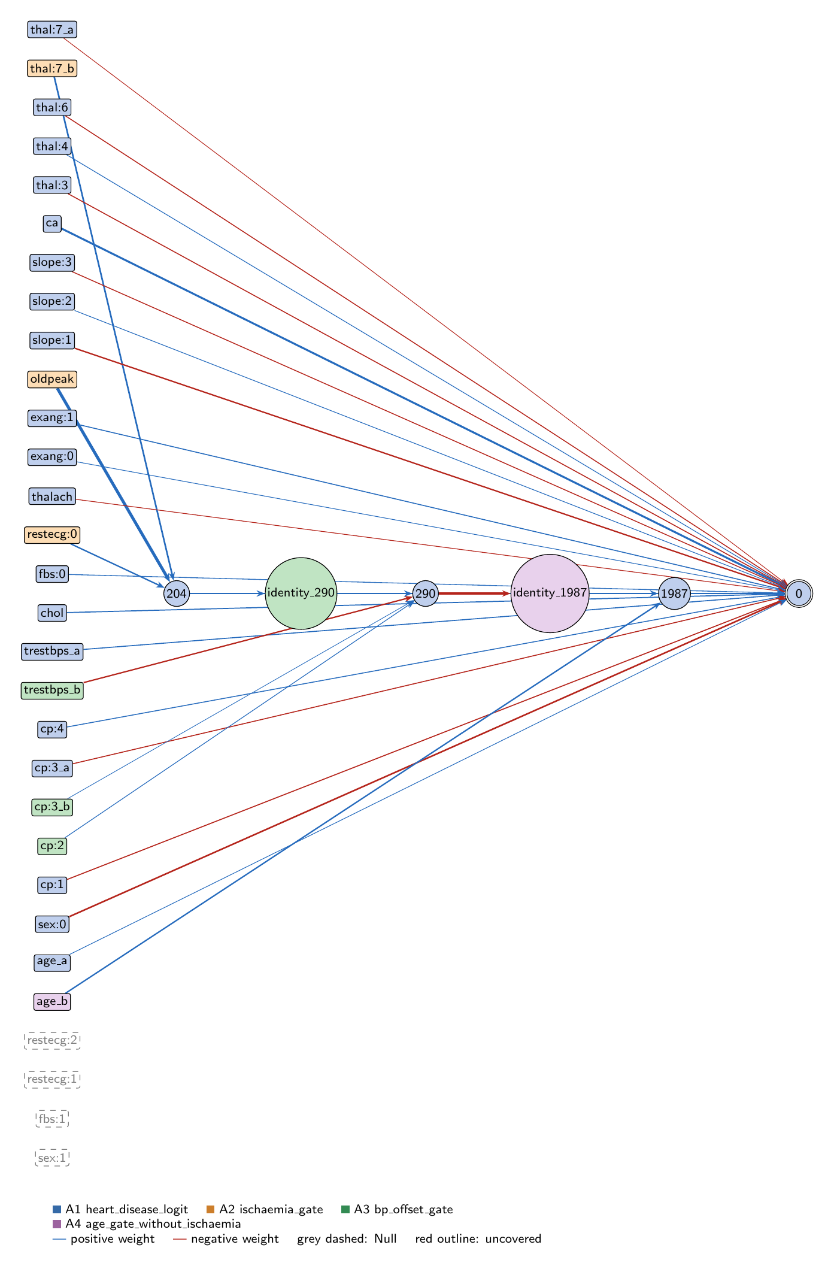
heart-s5-c1: full view of the explained model state.
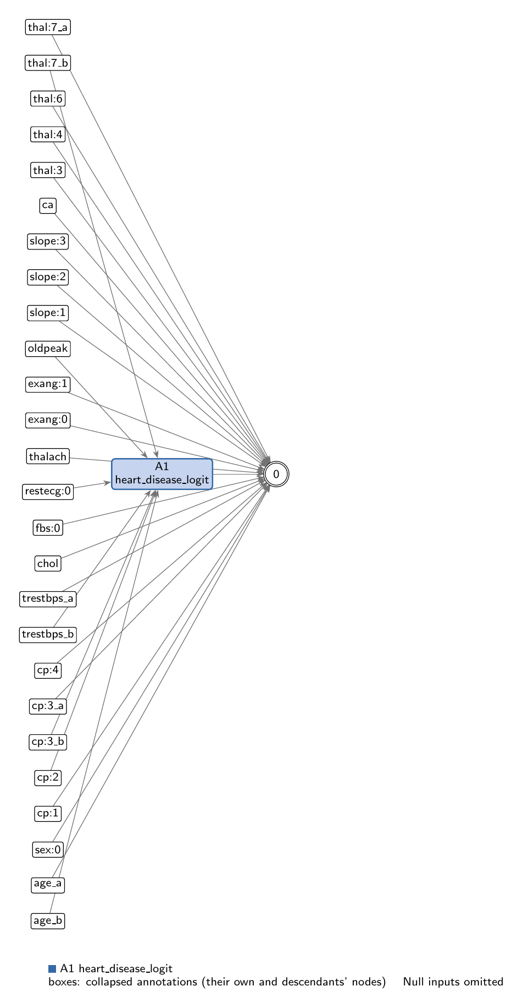
heart-s5-c1: collapsed view at hierarchy level 0 (fully recomposed).
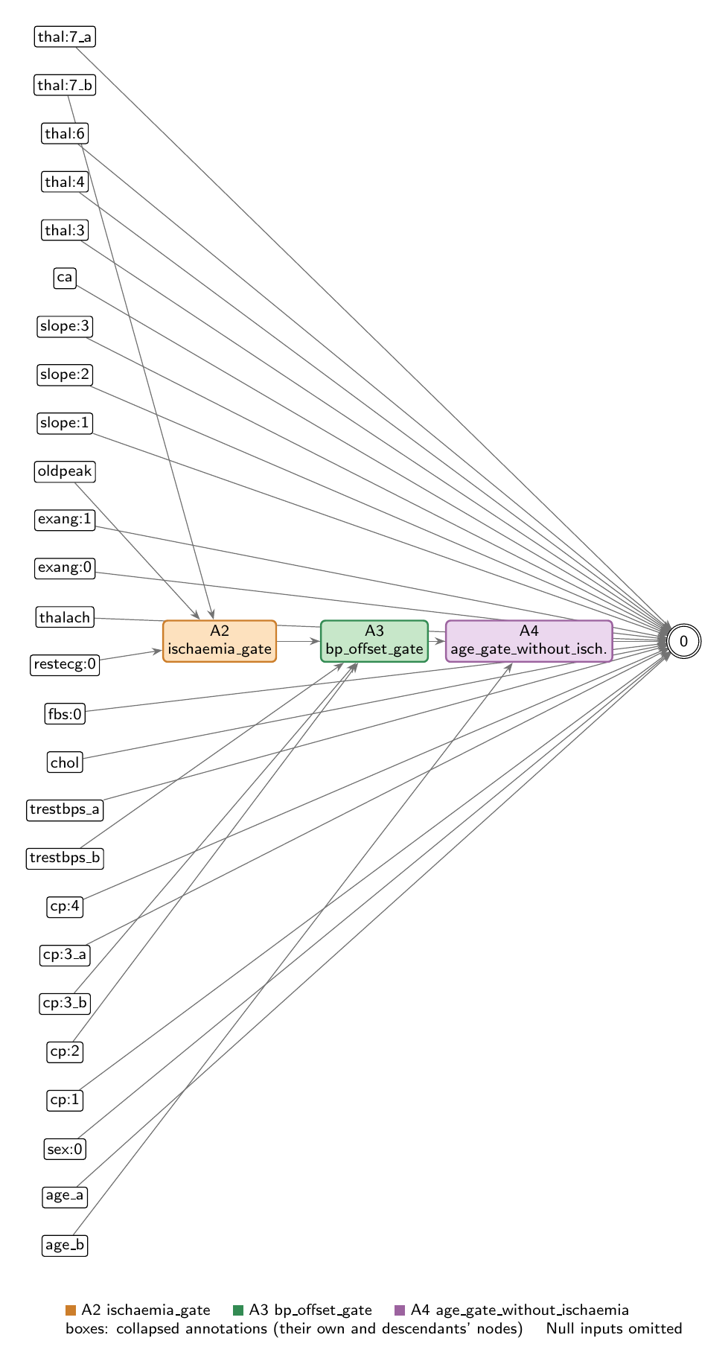
heart-s5-c1: collapsed view at hierarchy level 1.

Refactoring operations
All operations are function-preserving; max output change 2.22e-16 over 242 training rows.
- #26: split -26 into -26_a, -26_b
- #27: split -6 into -6_a, -6_b
- #28: split -8 into -8_a, -8_b
- #29: split -1 into -1_a, -1_b
- #30: identity node identity_290 before 290
- #31: identity node identity_1987 before 1987

Annotations

A1: heart_disease_logit
Composition annotation (depth 0); children A2, A3, A4.
- Entry nodes: -1_a (age_a), -2 (sex:0), -3 (sex:1), -4 (cp:1), -6_a (cp:3_a), -7 (cp:4), -8_a (trestbps_a), -9 (chol), -10 (fbs:0), -11 (fbs:1), -13 (restecg:1), -14 (restecg:2), -15 (thalach), -16 (exang:0), -17 (exang:1), -19 (slope:1), -20 (slope:2), -21 (slope:3), -22 (ca), -23 (thal:3), -24 (thal:4), -25 (thal:6), -26_a (thal:7_a)
- Exit nodes: 0
- Internal nodes: none
- Edges: 24; covers 35 candidate node(s)
Hypothesis. Root: p = sigmoid(z), z = -0.504 + LINEAR CORE + 0.143*ischaemia_gate + 0.170*bp_offset_gate + 0.143*age_gate_without_ischaemia. LINEAR CORE (19 direct input->output edges, z-scored inputs): ca +1.480, sex:0 -1.072, slope:1 -0.855, chol +0.546, cp:1 -0.493, trestbps +0.480, cp:3 -0.440, exang:1 +0.431, thal:3 -0.410, thal:6 -0.384, cp:4 +0.377, slope:3 -0.366, fbs:0 +0.278, thalach -0.207, thal:4 +0.183, slope:2 +0.153, exang:0 +0.149, age +0.117, thal:7 -0.077. Four inputs are unconnected (sex:1, fbs:1, restecg:1, restecg:2; zero-effect entries of this root). Oldpeak, restecg:0 and cp:2 have no direct edge and act only through the chain. COMPOSITION: serial and additive. The three children form a chain, each read out additively into z: ischaemia_gate (oldpeak, normal resting ECG, reversible defect) feeds bp_offset_gate (the ischaemia score minus a resting-BP offset), which in turn switches off age_gate_without_ischaemia (an extra age term for patients without ischaemia evidence). The chain therefore raises risk with ST depression, more steeply where resting BP is low, and adds a small age term where the chain is quiet. Identity nodes identity_290 and identity_1987 carry the chain links (204 -> 290, 290 -> 1987) so that each gate is its own leaf. EVIDENCE (train, n=242): full model AUC 0.9418, acc 0.872 (compute_performance). Linear core alone AUC 0.934; logit SD 3.14 (core) vs 0.67 (chain). Removing the whole chain (node 204 with downstream) gives 0.934; readout-only ablations: ischaemia 0.940, BP 0.939, age 0.941. Treating all three ReLUs as identities gives 0.936; one least-squares linear fit of the chain on its seven inputs gives 0.937 (R2 0.84); an L2 logistic regression on all 26 inputs gives 0.936. Mean |SHAP| (train, all 242): ca 0.144, sex:0 0.110, slope:1 0.100, thal:3 0.048, exang:1 0.047, chol 0.045, cp:4 0.044, cp:3 0.044. Interpretation: close to logistic regression plus one ischaemia correction: ST depression raises risk only above a threshold set by a normal resting ECG and a reversible defect, more so when resting BP is low; age gets a small extra weight when there is no such evidence. Counter-directional signs reported, not explained: restecg:0 positive in the ischaemia gate, trestbps negative in the BP gate, fbs:0 +0.28 directly. Same design as the 10-seed heart-s5 record (generation 37, key 9330: ischaemia gate -> resting-BP gate -> age term), here with three hidden nodes instead of six.
Closed form (SymPy, weights at 3 significant figures; y_i = exit node i):
y_0 = 1/(1.66*exp(-0.117*x_{age_a} - 1.48*x_{ca} - 0.546*x_{chol} + 0.493*x_{cp:1} + 0.44*x_{cp:3_a} - 0.377*x_{cp:4} - 0.149*x_{exang:0} - 0.431*x_{exang:1} - 0.278*x_{fbs:0} + 1.07*x_{sex:0} + 0.855*x_{slope:1} - 0.153*x_{slope:2} + 0.366*x_{slope:3} + 0.41*x_{thal:3} - 0.183*x_{thal:4} + 0.384*x_{thal:6} + 0.0766*x_{thal:7_a} + 0.207*x_{thalach} - 0.48*x_{trestbps_a} - 0.143*relu(0.875*x_{age_b} - 1.59*relu(0.176*x_{cp:2} + 0.0164*x_{cp:3_b} - 0.815*x_{trestbps_b} + 1.08*relu(2.59*x_{oldpeak} + 0.87*x_{restecg:0} + 1.15*x_{thal:7_b} + 0.247) - 0.495) + 0.203) - 0.143*relu(2.59*x_{oldpeak} + 0.87*x_{restecg:0} + 1.15*x_{thal:7_b} + 0.247) - 0.17*relu(0.176*x_{cp:2} + 0.0164*x_{cp:3_b} - 0.815*x_{trestbps_b} + 1.08*relu(2.59*x_{oldpeak} + 0.87*x_{restecg:0} + 1.15*x_{thal:7_b} + 0.247) - 0.495)) + 1)
Training split (n = 242): displayed closed form within 0.00186 of the forward pass; exact function within 2.78e-16.
Evidence (2 items; payloads in the JSON record):
- [analytical] analytical_formula; split: n/a (analytical). Root closed form (get_formula force=true); output is sigmoid.
- [empirical] empirical_viz; split: train. Train-split performance, ablations, linear replacements and SHAP.
Authorship: drafted by AI-assisted draft on 2026-11-10; verified by nobody (unverified).

A2: ischaemia_gate
Leaf annotation (depth 1); parent A1.
- Entry nodes: -12 (restecg:0), -18 (oldpeak), -26_b (thal:7_b)
- Exit nodes: 204
- Internal nodes: none
- Edges: 3; covers 3 candidate node(s)
Hypothesis. Ischaemia-evidence gate (raises risk). 204 = ReLU(0.247 + 2.593*oldpeak + 0.871*restecg:0 + 1.145*thal:7). Hypothesis: a one-sided ST-depression score that opens above an oldpeak threshold set by two flags (always open with a normal resting ECG and a reversible thallium defect; above z-oldpeak -0.09 with a normal ECG only, -0.33 with a defect only, +0.58 with neither), and then raises the logit with oldpeak, directly (0.143 per unit) and through the blood-pressure gate (a further 0.183 per unit while that gate is open). EVIDENCE (train, n=242): active for 48% (100% of the 44 patients with both flags, 20% of the 75 with neither); corr with oldpeak 0.88; disease rate 66% when active vs 24% when inactive. Mean |sensitivity| oldpeak 1.24 > thal:7 0.55 > restecg:0 0.42. This is the main nonlinear effect: removing it with its downstream effects lowers train AUC 0.942 -> 0.934 (to the linear-core level); an affine replacement recovers 0.938. Supported. Oldpeak and restecg:0 have no direct edge; they act only here. The positive restecg:0 weight (normal ECG raises the score) is counter-intuitive and is reported, not explained.
Closed form (SymPy, weights at 3 significant figures; y_i = exit node i):
y_0 = relu(2.59*x_{oldpeak} + 0.87*x_{restecg:0} + 1.15*x_{thal:7_b} + 0.247)
Training split (n = 242): displayed closed form within 0.0113 of the forward pass; exact function within 1.78e-15.
Evidence (2 items; payloads in the JSON record):
- [analytical] analytical_formula; split: n/a (analytical). Closed form from get_formula (force) with readouts and thresholds.
- [empirical] empirical_viz; split: train. Train-split sensitivity, activity, outcome rates and ablation.
Authorship: drafted by AI-assisted draft on 2026-11-10; verified by nobody (unverified).

A3: bp_offset_gate
Leaf annotation (depth 1); parent A1.
- Entry nodes: identity_290, -5 (cp:2), -6_b (cp:3_b), -8_b (trestbps_b)
- Exit nodes: 290
- Internal nodes: none
- Edges: 4; covers 4 candidate node(s)
Hypothesis. Blood-pressure offset gate on the ischaemia score (raises risk). 290 = ReLU(-0.495 + 1.079*ischaemia_gate - 0.815*trestbps + 0.176*cp:2 + 0.016*cp:3). Hypothesis: passes the ischaemia score on, minus an offset that grows with resting blood pressure; it adds 0.170 per unit to the logit and switches off the age gate. With the ischaemia gate closed it still opens for low resting blood pressure, so within this gate lower resting BP raises risk (0.170*0.815 = 0.139 per SD), partly offsetting trestbps's direct +0.48 edge. cp:2 (atypical angina) nudges it open; cp:3's weight 0.016 is negligible. EVIDENCE (train, n=242): active for 58% (83% with the ischaemia gate open, 35% without); with the ischaemia gate open, active for 100%, 87% and 59% of the low, middle and high resting-BP groups. Disease rate 51% when active vs 35% when inactive. Mean |sensitivity| ischaemia score 0.58 > trestbps 0.45 > cp:2 0.10 > cp:3 0.01. Readout ablation lowers train AUC 0.942 -> 0.939; an affine replacement fits it well (R2 0.97, AUC 0.941), so its nonlinearity matters little. Supported, small. The negative BP term inside a risk-raising gate is reported, not explained.
Closed form (SymPy, weights at 3 significant figures; y_i = exit node i):
y_0 = relu(0.176*x_{cp:2} + 0.0164*x_{cp:3_b} + 1.0*x_{identity_290} - 0.815*x_{trestbps_b} - 0.495)
Training split (n = 242): displayed closed form within 8.86e-04 of the forward pass; exact function within 8.88e-16.
Evidence (2 items; payloads in the JSON record):
- [analytical] analytical_formula; split: n/a (analytical). Closed form from get_formula (force) with readouts and thresholds.
- [empirical] empirical_viz; split: train. Train-split sensitivity, activity, outcome rates and ablation.
Authorship: drafted by AI-assisted draft on 2026-11-10; verified by nobody (unverified).

A4: age_gate_without_ischaemia
Leaf annotation (depth 1); parent A1.
- Entry nodes: identity_1987, -1_b (age_b)
- Exit nodes: 1987
- Internal nodes: none
- Edges: 2; covers 2 candidate node(s)
Hypothesis. Age gate without ischaemia evidence (raises risk with age, small). 1987 = ReLU(0.203 + 0.875*age - 1.589*bp_offset_gate), read out +0.143. Hypothesis: an extra age term (0.125 per SD of age, on top of age's direct +0.117) that acts only while the BP gate is closed or nearly closed, i.e. for patients without much ischaemia evidence; any opening of the BP gate cancels it (each unit of the BP gate removes 0.227 from the logit through this node until it closes). EVIDENCE (train, n=242): active for 35% (65% when the BP gate is closed, rising with age: 0%, 80%, 100% of the youngest, middle and oldest groups; 14% when the BP gate is open). Disease rate barely differs (43% vs 45%). Mean |sensitivity| BP gate 0.35, age 0.31. Removing it lowers train AUC only 0.942 -> 0.941. Supported, near-negligible.
Closed form (SymPy, weights at 3 significant figures; y_i = exit node i):
y_0 = relu(0.875*x_{age_b} + 1.0*x_{identity_1987} + 0.203)
Training split (n = 242): displayed closed form within 4.99e-04 of the forward pass; exact function within 2.22e-16.
Evidence (2 items; payloads in the JSON record):
- [analytical] analytical_formula; split: n/a (analytical). Closed form from get_formula (force) with readouts and thresholds.
- [empirical] empirical_viz; split: train. Train-split sensitivity, activity, outcome rates and ablation.
Authorship: drafted by AI-assisted draft on 2026-11-10; verified by nobody (unverified).

Audit against the definitions
- WARNING unverified: No human verification is recorded for this explanation.
end of thesis draft

