THESIS DRAFT - appendix: heart-s5-c3 explanation certificate - for review

Explanation certificate: heart-s5-c3
Rendered from the canonical JSON record heart-s5-c3.json (schema 1.4.0, SHA-256 644db15ecc0191f8ed73b9a23757dccfcf5f1809df487f9171d22800751515e6), which holds every evidence payload and the full graphs.
Dataset | Heart Disease (binary, prepared)
Experiment | 10seed-heart-s5, seed 5
Genome | 96fb45fb-972d-4aaa-b6d5-01fc63fbc4e6 (NEAT key 9698, generation 39)
Explanation | 1b3f669d-9fb5-4126-b6e4-35535db7b3b1 (30 operations)
Train AUC / accuracy | 0.9376 / 0.8884 (n = 242)
Test AUC / accuracy | 0.9084 / 0.8197 (n = 61)
Output activation | sigmoid
Phenotype | 31 nodes (26 inputs, 4 hidden, 1 output), 26 enabled edges
Explained model state | 32 nodes, 26 enabled edges
Function preservation | max |change in output| = 2.22e-16 (train)
Annotations | 3 (2 leaf, 1 composition)
Structural coverage | 1 (31 of 31; 7 Null)
Compositional coverage | 1
Uncovered nodes / edges | 0 / 0
Missing compositions | 0
Full coverage | yes
Drafted by | AI-assisted draft
Verified by | unverified
Drafter's summary. Mostly logistic regression: 17 direct edges (logit SD 3.22; train AUC 0.932 alone) plus an ST-depression chain and an age hinge (logit SD 0.80 together) to 0.938. The chain scores oldpeak (threshold lowered by a normal resting ECG) and adds a second, much steeper stage of the same score, so oldpeak's effect is a hinge (about 0.12 logit per SD, then about 1.10 per SD above z -0.39 with a normal ECG or +0.40 without); age enters only through a small hinge starting just below the median. Same ischaemia gate as the 10-seed heart-s5 record (key 9330) and its cluster-1 sibling, but with no resting-BP offset and a free-standing age term.
What resisted explanation. Nothing resisted coverage. The chain 204 -> 3487 -> 290 (with 204 -> 290 as well, and both 204 and 290 read out) was kept as one two-exit leaf rather than two leaves: 3487's only input is 204, so it cannot be intercepted by an identity node (add_identity_node must leave one input un-redirected), and splitting 204 would have duplicated the gate. 3487 is a near-copy of 204 (ReLU(0.94*204 - 0.002)), so 290 = ReLU(1.818*204 - 0.470): a second, steeper threshold on the same score. Counter-directional signs reported, not explained: a normal resting ECG (restecg:0) lowers the oldpeak threshold inside the chain (raising risk) while its direct edge is -0.188; fbs:0 +0.27 directly; thal:7 only +0.025. The age hinge barely matters (readout ablation -0.0005 AUC). closed_form_max_abs_err 0.021 comes from 3-significant-figure display rounding in the nested chain formula (numeric error 1.8e-15).

Plain-language summary
AI-assisted draft for review (unverified). Each sentence cites the claims that back it; every cited claim was computed on the model and the training split and passed its automatic checks. Magnitudes are changes in predicted risk for a typical patient; confidence words follow the test-split check and n. The text describes what the model does, not the world.
Summary (drafted). For a typical patient (a 56-year-old man with no chest pain symptoms and median test results) the model predicts a risk of heart disease of about 18%; it adds up most of its inputs independently, and two parts add to that sum: a signal from ST depression on exercise and the resting ECG that acts on 105 of 242 training patients, and an age term that acts on 148. [C25, C30, C34] These add up independently, and these lower the risk: being a woman takes a typical patient's predicted risk from about 18% to about 2%, typical angina to about 2%, non-anginal chest pain to about 4% and atypical angina to about 10%; fasting blood sugar above 120 mg/dL lowers it to about 9%; and a higher maximum heart rate lowers it steadily, from about 23% at 118 to about 15% at 175 beats per minute. [C10, C09, C11, C15, C12, C14] Each extra vessel coloured by fluoroscopy adds about the same, from about 18% at 0 to about 86% at 2 vessels, flattening out near the top because the predicted risk cannot go much higher; a flat rather than upsloping ST segment raises it to about 56%, a reversible defect on the thallium scan to about 38% and chest pain brought on by exercise to about 35%; higher cholesterol raises it steadily, from about 11% at 193 mg/dL to about 33% at 308 mg/dL, and higher resting blood pressure steadily, from about 12% at 110 mm Hg to about 30% at 155 mm Hg. [C01, C04, C06, C08, C05, C07] Through this sum alone, a resting ECG other than normal raises it from about 18% to about 24%; the resting ECG also acts through the ST depression signal (below). [C16] Some rarer results also count (the model has little data on this, n = 2 to 17): a thallium result coded 4 raises the risk to about 79%, a fixed defect on the thallium scan lowers it to about 9%, and a downsloping ST segment leaves it at about 19%. [C02, C13, C19] This part reads ST depression on exercise and the resting ECG, and acts on 105 of 242 training patients, 66 of whom had heart disease; for the typical patient it acts on, the predicted risk is about 76% without it and about 91% with it. [C30] Through it, more ST depression adds nothing until about 0.5 mm, then raises the predicted risk steadily: for a typical patient from about 16% at 0 mm to about 60% at 2.8 mm. [C26] ST depression counts more with a normal resting ECG, nothing until about 0.5 mm and then steadily, from about 16% to about 60%, against about 21% to about 48% with any other resting ECG. [C28] Through it, a resting ECG other than normal lowers a typical patient's risk from about 18% to about 16%. [C27] This part acts on 148 of 242 training patients, 81 of whom had heart disease; for the typical patient it acts on, the predicted risk is about 91% without it and about 92% with it. [C34] Through it, age adds nothing until about 53 years, then raises the risk steadily, for a typical patient from about 18% at 42 to about 19% at 66 years. [C32, C33]
Summary (offline template). The model treats a higher number of vessels coloured by fluoroscopy as raising the predicted risk of heart disease steadily, each extra vessel adding about the same: for a typical patient, it goes from about 18% at 0 vessels to about 86% at 2 vessels, flattening out near the top because the predicted risk cannot go much higher (on the training data only). [C01] The model treats a higher ST depression on exercise as raising the predicted risk of heart disease with nothing until about 0.5 mm, then steadily: for a typical patient, it goes from about 16% at 0.0 mm to about 60% at 2.8 mm (on the training data only). [C03] For a typical patient, the model gives a higher predicted risk of heart disease if the ST segment is flat at peak exercise (about 56%) than if the ST segment slopes up at peak exercise (about 18%) (on the training data only). [C04] A higher ST depression on exercise clearly raises the predicted risk of heart disease, and even more so if the resting ECG is normal (with nothing until about 0.5 mm, then steadily for patients with a normal resting ECG): for a typical patient, ST depression on exercise going from 0.0 mm to 2.8 mm moves the predicted risk of heart disease from about 16% to about 60% if the resting ECG is normal, and from about 21% to about 48% if resting ECG is something other than a normal resting ECG. [C28] Through one part of the model, age only slightly adds to the predicted risk of heart disease once it rises above about 53 years: for a typical such patient, going from 29 years to 68 years moves it from about 18% to about 20% (on the training data only). [C33]
ann_29 (heart_disease_logit). The model treats a higher number of vessels coloured by fluoroscopy as raising the predicted risk of heart disease steadily, each extra vessel adding about the same: for a typical patient, it goes from about 18% at 0 vessels to about 86% at 2 vessels, flattening out near the top because the predicted risk cannot go much higher (on the training data only). [C01] For a typical patient, the model gives a higher predicted risk of heart disease if thallium stress test result coded 4 (meaning not recorded) applies (about 79%) than if the thallium scan is normal (about 18%) (on the training data only). The model has little data on this: only 2 training patients (thallium stress test result coded 4 (meaning not recorded)). [C02] The model treats a higher ST depression on exercise as raising the predicted risk of heart disease with nothing until about 0.5 mm, then steadily: for a typical patient, it goes from about 16% at 0.0 mm to about 60% at 2.8 mm (on the training data only). [C03] For a typical patient, the model gives a higher predicted risk of heart disease if the ST segment is flat at peak exercise (about 56%) than if the ST segment slopes up at peak exercise (about 18%) (on the training data only). [C04] The model treats a higher serum cholesterol as raising the predicted risk of heart disease steadily: for a typical patient, it goes from about 11% at 193 mg/dL (5.0 mmol/L) to about 33% at 308 mg/dL (8.0 mmol/L) (on the training data only). [C05] For a typical patient, the model gives a higher predicted risk of heart disease if the thallium scan shows a reversible defect (about 38%) than if the thallium scan is normal (about 18%) (on the training data only). [C06] Other effects: a higher resting blood pressure raises it steadily; chest pain brought on by exercise (rather than no chest pain on exercise) raises it; typical angina (rather than no chest pain (asymptomatic)) lowers it; female (rather than male) lowers it; non-anginal chest pain (rather than no chest pain (asymptomatic)) lowers it; fasting blood sugar above 120 mg/dL (rather than fasting blood sugar of 120 mg/dL or less) lowers it; a fixed defect on the thallium scan (rather than a normal thallium scan) lowers it; a higher maximum heart rate lowers it steadily; and 2 still smaller effects listed in the evidence table (on the training data only). The model has little data on some of these: only 15 training patients (a fixed defect on the thallium scan). [C07, C08, C09, C10, C11, C12, C13, C14] Smaller effects, each changing the predicted value only slightly: a higher age raises it with nothing until about 53 years, then steadily; a downsloping ST segment (rather than an upsloping ST segment) raises it (on the training data only). The model has little data on some of these: only 17 training patients (a downsloping ST segment). [C18, C19]
ann_27 (ischaemia_chain). This part acts on 105 of 242 training patients (43%). [C30] For a typical patient it acts on, it raises the predicted risk of heart disease from about 76% without this part to about 91% with it (on the training data only). [C30] In the training data, 66 of these 105 patients had heart disease. [C30] A higher ST depression on exercise clearly raises the predicted risk of heart disease, and even more so if the resting ECG is normal (with nothing until about 0.5 mm, then steadily for patients with a normal resting ECG): for a typical patient, ST depression on exercise going from 0.0 mm to 2.8 mm moves the predicted risk of heart disease from about 16% to about 60% if the resting ECG is normal, and from about 21% to about 48% if resting ECG is something other than a normal resting ECG. [C28] Through this part, the model treats a higher ST depression on exercise as raising the predicted risk of heart disease with nothing until about 0.5 mm, then steadily: for a typical patient, it goes from about 16% at 0.0 mm to about 60% at 2.8 mm (on the training data only). [C26] Through this part, for a typical patient, the model gives a slightly lower predicted risk of heart disease if resting ECG is something other than a normal resting ECG (about 16%) than if the resting ECG is normal (about 18%) (on the training data only). [C27]
ann_28 (age_hinge). This part acts on 148 of 242 training patients (61%). [C34] For a typical patient it acts on, it slightly raises the predicted risk of heart disease from about 91% without this part to about 92% with it (on the training data only). [C34] In the training data, 81 of these 148 patients had heart disease. [C34] Through this part, age only slightly adds to the predicted risk of heart disease once it rises above about 53 years: for a typical such patient, going from 29 years to 68 years moves it from about 18% to about 20% (on the training data only). [C33] Through this part, the model treats a higher age as slightly raising the predicted risk of heart disease with nothing until about 53 years, then steadily: for a typical patient, it goes from about 18% at 42 years to about 19% at 66 years (on the training data only). [C32]
Worth checking against what is known. Worth checking: the model treats fasting blood sugar above 120 mg/dL as lowering the risk of heart disease (for a typical patient from about 18% to about 9%). [C12] Worth checking: patients with typical angina get the lowest predicted risk of all chest pain types, below patients with no chest pain symptoms. [C09, C11, C15] Worth checking: the model treats a fixed defect on the thallium scan as lowering the risk compared with a normal scan, from only 15 training patients. [C13] Worth checking: the model gives a higher predicted risk to the 2 training patients whose thallium result is coded 4, a code the dataset documentation does not define. [C02] Worth checking: ST depression on exercise raises the predicted risk more when the resting ECG is normal than when it is not. [C28]
Claim | What is checked | Risk, typical patient | Estimate (log-odds; OR); range across patients | n | Test check | Verified | Words
C01 | direction: number of vessels coloured by fluoroscopy: 0 vessels to 2 vessels (whole model) | 18% to 86% | log-odds 3.33, OR 28.0; range across patients 3.33 to 3.33 | 242 | train; test unclear (AUC gain 0.029 [-0.039, 0.100], n=61) | yes | on the training data only
C02 | direction: thallium stress test result: a normal thallium scan to thallium stress test result coded 4 (meaning not recorded) (whole model) | 18% to 79% | log-odds 2.85, OR 17.4; range across patients 2.85 to 2.85 | 135, 2 (small n) | train; test unclear (AUC gain 0.020 [-0.012, 0.058], n=61) | yes | the model has little data on this; on the training data only
C03 | direction: ST depression on exercise: 0.0 mm to 2.8 mm (whole model) | 16% to 60% | log-odds 1.65, OR 5.20; range across patients 1.22 to 2.08 | 242 | train; test unclear (AUC gain 0.023 [-0.001, 0.055], n=61) | yes | on the training data only
C04 | direction: slope of the ST segment at peak exercise: an upsloping ST segment to a flat ST segment (whole model) | 18% to 56% | log-odds 1.75, OR 5.75; range across patients 1.75 to 1.75 | 115, 110 | train; test disagrees (AUC gain -0.024 [-0.071, 0.009], n=61) | yes | on the training data only
C05 | direction: serum cholesterol: 193 mg/dL (5.0 mmol/L) to 308 mg/dL (8.0 mmol/L) (whole model) | 11% to 33% | log-odds 1.32, OR 3.73; range across patients 1.32 to 1.32 | 242 | train; test disagrees (AUC gain -0.019 [-0.058, 0.008], n=61) | yes | on the training data only
C06 | direction: thallium stress test result: a normal thallium scan to a reversible defect on the thallium scan (whole model) | 18% to 38% | log-odds 1.00, OR 2.72; range across patients 1.00 to 1.00 | 135, 90 | train; test unclear (AUC gain 0.020 [-0.012, 0.058], n=61) | yes | on the training data only
C07 | direction: resting blood pressure: 110 mm Hg to 155 mm Hg (whole model) | 12% to 30% | log-odds 1.19, OR 3.30; range across patients 1.19 to 1.19 | 242 | train; test unclear (AUC gain 0.008 [-0.018, 0.037], n=61) | yes | on the training data only
C08 | direction: exercise-induced angina: no chest pain on exercise to chest pain brought on by exercise (whole model) | 18% to 35% | log-odds 0.89, OR 2.44; range across patients 0.89 to 0.89 | 160, 82 | train; test agrees (AUC gain 0.022 [0.003, 0.049], n=61) | yes | clearly
C09 | direction: chest pain type: no chest pain (asymptomatic) to typical angina (whole model) | 18% to 2% | log-odds -2.43, OR 0.09; range across patients -2.43 to -2.43 | 108, 22 | train; test agrees (AUC gain 0.033 [0.008, 0.066], n=61) | yes | clearly
C10 | direction: sex: male to female (whole model) | 18% to 2% | log-odds -2.19, OR 0.11; range across patients -2.19 to -2.19 | 159, 83 | train; test unclear (AUC gain 0.025 [-0.007, 0.066], n=61) | yes | on the training data only
C11 | direction: chest pain type: no chest pain (asymptomatic) to non-anginal chest pain (whole model) | 18% to 4% | log-odds -1.69, OR 0.18; range across patients -1.69 to -1.69 | 108, 70 | train; test agrees (AUC gain 0.033 [0.008, 0.066], n=61) | yes | clearly
C12 | direction: fasting blood sugar: fasting blood sugar of 120 mg/dL or less to fasting blood sugar above 120 mg/dL (whole model) | 18% to 9% | log-odds -0.80, OR 0.45; range across patients -0.80 to -0.80 | 209, 33 | train; test unclear (AUC gain 0.000 [-0.013, 0.013], n=61) | yes | on the training data only
C13 | direction: thallium stress test result: a normal thallium scan to a fixed defect on the thallium scan (whole model) | 18% to 9% | log-odds -0.80, OR 0.45; range across patients -0.80 to -0.80 | 135, 15 (small n) | train; test unclear (AUC gain 0.020 [-0.012, 0.058], n=61) | yes | the model has little data on this; on the training data only
C14 | direction: maximum heart rate: 118 beats per minute to 175 beats per minute (whole model) | 23% to 15% | log-odds -0.54, OR 0.58; range across patients -0.54 to -0.54 | 242 | train; test agrees (AUC gain 0.014 [0.002, 0.035], n=61) | yes | clearly
C15 | direction: chest pain type: no chest pain (asymptomatic) to atypical angina (whole model) | 18% to 10% | log-odds -0.71, OR 0.49; range across patients -0.71 to -0.71 | 108, 42 | train; test agrees (AUC gain 0.033 [0.008, 0.066], n=61) | yes | clearly
C16 | direction: resting ECG: a normal resting ECG to resting ECG other than a normal resting ECG (direct contribution only, not through any part) | 18% to 24% | log-odds 0.38, OR 1.46; range across patients 0.38 to 0.38 | 121, 121 | train; test unclear (AUC gain 0.005 [-0.005, 0.024], n=61) | yes | on the training data only
C17 | direction: resting ECG: a normal resting ECG to resting ECG other than a normal resting ECG (whole model) | 18% to 21% | log-odds 0.02, OR 1.02; range across patients -0.49 to 0.38 | 121, 121 | train; test disagrees (AUC gain 0.003 [-0.013, 0.021], n=61) | no | slightly; on the training data only
C18 | direction: age: 42 years to 66 years (whole model) | 18% to 19% | log-odds 0.10, OR 1.11; range across patients 0.10 to 0.10 | 242 | train; test disagrees (AUC gain -0.003 [-0.017, 0.004], n=61) | yes | slightly; on the training data only
C19 | direction: slope of the ST segment at peak exercise: an upsloping ST segment to a downsloping ST segment (whole model) | 18% to 19% | log-odds 0.05, OR 1.05; range across patients 0.05 to 0.05 | 115, 17 (small n) | train; test disagrees (AUC gain -0.024 [-0.071, 0.009], n=61) | yes | slightly; the model has little data on this; on the training data only
C20 | magnitude: number of vessels coloured by fluoroscopy: 0 vessels to 2 vessels, typical patient | 18% to 86% | log-odds 3.33, OR 28.0 | 242 | train; test unclear (AUC gain 0.029 [-0.039, 0.100], n=61) | yes | on the training data only
C21 | magnitude: ST depression on exercise: 0.0 mm to 2.8 mm, typical patient | 16% to 60% | log-odds 2.08, OR 8.01 | 242 | train; test unclear (AUC gain 0.023 [-0.001, 0.055], n=61) | yes | on the training data only
C22 | magnitude: slope of the ST segment at peak exercise: an upsloping ST segment to a flat ST segment, typical patient | 18% to 56% | log-odds 1.75, OR 5.75 | 115, 110 | train; test disagrees (AUC gain -0.024 [-0.071, 0.009], n=61) | yes | on the training data only
C23 | magnitude: serum cholesterol: 193 mg/dL (5.0 mmol/L) to 308 mg/dL (8.0 mmol/L), typical patient | 11% to 33% | log-odds 1.32, OR 3.73 | 242 | train; test disagrees (AUC gain -0.019 [-0.058, 0.008], n=61) | yes | on the training data only
C24 | magnitude: thallium stress test result: a normal thallium scan to a reversible defect on the thallium scan, typical patient | 18% to 38% | log-odds 1.00, OR 2.72 | 135, 90 | train; test unclear (AUC gain 0.020 [-0.012, 0.058], n=61) | yes | on the training data only
C25 | structure: made of ischaemia_chain, age_hinge and inputs sex, cp, trestbps, chol, fbs, restecg, thalach, exang, slope, ca, thal; added |  | log-odds n/a, OR n/a | 242 | train | yes
C26 | direction: ST depression on exercise: 0.0 mm to 2.8 mm (through this part) | 16% to 60% | log-odds 1.65, OR 5.20; range across patients 1.22 to 2.08 | 242 | train; test unclear (AUC gain 0.023 [-0.001, 0.055], n=61) | yes | on the training data only
C27 | direction: resting ECG: a normal resting ECG to resting ECG other than a normal resting ECG (through this part) | 18% to 16% | log-odds -0.36, OR 0.70; range across patients -0.86 to 0.00 | 121, 121 | train; test unclear (AUC gain 0.006 [-0.009, 0.028], n=61) | yes | slightly; on the training data only
C28 | interaction: effect of ST depression on exercise (0.0 mm to 2.8 mm) by resting ECG: resting ECG other than a normal resting ECG minus a normal resting ECG; stronger in a normal resting ECG | resting ECG other than a normal resting ECG: 21% to 48%; a normal resting ECG: 16% to 60% | log-odds difference -0.86, OR 0.42 | 121, 121 | train; test agrees (AUC gain 0.006 [-0.009, 0.028], n=61); group difference on test -0.86 [-0.86, -0.86] | yes | clearly
C29 | threshold: ST depression on exercise: fold at about 0.9 mm (starts) | 16% to 74% (typical patient with a fold) | fold 0.92 mm (IQR 0.45 to 1.38); past it log-odds 2.30, OR 9.93; range across patients 1.86 to 2.73 | 242, 105 | train; test unclear (AUC gain 0.023 [-0.001, 0.055], n=61) | no | on the training data only
C30 | subgroup: who this part acts on: 105 of 242 patients | 76% to 91% (typical patient this part acts on (risk without the part, then with it)) | share 0.43; log-odds 1.03, OR 2.80; range across patients 0.03 to 2.33 | 105, 137 | train; test unclear (AUC gain 0.026 [-0.001, 0.062], n=61) | yes | on the training data only
C31 | structure: its formula reproduces it on 242 training patients (largest difference 1.77636e-15) |  | log-odds 2e-15, OR n/a | 242 | train | yes
C32 | direction: age: 42 years to 66 years (through this part) | 18% to 19% | log-odds 0.10, OR 1.11; range across patients 0.10 to 0.10 | 242 | train; test disagrees (AUC gain -0.003 [-0.017, 0.004], n=61) | yes | slightly; on the training data only
C33 | threshold: age: fold at about 53 years (starts) | 18% to 20% (typical patient with a fold) | fold 52.8 years (IQR 52.8 to 52.8); past it log-odds 0.12, OR 1.13; range across patients 0.12 to 0.12 | 242, 148 | train; test disagrees (AUC gain -0.003 [-0.017, 0.004], n=61) | yes | slightly; on the training data only
C34 | subgroup: who this part acts on: 148 of 242 patients | 91% to 92% (typical patient this part acts on (risk without the part, then with it)) | share 0.61; log-odds 0.06, OR 1.07; range across patients 0.009 to 0.12 | 148, 94 | train; test disagrees (AUC gain -0.003 [-0.017, 0.004], n=61) | yes | slightly; on the training data only
C35 | null: this part barely changes predictions (switched off) |  | max change 0.032 (max |change in predicted risk|) | 242 | train | no
C36 | structure: its formula reproduces it on 242 training patients (largest difference 0.0) |  | log-odds 0.00, OR n/a | 242 | train | yes

Not supported by the model
- C17: direction claim about resting ECG in the whole model: not supported by the model (44% of patients have the opposite sign (allowed: 10%)).
- C29: threshold claim about ST depression during exercise (compared with rest) in part ann_27: not supported by the model (the fold changes the curve by only 0.095 log-odds compared with a straight line (needed 0.1)).
- C35: null claim about age in part ann_28: not supported by the model (predictions move by up to 0.032).

Coverage
Candidate nodes are all nodes of the explained model state except the output nodes. A candidate node is covered when some annotation of the hierarchy (a leaf, or a composition with its descendants) contains it and all its enabled outgoing edges. Exact Null parts (no path to an output over enabled, non-zero-weight edges; zero-weight edges) count as covered.
- Null, disconnected input (7): -11 (fbs:1), -13 (restecg:1), -14 (restecg:2), -16 (exang:0), -20 (slope:2), -3 (sex:1), -5 (cp:2)
- Uncovered nodes: none
- Uncovered edges: none
- Missing compositions: none

Annotation hierarchy
- A1: heart_disease_logit (composition)
- A2: ischaemia_chain (leaf)
- A3: age_hinge (leaf)

Network figures
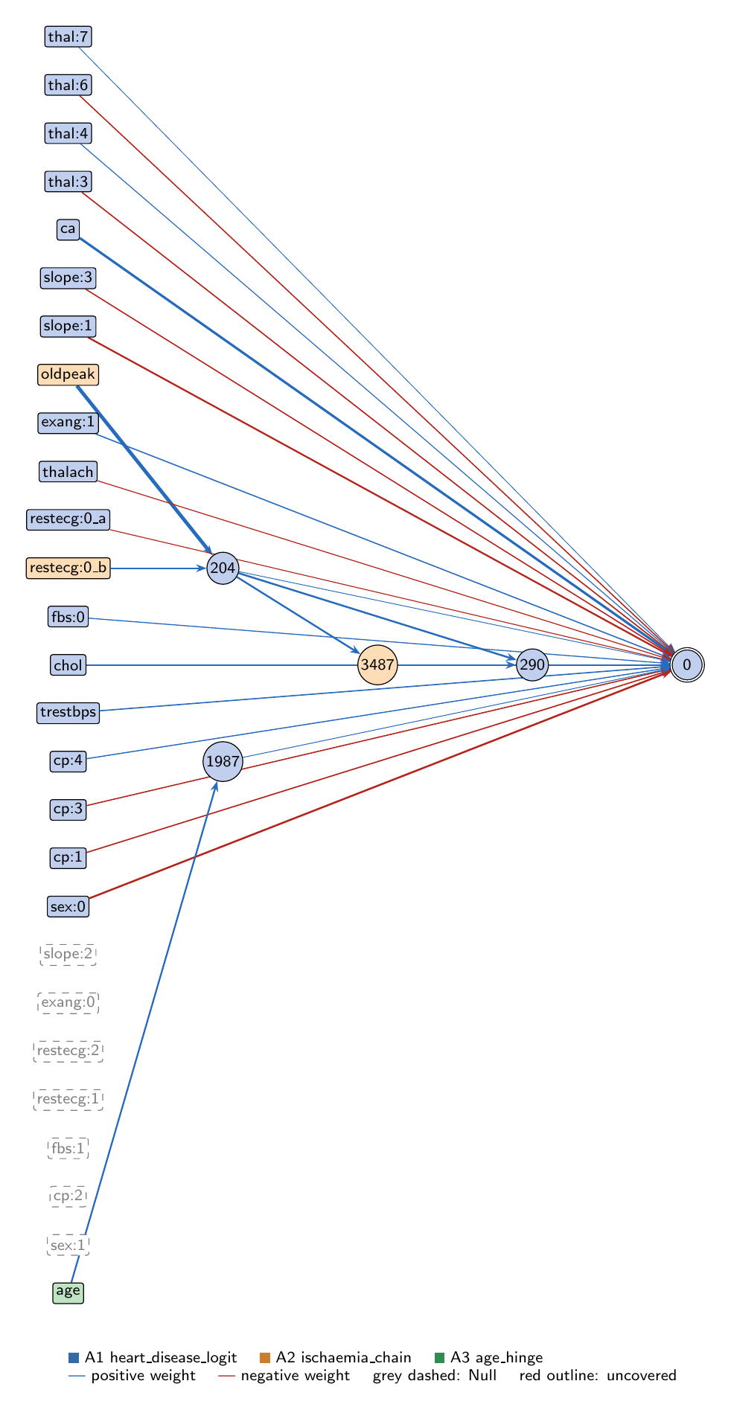
heart-s5-c3: full view of the explained model state.
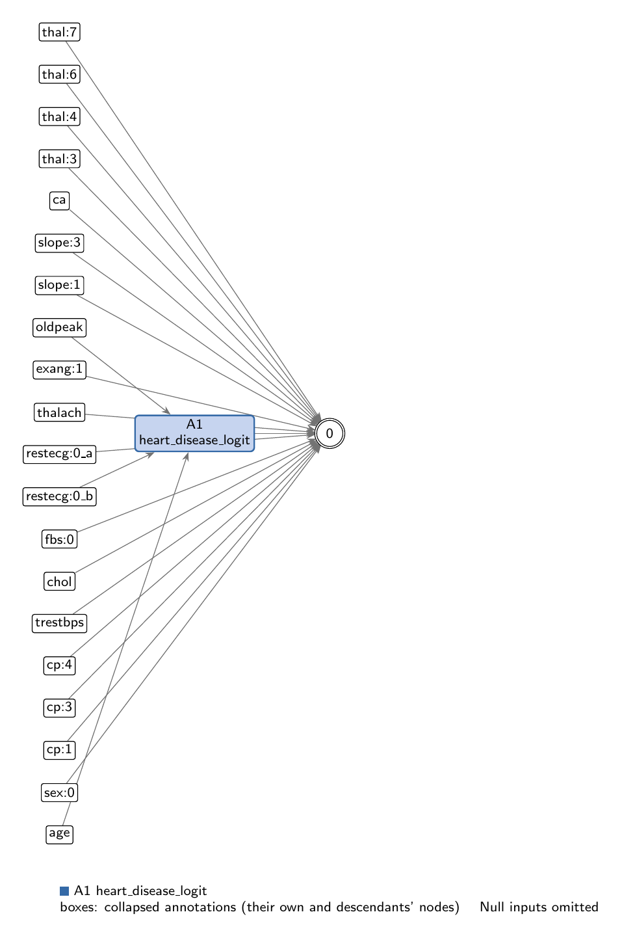
heart-s5-c3: collapsed view at hierarchy level 0 (fully recomposed).
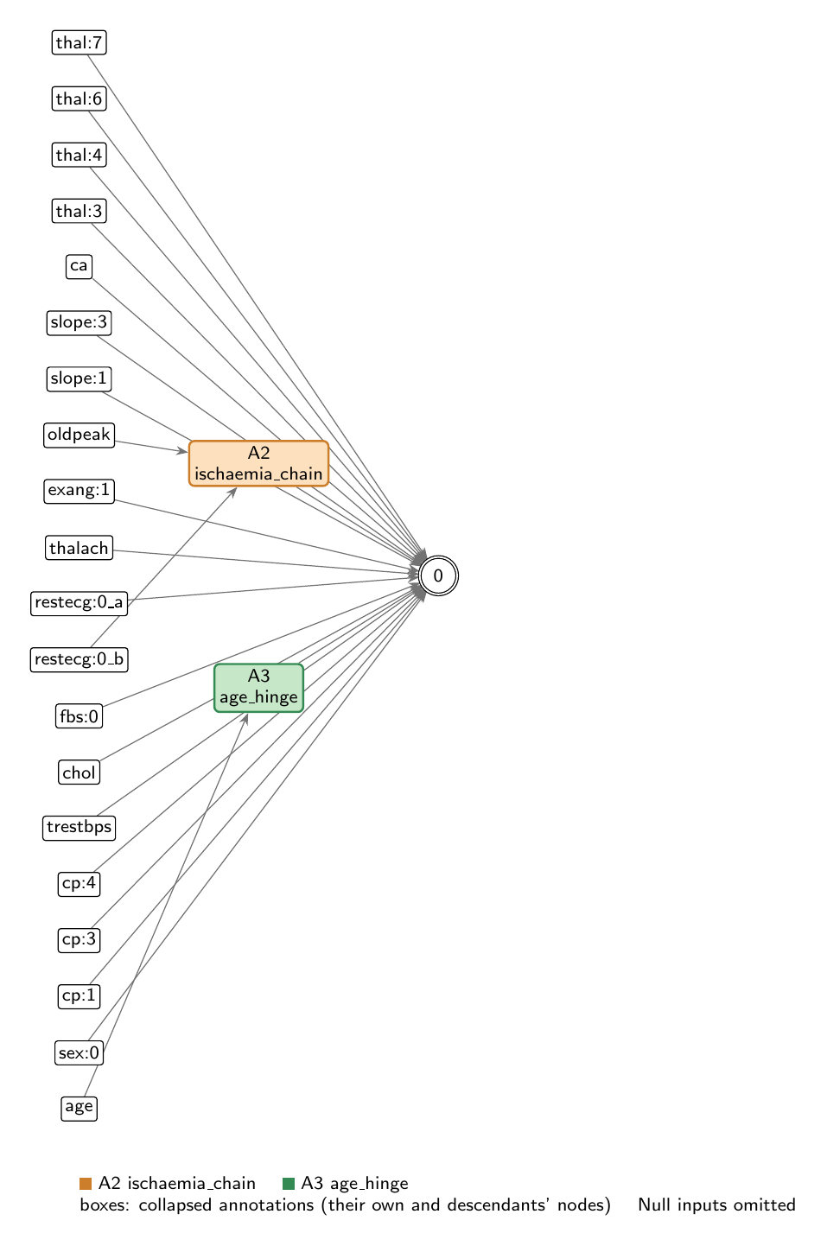
heart-s5-c3: collapsed view at hierarchy level 1.

Refactoring operations
All operations are function-preserving; max output change 2.22e-16 over 242 training rows.
- #26: split -12 into -12_a, -12_b

Annotations

A1: heart_disease_logit
Composition annotation (depth 0); children A2, A3.
- Entry nodes: -26 (thal:7), -25 (thal:6), -24 (thal:4), -23 (thal:3), -22 (ca), -21 (slope:3), -20 (slope:2), -19 (slope:1), -17 (exang:1), -16 (exang:0), -15 (thalach), -14 (restecg:2), -13 (restecg:1), -11 (fbs:1), -10 (fbs:0), -9 (chol), -8 (trestbps), -7 (cp:4), -6 (cp:3), -5 (cp:2), -4 (cp:1), -3 (sex:1), -2 (sex:0), -12_a (restecg:0_a)
- Exit nodes: 0
- Internal nodes: none
- Edges: 20; covers 31 candidate node(s)
Hypothesis. Root: p = sigmoid(z), z = -0.536 + LINEAR CORE + 0.049*ischaemia_chain[204] + 0.216*ischaemia_chain[290] + 0.082*age_hinge. LINEAR CORE (17 direct input->output edges, z-scored inputs): ca +1.485, sex:0 -1.042, slope:1 -0.873, chol +0.551, cp:1 -0.494, trestbps +0.483, thal:3 -0.471, cp:3 -0.442, slope:3 -0.434, exang:1 +0.423, thal:6 -0.421, cp:4 +0.354, fbs:0 +0.274, thalach -0.213, restecg:0 -0.188, thal:4 +0.172, thal:7 +0.025. Seven inputs are unconnected (sex:1, cp:2, fbs:1, restecg:1, restecg:2, exang:0, slope:2; zero-effect entries of this root). Oldpeak and age have no direct edge and act only through the children; restecg:0 acts both directly and through the ischaemia chain (split into restecg:0_a direct and restecg:0_b). COMPOSITION: additive. The two children are read out additively into z: ischaemia_chain (two exits: a one-sided ST-depression score opened earlier by a normal resting ECG, and a steeper second stage of the same score) and age_hinge (an age term that starts just below the median age). Together the chain gives oldpeak a hinge-shaped effect: about 0.12 logit per SD between its two thresholds and about 1.10 per SD above the second (z-oldpeak -0.39 with a normal ECG, +0.40 otherwise). EVIDENCE (train, n=242): full model AUC 0.9376, acc 0.888 (compute_performance). Linear core alone AUC 0.9317; logit SD 3.22 (core) vs 0.80 (nonlinear readouts). Removing the whole chain (204 with downstream) gives 0.9317; readout-only ablations: 204 0.9380, 290 0.9341, age 0.9371. All ReLUs as identities 0.9304; one least-squares linear fit of all nonlinear readouts on restecg:0, oldpeak and age gives 0.9355 (R2 0.88); an L2 logistic regression on all 26 inputs gives 0.9355. Mean |SHAP| (kernel, all 242 train rows): ca 0.141, sex:0 0.104, slope:1 0.099, oldpeak 0.060, thal:3 0.054, exang:1 0.045, chol 0.044, cp:3 0.043, cp:4 0.040, trestbps 0.040. Interpretation: close to logistic regression plus one ST-depression correction that switches on above a threshold (lower for patients with a normal resting ECG) and a small age term above median age. Counter-directional signs reported, not explained: a normal resting ECG lowers the oldpeak threshold inside the chain (raising risk), fbs:0 (normal fasting sugar) +0.27 directly, thal:7 (reversible defect) only +0.025. Compared with the 10-seed heart-s5 record (generation 37, key 9330: ischaemia gate -> resting-BP gate -> age term) and its cluster-1 sibling: the same ischaemia gate on oldpeak and restecg:0, but here the second stage is a steeper copy of the score (no resting-BP offset) and the age term is a free-standing hinge (not switched off by the chain).
Closed form (SymPy, weights at 3 significant figures; y_i = exit node i):
y_0 = 1/(1.71*exp(-1.49*x_{ca} - 0.551*x_{chol} + 0.494*x_{cp:1} + 0.442*x_{cp:3} - 0.354*x_{cp:4} - 0.423*x_{exang:1} - 0.274*x_{fbs:0} + 0.188*x_{restecg:0_a} + 1.04*x_{sex:0} + 0.873*x_{slope:1} + 0.434*x_{slope:3} + 0.471*x_{thal:3} - 0.172*x_{thal:4} + 0.421*x_{thal:6} - 0.0253*x_{thal:7} + 0.213*x_{thalach} - 0.483*x_{trestbps} - 0.0824*relu(0.872*x_{age} + 0.191) - 0.0487*relu(2.5*x_{oldpeak} + 0.98*x_{restecg:0_b} + 0.245) - 0.216*relu(0.862*relu(0.94*relu(2.5*x_{oldpeak} + 0.98*x_{restecg:0_b} + 0.245) - 0.00219) + 1.01*relu(2.5*x_{oldpeak} + 0.98*x_{restecg:0_b} + 0.245) - 0.468)) + 1)
Training split (n = 242): displayed closed form within 0.00216 of the forward pass; exact function within 2.78e-16.
Evidence (2 items; payloads in the JSON record):
- [analytical] analytical_formula; split: n/a (analytical). Closed form of the full model and its collapsed form in terms of the children.
- [empirical] empirical_viz; split: train. Train-split performance, whole-model SHAP and ablation / linear-replacement analysis.
Authorship: drafted by AI-assisted draft on 2026-11-10; verified by nobody (unverified).

A2: ischaemia_chain
Leaf annotation (depth 1); parent A1.
- Entry nodes: -12_b (restecg:0_b), -18 (oldpeak)
- Exit nodes: 204, 290
- Internal nodes: 3487
- Edges: 5; covers 3 candidate node(s)
Hypothesis. Ischaemia chain (raises risk with ST depression, in two stages). 204 = ReLU(0.245 + 2.501*oldpeak + 0.980*restecg:0); 3487 = ReLU(0.940*204 - 0.002) (a near-copy of 204); 290 = ReLU(-0.468 + 1.008*204 + 0.862*3487) = ReLU(1.818*204 - 0.470) whenever 204 > 0.0023. Readouts: logit += 0.049*204 + 0.216*290. Hypothesis: an ST-depression score that opens above an oldpeak threshold set by the resting ECG (z-oldpeak -0.49 with a normal ECG, +0.29 otherwise) and then a second, much steeper stage once the score passes 0.259 (z-oldpeak -0.39 with a normal ECG, +0.40 otherwise). Net effect on the logit: about 0.12 per SD of oldpeak between the two thresholds and about 1.10 per SD above the second, i.e. a hinge in oldpeak whose position moves about 0.78 SD lower with a normal resting ECG. EVIDENCE (train, n=242): 204 active for 105/242 (58 of 121 with a normal ECG, 47 of 121 without); 290 active for 96/242; disease rate 66% when 290 is active vs 30% when not; corr(204, oldpeak) 0.91. Sensitivities (mean |d exit/d entry|): 290: oldpeak 1.82, restecg:0 0.71; 204: oldpeak 1.09, restecg:0 0.43. Ablation: removing 204 with its downstream (the whole chain) lowers train AUC 0.9376 -> 0.9317, the linear-core level; removing the steepener readout (290) alone 0.9341; removing 204's own readout 0.9380 (no loss). An affine replacement of 290 on 204 fits almost perfectly (R2 0.998, AUC 0.9376): the steepening is a hinge that the data barely probe on its flat side. Supported. Oldpeak has no direct edge and acts only here. Counter-intuitive sign reported, not explained: a normal resting ECG (restecg:0) lowers the oldpeak threshold (raising risk) inside the chain, partly offset by its direct -0.188 edge.
Closed form (SymPy, weights at 3 significant figures; y_i = exit node i):
y_0 = relu(2.5*x_{oldpeak} + 0.98*x_{restecg:0_b} + 0.245)
y_1 = relu(0.862*relu(0.94*relu(2.5*x_{oldpeak} + 0.98*x_{restecg:0_b} + 0.245) - 0.00219) + 1.01*relu(2.5*x_{oldpeak} + 0.98*x_{restecg:0_b} + 0.245) - 0.468)
Training split (n = 242): displayed closed form within 0.0205 of the forward pass; exact function within 1.78e-15.
Evidence (2 items; payloads in the JSON record):
- [analytical] analytical_formula; split: n/a (analytical). Closed form from get_formula.
- [empirical] empirical_viz; split: train. Train-split sensitivity, line plot, activity, outcome rates and ablations.
Authorship: drafted by AI-assisted draft on 2026-11-10; verified by nobody (unverified).

A3: age_hinge
Leaf annotation (depth 1); parent A1.
- Entry nodes: -1 (age)
- Exit nodes: 1987
- Internal nodes: none
- Edges: 1; covers 1 candidate node(s)
Hypothesis. Age hinge (raises risk with age above a threshold, small). 1987 = ReLU(0.191 + 0.872*age), read out +0.082. Hypothesis: age's only route to the output; nothing below z-age -0.22 (just under the median age), then +0.072 logit per SD of age. EVIDENCE (train, n=242): active for 148/242; disease rate 55% when active vs 28% when not; line plot correlation 0.90; mean |sensitivity| 0.53. Removing it lowers train AUC 0.9376 -> 0.9371; an affine replacement (R2 0.80) gives 0.9376. Supported, near-negligible.
Closed form (SymPy, weights at 3 significant figures; y_i = exit node i):
y_0 = relu(0.872*x_{age} + 0.191)
Training split (n = 242): displayed closed form within 2.75e-04 of the forward pass; exact function within 0.
Evidence (2 items; payloads in the JSON record):
- [analytical] analytical_formula; split: n/a (analytical). Closed form from get_formula.
- [empirical] empirical_viz; split: train. Train-split sensitivity, line plot, activity, outcome rates and ablations.
Authorship: drafted by AI-assisted draft on 2026-11-10; verified by nobody (unverified).

Audit against the definitions
- WARNING unverified: No human verification is recorded for this explanation.
end of thesis draft

