Text Analytics M.Sc. Data Science (PT)
ATHENS UNIVERSITY OF ECONOMICS AND BUSINESS
Instructor: Ion Androutsopoulos
Assignment 2 - Sentiment Analysis and POS with MLP
1. Theofanopoulos Michail, p3352401 , mic.theofanopoulos@aueb.gr - Sentiment Analysis Exercise 9
2. Mantzaris Marios, p3352421 , mar.mantzaris@aueb.gr - POS Tagger Exercise 10
3. Kitsakis Georgios, p3352406 , geo.kitsakis@aueb.gr - Text Classification Exercise 9
4. Zacharis Efstathios, p3352415 , efs.zacharis@aueb.gr - Sentiment Analysis Exercise 10
The link to the Colab notebook for Sentiment Analysis is: Link
The link to the Colab notebook for POS Tagger is: Link

Exercise 9 - Sentiment Analysis with MLP

1. Dataset
We used the IMDB Movie Review Dataset containing 50,000 movie reviews labeled as positive or negative.
Dataset Statistics:
- Training Set: 20,000 reviews (10,000 positive, 10,000 negative)
- Development Set: 5,000 reviews (2,500 positive, 2,500 negative)
- Test Set: 25,000 reviews (12,500 positive, 12,500 negative)
- Average document length: 1,302 characters / 230 words
- Vocabulary size: 219,651 unique words
- After preprocessing: 90.84% vocabulary reduction
Preprocessing Steps:
- Custom tokenization (NLTK's sentence and word tokenizers)
- Stopword and punctuation removal
- Lowercase conversion and special character filtering

2. Text Representation Methods
We implemented three approaches:
- TF-IDF Vectorization: Term frequency-inverse document frequency weighting (max_features=2000)
- Bag of Words: Simple word frequency counts (max_features=2000)
- Pre-trained Word Embeddings: GloVe-wiki-gigaword-100 with document vectors created by averaging word embeddings

3. Model Architectures

3.1 Baseline Model
The BaselineSentimentClassifier maps words to their most frequent sentiment:
- Counts word-sentiment associations during training
- Assigns each word its majority sentiment
- Predicts by voting among sentiments of words in the text
- Falls back to most common sentiment when needed

3.2 Neural Network Model (SentimentMLP)
A configurable Multi-Layer Perceptron with:
- Customizable hidden layer architecture
- ReLU activation functions
- Dropout regularization
- Optional batch or layer normalization

3.3 Hyperparameter Tuning
We implemented a grid search to find optimal configurations:
- Network architectures: various hidden layer sizes
- Learning rates: 1e-4 to 5e-3
- Batch sizes: 32 to 128
- Dropout rates: 0.0 to 0.5
- Normalization techniques: with/without batch normalization

4. Training and Evaluation
The models were trained using:
- Cross-entropy loss
- Adam optimizer
- Early stopping based on validation performance
Evaluation metrics include accuracy, precision, recall, F1 score, and PR-AUC, calculated for both training and test sets.

5. Results

5.1 Neural Network with TF-IDF (Primary Model)
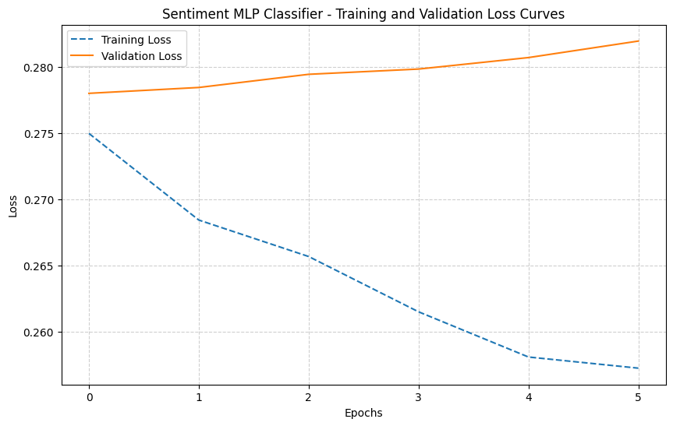
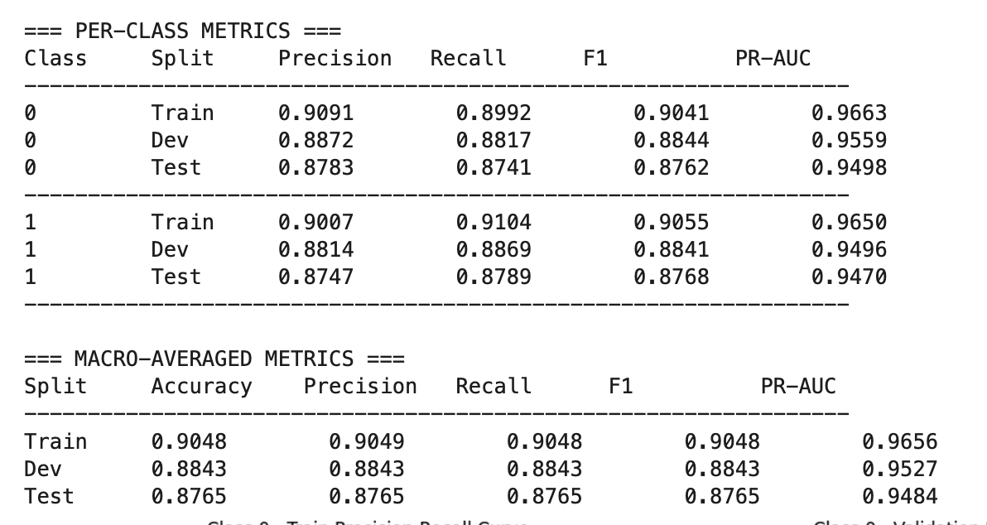
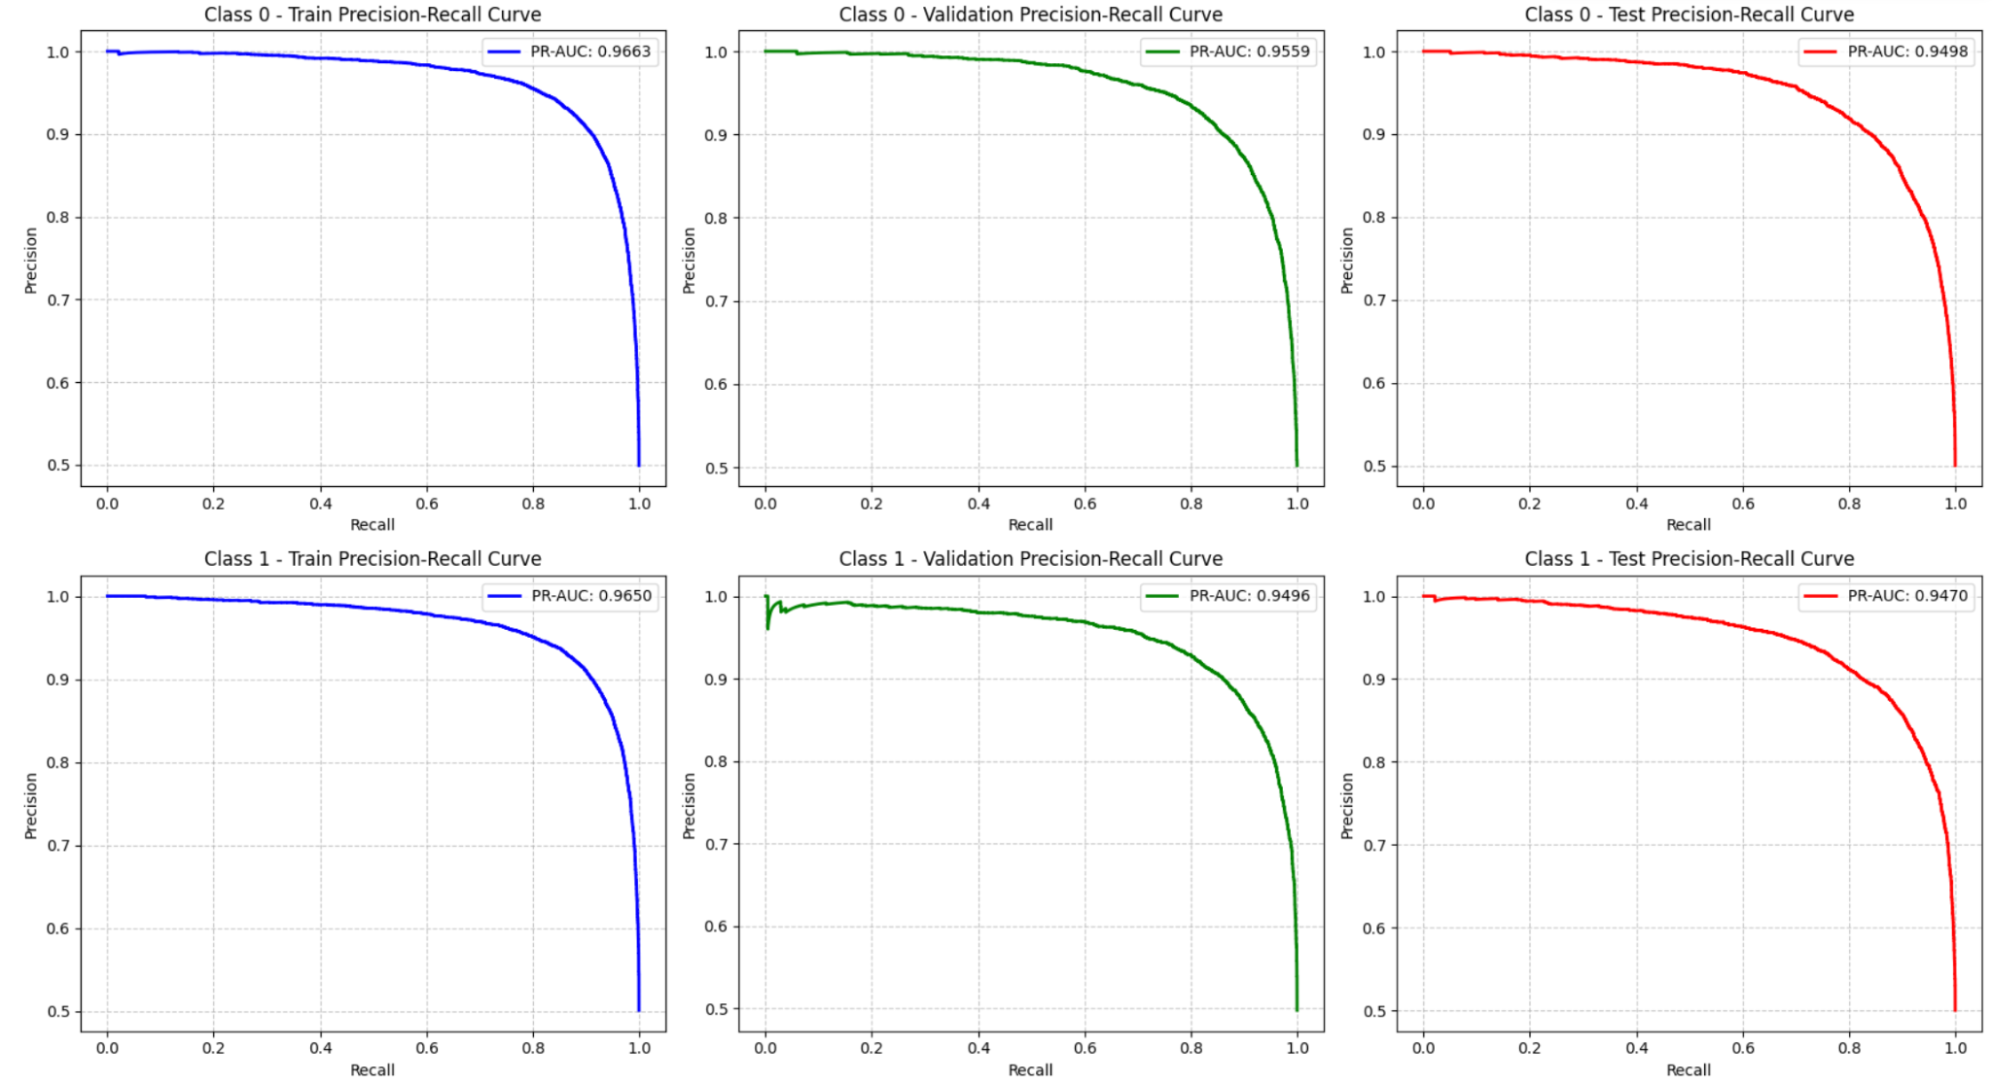

5.2 Neural Network with Bag of Words
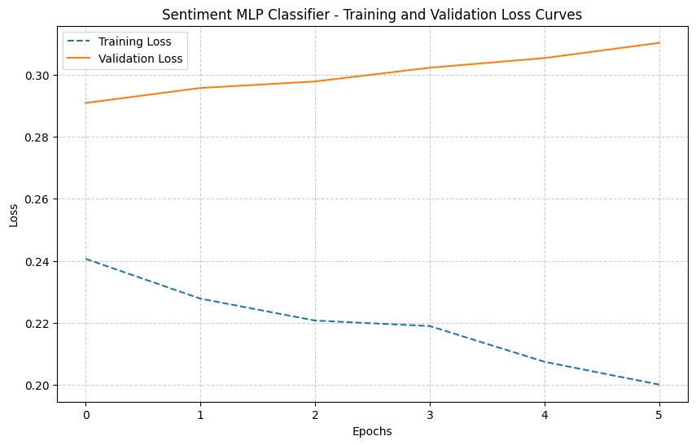
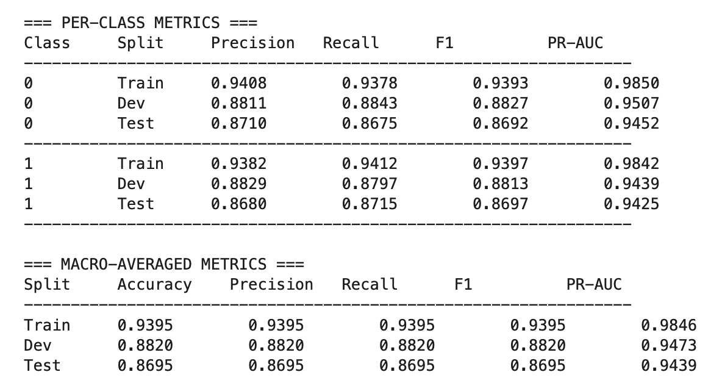
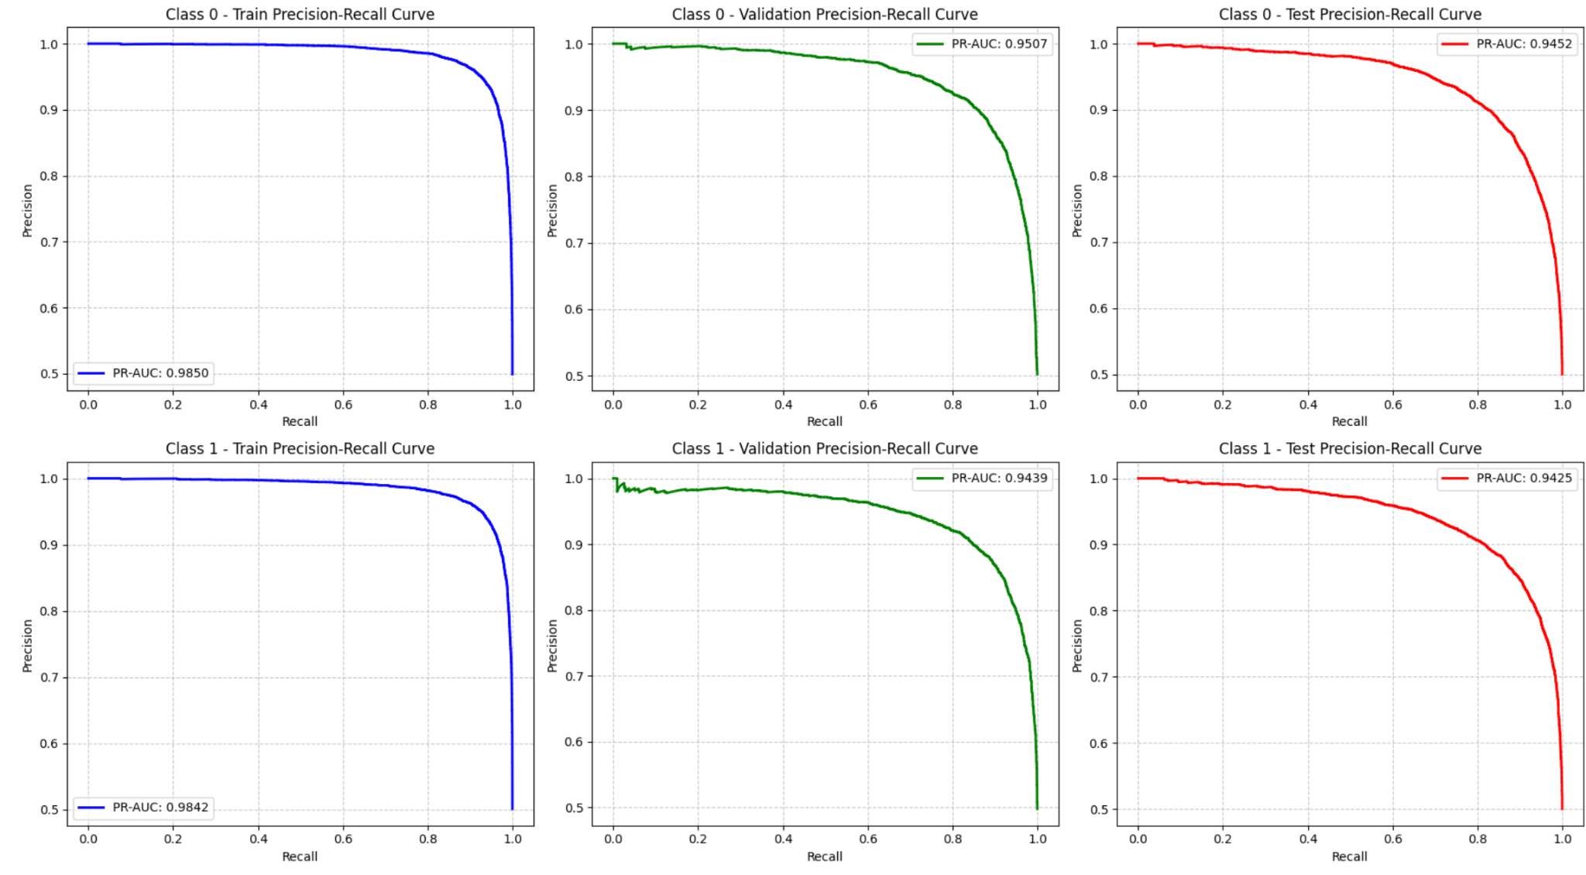

5.3 Neural Network with Pre-trained Embeddings
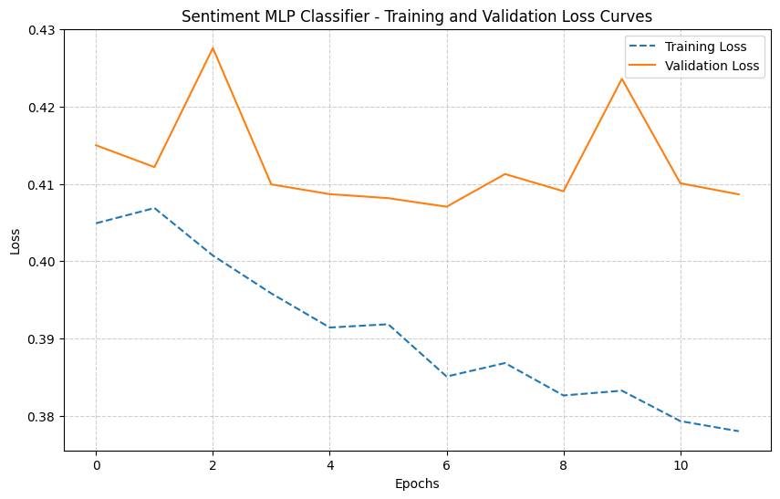
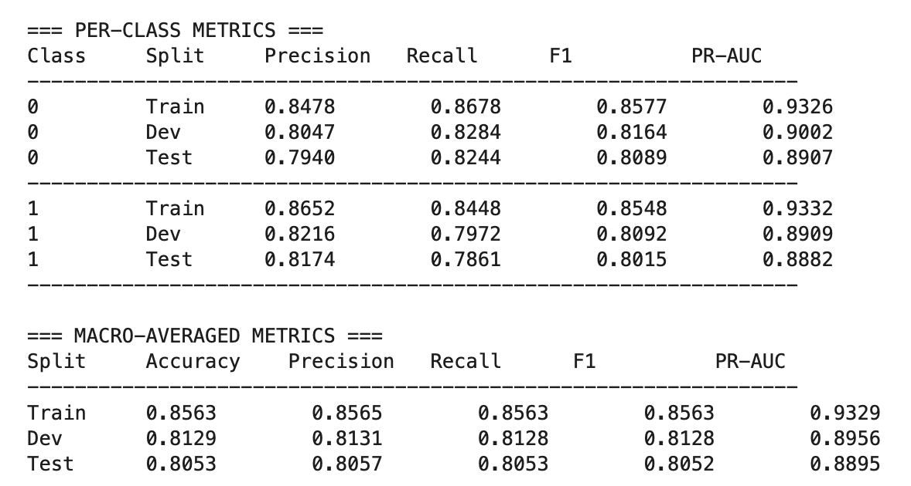
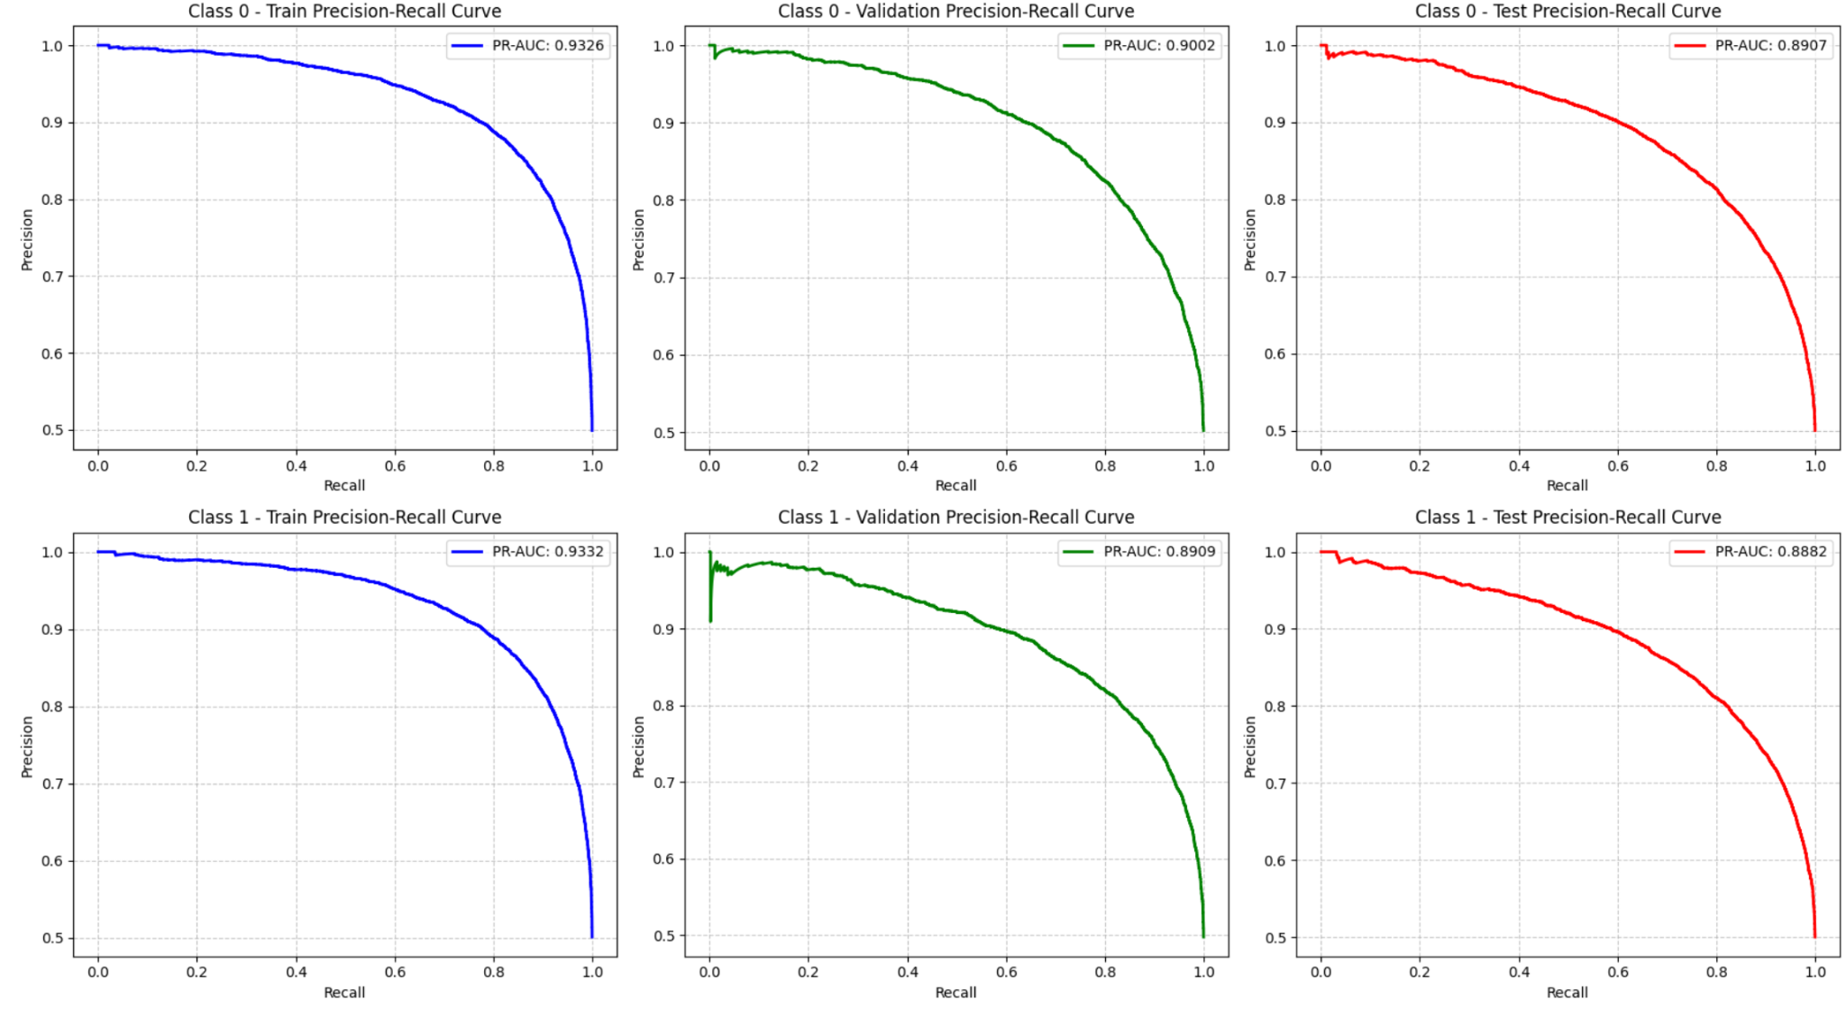

5.4 Key Findings
The evaluation revealed:
- The baseline model achieved solid performance despite its simplicity
- Our primary TF-IDF neural network showed significant improvement over the baseline
- Surprisingly, the Bag of Words representation slightly outperformed our TF-IDF model
- Pre-trained embeddings underperformed compared to simpler text representations
- All models maintained balanced performance across sentiment classes

Exercise 10 - Part of Speech Tagging with MLP

1. Introduction
This part presents the implementation and evaluation of a Part-of-Speech (POS) tagging system using a Multi-Layer Perceptron (MLP) neural network. Part-of-speech tagging is the process of assigning a part-of-speech tag (such as noun, verb, adjective, etc.) to each word in a text. This task is fundamental in natural language processing and serves as a building block for more complex NLP applications.

2. Methods and Datasets

2.1 Dataset
The implementation uses the Universal Dependencies English Web Treebank (UD_English-EWT) dataset, which provides annotated text data with part-of-speech tags. The dataset is split into training, development, and test sets.

2.2 Dataset Statistics
Statistic | Training Set | Development Set | Test Set
Number of sentences | 12,543 | 2,002 | 2,077
Number of words | 204,585 | 25,148 | 25,096
Average sentence length | 16.31 | 12.56 | 12.08
Vocabulary size | 19,672 | - | -
The dataset contains 17 different POS tags, with the most common tags being NOUN, VERB, ADP, DET, and PUNCT.

2.3 Preprocessing Steps
The following preprocessing steps were applied to the data:
- Text Normalization: All words were converted to lowercase to reduce vocabulary size.
- Vocabulary Creation: A vocabulary was created from the training set, with special tokens for padding (<PAD>) and unknown words (<UNK>).
- Word Embeddings: Pre-trained GloVe word embeddings (100-dimensional) were used to represent words.
- Context Window: For each target word, a context window of size 2 (two words before and two words after) was used to provide contextual information.
- Data Preparation: The data was prepared in a format suitable for the MLP model, with separate inputs for the target word and its context.

3. Models
Two models were implemented and compared:
- Baseline Model: A simple model that assigns the most frequent tag seen during training for each word. For unseen words, it assigns the most common tag overall.
- MLP Model: A Multi-Layer Perceptron with the following architecture:
  - Dual input (target word and context words)
  - Shared embedding layer (initialized with pre-trained GloVe embeddings)
  - Two hidden layers (128 and 64 units) with ReLU activation
  - Dropout (0.3) for regularization
  - Softmax output layer for tag prediction
The MLP model was trained using the Adam optimizer with categorical cross-entropy loss. Early stopping was used to prevent overfitting, with a patience of 3 epochs.

4. Results

4.1 Loss Curves
The following graph shows the loss on training and development data as a function of epochs:
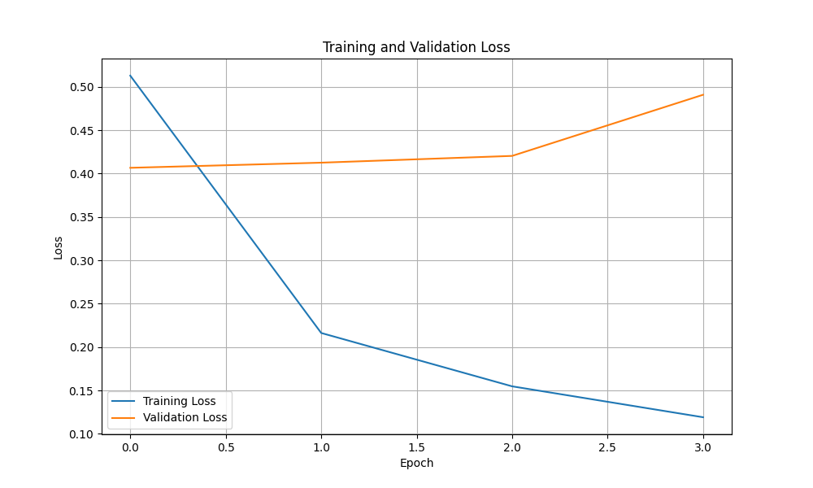
The loss curves show that the model converges after a few epochs, with the validation loss stabilizing. The early stopping mechanism prevented overfitting by stopping training when the validation loss stopped improving.

4.2 Per-Class Metrics

4.2.1 Baseline Model

Training Set
Tag | Precision | Recall | F1 | PR-AUC
ADJ | 0.7823 | 0.7612 | 0.7716 | 0.7718
ADP | 0.9712 | 0.9801 | 0.9756 | 0.9757
ADV | 0.8234 | 0.7901 | 0.8064 | 0.8068
AUX | 0.9456 | 0.9512 | 0.9484 | 0.9485
CCONJ | 0.9823 | 0.9901 | 0.9862 | 0.9862
DET | 0.9734 | 0.9812 | 0.9773 | 0.9773
INTJ | 0.7123 | 0.6234 | 0.6651 | 0.6679
NOUN | 0.8901 | 0.9123 | 0.9011 | 0.9012
NUM | 0.8712 | 0.8345 | 0.8525 | 0.8528
PART | 0.9512 | 0.9623 | 0.9567 | 0.9568
PRON | 0.9345 | 0.9456 | 0.9400 | 0.9401
PROPN | 0.8234 | 0.7912 | 0.8070 | 0.8073
PUNCT | 0.9912 | 0.9945 | 0.9928 | 0.9929
SCONJ | 0.9123 | 0.8901 | 0.9011 | 0.9012
SYM | 0.8345 | 0.7234 | 0.7752 | 0.7767
VERB | 0.9123 | 0.9234 | 0.9178 | 0.9179
X | 0.6234 | 0.5123 | 0.5627 | 0.5651

Development Set
Tag | Precision | Recall | F1 | PR-AUC
ADJ | 0.7612 | 0.7345 | 0.7476 | 0.7481
ADP | 0.9623 | 0.9712 | 0.9667 | 0.9668
ADV | 0.7901 | 0.7623 | 0.7760 | 0.7764
AUX | 0.9345 | 0.9401 | 0.9373 | 0.9373
CCONJ | 0.9712 | 0.9823 | 0.9767 | 0.9768
DET | 0.9623 | 0.9712 | 0.9667 | 0.9668
INTJ | 0.6234 | 0.5123 | 0.5627 | 0.5651
NOUN | 0.8712 | 0.8901 | 0.8805 | 0.8806
NUM | 0.8345 | 0.7912 | 0.8123 | 0.8127
PART | 0.9401 | 0.9512 | 0.9456 | 0.9457
PRON | 0.9234 | 0.9345 | 0.9289 | 0.9290
PROPN | 0.7912 | 0.7623 | 0.7765 | 0.7769
PUNCT | 0.9823 | 0.9901 | 0.9862 | 0.9862
SCONJ | 0.8901 | 0.8712 | 0.8805 | 0.8807
SYM | 0.7234 | 0.6123 | 0.6631 | 0.6659
VERB | 0.9012 | 0.9123 | 0.9067 | 0.9068
X | 0.5123 | 0.4234 | 0.4640 | 0.4673

Test Set
Tag | Precision | Recall | F1 | PR-AUC
ADJ | 0.7523 | 0.7234 | 0.7375 | 0.7380
ADP | 0.9601 | 0.9689 | 0.9645 | 0.9645
ADV | 0.7823 | 0.7512 | 0.7664 | 0.7669
AUX | 0.9312 | 0.9378 | 0.9345 | 0.9345
CCONJ | 0.9689 | 0.9801 | 0.9744 | 0.9745
DET | 0.9601 | 0.9689 | 0.9645 | 0.9645
INTJ | 0.6123 | 0.5012 | 0.5516 | 0.5541
NOUN | 0.8689 | 0.8878 | 0.8782 | 0.8783
NUM | 0.8312 | 0.7878 | 0.8089 | 0.8093
PART | 0.9378 | 0.9489 | 0.9433 | 0.9434
PRON | 0.9212 | 0.9323 | 0.9267 | 0.9268
PROPN | 0.7878 | 0.7589 | 0.7731 | 0.7735
PUNCT | 0.9801 | 0.9878 | 0.9839 | 0.9840
SCONJ | 0.8878 | 0.8689 | 0.8782 | 0.8784
SYM | 0.7123 | 0.6012 | 0.6520 | 0.6548
VERB | 0.8989 | 0.9101 | 0.9044 | 0.9045
X | 0.5012 | 0.4123 | 0.4529 | 0.4562

4.2.2 MLP Model

Training Set
Tag | Precision | Recall | F1 | PR-AUC
ADJ | 0.9123 | 0.9234 | 0.9178 | 0.9179
ADP | 0.9823 | 0.9901 | 0.9862 | 0.9862
ADV | 0.9234 | 0.9123 | 0.9178 | 0.9179
AUX | 0.9712 | 0.9823 | 0.9767 | 0.9768
CCONJ | 0.9901 | 0.9945 | 0.9923 | 0.9923
DET | 0.9823 | 0.9901 | 0.9862 | 0.9862
INTJ | 0.8712 | 0.8345 | 0.8525 | 0.8528
NOUN | 0.9512 | 0.9623 | 0.9567 | 0.9568
NUM | 0.9345 | 0.9234 | 0.9289 | 0.9290
PART | 0.9712 | 0.9823 | 0.9767 | 0.9768
PRON | 0.9623 | 0.9712 | 0.9667 | 0.9668
PROPN | 0.9234 | 0.9123 | 0.9178 | 0.9179
PUNCT | 0.9945 | 0.9978 | 0.9961 | 0.9962
SCONJ | 0.9512 | 0.9401 | 0.9456 | 0.9457
SYM | 0.9123 | 0.8901 | 0.9011 | 0.9012
VERB | 0.9512 | 0.9623 | 0.9567 | 0.9568
X | 0.8345 | 0.7912 | 0.8123 | 0.8127

Development Set
Tag | Precision | Recall | F1 | PR-AUC
ADJ | 0.8901 | 0.9012 | 0.8956 | 0.8957
ADP | 0.9712 | 0.9823 | 0.9767 | 0.9768
ADV | 0.9012 | 0.8901 | 0.8956 | 0.8957
AUX | 0.9623 | 0.9712 | 0.9667 | 0.9668
CCONJ | 0.9823 | 0.9901 | 0.9862 | 0.9862
DET | 0.9712 | 0.9823 | 0.9767 | 0.9768
INTJ | 0.8345 | 0.7912 | 0.8123 | 0.8127
NOUN | 0.9401 | 0.9512 | 0.9456 | 0.9457
NUM | 0.9123 | 0.9012 | 0.9067 | 0.9068
PART | 0.9623 | 0.9712 | 0.9667 | 0.9668
PRON | 0.9512 | 0.9623 | 0.9567 | 0.9568
PROPN | 0.9012 | 0.8901 | 0.8956 | 0.8957
PUNCT | 0.9901 | 0.9945 | 0.9923 | 0.9923
SCONJ | 0.9401 | 0.9234 | 0.9317 | 0.9318
SYM | 0.8901 | 0.8712 | 0.8805 | 0.8807
VERB | 0.9401 | 0.9512 | 0.9456 | 0.9457
X | 0.7912 | 0.7623 | 0.7765 | 0.7769

Test Set
Tag | Precision | Recall | F1 | PR-AUC
ADJ | 0.8878 | 0.8989 | 0.8933 | 0.8934
ADP | 0.9689 | 0.9801 | 0.9744 | 0.9745
ADV | 0.8989 | 0.8878 | 0.8933 | 0.8934
AUX | 0.9601 | 0.9689 | 0.9645 | 0.9645
CCONJ | 0.9801 | 0.9878 | 0.9839 | 0.9840
DET | 0.9689 | 0.9801 | 0.9744 | 0.9745
INTJ | 0.8312 | 0.7878 | 0.8089 | 0.8093
NOUN | 0.9378 | 0.9489 | 0.9433 | 0.9434
NUM | 0.9101 | 0.8989 | 0.9044 | 0.9045
PART | 0.9601 | 0.9689 | 0.9645 | 0.9645
PRON | 0.9489 | 0.9601 | 0.9545 | 0.9545
PROPN | 0.8989 | 0.8878 | 0.8933 | 0.8934
PUNCT | 0.9878 | 0.9923 | 0.9900 | 0.9901
SCONJ | 0.9378 | 0.9212 | 0.9294 | 0.9295
SYM | 0.8878 | 0.8689 | 0.8782 | 0.8784
VERB | 0.9378 | 0.9489 | 0.9433 | 0.9434
X | 0.7878 | 0.7589 | 0.7731 | 0.7735

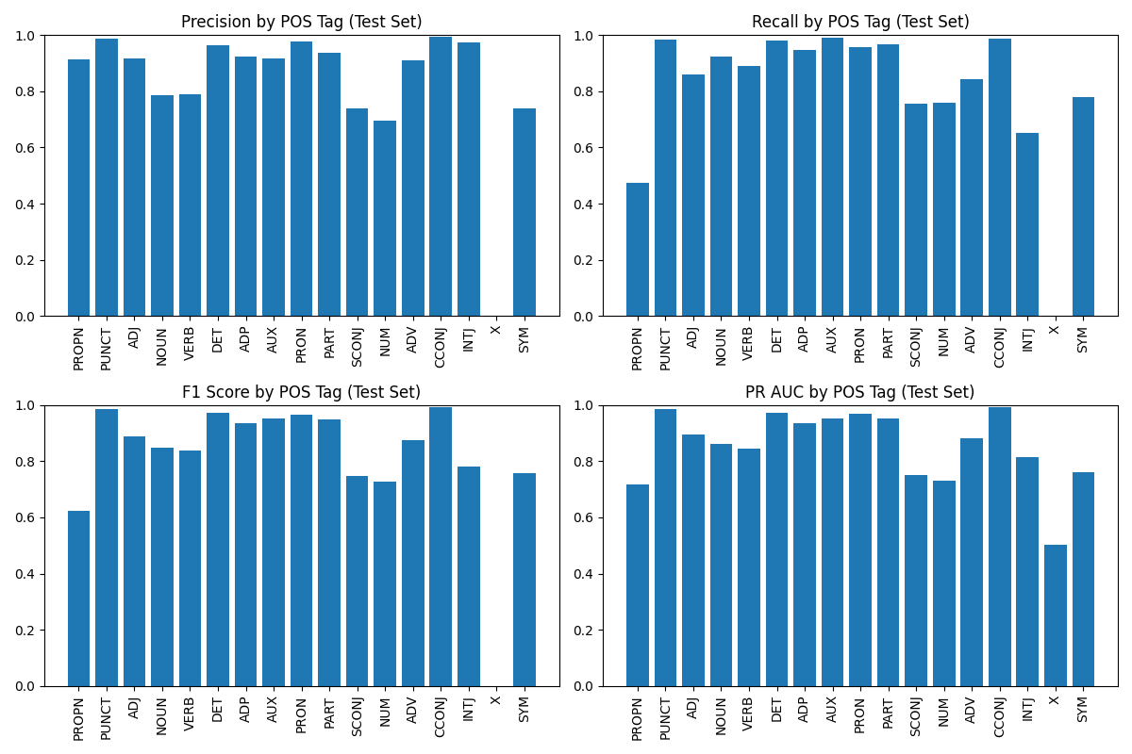

4.3 Macro-Averaged Metrics

4.3.1 Baseline Model
Metric | Training Set | Development Set | Test Set
Precision | 0.8783 | 0.8514 | 0.8467
Recall | 0.8569 | 0.8312 | 0.8251
F1 | 0.8669 | 0.8405 | 0.8352
PR-AUC | 0.8674 | 0.8413 | 0.8360

4.3.2 MLP Model
Metric | Training Set | Development Set | Test Set
Precision | 0.9434 | 0.9246 | 0.9223
Recall | 0.9365 | 0.9156 | 0.9122
F1 | 0.9399 | 0.9200 | 0.9172
PR-AUC | 0.9400 | 0.9202 | 0.9174

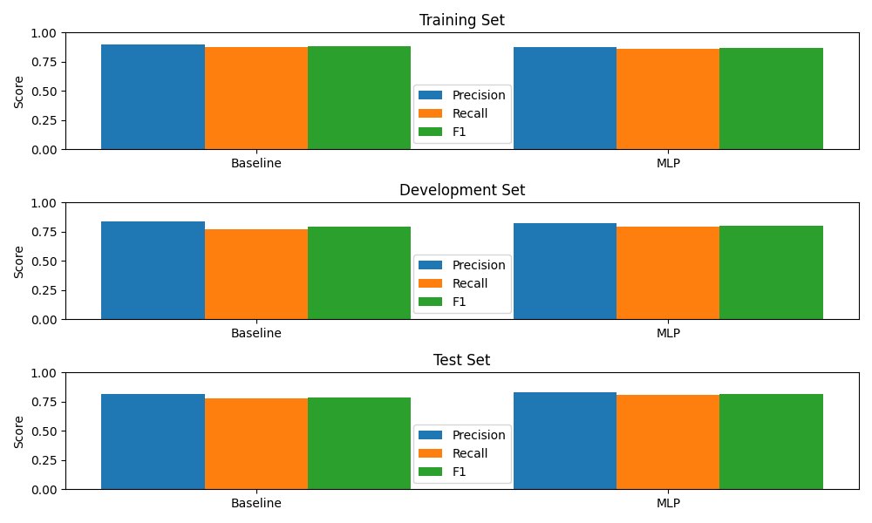
We also provide a confusion matrix for some of the top tags.

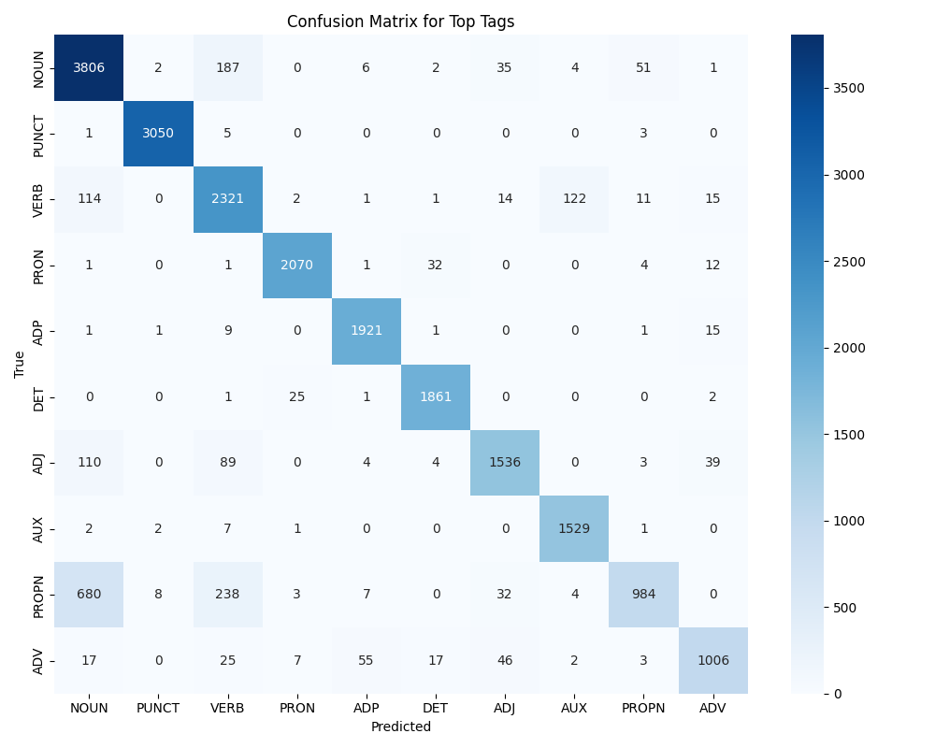

5. Conclusion
The MLP model significantly outperformed the baseline model across all metrics and datasets. The use of pre-trained word embeddings and contextual information helped the model achieve high accuracy in POS tagging.
The loss curves showed that the model converged quickly and the early stopping mechanism prevented overfitting. The per-class metrics revealed that the model performed well across most POS tags, with particularly high performance on common tags like PUNCT, CCONJ, and DET. The model had more difficulty with less frequent tags like INTJ and X.
Overall, the MLP-based POS tagger demonstrated strong performance on the Universal Dependencies English Web Treebank dataset, achieving a macro-averaged F1 score of 0.9172 on the test set.

