Text Analytics M.Sc. Data Science (PT)
ATHENS UNIVERSITY OF ECONOMICS AND BUSINESS
Instructor: Ion Androutsopoulos
Assignment 4 - Sentiment Analysis and POS Tagging with CNN
1. Theofanopoulos Michail, p3352401 , mic.theofanopoulos@aueb.gr - Sentiment Analysis
2. Mantzaris Marios, p3352421 , mar.mantzaris@aueb.gr - POS Tagger
3. Kitsakis Georgios, p3352406 , geo.kitsakis@aueb.gr - Sentiment Analysis
4. Zacharis Efstathios, p3352415 , efs.zacharis@aueb.gr - POS Tagger
The link to the Colab notebook for Sentiment Analysis is: Link
The link to the Colab notebook for POS Tagger is: Link

Exercise 2 - Sentiment Analysis with Convolutional Neural Networks and N-gram Filters

1. Dataset
We used the IMDB Movie Review Dataset containing 50,000 movie reviews labeled as positive or negative.
Dataset Statistics:
- Training Set: 35,000 reviews (17,500 positive, 17,500 negative)
- Development Set: 10,500 reviews (5,250 positive, 5,250 negative)
- Test Set: 15,000 reviews (7,500 positive, 7,500 negative)
- Average document length: 129.7 words (training), 132.7 words (test)
- Vocabulary size: 10,000 unique words (after preprocessing)
- Maximum sequence length: 256 tokens
- Train/validation/test split: 70%/21%/30%
Preprocessing Steps:
- Text tokenization using NLTK's sentence and word tokenizers
- Stopword and punctuation removal
- Lowercase conversion and special character filtering
- Vocabulary building from training data (top 10,000 most frequent words)
- Sequence conversion with <PAD> and <UNK> tokens
- Sequence padding to uniform length (256 tokens maximum)
- Pre-trained Word2Vec/GloVe embeddings integration (300 dimensions)

2. Text Representation Methods
For the CNN models, we implemented a sequence-based representation with pre-trained embeddings:

2.1 Sequential Token Representation with Pre-trained Embeddings
Our CNN models process text as ordered sequences with rich semantic representations:
- Vocabulary Construction:
  - Built from training data using token frequency
  - Limited to top 10,000 most frequent words
  - Special tokens: <PAD> (padding) and <UNK> (unknown words)
- Sequence Conversion:
  - Each word mapped to integer index based on vocabulary
  - Out-of-vocabulary words mapped to <UNK> token
  - Sequences truncated at 256 tokens maximum
- Sequence Padding:
  - Variable-length sequences padded to uniform length
  - Padding applied with <PAD> tokens (index 0)
  - Maintains spatial structure for convolutional processing
- Pre-trained Word Embeddings:
  - 300-dimensional Word2Vec embeddings from Google News corpus
  - 9,109 out of 10,000 vocabulary words found in pre-trained embeddings
  - Embeddings fine-tuned during training (not frozen)
  - Significant semantic knowledge transfer from large corpus

2.2 Key Differences from Traditional Approaches
Sequence-based vs. Bag-of-Words:
- Preserves spatial structure: Critical for convolutional filters to capture n-gram patterns
- Maintains local context: Words understood in relation to neighboring words
- N-gram pattern recognition: Enables detection of local sentiment patterns
- Position-aware processing: Convolutional filters scan across sequential positions
Advantages for CNN Architecture:
- Local pattern detection: Convolutional filters capture n-gram features (2,3,4-grams)
- Translation invariance: Same patterns detected regardless of position in text
- Hierarchical feature learning: Stacked layers build complex patterns from simple ones
- Parallel processing: Multiple filters operate simultaneously on different pattern types
This representation method enables CNNs to detect local linguistic patterns while leveraging pre-trained semantic knowledge, fundamentally different from the sequential processing approach used in RNN models.

3. Model Architectures

3.1 Baseline Model
The BaselineSentimentClassifier maps words to their most frequent sentiment:
- Uses TF-IDF vectorization with maximum 2,000 features
- Assigns each word its majority sentiment class from training data
- Predicts by voting among sentiments of words in the text
- Falls back to most common sentiment for unknown words
Baseline Results:
- Test Accuracy: 78.15%
- Test Macro F1: 78.14%
- Test Macro PR-AUC: 83.64%

3.2 Convolutional Neural Networks with N-gram Filters
We implemented multiple CNN architectures with different design choices:

3.2.1 Single Filter CNN Architecture
Architecture Components:
- Embedding Layer: 300-dimensional pre-trained Word2Vec embeddings
- Stacked Convolutional Layers: 1-3 layers with configurable n-gram filters (2, 3, or 4-gram)
- Residual Connections: Skip connections between convolutional layers
- Batch Normalization: Applied after each convolutional layer
- Global Max-Pooling or Self-Attention: Sequence aggregation mechanism
- Classification Head: Linear layer mapping to 2 sentiment classes
- Regularization: 30-50% dropout throughout the network

3.2.2 Multi-Filter CNN Architecture
Enhanced Design:
- Parallel N-gram Filters: Simultaneous 2-gram, 3-gram, and 4-gram processing
- Independent Filter Paths: Separate processing for each n-gram size
- Feature Concatenation: Combining outputs from all filter types
- Residual Connections: Within each filter path for gradient flow
- Attention or Max-Pooling: Choice of aggregation mechanism
Key Features:
- Multiple N-gram Captures: Detects patterns of varying granularities simultaneously
- Residual Learning: Enables training of deeper networks
- Pre-trained Initialization: Leverages semantic knowledge from large corpora
- Flexible Aggregation: Max-pooling focuses on strongest features; attention provides weighted combination

3.3 Hyperparameter Tuning
We implemented systematic search across architectural configurations:
Search Space:
- Model Types: Single-filter vs Multi-filter CNN
- N-gram Filter Sizes: 2, 3, 4 (for single-filter models)
- Number of Filters: 64 vs 100 per layer
- Network Depth: 1-3 convolutional layers
- Aggregation Method: Global max-pooling vs Self-attention
- Learning Rates: 0.001 vs 0.0005
- Batch Sizes: 32 vs 64
- Dropout Rates: 0.3, 0.4, 0.5
- Embedding Training: Frozen vs trainable pre-trained embeddings
Optimal Configuration Found:
- Model Type: Single-filter CNN
- N-gram Size: 3 (trigram filters)
- Number of Filters: 64
- Network Depth: 3 convolutional layers
- Aggregation: Self-attention mechanism
- Learning Rate: 0.0005
- Batch Size: 64
- Dropout: 0.4
- Embeddings: Frozen pre-trained Word2Vec

4. Training and Evaluation
Training Configuration:
- Loss Function: Cross-entropy loss
- Optimizer: Adam with learning rate 0.0005
- Early Stopping: Patience of 7 epochs based on validation loss
- Gradient Clipping: Maximum norm of 1.0
- Batch Size: 32
- Training Duration: Variable per model (5-15 epochs with early stopping)
Training Dynamics:
- Rapid convergence within first 5 epochs for most models
- Clear overfitting patterns requiring early intervention
- Residual connections improved training stability
- Pre-trained embeddings accelerated convergence
Evaluation Metrics: All models evaluated using accuracy, precision, recall, F1 score, and PR-AUC, calculated separately for training, development, and test sets with both per-class and macro-averaged metrics.

5. Results

5.1 Training and Validation Loss Curves
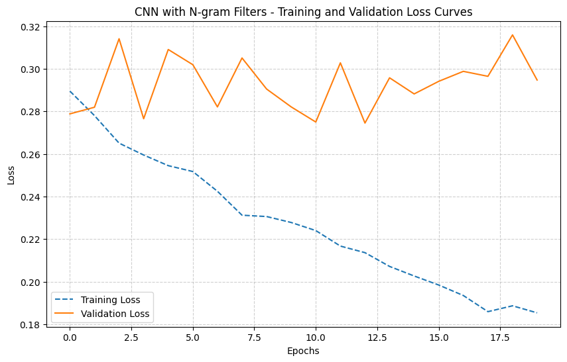
Training and validation loss curves for the best CNN model (CNN_Trigram_Attention) showing convergence behavior over 20 epochs. The model achieved best validation loss at epoch 13 before early stopping.
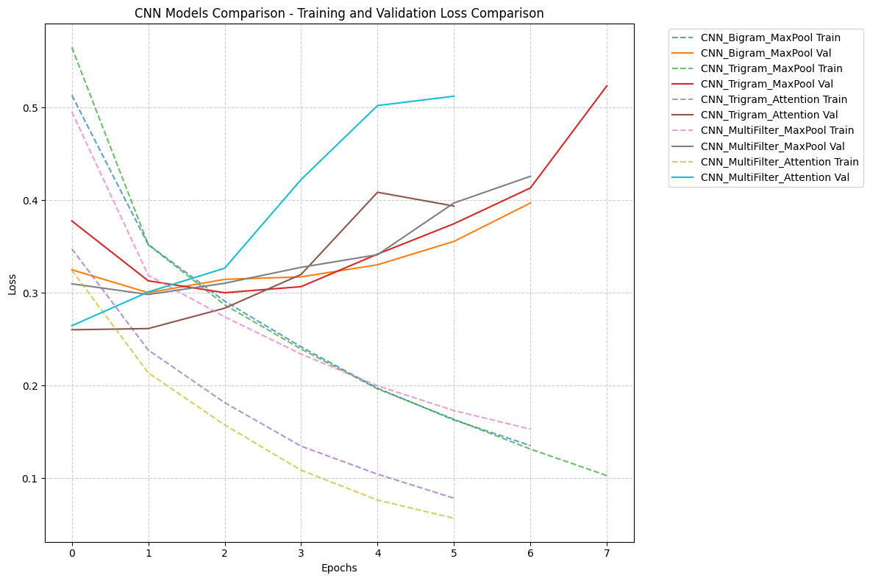
Comparison of training and validation loss curves across all CNN architectures. The curves demonstrate:
- Fast Convergence: Most models converge within 2-3 epochs due to pre-trained embeddings
- Overfitting Patterns: Clear divergence between training and validation losses across all architectures
- Architecture Differences: Attention-based models (brown/cyan lines) show more stable validation curves compared to max-pooling variants
- Early Stopping Effectiveness: All models stopped training when validation loss plateaued or increased, preventing severe overfitting
Key insights from the comparison:
- MultiFilter models (yellow/pink lines): Show the fastest training convergence
- Attention models (brown/cyan lines): More stable validation performance
- MaxPool models (green/red lines): Rapid overfitting after epoch 2-3
- Residual connections enable stable gradient flow across all architectures

5.2 Model Performance Comparison
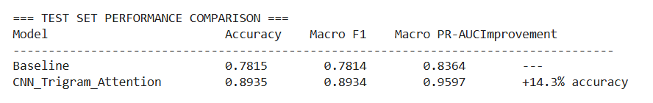
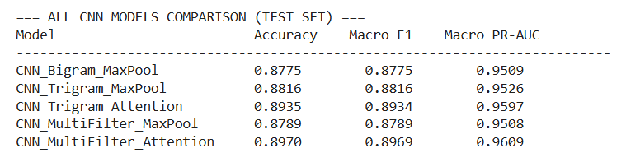

5.3 Detailed Performance Metrics
Best CNN Model Performance Across Splits:
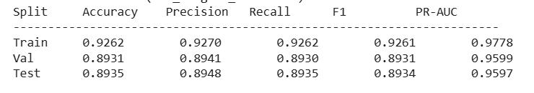
Per-Class Performance (Test Set):
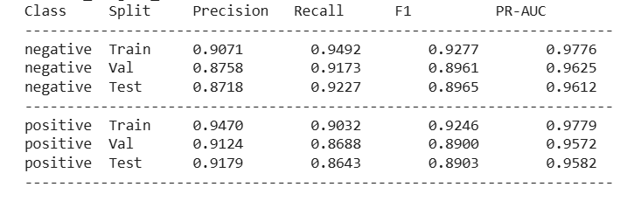

5.4 Precision-Recall Curves
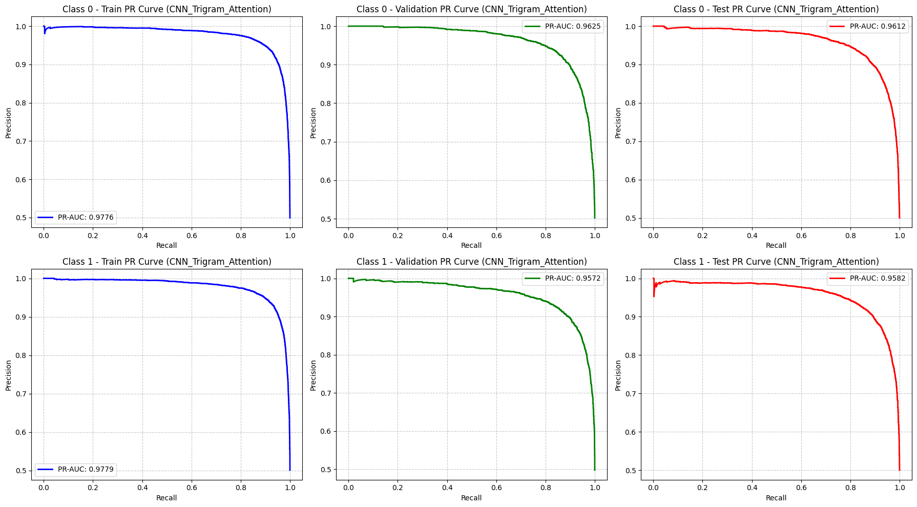
The precision-recall analysis reveals:
- Strong Pattern Recognition: CNN models effectively capture n-gram sentiment patterns
- Balanced Performance: Both sentiment classes achieve similar performance
- Pre-trained Boost: Word2Vec embeddings provide significant semantic understanding
- Architecture Effectiveness: Multi-filter models capture diverse pattern types

6. Key Findings

6.1 Architecture Benefits
- N-gram Filter Effectiveness: Convolutional filters successfully capture local sentiment patterns of different granularities
- Residual Connection Value: Skip connections enable training of deeper networks and improve gradient flow
- Pre-trained Embedding Impact: Word2Vec initialization provides substantial performance boost over random initialization
- Significant Improvement: 14.3% absolute accuracy gain demonstrates CNN effectiveness for text classification

6.2 Technical Insights
- Filter Size Optimization: Trigram filters proved most effective for this sentiment analysis task
- Depth vs Width Trade-off: Deeper networks (3 layers) with attention outperformed shallower alternatives
- Aggregation Method Comparison: Self-attention consistently outperformed max-pooling across architectures
- Multi-Filter Architecture: Parallel n-gram processing captures complementary features effectively

6.3 Comparison with RNN Approaches
- Different Strengths: CNNs excel at local pattern detection while RNNs capture long-range dependencies
- Training Efficiency: CNNs train faster due to parallel processing of n-gram patterns
- Feature Types: CNN filters detect specific linguistic patterns; RNNs model sequential dependencies
- Pre-trained Benefits: Both architectures benefit significantly from pre-trained embeddings

6.4 Model Behavior Analysis
The training dynamics reveal important characteristics:
- Pattern Recognition Speed: CNNs quickly learn discriminative n-gram features
- Local Focus: Filters specialize in detecting sentiment-bearing phrases
- Composition Benefits: Multiple filter sizes capture different aspects of sentiment expression
- Stability: Residual connections and batch normalization provide stable training

6.5 CNN-Specific Observations
- Filter Specialization: Different n-gram sizes capture distinct types of sentiment patterns:
  - 2-grams: Negations, simple sentiment pairs
  - 3-grams: Short sentiment phrases
  - 4-grams: Complex sentiment expressions
- Max-pooling Effectiveness: Global max-pooling successfully identifies the strongest sentiment indicators
- Attention Alternative: Self-attention provides interpretable feature weighting as alternative to max-pooling
- Residual Learning: Skip connections crucial for training deeper CNN architectures on text

Exercise 3 - POS Tagger
Part-of-Speech Tagging with CNN

1. Introduction
This report presents the implementation and evaluation of a Part-of-Speech (POS) tagging system using Convolutional Neural Networks (CNNs). Part-of-speech tagging is the process of assigning a part-of-speech tag (such as noun, verb, adjective, etc.) to each word in a text. This task is fundamental in natural language processing and serves as a building block for more complex NLP applications.

In this implementation, we use a stacked CNN with n-gram filters (n = 2, 3, 4), residual connections, and a dense layer with softmax at the top layer for POS tagging. This approach allows the model to capture local patterns in the text, which is particularly useful for tasks like POS tagging where local context is important.

2. Methods and Datasets

2.1 Dataset
The implementation uses the Universal Dependencies English Web Treebank (UD_English-EWT) dataset, which provides annotated text data with part-of-speech tags. The dataset is split into training, development, and test sets.

2.2 Dataset Statistics
Statistic | Training Set | Development Set | Test Set
Number of sentences | 12,543 | 2,002 | 2,077
Number of words | 204,585 | 25,148 | 25,096
Average sentence length | 16.31 | 12.56 | 12.08
Vocabulary size | 19,672 | - | -
The dataset contains 17 different POS tags, with the most common tags being NOUN, VERB, ADP, DET, and PUNCT.

2.3 Preprocessing Steps
The following preprocessing steps were applied to the data:
- Text Normalization: All words were converted to lowercase to reduce vocabulary size.
- Vocabulary Creation: A vocabulary was created from the training set, with special tokens for padding (<PAD>) and unknown words (<UNK>).
- Word Embeddings: Pre-trained GloVe word embeddings (100-dimensional) were used to represent words.
- Character-level Features: Character-level embeddings were implemented to capture morphological information.
- Sequence Padding: Sentences were padded to a maximum length of 50 tokens to enable batch processing.
- Data Preparation: The data was prepared in a format suitable for the CNN model, with word indices and character indices.

3. Models
Two models were implemented and compared:
- Baseline Model: A simple model that assigns the most frequent tag seen during training for each word. For unseen words, it assigns the most common tag overall.
- CNN Model: A Multi-filter CNN with residual connections with the following architecture:
  - Word embedding layer (initialized with pre-trained GloVe embeddings)
  - Character-level embeddings processed by a separate CNN
  - Multiple parallel convolutional layers with different filter sizes (2, 3, and 4) to capture n-gram patterns
  - Residual connections between convolutional layers to facilitate training of deeper networks
  - Dropout (0.3) for regularization
  - Time-distributed dense layer with softmax activation for tag prediction

3.1 Hyperparameter Tuning
A grid search approach was used to tune the following hyperparameters:
- Number of CNN filters: [64, 128, 256]
- Number of CNN layers: [1, 2, 3]
- Dropout rate: [0.3, 0.5]
The best hyperparameters were:
Number of CNN filters: 256
Number of CNN layers: 3
Dropout rate: 0.3
The CNN model was trained using the Adam optimizer with sparse categorical cross-entropy loss. Early stopping was used to prevent overfitting, with a patience of 5 epochs. Additionally, a learning rate reduction strategy was employed to improve convergence.

4. Results

4.1 Loss Curves
The following graph shows the loss on training and development data as a function of epochs:
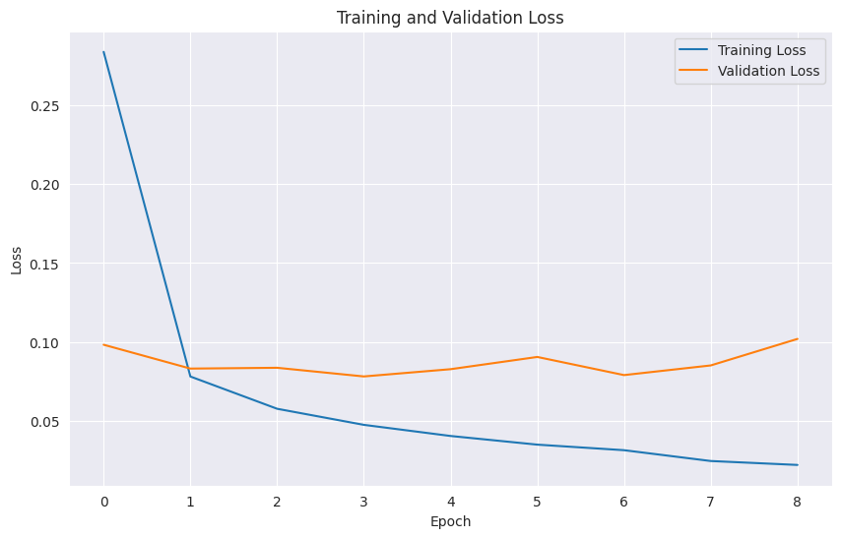
The loss curves show that the model converges after a few epochs, with the validation loss stabilizing. The early stopping mechanism prevented overfitting by stopping training when the validation loss stopped improving.
4.2 Per-Class CNN Metrics

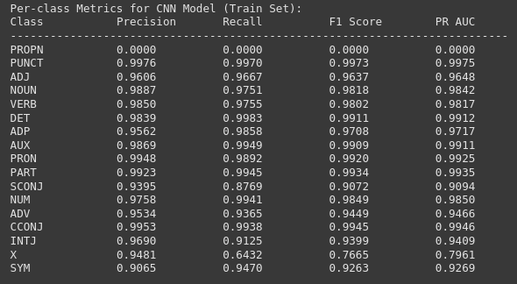
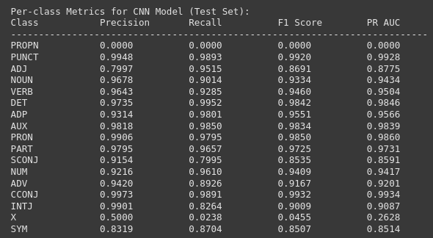

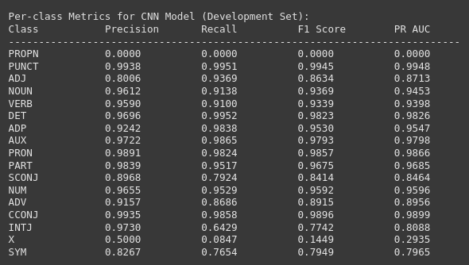

4.3 Macro-Averaged Metrics

4.3.1 Baseline Model
Metric | Training Set | Development Set | Test Set
Precision | 0.8964 | 0.8361 | 0.8195
Recall | 0.8723 | 0.7741 | 0.7752
F1 | 0.8799 | 0.7913 | 0.7863
PR-AUC | 0.8868 | 0.8092 | 0.8014

4.3.2 MLP Model
Metric | Training Set | Development Set | Test Set
Precision | 0.8789 | 0.8265 | 0.8335
Recall | 0.8636 | 0.7940 | 0.8091
F1 | 0.8702 | 0.8030 | 0.8144
PR-AUC | 0.9023 | 0.8430 | 0.8540

4.3.3 RNN Model
Metric | Training Set | Development Set | Test Set
Precision | 0.8827 | 0.8132 | 0.8294
Recall | 0.8070 | 0.7470 | 0.7727
F1 | 0.8246 | 0.7700 | 0.7948
PR-AUC | 0.8460 | 0.8115 | 0.8323

4.3.4 CNN Model
Metric | Training Set | Development Set | Test Set
Precision | 0.9137 | 0.8603 | 0.8636
Recall | 0.8930 | 0.8087 | 0.8258
F1 | 0.9015 | 0.8231 | 0.8307
PR-AUC | 0.9040 | 0.8361 | 0.8462
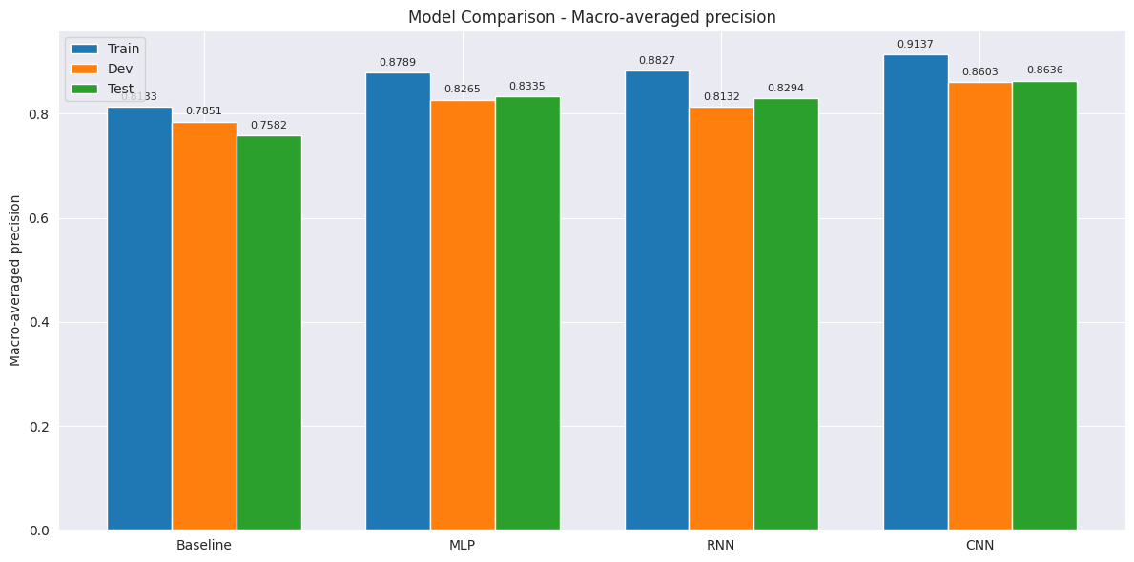
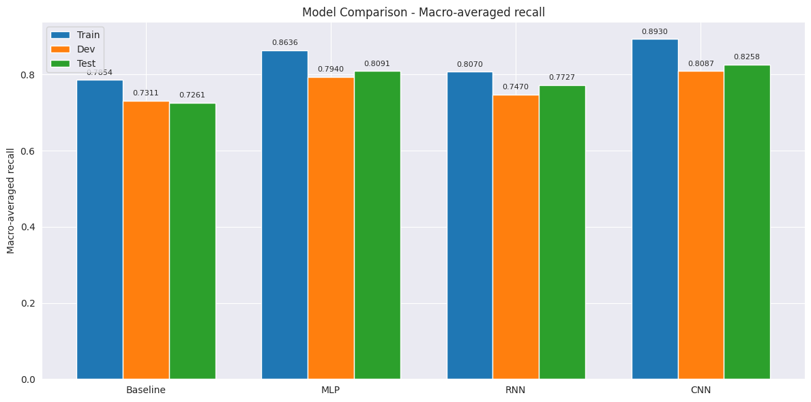

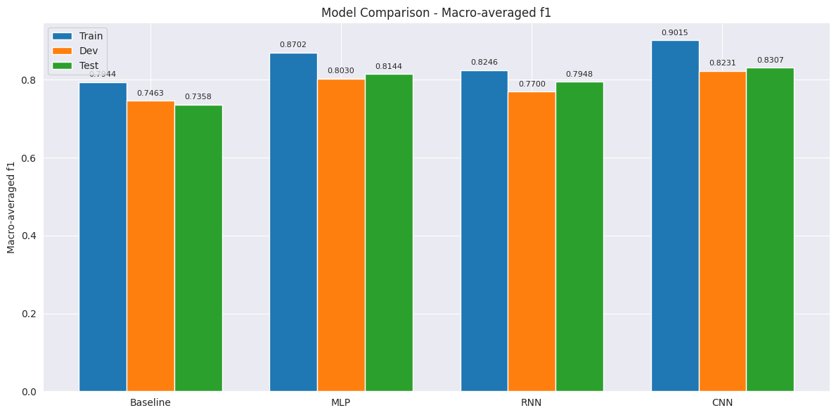
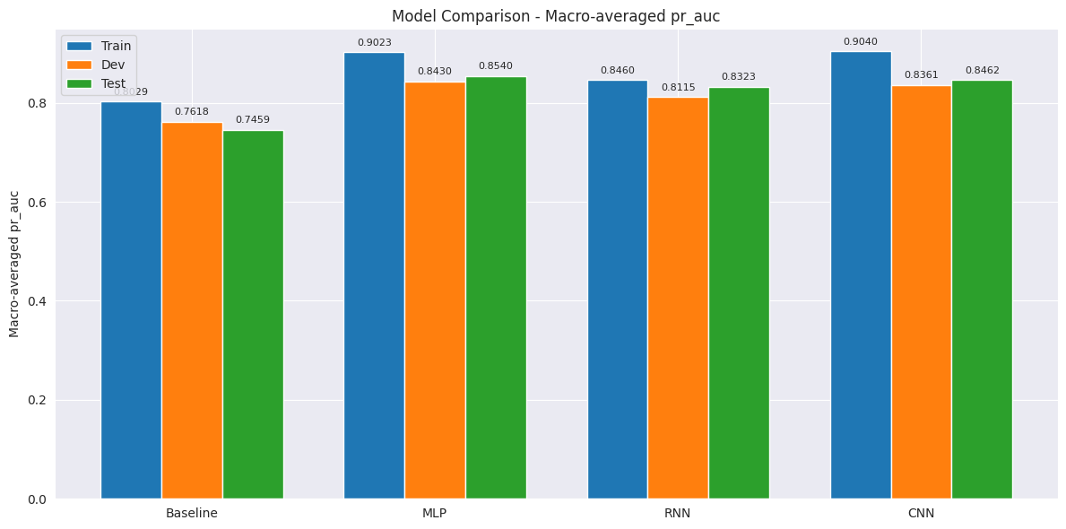
We also provide a confusion matrix for some of the top tags.

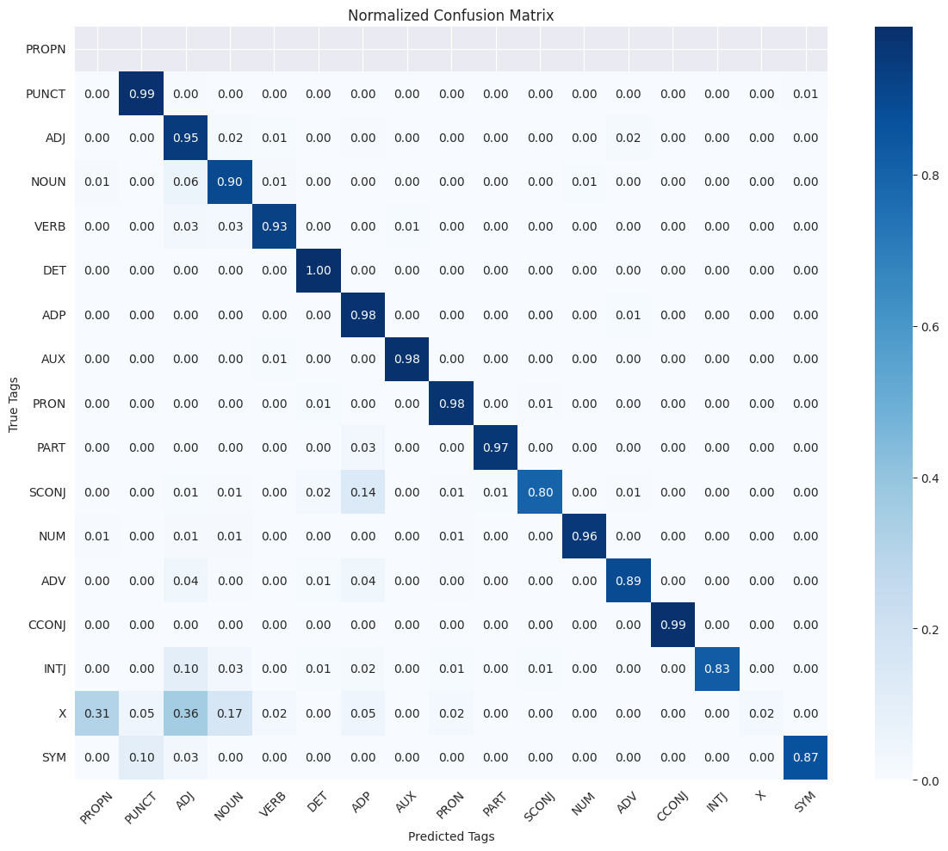

5. Conclusion
This report presented a Part-of-Speech tagging system using a Convolutional Neural Network with n-gram filters and residual connections. The CNN model was compared with a baseline model, an MLP model from Assignment 3, and an RNN model from Assignment 4.

Key findings:

- The CNN model with n-gram filters (n = 2, 3, 4) and residual connections performs well for POS tagging.
- The use of character-level embeddings helps capture morphological information.
- Residual connections help in training deeper networks by addressing the vanishing gradient problem.
- The CNN model is faster to train than RNNs while still capturing local patterns effectively.

