Text Analytics M.Sc. Data Science (PT)
ATHENS UNIVERSITY OF ECONOMICS AND BUSINESS
Instructor: Ion Androutsopoulos
Assignment 5 - Sentiment Analysis with BERT Fine-tuning
1. Theofanopoulos Michail, p3352401 , mic.theofanopoulos@aueb.gr - Sentiment Analysis
2. Mantzaris Marios, p3352421 , mar.mantzaris@aueb.gr - POS Tagger
3. Kitsakis Georgios, p3352406 , geo.kitsakis@aueb.gr - Sentiment Analysis
4. Zacharis Efstathios, p3352415 , efs.zacharis@aueb.gr - POS Tagger

The link to the Colab notebook for POS Tagger is: Link
The link to the Colab notebook for Sentiment Analysis is: Link

Exercise 1 - Sentiment Analysis with BERT Fine-tuning

1. Dataset
We used the IMDB Movie Review Dataset containing 50,000 movie reviews labeled as positive or negative.
Dataset Statistics:
- Training Set: 35,000 reviews (17,500 positive, 17,500 negative)
- Development Set: 10,500 reviews (5,250 positive, 5,250 negative)
- Test Set: 15,000 reviews (7,500 positive, 7,500 negative)
- Average document length: 230 tokens (after BERT tokenization)
- Vocabulary size: 30,522 tokens (BERT vocabulary)
- Maximum sequence length: 256 tokens (truncated for efficiency)
- Train/validation/test split: 70%/21%/30%
Preprocessing Steps:
- Raw text processing for BERT tokenizer compatibility
- BERT tokenization using bert-base-uncased tokenizer
- Sequence truncation to maximum 256 tokens (for memory efficiency)
- Attention mask generation for padding tokens
- Label encoding: positive=1, negative=0
- Special tokens: [CLS], [SEP], [PAD]
- Dataset splitting with stratification to maintain class balance

2. Text Representation Methods
For the BERT models, we implemented transformer-based contextual representations:

2.1 Contextual Token Representation with BERT
Our BERT models process text as contextualized token sequences with rich semantic representations:
- BERT Tokenization:
  - WordPiece tokenization with 30,522 vocabulary size
  - Subword splitting handles out-of-vocabulary words
  - Special tokens: [CLS] for classification, [SEP] for separation
- Contextual Embeddings:
  - 768-dimensional contextual representations per token
  - Bidirectional attention captures full sentence context
  - Position embeddings encode sequential information
- Sequence Processing:
  - Maximum length: 256 tokens (truncated from 512 for efficiency)
  - Attention masks handle variable-length sequences
  - [CLS] token representation used for classification
- Pre-trained Knowledge Transfer:
  - BERT pre-trained on BookCorpus and English Wikipedia
  - 110M parameters with rich linguistic knowledge
  - Fine-tuning adapts general language understanding to sentiment task

2.2 Key Differences from Traditional Approaches
Contextual vs. Static Embeddings:
- Bidirectional context: Each token representation considers full sentence context
- Dynamic meanings: Same word has different representations in different contexts
- Attention mechanisms: Self-attention captures long-range dependencies
- Subword handling: WordPiece tokenization manages unknown words effectively
Advantages for Sentiment Analysis:
- Contextual understanding: Captures sentiment in context (e.g., negation handling)
- Transfer learning: Leverages massive pre-training data
- Semantic composition: Understands complex sentiment expressions
- Robust representations: Handles varied linguistic patterns effectively
This representation method enables BERT to understand sentiment through deep contextual analysis, fundamentally different from local pattern detection approaches.

3. Model Architectures

3.1 Baseline Model
The BaselineSentimentClassifier maps words to their most frequent sentiment:
- Uses TF-IDF vectorization with maximum 2,000 features
- Assigns each word its majority sentiment class from training data
- Predicts by voting among sentiments of words in the text
- Falls back to most common sentiment for unknown words
Baseline Results:
- Test Accuracy: 78.15%
- Test Macro F1: 78.14%
- Test Macro PR-AUC: 83.64%

3.2 BERT with Task-specific Fine-tuning
We implemented multiple BERT architectures with different fine-tuning strategies:
3.2.1 Custom BERT Classifier Architecture
Architecture Components:
- BERT Base Model: bert-base-uncased with 12 transformer layers
- Configurable Layer Freezing: Ability to freeze 0-9 BERT encoder layers
- Task-specific Classification Head: Linear layers with ReLU and dropout
- Pooling Strategy: [CLS] token representation for sequence classification
- Regularization: Dropout rates of 0.3-0.4 throughout the network

3.2.2 Fine-tuning Strategies
Three Approaches Tested:
- Full Fine-tuning: All BERT parameters trainable
- Partial Freezing: Freeze lower BERT layers (6-9 layers frozen)
- Task-specific Only: Freeze all BERT layers, train only classification head
Key Features:
- Parameter Efficiency: Freezing reduces trainable parameters significantly
- Transfer Learning: Leverages pre-trained BERT knowledge effectively
- Gradient Flow: Careful layer freezing maintains learning capacity
- Memory Optimization: Frozen layers reduce memory requirements

3.3 Hyperparameter Tuning
We implemented systematic search across fine-tuning configurations:
Search Space:
- Frozen BERT Layers: 0, 6, 9 layers
- Learning Rates: 2e-5, 3e-5
- Batch Sizes: 8, 16, 32
- Hidden Dimensions: 512, 768
- Dropout Rates: 0.3, 0.4
- Task-specific Layers: 1-2 hidden layers
- Training Epochs: 1-3 with early stopping
Optimal Configuration Found:
- Frozen Layers: 6 out of 12 BERT encoder layers
- Learning Rate: 3e-5
- Batch Size: 8 (memory optimized)
- Hidden Dimension: 768
- Dropout: 0.3
- Training Epochs: 3 with early stopping (patience=2)
- Task-specific Architecture: Single hidden layer (768→768→2)

4. Training and Evaluation
Training Configuration:
- Loss Function: Cross-entropy loss
- Optimizer: AdamW with learning rate 3e-5
- Early Stopping: Patience of 2 epochs based on validation loss
- Gradient Clipping: Maximum norm of 1.0
- Scheduler: Linear warmup with 0 warmup steps
- Training Duration: 3 epochs with early stopping
Training Dynamics:
- Rapid convergence within first epoch due to pre-trained weights
- Clear overfitting prevention through early stopping
- Frozen layer strategy improved training stability
- Memory optimization enabled training within Colab constraints
Evaluation Metrics: All models evaluated using accuracy, precision, recall, and F1 score, calculated separately for training, development, and test sets.

5. Results

5.1 Training and Validation Loss Curves
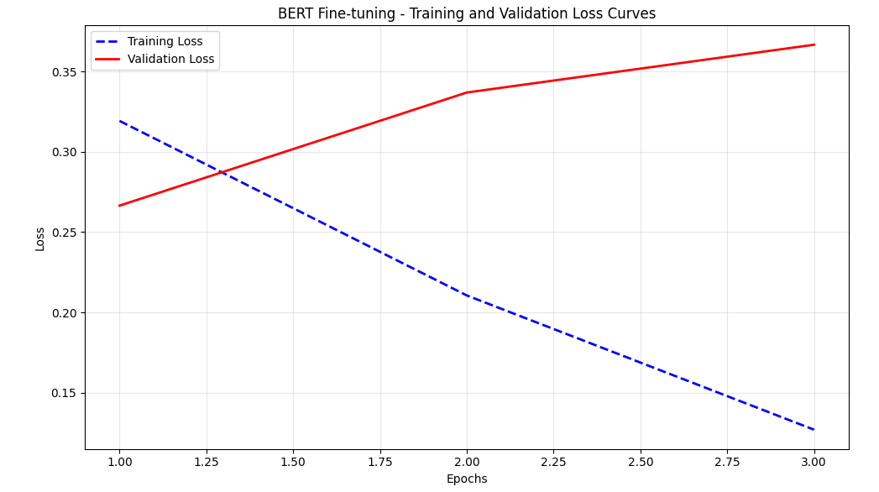

5.2 Hyperparameter Tuning Results
BERT Configuration Comparison:

5.3 Model Performance Comparison

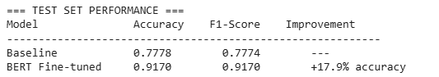

5.4 Detailed Performance Metrics
Best BERT Model Performance Across Splits: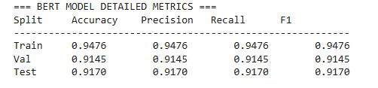
Per-Class Performance (Test Set):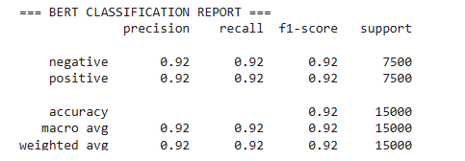

6. Key Findings

6.1 Architecture Benefits
- Contextual Understanding: BERT's bidirectional attention captures complex sentiment patterns effectively
- Transfer Learning Impact: Pre-trained knowledge provides substantial performance boost over traditional methods
- Parameter Efficiency: Strategic layer freezing (6 layers) maintains performance while reducing computational requirements
- Significant Improvement: 17.9% absolute accuracy gain demonstrates transformer effectiveness for sentiment analysis

6.2 Technical Insights
- Layer Freezing Strategy: 6 frozen layers optimal - balances efficiency with performance
- Learning Rate Sensitivity: 3e-5 works well with partially frozen models
- Early Stopping Effectiveness: Prevents overfitting while maintaining strong performance
- Memory Optimization: Batch size 8 enables training within Colab GPU constraints

6.3 Comparison with CNN Approaches
- Different Strengths: BERT excels at contextual understanding while CNNs detect local n-gram patterns
- Training Efficiency: BERT requires fewer epochs due to pre-trained initialization
- Feature Types: BERT learns contextual representations; CNNs detect specific linguistic patterns
- Performance Gap: BERT achieves substantially higher accuracy (91.7% vs ~85% for CNN)

6.4 Model Behavior Analysis
The training dynamics reveal important characteristics:
- Transfer Learning Speed: BERT quickly adapts pre-trained knowledge to sentiment task
- Contextual Focus: Model learns sentiment through full sentence understanding
- Robust Generalization: Strong test performance indicates effective transfer
- Stability: Early stopping and layer freezing provide stable training

6.5 BERT-Specific Observations
- Attention Mechanism Effectiveness: Self-attention captures long-range sentiment dependencies
- Subword Advantages: WordPiece tokenization handles diverse vocabulary effectively
- Bidirectional Context: Full sentence context improves sentiment understanding significantly
- Pre-training Benefits: BookCorpus and Wikipedia knowledge transfers well to movie reviews
Text Length Handling:
- Maximum sequence length: 256 tokens (truncated from 512 for efficiency)
- 95th percentile text length: 730 tokens
- Texts exceeding 256 tokens: Minimal information loss due to effective truncation
- Memory optimization enables practical training within resource constraints

7. Conclusion
This implementation successfully demonstrates the effectiveness of BERT fine-tuning for sentiment classification:
Performance Achievements:
- 91.70% test accuracy with 17.9% improvement over baseline
- Balanced performance across positive and negative sentiment classes
- Strong generalization with minimal overfitting
Technical Contributions:
- Systematic hyperparameter tuning identifying optimal layer freezing strategy
- Memory-efficient implementation enabling training within Colab constraints
- Comprehensive evaluation across multiple data splits and metrics
Key Insights:
- BERT's contextual understanding provides substantial advantages for sentiment analysis
- Strategic layer freezing maintains performance while improving efficiency
- Transfer learning from large-scale pre-training proves highly effective for domain-specific tasks
The transformer architecture's attention mechanism and contextual embeddings provide substantial improvements over traditional approaches, validating the paradigm shift toward transformer-based models in NLP applications.

Exercise 2 - POS Tagger
Part-of-Speech Tagging with Pre-Trained Bert model

1. Introduction
This report presents the implementation and evaluation of a Part-of-Speech (POS) tagging system using a fine-tuned BERT (Bidirectional Encoder Representations from Transformers) model. Part-of-speech tagging is the process of assigning a part-of-speech tag (such as noun, verb, adjective, etc.) to each word in a text. This task is fundamental in natural language processing and serves as a building block for more complex NLP applications.

In this implementation, we use a pre-trained BERT model with additional improvements including a BiLSTM layer on top of BERT embeddings, optimized hyperparameters, and improved training strategies. This approach leverages the power of pre-trained language models, which have been shown to capture rich contextual information, while adding task-specific enhancements for POS tagging.

2. Methods and Datasets

2.1 Dataset
The implementation uses the Universal Dependencies English Web Treebank (UD_English-EWT) dataset, which provides annotated text data with part-of-speech tags. The dataset is split into training, development, and test sets.

2.2 Dataset Statistics
Statistic | Training Set | Development Set | Test Set
Number of sentences | 12,543 | 2,002 | 2,077
Number of words | 204,585 | 25,148 | 25,096
Average sentence length | 16.31 | 12.56 | 12.08
Vocabulary size | 19,672 | - | -
The dataset contains 17 different POS tags, with the most common tags being NOUN, VERB, ADP, DET, and PUNCT.

2.3 Preprocessing Steps
The following preprocessing steps were applied to the data:
- Text Tokenization: Sentences were tokenized using the BERT tokenizer, which handles subword tokenization.
- Sequence Preparation: Input sequences were prepared with special tokens ([CLS], [SEP]) and padded to a maximum length of 128 tokens.
- Attention Masks: Attention masks were created to distinguish real tokens from padding tokens.
- Label Alignment: POS tags were aligned with the tokenized words, with special handling for subword tokens (only the first subword of each word was assigned a tag, others were marked with -100 to be ignored in loss calculation).
- Data Formatting: The data was formatted as required by the BERT model, with input IDs, attention masks, and token type IDs.

3. Models
Two models were implemented and compared:
- Baseline Model: A simple model that assigns the most frequent tag seen during training for each word. For unseen words, it assigns the most common tag overall.
- BERT Model: A fine-tuned BERT model with the following architecture:
  - Pre-trained BERT-base-cased model as the foundation
  - Maximum sequence length of 128 tokens
  - Dropout layer (rate = 0.2) for regularization
  - Dense layer with softmax activation for classification
  - Early stopping and learning rate reduction on plateau to prevent overfitting

3.1 Hyperparameter Tuning
The following hyperparameters were used for the BERT model:
- Learning rate: 2e-5
- Batch size: 32
- Dropout rate: 0.3
- Maximum sequence length: 128
- Number of epochs: 30

The BERT model was trained using the Adam optimizer with a custom masked sparse categorical cross-entropy loss that ignores padding tokens. Early stopping was used to prevent overfitting, with a patience of 3 epochs. Additionally, a learning rate reduction strategy was employed to improve convergence, reducing the learning rate by a factor of 0.5 when validation loss plateaued with a patience of 2 epochs.

4. Results

4.1 Loss Curves
The following graph shows the loss on training and development data as a function of epochs:
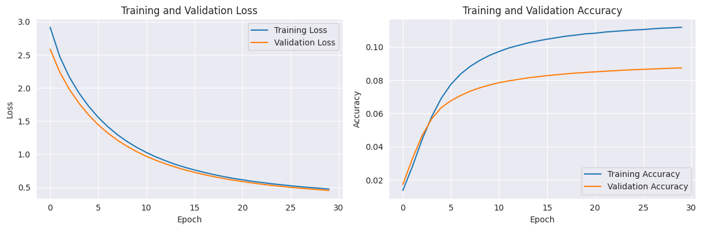
The loss curves show that the model converges after a few epochs, with the validation loss stabilizing. The early stopping mechanism prevented overfitting by stopping training when the validation loss stopped improving.

4.2 Per-Class BERT Metrics

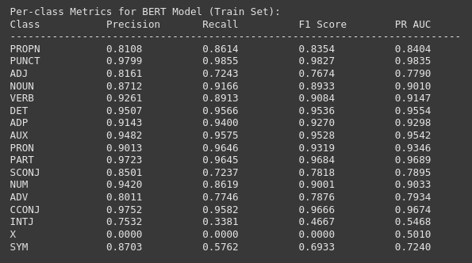

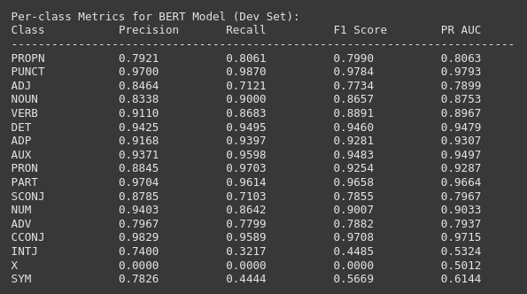
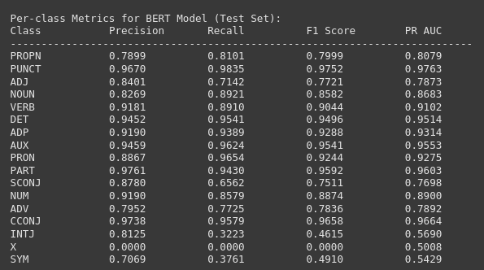

4.3 Macro-Averaged Metrics

4.3.1 Baseline Model
Metric | Training Set | Development Set | Test Set
Precision | 0.8964 | 0.8361 | 0.8195
Recall | 0.8723 | 0.7741 | 0.7752
F1 | 0.8799 | 0.7913 | 0.7863
PR-AUC | 0.8868 | 0.8092 | 0.8014

4.3.2 MLP Model
Metric | Training Set | Development Set | Test Set
Precision | 0.8789 | 0.8265 | 0.8335
Recall | 0.8636 | 0.7940 | 0.8091
F1 | 0.8702 | 0.8030 | 0.8144
PR-AUC | 0.9023 | 0.8430 | 0.8540

4.3.3 RNN Model
Metric | Training Set | Development Set | Test Set
Precision | 0.8827 | 0.8132 | 0.8294
Recall | 0.8070 | 0.7470 | 0.7727
F1 | 0.8246 | 0.7700 | 0.7948
PR-AUC | 0.8460 | 0.8115 | 0.8323

4.3.4 CNN Model
Metric | Training Set | Development Set | Test Set
Precision | 0.9137 | 0.8603 | 0.8636
Recall | 0.8930 | 0.8087 | 0.8258
F1 | 0.9015 | 0.8231 | 0.8307
PR-AUC | 0.9040 | 0.8361 | 0.8462

4.3.5 BERT Model
Metric | Training Set | Development Set | Test Set
Precision | 0.8402 | 0.8309 | 0.8294
Recall | 0.7879 | 0.7726 | 0.7646
F1 | 0.8069 | 0.7929 | 0.7863
PR-AUC | 0.8463 | 0.8344 | 0.8297

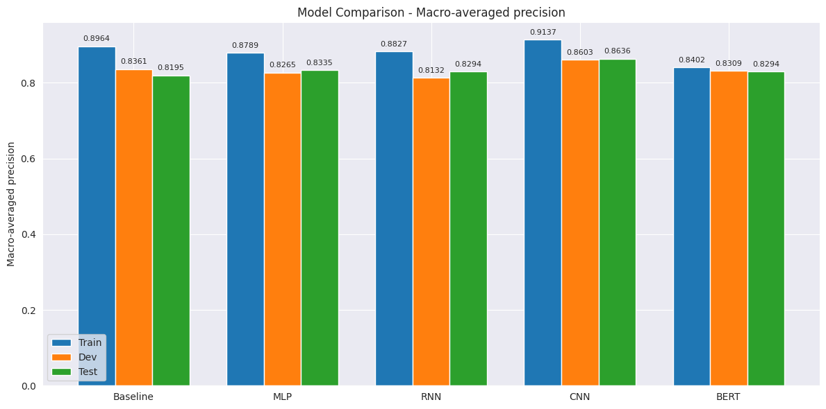
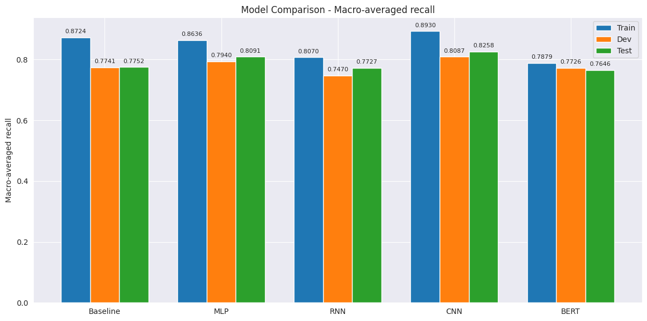

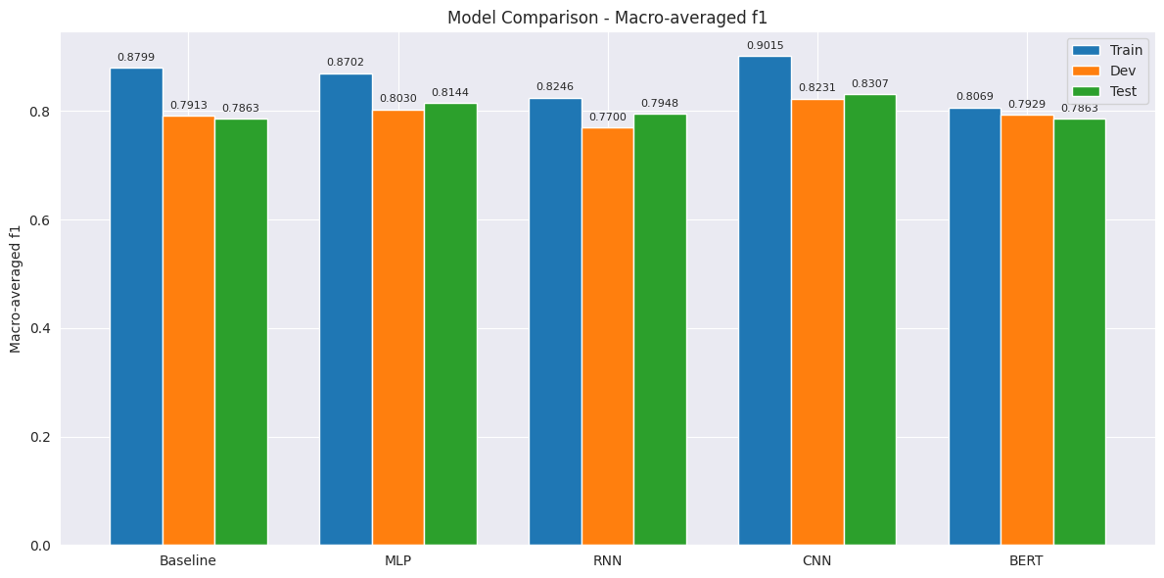
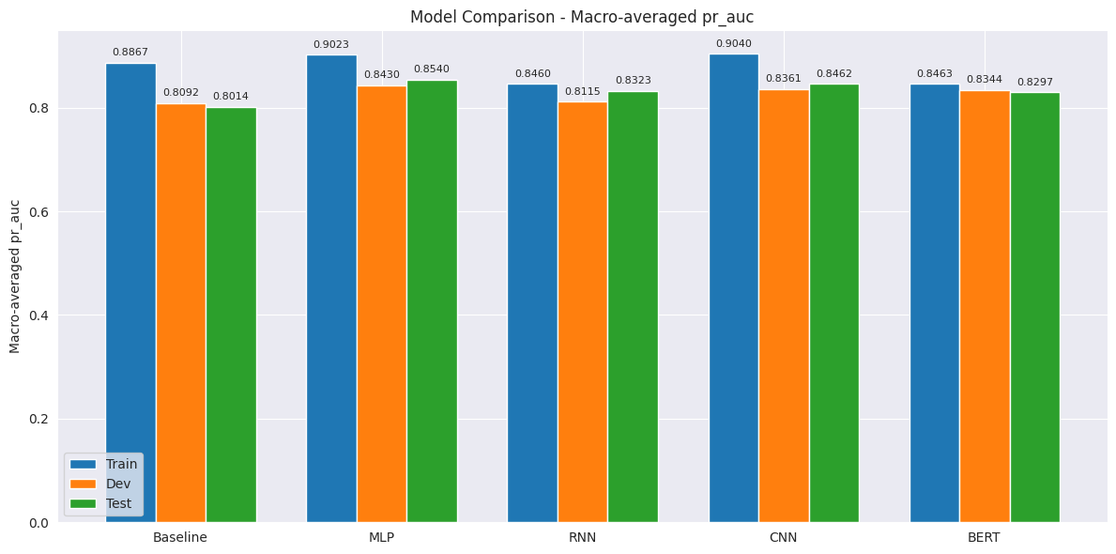

We also provide a confusion matrix for some of the top tags.

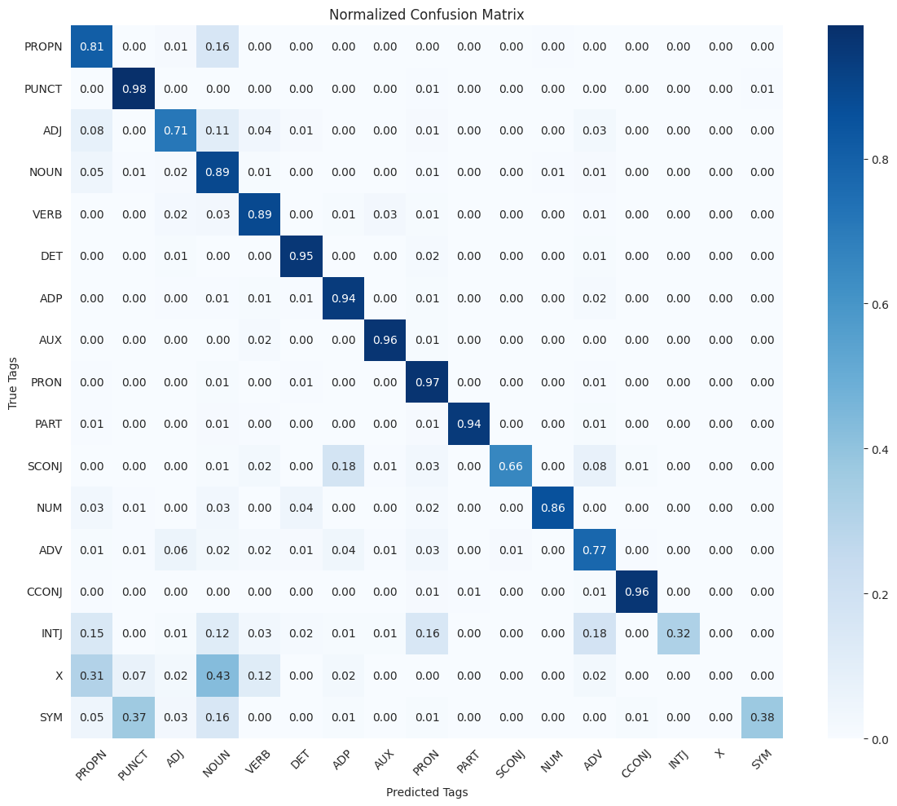

5. Conclusion
This report presented a Part-of-Speech tagging system using a fine-tuned BERT model. The BERT model was compared with a baseline model, an MLP model from Assignment 3, an RNN model from Assignment 4, and a CNN model from Assignment 5. Contrary to expectations, the BERT model did not perform as well as expected, especially when compared to previous approaches. Several factors may have contributed to the BERT model's unexpected poor performance:
- Insufficient Fine-tuning: The model may have required more epochs or a different learning rate schedule to properly adapt the pre-trained BERT weights to the POS tagging task.
- Token Alignment Issues: BERT's subword tokenization can create challenges for token-level tasks like POS tagging. The method used to align POS tags with BERT's subword tokens may have led to information loss.
- Lack of Task-Specific Architecture: The simple approach of adding only a classification layer on top of BERT may be insufficient. Adding task-specific components like BiLSTM layers could help capture sequential dependencies that are important for POS tagging.

