Evidence Gathering Document for SQA Level 8 Professional Developer Award.

This document is designed for you to present your screenshots and diagrams relevant to the PDA and to also give a short description of what you are showing to clarify understanding for the assessor.


Each point that required details the Assessment Criteria (What you have to show) along with a brief description of the kind of things you should be showing.

Please fill in each point with screenshot or diagram and description.

Week 2

Unit | Ref | Evidence
I&T | I.T.5 | Demonstrate the use of an array in a program. Take screenshots of:  *An array in a program  *A function that uses the array  *The result of the function running

Paste Screenshot here

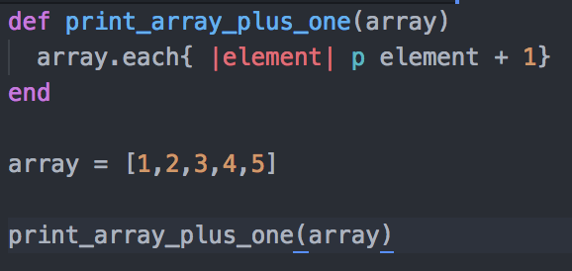

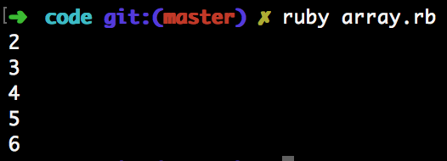

Description here

Creates an array of integers. Function prints each of those integers + 1.

Unit | Ref | Evidence
I&T | I.T.6 | Demonstrate the use of a hash in a program. Take screenshots of:  *A hash in a program  *A function that uses the hash  *The result of the function running

Paste Screenshot here

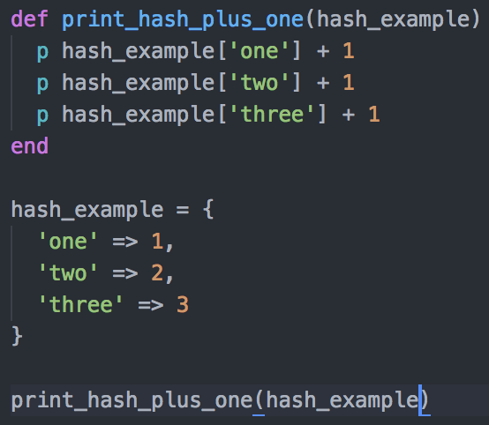

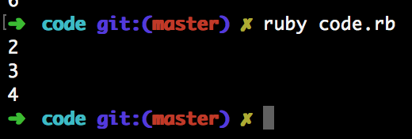

Description here

Creates a hash of string key integer values. Function prints each of those integers + 1.

Week 3

Unit | Ref | Evidence
I&T | I.T.3 | Demonstrate searching data in a program. Take screenshots of:  *Function that searches data  *The result of the function running

Paste Screenshot here
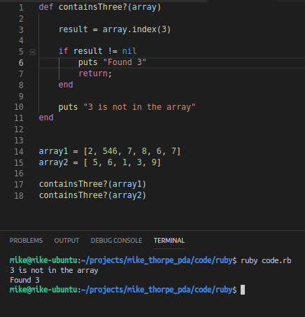

Description here

Function searches an array for the number 3. Logs a string to the console indicating if three has been found when .find_index does not return nil else returns a string indicating that 3 is not in the array passed.

Unit | Ref | Evidence
I&T | I.T.4 | Demonstrate sorting data in a program. Take screenshots of:  *Function that sorts data  *The result of the function running

Paste Screenshot here
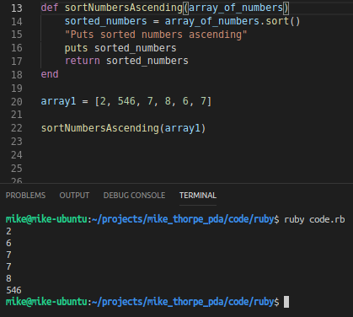

Description here

Function returns a new array of numbers sorted in ascending order given an array of numbers is passed. The new array is logged to the screen.

Week 5

Unit | Ref | Evidence
A&D | A.D.1 | A Use Case Diagram

Paste Screenshot here
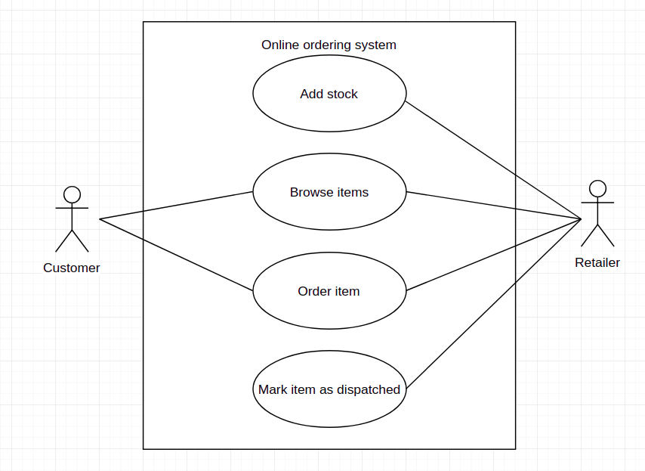

Description here
Diagram above shows interaction between customer, retailer and a simple online ordering system for buying items.

Unit | Ref | Evidence
A&D | A.D.2 | A Class Diagram

Paste Screenshot here

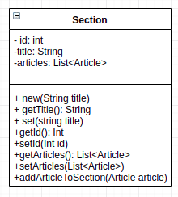

Description here
The above shows a diagram of a class – private and public methods and properties are indicated with a ‘-’ and ‘+’ respectively. Top half displays properties, bottom half shows methods. Return type is indicated after ‘:’ for each method that returns.

Unit | Ref | Evidence
A&D | A.D.3 | An Object Diagram

Paste Screenshot here
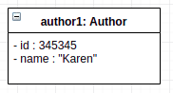

Description here

The above shows an object diagram, indicating the values of its properties and the Class it was instantiated from.

Unit | Ref | Evidence
A&D | A.D.4 | An Activity Diagram

Paste Screenshot here
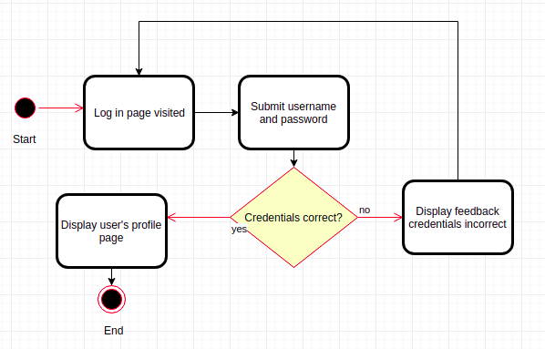

Description here

Above shows an activity diagram of the process of logging on to a system. Activites are in rectangular boxes, conditionals in diamonds and start and termination points are represented by circles.

Unit | Ref | Evidence
A&D | A.D.6 | Produce an Implementations Constraints plan detailing the following factors:  *Hardware and software platforms  *Performance requirements  *Persistent storage and transactions  *Usability  *Budgets  *Time

Paste Screenshot here
Topic | Constraint | Solution
Hardware and software platforms | Application must be cross platform | Create web app based solution capable of running in any modern browser
Performance requirements | App must start within 20s and all user requests must complete within 2s | Hosting web app on Heroku should give specified performance
Persistent storage and transactions | Exercise and workout data must be stored persistently. One workout can have many exercises and each exercise can be associated with many workouts. | Persist data via relational datbase (Postgres). Transactions to and from the db should be facilitated by restful routes.
Usability | A new user can quickly learn how to use the app | Implement a help view which is always accessible via the nav bar with a guide on how to use the app
Budgets | No monetary budget for project | Use only free open source tools and libraries for development
Time | Application must be produced in 7 days | Tight timescale so planning must be stringent to only include necessary features in MVP. Use of Trello to prioritize features. Extension features must only be implemented when MVP features are complete.

Description here
The table above details project constraints and how they can be met using technical and management solutions.

Unit | Ref | Evidence
P | P.5 | User Site Map

Paste Screenshot here

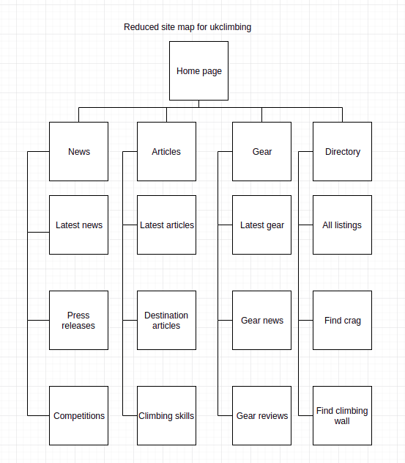

Description here

The above is a reduced site map for ukclimbing mapping out the tree of links from the homepage.

Unit | Ref | Evidence
P | P.6 | 2 Wireframe Diagrams

Paste Screenshot here

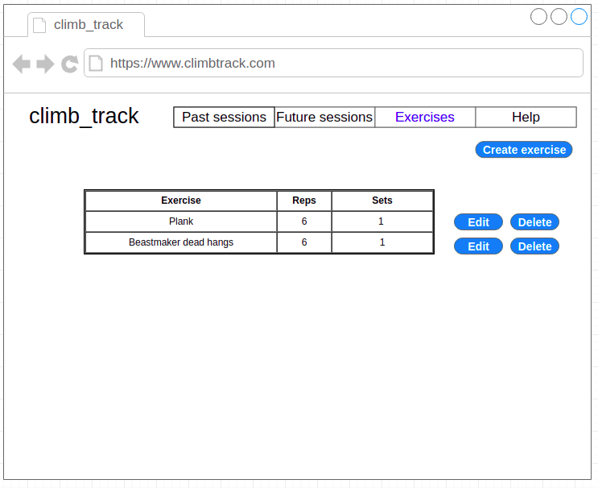

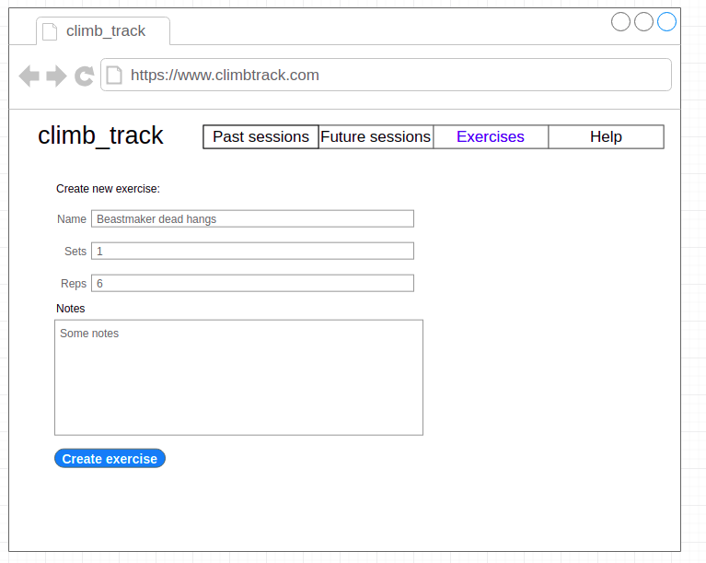

Description here
Wireframes showing exercise creation and list of exercises page for climb_track solo ruby project.

Unit | Ref | Evidence
P | P.10 | Example of Pseudocode used for a method

Paste Screenshot here
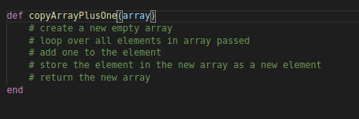

Description here
Psudo code for a method to create a copy of an array with 1 added to each element.

Unit | Ref | Evidence
P | P.13 | Show user input being processed according to design requirements. Take a screenshot of:  * The user inputting something into your program  * The user input being saved or used in some way

Paste Screenshot here
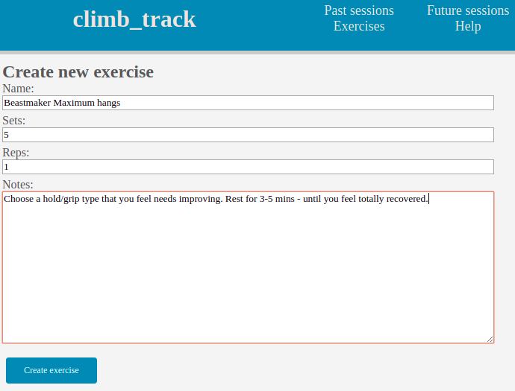
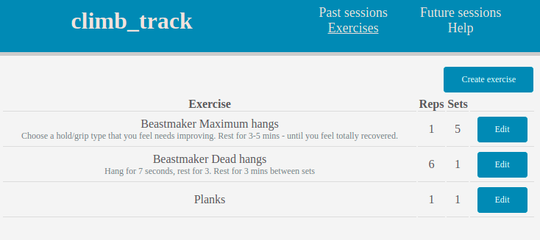

Description here

Adding new exercise data to the list of exercises in the climb_track app

Unit | Ref | Evidence
P | P.14 | Show an interaction with data persistence. Take a screenshot of:  * Data being inputted into your program  * Confirmation of the data being saved

Paste Screenshot here

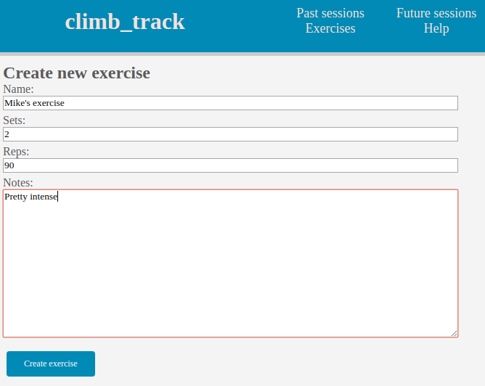
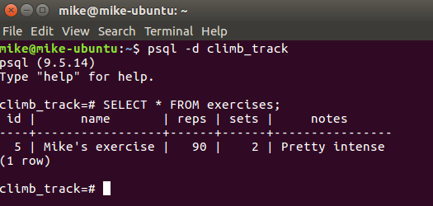

Description here

The above shows an exercise being added to the climb_track db via the climb_track program – results are shown using psql at the command line.

Unit | Ref | Evidence
P | P.15 | Show the correct output of results and feedback to user. Take a screenshot of:  * The user requesting information or an action to be performed  * The user request being processed correctly and demonstrated in the program

Paste Screenshot here

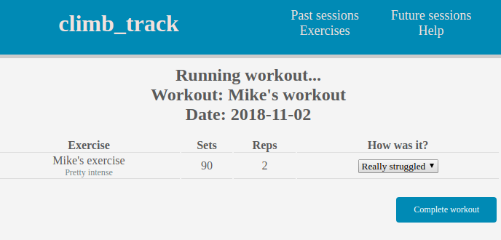
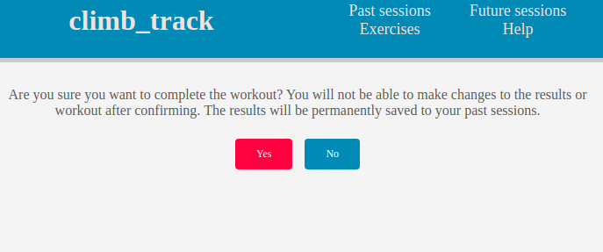

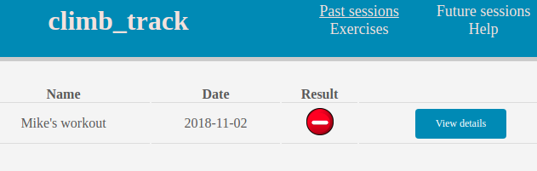

Description here
By clicking the complete workout button and confirming the completion of the workout, the workout is marked as complete and moved from the list of future sessions to the list of past sessions.

Unit | Ref | Evidence
P | P.18 | Demonstrate testing in your program. Take screenshots of:  * Example of test code  * The test code failing to pass  * Example of the test code once errors have been corrected  * The test code passing

Paste Screenshot here

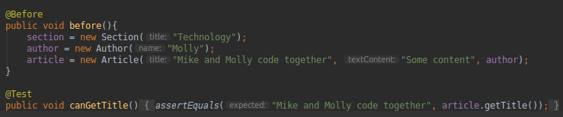
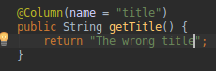
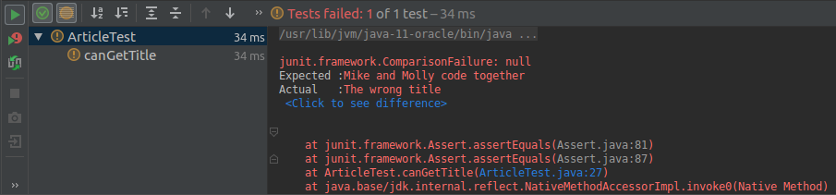

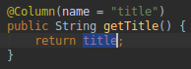

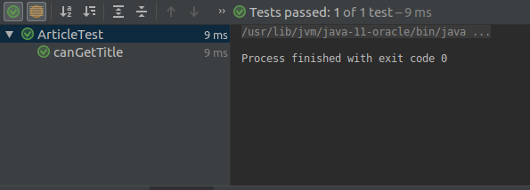

Description here
Above is shown the unit test for a getter, the broken getter, the test failing to pass when run on the broken (hard coded) getter, the fix (return the value of the property from the getter) and the test code passing after the fix.

Week 7

Unit | Ref | Evidence
I&T | I.T.7 | The use of Polymorphism in a program and what it is doing.

Paste Screenshot here
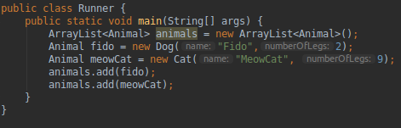

Description here
The above is an example of polymorphism as we are treating the Dog and Cat objects as if they were Animal objects as they both inherit from the Animal class.

Unit | Ref | Evidence
A&D | A.D.5 | An Inheritance Diagram

Paste Screenshot here
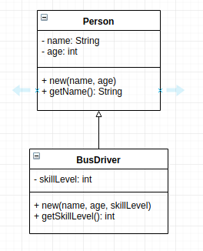

Description here

The above diagram shows the inheritance hierarchy between a super (Person) and sub class (bus driver). The sub class inherits all of the properties and methods of its parent and has its own in addition.

Unit | Ref | Evidence
I&T | I.T.1 | The use of Encapsulation in a program and what it is doing.

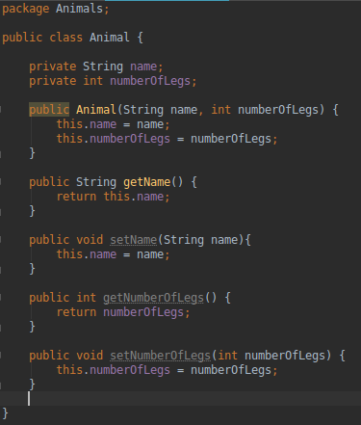
Paste Screenshot here

Description here
The name and number of legs properties are encapsulated in the Animal class – they are kept private and the only way they are exposed for modification is via the respective setter methods. This means that we can control how and if they are modified. We can also control if they can be read from outside the class with the use of getter methods.

Unit | Ref | Evidence
I&T | I.T.2 | Take a screenshot of the use of Inheritance in a program. Take screenshots of:  *A Class  *A Class that inherits from the previous class  *An Object in the inherited class  *A Method that uses the information inherited from another class.

Paste Screenshot here

The class

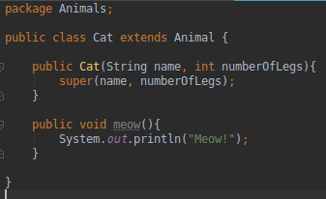

The class that inherits from the previous class
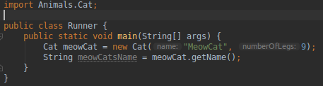

Description here

An Object in the inherited class (Cat)
A Method that uses the information inherited from another class. - we call the getName() method from the Animal class on the Cat object

Week 10

Unit | Ref | Evidence
P | P.11 | Take a screenshot of one of your projects where you have worked alone and attach the Github link.

Paste Screenshot here
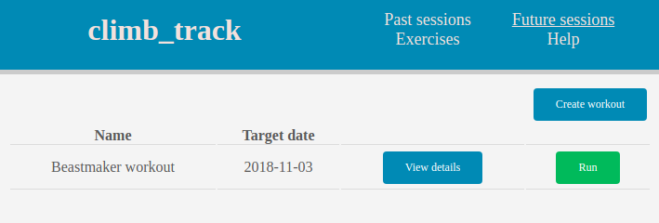
https://github.com/mikethorpe/climb_track

Description here

climb_track solo Ruby project

Unit | Ref | Evidence
P | P.12 | Take screenshots or photos of your planning and the different stages of development to show changes.

Paste Screenshot here
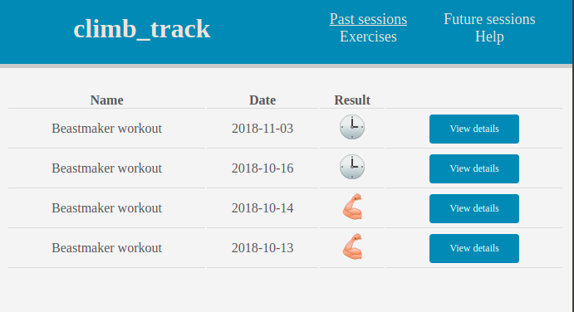
Link to wireframes: https://github.com/mikethorpe/climb_track/blob/master/design_docs/wire_frame_model.xd

Description here

Wireframes show structure of views and are demonstrated here in the photo of the past sessions page. The result column was updated during development to feature an emoji symbol to indicate the result and a help view was created.

Unit | Ref | Evidence
P | P.9 | Select two algorithms you have written (NOT the group project). Take a screenshot of each and write a short statement on why you have chosen to use those algorithms.

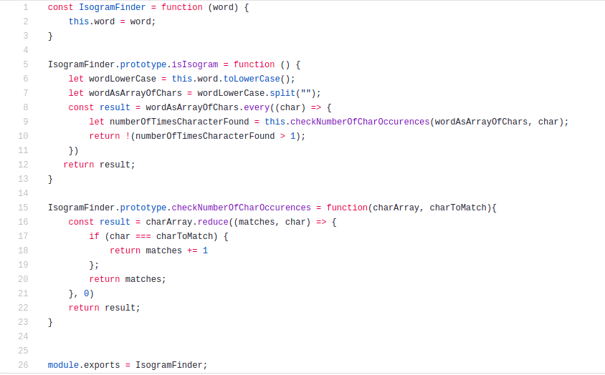
Paste Screenshot here

Isogram finder:

Pangram finder:
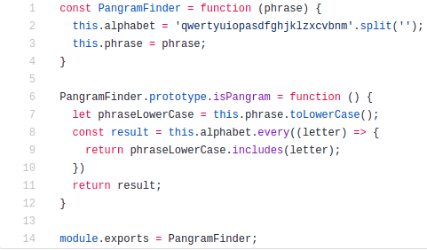

Description here

The pangram finder identifies if a string is a pangram regardless of case. The isogram finder finds words without a repeating letter regardless of case. I chose these as they are both clear examples of problem solving with logic (i.e. algorithms) written in code.

Week 12

Unit | Ref | Evidence
P | P.16 | Show an API being used within your program. Take a screenshot of:  * The code that uses or implements the API  * The API being used by the program whilst running

Paste Screenshot here
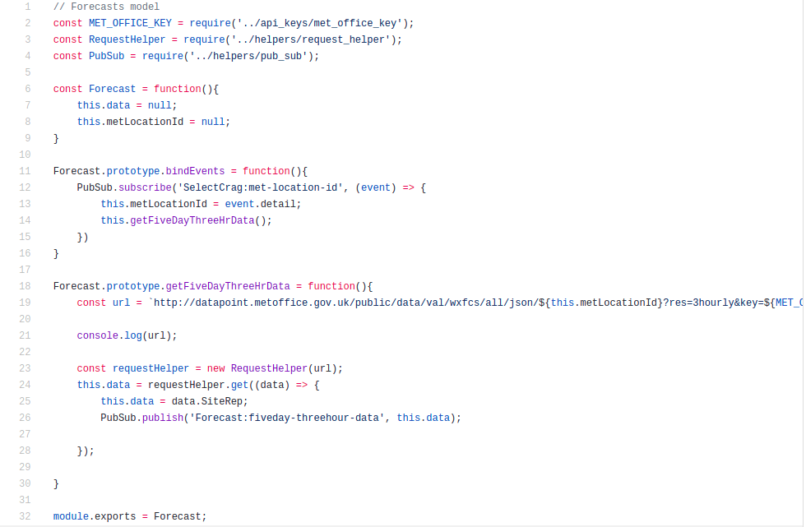

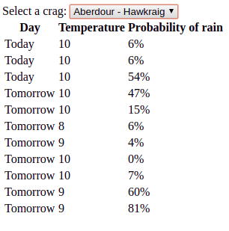

Description here

The above shows the code that gets the data from the API and rebroadcasts it to a view where it can be rendered. The rendering of the data in the view as the program runs is also shown above.

Week 15

Unit | Ref | Evidence
P | P.1 | Take a screenshot of the contributor’s page on Github from your group project to show the team you worked with.

Paste Screenshot here

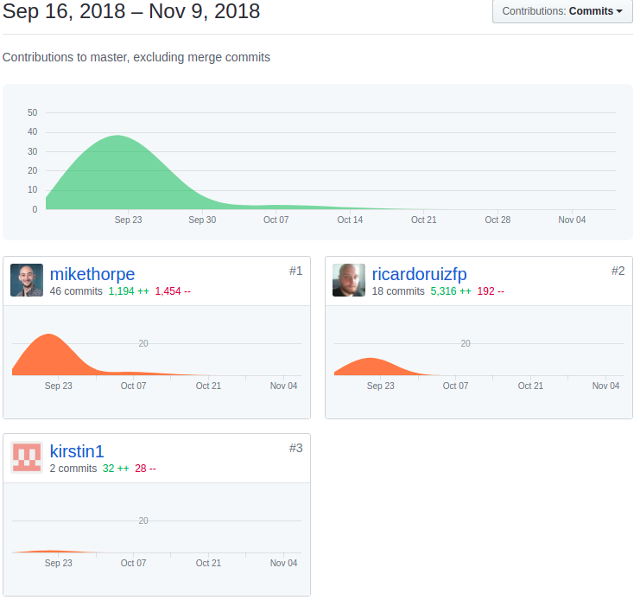

Description here
Contributions to the JS team project

Unit | Ref | Evidence
P | P.2 | Take a screenshot of the project brief from your group project.

Paste Screenshot here
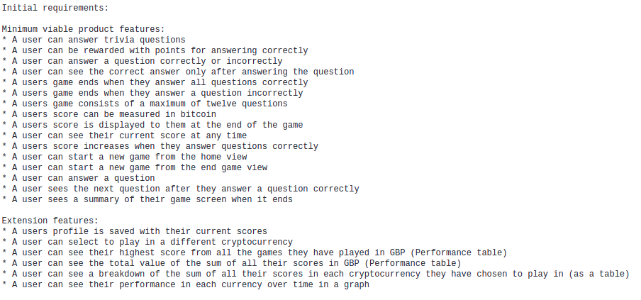
Description here

JS Team project brief – a list of initial requirements

Unit | Ref | Evidence
P | P.3 | Provide a screenshot of the planning you completed during your group project, e.g. Trello MOSCOW board.

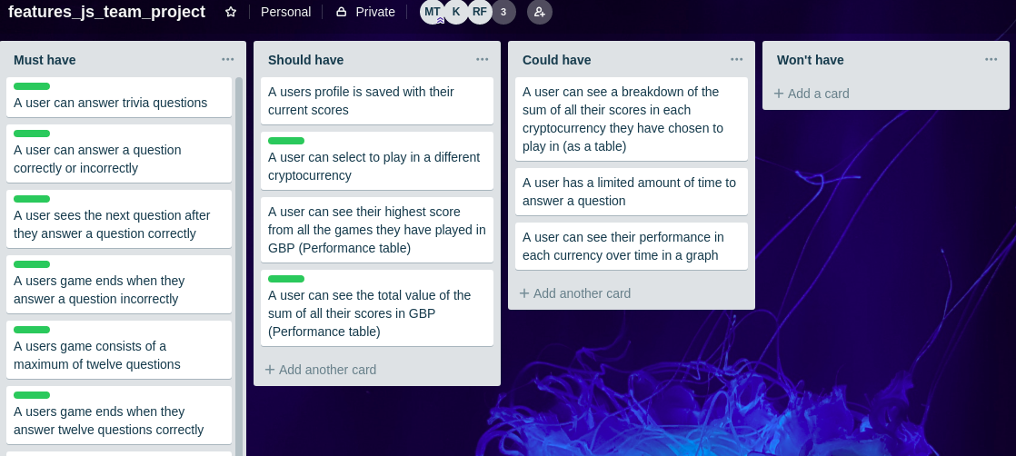
Paste Screenshot here

Description here
Trello MOSCOW board from JS team project showing features and their relative priority for implementation

Unit | Ref | Evidence
P | P.4 | Write an acceptance criteria and test plan.

Paste Screenshot here

Acceptance criteria | Expected result / output | Pass / Fail
A user can create a new exercise | Given the create new exercise view has been loaded.  And exercise details have been entered.  When create exercise is clicked.  Then the exercise is added to a list of all exercises | Pass
A user can change the name of an existing exercise | Given the edit page for an existing exercise has been loaded.  And the new exercise name has been entered  When update exercise is clicked  Then the name of the exercise is updated | Fail
A user can delete an exercise that is not associated with a workout | Given the exercises page has been loaded  And an exercise that is not associated with a workout exists  When the option to delete the exercise is chosen  And the option is confirmed  Then the exercise is deleted | Pass
A user can view the details of an exercise | Given the exercises page has been loaded  And an exercise exists  When the option to view the exercise is selected  The the details of the exercise are displayed | Pass

Description here

Above is an acceptance criteria and test plan. Acceptance criteria – workflows that theh application should satisfy are displayed in the left hand column. The middle column shows the test to be performed to ensure the acceptance criteria are met. The right hand column indicates whether or not the test passed on its last run.

Unit | Ref | Evidence
P | P.7 | Produce two system interaction diagrams (sequence and/or collaboration diagrams).

Paste Screenshot here
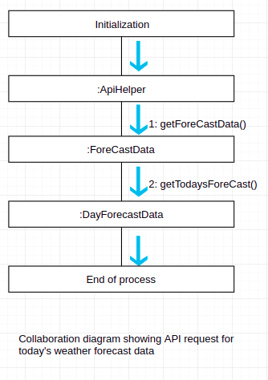

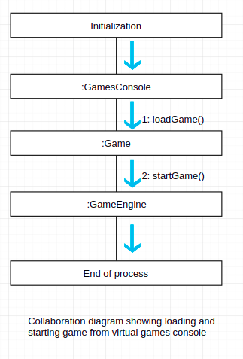

Unit | Ref | Evidence
P | P.8 | Produce two object diagrams.

Paste Screenshot here

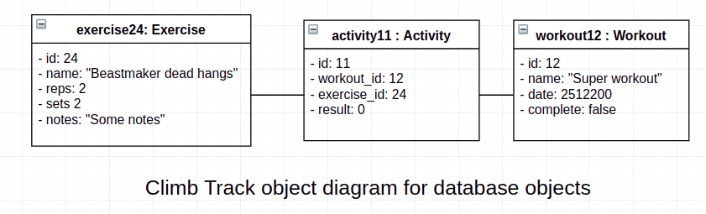

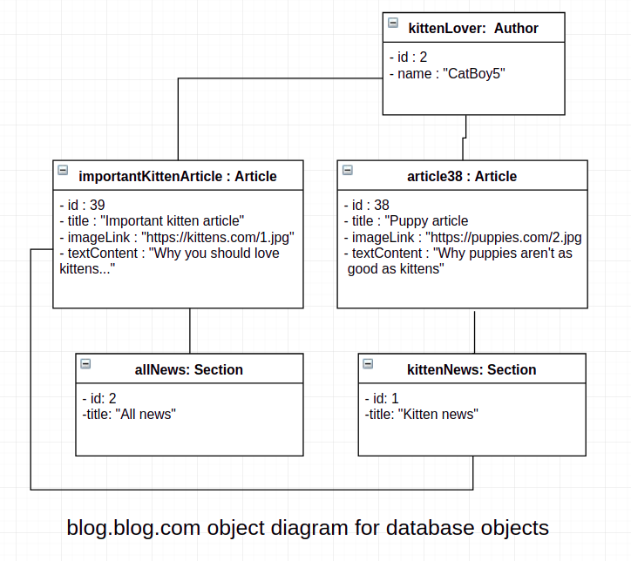

Description here

The above shows object diagrams for the climb track (ruby project) db objects – all have a 1 to 1 relationship, and the blog.blog.com (java project) db objects – an author can have many articles and each article can be associated with many sections. Each object has been instantiated with values for all properties.

Unit | Ref | Evidence
P | P.17 | Produce a bug tracking report

Paste Screenshot here
Bug / Error: | Solution: | Date:
Name of new exercise is not displayed on exercise details or list view | ‘name’ param in post request incorrectly referenced as Name in exercise.rb model options. Now referenced correctly. | 30/10/2018
Foreign key violation error thrown when attempting to delete and exercise that is associated with a workout | Modified design and implementation so delete button is not shown for exercises that are associated with a workout(s). No longer possible for user to delete exercise associate with a workout. | 25/07/2018
Trying to add exercise to workout when no exercises exist throws error | Exercise id is passed as nil from selector in update_activities.erb when no exercises exist. Added conditional statement in workouts_controller.rb to check exercise id is not nil before adding exercise to workout. | 26/07/2018
Exercise reps not displayed on list of exercises | Reps not referenced from params in show exercises/index.erb table. Reference to exercises.reps in params updated. Fixed | 10/10/2018
Exercise can be created with negative number of sets | Min attribute added to number input html tag for sets input in exercises/new.erb | 10/10/2018

Description here

Bug tracking report show above demonstrating a description of the bug / error without technical assumption of the cause. Solution indicates the technical solution including design and implementation changes.

