Mike Maher 10182914

Website Design and Development for Patrick Farrell Physiotherapy Clinic. This document includes the steps taken in designing, developing and optimising a website for the clinic, based on the brief outlined in the Assignment specification.

Web Design & Development Assignment

B8IT053

Contents

Planning 2

Design & Development 2

JavaScript 2

1. Choosing a Web Host 3

2. Search Engine Optimisation Techniques 3

i. Using metadata (<meta> tags) 3

ii. Generating an XML sitemap 3

3. Weekly Log 4

4. Authors Reflection 5

Appendix 6

Figures 6

Figure 1: Wireframe 6

Figure 2: Clinic Logo 6

# Planning

Before designing the site, a layout and sign plan is required. For this site, the pages chosen were:

* Home
* About Us
* Staff
* Services
* Testimonials
* Contact us
* Bookings
* FAQs

# Design & Development

Before design can be considered, each page needs information to manipulate. The information to be displayed on each page will determine what design suits the overall site. For example the navigation bar will be present on every page so it would be considered good practice for this to be easily visible and in the same location. Other content like the clinic logo, footer sitemap and main content/title elements have relative positions on each page, helping the user gain familiarity with the site.

Following this a design layout of each page is necessary. A simple brochure-style (see Appendix figure 1) was chosen as it is easy to navigate and each page has the same layout to make the theme familiar to the user. In designing a website for a business it is important to choose display aspects that reflect the business. For example for medical professions such as physiotherapists soft colours that reflect cleanliness or warm colours that highlight comfort or warmth are often considered. For this website the primary colours were a clean white and soft green and warm purple.

Appropriate images were gathered to reflect each service and a logo was created incorporating the colours chosen for the site (see Appendix figure 2).

# JavaScript

JavaScript is a powerful programming language used to add dynamic aspects to web pages. In this assignment JavaScript was used to display an array of images as a banner on the home page. Each image has a heading acting as dynamic title to entice the user to read further. Of note here is the image that states that the clinic was nominated for the national healthcare awards. This demonstrates the quality service offered.

JavaScript is also used to hide the answers to the frequently asked questions. Hiding this text presents the user with an easier to read body of text that enables them to quickly find the question they are looking for. This script uses the pre-written JavaScript functions contained in the JQuery Library available online at:

<http://ajax.googleapis.com/ajax/libs/jquery/1.3.2/jquery.min.js>.

# 1. Choosing a Web Host

In choosing a web hosting package a number of things need to be considered:

* Price
* Reliability
* The needs of the site to be hosted
* Space required
* Shared or dedicated server
* Support

The Web hosts researched for this assigned were “Register365.com”, “blacknight.com” and “iccmhosting.ie”. The latter was considered as it is an Irish company offering a great price and boosting reliable service with 99.9% uptime and .ie domain name included in their packages. Their business plan is €5.99 a month and a key attraction being they are Irish based; as such they have local offices and local support. It is noted they may however be a conduit or “middle-man” using one of the above services, it is an advantage to have that support locally.

Registering a .ie domain is a laborious task as it requires a lot more information than registering a .com or .org domain name for example. The .ie Domain Registry (IEDR) must be contacted and the owner of the site must provide documentation stating intent and a registered business. However it is a worthwhile endeavour for Irish businesses such as Patrick Farrell Physiotherapy given it is an immediate indicator that the business is Irish with a Search Engine returning thousands of results per search, the .ie extension will help the user find what they’re looking.

As mentioned above iccmhosting offer a .ie domain name as part of their plan. The site owner will still need to provide the required documentation but ICCM will file the request and deal with any other requirement form the IEDR. From an examination point of view a free hosting site was used, namely x10hosting, however should Patrick Farrell have sought to proceed with the site, the recommendation would be for the use iccmhosting given the points above.

# 2. Search Engine Optimisation Techniques

Techniques used to optimise the site for search engines include:

## i. Using metadata (<meta> tags)

Meta tags allow for data about data (metadata) to be entered about the website. This data is picked up by search engines to try and return the best match for a user. On this site the meta types “description” and “keywords” are used. Description will show up in the brief summary of a search result and the keywords are used to help the engine return the closest match through the use of key words as 'Physiotherapy', 'Dublin', 'Sport Injury', 'acupuncture' etc.

## ii. Generating an XML sitemap

XML sitemaps correctly index a website in order to help a search engine find it. An xml sitemap is added to a search index and when a user enters a search it is compared against this index. To generate the sitemap, an online generator was used (<https://www.xml-sitemaps.com/>). Then the site is added to Google’s search index using the Google webmasters tools.

# 3. Weekly Log

|  |  |  |  |
| --- | --- | --- | --- |
| Week | Activities | Problems | Resolutions |
| 1 | * Project Plan * Site Structure * Content Gathering * HTML   + Content editing | Matching image sizes | Set up Photoshop templates for each staff member, banner etc. Cropped or resized images to template |
| 2 | * HTML cont.   + Constructing pages * CSS   + Page Layout   + Page Styling | Visualising the pages without colours and formatting | Applied basic formatting CSS to help visualise than completed CSS when content was added |
| 3 | * JavaScript   + Adding Slide Show to home page   + Hiding FAQ Answers   + Messages and alerts | Fade and image swap out of sync for the slider | Declared the script just before the </body> closing tag, so all the content as loaded before the script is called |
| 4 | * Form Validation * Addition of external links * Sitemap | Problems with incorrect regular expressions | Match Expressions with standard ones found online  Changed the input type of email from “text” to “email” |
| 5 | * SEO   + Relevant titles   + Metadata   + Xml Sitemap * Validation | Some errors in html & CSS validation | In html used some obsolete attributes such as “type” and “language”  CSS errors were syntax errors or spelling errors. |
| 6 | * Report * Hosting | FTP transfer  Images not transferring | Images were too large for ftp, and some were loading slowly. Optimised for web so all images present and loading quickly |

# 4. Authors Reflection

The purpose of this assignment was to develop a website to the latest standards in web design (html5, CSS3 etc). As someone having studied web design in the past, I found that I had much to learn since the development of these most recent standards. I feel upon completing this assignment I have developed my knowledge and ability to develop modern websites that conform to these standards. I have learned the power of many tools that exist to aid web developers such as the online code validation tools. Before this module and this assignment I had very little experience in ftp transfers, SEO and other essential mechanics of a live website. Though no longer required for the assignment I have published the website using free hosting and have as a result, gained experience in transferring files, adding the site to Google’s index and generating xml sitemaps.

A live version of the site is available at <http://pfphysio.x10host.com/index.html>.

# Appendix

## Figures

### Figure 1: Wireframe

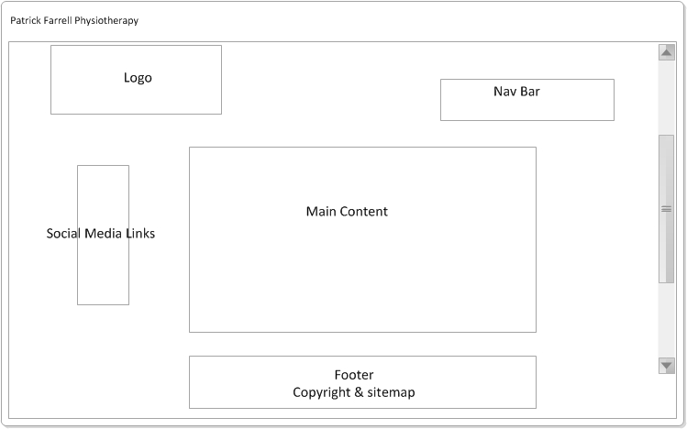

### Figure 2: Clinic Logo

