Assignment M2: Outlooks for Outlook

Michael Tong  
mtong2@gatech.edu

**Abstract.** With information gathering techniques enacted in assignment M2 for Microsoft Outlook, this study reviews and discusses the results of those exercise and ties their analysis into answering the seven overarching needfinding questions. Lastly, the study identifies measures for future improvement.

# Introduction

Previously, it had been discussed in Assignment M1 that the Outlook interface could benefit from design alterations. Before redesigns are considered, the study drafted three different needfinding experiments to gather information for identifying the needs of the users. This report discusses the results of those three experiments, where a survey was administered to students at GT, a line of apprenticeship was developed with field specialists, and the Outlook interface was examined in comparison with its competitors. The results of these experiments are compiled into the Data Inventorying section, where the seven principle needfinding questions are addressed. Lastly, the report discusses future endeavors in both needfinding and the effort overall

# Initial Survey Exploration

From the previous assignment, an approach for this project involved a general survey to generate an overview of student’s opinions on the Microsoft Outlook application. The surveyed population are strictly GT students, which does induce biases which will be discussed later. As noted in the previous discussion, surveys can provide a simple means to analyzing large quantities of data through discretizing responses. In order to take advantage of this format, a general survey of 12 questions was released with ~40 responses. Five of the questions released were not free text and could be processed quickly for simple summaries such as the count of each response. The focus of this discussion will be on these responses since the remaining questions are free text and require significantly more resources to process.

## Question 1: Age Group

The first question is fairly straight forward to capture the demographics of the survey population. Default age ranges are under 18, 18-29, 30-39, 40-49, 50-64, 65+. Figure 1 in the Appendices displays that over half the surveyed population falls in the age range of 18-29, which is to be expected. To the surprise of this study, there are a few members in the age range of 50-64 in the OMCS program which is heartwarming.

## Question 4: Primary use for Outlook

The next categorical question is 4, which asks users “What is your primary use for Outlook?” The goal of this question is to understand where surveyors utilize the application. Figure 2 displays the counts of each response and surprisingly, only a quarter of respondents (10) said they use Outlook for academic purposes, which is surprising since it is a default application for the surveyed population.

## Question 6: Feature usage in Outlook

Discussed in the previous assignment, a subjective analysis led the author to believe that Outlook’s interface is overcluttered with unnecessary features. To support this hypothesis, Question 6 of the survey asked users what features they used in the application. As a follow up from the previous question, the results from Figure 3 were not surprising since a majority of user’s used the application for work. Email, Calendar, and Meetings nearly matched or exceeded the count of user’s that used Outlook primarily for work. What is important is that the three features for Groups, Tasks, and Notes, are utilized by under 10% of the sample population, supporting the author’s initial hypothesis.

## Question 8: Is Outlook Preferred?

Question 8 of the survey is tasked with determining whether user’s preferred Outlook over the competitors. Alone, this question doesn’t provide too much information, but does supplement the following question. Figure 4 displays that roughly 2/3rd of the sample population prefer Outlook.

## Question 11: How is Outlook doing?

Question 11 is similar to Question 8, but adds the respondents overall satisfaction with Outlook. From Figure 5, it is found that while 2/3rd’s of the sample population prefer Outlook, only 1/8th of the respondents find the application *enjoyable,* whereas over half the population were dissatisfied.

## Conclusions

From the simple survey devised, the study has gathered pretty significant information into how best to improve the application. It should be reiterated that there is a clear bias in this study with it only being conducted within the student body at GT, but the purpose of this effort is to improve the experience for students. Other biases resulting from the survey include the fact that responses were given in a particular order and some questions may bias the responses to following questions. The surveyor spent some time to ensure that this bias is minimized through considering the independence of each question.

# Exploring Apprenticeship’s and Ethnography

At this time, the author has reached out to Microsoft for an apprenticeship for the Outlook platform but has yet to receive a response.

Fortunately, employees from Booz Allen Hamilton (BAH) have been supportive of the request and as of now, two members from the Human Centered Design and User Experience (UX) group have extended their support. In particular, the UX designer has had experience with email applications in the past and will hopefully be able to translate design rationale from this analysis moving forward.

Unfortunately, without Microsoft’s support, design considerations and questions will be more difficult to integrate and understand, but the opportunity still exists. Additionally, while the UX designer has experience in email interfaces, it could pose a potential bias to the study, primarily in the form of confirmation bias. Management of this bias can be done moving forward through questioning their assumptions in particular design decisions. Another bias that exists is that within BAH, and if Microsoft becomes a supporter of the effort, the default use of Outlook may narrow thinking into what the platform currently does, as opposed to the overall goal of the application. In order to combat this bias, the question of “what is the ultimate purpose of this task?” should be reiterated throughout the design lifecycle.

# Exploring Existing Interfaces

From the survey responses, it comes to no surprise that Google products are mentioned in nearly half of the responses as a supplemental product, even though Outlook provides the same functionality. As such, this study performed a preliminary comparison between the two interfaces with the goal of identifying why it is used over the Outlook option. Firstly, with every respondent stating that they use Outlook for their Email, why are they also using Gmail? After examining both interfaces shown in Figures 6 and 7 of the appendices, it is found that they are remarkably similar. The primary difference between the two interfaces is how emails are viewed. In Gmail, clicking on an email emphasizes the contents by removing the mailbox items, whereas in Outlook, email contents are displayed on the right-hand panel. Additionally, addressee information is hidden by default in the Gmail application, where it is heavily emphasized in the Outlook application. Ultimately, what is found through this analysis is that Gmail provides an interface that is geared towards reading low volume, personal emails, whereas with Outlook, it is geared more towards larger volumes work emails. This conclusion is hypothesized by the study from first identifying that it takes less clicks for users to view new emails in Outlook, but the Gmail interface provides a better viewing experience of those emails (more space is used). As such, it appears that the goal of Outlook is to allow users to cycle through multiple emails by maintaining the mailbox contents viewable, where Gmail requires the user to click the back button. From a performance standpoint, it is faster to read separate emails in Outlook. The second form of support for the hypothesis is that addressee information is emphasized in Outlook for each email, where Gmail hides a majority of the information by default. In personal emails, CCs and multiple destinations are less common, where in a corporate environment, they are almost standard. These two subtle differences are interesting because it supports the survey responses for Outlook being used primarily as an interface for work. Moving forward with design improvements, this understanding should be maintained.

Bias in this section have been accounted for by not only exploring what is considered the most popular alternative interfaces. The bias was relieved through analyzing the most popular responses to the survey question for what separate interface respondents use in addition to Outlook. From the responses came the Google platform, which was then analyzed.

# Data Inventorying

After successfully administering a survey, developing an apprenticeship, and analyzing the competing interface, the study has developed sufficient information to answer the seven principle needfinding questions. The result of these needfinding endeavors provides a unique insight into Outlook and its potential niche use case, which has allowed this study to better focus into a specific field of interest. To begin, the study summaries the demographics of the sample population.

## The User

From this survey, it is identified that the users are GA tech students mostly within the age range of 18-29. Since the application is accessible on a desktop and mobile, their locations vary. However, it had been determined in the survey that over 3/4th’s of the survey population uses Outlook for work, which may lead to the assumption that an office environment is the primary location of engagement. As such, respondents are most likely engaged at work and focused on tasks such as the contents of the email itself.

## Goals and Tasks

Since the survey and analysis of existing interfaces projects Outlook to emphasize a work or professional environment, the study will move forward with that perspective. With this understanding, the study transitions the goal to a potential redesign that supports work productivity. Additionally, the survey provides insight into how users accomplish the goal of productivity with the Outlook interface through highlighting three tasks in particular, namely email, calendar and meetings, where each uniquely supports an aspect of the working environment. In order to accomplish these tasks, the survey has found that users often supplement Outlook with additional interfaces such as Google Calendar and Gmail.

In comparison with these separate interfaces, the exploration into Outlook and Gmail has found that they are remarkably similar, but small caveats in how emails are viewed may make a significant difference, enough for users to implement them into separate aspects of their lives. As an example, from these more detailed analyses, the study finds that subtasks do exist in the form how information is projected to the user. From the email interfaces, the study finds that selection and the resulting display differs between Outlook and Gmail. These two interfaces both accomplish the user’s goal of hosting an email service, but each one displays different levels of detail in doing so, which users may find better or worse within a working environment.

## Defining Requirements

From the needfinding exercises, this study has better developed a focal point for where to emphasize its efforts. With over 90% of respondents identifying “work” as the primary use for Outlook, this study will move forward in gathering details and considering improvements related to working productivity. The identifier for success has also evolved from superficial improvements such as how quickly can an email be composed in Outlook, to how well does the interface support the business goals of an email? Other metrics that are to be considered is how well the calendar feature is at correctly managing a user’s workday, and if meetings effectively managed with the meetings feature. If a redesign is considered for the three primary features of Outlook, the prototype must improve the efficacy of these features in a working environment.

## Continued Needfinding

The study has greatly benefitted from the initial general survey through developing a focal point to move forward on. To continue this development, another survey will be administered, but with a focus on questions surrounding Outlook as a tool for a working environment. Additionally, a result of this shift in focus is that working professionals should be the target of the survey. As such, the survey will also be sent across the author’s workplace, where Outlook is the standard email interface.

For the apprenticeship, the hope is Microsoft responds and can be utilized as a resource for this effort. In the meantime, the two professionals at BAH will be engaged in more detail regarding the use of email, calendar, and meeting interfaces to hopefully develop a greater understanding of why, for instance, Outlook and Gmail have different email views, and is it significant?

Further analysis needs to be made into Google Calendar, where a portion of respondents identified as a supplemental product to Outlook’s calendar feature. This will be of particular interest since a Calendar is a relatively simple application and from face value, both applications appear to be very similar once again. It will be interesting if another small design different could exemplify itself into specific use environments once again.

# Appendices

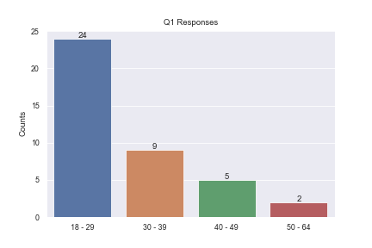

**Figure 1**: Q1 response count

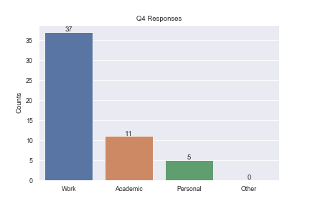

**Figure 2:** Q4 response count

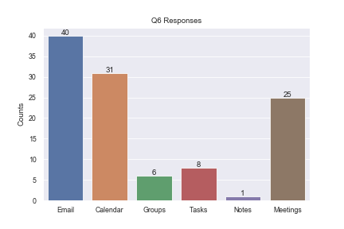

**Figure 3**: Q6 Response Count

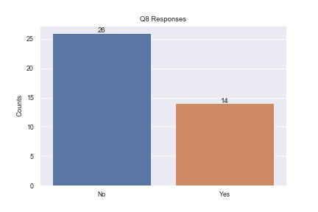

**Figure 4**: Q8 Response Count

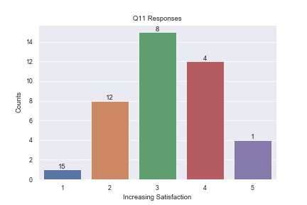

**Figure 5**: Q11 Response Count

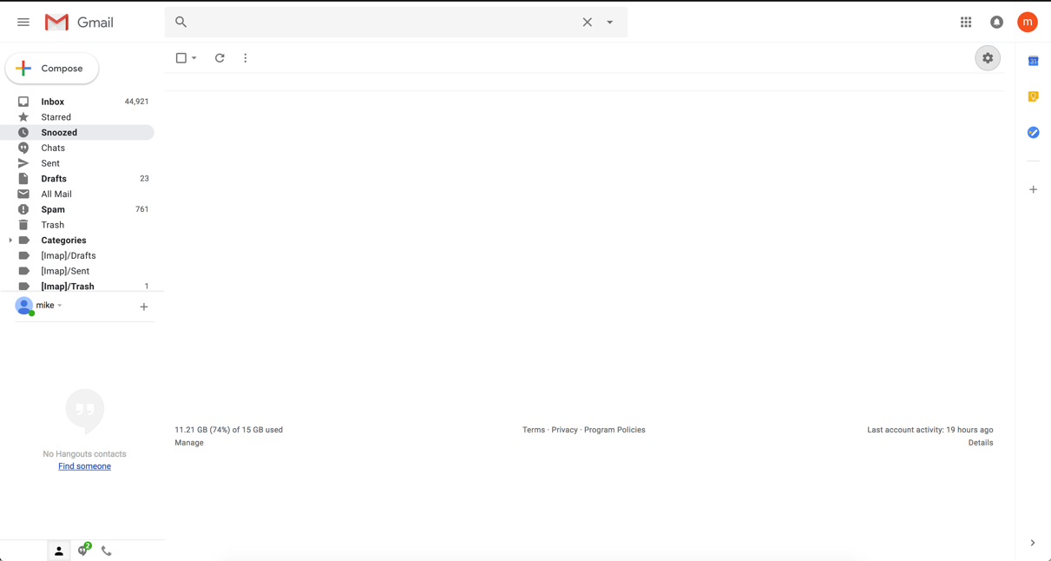

**Figure 6**: Gmail Interface

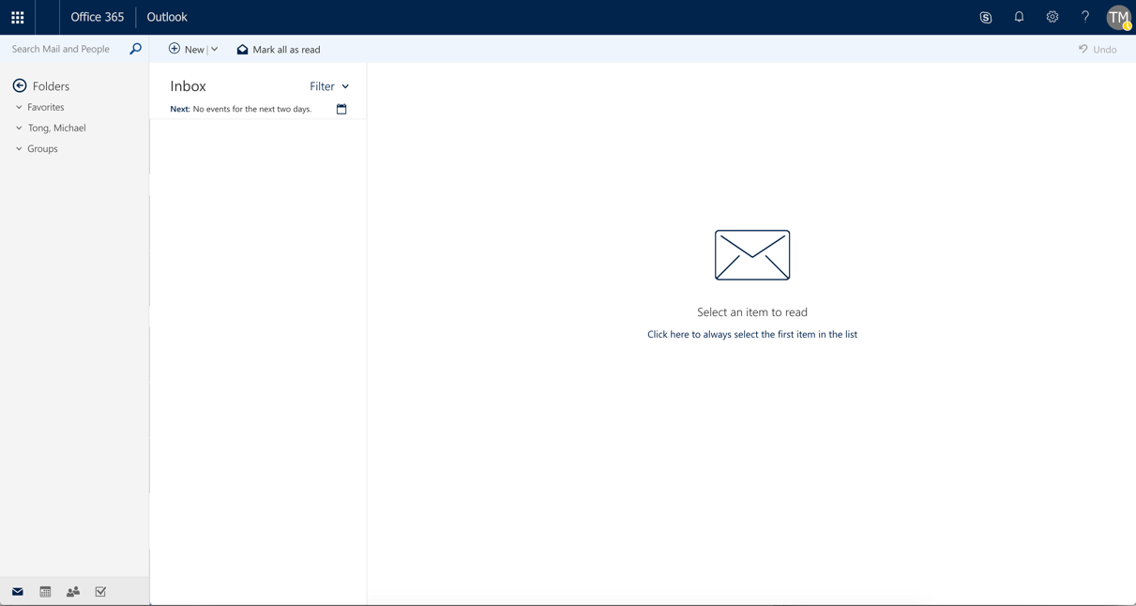

**Figure 7:** Outlook Interface