Assignment M3: Outlooks for Outlook

Michael Tong  
mtong31@gatech.edu

**Abstract.** This report provides an overview on three prototype ideas that were conceptualized through detailed brainstorming for the Outlook interface. The report discusses the implementation of a new email option, standardizing design across platforms, and new buttons, all of which are to increase the efficacy of the interface.

# Introduction

Previously, Assignment M2 (Tong 2018) discussed and analyzed the Outlook interface to identify if and where improvements can be made. From the survey, apprenticeship, and exploration of similar interfaces, the results determined that the focus should be on the overall layout, as well as email, calendar, and meetings features. It was also discovered that over 90% of respondents to the survey use Outlook for work, and not personal use, which led to the focus on increasing work environment productivity as stated in the Data Inventorying section of Assignment M2. In this report, the focus is on translating the results of the discussion and analysis into new ideas to improve the Outlook interface. The discussion beings with a brainstorming session where conceptualization of ideas begin.

## Brainstorming the Plan

As recommended by the lectures the brainstorming session begins with an individual approach and then moves into a group session. To enhance the brainstorming exercise, I’ll be performing it three times throughout the week which provides the benefit of allowing new ideas to form, and more importantly gives me some time to actively focus on improvements as Outlook is used throughout the day. Since the interface contains various components of interest, brainstorming will also be broken down into individual sections, focusing on the three major features identified in assignment M2, namely email, meetings, and calendar, in additional to the interface overall. After day three, I will be meeting with a UX subject matter expert to discuss additional ideas. The goal of this process will be to aim for 20 ideas in total.

## Execution and Results

The brainstorming exercise was executed as planned and achieved the 20 ideas. Unfortunately, the group session wasn’t too productive and only created an additional two ideas. These ideas are captured in a markdown chart shown in Figure 1 below. From the results, it’s found that most ideas are captured in the email interface, which is beneficial since the needfinding survey results supported the hypothesis that most people use the platform for this particular feature.

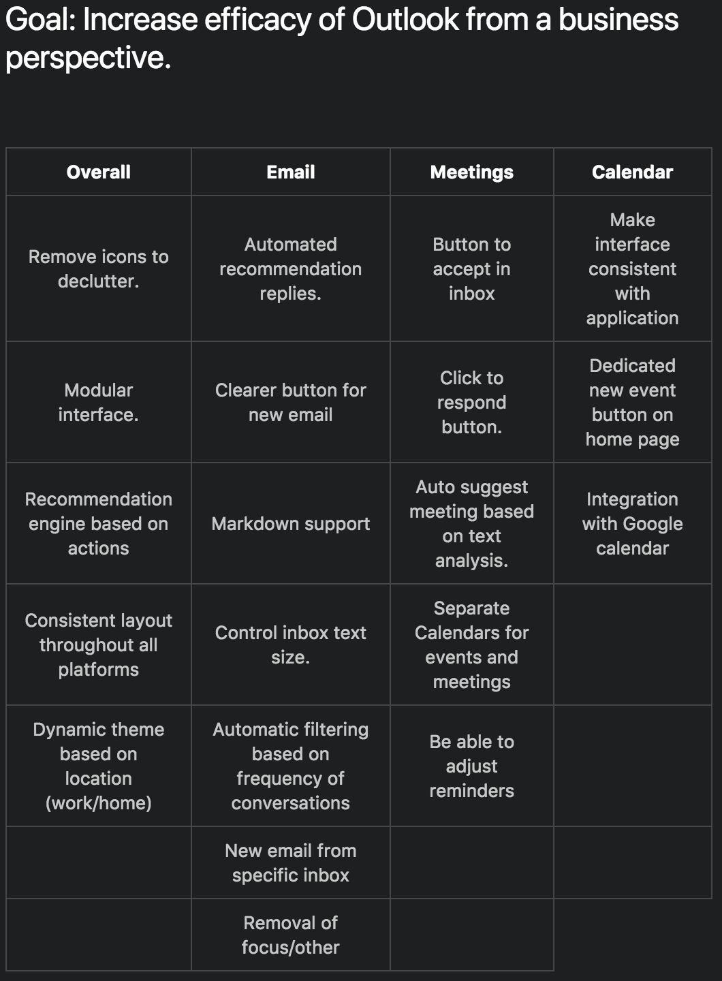

**Figure 1:** Brainstorming results

## Selection Criteria

From our brainstorming results our plan is now to isolate three specific ideas to be prototyped in the follow sections. The approach used for selection is the generation of different personas within an office environment, which emphasizes the requirements definition from M2. Four personas are created which represent a non-technical employee, technical employee, secretary, and manager, and are displayed in the appendices. From these personas it’s identified that email should be the primary focus of the interface redesign and as such, one idea to focus on is the implementation of a “New Email” button from a specific folder location. This addition will automatically place email responses from an email chain into the folder that it was created from, instead of having to drag it from the inbox after receiving a response. The next idea explored is to make the application consistent throughout all platforms. From the web application, it is significantly different from the desktop application, mostly in the display of icons, but also in functionality. This idea targets the implementation of a consistent layout through web, desktop, and mobile. The final idea considered for a prototype design is the creation of an overlay button on emails for meetings and events that allows the user to quickly respond to them. Currently, when emails are highlighted additional buttons appear on the top right which provides the option to delete, achieve, and flag the email. When a meeting or event is highlighted, these buttons could be altered to include accept, tentative, and decline in response to the contents.

# Prototype 1: Wireframing

For the implementation of the “New Email from Folder” idea, the decision is to prototype it through a wireframe. Shown below in Figure 2, the wireframe is simple to exemplify the fact that it is a prototype and is colored to highlight the areas of significance. Purple is the selected folder, the “New” button which exists on the current interface is grey to show it’s depressed, and the yellow highlight is used to show the considered idea.

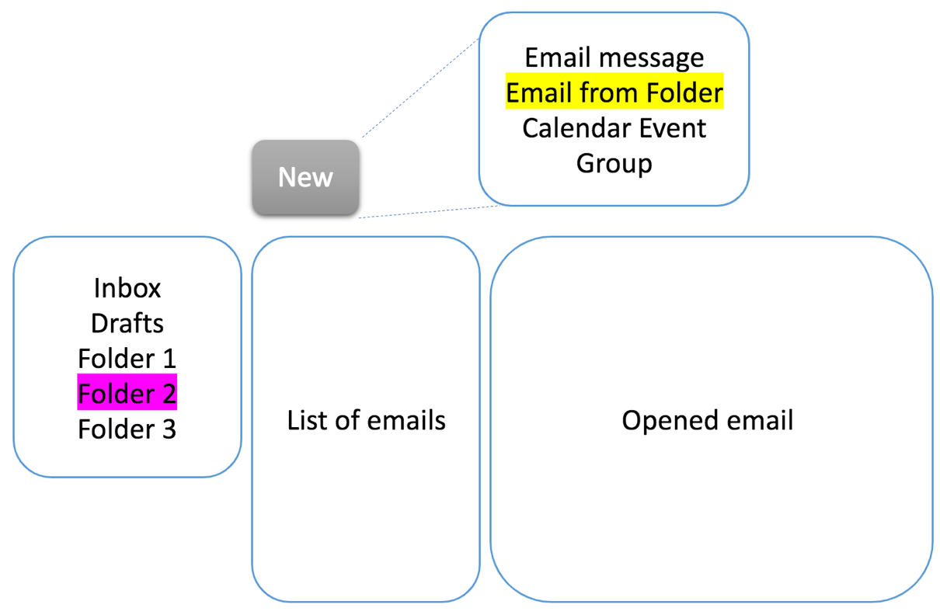

**Figure 2:** New email option wireframe.

From the wireframe, the prototype establishes a new option for the Outlook interface which can help users better organize their emails. As a result, this prototype improves the working productivity of users, which meets one of the requirements definitions discussed in the M2. With the surveyed population primarily using Outlook at work, the implementation of this new feature will increase the productivity of users by allowing them to quickly manage emails into specific folders, which the surveyed population mentioned they use to keep track of emails. This idea meshes well with the specific data inventorying discussion made in M2 regarding email efficacy but does not establish innovative conceptions for the calendar or meeting feature, which was also identified to be an area for improvement.

# Prototype 2: Verbal

The idea to create a consistent interface across all platform is prototyped through a verbal discussion to gauge the viability and impact that it may have on users. Similar to the persona selection criteria, these questions are scripted to understand how specific individuals would respond to the particular idea. To generate a better prototype through avoiding personal bias, a UX designer from the apprenticeship discussion in M2 assisted the verbal discussion. To begin this prototype, a verbal description of the idea is curated below.

“I am considering the redesign of the Outlook interface to limit the alteration in the layout and features when you use the application across different platforms such as, on a desktop app, mobile app, or on the web. The goal is to maintain a consistent layout of buttons and options from their respective screens so that you as the user do not have to memorize different nuances when you access Outlook from different locations.”

With the general statement created, additional follow up questions are also constructed to better isolate the desire and suitability of the idea as discussed below.

*“Do you frequently use multiple platforms for Outlook?”* This question aims to understand the usefulness of the idea. If a large number of users do not use Outlook on different platforms, then there may not be a need to streamline the design. From the wise words of my UX mentor, she stated that “no, I only use Outlook for work and do not want work email following me home.” This question would be an excellent survey question for continued needfinding discussed in M2. While this question does not specifically address a work environment to supplement the requirements stated in M2, it is associated with increasing the efficacy of the platform by creating a more invisible interface for users through limiting the gulf of execution. Since many surveyed users stated that Outlook is their primary email for work, the comment stated by my mentor may be significant in determining how useful the alteration really is.

*“Do you make a lot of slips and mistakes when using Outlook on your non-native platform?”* This question attempts to distinguish if the implementation of different platforms hinders the productivity of users by causing accidental operations. This question once again attempts to understand the efficacy improvements resulting from the idea and thus the potential need.

*“Are there platform specific functions that you utilize?”* If incorporation of this idea does come into fruition, it is important to maintain features that users may be acclimated with on specific platforms. Since the platforms differ, if the decision is to unify the design into a single one it will be important to determine which features to maintain and remove from their respective origins.

*“Which platform do you use the most and which do you believe has the best layout?”* This question aids in isolating the platform to work off of. Based on the results of this question, a higher fidelity prototype can be built off of the specific platform.

The responses to the verbal prototype supports the data inventorying guidelines stated in M2 for continued needfinding by presenting additional survey questions that can be presented to another survey population. While it fails to directly influence the improvement of Outlook in a corporate or work environment discussed in the defining requirements section of M2, the idea does potentially impact the efficacy of the interface through limiting the gulf of evaluation through increasing consistency.

# Prototype 3: Textual Prototype

From the survey comments generated in M2, a large portion of users stated that their email inbox often clutters up quickly. To aid in alleviating the number of emails, the introduction of a quick select button for meetings and events may improve the efficacy of the interface and benefits a working environment as emphasized in the M2 discussion and analysis. The integration of these buttons will allow users to quickly select their response to meetings and events that they expect to be coming or are on a repeated schedule. Currently, when emails in Outlook are highlighted icons appear in the top right corner that allows a user to quickly delete, achieve, or flag the selected email. These buttons are used to help cycle through emails faster by limiting the movement and clicks necessary to complete those specified actions. The idea presented in this section is to append three additional buttons that will act similarly but specific to meetings and events. These buttons will mimic the current selection options for meetings and events, namely accept, tentative, and decline. The icons will also match them in style which is a green checkmark, purple question mark, and a red cross, respectively. Once the specific response is chosen, the calendar icon should provide feedback to notify the user that the action was taken, maybe along the lines of jumping or vibrating in place.

Since 75% of respondents stated they used the calendar feature, 66% stated that they use the meetings feature, and over 90% stated they use Outlook primarily for work, the ability to quickly respond to meetings may increase the productivity of users in a working environment. From the requirements stated in Assignment M2, the implementation of this idea satisfies the focus on efficacy in a working environment and meshes well with this audience since meetings and events tend to be work and productivity focused.

# Conclusion

After brainstorming 20 new ideas, three were isolated through a persona model and analyzed with a wireframe, verbal, and textual prototype. These prototypes together cover the demands of the data inventory section of assignment M2 through understanding the user, their goals, requirements, and continued needfinding. With this report, a higher fidelity prototype can be approached to improve upon the Outlook interface.

# References

1. Tong, M. (2018). Assignment M2: Outlooks for Outlook. *OMS CS6750 Human-Computer Interaction*. Washington, DC.

# Appendices

Personas are displayed below:

Joe

**Position**: Stock room

**Primary use:** Email

**Frequency of use:** Limited

**Desires:** Simple interface, accessible, efficient.

Stacey

**Position**: Engineer

**Primary use:** Email, meetings, calendar

**Frequency of use:** Occasionally

**Desires:** Control of the interface, ability to easily separate projects, automatically manage meetings.

Sam

**Position**: Secretary

**Primary use:** Email, meetings

**Frequency of use:** Frequently

**Desires:** Keep track of emails more efficiently, manage meetings and arranging them simply.

Emily

**Position**: Manager

**Primary use:** Email, meetings, calendar

**Frequency of use:** Frequently

**Desires:** Ability to send out emails to people of interest, manage meetings and scheduling.