Part 1: Technical Indicators

For the first portion of this report, a discussion of 5 technical indicators will be discussed, namely, simple moving average (SMA), Bollinger Bands (BB), exponential moving average (EMA), moving average convergence divergence (MACD), and stoichastic oscillator (SOSC). Implementation of these indicators into a trading strategy will be discussed in the following sections.

The first technical indicator, simple moving average (SMA), is aptly named as it is simply a rolling mean across data points. A rolling mean consists of data and a window, and returns another dataset. The returned dataset points represent the average of values prior to that point, where the number of points to average over represents the window (often in the notation of X-day SMA, where X is the window length). When this model is applied, it suppresses outliers in the dataset by diluting their overall impact. The SMA is commonly used as a means to apply other technical indicators and to return a smoother trend of data. There are some anecdotal trends that are identified through the SMA, such as the “death cross”, which represents a bearish signal, and occurs when the 50-day crosses the 200-day SMA. Implementation of the SMA is also characterized by it’s name, due to the pandas library providing a specialized method for applying a SMA to a pandas dataframe. The pandas method used is pandas.DataFrame.rolling(window).mean(). Implementation of this method on the JPM stock data is shown below.
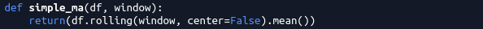Code 1: Pandas implementation of SMA

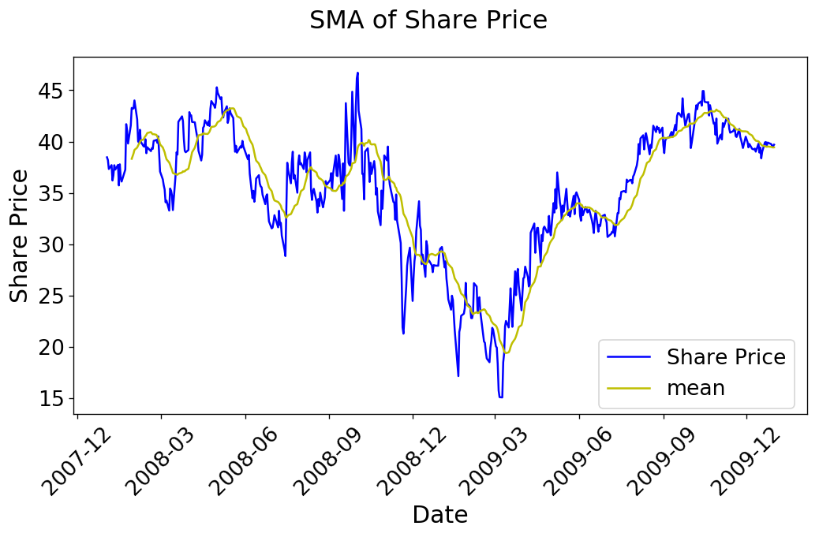Figure 1: 19 Day SMA for JPM
As discussed earlier, the SMA is typically utilized as a foundation for other technical indicators. One such indicator is the Bollinger Band (BB). BBs are a common indicator which generates two additional datasets to represent the SMA adjusted by the standard deviation. What manifests is two SMA trends above and below the SMA, where the separation from the SMA is a proportion of the rolling standard deviation. Commonly, the standard deviation used is two, both above and below. The rolling standard deviation is found similar to the rolling mean, using the pandas library shown below, with its associated plot. The plot uses a standard deviation of 1.45, which had been optimized for portfolio return (discussed in the later sections)

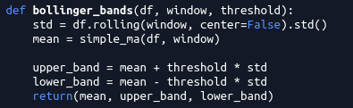Code 2: Bollinger Band Implementation

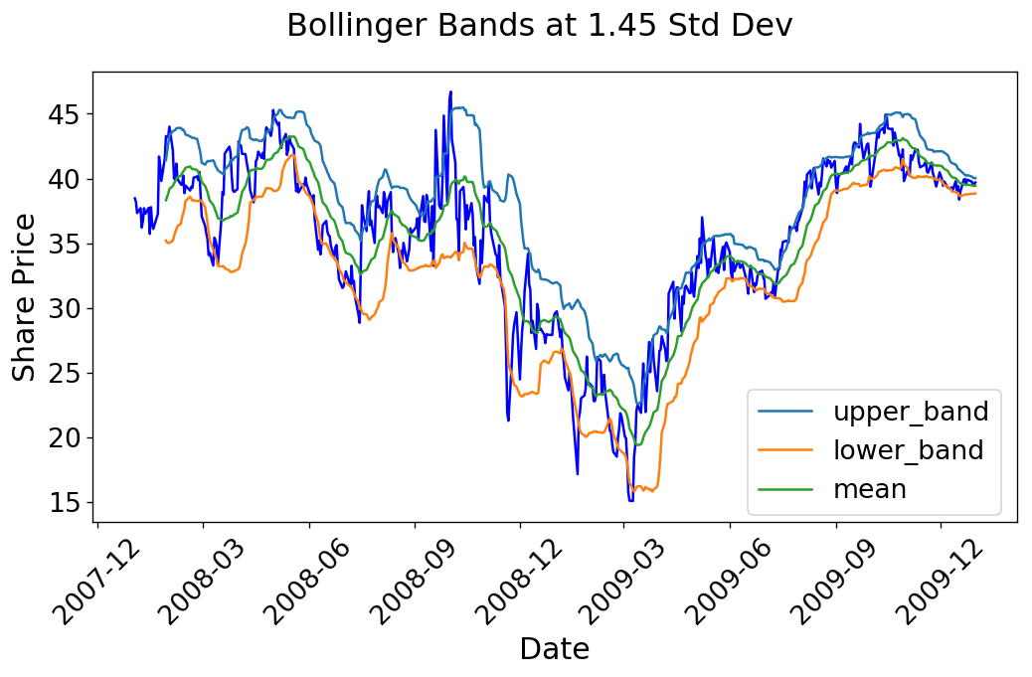Figure 2: 19 Day Bollinger Bands and SMA For JPM (note the 1.45 std deviation as opposed to 2)

SMA is not the only popular method to average datasets for technical indicators. The Exponential Moving Average (EMA) is another method of producing a “rolling mean” trend. EMA is similar to the SMA in the rolling regard, however, EMA weighs recent data more heavily, meaning that recent price changes have a larger impact on the moving average. The EMA forms a similar plot trend to the SMA, and is used in similar regards. Typically the EMA notation is EMA-X, where X is the number of days, or the window period. The EMA is often used as a foundation for other technical indicators as well, which will be discussed in succeeding sections. Implementation of the EMA through Python is once again through the pandas library, shown below, with it’s respective plot for the JPM ticker.

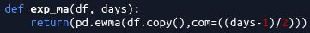Code 3: Exponential Moving Average Implementation

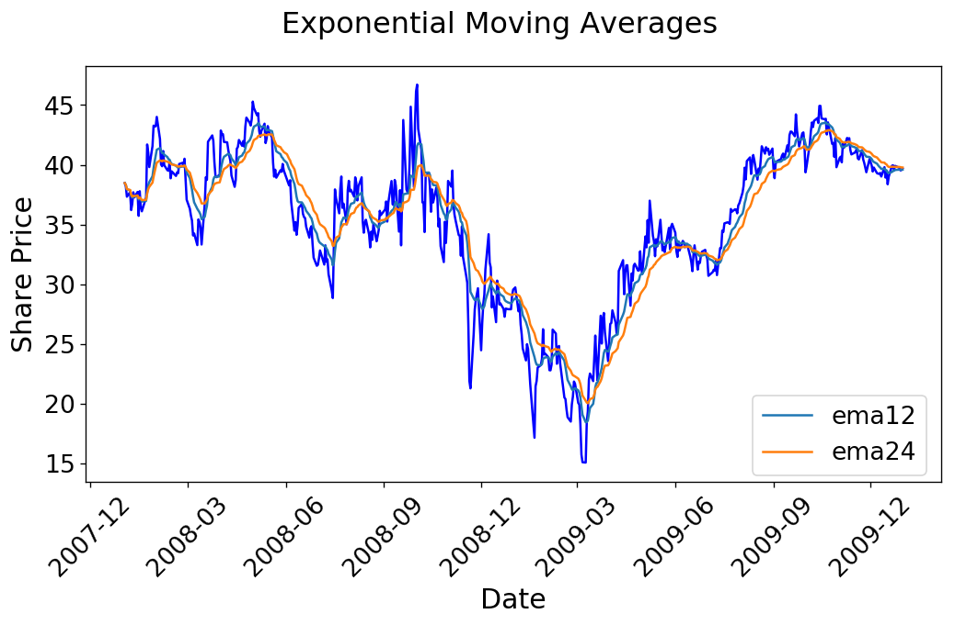Figure 3: 12 and 24 Day EMA for JPM

An application of the EMA can be found in the Moving Average Convergence Divergence (MACD), which is classified as a momentum indicator. As such, it seeks to determine how “strong” a price point is moving, through the comparison of two moving average points. For the MACD an EMA is used to determine two components, the MACD and the MACD signal. The signal is simply a moving average of the MACD, which is utilized as a indicator of strong movements if crossed. The traditional MACD windows used are 26 and 12 day EMAs. Therefore the MACD is simply calculated as the difference of the two EMAs, and the MACD signal is determined as a moving average of those points. The Python implementation and plot is provided below.

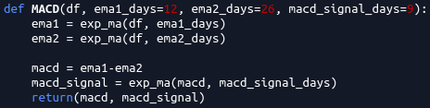Code 4: MACD Implementation

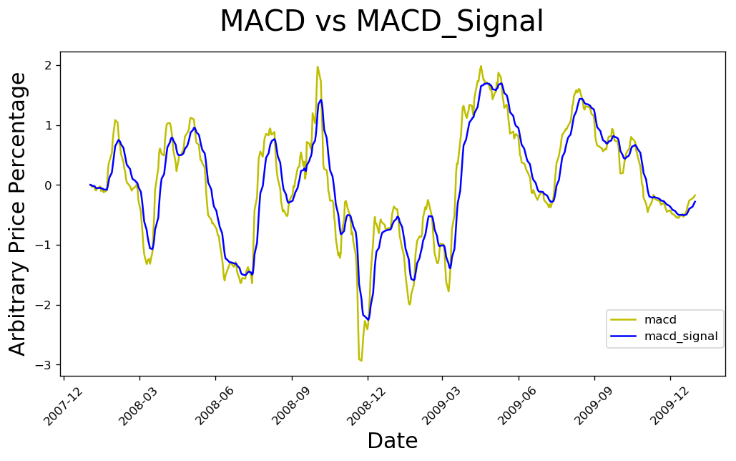Figure 4: 12/26 day MACD Plot for JPM with a 9 Day Signal

Another momentum indicator implemented for this strategy is the Stochastic Oscillator (SOSC). Being an oscillator, this analytic method returns normalized values scaled between 0 to 100. Rather than returning specific price points, this analytic tool is a relative measure of where a point lies with respect to the rolling window’s high and low prices. This value is captured commonly as the variable “K”, and analyst typically further average the “K” value over a short period to dilute any extreme values (eg. the min or max of the window), which is represented as “D”. The traditional moving average window for D is three days, whereas the min and max window is 14 days. Often, the SOSC is used to determine when a particular price point is oversold or overbought, which is traditionally represented as K or D values below 20 and above 80 respectively. To find the SOSC values at specific data points, a rolling min and max is first calculated, and each point within the window is compared to those values using the formal expression shown below:

Implementation in Python surprising utilizes the Pandas library once again, where the rolling min and max functions are calculated.

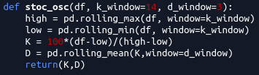Code 5: Stochastic Oscillator Implementation

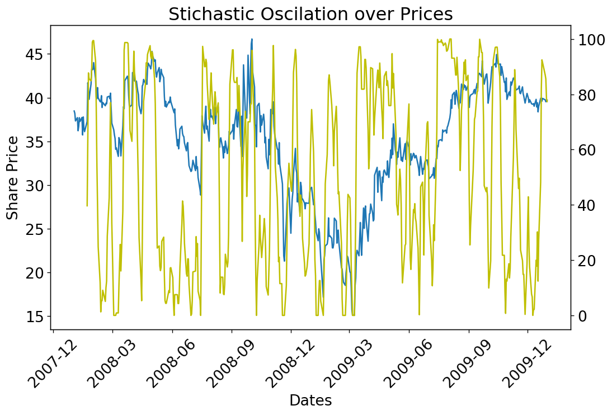Figure 5: Stochastic Oscillator "D" Value plotted over the JPM Share Price
Part 2: Best Possible Strategy

For our manual strategy, a performance comparison is generated by creating a function which returns a list of trades that maximizes returns for a given share over a period of time. Historic adjusted close prices are used, and the concept implemented is that a share is longed prior to a rise, and shorted prior to a descent. To generate these trades, the difference between successive days was first determined, which represents if a share increase or decreased in value in the following day. The Python implementation used to determine this is a difference between the share price data and a shift of the share price data by one day. Once we have the price difference between each successive day, the actual difference is not relevant, so for my implementation I had normalized the values to either 1 or -1, representing increases and decreases respectively. Since there may exist successive dates where the price does not change, the returned value is zero, which in my implementation returns a nan value due to the normalization process used. To avoid future issues, these nan values must be accounted for. Since the eventual goal of this process is to determine inflection points in the price data, that is, when the price difference changes from positive to negative or vice-vera, a backfill for the price difference can be used. A forward fill method was not employed due to it potentially creating a signal on the last day, if it were to be a zero difference day, thus creating information.
With our price difference dataframe, the goal is to trade on instances where the values change sign, or the inflection points. This is performed by comparing the previous date’s signage

