Our AI helps us identify microorganisms in sample plates and it is able to differentiate between types of bacteria. You can use this link to see some image samples: https://we.tl/t-Sb2cAmhhxDvybDOq

We want to take our AI to the next level. We are currently spending too much time and using too much manpower making annotations. We want our AI to be able to identify colonies and bacteria automatically and ask us to annotate those which it is uncertain.

Our current system is running on DINOv3, which we believe is a superior architecture than YOLOv8 or RT-DETR. We are interested in maintaining DINOv3 and develop it further to improve its automation. In the end we want to reduce the manual labor as much as possible using the same model. Do you think this is possible?

https://ai.meta.com/research/dinov3/

This is a flow diagram of our current model. Where could we implement that detection head?
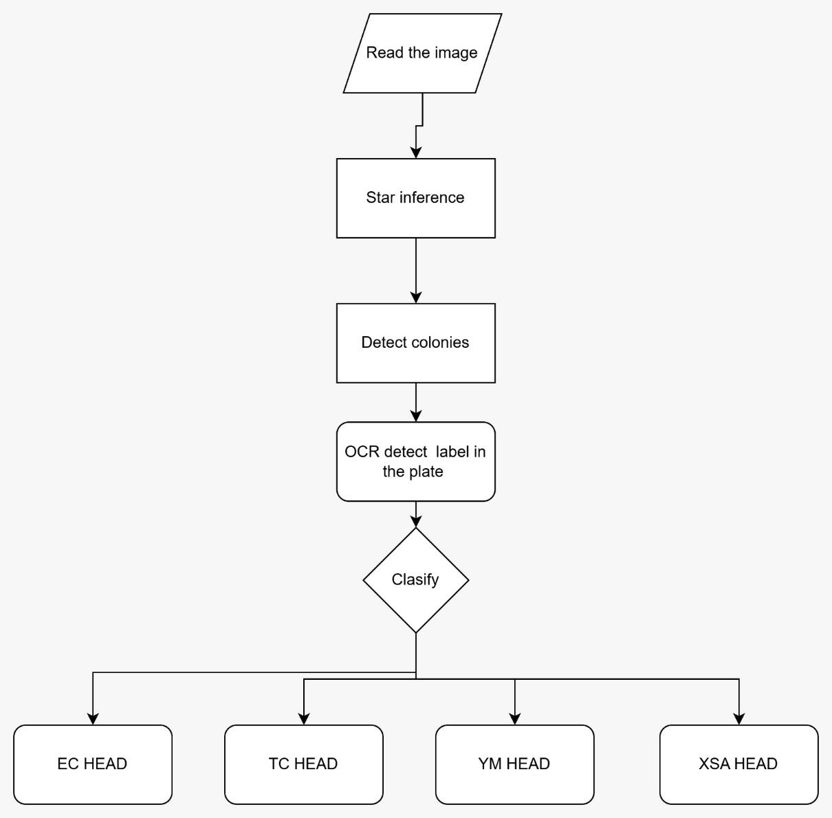
The main issue is before we begin training the AI we generate a dataset with an average of 2000 images that need to be manually annotated

Me:
1. Start with 100–200 randomly selected images – annotate normally. This gives the first model something to learn from.
2. Train initial model.
3. Run inference on all remaining ~1,800–1,900 images.
For each image, your DINOv3 + heads produce predictions for every colony. Compute an image‑level uncertainty score by:
- Averaging per‑colony entropy across all colonies in the image
- Or taking the minimum confidence of any colony (to catch challenging plates)
4. Sort images by uncertainty, select the top 5–10% (e.g., 100–200 images). These are the images the model is most confused about.
5. Send only those images for human annotation. Your team labels them – but now they are labeling the model’s blind spots, not random images.
6. Retrain the classification heads on the expanded labeled set.
7. Repeat steps 3–6 for 4–6 rounds. Each round the model improves, and the number of uncertain images shrinks.
After 4–6 rounds, you typically reach the same accuracy as training on 2,000 random images, but with only 500–600 total annotations.

I can build you a lightweight active learning script that plugs directly into your existing DINOv3 pipeline:
- It loads your trained model (or a partially trained one)
- Runs inference over a folder of unlabeled images
- Computes uncertainty scores
- Outputs a ranked list of images to annotate next
- Optionally integrates with Label Studio for seamless handoff

We convert the raw export from Labelbox into an internal target format because Labelbox provides annotations in an administrative format and in pixel coordinates. Our model requires a compact, normalized, and head-aware format: bounding boxes [cx, cy, w, h] in the [0,1] range, clean labels, and enough information to derive plate_id and head_id. We also filter/remap non-bacterial labels so that DETR training learns only the classes corresponding to each head.

IT says: Ideally, we should use DINOv3 because ResNet50 was the first backbone we used, and it didn’t work completely well; it failed a bit.

IT says that the point is that we are looking to optimize Dinov3. If you use resnet then the demo will be similar to something that we had before.

The team is a bit cautious about giving direct access to our codebase. Instead, the idea is you could talk us through how the active learning setup works, what changes were made, and how everything connects and we can implement it on our end. Some documentation or an explanation would work.

Moving forward, we now want to improve our model. Like I mentioned before, we are cautious about sharing access to our code. However, we would like to know if you would be interested in developing a complete tool for us, adapting the improved active learning. The idea is that you think outside of the box and show us different or new ways to improve the model. If you are interested, please feel free to send me your quote for that kind of work.

Sure, let me explain more clearly. At first we mainly wanted your feedback on how to improve our current setup and whether what we had was already the best possible approach.

Now, what we'd like is for you to actually build and implement the system. Basically, we need an Al service/server that receives photos and returns inference results automatically.

We'd also like you to evaluate and use a better model or training/inference system than the one we currently have, if possible.

Optimally DINOv3 or better.

The manager is interested, he would like to know a few things before moving forward. He would like to clarify if you would give us a fully trained model or if we have to do it ourselves. Basically he wants to make sure we are getting the complete model and that there are no hidden costs
When we train our current model, we have to rent a gpu at a data center and spend almost a week training the model
We understand from your quote that you will build and also test the model but we want to be able to see it in action as it moves forward.

Option 1 sounds good to us. As I understand it, you would deliver all of the work you've completed, including documentation or evidence of the training process and how long it took, so that we can modify or retrain the model ourselves in the future if needed.
Could you also clarify how you would deliver everything at the end of the project? Would it be provided as a compressed file, or would it be possible for you to create a GitHub repository that we can access during development to monitor progress, and then transfer ownership or provide the full repository upon completion?
Please let us know what delivery method you recommend and what materials will be included in the final handoff.

YM : 30 EC : 30 TC : 25 XSA : 25 LM : 25 ETB : 20 BC : 20 LS : 15 ALL : 10

