Assignment2

Michael Vanderbilt

Matthew Chan

Code

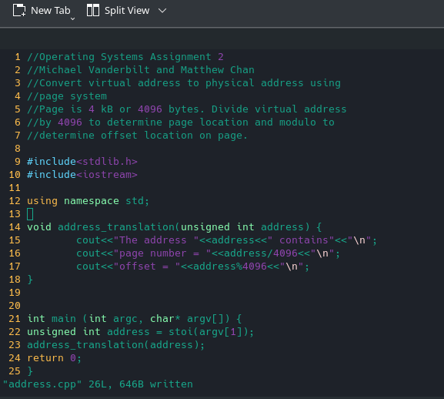

Sample Run

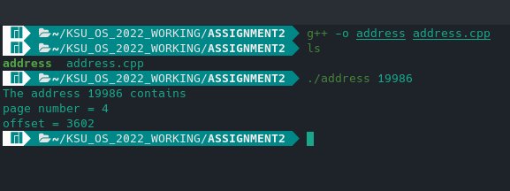

Analysis

1. Program is to take the virtual address and convert to the actual physical address
2. Code takes the virtual addres number
   1. Code uses the paging system ie page is 4096 bytes
   2. In the sample run 19986 bytes is divided by 4096 with an integer result of 4
   3. Thus the page number is 4
   4. The remainder of 19986 by 4096 provides the offset of direct location on the page