Assignment2
Michael Vanderbilt
Matthew Chan

Code

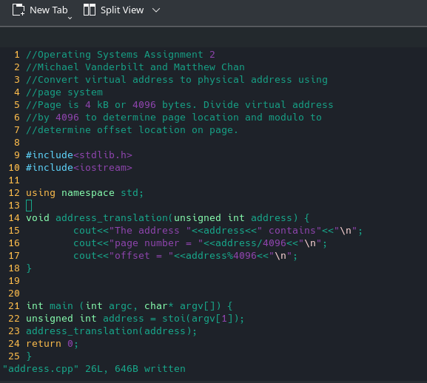

Sample Run
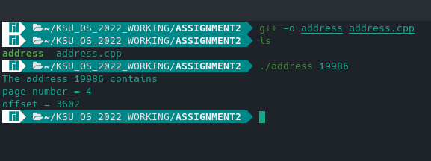

Analysis

- Program is to take the virtual address and convert to the actual physical address
- Code takes the virtual addres number
  - Code uses the paging system ie page is 4096 bytes
  - In the sample run 19986 bytes is divided by 4096 with an integer result of 4
  - Thus the page number is 4
  - The remainder of 19986 by 4096 provides the offset of direct location on the page

