**Problem 1:**

Step size = 10-2. Time for entire simulation = 28.87 seconds.

Torque as a function of time with step size of 10-2:

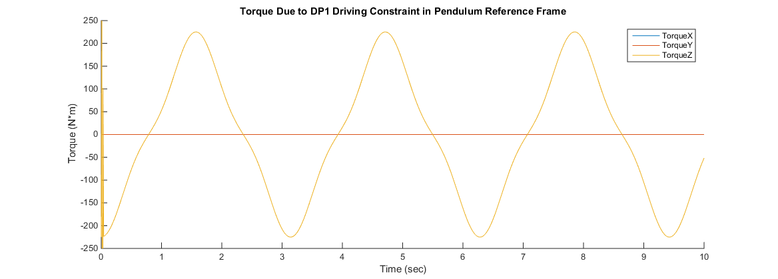

**Problem 2:**

Step size = 10-2. Time for entire simulation = 49.22 seconds.

Results for origin of 1st pendulum:

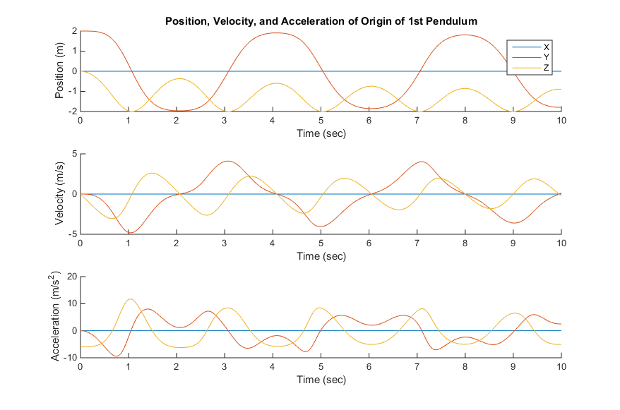

Results for origin of 2nd pendulum:

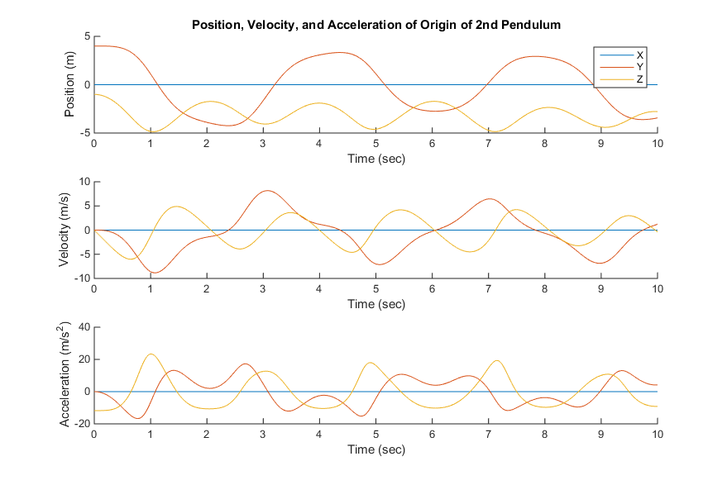

Results for violation of velocity constraint equations for revolute joint between the pendulums:

