**Problem 1:**

Simulation Times with h = 0.01 s:

Newton-Raphson = 56.4 s

Modified-Newton = 42.8 s

Quasi-Newton = 39.1 s

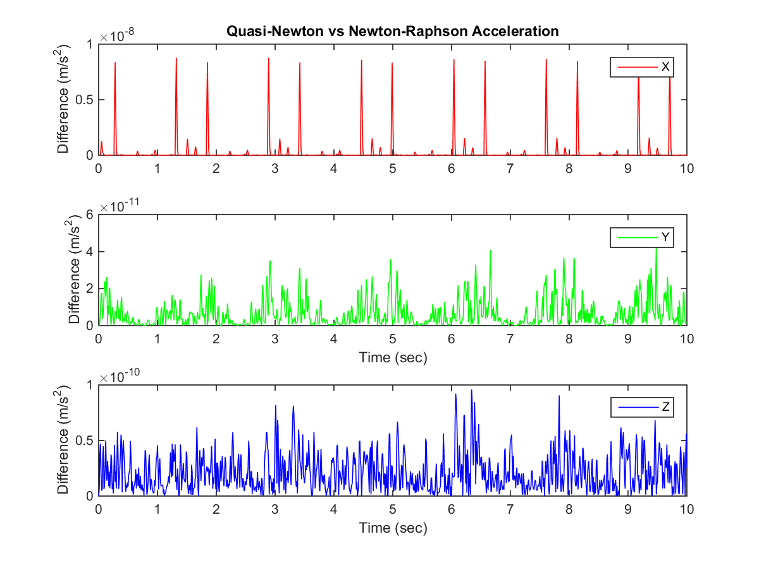

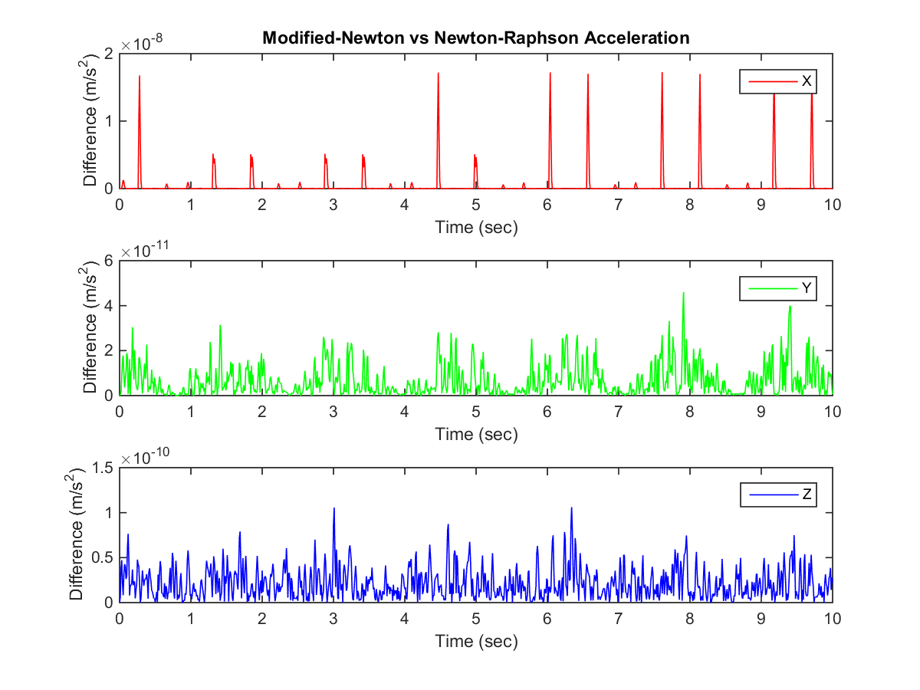

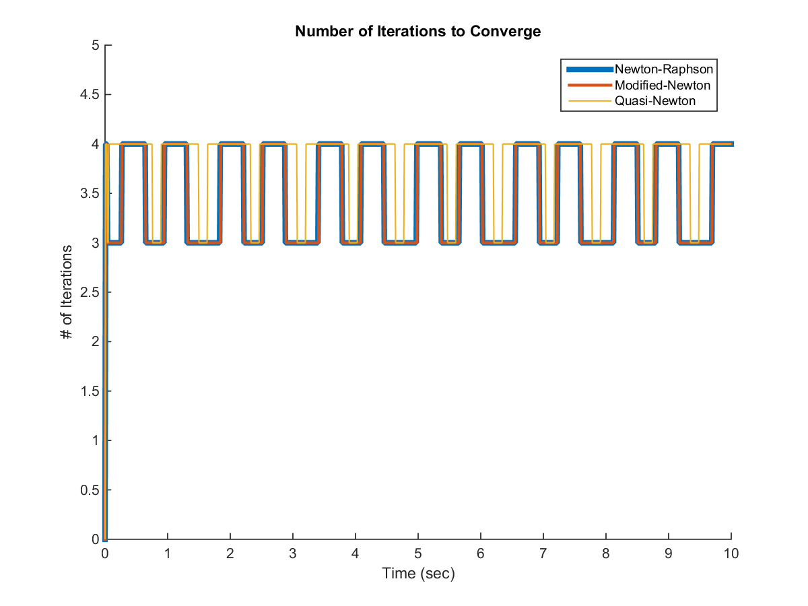

**Problem 2:**

Simulation Times with h = 0.01 s:

Newton-Raphson = 109.3 s

Modified-Newton = 79.2 s

Quasi-Newton = 68.3 s

