**Problem 1:**

Torque due to DP1 driving constraint vs time:

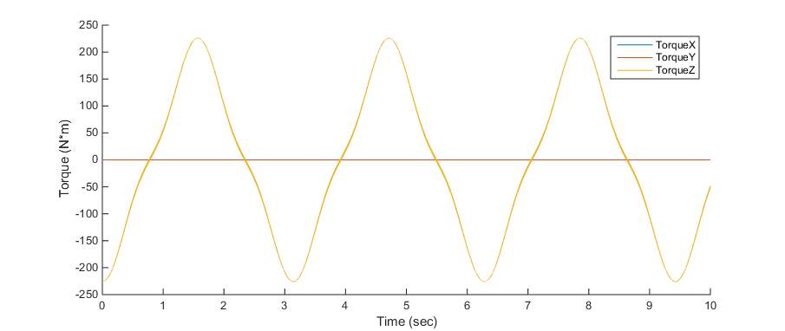

Torque due to DP1 driving constraint and ϴ(t) vs time:

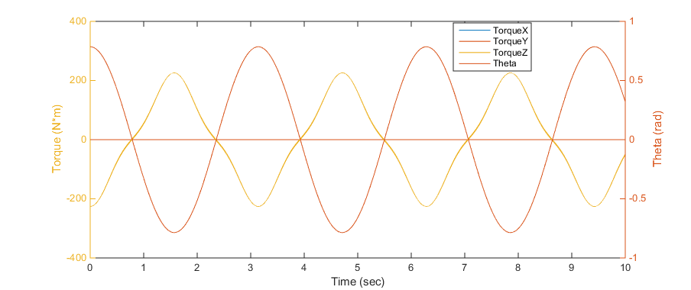

**Problem 3:**

Theory suggests that this initial value problem has a stability region where $\left|1+hλ\right| ≤1$. Therefore, the solution should become unstable in each case as follows:

*λ* = -10, *h­unstable* = 0.2

*λ* = -100, *h­unstable* = 0.02

*λ* = -1000, *h­unstable* = 0.002

See the plots below. These show the Forward Euler solution and the error of the Forward Euler solution for each value of *λ* and a range of values of h. By looking at the error plots we see that, for each value of *λ*, the Forward Euler solution is stable when h is smaller than *h­unstable*, but becomes unstable once h becomes greater than *h­unstable*.

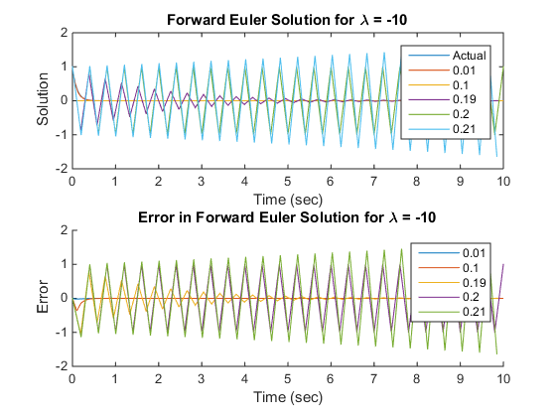

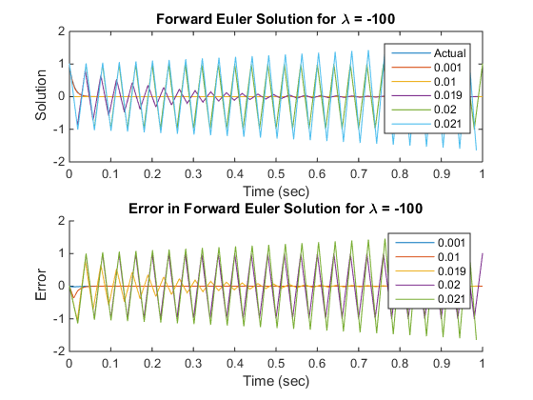

**h = 0.0021 removed:**

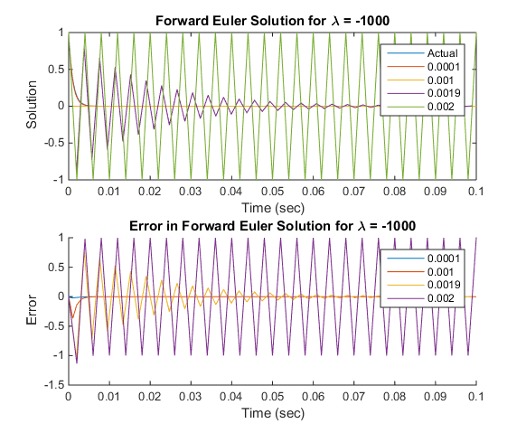

**h = 0.0021 included:**

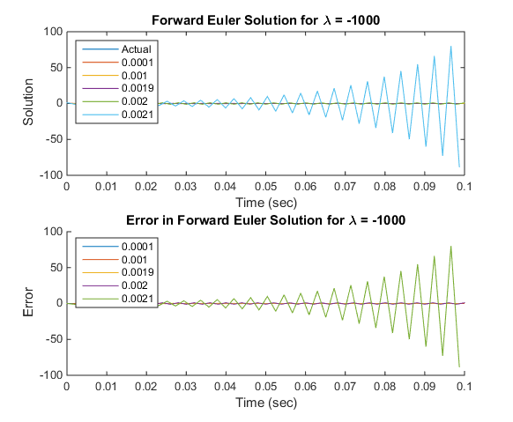

**Problem 4:**

See first plot below for the solution when α = 0 and β = 1. For the sensitivity analyses I varied α between -2 and 2 while keeping β = 1 and varied β between -1 and 3 while keeping α = 1. Ideally, I would have kept α = 0 for the β sensitivity analysis because this is the nominal value, but there is no variation in x(t) or y(t) when α = 0.

This sensitivity analysis showed that y(t) is much more sensitive to α and β than x(t). Also, it showed that both x(t) and y(t) are more sensitive to α than β.

**Exact solution for x(t) and y(t):**

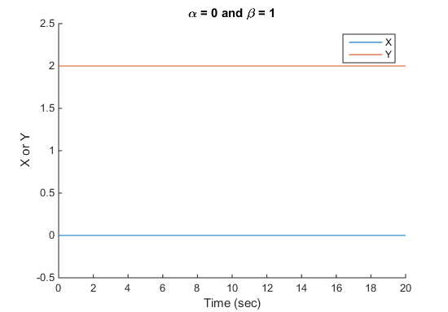

**Sensitivity to α when β = 1:**

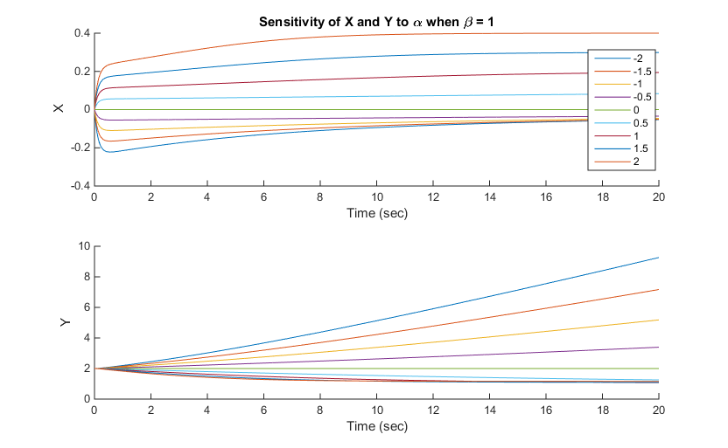

**Sensitivity to β when α = 1:**

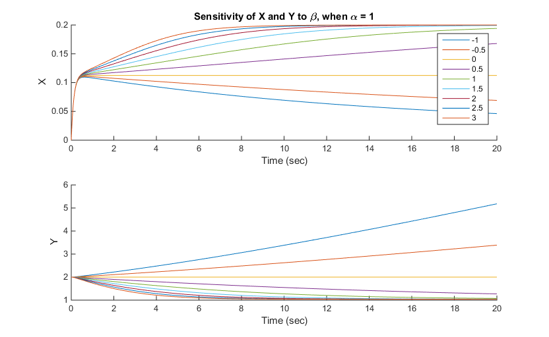

**Problem 5:**

See figure below for the convergence plots of the Backward Euler and the 4th order BDF methods. The slope of the Backward Euler convergence plot is 0.997 and the slope of the 4th order BDF plot is 3.974. As expected, the slope of the Backward Euler convergence plot is approximately 1 and the slope of the 4th order BDF convergence plot is approximately 4. I expected these values because the slope of the convergence plots should represent the accuracy order and the convergence order of these methods, which are 1 and 4, respectively.

