Project Introduction
This project provides tools for analyzing chromatogram data using CNN and YOLO models along with a graphical user interface.
- gui_peak_detection_CNN_YOLO.py: Provides a graphical user interface for peak detection and segmentation of chromatogram data, supporting CNN and YOLO models.
- read_cdf.py: Used for reading and processing chromatogram data files in CDF format.

Dependencies
This project requires the following Python packages:
- os
- netCDF4
- pandas
- numpy
- scipy
- matplotlib
- collections
- json
- tkinter
- PIL
- torch
- torchvision
- cv2
- ultralytics
Please ensure the latest versions of these packages are installed.

Classes and Methods

EnhancedChromatogramGUI
This class provides a graphical user interface for peak detection and segmentation of chromatogram data.

Main Methods
- detect_peaks_and_contours(): Detect peaks and contours.
- display_roi_segmentation_detail(): Display ROI segmentation details.
- load_cdf_file(): Load CDF file.
- load_cnn_model(): Load CNN model.
- load_yolo_model(): Load YOLO model.
- perform_yolo_segmentation(): Perform YOLO segmentation.
- apply_models(): Apply models.

ReadCdf
This class is used for reading and processing chromatogram data files in CDF format.

Methods
- drift_time(): Calculate drift time.
- interp(): Interpolation processing.
- modulation_time(): Get modulation time.
- scan_duration(): Calculate scan duration.

Usage

GUI Interface
To use the graphical user interface, run the gui_peak_detection_CNN_YOLO.py script. The interface will allow you to load CDF files, select model weights, adjust parameters, and view detection results.
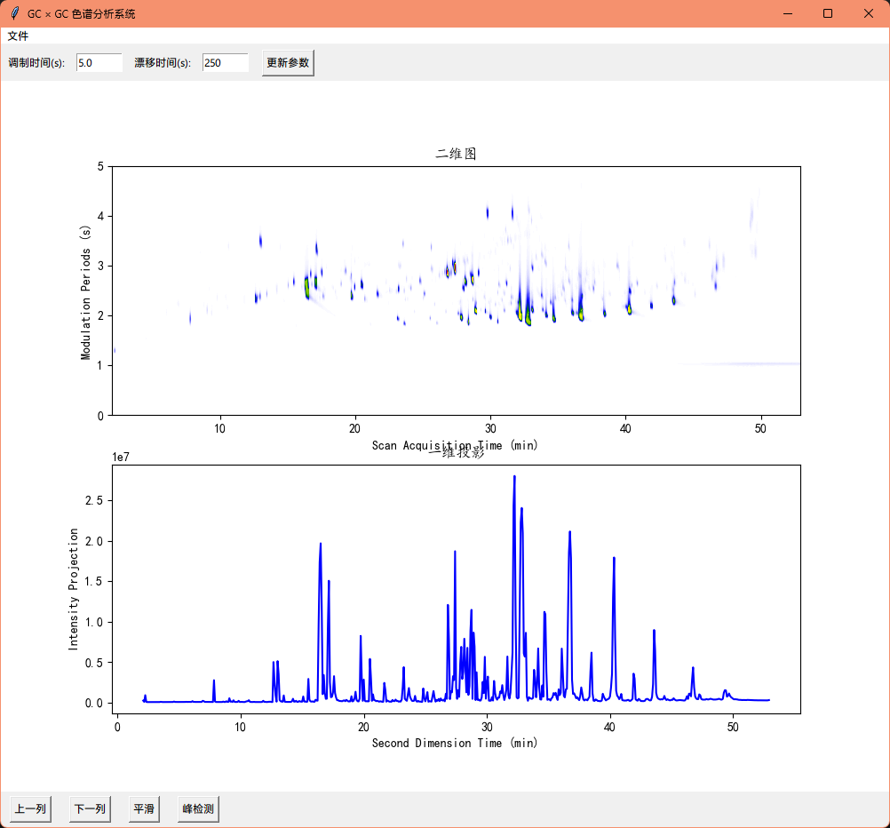
Click on peak detection for preliminary contour detection and to construct the contour heat map (ROIs):
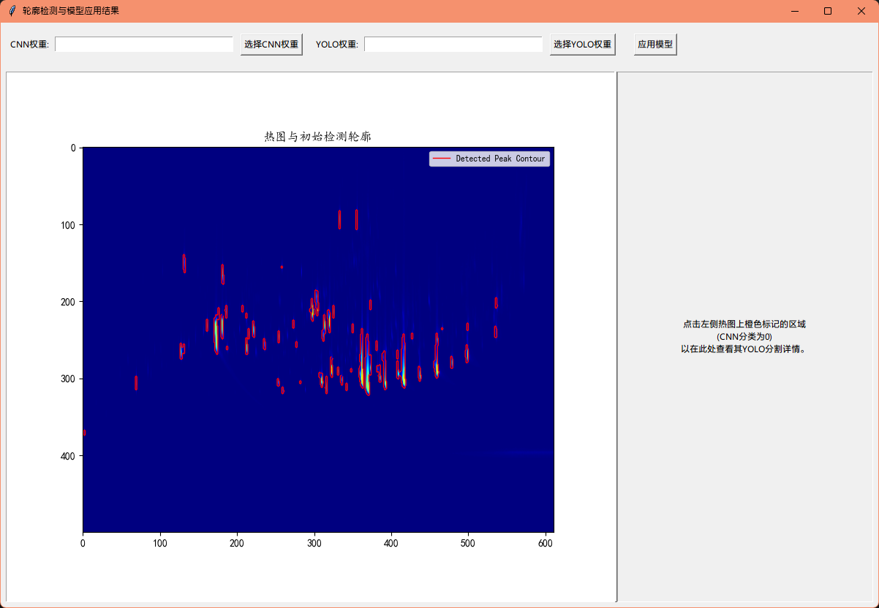
Select the classification model weights and YOLO segmentation model weights to automatically perform contour classification and segmentation. The results are as follows:
