**Forwarding:**

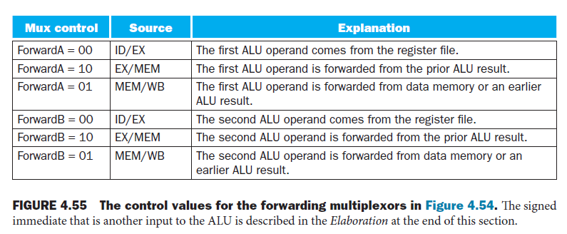

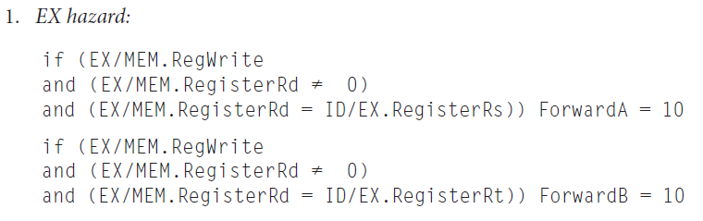

*2. MEM hazard:*

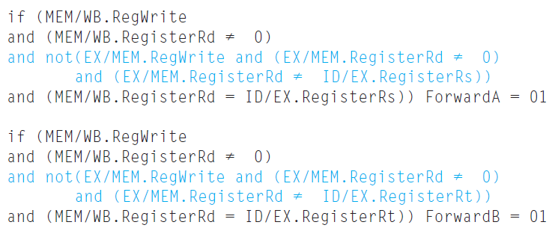

**Stall hazards:**

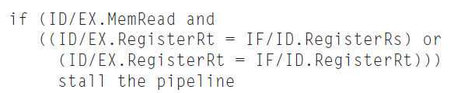

**Diagram to use for the hardware**

