VIAX ESSAY COURSES MIKE WANG

WEEK 1 SEPT 18TH, 2020

**Viax Home-Work 1**

**Part I: Choosing the most informative 5 channels**

After cutting out the prior seizure onsite samples and post seizure onsite samples, I plotted the voltage vs sample graph for each of the 47 channels (as shown in the following figures). By inspection, the majority of the channels are varying smoothly, which shows no sign for correlation with seizure. However, for channel 21, 22, 23, 24, and 25 contain periodical spikes during the seizure onsite time period. Therefore, in the following experiment, we will be focusing on the line-length, energy, variance and spectral power analyses on these five channels.



**Part II: Find the following features (line length, energy, spectral power) and plot them accordingly**

1, Line Length (Window = 1s, Window Moving = 1s/step)

Based on the Line Length equation:

We plot the graph respect to all five channels:

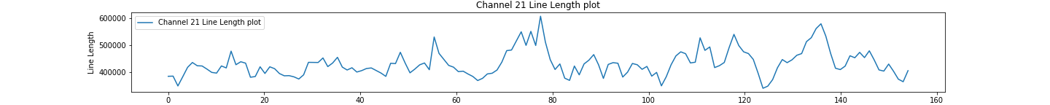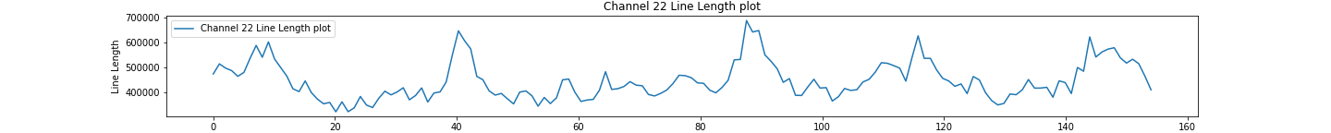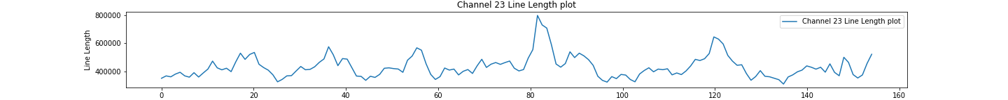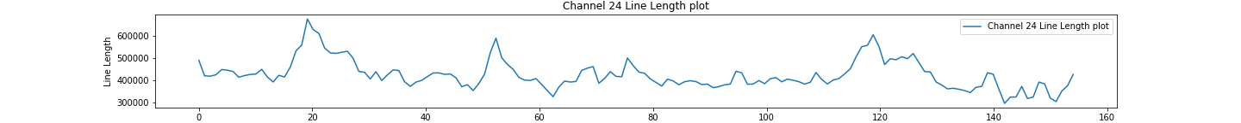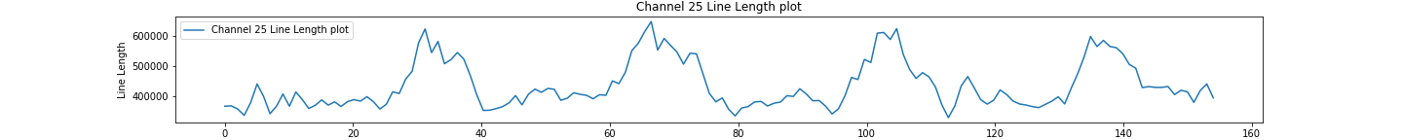

2, Energy (Window = 1s, Window Moving = 1s/step)

Based on the Line Length equation:

We plot the graph respect to all five channels:



3, Power Spectral

Based on the Line Length equation:

And the Butter Band-Pass code from:

https://scipy-cookbook.readthedocs.io/items/ButterworthBandpass.html

We plot the graph respect to all five channels:

3.1 Beta (12-30Hz)

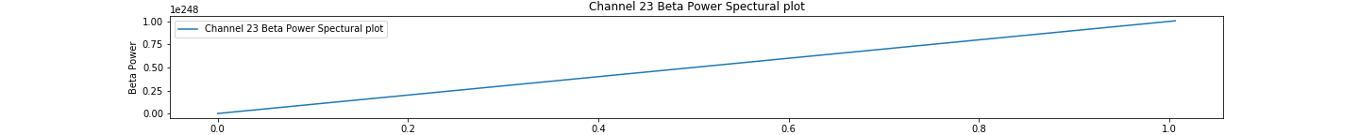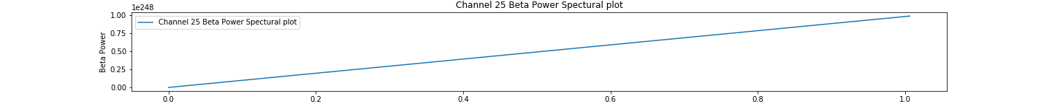

3.2 HFO (100-600Hz)

