FOLLOWING THE COMMERCIALS: COT DATA ANALYSIS

Written By: The Traders @ TradeLikeAHedgeFund.com
info@tradelikeahedgefund.com

==Updated May 22, 2017==

INTRODUCTION

==This material is conveyed as a solicitation for entering into a derivatives transaction.==

The Commodities markets weren’t created strictly as a casino. There is so much more happening in the Commodities marketplace than simply speculation. Perhaps most importantly, hedging is a crucial action taken in the markets so Commercial hedgers, farmers, and other potential hedgers can seek to limit their losses due to unforeseen dramatic events that may deleteriously affect grain prices, Cattle prices, or even Currency prices.

Commercial hedgers are businesses (think “commerce”) that hedge – or transfer -- their risk, and the Commodities markets is one way in which they do that. For example, McDonalds is a commercial hedger in the Beef market (Live Cattle, Feeder Cattle, etc). These businesses are called “Commercial hedgers” and they hedge the risk of Cattle price movements in the Commodity futures markets.

So what business type would be a Currency hedger? If you answered “bank” or “financial institution,” you would be right. Think of each business you drive by each day, and think of what Commodity product/market/s they could potentially hedge to try to limit their losses with regards to their costs of what they are selling or providing to the marketplace? Who could potentially hedge Cotton? If you answered “clothing designer” or “clothing retailer,” you would again be right. (Remember that in order to be considered a bona fide hedger, one must own the physical product.)

So it is decidedly important to see that the Commodity financial marketplace is not just one giant casino where people can either make a speculative fortune or lose a speculative fortune. Rather, there is a lot going on, and these markets can be utilized as a tool in myriad ways, with regards to both speculation and hedging. Indeed, these markets provide much-needed liquidity in the marketplace for these Commercial hedgers as well as speculators, both small and large.

Farmers hedge as well. They grow Soybeans, Corn, etc. so they need to hedge their crops for a potential weather disaster, which under normal circumstances they would not need to worry. But remember that farmers – like Commercial Hedgers – aren’t trying to make a “huge fortune” by betting in the Commodities markets; they’re trying to hedge their risk of loss. If Corn prices go to the floor because of a horrible weather event, that farmer would have to sell his Corn at depressed levels, which will have a direct effect on his/her income for the year, and his/her business will be adversely affected. Although farmers can receive subsidies from the government, they still have some risk if they cannot ‘hedge’ against possible loss.

There is also a group called Small Speculators who are exactly that, “small speculators” in the marketplace. As well, there is a group called Large Traders in the marketplace. These are brokerage firms and hedge funds.

The Commodity Futures Trading Commission (CFTC), the Commodities markets’ regulatory body, requires Futures Commission Merchants to report their Futures and their Options positions each week. They collect the data every Tuesday, yet the report comes out on Friday by 12:30 Pacific Time (non-holiday Fridays). The report is called the Commitment of Traders (COT) Report. The two groups we will follow as to helping us pick directional trades in specific markets are the Commercial Hedgers (“Commercials”) and the Large Traders. We disregard the Small Speculators Data with regards to using COT Data to trade.

So the Commercial Hedgers can be the processors (the businesses like McDonalds, a bank like Wells Fargo, or General Mills) or producers (eg farmers) who wish to “transfer their risk” from these cataclysmic events that can otherwise have an adverse effect on one’s business, one’s industry, or the price of the product/Commodity/Currency the specific business in discussion needs to earn revenues/profits.
The website where to find these CFTC COT Reports updated each Friday is as follows:

www.cftc.gov/marketreports/commitmentsoftraders/index.htm

In our opinion, this short, but pithy e-book will tackle some specific markets and will illustrate how this COT Report has been a fantastic gauge as to indicating when we may see a positive or potential market move in the Futures price. We will use the COT Line Chart that is in the drop-down on barchart.com (a site we will cover more in a bit).

Additionally, we will use the monthly continuous charts in this informational e-book.

For selecting directional trades betting on a futures price to go up overall, we generally look for the Commercials to be historically their longest (the greatest number of Futures contracts that they bought (eg betting on that Futures contract to rise) and where we look for the Large Traders to be historically their shortest (the greatest number of Futures contracts that they sold (eg betting on that Futures price to fall).

For selecting directional trades betting on a futures price to go down overall, we generally look for the Commercials to be historically their shortest (the greatest number of Futures contracts that they bought (eg betting on that Futures contract to go lower) and where we look for the Large Traders to be historically their longest (the greatest number of Futures contracts that they bought (eg betting on that Futures price to rise).

To us, “historically” typically means the Commercials are the longest or almost the longest in the last 1-3 years and the Large Traders are the shortest or almost the shortest in the last 1-3 years. Having the Commercials being the longest in the last 3 months or even the last year is oftentimes not enough. 1-3 years is a good gauge. You can also be more conservative in your trade selections, and say that you will not get long a contract unless these Commercials are the longest they’ve been in 5 years or in 7 years. But 1-3 years is generally a decent gauge.

And the longest or shortest is not always the case, but oftentimes near the longest historically or near the shortest historically may work well for strong speculative plays in a specific market.

Throughout this ebook, we will also look at the EMA, or the Exponential Moving Average and we will look at how the futures price “responds” or “reacts” to these COT
Report historical net longs, historical net shorts, etc. We construct a “story” about the potential strength or weakness of a particular market going forward. Indeed, it must be stated clearly that there is no guarantee and – to use an analogy – we are merely akin to lawyers who are bringing forth evidence that we believe will help our case, but there's no guarantee that we're going to “win” our case. Therefore, we recommend putting in stops whenever you place a trade.

Other “evidence” that we might use are as follows in these e-book examples:

Repeated market tops (double-tops or triple-tops)
Head-and-shoulders formation

This does not mean that we don’t look at a super-short time frame chart (like 1-minute, or the 5-minute chart, etc) in order to pick trades or that we don’t look at the daily chart or even the intra-day chart to help pick trades. However, we have elected for the purposes of clarity and simplicity for this e-book to simply illustrate this COT Report data and our analysis through use of the COT Report when coupled with the EMA, a few other price formations, and overall price action (price trends).

BARCHART

To look at a user-friendly visual representation of this COT Data, we really like the URL that follows: www.barchart.com.

Hence, we have utilized charts from their site to draw our specific data from (contracts- wise), and we have used their charts and site even in selecting trades for our brokerage firm to recommend to our clients. This site we believe is visually appealing with regards to scrutinizing COT Data and allowing us ample opportunity as Commodity brokers to make market predictions based on the patterns displayed on the site. Being one of the most popular COT and technical trading sites on the web, barchart.com, in our opinion, is an exemplary website for anyone who wishes to follow along with this ongoing data that helps trading firms like ours make trade predictions for our valued clients.

One of the main reasons we love this website is because it is a dynamic site with continuous improvements and not simply a static website with inactive Managers.

Another plus for our clients is that the site is free and requires no software to utilize.

In this e-book, we will be using the monthly charts on Barchart and the trades will be played out over weeks and oftentimes months, not simply a day or two. The chart observations and recommendations in this e-book are based on medium-term to longer-term position trading. This text will seek to show that one can use COT Data (and some EMA and price formation analysis) to select directional trades.

Remember, though, the mantra that is important in any respectable text on speculating in these markets:

THE RISK OF LOSS IN TRADING CAN BE SUBSTANTIAL AND IS NOT FOR EVERYONE. PAST PERFORMANCE DOES NOT NECESSARILY INDICATE FUTURE RESULTS. ONLY TRADE WITH RISK CAPITAL.
THIS PAGE LEFT BLANK INTENTIONALLY.

CANADIAN DOLLAR

The Canadian dollar, or the “loonie” as it’s more colorfully called, is a risk appetite currency. This means that if global investors are excited about the current and future prospects of global economies, then we normally see the Canadian Dollar rally. The reason why the Canadian Dollar rallies is because Canada offers relatively high interest rates among first-world countries (eg ones with relatively low currency default risk), so global investors would place their money in
Canadian assets and Canadian banks since their rates are relatively high. What happens is the foreign investor has to convert his local currency (Yen, US Dollar,
Swiss Franc, etc) to Canadian dollars. This means that he “dumps” his local currency into the money supply (more supply) and then “buys” Canadian dollars (since Canadian banks and Canadian assets are bought with Canadian currency). Higher supply of US Dollars is a factor for lower US Dollar futures and lower supply of Canadian Dollars is a factor for a higher/stronger Canadian Dollar futures. This is obviously a vast over-simplification, but remember that the Canadian Dollar truly is a risk appetite currency and should always be remembered
as such.

Since the 1970s, when it was floated against all the world’s other currencies, the Canadian dollar was officially established as a global reserve currency. With regards to the Commitment of Traders Report, we see in Diagram 1.1 that a strong net short position by the Commercial hedgers in March 2010, being short -100, 787 contracts. Meantime, we also see that the Large Traders had a strong net long position in March 2010, being long +70, 296 contracts. April, May, and June saw the loonie fall though it just fell to the Exponential Moving Average line, so make sure not to get too aggressive with trading on the COT Report data. Also, the market might have immediately went against you if you got short in March or even early April, so the question is making sure to watch your stops and to keep watching price action if you indeed elect to get short again if you get stopped out of your short position.

If you stayed in too long, you would have eventually seen the price continue the upward rally above the EMA in subsequent months, so savviness in trading this COT data using the monthly CAD chart is paramount.

DIAGRAM 1.1 [Source: barchart.com]

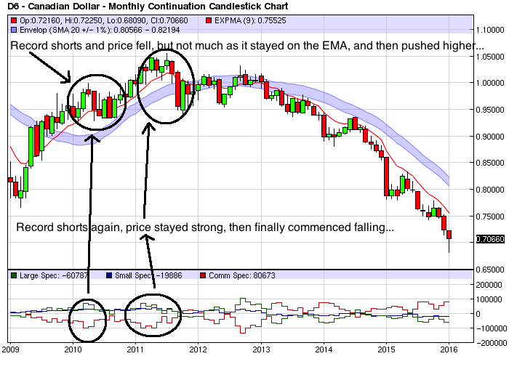

What is particularly important to note is the famous adage that “trends tend to persist.” Note that once the Canadian dollar market turns solidly bearish, it starts closing right on the price envelope (from closing above it before), then it starts closing below the price envelope commencing the 2nd quarter 2013 and continues this strong monthly downtrend for many moons in a row as we see in the monthly continuous chart at Diagram 1.2.

Diagram 1.2 [Source: barchart.com]

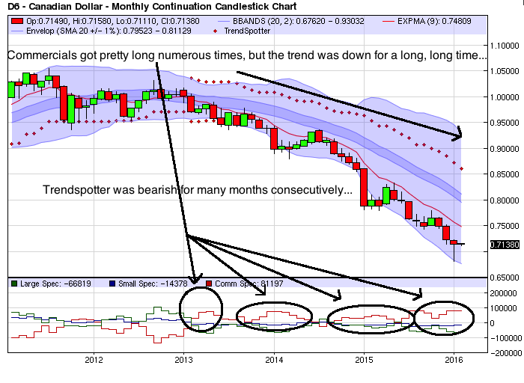

Indeed, we see a very bearish market as the monthly price chart doesn't reflect hardly any end-of-month (“EOM”) closes on or above the EMA, which here makes sure that the price doesn't even get close to the top of the price envelope for myriad consecutive years (2013-present).

Blatantly, the Canadian Dollar futures price completely ignores these historically record Long positions by the Commercial hedgers that occur for 3 years and instead remains solidly entrenched in a downtrend that seems to be keyed at least partially on the record Short Commercial positions that we see reflected at the end of the 3rd quarter 2012.

Trendspotter also helps in this chart as it has relayed a bearish status for over 2.5 years now and this monthly continuous chart palpably reflects said bearishness. We believe that it's crucial to use secondary and tertiary indicators and not simply the COT Report data in order to gauge whether one should be Long, Short, or even flat a market (not in any speculative play in either position, but rather out of the market with cash on the sidelines).
JAPANESE YEN

As a sharp contrast to the Canadian Dollar, itself one of the major “risk appetite” currencies, the Japanese Yen is decidedly a “risk aversion” currency, meaning that if there is a general fear for the overall global economic future, then this currency will normally strengthen against the US Dollar. In a paper published by the International Monetary Fund in January 2013, they clearly state that “During these [risk-off] episodes, currency markets exhibit recurrent patterns, as the Japanese yen, Swiss franc, and U.S. dollar appreciate against other G-10 and emerging market currencies.”

The yen had been in a deflationary spiral, and was depreciating for many years before the economic crash of 2008. However, once the ’08 global crash commenced, other major currencies other than the Swiss Franc began depreciating against the Yen as global investors took capital out of higher-risk currencies and moved these funds to the safety of not only US Treasuries, but also into the Japanese Yen.

On April 4th, 2013, the Bank of Japan announced that they were going to expand their Asset Purchase Program by $1.4 trillion USD over the subsequent two years. The BOJ (“Bank of Japan”) hopes that this will bring Japan out of the deflationary quagmire their country has been stuck in. The BOJ’s aim is to move them into a more inflationary environment, with their target being 2%. The amount of purchases is so substantial that – once converted from US dollars to Japanese Yen -
- it would effectively double the M2, or the total money supply in circulation in
Japan.

This would have an effect on export prices, but we will not get into that more in-depth economic analysis in this ebook. Rather, we will focus on the fact that this BOJ move illustrates that Currency fundamentals should be seen as just like any other Commodity’s fundamentals; it’s all about supply and demand. Therefore, if there is a massive supply of Japanese Yen pumped into the market over the next two years, this would mean that there’s more currency supply and as long as the demand for that currency doesn’t explode upwards, then it would stand to reason that the price/value of that Currency should drop. Well, as we see in Diagram 2.1, the Japanese Yen has dropped pretty low commencing even before April 2013, and perhaps this is a primary fundamental reason why the price has been continuing to fall overall these past years.

Why bring up supply and demand, or fundamentals, here?

Simply put, there is not merely one indicator that a market participant ought to look at in order to decide whether or not to get Long, Short, or remain flat a market (or play it to stay within a certain price range). Rather, it is shrewd to take various salient factors into account when deciding how to participate (or not) in a Commodity futures market.

DIAGRAM 2.1[Source: barchart.com]

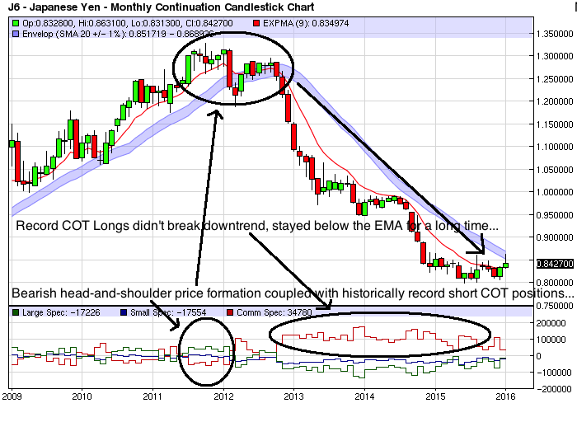

We also see a bearish head-and-shoulders technical formation in the Yen futures monthly continuous chart, which is especially noteworthy because these EOM futures prices closed above the EMA most of the months during this bearish formation (and at least at the top of the price envelope). Indeed, the Commercial hedgers got pretty net Short during the second half of 2011, but then pop up pretty Long during the first part of 2012, yet we still see the setup as bearish and the futures price starts falling towards the end of 2012 after a fairly Short switchover by the Commercial hedgers.

Note that there are numerous head-fakes both up and down before this price drop starts towards the end of 2012 after forming the bearish head-and-shoulders pattern. We at Ramarcher like these patterns that occur on the monthly continuous charts rather than daily or weekly charts as we believe that they are more reliable though one still must be very nimble and savvy to trade these markets – even with accurate COT data analysis.

Biggest piece of evidence? Well, look at Diagram 2.1 again. Note that the Commercial hedgers get super-Long basically for 3 years straight (2013-present) and still the Yen futures continues its downward descent without closing EOM above the EMA during this time. So as my first boss used to say religiously, “Don't fight the tape.” And if “the tape” (as in repeated end-of-month closes below the EMA) keeps saying “bearish,” then we gotta ignore the COT data as the protracted price drop is clearly keying off of previous COT data and where the Commercial hedgers were at previously.

So where is the Yen headed now? It's really tough to call a bottom just because we have seen a few months close above the EMA, but it's definitely a market to watch. Still, I wouldn't get Short here as I believe that it's much tougher to continue to play this market lower over the medium-term to long-term after this strong of a downtrend in price.

NATURAL GAS

Now let's take a gander at COT Report data for Natural Gas Futures and see where we might have seen a corresponding futures price move that reflected said data. Diagram 3.1 illustrates that in early 2011 we saw the Commercial hedgers get historically long while the Large Traders got historically short this market. Indeed, this prefigured a 3-month rally, but note that it didn't prefigure a sharper or longer rally. This was indeed a pop upwards – albeit a nice move – but still was in an overall downtrend and it resumed said downtrend not soon after this pop up.

DIAGRAM 3.1 [Source: barchart.com]

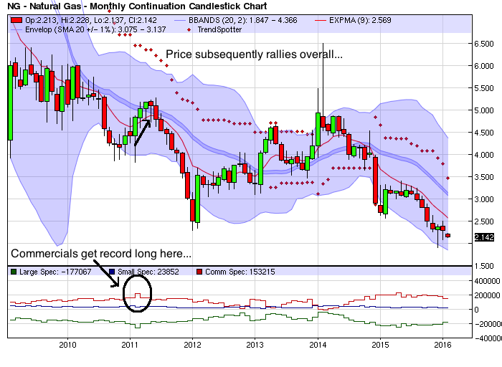

Later on, in early 2014, as we see in Diagram 3.2, the Commercial hedgers get net short this market which hasn't happened in years. Consequently, the price bounces around a bit, forming a double top formation which can be seen as bearish, then subsequently starts falling commencing April 2014 and continues falling overall all the way to when this ebook was published in early 2016.

Note that even though the Commercials get historically record long this market throughout most of 2015 and the Large Speculators get historically short this market throughout the same time period, one might assume that the price would rally. Again, as we've iterated before, there is no silver bullet, there is no “one” indicator that will tell us when to get long or short a particular market.

Additionally, it's crucial to watch the price action and see how the price responds to this COT Report data and we can clearly see that the EOM (end-of-month) Natural Gas futures prices closes below the EMA umpteen consecutive times, re-affirming the bearish trend that the market remains in.

As we commented earlier, “trends tend to persist” and this is clearly illustrated with the overall Natural Gas futures price action from 2nd quarter 2014 to the present.

Diagram 3.2 [Source: barchart.com]

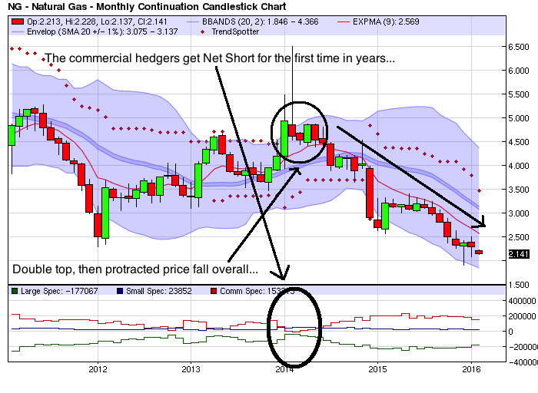
Seeing as the Commercial Hedgers are now pinching down and the Large Speculators are pinching up, we would not choose this time to get Long this market. Indeed, we wouldn't “fight the tape,” as it were and the path of least resistance currently is still down, especially since we haven't seen the EOM (end-of-month) Natural Gas futures close above the Exponential Moving Average (EMA) since the 2nd quarter 2014.

CRUDE OIL

Crude Oil is one of the biggest headline grabbers and certainly seems to intrigue many would-be and actual market participants. Still, the initial and maintenance margins are quite often substantial, which participants need to keep in mind when trading this market.

Indeed, after a substantial futures price run-up, we see that in April 2011 there is a historically short Commercial position coupled with a historically long Large Spec position and the futures price falls from above 110 to around 80 within 5 months.

Diagram 4.1 [Source: barchart.com]

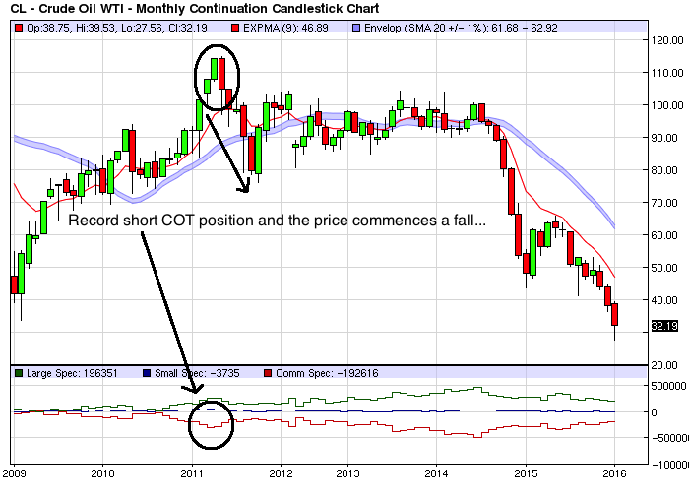
Is this an easy trade to pick? Not even close. Note that the price takes 2 months to close below the EMA and even then, it's not obvious that the price will continue to fall. No, what is crucial is position sizing, putting in appropriate stops, and not getting married to any trade no matter how confident one gets. There are other indicators we might add in order to help us select whether or not to get Long, Short, flat, or even market neutral (playing for the Crude price to stay in a price range), yet in this ebook we are primarily focused on the COT Report Data plus perhaps a few popular technical price formations like double tops, triple tops, and head-and-shoulders formations.

Later on, as Diagram 4.2 displays, although we see the Commercials get more and more historically record short Crude futures, nevertheless the price stays in a relatively tight $10-dollar-or-so range that lasts all of 2 years.
It's only once the Commercials get historically super-record short in mid-2014 that we see the futures price take a protracted tumble. This is especially tough to gauge because the Commercials had already gotten historically more and more record short around 5-6 times before they pinched even “lower,” so it isn't easy to keep guessing that the price'll drop hard over and over again.

Diagram 4.2 [Source: barchart.com]

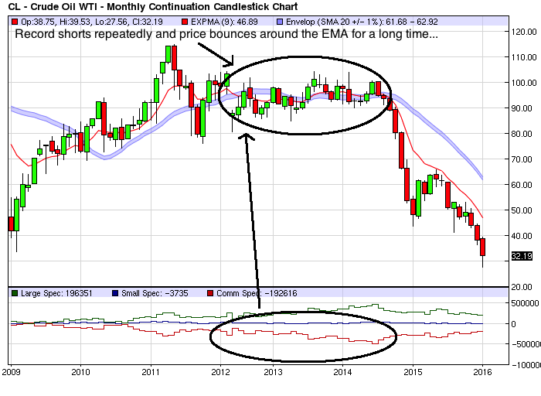
Again, one must look at other indicators and also put in appropriate stops while waiting for what may or may not be a precipitous drop in the Crude Oil futures price. Note that the price action is not particularly bullish and that the Commercials keep getting shorter and shorter. This would at least make us think that the next big move might very well be down, yet again, no one has a crystal ball and timing is paramount.

Another strong piece of evidence that might suggest that Crude is going to fall soon is the triple top that occurs between mid-2014 and mid-2015. This potential bearishness is supported by the Commercials getting more and more historically short this market with the third top coinciding closely with the timing of the Commercials being the most historically short they've been in at least 4+ years.

This presages a strong price drop overall and we are still in the throws of bearishness though I wouldn't get short at these levels currently, especially with the Commercials starting to pinch more “up” and with the price already having fallen sharply from 100 to 32.

Diagram 4.3 [Source: barchart.com]

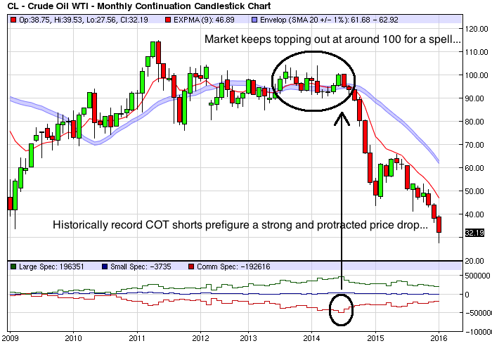

SILVER

While Gold has always been considered a store of financial value exclusively, its step-sibling Silver has not only been a store of financial value, but it's also been a store of industrial value, or as a utility. Still, this dual value of Silver has not given it a premium compared with Gold; on the contrary, the Silver futures price has basically always been a mere fraction of the Gold price.

Note Diagram 5.1 where we see the Monthly Silver futures price over the last 5 years. This might look like an easy trade because the market stays high and goes straight down for many years. Actually it's a challenging trade precisely because the market doesn't change direction. Still, the Trendspotter indicator shows a “SELL” for over 3 years in a row and the End-of-Month price close never even touches the 20-Day Simple Moving Average Envelope we've added as a study to our chart. This would make being perpetually short seemingly obvious, right?

Hmm..Actually, no. The Commercial hedgers get historically short numerous times over the last few years and that might normally presage at least one change in price direction from down the up. But the Silver futures price has done nothing but fall overall in the last 3-5 years.

This price chart makes it very obvious that one must keep various indicators in mind when deciding what trade to enter or not. Just the COT Data is not enough as that data was essentially ignored and the Silver futures price just kept falling and falling.

Diagram 5.1 [Source: barchart.com]

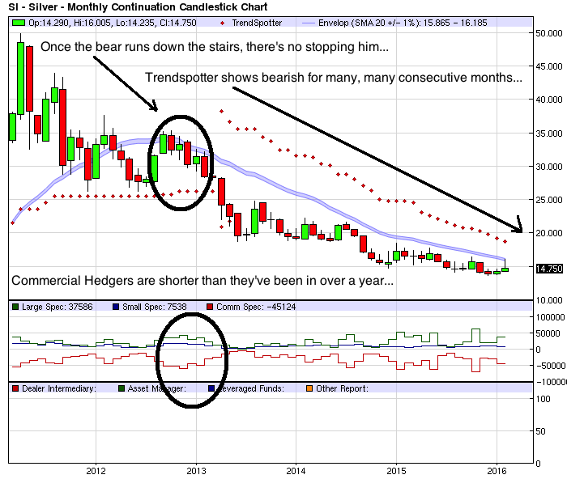
Some might think that one should just watch the Trendspotter indicator, but note that this indicator only works extremely well during massively trending markets – like substantial and long-term dips or substantial and long-term price rallies.

CONCLUSION

As principal traders of LikeAHedgeFund.com, we look at 10+ indicators in order to decide on which market to enter and when, which market to exit and when, and when to remain “flat,” or in a cash position outside of a market. The Commitment of Traders Report data (some of which has been analyzed in this ebook) is simply one piece of a larger puzzle that we employ as traders in these markets.

Hence, we must request that you look at any one indicator or any one piece of data with a LARGE grain of salt. There is NO SILVER BULLET out there. It does not exist, whether in technical analysis or fundamental analysis or both. There may be fundamental catalysts -- like interest rate changes or crop reports or drought conditions -- or technical indicators that may or may not affect the futures price of a particular Commodity or Currency, etc.

We encourage all market participants to keep the principles of proper portfolio management in mind when deciding whether or not to speculate in the futures markets.

Remember the key disclaimers:

PAST PERFORMANCE IS NOT NECESSARILY INDICATIVE OF FUTURE RESULTS. THE RISK OF LOSS IN TRADING CAN BE SUBSTANTIAL AND IS NOT FOR EVERYONE. TRADE ONLY WITH RISK CAPITAL. THIS ELECTRONIC COMMUNICATION AND ITS CONTENTS ARE INTENDED FOR THE RECIPIENT ONLY AND MAY CONTAIN CONFIDENTIAL, NON-PUBLIC AND/ OR PRIVILEGED INFORMATION. IF YOU HAVE RECEIVED THIS ELECTRONIC COMMUNICATION IN ERROR, PLEASE ADVISE THE SENDER IMMIDETIALY AND DELETE IT FROM YOUR SYSTEM, IF PERMITTED BY LAW. TRADELIKEAHEDGEFUND.COM DOES NOT WARRANT THE ACCURACY, RELIABILITY OR COMPLETENESS OF ANY INFORMATION CONTAINED IN THIS ELECTRONIC COMMUNICATION OR THE APPROPRIATENESS OF ANY TRANSACTION. TRADELIKEAHEDGEFUND.COM DOES NOT ASSUME ANY RESPONSIBILITY FOR ERRORS OR OMISSIONS. THIS MATERIAL HAS BEEN PREPARED BY A SALES OR TRADING EMPLOYEE OR AGENT OF TRADELIKEAHEDGEFUND.COM AND IS A SOLICITATION FOR ENTERING INTO A DERIVATIVES TRANSACTION. THIS MATERIAL IS NOT A RESEARCH REPORT AS DEFINED IN APPLICABLE CFTC REGULATIONS. ANY MARKET OR OTHER VIEWS EXPRESSED HEREIN ARE THOSE OF THE SENDER ONLY AS OF THE DATE INDICATED AND NOT NECESSARILY THOSE OF TRADELIKEAHEDGEFUND.COM. TRADING FUTURES, OPTIONS ON FUTURES AND RETAIL OFF-EXCHANGE FOREIGN CURRENCY TRANSACTIONS INVOLVES SUBSTANTIAL RISK OF LOSS AND IS NOT SUITABLE FOR ALL INVESTORS. THERE ARE NO GUARANTEES OF PROFIT. YOU SHOULD CAREFULLY CONSIDER WHETHER TRADING IS SUITABLE FOR YOU IN LIGHT OF YOUR CIRCUMSTANCES, KNOWLEDGE AND FINANCIAL RESOURCES. YOU MAY LOSE ALL OR MORE THAN YOUR INITIAL INVESTMENT. OPINIONS, MARKET DATA AND RECOMMENDATIONS ARE SUBJECT TO CHANGE WITHOUT NOTICE. TRADELIKEAHEDGEFUND.COM SHALL NOT BE HELD RESPONSIBLE FOR ANY ACTIONS TAKEN BASED ON THIS ELECTRONIC COMMUNICATION. PARTIES ACTING ON THIS ELECTRONIC COMMUNICATION ARE RESPONSIBLE FOR THEIR OWN ACTIONS. PAST PERFORMANCE IS NOT NECESSARILY INDICATIVE OF FUTURE RESULTS.

